HSCode – 4- Dairy products.

<https://economictimes.indiatimes.com/industry/cons-products/food/indias-dairy-products-export-seen-flat-at-30000-tonnes-in-2016-usda/articleshow/49536867.cms?from=mdr>

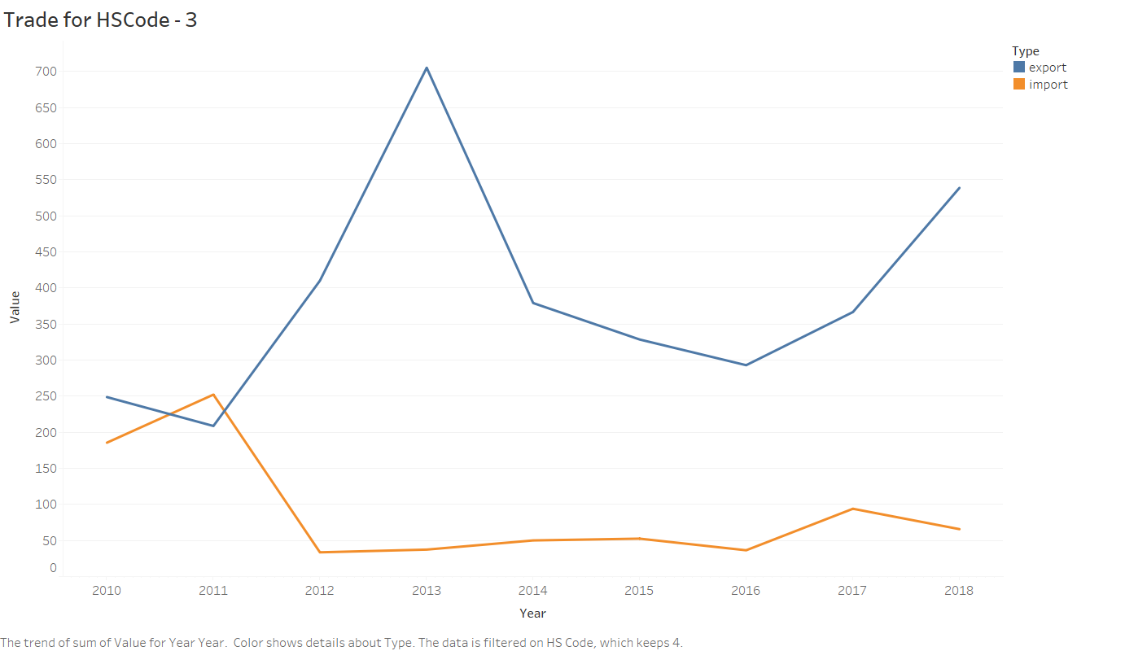

**India's dairy products export seen flat at 30,000 tonnes in 2016: USDA(U.S. department of Agriculture)**

**The domestic milk consumption is also estimated to rise by 5 per cent to 62.75 million tonnes on population growth in the said period.**

HSCode – 7- Edable vegetables and bulbs.

Huge drop of import in 2018,

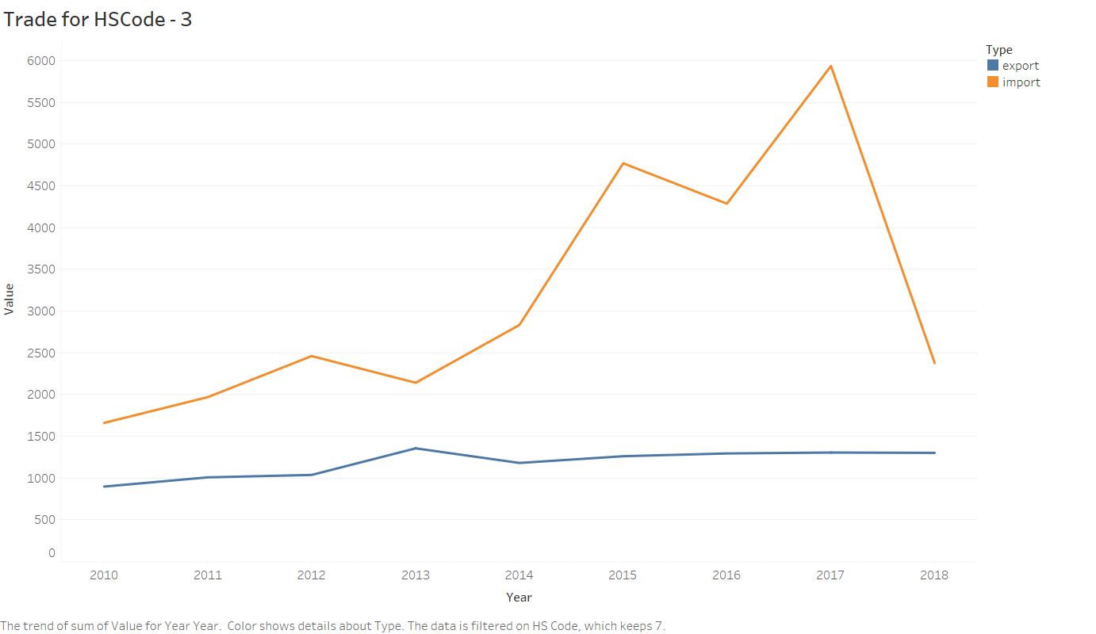

Trend of hs code 8- fruits and melons are increasing trend

EDIBLE FRUIT AND NUTS; PEEL OR CITRUS FRUIT OR MELONS.

**India imports 24 times more apples than it produces. Fnbnews.**

<http://www.fnbnews.com/Interview/india-imports-24-times-more-apples-than-it-produces-45559>

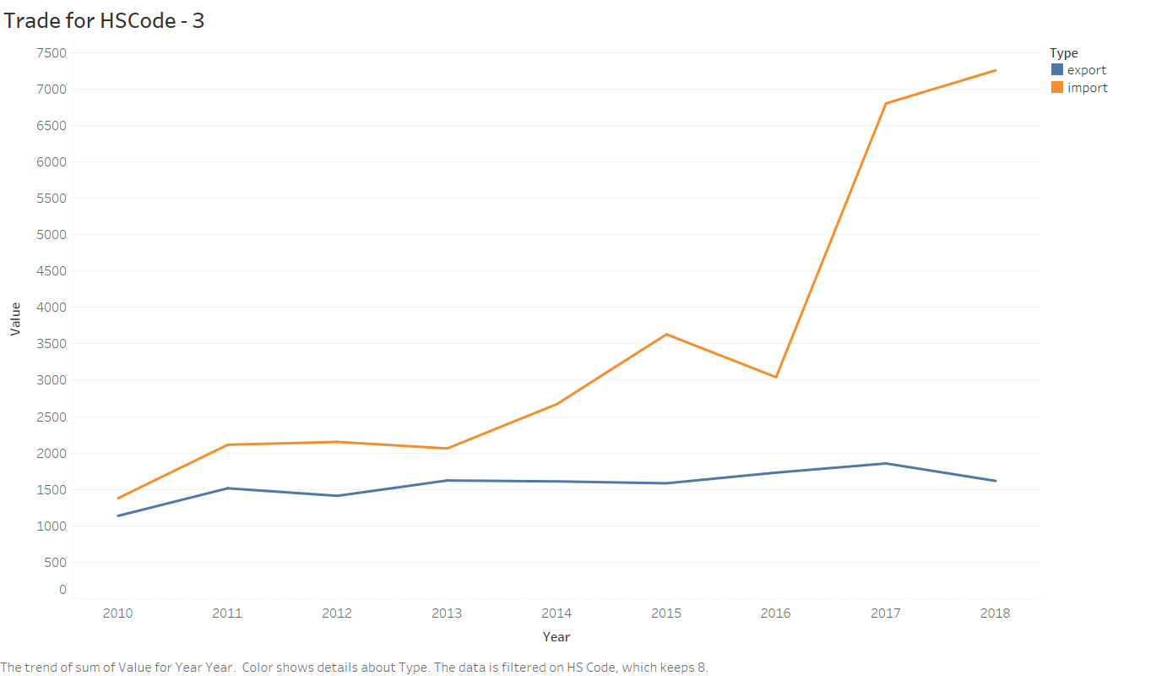

HSCode – 14(VEGETABLE PLAITING MATERIALS; VEGETABLE PRODUCTS NOT ELSEWHERE SPECIFIED OR INCLUDED.)

Vegetable materials of a kind used primarily for plaiting (for example, bamboos, rattans, reeds, rushes, osier, raffia, cleaned, bleached or dyed cereal straw, and lime bark).

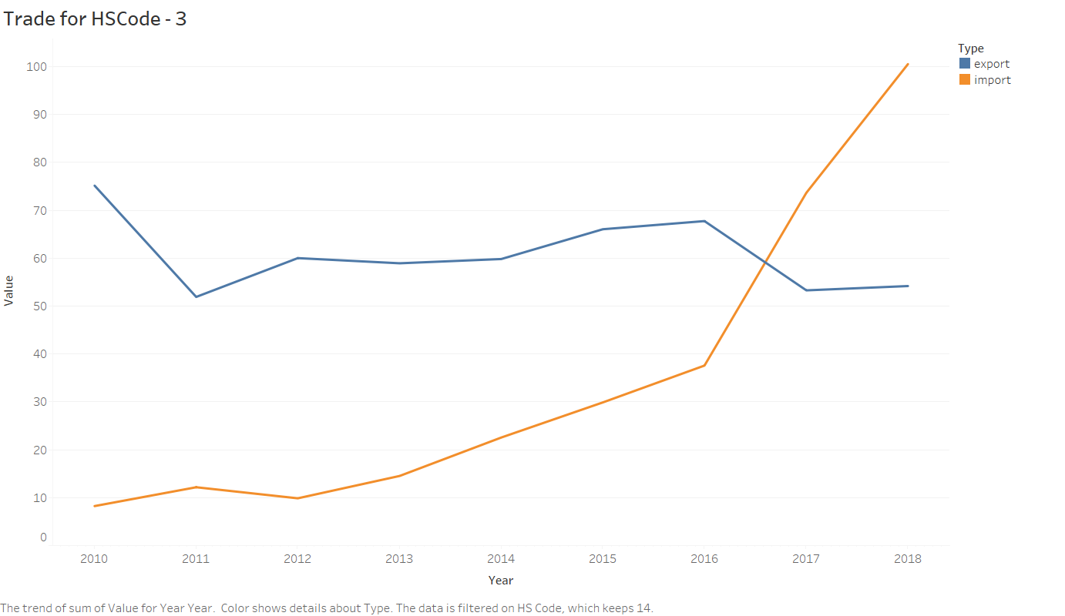

HSCode 16 –

PREPARATIONS OF MEAT, OF FISH OR OF CRUSTACEANS, MOLLUSCS OR OTHER AQUATIC INVERTEBRATES

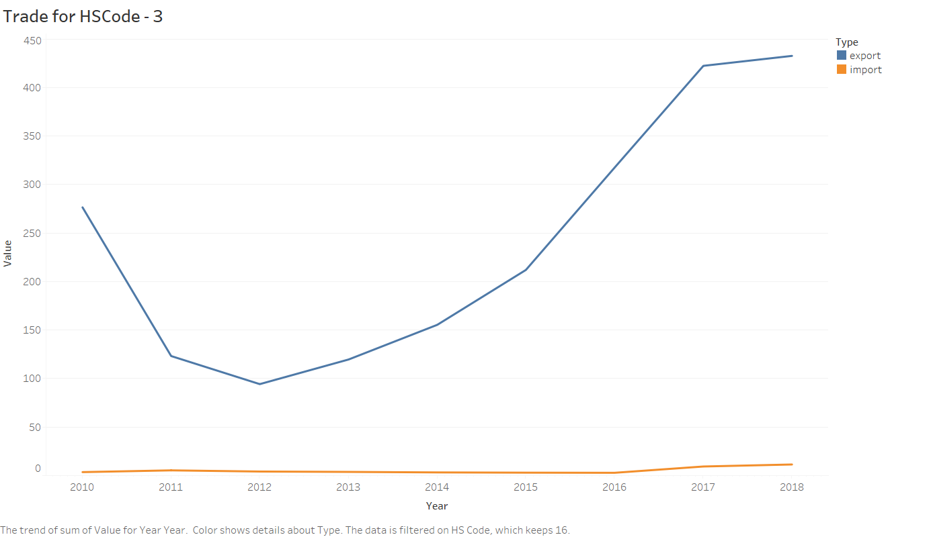

Indian seafood export touches new high at $7.08 billion  
The quantity was up by 21.35% while the value rose 19.1% over the previous year.

Jul 02, 2018

Read more at:  
[//economictimes.indiatimes.com/articleshow/64825570.cms?from=mdr&utm_source=contentofinterest&utm_medium=text&utm_campaign=cppst](https://economictimes.indiatimes.com/articleshow/64825570.cms?from=mdr&utm_source=contentofinterest&utm_medium=text&utm_campaign=cppst)

HSCode – 17

SUGARS AND SUGAR CONFECTIONERY.

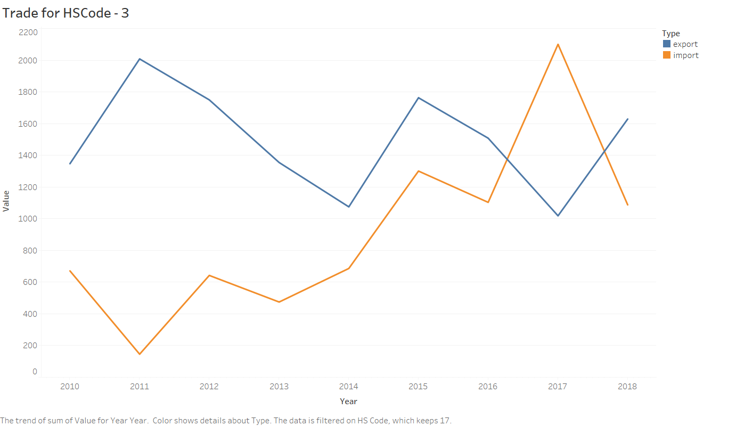

HSCode – 25

SALT; SULPHUR; EARTHS AND STONE; PLASTERING MATERIALS, LIME AND CEMENT.

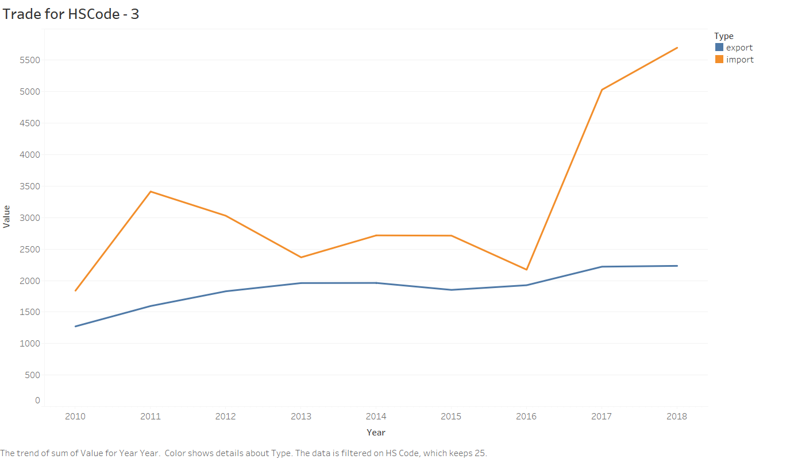

HSCode – 27

MINERAL FUELS, MINERAL OILS AND PRODUCTS OF THEIR DISTILLATION; BITUMINOUS SUBSTANCES; MINERAL WAXES.

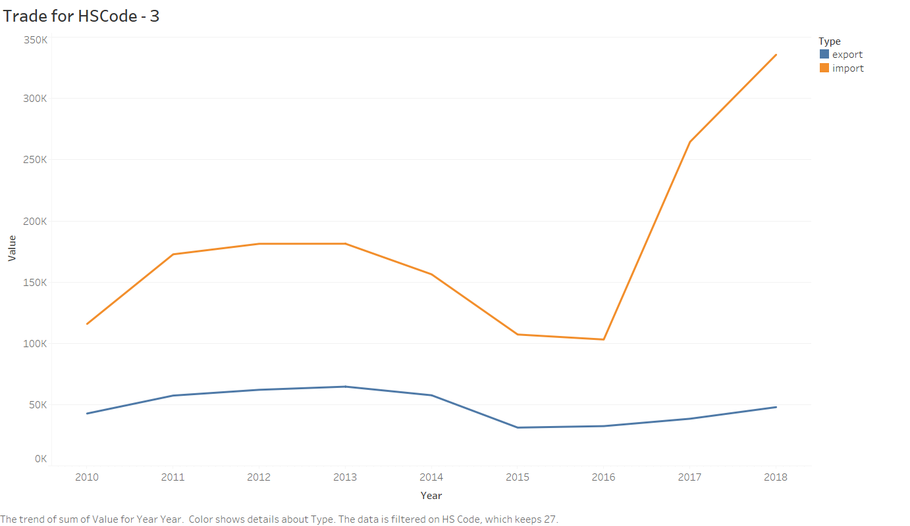

HScode 28,29 also increased a lot following the same pattern

HS Code – 32

TANNING OR DYEING EXTRACTS; TANNINS AND THEIR DERI. DYES, PIGMENTS AND OTHER COLOURING MATTER; PAINTS AND VER; PUTTY AND OTHER MASTICS; INKS.

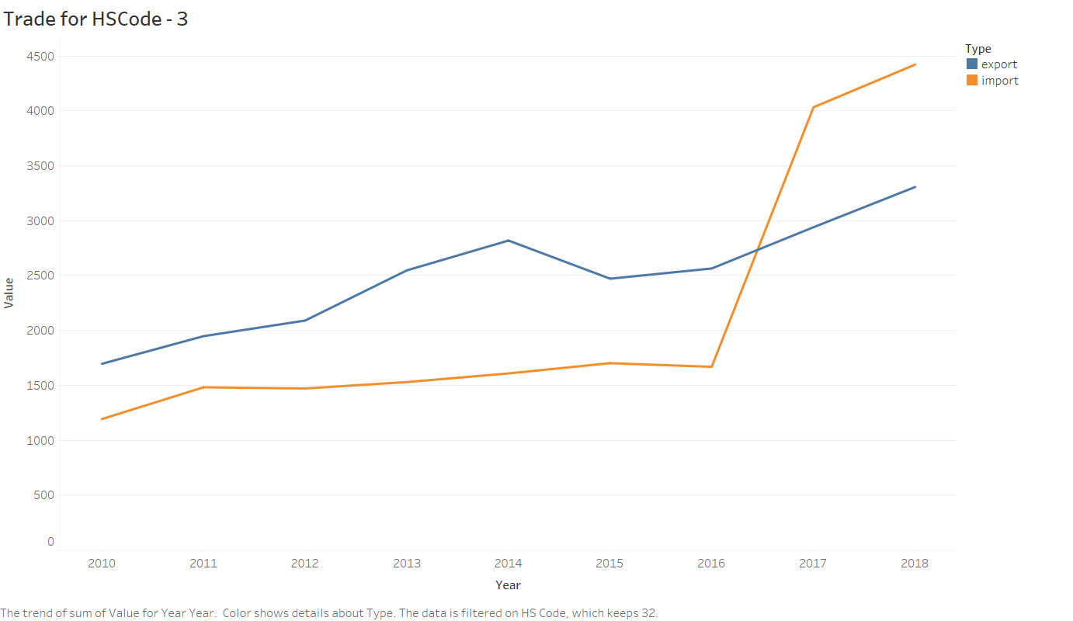

HSCode – 41

RAW HIDES AND SKINS (OTHER THAN FURSKINS) AND LEATHER

# India’s Leather Exports Decline, As Cow-Related Violence Increases

Export growth slowed to 9.37% in 2014-15 and declined more than 19 percentage points in 2015-16, the data show.

-new delhi, stated by india spend

<https://www.indiaspend.com/indias-leather-exports-decline-as-cow-related-violence-increases-99395/>

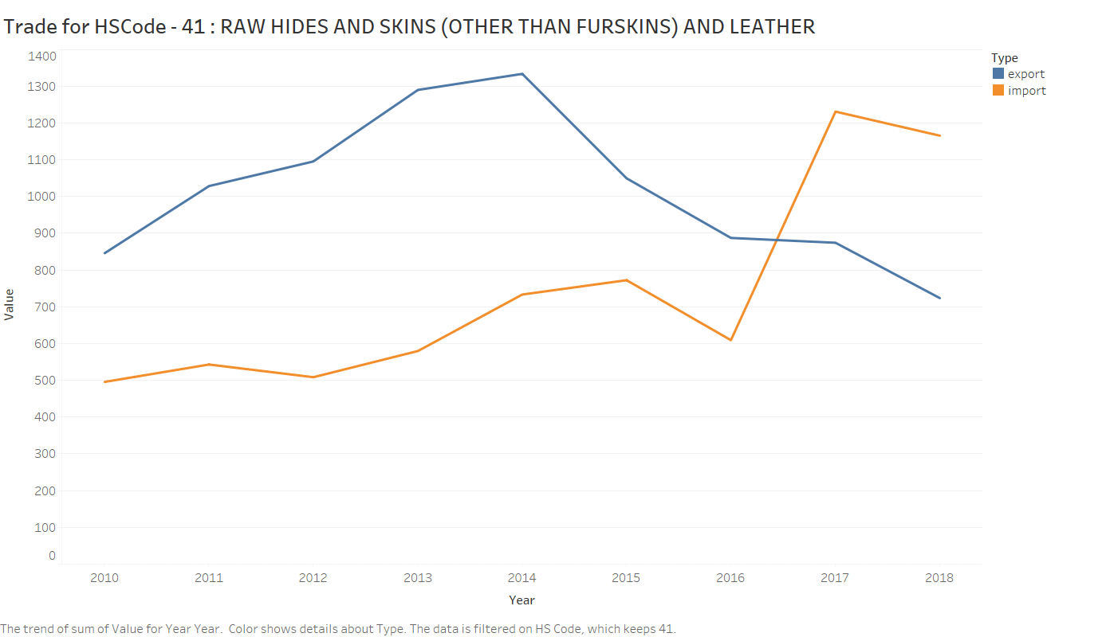

HSCode - 43

FURSKINS AND ARTIFICIAL FUR, MANUFACTURES THEREOF.

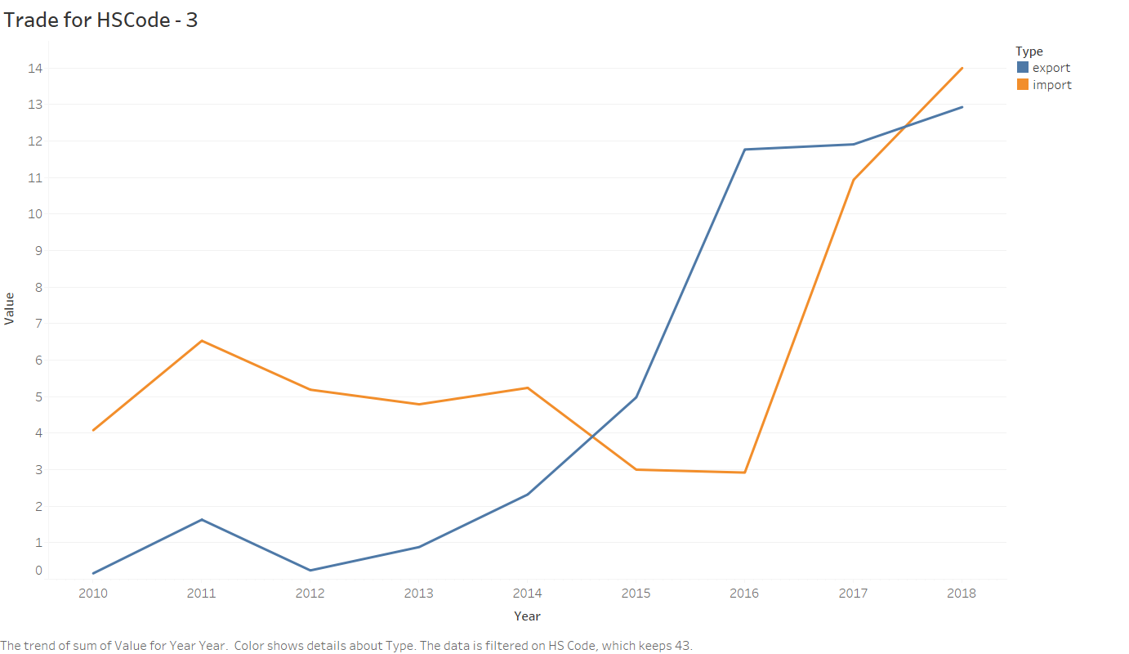

HSCode – 46

MANUFACTURES OF STRAW, OF ESPARTO OR OF OTHER PLAITING MATERIALS; BASKETWARE AND WICKERWORK.

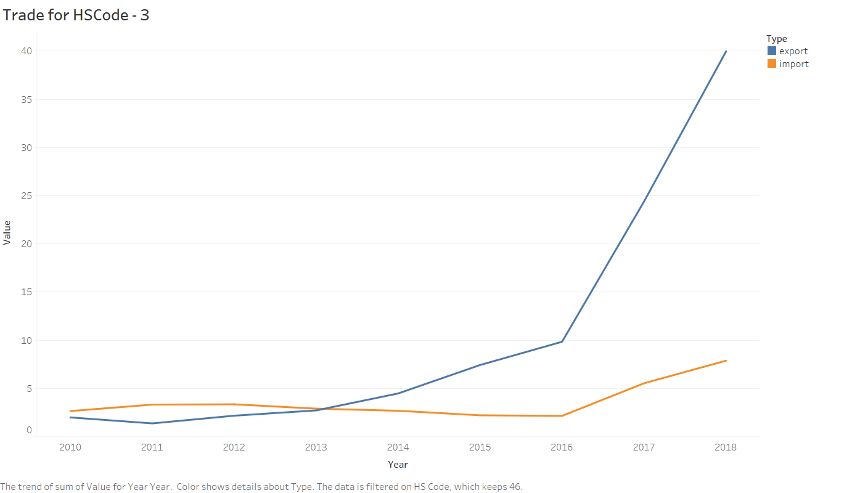

HScode – 50, silk

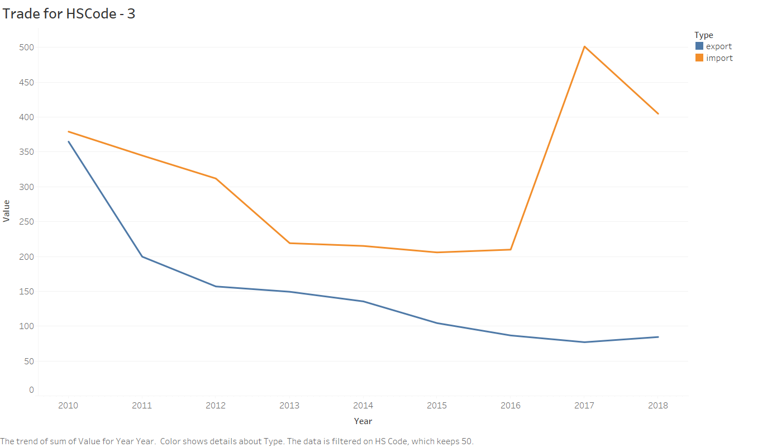

Currently, any import of silk fabrics from Vietnam attracts zero per cent duty, which makes India’s silk fabrics expensive. This has significantly affected the domestic market of India.

 Bharat Gandhi, Chairman, The Federation of Indian Art Silk Weaving Industry, averred that the phenomenal rise in the import of silk fabrics from Vietnam in last 2 years has deteriorated the conditions of silk fabric manufacturers hailing from Indian cities of Bhagalpur, Varanasi, Bengaluru, Surat and some parts of Tamil Nadu.

11-January-2019

<https://apparelresources.com/business-news/sourcing/increase-import-silk-fabrics-vietnam-big-threat-india/>

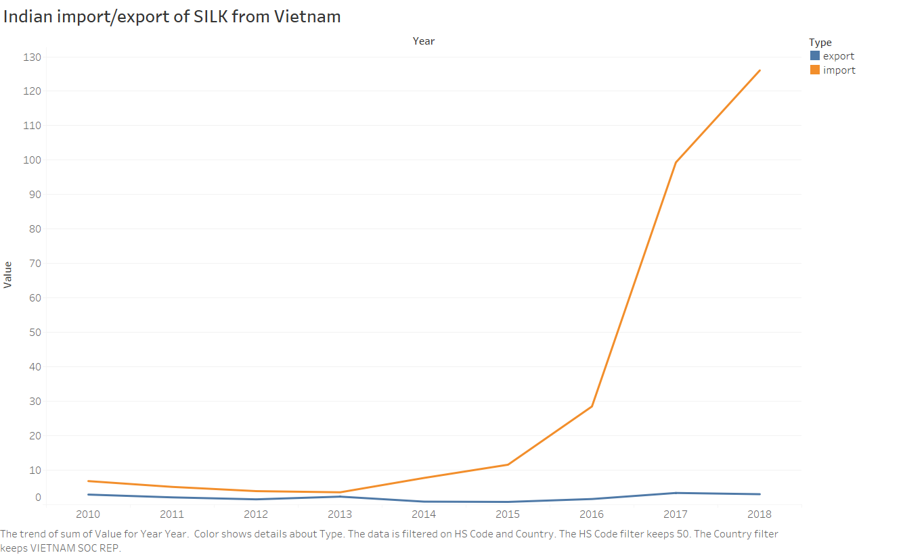

HSCode 54 and 55, import is increasing by great amount from 2017 and export is decresing

54 - MAN-MADE FILAMENTS.

55 - MAN-MADE STAPLE FIBRES.

55 image

KOLKATA: Confederation of Indian Textile Industry (CITI) chairman Sanjay Jain on Saturday stated that the continuous rise of man made fibre (MMF) imports, especially after GST implementation, is deeply hurting the domestic textile industry.

Read more at:  
[//economictimes.indiatimes.com/articleshow/71128013.cms?from=mdr&utm_source=contentofinterest&utm_medium=text&utm_campaign=cppst](https://economictimes.indiatimes.com/articleshow/71128013.cms?from=mdr&utm_source=contentofinterest&utm_medium=text&utm_campaign=cppst)

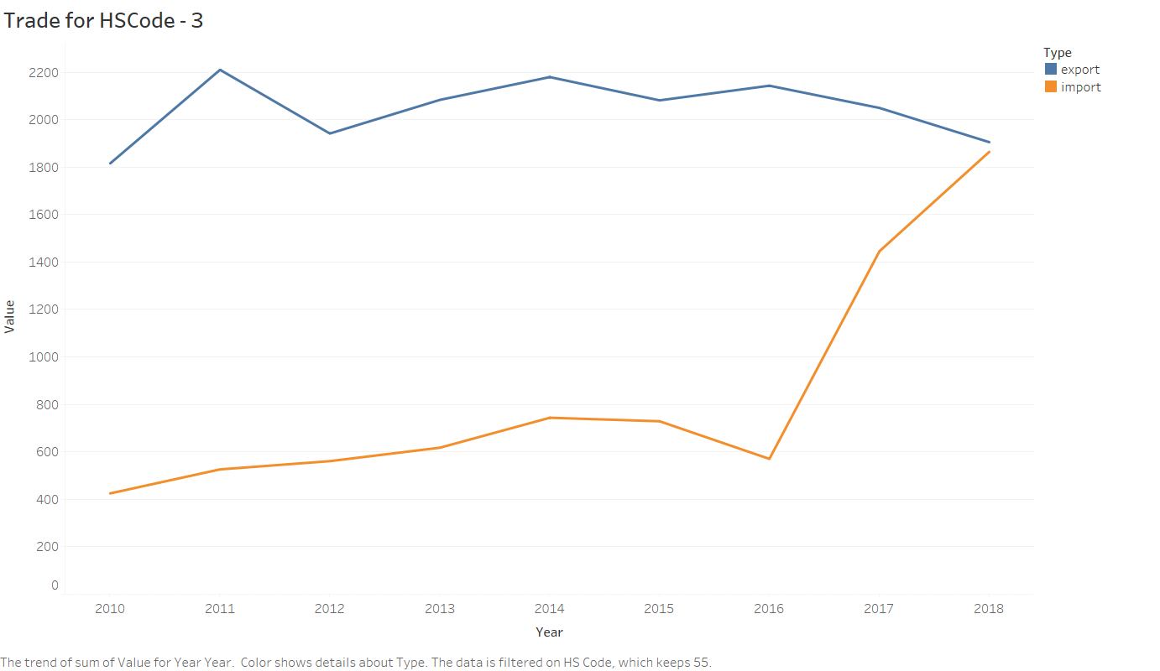

HSCode – 56

WADDING, FELT AND NONWOVENS; SPACIAL YARNS; TWINE, CORDAGE, ROPES AND CABLES AND ARTICLES THEREOF.

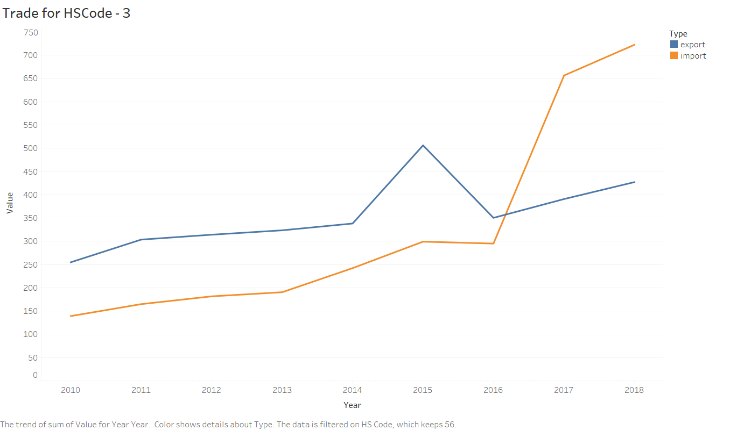

HSCode – 58

SPECIAL WOVEN FABRICS; TUFTED TEXTILE FABRICS; LACE; TAPESTRIES; TRIMMINGS; EMBROIDERY.

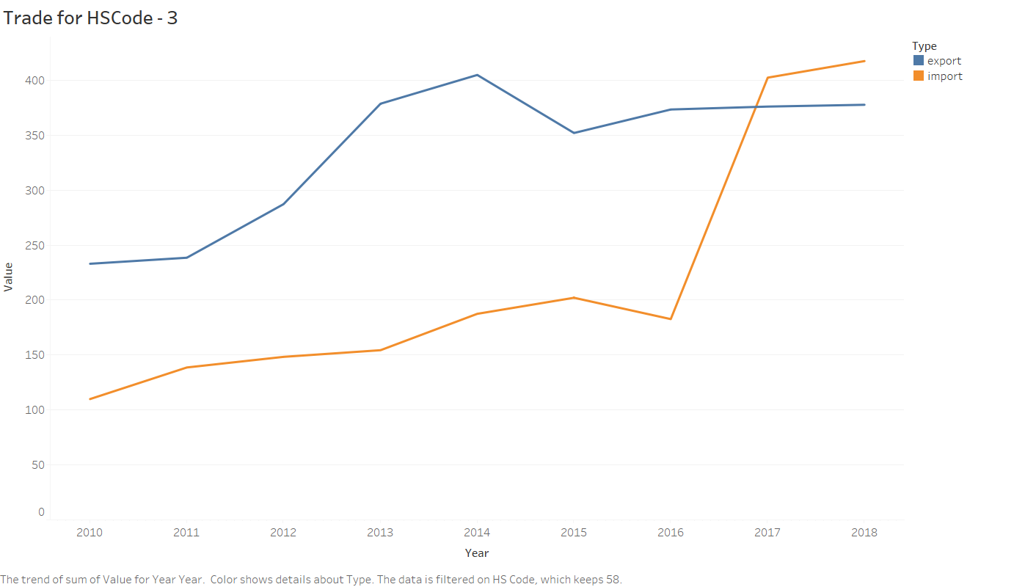

HSCode – 68

ARTICLES OF STONE, PLASTER, CEMENT, ASBESTOS, MICA OR SIMILAR MATERIALS.

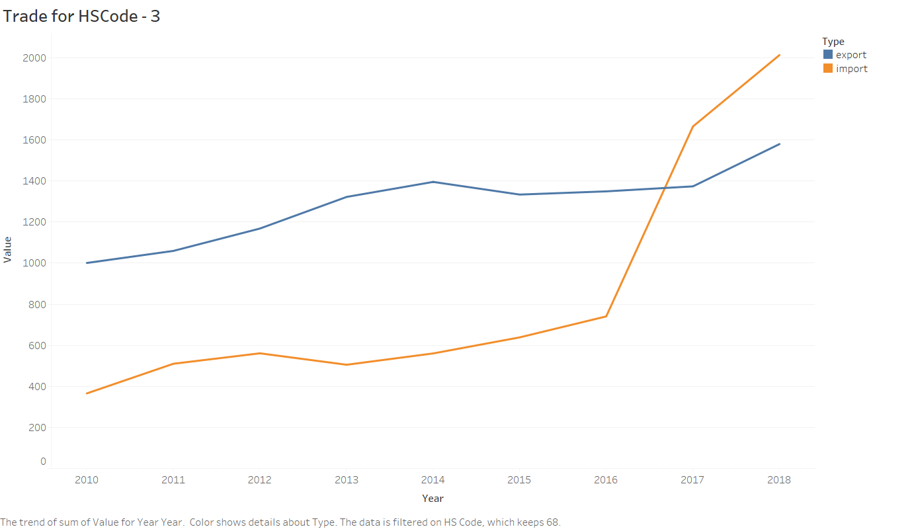

HS Code – 69

CERAMIC PRODUCTS.

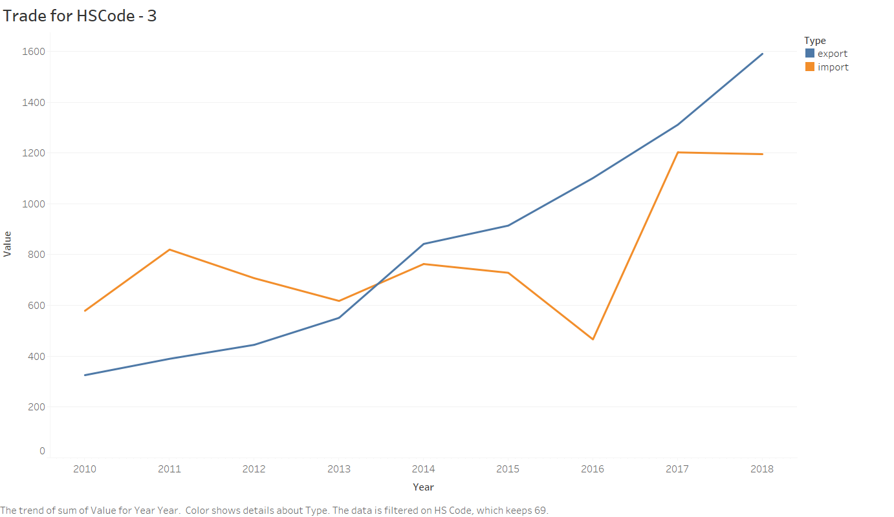

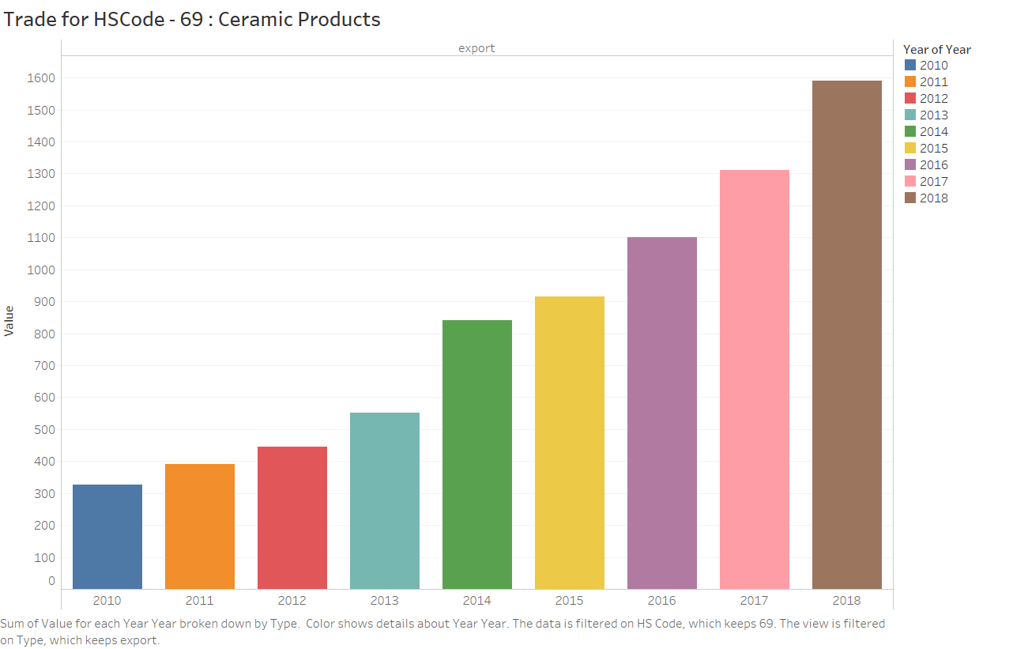

During 2017, India was the 24th largest ceramic trading nation in the world and accounted for a share of around 0.9% in total ceramics trade. During the period, from 2010 to 2017, India’s ceramics trade increased from US $836.8 million to US $1.8 billion at a CAGR of 10.07%.

By CATR, (Centre for Advance Trade Research) | August 29, 2018

<https://www.tpci.in/blogs/product-profile-ceramics/>

HSCode – 73

ARTICLES OF IRON OR STEEL

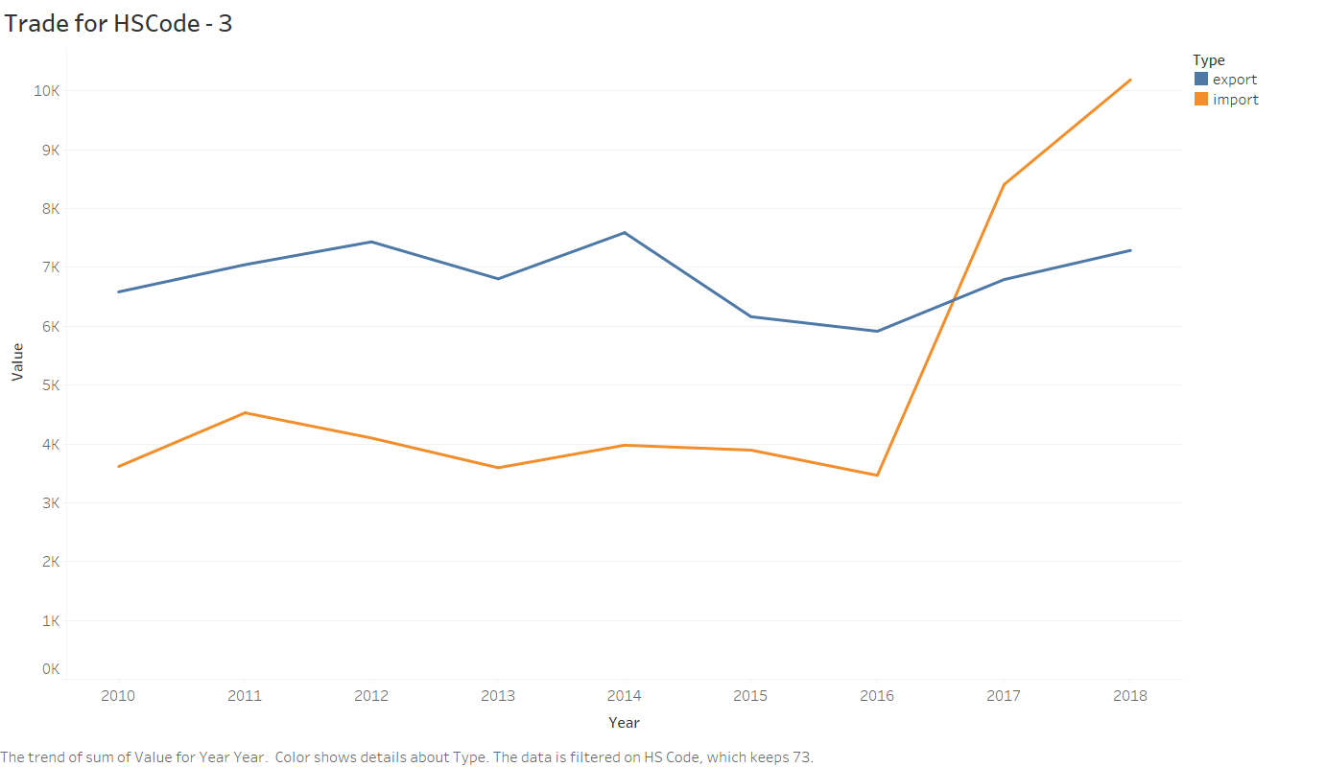

HSCode – 74

COPPER AND ARTICLES THEREOF.

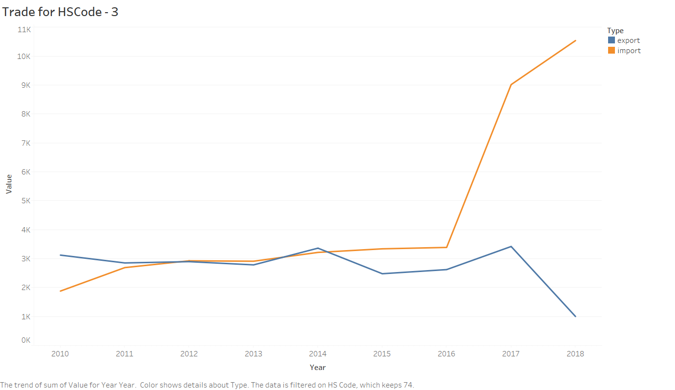

HSCode – 79

ZINC AND ARTICLES THEREOF.

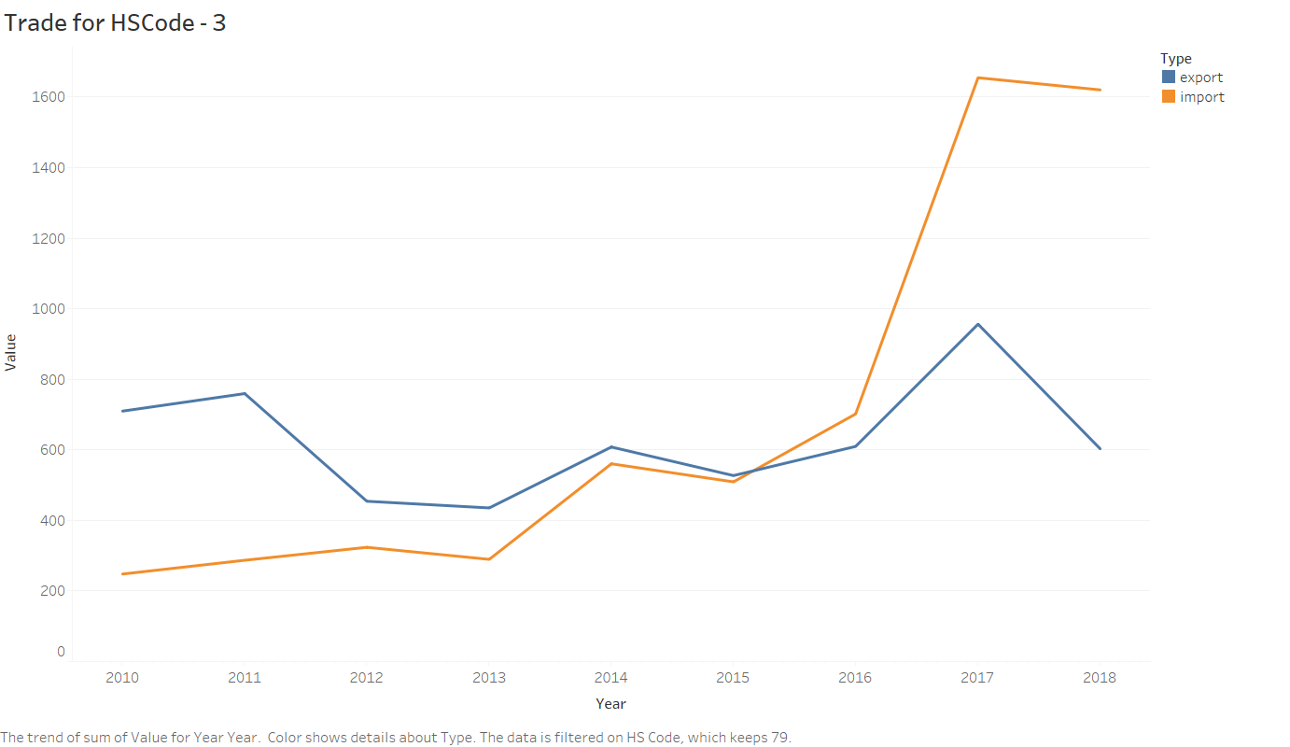

HSCode – 89

SHIPS, BOATS AND FLOATING STRUCTURES.

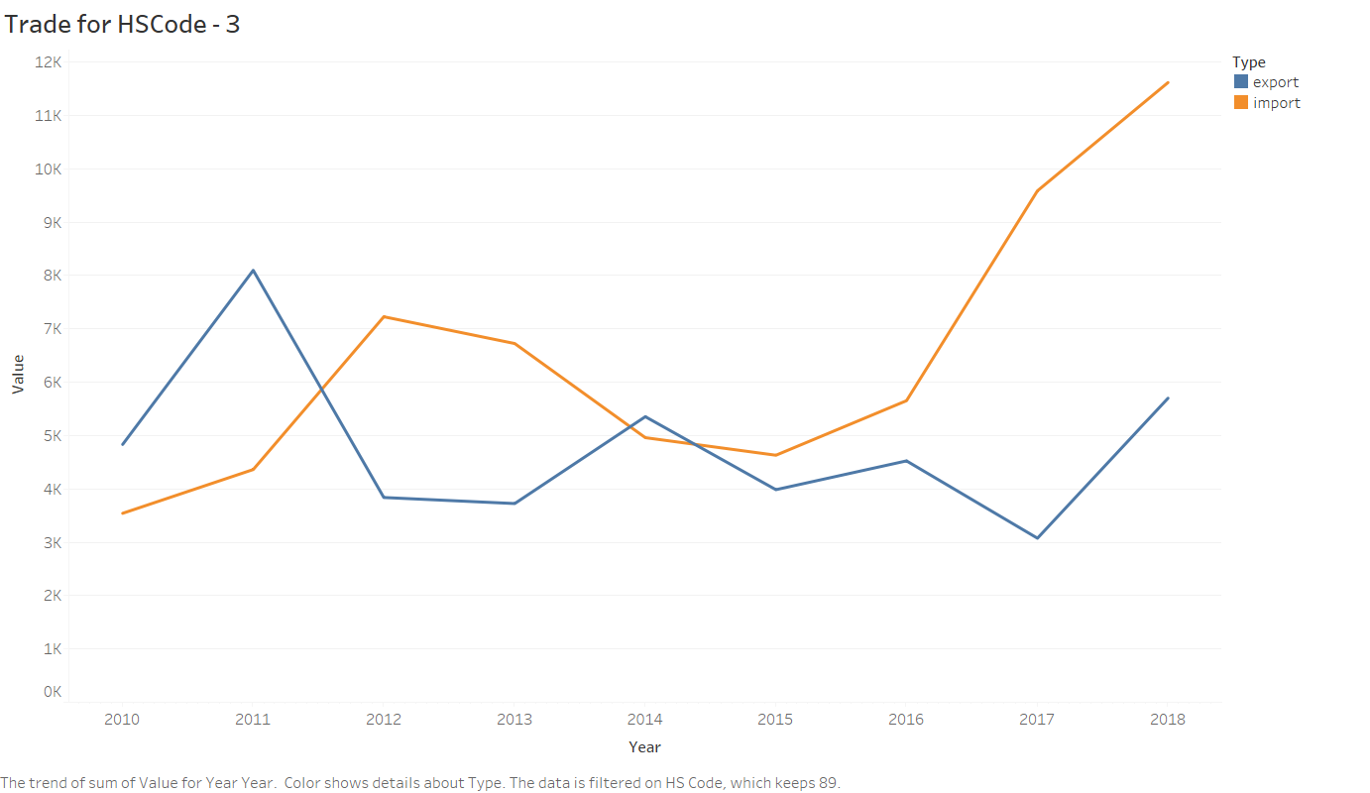

Petroleum and crude oil imports continued to inflate India’s import bill, rising 42.64% from last year to $11.65 billion, government data showed on Thursday.  
Feb 16, 2018

Read more at:  
[//economictimes.indiatimes.com/articleshow/62934403.cms?from=mdr&utm_source=contentofinterest&utm_medium=text&utm_campaign=cppst](https://economictimes.indiatimes.com/articleshow/62934403.cms?from=mdr&utm_source=contentofinterest&utm_medium=text&utm_campaign=cppst)