About Dataset –

The data is taken from Kaggle - [Link](https://www.kaggle.com/lakshyaag/india-trade-data/downloads/india-trade-data.zip/2)

The data set has two CSV file i.e. import data as well as export data from year 2010 to 2018.

Each data set has 5 columns -

1. HS Code – Harmonized System Code
2. Commodity – Description of the Harmonized System.
3. Value - Trade values for export and import of commodities in million US$
4. Country – Country from which import or export took place
5. Year – Year of import or export

HS Code - [Link to Wikipedia](https://en.wikipedia.org/wiki/Harmonized_System)

The **Harmonized Commodity Description and Coding System**, also known as the **Harmonized System** (**HS**) of [tariff](https://en.wikipedia.org/wiki/Tariff) [nomenclature](https://en.wikipedia.org/wiki/Nomenclature) is an internationally standardized system of names and numbers to classify traded products. It came into effect in 1988 and has since been developed and maintained by the [World Customs Organization](https://en.wikipedia.org/wiki/World_Customs_Organization) (WCO) (formerly the Customs Co-operation Council), an independent intergovernmental organization based in [Brussels](https://en.wikipedia.org/wiki/Brussels), Belgium, with over 200 member countries

Goal –

1. What HS Code we import/export the most?
2. From which country we import export the most?
3. Rate of change of trades in years.
4. From the country we import/export the most, what are the products HS Code traded.
5. Any future predictions on the Indian trade.
6. What category we trade the most year wise.
7. Highest trading country year wise.

Completed -

1. HS Code wise total value plot (Highest 15 imported HS Codes - **import** and export)
2. Top 5 imported HS Code analysis
3. Top 15 country from which we import bar chart
4. Year wise analysis of top 6 countries which we import.
5. Year wise total value plot (All years included)
6. Country wise total value plot (Highest 15 countries)

Remaining -

1. What does India Import and export most year wise?

Q. How much India import/export every year?

Ans.

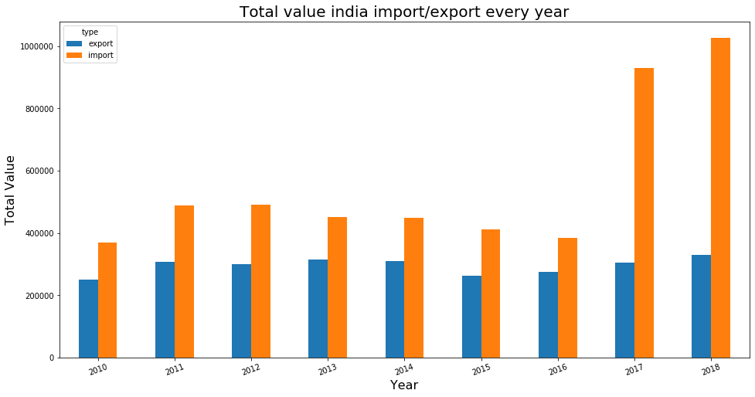

Q - Why there is a bump in the import from year 2017?

Ans - It is because GST was launched in the year 2017 and Basic Custom duty was revised and thus leading to such a bump.

Q – what does India Import/Export the most

Ans –

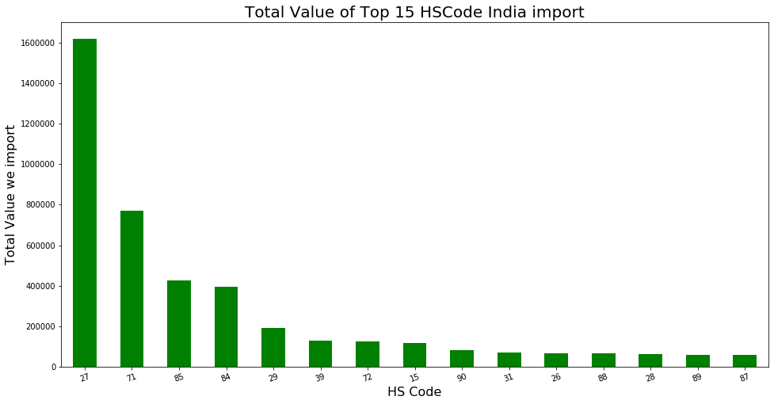

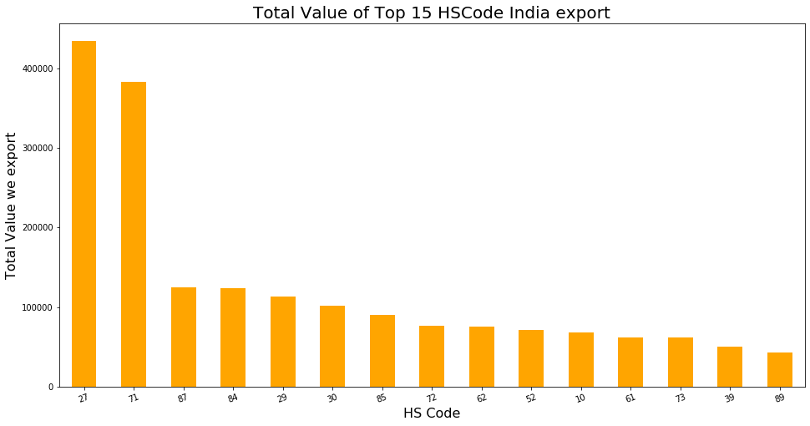

Q – Top 15 Country from which we Import/Export?

Ans –

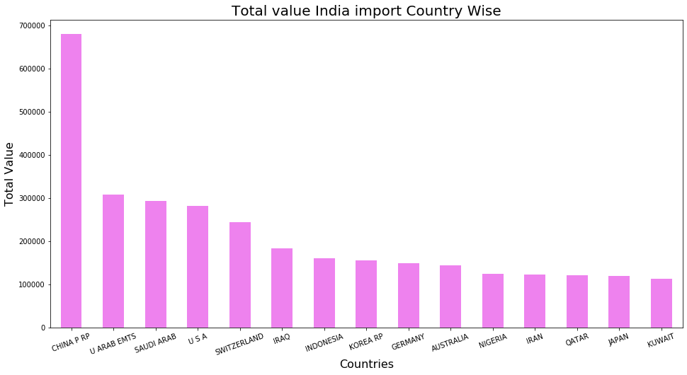

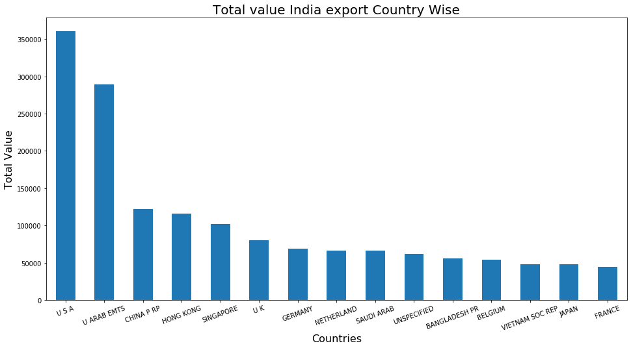

Q – trade with Chine year wise?

Ans –

