

**CRYPTOSTARTER**

The next generation decentralized, borderless, tokenizable crowdfunding platform on the blockchain

Whitepaper

2017

**Contents**

1 Executive Summary

1.1 Problems of Crowdfunding

1.2 Solutions provided by Cryptostarter

1.3  Mission Statement

1.4  Core Objectives

1.3.1  Build the World’s most open crowdfunding platform and crowdfunded assets exchange

1.3.2  Build borderless crowdfunding platform

1.3.3  Make crypto crowdfunding platform easy to use for everyone

2  Cryptostarter Model: How it Works

3  Cryptostarter platform architecture

4 Cryptostarter projects and participating benefits

5 Roadmap

6 Token Auction

7 Projected use of received contributions after ICO

1 Executive Summary

Since 2015, more than 25 billion dollars was raised via Crowdfunding platforms and by 2025 the World Bank Report estimates the global crowdfunding investments will reach $93 billion. This figure approximately equals a current market capitalization of all crypto currencies, representing nearly 800 unique market traded crypto currencies that we have today in total. Hundreds of thousands of creative projects, art works and technical developments emerged with help of crowdfunding platforms.

The challenge that **CryptoStarter** attempts to solve is to connect crowdfunding and crypto currency, at the same time making it simple to use and accessible to non-technical artists and entrepreneurs. Despite rapid development of crypto currency markets not all potential participants were able to use crypto currency advantages due to a number of reasons. Starting from the country where crypto currency lacks local support and up to simply the lack of knowledge and motivation to learn how to use crypto currency.

**CryptoStarter** transforms the crowdfunded product or startup project into sellable swappable tokens built on bitcoin / ethereum protocol. This allows to turn a promise of a project or product into instantly valuable futures asset that can be either resold to those who missed the deadline to support or it can be swapped to other projects tokens.

**1.1  Problems of Crowdfunding**



**Dream maker of Promise Breaker?**

The recent years analysis of Kickstarter alike platform raises a question to each new coming project: is this new project a dream maker or a promise breaker? At first on Kickstarter it was possible to see how a little start-up that helped finance fearless little ventures of individual small entrepreneurs. At that point, with the appearance of the first $100,000 venture, and afterward the first $1,000,000 veture examples, it slowly moved toward becoming a fast “getting rich” plan. It has turned into a model of untrustworthiness and broken dreams. So it is clear that crowdfunding projects funded in an established way have nothing to give their supporters aside from an easy-to-break promise that when the product is ready, the supporters will get a long-waited product as a reward. And there is no way of quitting the “train” when the campaign has been financed by backer, no mechanism of lowering the risk of non-accomplishment case. Turning “promises” into swappable assets can open a whole new market of crowdfunded equity.



**Borders and different legislations exclude some countries**

Kickstarter and other platforms have been mostly operating in western countries. Due to specific legislations it is not easy to launch a crowdfunded campaign across many countries, giving no chance to a large scale of countries and potentially new markets to use the crowdfunding platform. This is simply not fair. But thanks to blockchain technology and gradually emerging adaptation and regulation of blockchain in many countries – the projects can be supported instantly and borderless.



**The knowledge barrier to use Crypto Currency for own crowd funding project**

While it is possible to use a number of different crypto currencies available today to crowd fund your own project – the lack of knowledge and hustle to set up such an infrastructure to organize this process – doesn’t allow a lot of talented artists, makers and entrepreneurs to use crypto currency advantages. If this technology can be simplified in terms of use – it can open a lot bigger market for crowdfunding.

**1.2  Solutions provided by CryptoStarter**

  
**Turning crowdfunding “promises” into sellable swappable tokens**

**CryptoStarter** platforms allows to receive reward for backing the project as tokens so that the backers can spend, swap, sell their reward before the physical product or a startup company is ready. This can enable a profit-oriented corporate as well as individual backers.

  
**Making crowdfunding platform borderless and accessible to all countries**

**CryptoStarter** platform uses blockchain to build a crowdfunding service that can be used from anywhere.

  
**Making crypto crowdfunding platform easy to use for everyone**

**CryptoStarter** platform attempts to make it’s platform not only accessible from anywhere but also easy to use by talented artists, makers and entrepreneurs who has no technical knowledge of how to use crypto currencies.

**1.3  Mission Statement**

The mission of **CryptoStarter** is to give a chance for existence to every potential start-up project, anywhere on the planet, made by anyone, and from the other hand give full control of investments submitted by supporters in form of tokens, that can allow exiting from campaign as well as profiting from campaign by resell. With blockchain technology the new solutions beyond borders, beyond traditional venture financing are possible.

Our mission is to make boldest ideas come true using the power of blockchain crowdfunding.

Decentralized. Borderless. Peer-to-peer.

**1.4  Core Objectives**

**Build the World’s most open crowdfunding platform and crowdfunded assets exchange**

Secure phased investment with a reward in form of sellable token

To protect investors and stimulate project owners: a platform will have a phased release of funds based on voting, smart contracts to confirm the fact that the project has completed the next stage and is entitled to receive the next tranche of investments. In case of failure of the current project stage in the opinion of investors - the money should be automatically returned to investors.

Another form of protection is that the backers receive reward tokens of the future product. These tokens can be sold in any stage of the project, as well as swapped to another tokens and crypto currencies.



**Build borderless crowdfunding platform**

Transparency of borders

**CryptoStarter** sets objective to allow to start projects anywhere in the world as well as to be funded from anywhere in the world. Allowing to transfer the payments without large commissions, long expectations and cross-border restrictions.



**Make crypto crowdfunding platform easy to use for everyone**

**CryptoStarter** will allow to use local currencies. For convenience of investing and withdrawal of funds, there should be an opportunity to enter and withdraw money in the local currency used in the place where the project owner or investor is located. Easy to use interface and client wallet application.

2 **CryptoStarter** Model: HOW IT WORKS

Cryptostarter platform model can be illustrated via use case diagrams below (image 1 and image 2). Users of the platform are generally able to create 2 types of projects:

1. **Simple project token**, where there is just a project token that can be redeemed in the end
2. **Complex project token**, where the token can represent a digital crypto share of the crowdfunded startup company, or token can be a new crypto-currency. This type of the project allows to list the token not only in CryptoStarter Exchange, but also on any popular crypto-currency exchanges (like Bittrex, Poloniex, Coinbase, Kraken, GDAX etc. ).

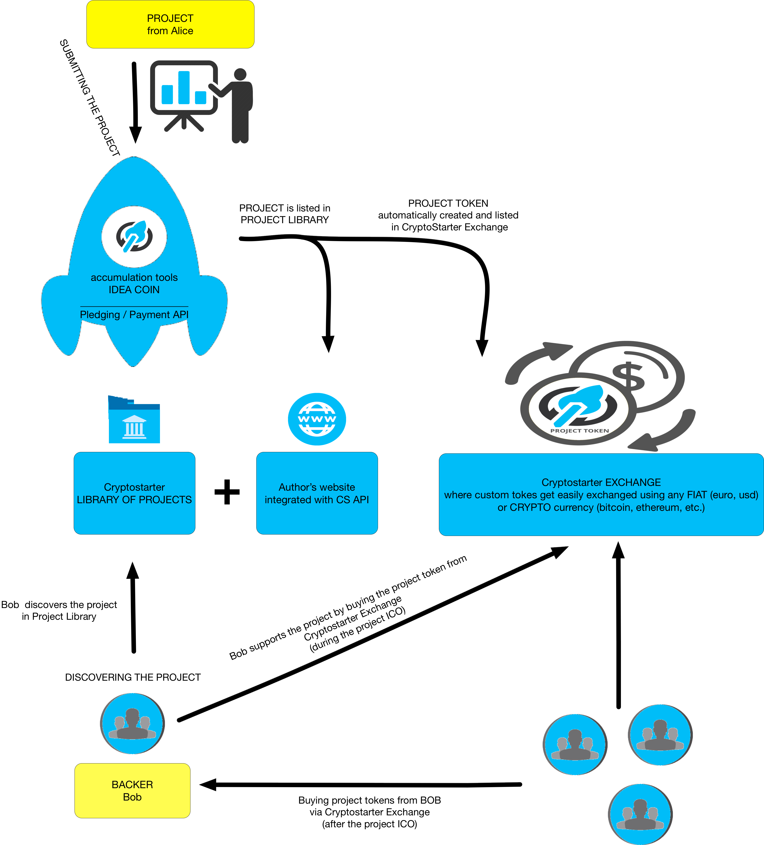

Image 1. Simple project token (case A)

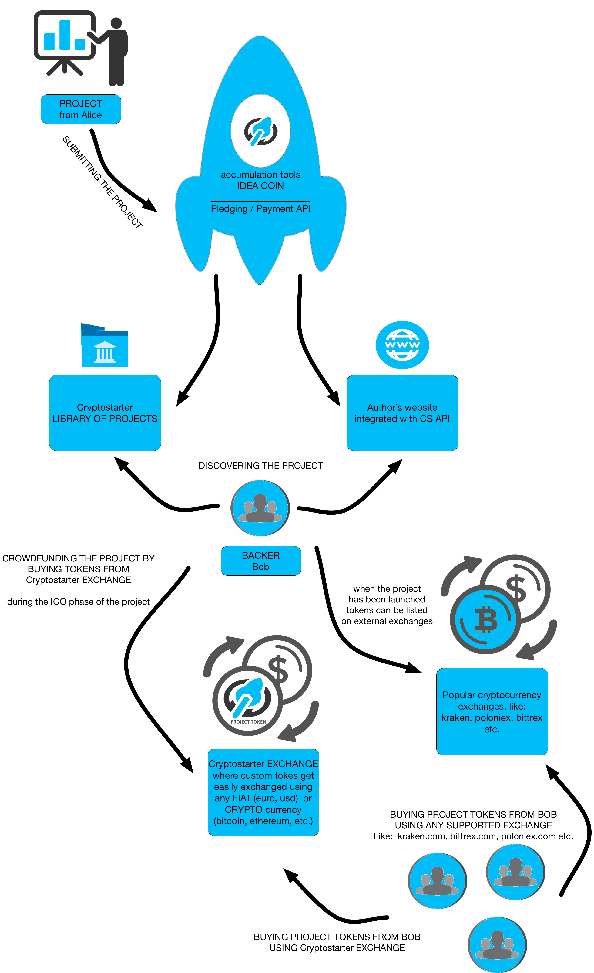

Image 2. Complex project token (case B)

As specified in the diagrams above CryptoStarterplatform allow to perfrom crowdfunding campaign borderlessly in any FIAT or CRYPTO currency.

Preseting the typical use case in the following example will help to understand the basic work mechanism of CryptoStarterplatform.

Alice is an entrepreneur that wants to launch on the market: Alice Smart Watch.

Bob is an electronic gadgets enthusiast.

Chester is an investor that researches the market of technical projects.

1. Alice creates Cryptostarter account with associated receiving address.
2. She submits a new project into **CryptoStarter** platform

→ The project becomes visible in **CryptoStarter** projects libarary – the show case of all projects available. Alice can now promote on the platform as well as externally (including the integration to other web services, by pasting generated iFrame snippets)

→ Alice sets how many project tokens she wants to issue, for instance 1000 tokens

Immediately upon project publishing and setting the number of tokes – the tokes get listed in **CryptoStarter** Exchange.

1. **CryptoStarter** exchange lists 1000 tokes for sale. Bob discovers a cool Alice Smart Watch project either in Cryptostarter Projects Library, in Alice’s own project’s website, in Cryptostarter exchange or even in other centralized crowdfunding websites.
2. Bob in a few clicks submits the purchase of the Alice Smart Watch token (ASW token) either via any FIAT currency (EUR, USD, etc.) or via crypto-currency like Bitcoin, Ethereum etc. The token gets immediately displayed in either Bob’s Ethereum Mist Wallet, in Bob’s secure cryptostarter WEB Wallet, or orther options.
3. Assuming the project expected delivery is 6 month, in 3 month Bob realizes that he can’t wait for a Smart Watch product any longer and decides to sell his ASW token.

So Bob goes to Cryptostarter exchange (or other external exchange) and sells his token to Chester. Chester is an investor who find ASW project very promising, assumes that the prices will rise in the future because initial offering of ASW tokens is long time sold out.

1. After 6 month Alice starts to ship her Smart Watches to her backers.

Chester has bought 5 ASW tokens so far and sold 4 of them with profit. Chester goes to Cryptostarter or to Alice Smart Watch Web Shop and buys a Smart Watch for 1 ASW token that he kept to make a birthday gift to his son.

3 Cryptostarter platform architecture

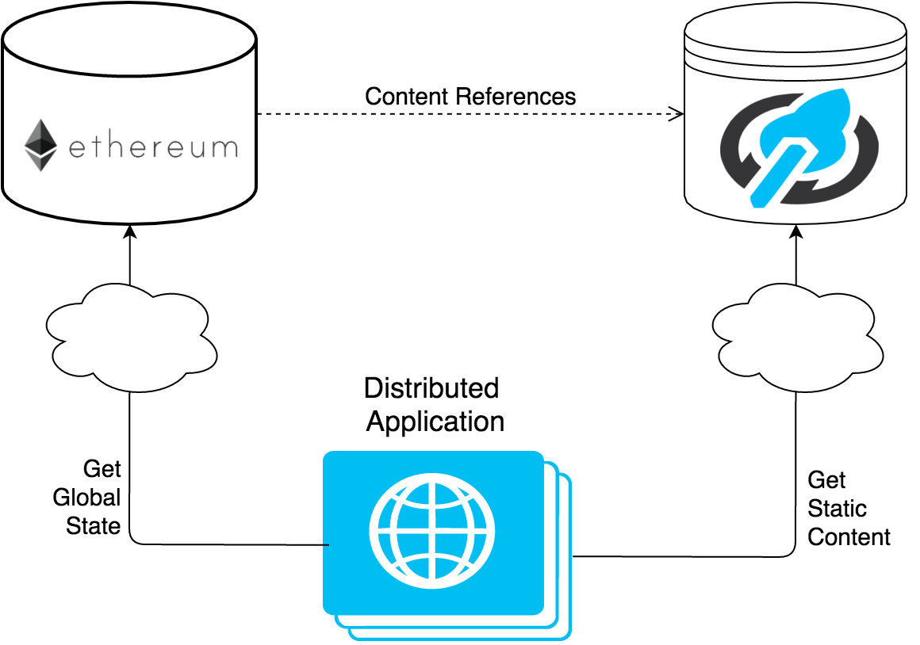

Image 3. Cryptostarter platform architecture

The CryptoStarter platform is being built and deployed using well established completely decentralized platform Ethereum. In the short run, CryptoStarter will use ETHEREUM blockchain to create and deploy it’s own platform token IDEA coin, to create custom project tokens abstracting the cryptostarter users from complex details of deploying a custom token into Ethereum blockchain. Cryptostarter will use state channels to achieve higher possibilities for scalability.

4 Crypostarter projects and participating benefits

In this chapter we describe the kinds of crowdfunding projects that can be launched with **CryptoStarter**. Here are a few types of projects that can be launched with our platform, it only suggests what is possible and assumes there can be more kinds of projects that users of CryptoStarter can come up with:

**Technology**

Different kinds of gadgets, sold with Gadget Tokens

**Games**

Different variations of game early access models with redeeming the custom token

**Design**

Any designer custom product: cloth, accessories, furniture

**Film & Video**

Short films and series financed with cryptostarter. Access based on film custom token.

**Infrastructure projects**

Some small or big infrastructure projects that can bring benefits to the community as well as good returns on investments to, like for example building a bridge, providing a watering systems to dry regions, transport infrastructure, building solar panels and others.

**Companies IPOs**

Cryptostarter allows to use custom project token as a digital share, which makes ICO a traditional IPO, whereas it doesn’t require complex registration procedures and it is truly borderless.

Cryptostarter intends to allow every potential start-up project in any country, made by anyone, to simply and quickly launch to test with global community of interested people wether the project represents a real value and utility, thereby including the countries and approximately 2 billion people into the global economy, giving them the access to financial instruments that in the moment mostly only the highly developed countries are privileged to have.

5 Roadmap

**Project start**

Start the development of the CryptoStarter platform.

April 2017

**Alpha version**

The core of the CryptoStarter platform, the approval of White Paper and MVP.

May 2017

**Alpha version 2**

Unstable version of the CryptoStarter platform with the main functionality.

July 3rd, 2017

**Beta**

Platform CryptoStarter with the basic functionality.

4-18 September 2017

**Beta 2**

Platform CryptoStarter with full MVP functionality.

October 1-10, 2017

**ICO**

Preliminary sale of tokens.

November 1, 2017

**Early Access**

The owners of projects who have decided to register their projects before the public launch of the CryptoStarter platform will gain access to the platform.

November 15, 2017

**Release 1.0**

Platform release in the MVP version.

November 15, 2017

**Post-ICO**

Selling tokens from the site until the moment they enter the first exchange. The cost of coins for post-ICO will be doubled relative to the ICO price.

November-December 2017

**Listing in popular crypto-currency exchanges**

Start trading tokens on stock exchanges. Completion of post-ICO.

December 2017

**Release 2.0**

In this version, incremental investment will be added and the funds will be returned through a smart contract.

February-March 2018

**Release 3.0**

In this version, resold tokens-futures for each registered project will be added, as well as the possibility of exchanging and trading them within the CryptoStarter platform.

April 2018

**CryptoStarter Frame**

Special widget CryptoStarter for installation on any site, allowing you to collect payments and display information about the project anywhere.

June 2018

**Release 4.0**

In this version, the platform will acquire full decentralization, including all site data.

July 2018

6 Token Auction

**Generally established mechanism**

Cryptostarter or “IDEACOIN” tokens can be obtained in a number of ways.

Traditionally in vast majority of cryptocurrencies the way that the tokes get distributed is via a proof of work or proof of stake model.

This models can be changed depending on the amount of supply of the tokens. This amount can be traced by prediction supply curve of token distribution, which shows with which speed the tokens are getting distributed.

For the short history of few years there has been proposed an informal model to perform the token purchase.

This model is: cryptocurrency is getting sent to an address in exchange for some amount of target tokens (in our case IDEACOINS – cryptostarter platform tokens). The usual lifespan of such an initial offering runs for about 30 to 60 days. The rate of how much target tokens (IDEACOINS) the investor receives for 1 ETH (for example ETHEREUM) decreases over this initial offer period of 30 – 60 days. For instance the ratio during the first 10 days may remain at 1 ETH for 100 IDEACOINS and then it can decrease linearly to 1.25 ETH for 100 Tokens and so on as the time goes. The amount of tokens that have been generated depends on how much cryptocurrency tokens (BTC, ETH, etc.) the project received. Hence if the current offer is 1 ETH for 100 IDEACOINS and 1M ETH has been sent, then 100M tokens will be created.

**IDEACOINS tokens auction**

In the Cryptostarter launch, 100 million IDEACOIN tokens (IDEA) will be created and a significant part of them will be distributed during the ICO of Cyrptostarter.

The ICO will be completed depending on when either of several conditions happen:

* IF approximately one of 3 funding targets is reached:

1. minimum target reached 4M USD denominated in ETH worth of IDEA
2. moderate target reached 10M USD
3. maximum target reached 40M USD

* OR if 80 million IDEA tokens will get sold

The IDEA Coin Cryptostarter ICO can be divided supposedly into 3 time periods. Each period the distribution rate of how many IDEA coins will be distributed for 1 ETH will change.

During the launch, inverstors of Cryptostarter can send Ether to a token launch address, thereby committing to buy IDEA tokens at the given conversion rate depending on the moment in time of the ICO period.

7 Projected use of received contributions after ICO

Contributions received during ICO will be used exclusively for the development and expansion of the CryptoStarter platform and network. Here below is provided our projected use of received contributions in 3 different potential contribution scenarios that will drive the Cryptostarter growth.

**Scenario 1**

If contributions meet minimum funding targets of 4M USD, we expect the vast majority of contributions being used to fund the development (70%) of the Cryptostarter platform. We plan significant part of the contributions to be spent on marketing and platform promotion. We also plan to allocate part of the contributions to fund the projects of Cryptostarter platform of multiple project authors in early launch period.

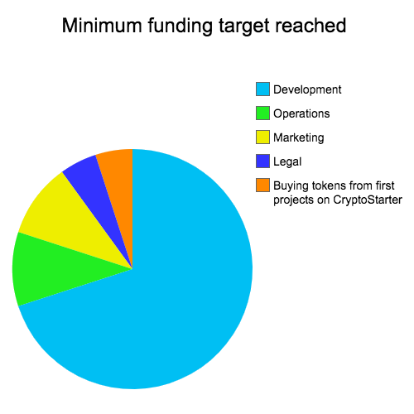

Image 4. Minimum funding target funds allocation scenario

**Scenario 2**

If total contributions received reaches moderate level of funding (10M USD) the Cryptostarter team will increase the part of marketing and promotion as well as the part to finance first Cryptostarter projects on the platform.

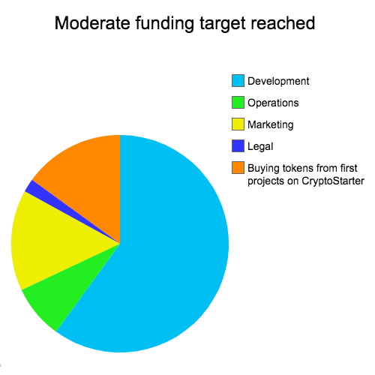

Image 5. Moderate funding target funds allocation scenario

**Scenario 3**

If total fund raised reach maximum expected 40M USD, we will significantly increase the part of the funds used to finance first projects on Cryptostarter launched by first users, as well as further increase of marketing/promotion part.

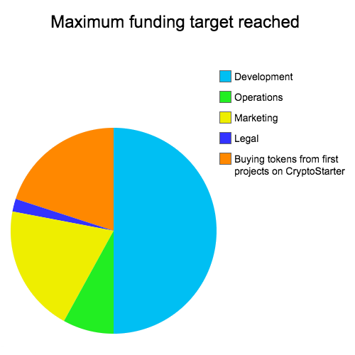

Image 4. Maximum funding target funds allocation scenario