Overview

Escape the room.

You are stuck in a room with a computer, an encrypted passcode, a key to decrypt, and a computer locked door.

In order to get out you must crack the passcode and enter it into the computer to unlock the door.

## Step 1: Setup

### Part 1:

* Navigate to repl.it in Google Chrome
* Once there press the “new repl” button (pictured below)

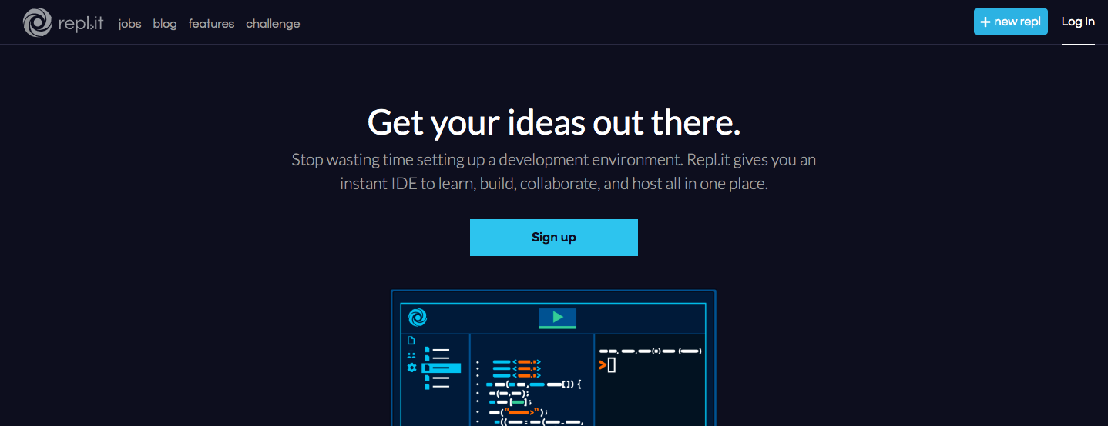

* You will see the following form popup, please select the language of your choice to begin (Java or C++)
* Then copy and paste this link into the textbox below where you chose your language
  + Link for C++:

<https://github.com/ajpen/cpp-caesar-cipher-workshop.git>

* + Link for Java:

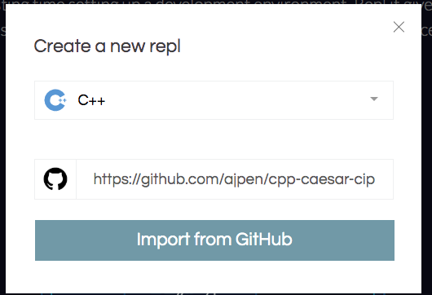

## Now you should see a new repl project with four lesson folders

## Step 2: Lessons

Lesson 1: Introduction (Section 1 Lesson)

* Copy the code in the main class inside of the folder Section1Lesson to the Main.java file on the root of your repl
* Follow the instructions in the comments
* Intro to course topics
  + Char data type
  + ASCII character encoding
  + If statements

Lesson 2: Write a function that converts an ASCII (Section1_1)

* Copy the code in the main class inside of the folder Section1_1 to the Main.java, or main.cpp file on the root of your repl
* Fill out the section with the comment your “code here” in function characterToAlphabeticalIndex
  + If input character is == ‘a’ the function should return 0
  + If input character is == ‘b’ the function should return 1
  + If input character is == ‘z’ the function should return 25
  + If input character is == ‘A’ the function should return 0
  + If input character is == ‘B’ the function should return 1
  + If input character is == ‘Z’ the function should return 25
* Task: make sure the code runs without error
  + If errors occur read error code to debug (See below example)

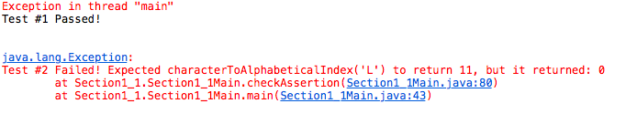

* Here you see the where your function failed to pass its unit tests
  + You can see what value the function was passed where it says “characterToAlphabeticalIndex(‘L’), in this case the value ‘L’ was passed
  + Next to that where it says “return 11” indicates the expected return value
  + And after that where it says “but it returned:0” indicates that your function’s code returned 0

Lesson 3: Encoding/Decoding Characters with a shift (Section1_2)

* Copy the code in the main class inside of the folder Section1_2 to the Main.java, or main.cpp file on the root of your repl
* You are given the function that you created in the previous step, now you must use it to:
  + Get the Index of both the letter, and the key with the “characterToAlphabeticalIndex” function
  + Shift the index of the letter by the index of the key
    - For instance if you have the letter ‘a’ and key ‘b’ you should have a shifted index of 1
  + Ensure that the shifted value is less than 25, and if it is greater than 25 wrap it back around

You should only need to update the code near the comment: //Your Code Here press control ‘f’ to find

Lesson 4: Encoding Entire words with a Loop (Section2)

* Copy the code in the main class inside of the folder Section2 to the Main.java, or main.cpp file on the root of your repl
* Look for the comment // Here, you'll create a loop that will encode every letter in the originalString
* Encode the original string, and save its value to encrypted string with a loop

Lesson 5: Creating a function to encode an entire word (Section3)

* Copy the code in the main class inside of the folder Section3 to the Main.java, or main.cpp file on the root of your repl
* Write a function named encryptString
* It should take two parameters: a char array for the text to be encrypted, and a char for the key to shift by.
* Task: Print the alphabet, one character per line, without using arrays

Challenge! Crack the Code and Escape!

* Given the encrypted code and the key, submit the correct decoded string + your name. If you’ve successfully cracked the code, you can leave.

**C++ Version**

Codebase: <https://github.com/ajpen/Cpp-Workshop>

**JAVA Version**

<https://github.com/andrewrubinstein/JavaCryptographyWorkshop>

Challenge:

<http://ajpen.pythonanywhere.com/>