Machine Learning (COS6026-B)
Second Coursework

Dr Paul Trundle
p.r.trundle@bradford.ac.uk

Original coursework specification and design by Professor Rami Qahwaji

Background
Mars is the main planet considered for possible human colonisation because it has striking similarities to Earth. Mars has its own ice water and the duration of a solar day on Mars is around 24 hours and 40 minutes, slightly more than Earth. The Martian year is around 687 days, almost twice that of Earth. Both planets have similar axial tilt, which ensures similar seasons. Mars is a terrestrial planet with a thin atmosphere, with its own surface features such as impact craters, valleys, dunes, and polar ice caps. Mars had its own encounter with climate change and studying its atmosphere could reveal crucial details on its formation and evolution, and also why Mars has less atmosphere than Earth. Understanding and predicting weather patterns is very important for future human missions.
For this coursework we will be working with Mars Weather Data representing the weather conditions on Mars from Sol 1 (August 7, 2012 on Earth) to Sol 1895 (February 27, 2018 on Earth). This unique data was measured and transmitted via the Rover Environmental Monitoring Station (REMS) on-board the Curiosity Rover. The dataset is available on https://www.kaggle.com/imkrkannan/mars-weather-data
The data covers different attributes such as identification number of a single transmission (id), date on Earth (terrestrial_date), solar longitude or the Mars-Sun angle (ls), Martian Month (month), minimum temperature (min_temp), maximum temperature (max_temp), atmospheric pressure (pressure), average wind speed (wind_speed), overall weather conditions for a given sol based on atmospheric opacity (atmo_opacity).

Aim
-To produce an explainable machine learning system for the recognition for the prediction of mars weather patterns (temperature, pressure, etc) or combination of these attributes. The system will be trained and tested on the Mars Weather Dataset.
- To write a research report on the background, rationale, development, implementation, evaluation, explainability and conclusions of your machine learning system.

Problem statement
Machine Learning has the potential to support the development of innovative solutions for improved real-life and real-time weather prediction. For this coursework, your aim is to investigate the problem of weather patterns prediction and identification using machine learning. In doing so, you would be expected to perform the following tasks:
- Investigate the Mars Weather Data and understand the significance and meaning of data attributes and features
- Develop pre-processing and/or feature extraction techniques (if needed)
- Develop and implement (using Python, Weka, Matlab etc) a machine learning system that to demonstrate your ideas
- Demonstrate the feasibility of your design by evaluating your system using machine learning metrics
- Discuss the explainability aspects and their potential to increase the reliability and trust in your ML system
- Discuss your findings making recommendations for further investigation and improved implementation.
- Write a 1000 word report to present your work and findings.

Dataset
Mars Weather dataset is available publicly at: https://www.kaggle.com/imkrkannan/mars-weather-data

Critical Discussions:
The marking criteria focuses strongly on the critical discussions and reflections for your developed ML system. To enrich the discussion, you are encouraged to consider discussing one or more of these topics:
- Methods for improving the performance, including improved data pre-processing, feature extraction, feature selection, etc
- Methods for improving the explainability and/or trustworthiness of your ML system
- Comparison with quantum ML
- Integration/addition of additional data(sets) to enhance the outcomes of your work

Useful Reading
I Priyadarshini, V Puri, "Mars weather data analysis using machine learning techniques, "Earth Science Informatics, 2021, https://doi.org/10.1007/s12145-021-00643-0

Effort required
The coursework is worth 50% of the module marks. You are expected to demonstrate good effort in exploring the background of this problem, understanding the datasets, processing the data, developing meaningful machine learning system and implementing some basic aspects, and writing up your report. The coursework is worth 50% of the marks for this 20-credit module. A 20-credit module is nominally 200 hours of your time, some of which is spent in lectures, labs and private study. You should expect to be spending around 70 hours on this coursework.
The development of machine learning system goes through different phases, as discussed in lectures. The AI life Cycle is shown below, as a quick reminder. You should consider these phases in your report when demonstrating the design and development of your system. As there are many phases in the AI life Cycle, you need to describe the goals and objectives of your system, the feasibility of selected data, different users and their requirements, the basic design of the system, training and testing concepts, deployment challenges, etc. You are encouraged to implement one of these phases in a programming language or software tool (Python, Matlab, Weka, etc).

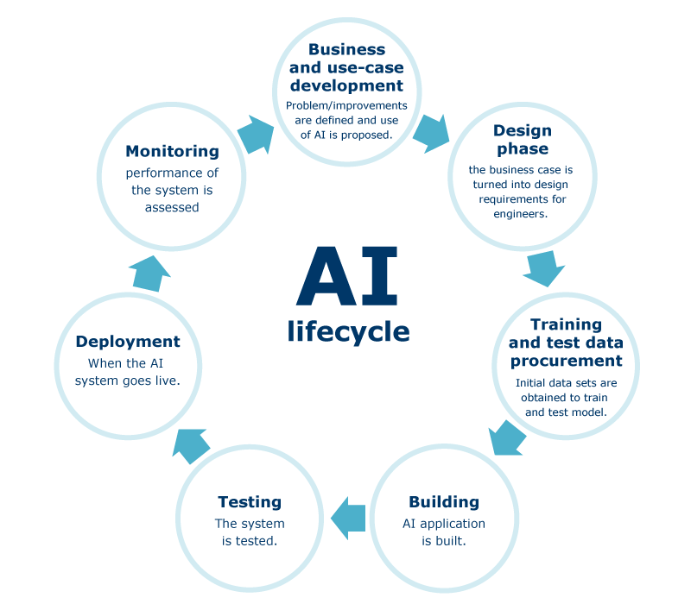

Deadline for submission of report
The report must be submitted through Canvas before 4.00 pm Friday 9th May 2025
Late submissions (without acceptable extenuating circumstances) will receive a mark of zero.

Report structure
Your report (about 1000 words) should contain the information listed below.
- Cover Page: Title, author, affiliation of the author, date, and abstract
- Introduction: A rough overview of the mars weather prediction challenge you are tackling and its importance, frequently formulated to attract the reader's interest to the report.
- Background: Here you are required to have an overview about space data and AI technologies. Then, you can describe relevant approaches and systems, or you can introduce basic concepts that are necessary for understanding the later material.
- Methodology and Data: This section contains an explanation, demonstration, description of the system architecture, or some interesting implementation techniques. Discussion of some targeted methods for solving the weather prediction problem will be mostly encouraged. Description of the knowledge representation (datasets used and data processing issues) are discussed in this part. The development of the AI system is discussed in this part as well
- Analysis and Discussions: You need to present your findings and discuss, analyse, evaluate and/or criticise what you implemented and described in the previous part.
- Conclusions and suggestions for future work: the major findings from doing this coursework will presented in this section. You can comment on the lessons learnt from doing this coursework, advantages/limitations of your AI, resources needed to implement the full system, what would you differently if you had more time, etc
- Bibliography and Citations: It is imperative that whenever you make reference to a fact of some sort, you cite an authoritative source for that fact; most frequently, these sources will be scientific articles.

Specific Learning outcomes
This coursework will enable you to apply basic principles of machine learning in solutions that require real-life problem solving, learning and decision-making. It will enable you to demonstrate an ability to share in discussions of machine learning, its current scope, development, strength and limitations.
Marking Scheme:

Criteria | >80% | 70-80% | 60-70% | 50-60% | 40-50% | 39-25% | <25%
Presentation of the report (25%) | Fully adheres to student guidelines. Complete lack of spelling and grammatical errors. Excellent use of appropriate and scientific language. Excellent structure and organisation. Excellent readability. | Good degree of adherence to student guidelines. Lack of spelling and grammatical errors. Good use of appropriate language. Excellent structure and organisation. Good readability | Mainly adheres to student guidelines. Minor spelling and grammatical errors. Good use of appropriate language. Well-structured with logical organisation. | Some adherence to student guidelines. Some spelling and grammatical errors. Inconsistent use of appropriate language. Organisation and progression evident. | Little adherence to student guidelines. Many spelling and grammatical errors. Minimal use of appropriate language. Inadequate attention to structure and organisation | Does not adhere to student guidelines. Major deficiencies in spelling and grammar. Lack of appropriate language. A disorganised report with lack of evident structure. | No report submitted. Paperwork submitted does not constitute a meaningful report.
Description and achievement (25%) | Novel or innovative solution to AI-based weather prediction. Exceptional amount of high quality work, which could include comprehensive testing, or critical reviews, or results incorporated into prototype. | The AI system presented is meaningful, innovative challenging and possibly complex. Problem explicitly stated with precise explanation of all research objectives. Excellent analysis and recommendations. | A relevant and original topic which is effectively translated into project aims and objectives which are clearly stated. Good analysis and recommendations. | Appropriate problem area chosen. Objectives outlines with the main areas of investigation identified. Some analysis and recommendations. | Limited topic choice with the problem area poorly defined. Objectives vague or insufficient. Very limited analysis and recommendations.  . | Simple or unoriginal problem showing lack of imagination. No analysis and recommendations | No software/project completed. No working software/project (does not apply to theoretical submission).
The demonstration of development capability (25%) | Signs of professionally developed AI concepts, excellent understanding of user requirements, excellent specifications and system requirements. Specification effectively interpreted with signs of original thinking and/or research. | Fully developed AI concepts, fully-developed user requirement , fully developed specification and System requirement. Evidence of excellent understanding of AI-development process and applications. | Evidence of developed AI concepts, developed user requirements, developed specifications and System requirements. Good understanding of the AI-development process and applications. | Partial in-depth development of AI concepts, Partial in-depth developed user requirements, Partial in-depth developed specifications and System requirements. Evidence of a fair understanding of the AI-development process and applications. | Limited development of AI concepts, limited developed user requirements, limited developed specifications and System requirements. Evidence of a limited understanding of the AI-development process and applications. | No or very limited development of AI concepts, no or very limited developed user requirements, no or very limited developed specifications and System requirements. No evidence of understanding of the AI-development process and applications. | No demonstration given. System failed to work. Student could not explain working of software or technical aspects of project (does not apply to theoretical submission).
Quality of work and understanding (25%) | Wide range of material investigated. Excellent evidence of critical evaluation and original thinking. Substantial number of appropriate references. Evaluation and recommendations fully and appropriately reviewed and presented. Excellent link to implementation. Research findings fully consider broader issues. | Good range of material. Good evidence of critical evaluation. Good number of appropriate references. Recommendations fully and appropriately reviewed and presented. Good discussion of implementation. Research findings discusses broader issues. | Focus on key areas using relevant sources. Good range of references with a varied bibliography. Clear recommendations identifying key issues. Research findings apparent with some consideration of broader issues. | Adequate information survey with some evidence of investigation of a key area. Appropriate range of references. Good bibliography. Recommendations identify some key issues. Research findings lack consideration of broader issues. | Limited sources of information used. Limited range of references. Limited bibliography. Limited recommendations. Lacking clarification of research findings. | Review of existing literature not evident. No references provided with limited or omitted bibliography. No recommendations. Conclusions do not link to research findings. | No understanding demonstrated. No conclusions. No future work suggested.

