5




United States Department of Agriculture

Agricultural Research Service

REPLACE METAL RIBBED ROOFING PANELS ON BUILDING 1A. PERFORMANCE WORK STATEMENT

USDA, ARS, PA, Northern Great Plains Agricultural Research Laboratory (NGPRL)
1701 10th Avenue SW
Mandan, ND.

DATE: June 15, 2026

STATEMENT OF WORK

TABLE OF CONTENTS
- Project Information
- Project Contact Persons
- Scope of Services
- Technical Project Requirements
- Background and Site Description
- Technical Cost Proposal
- Special Requirements
- Performance Schedule
- Government Furnished Equipment
- General Requirements

- Project Information:

  - Project Number: TBD

  - Project Title: REPLACE METAL RIBBED ROOF PANELS ON BUILDING 1A

  - Project Location:
USDA, ARS, PA, Northern Great Plains Agricultural Research Laboratory
1701 10th Ave SW.
Mandan, ND 58554

- Project Contact Persons:

  - WARRANTED CONTRACTING OFFICER
TBD Phone:
USDA ARS NPA, EDWARD T. SCHAFER AGRIC. RES.
1616 Albrecht Blvb. N.
Fargo, ND 58102-2765 Email:

  - ENGINEERING PROJECT MANAGER (EPM):
Mark McWilliams USDA, ARS, W Phone: 970-492-7025 2150 Centre Avenue, Building D, Suite 300
Fort Collins, CO 80526 Email: markmcwilliams@usda.gov

  - RESEARCH PROGRAM REPRESENTATIVES (RPR):
John Hendrickson Phone: 701-667-3048
USDA, ARS, PA, NGPRL Email: John.hendrickson@usda.gov
Northern Great Plains Agricultural Research Laboratory
1701 10th Ave SW.
Mandan, ND 58554

  - LOCATION ADMINISTRATIVE OFFICER (LAO):
Jeremy Will Phone: 701-667-3014
USDA, ARS, PA, NGPRL Email: Jeremy.will@usda.gov
Northern Great Plains Agricultural Research Laboratory
1701 10th Ave SW.
Mandan, ND 58554

  - LOCATION MONITOR (LM):
Mike Eberle Phone: 701-667-3075
USDA, ARS, PA, NGPRL Email: Michael.eberle@usda.gov
Northern Great Plains Agricultural Research Laboratory
1701 10th Ave SW.
Mandan, ND 58554

  - COLLATERAL DUTY SAFETY OFFICER (CDSO):
Holly Johnson Phone: 701-667-3003
USDA, ARS, PA, NGPRL Email: Holly.Johnson@usda.gov
Northern Great Plains Agricultural Research Laboratory
1701 10th Ave SW.
Mandan, ND 58554

- Scope of services:
The Contractor shall provide all professional services necessary for the accomplishment of each project and such required services shall be in accordance with requirements as described herein.

  - The Contractor shall provide services for the following tasks marked by an “X”:
[X] Provide a cost proposal and a technical proposal to complete the project as per project requirements.
[X] The contractor shall furnish all the skilled labor, materials, equipment, tools, transportation, and supervision necessary to remove and replace the building’s ribbed metal roof panels, metal trim, and exhaust and venting covers as shown in these documents.

- Technical Project Requirements:
The Contractor will work with site personnel to ensure each task is accomplished in a timely manner.

  - The Contractor’s work shall adhere to the criteria stated within these project requirements, drawings, and specifications. All construction shall comply with applicable federal, state, and local code requirements as well as current industry standards, (i.e.: EPA, ASTM, GSA, AASHTO, etc.) and health and safety codes, in effect at the time of contract award.

  - All work to meet all pertinent Unified Facilities Guide Specifications (UFGS) and ARS 242.1M standards. UFGS available at http://www.wbdg.org/ffc/dod/unified-facilities-guide-specifications-ufgs. ARS 242.1M available at https://www.afm.ars.usda.gov/ppweb/pps-and-manuals/.

- Background & Site Description:
  - Existing building dimensions are 100’L x 50’W.
  - Existing metal roof panels are galvanized steel.
  - Existing penetrations will be trimmed out with new color matched trim metal, exhaust covers, and venting boots.

- Technical Cost Proposal: Base Bid for this contract.

- Specific Requirements
  - Roofing Improvements
    - Remove and dispose of existing metal roof panels, flashing, trim, and venting on Building 1A and replace with new.
    - Ribbed metal roofing panels are to be replaced with new PBR panels 24-gauge (minimum) galvalume R-panels with associated trims and seals. To include ridge cap, pipe boots, sealants, closures, and fasteners.
    - Existing rake trim to be removed and salvaged for reinstallation.
      - Products must be warrantied for 25 years against rupturing, fail structurally, or perforate, similar-to Metal Sales Galvalume AZ55 product.
    - The galvalume panels will be 36 inches in width and length will be cut to the required lengths for the building, only full panels no overlapping seams will be allowed.
    - The galvalume panel rib configuration will be trapezoidal, all fasteners will be color matched and approved before installation.
    - The panels will be applied over open framing. The contractor has the responsibility to inspect all metal purlins, insulation, and surfaces for defects and/or rot and replace and repair to the approval of the COR.
    - Any ridge cap, closures, sealants, pipe boots, and fasteners must be replaced and the trim metal must match the roof panels.
    - Remove and replace existing vent stacks. 5 total sewer stacks, 3 chimney stacks, 1 exhaust hood and 1 TV antenna.
    - Contractor must install all new weather-stripping
    - All surface design and color of all roof metal panels, trim metals, and vents will be approved by COR before work proceeds.
    - All caulking required shall be an exterior, high grade elastomeric silicone based allowing maximum flexibility and adhesion. Sealant shall be applied where required as specified by manufacturer’s instructions and according to industry standards.
    - Any penetration, such as conduit, gas lines, vents, etc. shall have new boots to the COR approval.
    - Any old vents and hoods shall be replaced with new, and color matched to COR approval.

- Performance Schedule: When weather is appropriate, project should be completed 120 days after Notice to Proceed or sooner.

- Government Furnished Equipment\Services
  - None provided.

- General Requirements:
  - Permits: Where governing regulations and imposed codes and standards require notices, permits, licenses, inspections, tests, and similar items or actions in order to lawfully proceed with the required work, the Design Contractor shall obtain items and take those actions in accordance with the regulations of the governing authority. The costs of construction permits, licenses, inspections, etc., are the obligation of the future Construction Contractor.
  - Schedules shall be updated and furnished with each submittal.
  - Submittals shall be made as scheduled in the Special Requirements section. Each submittal shall be distributed electronically in Adobe for review, to the Location Monitor at the facility, Engineering Project Manager, and Contracting Officer. Each submittal shall contain the previous submittal's Excel comment sheet with responses, notes of meetings held with ARS personnel, design notes, calculations, and construction progress bi-weekly meetings during construction.
  - Changes in the scope of work or the task order that affect the level of effort of the Contractor must be pre-approved by the CO.
  - Disputes or questions that arise after the order of task has been negotiated will be resolved by the CO.

- Approximate Building Measurements:

Eave height:12ft. Apex: 14ft.
Length x Width: 100L x 50W

East view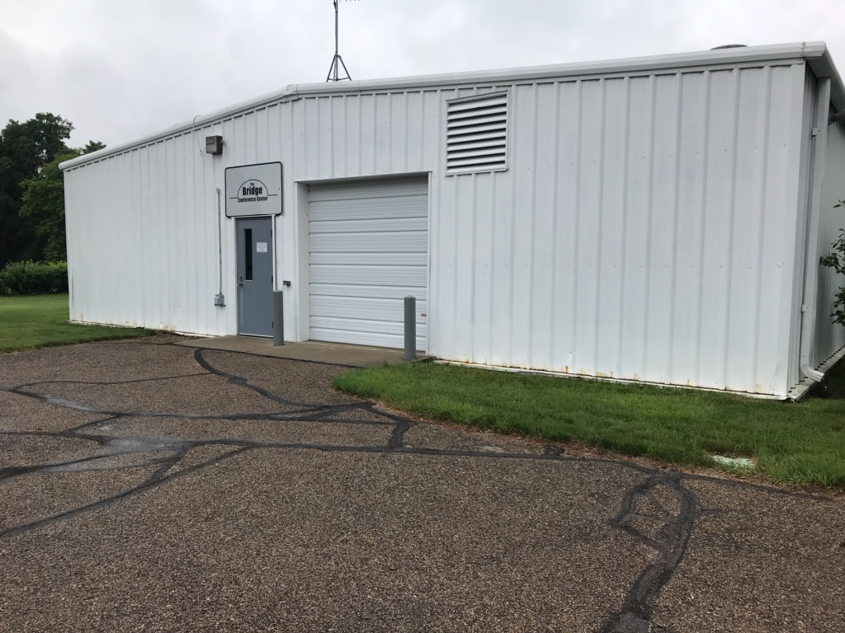
Roof
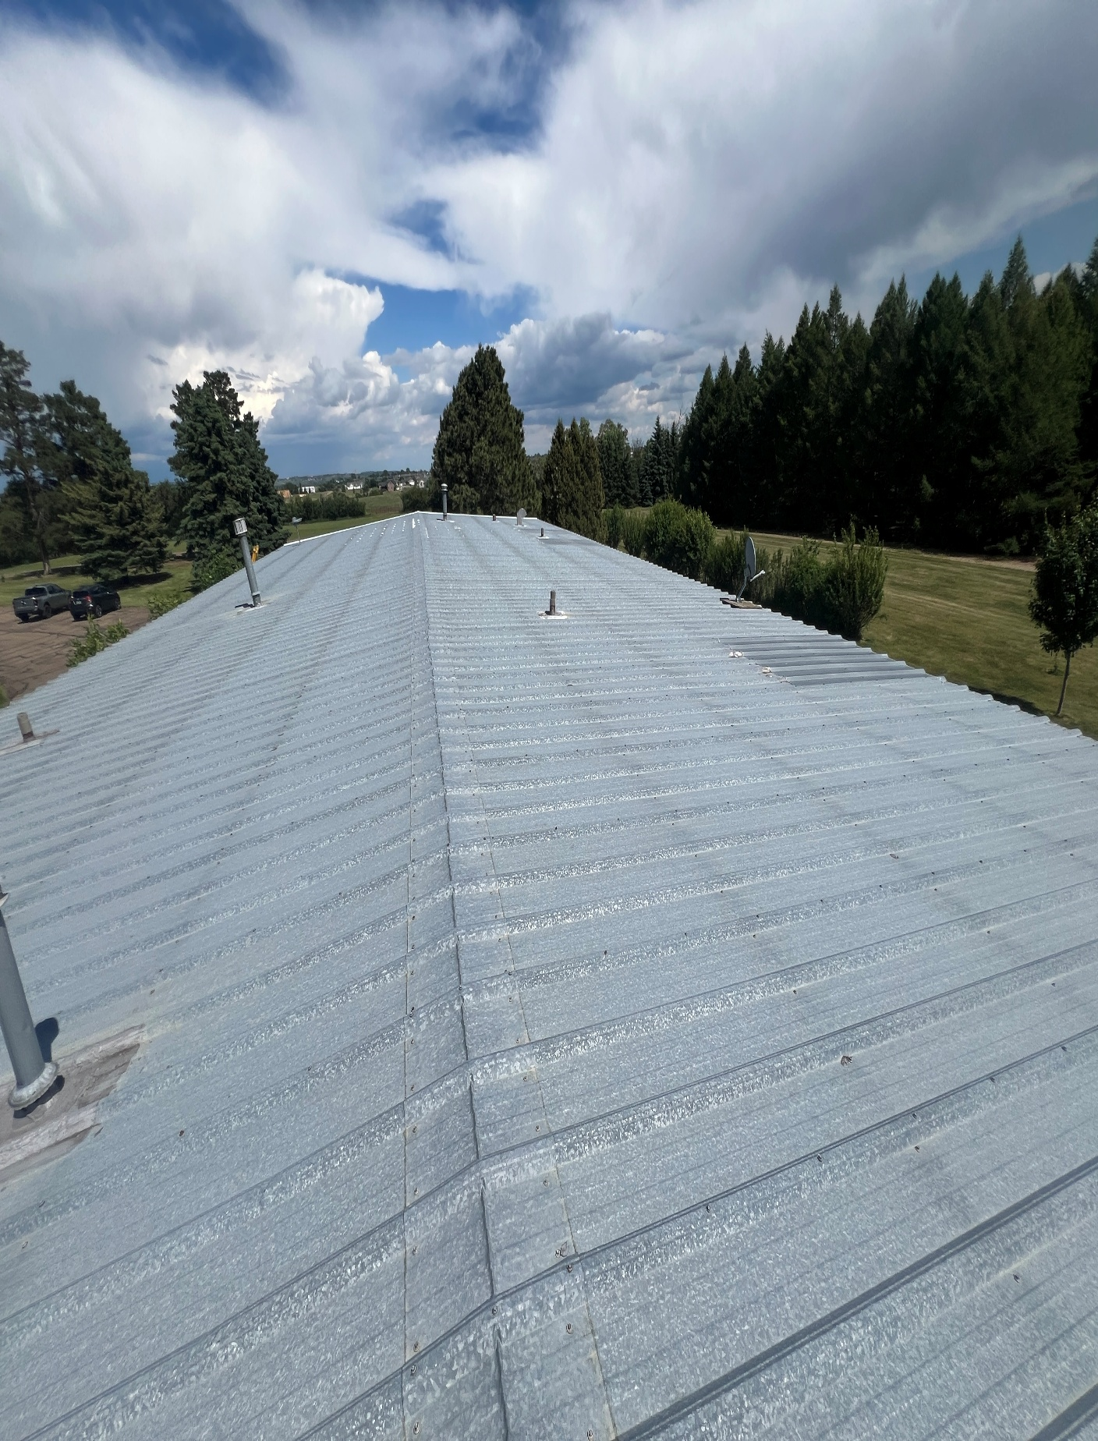

Roof
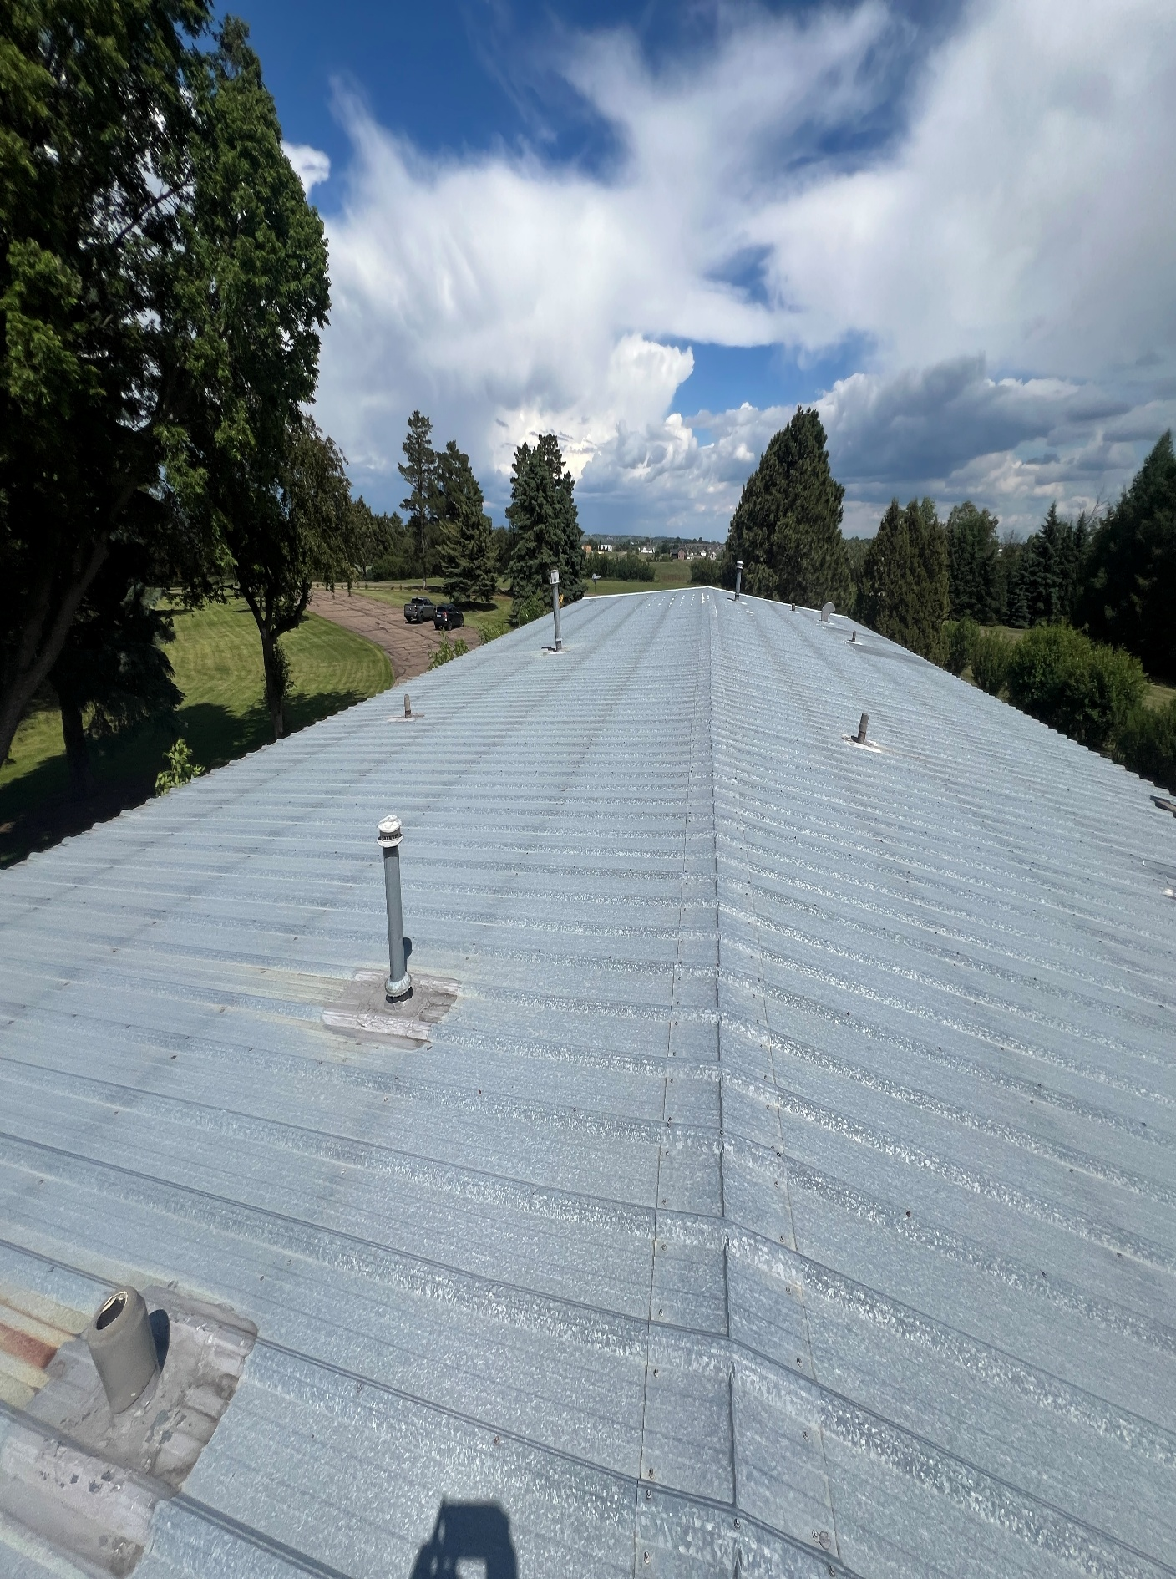

Roof
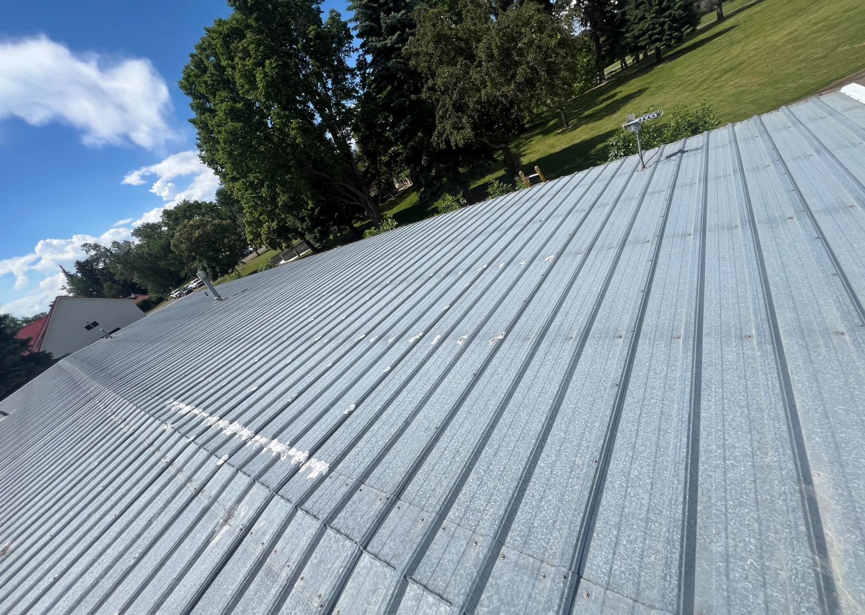

Roof
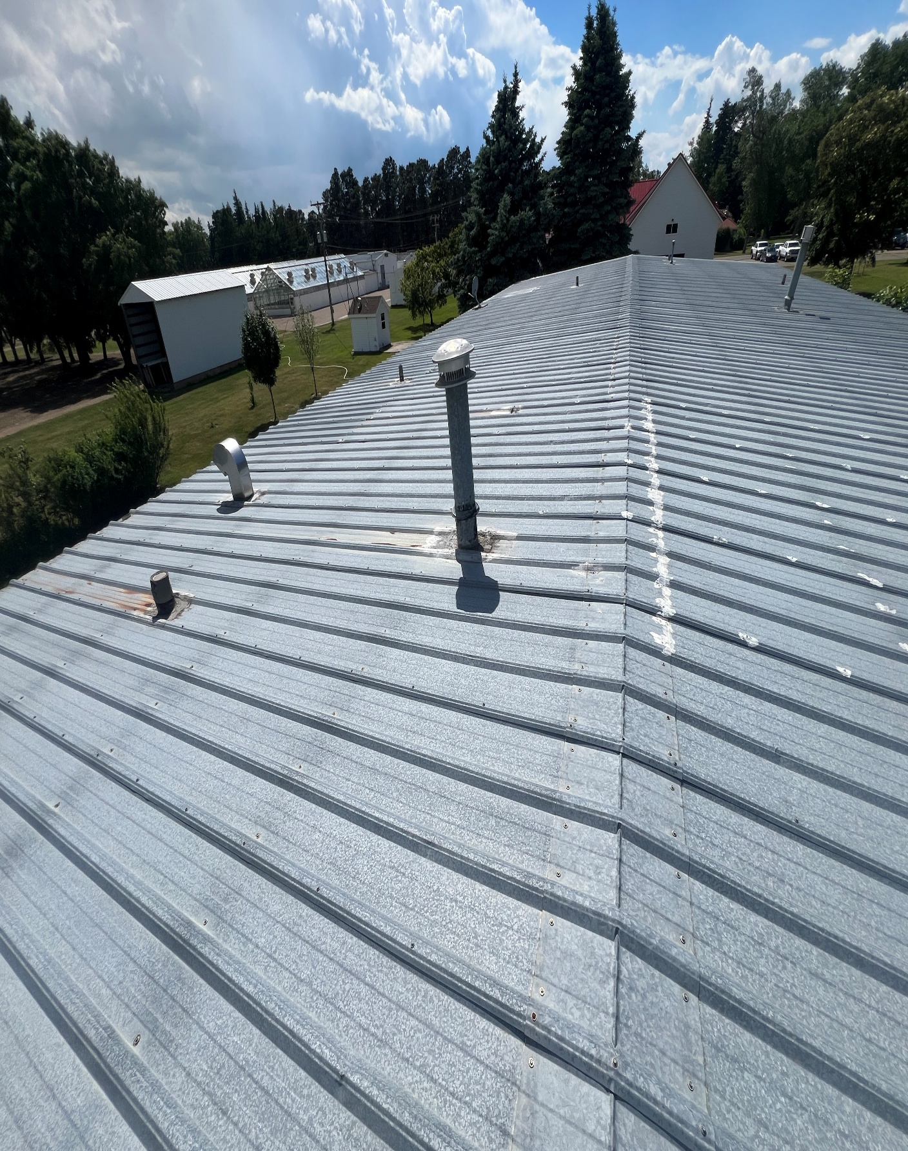

Roof
