Combined Synopsis/Solicitation for Commercial Items
Agile Professional Services ("APS”) Department of the Army

Project Name: | Agile Professional Services ("APS")
Solicitation Number: | W900KK-26-R-A023
NAICS Code: | 541990 (All Other Professional, Scientific, and Technical Services)
Set-Aside: | Total Small Business Set-Aside
Contract Type: | Labor Hours

1. General Information
This combined synopsis/solicitation is issued by Army Contracting Command - Orlando to procure Agile Professional Services ("APS"). The acquisition is structured to support critical technical and professional operations under a flexible framework, to be proposed and developed by the successful offeror.
Key acquisition parameters include:
- Set-Aside Status: 100% Total Small Business Set-Aside.
- Small Business Size Standard: $19.5M, or as defined by SBA regulations.
- Primary NAICS Classification: 541990 — All Other Professional, Scientific, and Technical Services.
- Contract Vehicle Type: Labor Hours.

2. Solicitation Details
This announcement constitutes the only solicitation; proposals are being requested and a written solicitation will not be issued. This combined synopsis/solicitation is prepared in accordance with the format in FAR Subpart 12.6, as supplemented with additional information included in this notice.
The solicitation document and incorporated provisions and clauses are those in effect through Federal Acquisition Circular FAC 2025-06, effective August 27, 2025.and DFARS Publication Notice (DPN) July 2, 2026.

As described in the attached FAR 52.212-2, The Army will adopt aspects of FAR Part 15 evaluation procedures. Considering the novel, and commercial, nature of these services this is deemed necessary to balance fairness, transparency, and competition with the interests of expediency and flexibility

3. Contract Pricing Structure
Offerors must complete the pricing structure below. Ensure all fully burdened hourly rates are specified for the designated labor categories.
See Attachment 10 - APS Pricing Workbook

4. Description of Requirement
CPE ST3 has a need for Agile Professional Services (APS) support services to provide the organization with the ability to augment its Military and Government Civilian workforce in order to execute its mission. The services will be limited to providing professional support services, under a Performance Based Services model, to CPE ST3 and CPE ST3 customers for limited requirements which are related to CPE ST3’s mission. Since its inception, CPE ST3 has relied on contractor support to conduct its mission in all phases of life cycle management due to insufficient personnel within the organization to successfully perform the required services. This model of a Government footprint with a scalable contractor workforce has enabled CPE ST3 to be very flexible and agile in its mission to support the changing needs of the Army.
The services to be performed will include related activities in support of all aspects of providing responsive integrated and interoperable infrastructure for simulation, training, testing, and threat solutions. APS support services are required for effective, efficient, and responsive full lifecycle management of efforts to include, but not limited to: vision statements and doctrine, development of architectures, program support (e.g., acquisition and budget planning, business and financial programming and execution, modeling, simulation, simulator, training device, and instrumentation development, documentation, fielding and execution, system analysis and integration, integrated logistics support, strategic planning, contingency and mission support, security cooperation/international relations, program oversight, independent verification validation and test evaluation, prototype development, sustainment and operations, and analysis of emerging technologies support), and subject matter experts on military tactics, techniques, and procedures. Potential areas of growth are envisioned but not limited to be in the areas of Cyber and Information Warfare, Robotics, Unmanned Vehicles, Home Station Training, Multi-Sensory Simulation, Artificial Intelligence, Hypersonics, Directed Energy, Electronic Warfare, Autonomous Systems, Multi-Domain Integration, Target and Threat Systems, Environment Modeling, Human Performance Training, Security Cooperation, Nuclear Engineering, and Medical Training.
The critical performance requirement is the successful development and transition of CPE ST3 from a traditional, staffing-based support model to a task-based, outcome-driven Agile delivery framework that is to be developed by the Performer. Success will be measured by the contractor's ability to develop and iterate, through performance under the resultant contract, a framework that both provides the following, and is able to be replicated across future requirements:
- Provide flexible and scalable teams of cleared specialized personnel.
- Implement and mature Agile, DevSecOps, and digital engineering practices.
- Integrate with government tools, environments, and processes (Jira, Power BI, etc.).
- Deliver measurable outcomes tied to mission readiness and warfighter needs, rather than just level-of-effort.
- Ensure compliance with DoD acquisition, cybersecurity (CMMC, RMF), and data rights regulations.
Work will be performed at Government facilities, Contractor facilities, and Remote locations. Primary Government sites include Orlando, FL, and Redstone Arsenal, AL (including 24/7 operations). Additional Government sites include: Fort Campbell, KY; Fort Hood, TX; Fort Drum, NY; Fort Irwin, CA; Fort Polk, LA; Fort Rucker, AL; Fort Bragg, NC; Hohenfels, Germany; and Camp Humphreys, South Korea.
The contractor should take into consideration that all acquisition support activities will be executed in accordance with applicable Federal, Department of War (DoW), and Army acquisition regulations, policies, and best practices.
*****Balance of Page Left Blank*****

Current Level of Effort data is provided here as a Magnitude reference, and for offeror consideration in Proposal development:

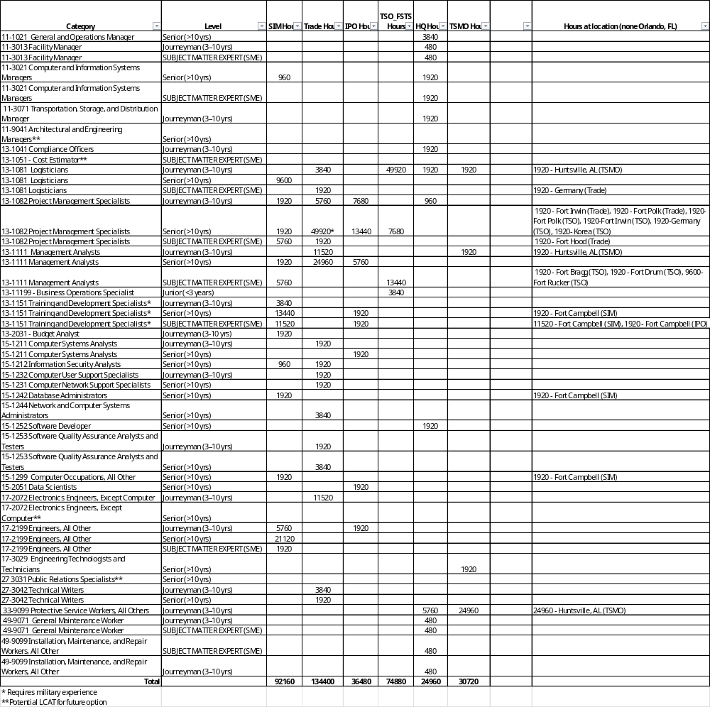

5. Period of Performance / Delivery Location

Period of Performance
Total Performance Period shall not exceed 66-months:
- Base Period – (15-Feb-27 to 14-Aug-27) Agile Development and Transition In
- Option Period 1 – (15-Aug-27 to 14-Aug-28) – Enterprise Performance
- Option Period 2 – (15-Aug-28 to 14-Aug-29) – Enterprise Performance
- Option Period 3 – (15-Aug-29 to 14-Aug-30) – Enterprise Performance
- Option Period 4 – (15-Aug-30 to 14-Aug-31) – Enterprise Performance
- Option Period 5 – (15-Aug-31 to 14-Feb-32) – Enterprise Performance and Transition Out
- Option Period 6 – (15-Feb-32 to 14-Aug-32) – Option to Extend the Term of Service under FAR 52.217-8

Place of Performance
Work will be performed at Government facilities, Contractor facilities, and Remote locations. Primary Government sites include Orlando, FL, and Redstone Arsenal, AL (including 24/7 operations). Additional Government sites include: Fort Campbell, KY; Fort Hood, TX; Fort Drum, NY; Fort Irwin, CA; Fort Polk, LA; Fort Rucker, AL; Fort Bragg, NC; Hohenfels, Germany; and Camp Humphreys, South Korea.

Tentative Milestone Schedule:
Sep-26 Phase I Notifications
Oct-26 Phase II Notifications
Nov-26 Phase III Notifications
Jan-27 Small Business PreAward Notifications
Jan-27 Award Notifications
15-Feb-27 Performance Start Date

6. FAR and DFARS Provisions and Clauses – SEE ATTACHMENT 7
The following provisions and clauses apply to this acquisition and are incorporated by reference or full text as applicable. The full text of the FAR and DFARS clauses may be accessed electronically at https://www.acquisition.gov/.

7. Proposal Submission Instructions
Phase I responses to this solicitation are due by 25 October 2026 / 11:59pm (Eastern). Submission due dates for all subsequent Phases will be issued via Advisory Notifications / Invitations. All submissions must be submitted via email to the designated POCs listed below:
Branch Chief / Contracting Officer: Lovisa D. Parks, Lovisa.d.parks.civ@army.mil
Team Lead / Contracting Officer: Troy D. Darling, troy.d.darling.civ@army.mil
Contract Specialists: Constance Hastings, constance.k.hastings.civ@army.mil
and Sophia Dasilva, sophia.g.dasilva.civ@army.mil

* Late Submissions: Late submissions will be handled in accordance with FAR 52.212-1(f).
See FAR 52.212-1, Instructions to Offerors — Commercial Items; for proposal submission instructions.

8. Organizational Conflict of Interest (“OCI) Disclosure:

8.1. General Requirement: Because of the Contractor’s proximity to inherently governmental functions and access to non-public, sensitive acquisition information, the Offeror must submit an Organizational Conflict of Interest (OCI) Mitigation Plan.

Definition of the Baseline Competitive Exclusion

A. Baseline Competitive Exclusion and Core Purpose: The “Baseline Competitive Exclusion” is a preventive procurement restriction established in accordance with FAR Subpart 9.5 (Organizational and Consultant Conflicts of Interest). Its core purpose is to neutralize potential conflicts of interest—specifically “biased ground rules” and “impaired objectivity”—that naturally arise because Contractor personnel on this contract will support sensitive pre-acquisition planning, technical analysis of alternatives, and requirements-gathering adjacent to inherently governmental functions.

B. Scope of the Exclusion (The “What”): Under the Baseline Competitive Exclusion, the Contractor is strictly prohibited from bidding on, competing for, performing, or otherwise supporting any competitive program work within the U.S. Army Capability Program Executive Simulation, Training, Test and Threat (CPE ST3) portfolio. This includes, but is not limited to:

- Product and hardware development;
- Tactical system integration;
- Software engineering and commercial software licensing;
- Platform testing and evaluation; and
- Fielding and sustainment hardware contracts.

C. Affected Entities (The “Who”): This exclusion applies corporately and collectively to:

- The Prime Contractor;
- All members of the Prime Contractor’s joint venture, teaming arrangement, or partnership;
- All proposed Subcontractors; and
- All parent companies, subsidiaries, sister sectors, and corporate affiliates of the Prime Contractor and its Subcontractors.

D. Duration (The “When”)

- Standard Duration: The Baseline Competitive Exclusion shall remain in effect for the entire duration of this contract (inclusive of all base years, option years, and any performance extensions or transition phases) plus an additional period of one (1) year following the final date of contract performance.

8.1.2 Baseline Acknowledgment: The Offeror must clearly state that they intend to abide by the Baseline Competitive Exclusion (preventing the Prime, Subcontractors, and Affiliates from bidding on CPE ST3 product/hardware work).

Basis of Evaluation: The Government will evaluate the Offeror’s OCI Mitigation Plan on a strictly “Acceptable/Unacceptable” basis. The evaluation will determine if the Offeror has successfully identified, avoided, neutralized, or mitigated all potential OCIs in accordance with FAR Subpart 9.5 and the strict criteria established in FAR 52.212-2 (Attached).

8.2.1 Evaluation Criteria: To receive a rating of “Acceptable,” the Offeror’s OCI Mitigation Plan must definitively meet both of the following two conditions:

- Condition A (Baseline Exclusion): The Offeror explicitly accepts the Baseline Competitive Exclusion for its entire team (Prime, Subs, Affiliates) without exception.

- Condition B (Firewall Exemption): The Offeror submits, as a part of their proposal, a completed and acceptable OCI mitigation Plan for any CURRENT OCI’s disclosed. Pre-existing OCI issues will NOT preclude contract award. To be rated “Acceptable” under Condition B, the plan must provide the specific documentation required for all three (3) objective firewall elements:

- Unequal Access to Information: Occurs when a contractor has access to non-public, sensitive, or proprietary information as part of its performance of a Government contract, and that information provides the contractor with an unfair competitive advantage in a later competition.

- Biased Ground Rules: Occurs when a contractor, in the course of performance, drafts or influences specifications, Statements of Objectives (SOOs), Statements of Work (SOWs), Program Objective Memorandum (POM), or acquisition plans for a future procurement, thereby biasing the competition in favor of its own capabilities, tools, or those of an affiliate.

- Impaired Objectivity: Occurs when a contractor’s work under one Government contract requires it to evaluate its own products, services, or performance (or those of a competitor, teammate, or affiliate) on another Government contract, thereby impairing its ability to render impartial, objective advice.

8.2.2 “Unacceptable” Rating and Ineligibility: A proposal that fails to provide a comprehensive OCI Mitigation Plan, or a plan that fails to objectively prove the isolation elements required for a Firewall Exemption, will receive a “Unacceptable” rating.

8.2.3 No Post-Award Negotiation: The Government will not make an award to an Offeror with an “Unacceptable” OCI Mitigation Plan. The Government will not conditionally approve the OCI Mitigation Plan or negotiate material firewall terms after contract award. If an Offeror receives a “Unacceptable” rating for this factor, their entire proposal will be deemed unawardable and removed from further consideration.

9. Additional Information
- Questions: The deadline to submit questions for this RFP has passed.

- Security Clearance Requirements: See Attachment 9 - DD254 for specifics.
  - Probable Facility Clearance without Storage
  - Probable Secret, Top-Secret, and TS/SCI requirements for certain employees.

10. Attachments:
- Statement of Objectives (SOO), dated 8 September 2026
- FAR 52.212-1 – Instructions to Offerors - Proposal Submission instructions
- FAR 52.212-2 – Evaluation Criteria – Evaluation Plan
- Wage Determinations
  - WD 2015-4377 REV 33 20260820 NC
  - WD 2015-4553 REV 31 20260730 FL
  - WD 2015-4603 REV 34 20260820 AL
  - WD 2015-4631 REV 34 20260812 AL
  - WD 2015-4675 REV 30 20260822 KY
  - WD 2015-5197 REV 33 20260812 LA
  - WD 2015-5237 REV 32 20260812 TX
  - WD 2015-5629 REV 29 20260513 CA
  - WD 2015-5775 REV 32 20260812 NY
- PWS Template
- QASP Template
- Provisions and Clauses
- CDRLs
  - A001 – Contractor’s Progress and Status Report
  - A002 – Phase-Out Transition Plan
  - A003 – Agile Dashboard
  - A004 – Agile Management Plan
- DD 254
  - SAP Addendum (incorporated into Attachment 9 (“ix.”))
  - SCI Addendum (incorporated into Attachment 9 (“ix.”))
- APS Pricing Workbook
- Army DSO JIRA Settings
- Compliance Matrix (Contractor’s Format in MS Excel)

Acknowledgement of Amendments:
Amendment 01:
The purpose of this amendment was to provide Attachment-6_Quality_Assurance_Surveillance_Plan_(QASP)_Proposal_Template_-_APS_20260903

Amendment 02:
The purpose of this amendment was to do provide responses to Industry questions, to revise the Combined Synopsis/Solicitation, to provide for revised submission dates, and to provide updated Attachments 1, 2, 3, 4.e, 5, and 10.

*****END OF COMBINED SYNOPSIS/SOLICITATION*****

