STATEMENT OF WORK
Repair by Replacement of One (1) 122-Ton Air-Cooled Chiller
Building 1057
Ellington Field JRB - Houston, Texas
September 10 2026

1. Purpose
The Government requires repair by replacement of the existing Trane air-cooled chiller serving Building 1057 with one (1) new nominal 122-ton air-cooled chiller. The Contractor shall furnish the labor, supervision, insurance, tools, equipment, materials, delivery, rigging, demolition, installation, reconnection, startup, warranty, cleanup, and incidental work identified in this Statement of Work for a complete replacement consistent with the quoted basis of work.

2. Existing Conditions / Basis of Work
- Existing equipment: Trane outdoor air-cooled chiller.
- Replacement basis: one (1) Carrier 30RC air-cooled scroll chiller, nominally 122 tons, or approved equal matching requirements.
- Existing electrical service is approximately 460V, 3-phase, 60 Hz; Contractor shall field verify before installation.
- Existing chiller is installed on an exterior concrete slab intended to remain and be reused.
- Existing chilled-water isolation valves are intended to remain and be used for isolation during replacement.
- Existing electrical breakers, fuses, and disconnects are intended to remain and be reused.
- Contractor shall field verify dimensions, connection locations, access, rigging requirements, piping configuration, controls, concrete pad and conditions affecting the quoted replacement work before proceeding.

3. Replacement Chiller - Minimum Requirements
- One (1) 30RC air-cooled scroll chiller, nominal 122 tons, or approved equal.
- 460V, 3-phase, 60 Hz.
- 7-inch color control-panel display with quick restart/capacity recovery.
- BACnet IP and BACnet MS/TP capability.
- Evaporator heater / freeze protection.
- 5 HP dual VFD pump package.
- Hot-gas bypass.
- Factory refrigerant charge.
- Carrier-Service remote connectivity capability.
- 10 kA SCCR.
- Suction service valve.
- Standard scroll compressor.
- Aluminum/copper condenser coil with E-coat.
- Greenspeed intelligence / high-efficiency variable condenser fans.
- Non-fused disconnect.
- Shell-and-tube direct expansion (DX) evaporator.
- Single-point power connection.
- Security grilles and end hail guards, including coil trim panels.
- Low-sound configuration including aero-acoustic fans.
- Factory startup.
- One (1) year labor warranty.

4. Demolition and Removal
- Mobilize to Building 1057 and coordinate work with the Government.
- Complete required lockout/tagout procedures before disconnecting the existing chiller.
- Recover existing refrigerant and dispose/recycle in accordance with applicable requirements.
- Disconnect chilled-water piping, electrical power, control conduit, and control wiring from the existing Trane chiller.
- Provide telehandler or equivalent rigging/lifting equipment required to remove the existing chiller and set the replacement chiller.
- Remove the existing Trane chiller from the site and dispose of it off-site.
- Remove and haul off trash and debris generated by this work.

5. Installation
- Set the new chiller on the existing concrete slab. Before installation, the Contractor shall field verify the slab's dimensions, condition, levelness, and compatibility with the replacement equipment. Structural evaluation, repair, enlargement, or replacement of the slab is not included unless separately authorized by the Government.
- Reconnect chilled-water piping as needed from the existing isolation valves to the new chiller inlet and outlet connection points.
- Provide incidental fittings and connection materials required for the quoted chiller replacement.
- Pressure test modified chilled-water piping.
- Reinsulate and provide exterior jacketing for disturbed piping in the immediate work area.
- Reconnect existing electrical power, conduit, and wiring as needed to serve the new chiller.
- Reconnect existing control wiring and terminate at the new chiller.
- Complete manufacturer/factory startup services.
- Verify the unit operates without abnormal leaks, alarms, vibration, or operational deficiencies before requesting acceptance.
- The Contractor shall provide the Government with an estimated duration of any anticipated power outage required to complete the chiller replacement. The estimate shall identify the expected outage length, affected equipment/areas, and proposed date/time. All planned outages shall be coordinated with and approved by the Government prior to interruption of power. The Contractor shall make reasonable efforts to minimize outage duration and restore power as quickly as practicable.

6. Controls
- Reconnect existing control wiring and terminate at the replacement chiller.
- Provide BACnet IP and BACnet MS/TP capability furnished with the chiller.
- Verify basic local chiller controls, enable/disable, alarms, and available existing control interface during startup.
- Contractor is required to lockout/tagout; disconnecting the existing electrical power, conduit, and wiring from the existing chiller; reconnecting the existing electrical power, conduit, and wiring to the replacement chiller; verifying voltage and phase rotation before startup; and coordinating and obtaining Government approval for any required power outage.
- Existing upstream breakers, fuses, feeders, and external disconnects shall remain and be reused, provided they are serviceable and compatible with the replacement chiller.
- New breakers, fuses, automatic transfer switches, feeders, external disconnecting means, and major electrical-system upgrades are not included in this SOW. Any required work outside these limitations shall be reported to the Government and shall not proceed without written authorization.

7. Startup and Basic Acceptance Testing
Testing shall be in accordance with installation and manufacturer startup activities required to demonstrate that the replacement chiller and modified chilled-water connections are operational. Whole Building Design Guide and manufacturer specifications and regulations.
- Factory-authorized chiller startup and manufacturer startup checklist.
- Verify proper voltage and phase rotation at the existing chiller connection before startup.
- Verify chiller and integral pump operation.
- Verify chilled-water flow and entering/leaving water temperatures available at the chiller.
- Pressure/leak test modified chilled-water piping.
- Verify refrigerant system has no apparent leaks associated with the installation.
- Verify controls and connected alarms/functions provided with the new chiller.
- Correct installation-related deficiencies identified during startup before final acceptance.

8. Submittals and Closeout
- Replacement chiller product data and equipment information.
- Manufacturer installation/startup information.
- Project schedule and equipment lead-time update.
- Refrigerant recovery documentation, as applicable.
- Pressure/leak test documentation for modified chilled-water piping.
- Manufacturer/factory startup report.
- Warranty documentation.
- Operation and Maintenance information provided by the manufacturer.
- Final equipment model and serial number.
- Basic record documentation identifying material deviations from the planned installation.
- Final cleanup and removal of project debris.

9. Safety and Coordination
- Comply with applicable, UFC’s, OSHA, lockout/tagout, refrigerant handling, rigging/lifting, installation safety, and manufacturer requirements.
- Coordinate outages, delivery, lifting, access, and startup with the Government.
- Protect adjacent Government property, pavement, piping, utilities, and equipment during the work.
- Repair damage caused by the Contractor's operations at no additional cost to the Government.
- Coordinate any crane/height notification requirements applicable to the lifting operation.

10. Warranty
Provide the manufacturer's standard equipment warranty applicable to the supplied chiller and a minimum one (1) year labor warranty beginning upon Government acceptance.

11. Place and Schedule of Performance
Work shall be performed at Building 1057, Ellington Field JRB, Houston, Texas. The Contractor shall coordinate equipment lead time, delivery, removal, installation, startup, and closeout with the Government.

12. Final Acceptance
- Existing chiller removed and disposed of off-site.
- New 122-ton chiller installed on the existing slab.
- Chilled-water piping reconnected, pressure tested, insulated, and free of installation-related leaks.
- Existing power and controls reconnected within the limits of this SOW.
- Factory startup successfully completed.
- Unit is operating and providing chilled-water cooling.
- Required startup, warranty, and closeout documents have been submitted.
- Work area is clean and project debris has been removed.
- Contractor to provide training of new unit to Government personnel.

13. Applicable Requirements
Perform the work in accordance with applicable federal, state, and local requirements; installation requirements; OSHA safety standards; refrigerant-handling requirements; manufacturer requirements; and applicable mechanical, electrical, environmental, Whole Building Design Guide and Unified Facilities Criteria provisions governing the work described in this SOW. Contractor is to secure a new Freon recovery tank, vacate the Freon from the unit to be replaced into the tank and return to the government as directed by the Department of War.

14. EXISTING CONDITIONS / PHOTO ATTACHMENTS
The following photographs document existing conditions at the Building 1057 chiller location. Photographs are provided for reference. The Contractor shall field verify actual conditions, dimensions, ratings, access, connection points, and serviceability before construction.
Attachment A - Existing Trane Equipment Data Plate / Nameplate
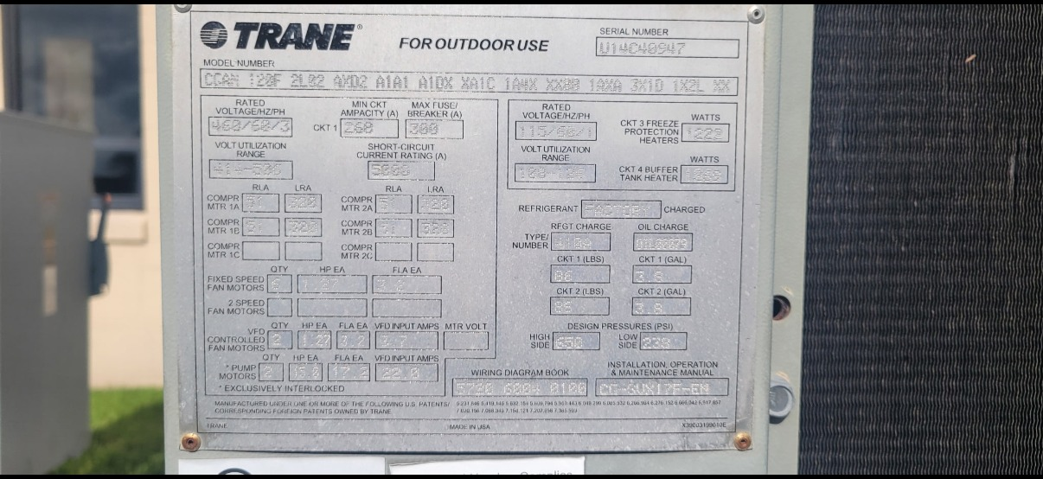
Field-verification reference only. Contractor shall verify actual conditions, dimensions, ratings, connection requirements, and serviceability before procurement and construction.

Attachment B - Existing Chiller Interior / Vessel and Condenser Coil Condition
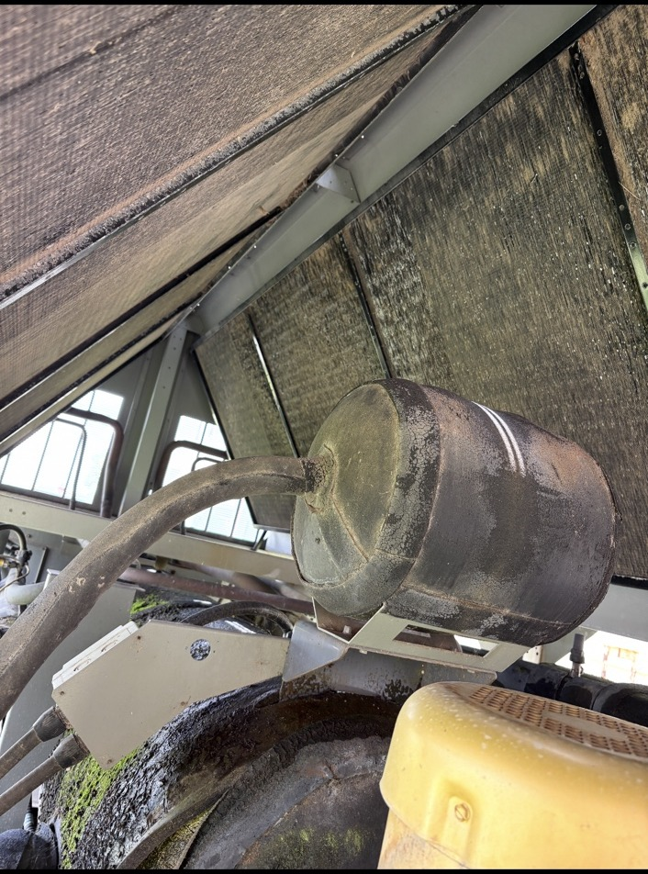
Field-verification reference only. Contractor shall verify actual conditions, dimensions, ratings, connection requirements, and serviceability before procurement and construction.

Attachment C - Existing Condenser Coil and Fan/Motor Condition
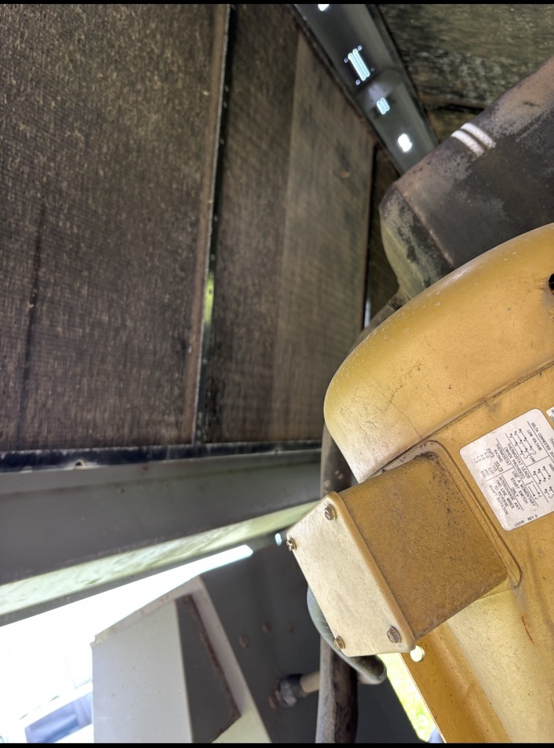
Field-verification reference only. Contractor shall verify actual conditions, dimensions, ratings, connection requirements, and serviceability before procurement and construction.

Attachment D - Existing Piping, Insulation, Sensors, and Biological/Surface Deterioration
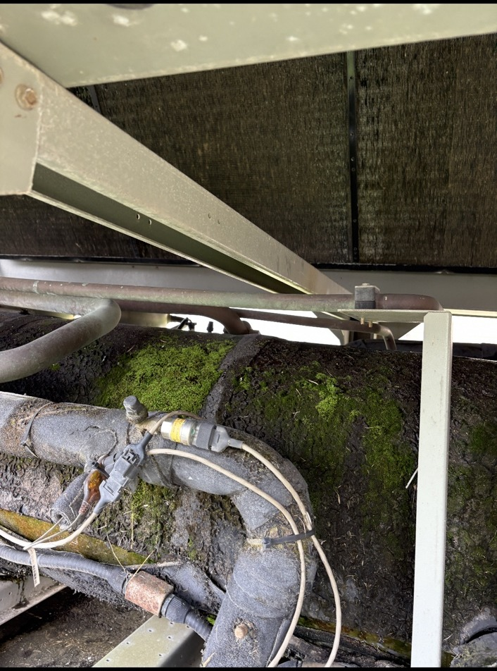
Field-verification reference only. Contractor shall verify actual conditions, dimensions, ratings, connection requirements, and serviceability before procurement and construction.

Attachment E - Existing Condenser Coil Condition
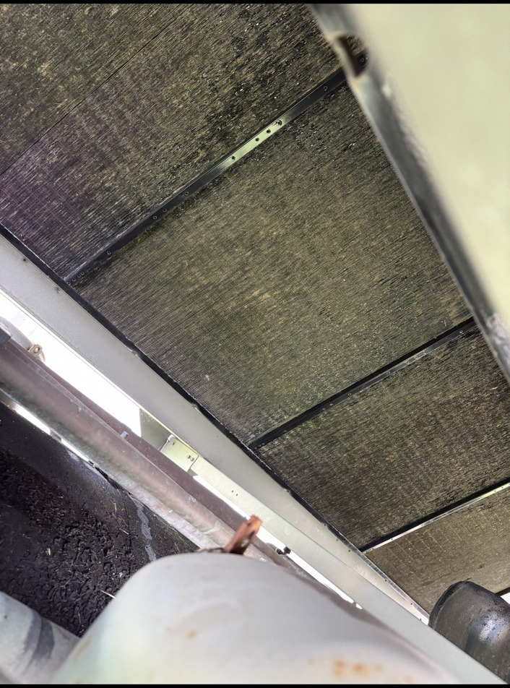
Field-verification reference only. Contractor shall verify actual conditions, dimensions, ratings, connection requirements, and serviceability before procurement and construction.

