Section C - Description/Specifications/Statement of Work
GENERAL SPECIFICATIONS
FORESTWIDE HVAC REPAIRS/REPLACMENTS FY26
      - SCOPE OF CONTRACT
        - This project includes repairing or replacing various HVAC equipment located at various locations across the Payette National Forest.
        - The work includes the following:
          - McCall Helibase-Replacement of an existing outdoor condenser unit
          - Council Engine Bay-Replacement of an existing ceiling mounted propane unit heater and replacement of blower motor in another ceiling mounted propane units heater
          - Fawn Hall Barracks-Reconfiguration of two return air grills for the central air system
        - Optional work includes Option A or B at the Payette NF Supervisor’s Office described as the following:
          - Option A-Repairing the three existing systems (IT room system, outdoor air system, and multi zone system).
          - Option B-Reconfiguration of the three existing systems (IT room system, outdoor air system, and multi zone system).
        - Quantities associated with these options are identified in the Schedule of Items.
      - PROJECT LOCATION
        - The site locations for the base work are as follows:
          - McCall Helibase – 605 South Mission Street Bldg. #3, McCall, ID 83638
          - Fawn Hall Barracks – 600 North Mission Street #4, McCall, ID 83638
          - Council Yard Engine Bay – 201 North Dartmounth Street (Hwy 95), Council, ID 83612
        - The site location for Option A or Option B is as follows:
          - McCall Supervisors Office – 500 North Mission Street Bldg. #2, McCall, ID 83638
      - SITE INFORMATION AND LIMITATIONS
        - The following site conditions are considered incidental to the contract and the contractor will not be paid directly for any of the following items:
          - Construction sites will be open to Forest Service employees during construction. The Contractor will be responsible for signing and limiting access where necessary. Contractor will be responsible to work with COR on schedule and construction so as to minimize disturbance to the users of the facilities.
          - Water is available at the site for construction purposes.
          - Utilities are available at the site for construction purposes.
          - Bathroom facilities are available onsite.
      - TRAFFIC CONTROL AND CONSTRUCTION SIGNING
        - No work that endangers, interferes, or conflicts with traffic or access to work sites shall be performed until a plan for satisfactory warning and handling of traffic has been submitted by the contractor and approved by the CO and Local Transportation Authority. Construction signing for traffic control shall conform to the Manual of Uniform Traffic Control Devices (MUTCD). All traffic control signs will be placed in areas adequate for a truck pulling a fifth wheel trailer to be turned around. Contractor shall not be paid directly for this item, rather it will be considered incidental to other items of work listed in the Schedule of Items.
        - Signing and barricades shall be adequate to protect Forest Service employees and the public.
      - WORK CAMPS, STAGING AND STORAGE AREAS
        - Areas for staging operations and storage of materials shall be approved by the CO. The Contractor must request in writing for approval from the CO to stage trailers (work) on site.
        - No overnight camping will be allowed on site.
      - INSPECTION OF WORKSITE
        - The contractor acknowledges they have taken the necessary steps to ascertain the nature and location of work and have investigated and satisfied themselves as to the general and local conditions that can affect the work or its cost (e.g. inclement weather, travel times to/from work sites, availability of accommodation and amenities at or near work sites, etc). Any failure of the contractor to take the actions described and acknowledged in this paragraph will not relieve the Contractor from the responsibility of estimating properly the difficulty and cost of successfully performing the work, or for proceeding to successfully perform the work without additional expenses to the government.
      - START DATE
        - July 2026
      - CONTRACT TIME
        - 60 Calendar Days
END OF SECTION C
MAY 2019
USDA FOREST SERVICE, R4
FORESTWIDE HVAC REPAIRS/REPLACEMENTS FY26
SECTION 000050 - PROJECT DESCRIPTION
- GENERAL
      - SUMMARY
        - This item shall consist
      - MEASUREMENT AND PAYMENT
        - Measurement shall be the JOB completed and ready for use. The quantity measured shall be paid for at the contract Lump Sum price as shown on the Schedule of Items.
1.3 RELATED WORK
        - The work shall be in accordance with the following project description.
- PRODUCTS - Not Applicable
- EXECUTION
      - BASE WORK
          - McCall Helibase-Replacement of existing outdoor condenser unit
            - Remove and dispose of the existing outdoor condenser unit located at the southeast corner of the building. See photo for condenser unit location.
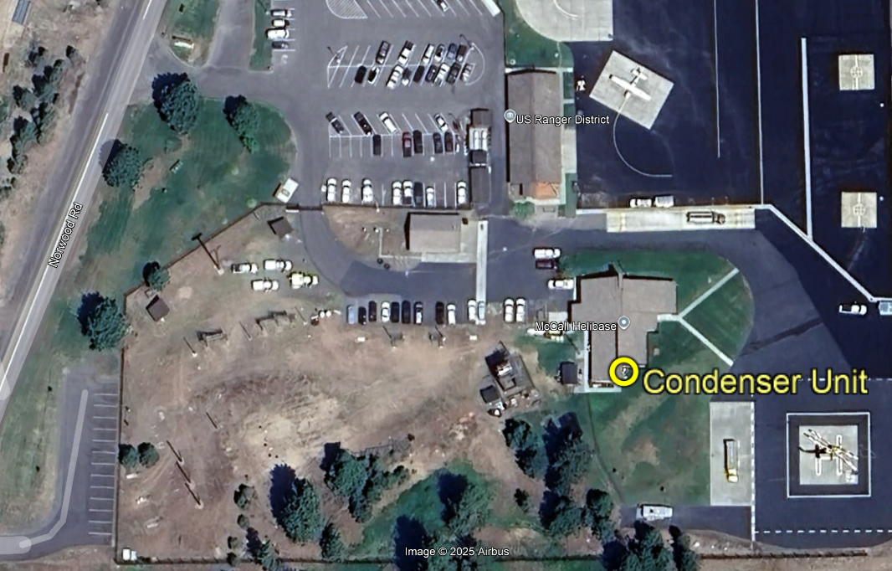

              - Existing outdoor condenser unit to be removed is an American Standard Model# 4A7A3024E1000AA, Serial# 12184HNW3F, 208/230 Volts, 1 phase, 60Hz, 12.0 Amp, 1/8 HP, manufacture date 5/2012.

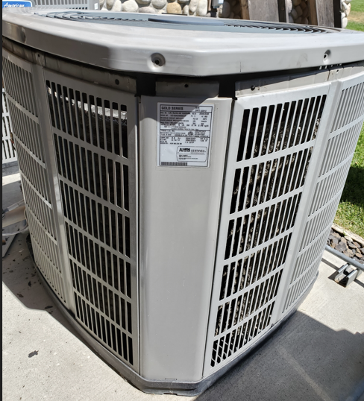
            - Retain existing indoor unit: American Standard Model# AUH2B080A9V3VAC, Serial# 12193T9A7G, 208/230 Volts, 1 phase, 60Hz, 12.0 Amp, 1/8 HP, manufacture date 5/2012.
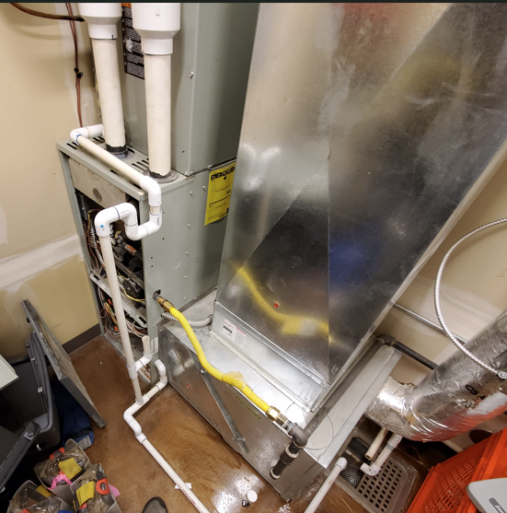
            - Ensure functionality of control wiring of system. Retain existing control wiring or replace if needed. If substantial length of wiring is needed to be replaced, a modification request can be submitted.
            - Examine existing refrigerant piping and ensure its integrity, repair/replace as necessary. Piping can be utilized for new type of refrigerant if flushed.
            - Provide and install new outdoor condenser unit at location of existing unit.
              - The new outdoor unit must be compatible with the existing indoor unit as well as meeting or exceeding key specifications as follows:

 | Description | Specification
 | Cooling Capacity | 2 tons (24,000 BTUh)
 | SEER Rating | Approximately 13 SEER (13.4 SEER2)
 | Refrigerant Type | R-410 or update to current code (R-32 or R-454)
 | Electrical | 200-230V, 1 Phase, 60 Hz
 | Compressor Type | Scroll, single-stage
 | Dimensions (approx.) | Height: 29 in, Width: 29 in, Depth: 26 in
 | Sound Level | 71-72 dB(A)
 | Outdoor Coil | All-aluminum Spine Fin™ coil
 | Gross Weight | Approximately 150 lbs

              - The unit shall have at least a 5-year warranty for the equipment.
              - Anchor unit to concrete slab per manufacturers recommendation.
            - Rework existing electrical connections as needed and replace any damaged conduits and/or conductors.
          - Council Yard Engine Bay-Replacement of existing ceiling mounted propane unit heater in engine bay and replacement of fan motor for ceiling mounted propane unit heater in the metal shop.
            - Remove and dispose of existing LPG unit heater (Lennox LF24-75A-P LPG) within the engine bay at the Council Yard Engine Bay building.
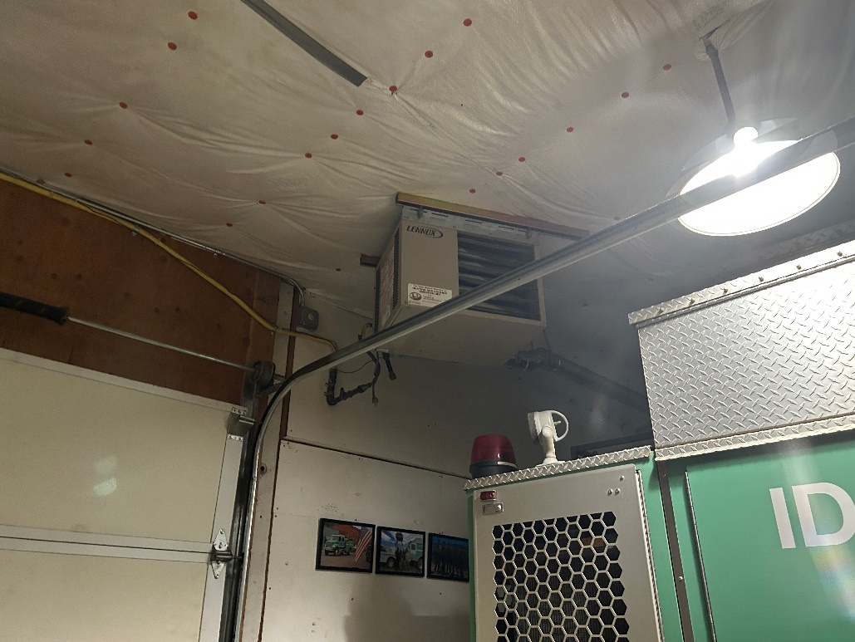
            - Ensure functionality of control wiring of system. Retain existing control wiring or replace if needed. If substantial length of wiring is needed to be replaced, a modification request can be submitted.
            - Provide and install new LPG unit heater at location of existing unit.
              - The new LPG unit heater shall meet or exceed key specifications as follows:

Description | Specification
Heating Capacity Input - Btuh | 75,000
Heating Capacity Output – Btuh | 60,000
Steady State Efficiency | 80.0%
Temperature rise - °F | 60
Flue size (round) | 4 inch
Gas Piping Size | ½ inch
Number of fans | 1
Fan Diameter - in | 14 inch
Number of blades | 5
Motor Output - hp | 1/8
Amps | 4.1
rpm | 1050
Air Volume - cfm | 950
Air throw at 8 ft. mounting height - ft. | 40
Electrical | 115V-60Hz-1ph
Weight (lbs) | 91
              - The unit shall have at least a 5-year warranty for the equipment.
            - Rework existing electrical connections as needed.
            - Replace the blower motor in the existing metal shop unit heater (ADP Cayenne FSA-P-75 unit); specifications are as follows:

 | Description | Specification
 | Height (in) | 17
 | Depth (in) | 25
 | Width (in) | 25
 | Flue connection (in) | 4
 | Gas connection NPT (in) | 1/2
 | Electrical | 120V, 1phase
 | Heating Capacity (MBH) | 75
 | Weight (lbs) | 91
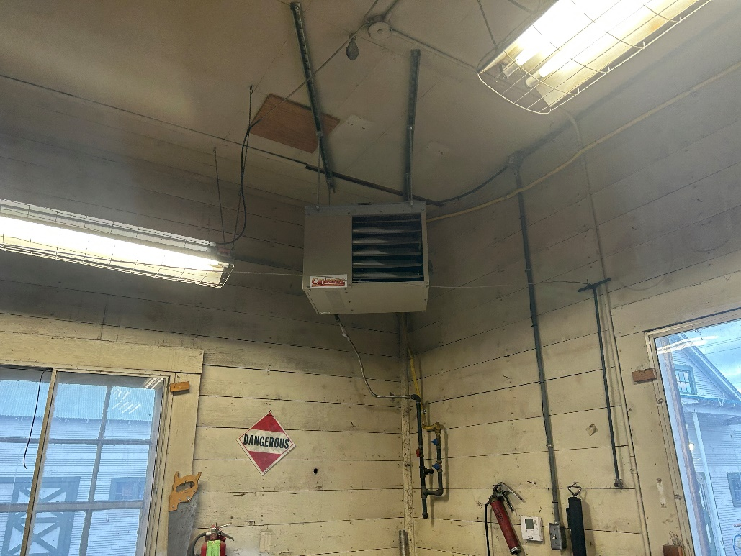
              - Ensure that unit heater is fully functional.
          - Fawn Hall Barracks-Upgrades of two return air grilles for the central air system.
            - Replace existing return grille located in central hallway of building with new larger eggcrate return grille.
              - Remove and dispose of existing return grille.
                - Dimensions of existing grille are 13.75-inches height x 15.75-inches width. The top of grille is 2.25-inches below the ceiling.
              - Reconfigure 2x4 wall framing to accommodate new return grille including framing a new opening through the existing wall to accommodate the new grille and associated ductwork.
              - Modify existing ductwork as needed to transition existing ductwork to new return grille.
                - Existing ductwork dimensions are 12-inches height x 14.25-inches width. The ductwork is 2.75-inches from the back wall and 3.5-inches below the ceiling. The ductwork is 2-inches above the top of the stacked washer and dryer units.
              - Install new return grille (nominally 12-inches height x 30-inches width) and connect to existing ductwork.
                - Basis of design is Titus 50R with standard finish and standard core.
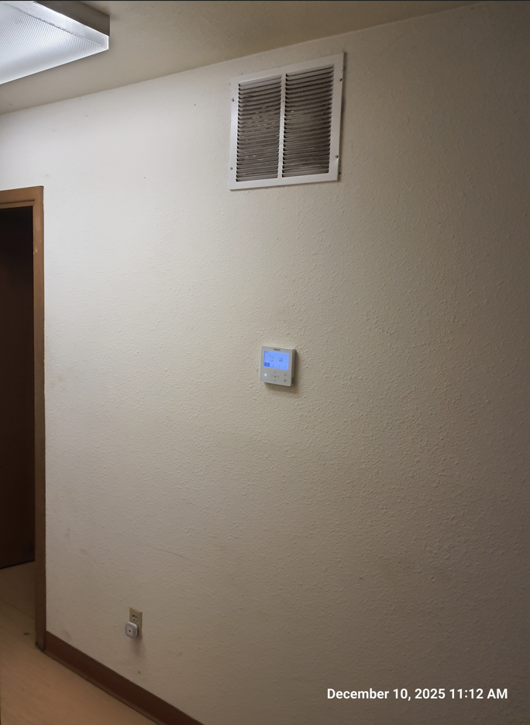
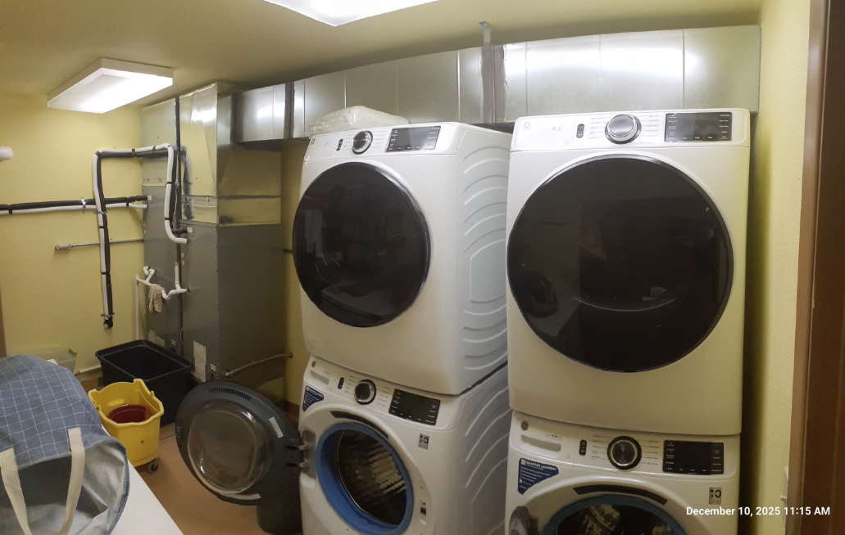

            - Replace existing return grille located in common area of building with new eggcrate return grille.
              - Remove and dispose of existing return grille.
                - Dimensions of existing grille are nominally 16-inches x 16-inches. Overall dimensions are 17.75 inches height x 21.75 inches width. The top of the grill is 24 inches below the ceiling.
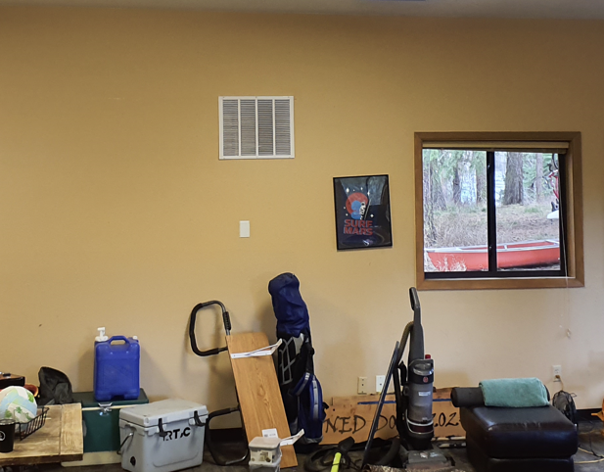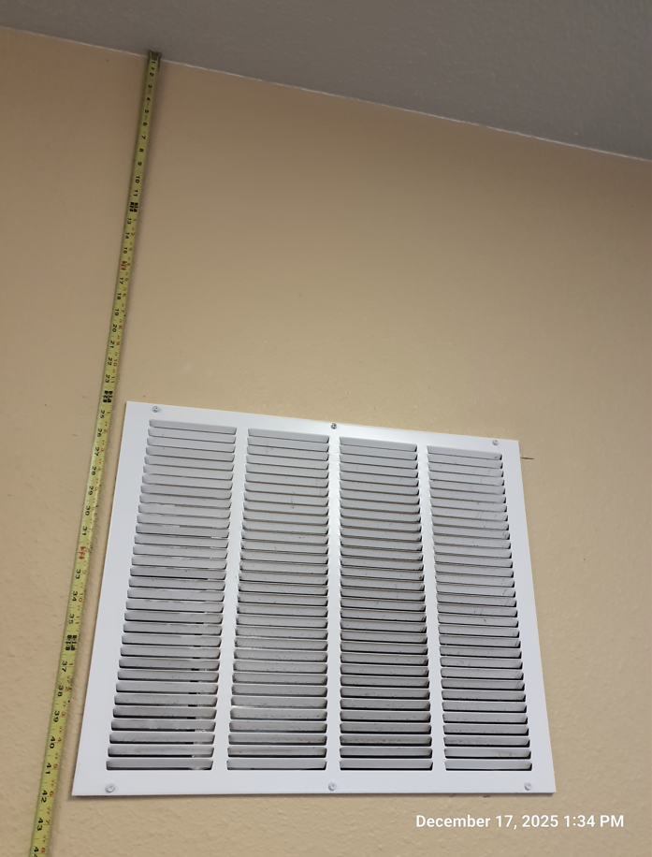
              - Reconfigure wall framing to accommodate new return grille.
                - Remove the existing 2x6 stud from within the duct, frame in header of the following size: (3) 2x10s with cripple studs on either side of the header to accommodate the new opening.
                - Repair/texture/repaint any removed drywall
              - Modify existing ductwork as needed to transition existing ductwork to new return grille.
                - This may require a new plenum to be installed on the air handler unit.
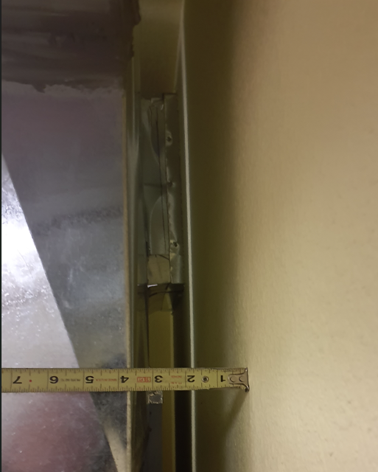
              - Install new return grille (nominally 24-inches height x 20-inches width) and connect to existing ductwork.
                - Basis of design is Titus 50R with standard finish and standard core.
      - OPTIONAL WORK (Payette NF Supervisor’s Office)
          - Payette NF Supervisor’s Office has three existing HVAC systems as described below:
              - IT room system is a single zone ductless split system air conditioner (cooling only), Daikin Skyair RZR series. 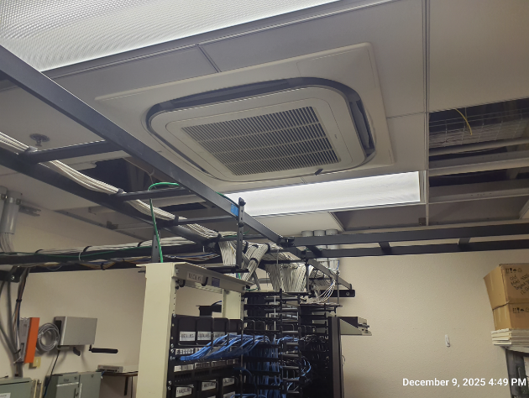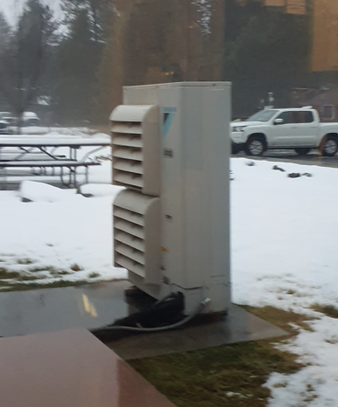
Make | Model | Description | Notes
Daikin | FCQ42PAVJU | IT Room Indoor Unit | Ceiling cassette
Daikin | RZR42PVJU | IT Room Outdoor Unit | Free standing heat pump
            - Outdoor air system is a ducted indoor air handler, Daikin FXMQ, paired with an outdoor VRV heat pump, Daikin RXYQ.
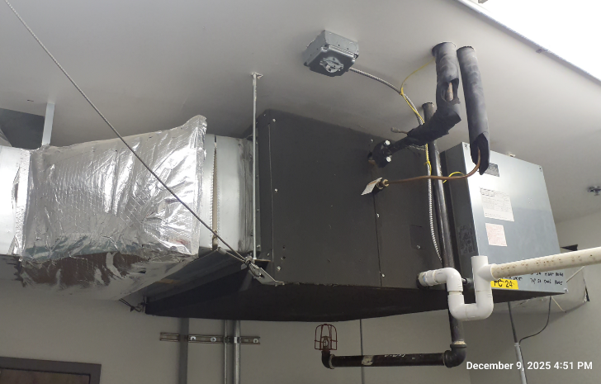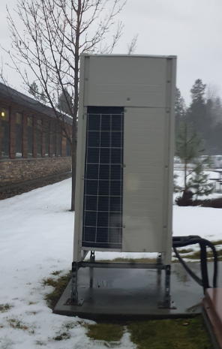
Make | Model | Description | Notes
Daikin | RXYQ96PBTJ | Outdoor Unit for OA Sys | VRV heat pump
Daikin | FXMQ96MFVJU | Indoor Unit for OA Sys | Fan Coil Unit
            - Multi zone system is a ducted system with local air handlers served by three ground source heat pumps in the mechanical room of the building.
            - All HVAC systems and equipment are connected to a central control panel (Dakin ITM) which is located in the mechanical room of the building. This control panel has the capacity to be remotely accessed for diagnostic purposes.
          - OPTION A
            - Repair existing IT room HVAC system.
              - Inspect system to identify any issues with system and communicate those to the COR.
              - Resolve all known issues with the existing system including a refrigerant leak at the outdoor unit heat exchanger coil and communication errors between the units and the central ITM. Error history of system is shown in below table.
 | Error | Dates | Notes
 | U0 | 4/9/2025, 10/31/2025 | Refrigerant shortage
 | E4 | 10/11/2025, 11/24/2025 | Low pressure fault
 | U4-01 | 5/16/2025 | Communication fault
            - Repair existing Outside Air HVAC system
              - Inspect system to identify any issues with system and communicate those to the COR.
              - Resolve all known issues with the existing system.
 | Error | Date | Notes
 | JA-6 | 12/1/2025 | High pressure sensor
 | E4 | 12/1/2025 | Low pressure fault
 | E7 | 12/1/2025 | Communication fault
 | U3 | 12/1/2025 | System test run
 | P9 | 12/1/2025 | Autocharge

            - Repair monitoring of multi-zone system pumps.
              - The central control panel (Daikin ITM) for the building HVAC systems monitors the operation of two pumps (ground source loop) for the building multizone system.
              - Sensors and wiring are in place to monitor pump operation and trigger an alarm if either pump shuts down.
              - This monitoring and alarm system is currently not working and needs to be repaired. The pumps and controls are shown in the photos.
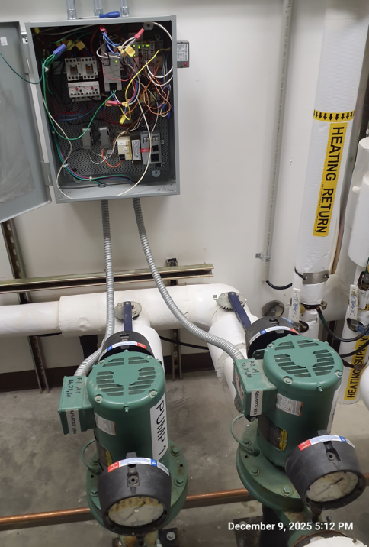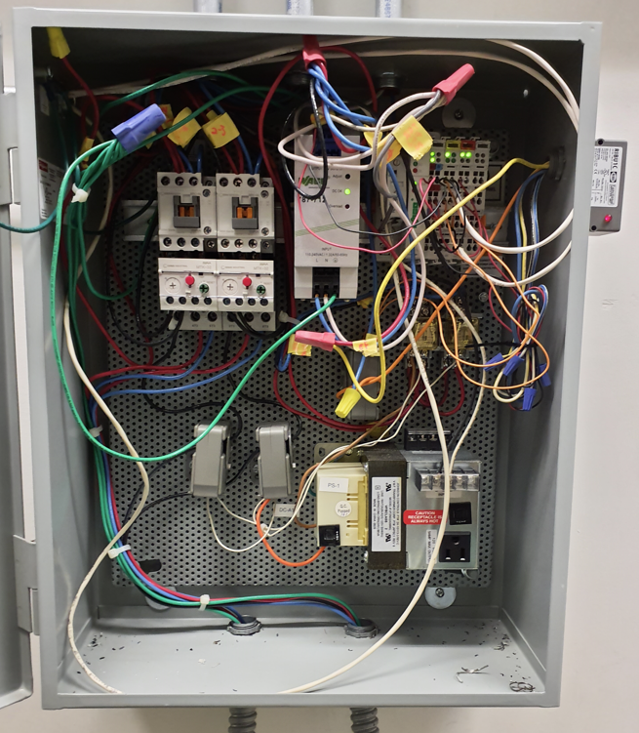

            - Install three-phase power monitor and conditioner for multi-zone system.
              - The multizone system frequently shuts down completely due to a power phase error (Daikin error code U2). This error causes shutdown of all twenty four air handlers throughout the building, leaving the entire building without HVAC.
              - After power cycling all equipment connected to the building multi zone system the error code is cleared and the building multi zone system resumes operation.
              - A three-phase power monitor and conditioner shall be installed per manufacturers recommendations for each condenser in the mechanical room (three units, each unit labeled HRU 1) to correct this problem with the building multi zone system. Basis of design is ICM Controls ICM450A or ICM450+.
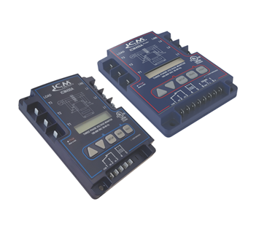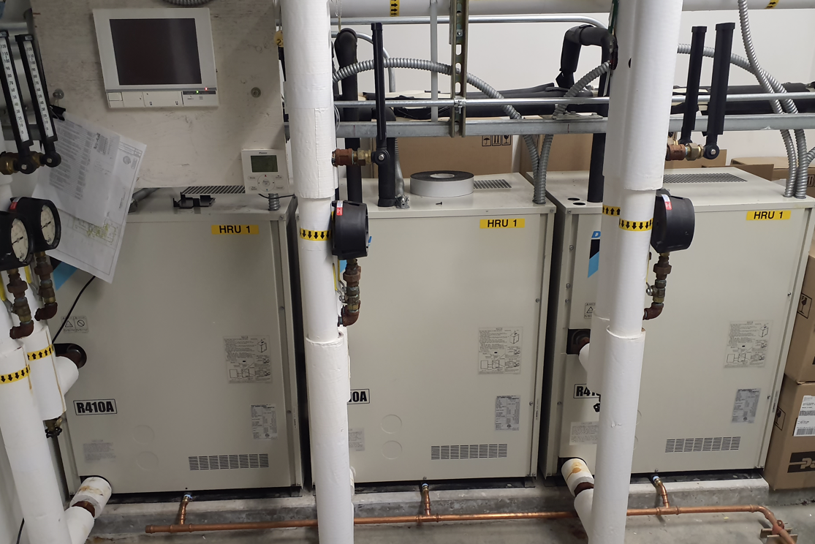
          - OPTION B
            - Upgrade of existing IT room HVAC system
              - Remove and dispose of existing IT room HVAC systems including indoor ceiling cassette unit, outdoor condenser unit, electrical disconnects and associated conduits, all associated refrigerant piping and all associated miscellaneous materials associated with system.
              - Patch penetrations into building with grout that matches the existing colors.
              - Retain wall mounted thermostat (Daikin BRC1E72 Nav remote) for use with new HVAC system or install new T-stat if new IT room is not compatible with existing thermostat.
              - Install new water source heat pump at approximate location of existing unit. Install new duct work, air terminals, and controls associated with new air handler. Also install seismic bracing for the unit (recommend repurposing seismic bracing from other fan coil unit that is being demolished). Connect and integrate water loop piping for new air handler to existing multizone system water loop piping. Install new 12-gpm pump in mechanical room. Program the system to be connected/controlled by the Daikin ITM.
                - Basis of design is Daikin SmartSource Compact Horizontal WSHP-WGC-H-048-ECM and Armstrong Astro 2 Series 12gpm circulator. 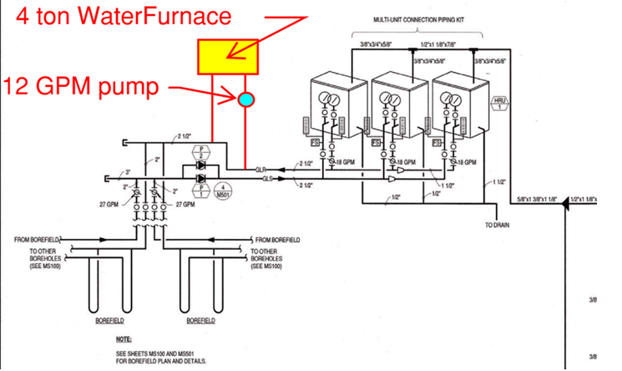
            - Upgrade of existing Outside Air HVAC system
              - Remove and dispose of existing outdoor air handler unit located in overhead of mechanical room including all associated refrigerant piping. Retain wall mounted thermostat (Daikin BRC1E72 Nav remote) for use with new outdoor air system. Also, retain the seismic bracing to use on the IT HVAC unit installation.
              - Remove and dispose of existing duct heater and filter rack located in hallway and in mailroom, replace the existing section of ducting as needed, and remove or reroute electrical for use with the new duct heater.
              - Install new variable speed inline fan with filter rack and 30kW duct heater.
                - Basis of design is Nailor DHRF 30kW duct heater and Twin City Fan DSI 165ANE variable speed fan with included accessories: aluminum backdraft damper, vibration isolators, filter box with two-inch thick disposable paper filter, motor mounted dial speed controller, 0-10 volt lead, 1HP/1160rpm/208V/1Ph/60Hz motor, NEMA 1 unfused disc switch mounted and wired.
            - Repair monitoring of multi-zone system pumps.
              - The central control panel (Daikin ITM) for the building HVAC systems monitors the operation of two pumps (ground source loop) for the building multizone system.
              - Sensors and wiring are in place to monitor pump operation and trigger an alarm if either pump shuts down.
              - This monitoring and alarm system is currently not working and needs to be repaired. The pumps and controls are shown in the photos.

            - Install three-phase power monitor and conditioner for multi-zone system.
              - The multizone system frequently shuts down completely due to a power phase error (Daikin error code U2). This error causes shutdown of all twenty four air handlers throughout the building, leaving the entire building without HVAC.
              - After power cycling all equipment connected to the building multi zone system the error code is cleared and the building multi zone system resumes operation.
              - A three-phase power monitor and conditioner shall be installed per manufacturers recommendations for each condenser in the mechanical room (three units, each unit labeled HRU 1) to correct this problem with the building multi zone system. Basis of design is ICM Controls ICM450A or ICM450+.
      - BUILDING ENVIRONMENT
        - Contractor shall maintain a clean, dust free office environment throughout the progress of work.
      - WORK NOT INCLUDED
        - N/A.
      - ALL OTHER PRODUCTS AND EXECUTION
        - Work shall be in accordance with the project description.

END OF SECTION
July 2026

