HW of Chap8 – rabbit5024

% Iinitial Conditions

p_0 = [8 0 20];

v_0 = [0 0 0];

a_0 = [0 0 0];

% Prediction horizon = K*dt; Control horizon = 1

dt = 0.1;

K = 20;

% weight for pos vel acc jerk

weight = [10;1;1;1];

% Constraints

% |v_xy|<=6, |a_xy|<=3, |j_xy|<=3, -1<=v_z<=6, -1<=a_z<=3, -2<=j_z<=2

constraintXY = [6 6 3 3 3 3];

constraintZ = [6 1 3 1 2 2];

3D Spiral Tracking Results

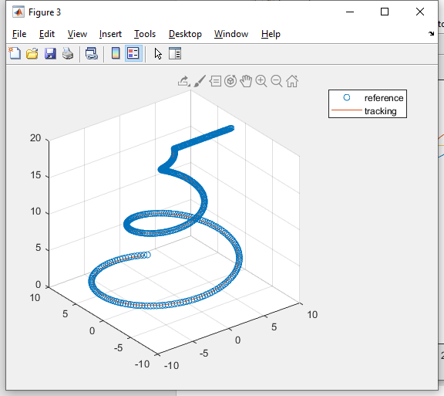

The calculated control output ‘jerk’ for 3 axes

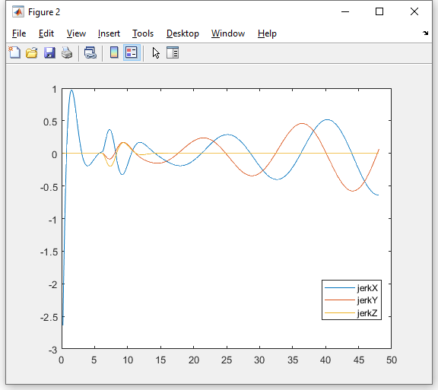

The Tracking results of z-axis

