System Design Specifications of

Autonomous Warehousing - Task and Path Planning

Task 5

**CONFIDENTIAL!**

|  |  |
| --- | --- |
| Version number | Version 1.0 |
| Distribution Group | Internal |
| Main responsible Coordinator | DAI-Labor, TU-Berlin |
| Current State Date | - |

Applications of Robotics and Autonomous Systems

Team Members:

* Florian Ziesche – Researcher - 354873
* Patrick Denzler - Main Coordinator - 358682
* Shreyas Gokhale - Technical Coordinator - 406031
* Uros Petkovic – Researcher - 406167
* Vincent Wölfer - Lead Developer - 359972

# Table of Contents

Table of Contents 2

List of Figures 3

List of Tables 4

1 Introduction 5

1.1 Motivation and Problem Definition 5

1.2 Objectives 5

1.3 General Constraints 5

2 Use cases / scenarios 5

3 State-of-the-Art 6

4 System Requirements, Architecture and Specifications 6

4.1 Requirements 6

4.2 System Architecture 6

4.3 System Specifications 7

5 Timeline 7

6 Frameworks and Tools 7

7 References 9

List of Figure

**No table of figures entries found.**

# List of Tables

**No table of figures entries found.**

# **Introduction**

Note that a very well put Introduction and Use-Case section will save you for the Introduction of the final report (copy and paste will be accepted).

## Motivation and Problem Definition

5 pts

The goal of the project, the motivation (mostly talking about our scenario and how your part contributes to the overall scenario), why your project would be useful to such a scenario.

The clear definition of your problem, e.g.: This project tries to solve the problem the factories facing in warehousing and the work assignment between workers to find and place suitable …… So, the technical problem is to find a suitable algorithm that assigns the most available robot with the task of picking up, transporting and storing the object in the warehouse so that the entire process consumes less time, energy ….

The project starts with receiving a command of “an object with an ID is ready to be picked”. The ID information gives the specifications of the object including: the size, the storage conditions, time for delivery, delivery means (delivery on site or delivery to an external address) etc.

## Objectives

8 pts

A paragraph to state the clear inputs and outputs of the project. How it connects to the other topics of the scenario.

Then, define the specific objectives of the project by bulletpoints. Usually these objectives define the main parts of the project stages. E.g.

* Research on multi-robot centralized / decentralized planning
* Installation and understanding of the existing auto smart factory environment
* Simple path planning approach for a single robot case
* Traffic management and planning for less encounter of multi-robots
* Implementation of dynamic obstacle avoidance
* Shape fitting on the object to detect possible deformations
* …

## General Constraints

2 pts

This project makes these assumptions:

* The number of the robots will be limited according to the size of the map
* The number of recognizable object shapes will be limited
* …

# **Use cases / scenarios**

10 pts

This section is a storyline of your project. Inspire from the overall scenario from the Week#1 slides and extend it with your own work. The clearer the scenario you define here leads to a more detailed system architecture and easy implementation phase.

Do not only define the perfect scenario running, also create some MISUSE cases / unexpected situations. E.g. although the human is assigned for the grasping task of the object, human is attending to somewhere else creating an unexpected situation. Then the robot recognizes the case and …. Another example, the robot assigned for the task of picking the object suddenly breaks down after it picked the object, what to do?.

# **State-of-the-Art**

10 pts

Start with pointing out the most available (for the last 3-5 years) solutions that are used, just like the content of this document is inspired [1], [2]. The methodologies used along with scenarios they were in. The brief details here should be fine.

**IMPORTANT:** The last paragraph is a discussion on which method would be useful for your case and why?

# **System Requirements, Architecture and Specifications**

## Requirements

10 pts

Define the system requirements here as bulletpoints. These are the points that you will realize (implement), so these should be clearly defined. You can think of the extension of specific objectives you set out (each bulletpoint there, will require several sub-points). The points read from top to bottom will describe sort of a more technical story line of your work. E.g:

* Process planning shall be triggered with a newly assigned production task.
* The products shall have a semantic description for the entire process planning, e.g. number of parts, possible printers to print each part and estimated quality etc.
* The semantically described product descriptions shall be used in scheduling task based on the properties set.
* Project code shall start / be triggered upon a new package arrival
* Task planner shall be responsible for selecting the bes available robot moving from their job load
* Human shall be able to be installed with different human types (e.g. expert, beginner, sleepy)
* Human shall have an interface allowing for external control of his actions (via a remote controller)
* …

This section is really important; therefore, please ask me if anything is not clear.

## System Architecture

23 pts

An example system architecture drawing given below. There are others also available in week 2 slides. Try to make each building block of the drawing as one node in your system (or several building blocks sub methods of a node together building one node). Important things to visualize:

* Each node planned to be developed
* Which services or topics these nodes provide
* Which nodes are utilizing those services and nodes (the connection/communication of the nodes)
* You may even define the parameters flowing between nodes (an extensive UML diagram).

The more detailed it is the easier for you to develop. So, I would spend significant amount of time to think and design. Note that this does not necessarily reflect the last version of your system. I will not grade how much similar your developed system to this diagram. It will surely be subject to change, and the updated version will be in your final report.

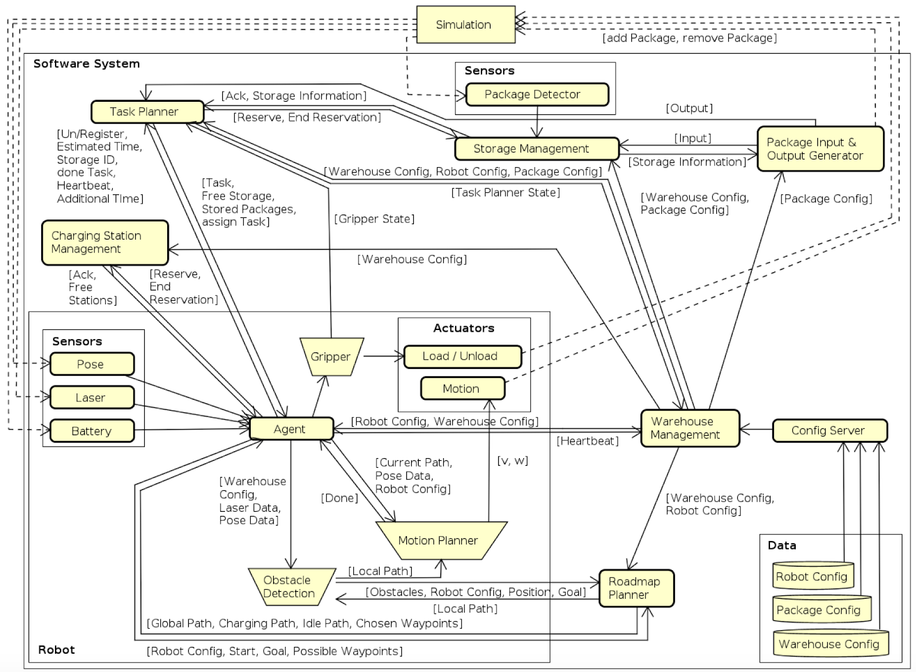

Figure System Architecture / Flow-Chart Diagram

## System Specifications

20 pts

Each of the building blocks you defined above in the sys architecture drawing (or only the nodes in your system) will be clarified here.

Inputs and outputs: You can either use the diagram above to show on it, or draw a new diagram or write down the inputs to the node (whether a service request or a topic subscription) and the outputs from it (whether a service response or publishing a topic). It is very flexible. You need to also show clearly the inputs and outputs of the overall system.

Methodology or functionality: Again for each of the modules / nodes / system components very briefly define each of their functionality, along with the methodology (the algorithm with brief descriptions) to be used.

# **Timeline**

7 pts

This part is majorly for you to have a rough agenda for yourself. You can state with bulletpoints by providing week numbers. WHAT I CARE HERE ARE THE MILESTONES. Define two milestones for your work. These milestones will be discussed and finalized with the lecturer during the lectures.

# **Frameworks and Tools**

5 pts

This section should briefly talk about what tools and frameworks you will use. You can refer to the components you mention under Section 5.2 and just list the tools/libraries that you would like to use to develop. Additionally, you need to state here, if any, user interface will be developed (e.g. could be a GUI or the controller for topic 3.1). E.g.:

* To realize object recognition Caffe library / Tensorflow version.. will be used
* OpenCV will be used for image processing tools
* PCL will be used for plain detection and point map of the objects
* Genetic algorithm provided in this link will be utilized as the scheduling algorithm.
* Matlab will be used to model servo motors
* Apache Spark library will be used for supervised learning algorithms provided.

NOTE: Don’t forget to put their references below by citing. E.g. their links, or papers to cite if they refer on their website.

# **References**

[1] Retrieved from: ec.europa.eu/idabc/servlets/Doc3cc5.doc?id=18625

[2] Retrieved from: <http://dioscuri.sourceforge.net/docs/URD_Dioscuri_KBNA_v1_1_en.pdf>