The Mobility on Demand
Booking System

Design and Documentation

Overview
A fleet of autonomous vehicles, some customers and a scheduler.

We are aiming for the following scenario. A fleet of autonomous vehicle is being used to provide mobility on demand service to customers. Vehicles know how to move autonomously between a set of stations, following predefined routes. Customers can request for a vehicle to come and pick them up at one of the stations, to bring them to another station. The booking can be done from a smart phone or a web browser.
Once a customer has made a request, a scheduler will assign a vehicle to that request and place the request in the vehicle's list of requests. The algorithm aim at minimizing the waiting time of the customer, while maintaining a first come first served policy.
The customer can then monitor the status and progress of the request in real time, in particular the remaining time to wait before the vehicle arrives at the requested pickup station.
Once the mission has been completed, i.e. the customer has reached the desired dropoff location, the vehicle proceeds with the next request in its queue if any, or remains at the current station otherwise.

Design
One database to rule them all.

The central component of the system is the data. This data includes the list of vehicles, their status and location, and the list of requests and their status. This data is stored in a MySQL database. The main benefit of using a database – as opposed to, say, an internal data structure in the scheduler – is to allow a standard communication protocol between all the agents: the SQL language, which is implemented in many programming languages on many platforms.
The second point of design takes into consideration the fact that the communication between the different agents is intermitent. As the vehicle and customers are mobile, the network connection cannot be assumed to be continuous. The communication protocol must hence allow for disconnection and reconnection without loss of data. This is achieved by two solutions. The first one is a “connect, communicate, disconnect” protocol. The second is to use a PHP layer around the database, i.e. a web API, to ensure that all SQL requests are made from the same host.
This leads to the system diagram shown of Figure 1.
Illustration 1: System diagram
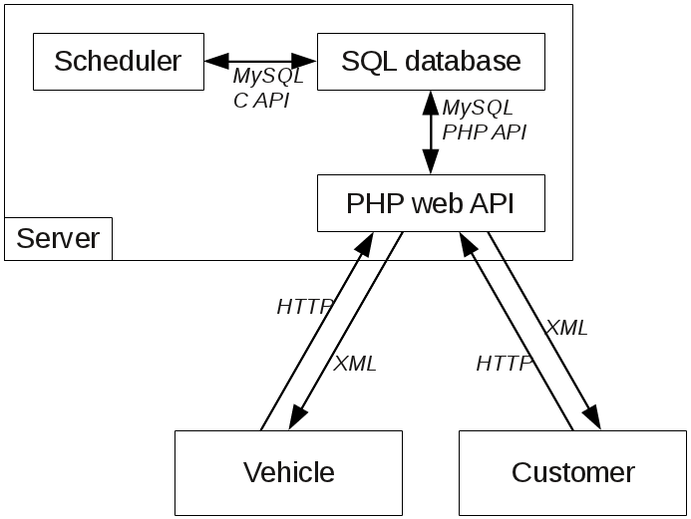Figure 1: System diagram
The PHP API consists in a set of scripts, one per action, that take POST or GET data as argument and return XML formatted data. From the client side (i.e. customer or vehicle), accessing the database consists in an HTTP request to the corresponding script and parsing the returned XML code.

Implementation

The database

Tables definition
- STATIONS:
  - Name (STRING)
  - Latitude (FLOAT)
  - Longitude (FLOAT)
- VEHICLES: information about vehicles
  - VehicleID: manually assigned to each vehicle (STRING)
  - Latitude (FLOAT) (updated by the vehicle itself)
  - Longitude (FLOAT) (updated by the vehicle itself)
  - Status: (STRING) (updated by the vehicle itself)
    - WaitingForAMission
    - GoingToPickupLocation
    - AtPickupLocation (waiting for the customer to board)
    - GoingToDropOffLocation
    - AtDropoff (waiting for the customer to alight)
    - NotAvailable
  - RequestID: which request is being processed
  - ETA: Estimated Time of Arrival in seconds (INT) (updated by the vehicle)
  - CurrentLocation (STRING). One of the stations or NULL
- REQUESTS: information about requests
  - RequestID: auto increment
  - CustomerID: (STRING) manually assigned to each customer
  - Status:
    - Requested (customer requested, but scheduler hasn't acknowledged it yet)
    - Acknowledged (scheduler has assigned a car to the request)
    - Confirmed (car is on the way)
    - Processing (customer on the car)
    - Completed (customer reached destination)
    - Cancelled (customer cancelled)
  - PickUpLocation (string, matching a station name)
  - DropOffLocation (string, matching a station name)
  - VehicleID: (string) ID of the car assigned to the mission
  - ETA: Estimated Time of Arrival in seconds (INT) (updated by the scheduler). Either time of arrival to pickup location if request status is Acknowledged or Confirmed, or time of arrival to dropoff location if request status is Processing.
  - CustCancelled: (boolean) customer asked to cancel the request. Only customer can modify this value.
  - VehicleAcknowledgedCancel: one of No (the vehicle has not processed the cancel request yet), Acknowledged, or Rejected.

Operations
- Customers
  - Make a booking: insert a new row in table REQUESTS. CustomerID and station names must be given (checked against the list of stations).
  - Check the status of the booking and ETA
  - Cancel the booking: set CustCancelled to true
- Vehicles
  - Check if any mission has been assigned (status Confirmed)
  - Update its status, location and ETA
  - Monitor CustCancelled and respond by setting VehicleAcknowledgedCancel.
- Scheduler
  - Monitor for Requested requests, assign a vehicle to it and sets the status to Acknowledged or Confirmed.
  - Monitor the vehicle’s state and ETA, and update the mission state and ETA accordingly
  - monitor CustCancelled and VehicleAcknowledgedCancel to cancel the request.
  - Manage the queue of requests: when a vehicle completed a request (its status becomes AtDropoff), mark it as Completed and sets the next request’s status to Confirmed.

Communication

Scheduler
Since the scheduler and the database are located on the same host, it is safe to communicate using direct SQL commands using the C++ connector (http://forge.mysql.com/wiki/Connector_C%2B%2B).

PHP web interface
A collection of PHP scripts, hosted on the same host as the database, allows to do HTTP requests to act with the database. Those scripts use the PHP MySQL API to communicate with the database. For instance list_requests.php takes as argument a combination of the following three variables: RequestID, VehicleID, CustomerID and returns the requests matching the arguments as a XML string.
For instance:
http://fmautonomy.no-ip.info/dbserver/list_requests.php?customerID=cust1
may return something like this:
<rootxml>
<requestList>
<request requestID="3" customerID="cust1" status="Cancelled" pickup="McDonald" dropoff="DCC Workshop"/>
<request requestID="7" customerID="cust1" status="Cancelled" pickup="E3A" dropoff="EA"/>
</requestList>
<status code="ok" msg=""/>
</rootxml>
All scripts return a XML document with the following structure.
- A root node called rootxml
- A status node with attribute code which is either “ok” or “err” and optionally a msg attribute indicating the problem encountered.

Customer (Androïd)
The Androïd application communicates with the database through the PHP interface. To make the HTTP call, the org.apache.http package is used. To parse the XML response, javax.xml and org.w3c.dom are used. All of this is implemented in DBInterface.java

Vehicle
The vehicle communicates with the database through the PHP interface as well. But the application being written in C++, the libraries used are different. Curl is used to handle the HTTP requests. Tinyxml is used to parse the XML result. This is implemented in HTTPClient.cpp and DBInterface.cpp.
Additionally, two components are defined for the vehicle: a RoutePlanner and a MissionComm. These are both threaded state machines abstract classes. The RoutePlanner component is in charge of moving the vehicle to a target station. The MissionComm component is in charge of interacting with the database, and transfering orders to the RoutePlanner.
For now, we have the following classes derived from MissionComm:
- PromptMissionComm: useful for development of the route planner. No database or internet connection required. Mission are prompted from the user directly.
- DBMissionComm: Missions are retrieved from the database
and from RoutePlanner:
- SimulatedRoutePlanner: no vehicle is required, not even a simulator (e.g. Gazebo). The simulated vehicle can either move instantly or simulate travelling time.
- RoutePlannerVehicle: real route planner on the golfcart.

