Documentation
for the
Navigation Stack

Changes
- 22 mars 2012, Brice: creation

Overview of the navigation stack
The navigation stack for the golfcart is based on the ROS navigation stack (http://www.ros.org/wiki/navigation), which architecture is shown on the following figure (taken from http://www.ros.org/wiki/nav_core):

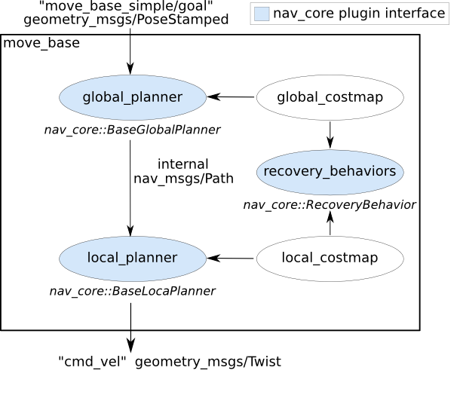
Basically, the move_base node maintains a global and a local costmap, and contains a global and a local planner. The recovery behavior essentially clears the costmaps when they become too cluttered and the robot is stuck.

The global planner and the local planner are base classes that are meant to be overriden. ROS provides several implementation, for instance Dynamic Window and Trajectory Rollout approaches to local control. Implementations are written as plugins for the move_base node.

The costmap is basically a grid based representation of obstacles. See http://www.ros.org/wiki/costmap_2d for detailed information. It can be initialized from the static map of the environment, and updated with information from the sensors.

The obstacle grid cells can have 3 values: occupied, free or unknown. Surrounding cells have values that depend on the robot's physical size: “definitely in collision” when an obstacle cell is within the inscribed radius of the robot, “possibly in collision” when an obstacle cell is within the circumscribed radius of the robot, hence whether there is a collision or not depends on the robot's orientation, “definitely not in collision” when there is no obstacle cell within the circumscribed radius of the robot.

Study of base_local_planner
This package provides implementations of the Trajectory Rollout and Dynamic Window approaches to local robot navigation on a plane. See www.ros.org/wiki/base_local_planner for details.
I believe studying in depth this package will be very instructive. Besides there are probably pieces of code that we can copy and paste.

costmap_model.cpp
Class CostmapModel, is a subclass of WorldModel. This is a mechanism that intends to abstract away different representation of the world, however, at the moment, only costmap is supported. The most important function is footprintCost that computes the cost with a given footprint. Actually, it only checks the cell at the border of the footprint, not within the footprint...

