***GE Capital Americas***

***Attivio Log File Analysis***

***User’s Guide***



**GE Capital Americas**

**1 Capital Drive**

**952-828-1684**

**10/1/2014**

Forrest Bentley

The Attivio Log File Analysis system will read Attivio Connector Log files, and Vehicle/Person Log files, and create summary CSV files for analysis using Excel.

Task Tracker System User’s Guide

Contents

Task Tracker System User’s Guide 2

Installation 2

Attivio Log File Analysis Main Screen 3

Vehicle/Person Analysis 4

Connector Analysis 6

Appendix 8

# Task Tracker System User’s Guide

# Installation

1. Create a Attivio Log File Analysis directory on your system (e.g. c:\AttivioLogAnalysis)
2. Go to the “T” drive [mapping = EPMNSHARED2$(\\FLTEPMNPFIPRC2)(T:)(T:))]
3. Copy all files from: T:\ITDOC\Strategy&Planning\Bentley\AttivioLogs into the directory you created in step 1.
4. Create a shortcut on your desktop with the following properties (assuming you created a directory called c:\AttivioLogAnalysis in step 1:
   1. Name: Attivio Log Analysis
   2. Target:

c:\AttivioLogAnalysis \BEDITWIN.exe -25000 call c:\AttivioLogAnalysis \Attiviolog.bed

* 1. Start in: c:\AttivioLogAnalysis

1. Double-click the shortcut you created on your desktop to start the system.

# Attivio Log File Analysis Main Screen

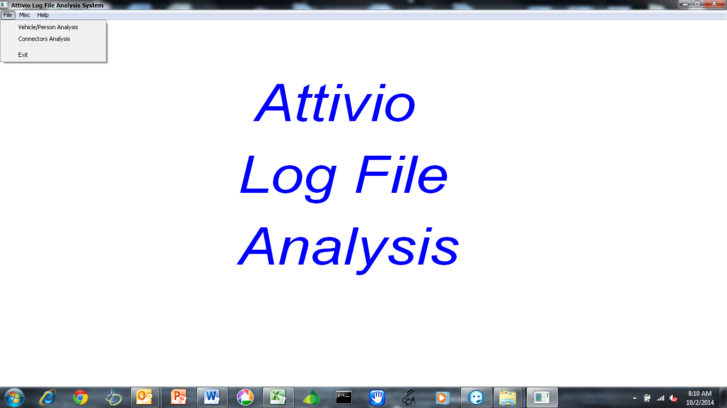

After double-clicking the desktop shortcut the Attivio Log File Analysis main window will display.

Click on the File menu selection to view the analysis functions.

# Vehicle/Person Analysis

Select the “Vehicle/Person Analysis” and “Vehciel Person Log Selection” window will open.

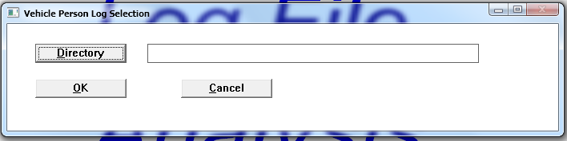

You can enter the Directory that contains the Vehicle/Person log files you’d like to process, and press the “OK” button.

Press the “Cancel” button to close the window without analyzing any log files.

You may also press the “Directory” button to select the appropriate directory.

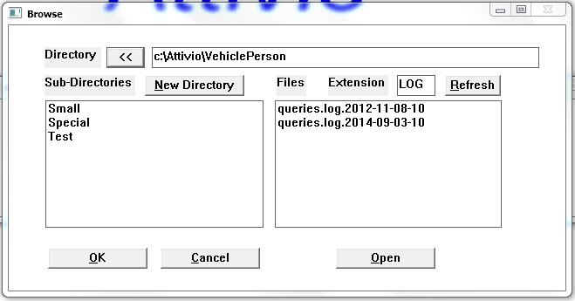

The window will open initially showing “c:\” in the Directory entry field.

Double-click any directory shown in the left list to drill down into that directory. Use the “<<” button to move up one level in the directory structure. After you’ve located the appropriate directory, press the “OK” button to begin processing the log files in that directory. Note: All log files in the selected directory, and all log files in sub-directories, will be processed.

If you’d like to process a single log file, double-click the appropriate log file in the list at the right side of the screen.

Press “Cancel” to close the selection window without analyzing any log files.

After you’ve selected a directory, or file, to process the progress window will open and indicate the current progress processing the log files.

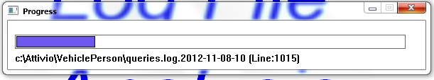

Once all files have been processed, the summary data will be written to c:\AttivioLogAnalysis\AttivioVehiclePerson.CSV, and the completion window will open.

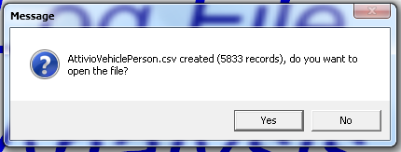

Press “Yes” if you’d like to open the output summary file in Excel. Note: If you already have windows open in Excel the file will be opened in Excel, but focus may not move to Excel. If this happens, select Excel from your task bar at the bottom of the screen and pick the window for the AttivioVehiclePerson.CSV file.

Press “No” if you’d like to look at the file later, and the window will close.

The summary data in Excel will have the following data:

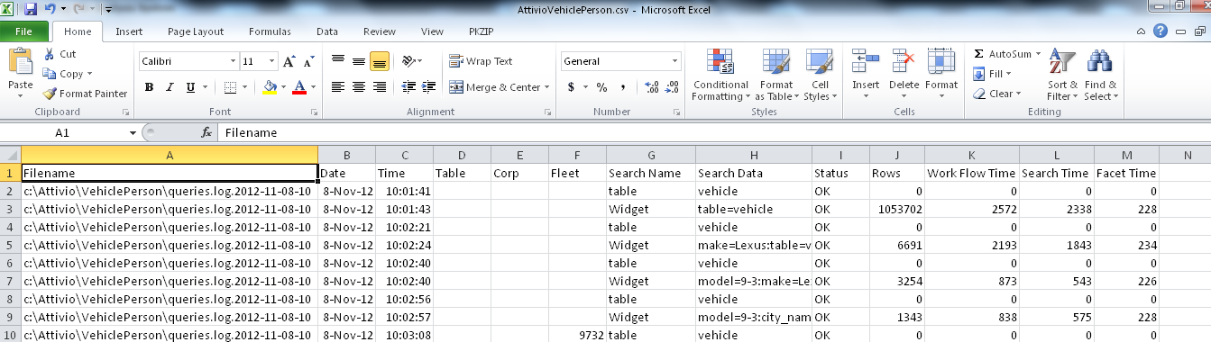

# Connector Analysis

Select the “Connector Analysis” and “Connector Log Selection” window will open.

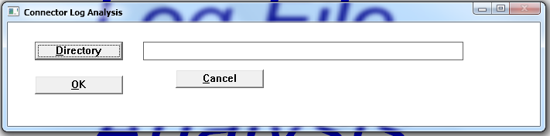

You can enter the Directory that contains the Conenctor log files you’d like to process, and press the “OK” button.

Press the “Cancel” button to close the window without analyzing any log files.

You may also press the “Directory” button to select the appropriate directory.

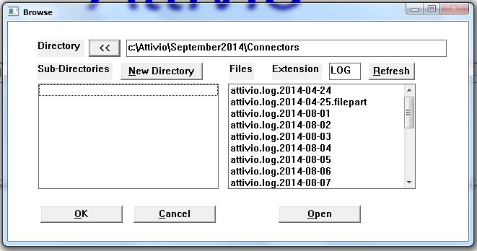

The window will open initially showing “c:\” in the Directory entry field.

Double-click any directory shown in the left list to drill down into that directory. Use the “<<” button to move up one level in the directory structure. After you’ve located the appropriate directory, press the “OK” button to begin processing the log files in that directory. Note: All log files in the selected directory, and all log files in sub-directories, will be processed.

If you’d like to process a single log file, double-click the appropriate log file in the list at the right side of the screen.

Press “Cancel” to close the selection window without analyzing any log files.

After you’ve selected a directory, or file, to process the progress window will open and indicate the current progress processing the log files.

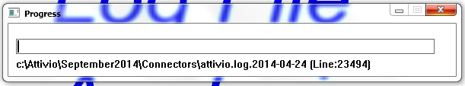

Once all files have been processed, the summary data will be written to c:\AttivioLogAnalysis\AttivioConnector.CSV, and the completion window will open.

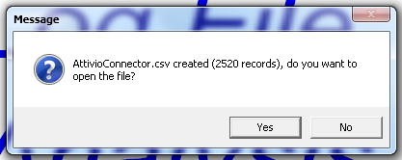

Press “Yes” if you’d like to open the output summary file in Excel. Note: If you already have windows open in Excel the file will be opened in Excel, but focus may not move to Excel. If this happens, select Excel from your task bar at the bottom of the screen and pick the window for the AttivioConnector.CSV file.

Press “No” if you’d like to look at the file later, and the window will close.

The summary data in Excel will have the following data:

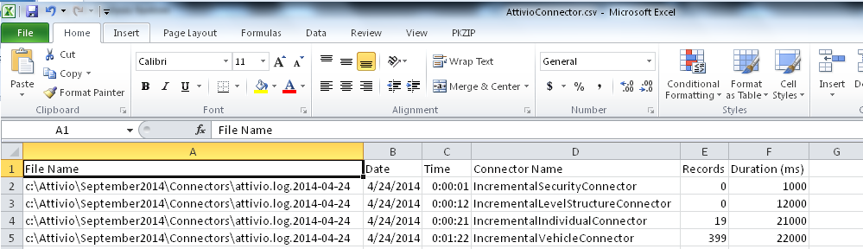

# Appendix

