***GE Capital***

***B-Edit Analysis System***

***User’s Guide***



**GE Capital**

**1 Capital Drive**

**952-828-1684**

**12/29/2013**

Forrest Bentley

B-Edit Analysis System uses BEDITWIN to control various development and analysis functions such as code review, visual program flow, visual call hierarchy, and Windows system design and development.

B-Edit Analysis System User’s Guide

Contents

B-Edit Analysis System User’s Guide 3

Installation 3

GECA B-Edit Analysis System - Main Window 4

Language Interface 5

Development Tab 6

B-Edit Interactive 6

B-Edit Batch Development 7

Builder System – B-Edit Batch 7

Code Selection Window 9

Code Assist Window 10

B-Edit Windows Development 20

Builder System Window 20

Window Maintenance Window 22

Builder Window Control Maintenance Window 26

Eclipse – Juno 39

3090 – Rumba 39

XAMPP 39

Exit 39

Analysis Tab 40

Code Checker 40

3090 Checker 41

View Program Flow 41

View COBOL Call Flow 46

POM Dependency Viewer 47

Download 3090 Source 47

Search Directory for String 49

Tools Tab 51

Convert CICS to DC-COBOL 51

SOAP UI 51

Toad 51

Fiddler 51

Task Manager 51

Performance Monitor 51

Calculator 52

Notepad 52

Search - Commercial 52

Directory Explorer 52

DOS CMD Window 52

Webex 52

Task Tracking 53

Continuous Delivery 58

SDLC Analytics Dashboard 58

Continuous Delivery Wiki 58

Jenkins 58

NOLA Tech Center Software COE 58

Governance 58

GEC Technology 59

GE Documentation 69

BPM Tools 69

GE Fleet Tab 70

Bachman on Net 70

Bachman Visual 70

IT Knowledge Gateway 70

MFO2 Architecture 70

Misc Tab 71

Banner On 71

Banner Off 71

Future Timeline 71

Explaining the Future 71

IT Tutorials 71

Pacman 72

Life 72

Help Tab 73

About B-Edit Analysis System 73

B-Edit Analysis System User’s Guide 73

B-Edit Overview 73

B-Edit User’s Guide/Language Reference 73

Local System Information 73

Appendix 74

Browse Window 74

Color Selection 76

3090 Code Checker Error and Warning Definitions 78

# B-Edit Analysis System User’s Guide

# Installation

1. Expand bedit.zip into c:\bedit
2. copy c:\bedit\bedit.exe c:\windows\system32
3. copy c:\bedit\beditwin\beditwin.exe c:\windows\system32
4. Create a desktop shortcut

"c:\bedit\beditwin\beditwin.exe call c:\bedit\beditwin\builder\builder.bed"

start in c:\bedit\beditwin\builder

# GECA B-Edit Analysis System - Main Window

Double click the shortcut after it’s created and the B-Edit Analysis Window will be displayed.

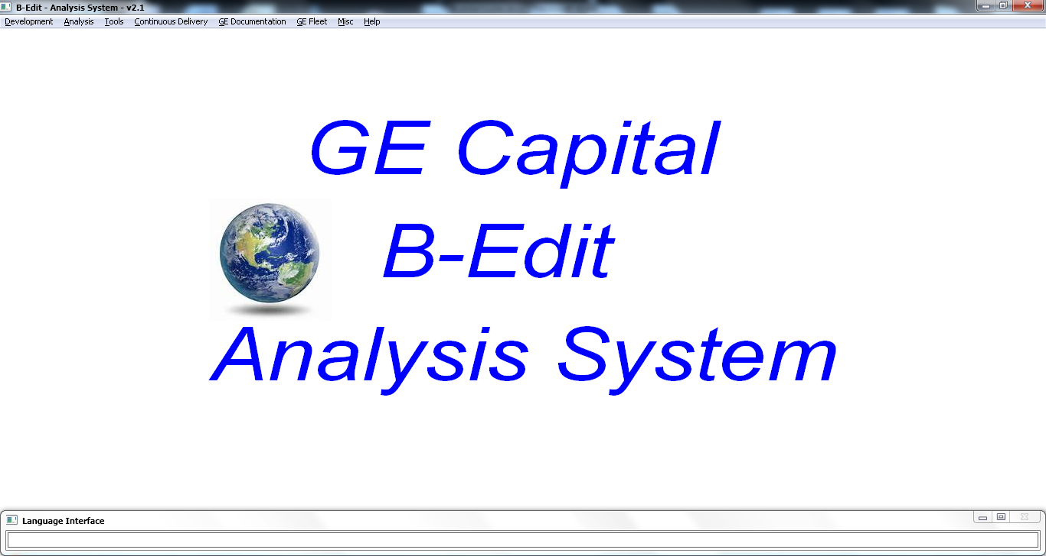

# Language Interface



This window allows you to enter English language commands rather than clicking on menu selections or control buttons. Language Interface Commands can be used in place of every menu selection in the Analysis system, e.g. enter “show bedit reference” to view the B-Edit Language Reference guide.

Important: You must enter the Language Interface commands in lower case.

You can also use Language Interface commands to create or modify Batch and Windows systems. E.g. if you want to create a new batch system with the system name “Testbatch” enter “create batch system Testbatch”, and if you want to create a new Windows system named “Testwin” enter “new windows system Testwin”. If you want to modify a Batch or a Windows system named Testsystem, enter “change Testsystem”. To create a new window named “Newwin” in a Windows system, enter “new window Newwin”. Once a window is open, you can use Language Interface commands to create, change, and move controls on the window e.g. to create OK and Cancel buttons on the screen enter “new buttons OK Cancel”, and to move the buttons enter “move ok cancel right 100”. Creating entire screens in a single Language Interface command becomes easy, e.g. you could enter “First Last City State Zip” create buttons OK Cancel across” to create a name/address screen containing text fields and corresponding entry fields, plus the OK and Cancel buttons under the last text/entry set. To move fields, e.g. move both the ok and cancel buttons, enter “move ok cancel right 100”, or “move all buttons right 100”.

Enter “help” to see a full description of all of the Language Interface commands.

Note: Press “F1” from any screen within the B-Edit Analysis System to set focus into the Language Interface screen.

# Development Tab

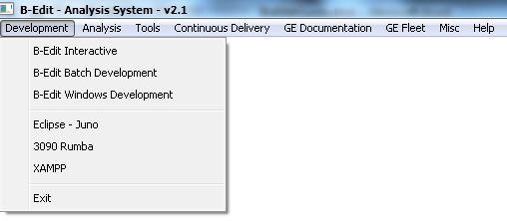

## B-Edit Interactive

This selection will open a DOS window to the B-Edit interactive BEDIT> prompt where you can enter any B-Edit command. See the B-Edit User’s Guide/Language Reference for a full list of B-Edit commands. To exit B-Edit Interactive enter “exit” and press enter.

## B-Edit Batch Development

This selection will open the Builder System window where you can create or maintain a B-Edit Batch system.

### Builder System – B-Edit Batch

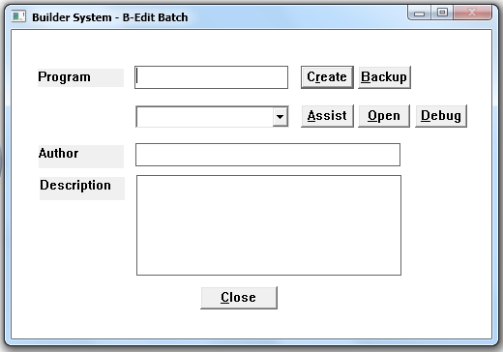

To Create a new system enter the Program name, Author, Description, and press the  button.

To backup all of the files related to an existing system, select the system from the dropdown, then press the  button. This will create a directory in the current Builder directory named “system_backup_CCYYMMDD_HHMMSS” and all the current system files will be copied into this backup directory. If you make changes that you want to revert back, go to the appropriate backup directory, and copy all of the files back to the current Builder directory. It’s good practice to make numerous backups during your design process so you don’t lose work.

Press the  button to open the code in the Code Assist window.

Press the  button to open the source code file (.bed).

Press the  button to open an existing program in the Interactive Debugger.

Press  to close the window.

When you create a system a skeleton program will be created including comments and initial processing modules.

### Code Selection Window

When you create a system the Code Selection window will be presented with a list of all of the Code Modules within the program.

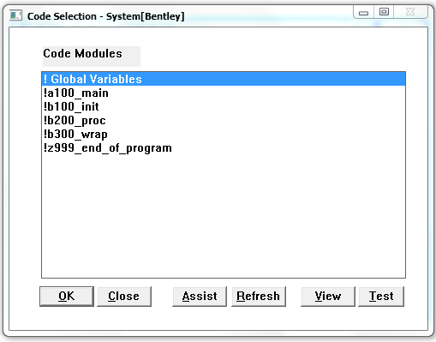

Select a Code Module, and press  to open that portion of code using your preferred text editing tool.

Press  to close the window.

Select a Code Module, and press  to open the Code Assist window.

Press  to refresh the Code Modules list. This is done in case you’ve updated some code that includes new modules.

Press  to view the program structure.

Press  to test the current program code.

### Code Assist Window

This is a powerful window used to create and maintain B-Edit Batch code.

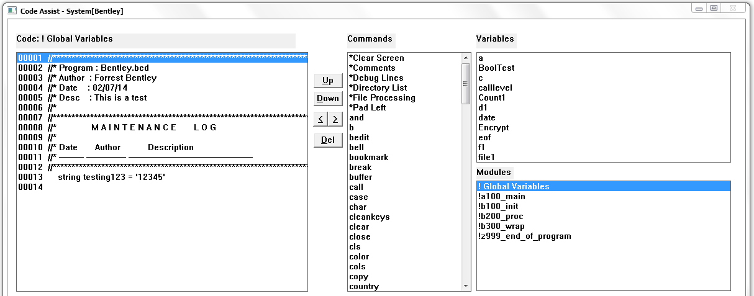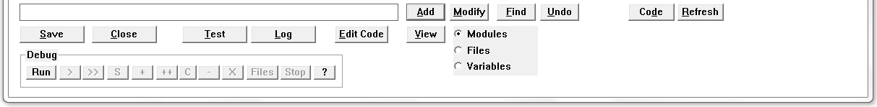

The Code Assist window consists of a list of Code lines for the selected module, a list of Commands that can be added to the code, a list of Variables/Modules that exist in the entire program, an Entry field for entering a line of code, and controls to manage the code.

Select a line of Code in the list, then click the  button to move that line up 1 line.

Select a line of Code in the list, then click the  button to move that line down 1 line.

Select a line of Code in the list , then click the  buttons to indent, or remove an indent, from a line of code.

Select a line of Code in the list , then click the  button to delete a line of code.

Enter a line of code in the Code Entry field at the bottom of the screen, then press the  button to add the line. The line will be added after the currently selected line in the Code list. If the new line of code contains a CALL to a module name that doesn’t already exist, then a the shell of the new module will be created, and the new module name will be added to the Variables/Modules list. If the new line of code creates a new variable (e.g. string or integer), then the new variable name will be added to the Variables/Modules list.

Double-Click a line of code, and the line will be copied to the Code Entry field. Make any changes to the line of code in the Code Entry field, then press the  button to update the code into the Code list.

Double-click a command in the Command List, and that line will either be created directly into the Code List (after the currently selected line), or into the Code Entry field. Some Commands will create multiple lines. E.g. The “*Comments” Command will create 3 frame comment lines in the Code list, and the “*file processing” Command will generate a number of common file processing commands into the Code list.

Some of the Command code generated will leave $*$Var1 and $*$Var2 variables in the Code list. Double-click a variable in the Variable list and all occurrences of $*$Var1 will be changed, and double-click another variable in the Variable list and $*$Var2 will be replaced if it exists in the Code list.

Double-click a variable/module in the Variable/Module list and if a $*$Var exists in the Code list then all occurrences will be replaced, but if none exist then the Variable/Module selected will be added to the Code Entry field at the end of the line. This way you can build up a line of code in the Code Entry field, then add it to the Code list once it’s ready.

Any command that updates the Code List is backed up before making the change. Press the “Undo” button to revert the code back to the state it was in prior to making the last change.

Select a module (line beginning with ‘!’) in the Variables/Modules list, then press the ‘Code’ button to load that module into the “Code” portion of the screen. Note: Pressing “Code” will save all changes made in the Code list before the new module code is loaded into the Code list.

Press the  button to refresh the screen.

Press the  button to save the changes made and close the Code Assist window.

Press the  button to discard the changes made to the code and close the Code Assist window.

Press the  button to test the program. Note: This will save all changes made in the Code list.

After testing the program you may want to view the BEDIT.LOG file created during the test. Press the  button to view the BEDIT.LOG file.

Press the  button to open the source code (.bed) file.

Press the  button to look at the program structure. If the  radio button is selected, then the Module call structure will be presented. If the  radio button is selected, then the File usage structure will be presented (identifies the modules where each file is used). If the  radio button is selected, then the Variable usage structure will be presented (identifies the modules where each variable is used). Since a program may contain many variables this function may take a while to present, therefore the progress bar is shown when presenting the Variable view. These selections are powerful tools to aide in program analysis.

Press the  button to open the Find/Modify window.

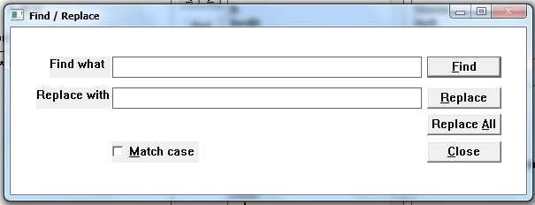

To Find text in the code, enter the text in the “Find what” field and press the  button. This will find the first occurrence of the text after the currently highlighted line of code. If the first occurrence is in a different code module, then that module will be shown in the Code list.

To Replace text, enter both “Find what” and “Replace with”, then press the  button. This will locate the first occurrence of the “Find what” text as is done with the “Find” button, then the located text will be replaced with the “Replace with” text.

Press the  button to replace all occurrences of the “Find what” text.

Click the  check-box if you want to force the Find and Replace functions to be case sensitive.

Press  to close the window.

#### Debugging

At the bottom of the screen there are a number of Debug buttons to assist in debugging the program. You can Debug both Batch and Windows programs, but the Debug buttons will be shown only when using the B-Edit Batch Development menu selection.

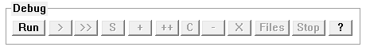

Press the  button to run the program, and start the Debugger. The B-Edit Analysis System Main Window will be hidden to make it easier to see the execution of the program that’s running. If you’re running a B-Edit Batch program you may have to locate it by pressing Alt-Tab, then move it off to the side of the screen so you can see both the “Code Assist” window and the Program Execution window. The execution of the program is stopped at the first line of the program waiting for Debugger input.

Press the  button (Step) execute 1 line of the program. The line of code will be executed and the next line of code will be highlighted. If the line of code contains a “call”, then the code for that module will be shown in the Code List.

Press the  button (Go) to execute all lines of code up to the first break-point that’s been set in the program. If no Break-Points exist from the current line of code to the end, then the program will finish.

When the program finishes (e.g. when an ‘exit’) is processed, then the Program Execution window will close as normal when a B-Edit program finishes, then the B-Edit Analysis System Main Window will be shown, and focus will be set to the Code Assist window.

Press the  button (Step-Over) to step over a line that contains a “call” statement. This means that the “call” will be executed, but the debugger won’t “Step” into the called module.

Press the  button (Set Break-Point) to set a Break-Point on the currently highlighted line of code. When a line is flagged to contain a Break-Point there will be a Break-Point symbol '«' at the start of the line: 

To located the appropriate spot of code you can use the “Find” button to locate text within the program, or if you know what module you want to debug, then double-click the module in the Module List and that module code will be shown in the Code List.

Press the  button (Set multiple Break-Point lines) to set Break-Points on every line that contains the text entered in the Code Entry field. After pressing the “++” button the first line in the code that matches the text will be shown with the Break-Point symbol.

Press the  button to open the Conditional Breakpoints window which will allow the maintenance of conditional breaks (e.g. if an integer variable’s contents becomes greater than a value). Conditional breaks will be in place until a break is caused by the condition set to be true, and once the condition is true, processing will pause on the line following the line that caused the condition to be true. After a condition break causes the program to pause, all conditional breaks will be removed.

Press the  button (Remove Break-Point) to remove a Break-Point from the currently selected line.

Press the  button (Remove all Break-Points) to remove all Break-Points that have been set in the program.

Press the  button to open the Debug File List View to view all of the currently opened files.

When the program hits a break-point, the Code Assist Debugger screen is brought to the foreground, and the Variables List will be updated with the current content of each of the variables in the system. This is very useful to help identify bugs in your program.

Press the  button to stop Debugging. This will not stop the program you were debugging, you must stop that program manually by closing that program window.

*IMPORTANT: Make sure you close all B-Edit program windows before starting another debug session. If there are multiple programs running that were launched with the debugger, then the debugging will not work properly (e.g. the code lines shown when stepping through the code may be incorrectly shown).*

Press the  button to see a description of each debug button.

#### Debug Conditional Breakpoints

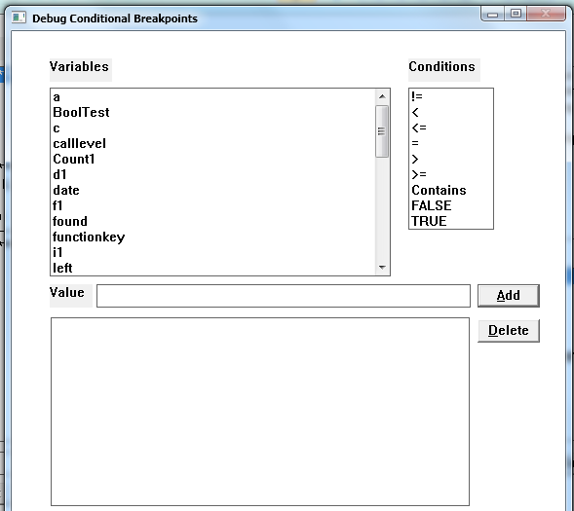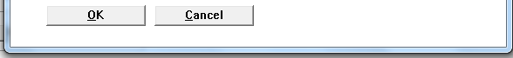

To set a Conditional Breakpoint, click a Variable in the Variables list which will be the variable used in the condition, click a Condition in the list, add a value in the Value entry field, then press the  button and the new condition will be added to the Condition list at the bottom of the screen. Note: If the Condition chosen in the list is TRUE or FALSE, then you don’t need to enter a Value.

Press the  button to delete a highlighted Condition in the list.

Press the  button to use the conditional breakpoints that are set in the list.

Press the  button to close the window and not use any conditional breaks.

#### Debug File List View

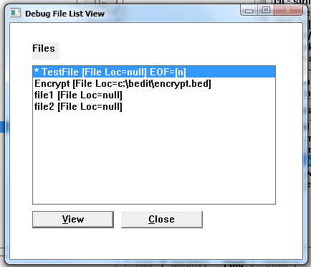

Each open file will be shown in the list including the external filename used to open the file if it exists. The current file will appear at the top of the list, including the EOF flag shown.

Select a file and click the  button, or just double-click a file in the list, and the contents of that file will be shown in the Debug View File Data window highlighting the current line in the file.

Press the  button to close the window.

#### Special Commands – B-Edit Batch Code Assist

There are a few Commands in the list that generate useful lines of code, these begin with ‘*’.

*Clear Screen: This will create code to clear the DOS screen.

*Comments: This will create 3 lines of comments to aide in documenting the program.

*Directory List: This will create code to walk a directory, and all subdirectories, creating a “DirFileList” file which can be used to process every file in the directory structure. The “Directory” string should be initialized to the directory you want to search prior to the “call DirList.bed” line. Note: If you move your “System”.bed file to another directory, and you’ve used this command, then you must copy the DirList.bed file also.

*File Processing: This will create a number of useful file processing lines (open a file, do loop to process the file). Change the “open” line’s “Filename” to whatever internal B-Edit filename you’d like to name the file, and change the “@Fileloc” to the actual location of the file (e.g. open FileNumber1 c:\test\file1).

*Pad Left: This will create code which will pad a field with zeros to the left and size it to a specified length.

## B-Edit Windows Development

This selection will open the Builder System window where you can create or maintain a B-Edit Windows system.

### Builder System Window

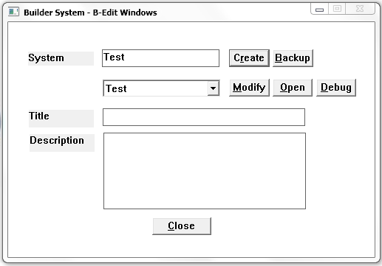

To backup all of the files related to an existing system, select the system from the dropdown, then press the  button. This will create a directory in the current Builder directory named “system_backup_CCYYMMDD_HHMMSS” and all the current system files will be copied into this backup directory. If you make changes that you want to revert back, go to the appropriate backup directory, and copy all of the files back to the current Builder directory. It’s good practice to make numerous backups during your design process so you don’t lose work.

To Create a new system enter the System Name, Title, Description, and press the  button.

If you’ve already created a B-Edit system you can choose the system by opening the System Dropdown, choosing the correct System, and pressing the  button.

Press the  button to open the program source (.bed) file.

After pressing either the  or  button, the “Window Maintenance” window is presented.

Press the  button to enter the Interactive Debugger.

Press  to close the window.

### Window Maintenance Window

After pressing either the “Create” button to create a new system, or the “Modify” button to modify a system, the Window Maintenance window will be presented.

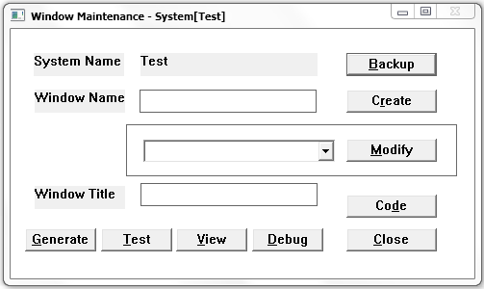

This window is where you add new windows to the system, or modify existing windows.

To backup all of the files related to this System press the  button. This will create a directory in the current Builder directory named “system_backup_CCYYMMDD_HHMMSS” and all the current system files will be copied into this backup directory. If you make changes that you want to revert back, go to the appropriate backup directory, and copy all of the files back to the current Builder directory. It’s good practice to make numerous backups during your design process so you don’t lose work.

To create a new window enter the Window Name, Window Title, and press the  button.

To modify an existing window choose the appropriate Window Name in the dropdown, then press the  button.

After pressing either the  or  buttons the Builder Window Control Maintenance window will be presented.

After you’ve created the windows and navigation for the system you can press the  button to generate B-Edit code to run the system. The B-Edit source code will be generated in the local directory so if you want to enhance the system you can update the source code with additional B-Edit functions. The generated source filename will be the System Name with a .BED extension, with a Windows definition file with a .WIN extension, and a menu definition file with a .MNU extension.

#### Testing the System

Use the  button if you’d like to test the system. Note: The  button will generate all code the same as the  button does.

Press the  button to open the Code Assist window, and automatically run the Debugger.

#### View the Window Navigation

Use the button if you’d like to see a visual representation of the window navigation that you’ve setup between the windows on the system.

Press  to close the window.

#### Code Maintenance

Press the  button to view, or update, the B-Edit code associated with actions on the screen The Code Selection list of B-Edit modules window will be presented.

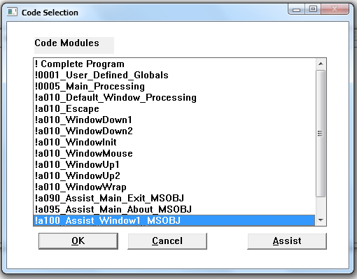

Select the appropriate module and press the  button to edit the B-Edit code for that module. The module B-Edit code will be opened in the editor you’ve chosen for “.bed” extension files. Add any B-Edit command line to the module to enhance the functionality when you test the system. Save the file after you’ve made changes, and close the editor.

If you want to create additional global variables, you should add them to !0001_User_Defined_Globals.

If you would like to create new modules, just open an existing module, and add the additional module to the end of the currently opened module code. If the new module has the same prefix as the module code you have open then the new module code will remain in the currently module code file, but if you create a module with a different prefix, then the next time you open the Code Selection window that new module will appear as a separate selection.

Note: If you open ‘!Complete Program’ you shouldn’t make changes here, this is for viewing only!

Press the  button to close the Code Selection window.

Press the  button to open the Code Assist window used to assist in code development.

#### Code Assist

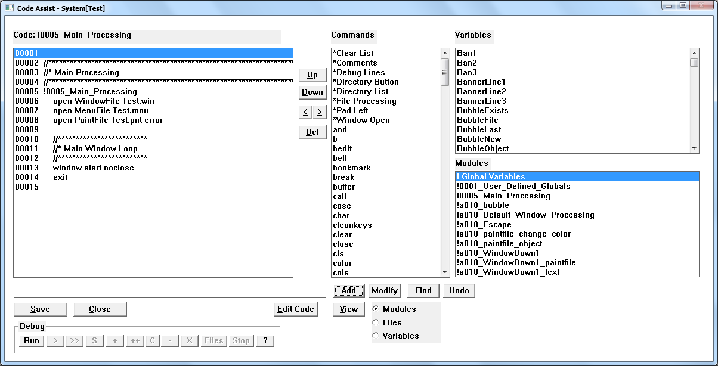

See Code Assist description above for Batch programs.

#### Special Commands – B-Edit Windows Code Assist

There are a few Commands in the list that generate useful lines of code, these begin with ‘*’.

*Clear List: This will create code to clear the contents of a List control.

*Comments: This will create 3 lines of comments to aide in documenting the program.

*Directory Button: This will create code to open the Directory Browse window. You must change the “DirField” to a field name that will contain the Directory selected on the Directory Browse window. You can make the DirField null if you don’t want to update a field with the Directory selected on the Directory Browse window. You must change the “FileField” to a field name that will contain the File selection on the Directory Browse window. You can make the FileField null if you don’t want to update a field with the File selected on the Directory Browse window. If you use this command, and you move the new “System”.bed file to another location, then you must also move the “System”Browse.bed file also.

*Directory List: This will create code to walk a directory, and all subdirectories, creating a “DirFileList” file which can be used to process every file in the directory structure. The “Directory” string should be initialized to the directory you want to search prior to the “call DirList.bed” line. Note: If you move your system.bed file to another directory, and you’ve used this command, then you must copy the DirList.bed file also.

*File Processing: This will create a number of useful file processing lines (open a file, do loop to process the file). Change the “open” line’s “Filename” to whatever internal B-Edit filename you’d like to name the file, and change the “@Fileloc” to the actual location of the file (e.g. open FileNumber1 c:\test\file1).

*Window Open: This will create the standard lines to open a window.

### Builder Window Control Maintenance Window

This window is used to create and maintain controls on a window within a system.

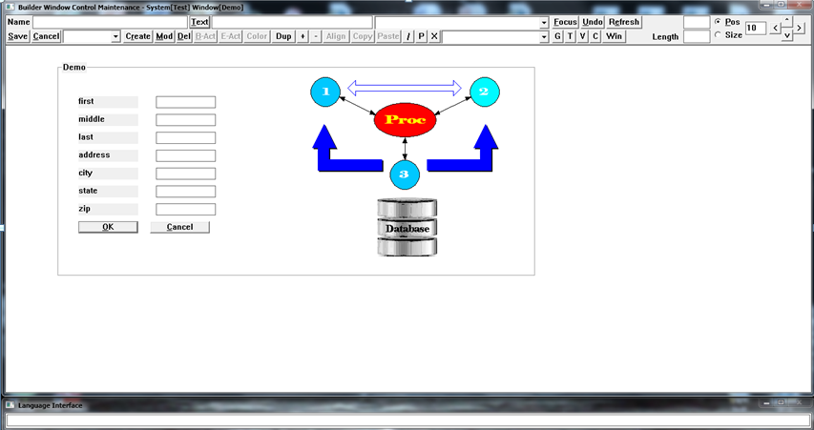

The window is divided into two sections:

1. The top of the window contains all of the creation, modification, and positioning controls:



1. The bottom of the window, called the Window Canvas, contains the created window and all of its controls. A box will appear with the Window Name, this represents the actual size of the window when it’s tested.

#### Control Creation

To create a control enter the Control Name, Control Text:



You can use the ‘&’ key anywhere in the Text entry as an accelerator designation for buttons), choose a Control Type from the radio button list, and press the “Create” button.

The name of the control will be converted to a full control name consisting of SystemName_WindowName_ControlName_ControlType, and this full control name must be used anytime you want to modify the control.

Select the type of control using the Control Type Dropdown, then press the  button.

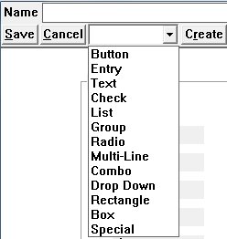

The control will be created in the Window Canvas area.

#### Special Control Selection

If you select the “Special” control type, then the Special Control Type selection window will be presented:

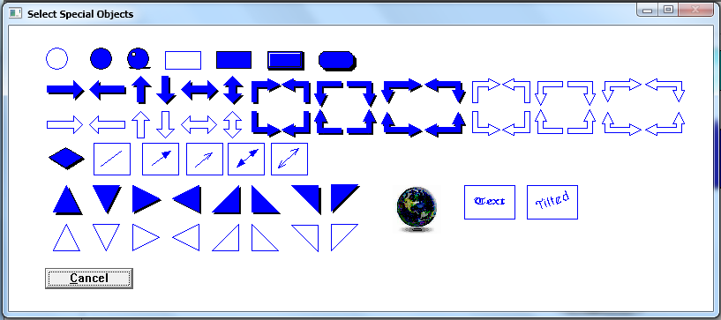

Choose the Special control you’d like to use by clicking it.

If the Special Object is Text or Tilted, then the Font controls will appear in the upper right portion of the Window Canvas. To choose a different Font, select a Font from the dropdown, then press the  button. The currently selected font will be shown to the right of the dropdown. You can change the Font anytime by setting the Focus to a Text Special Object, then select the appropriate Font and press the button.

If the Special Object is a bitmap then the standard file selection window will be shown: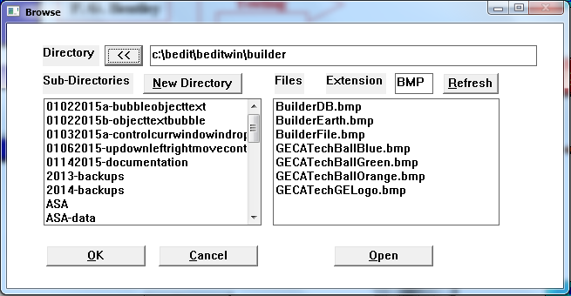

Navigate to the directory that contains the image file you’d like to use (BMP, JPG, JPEG), and double click the image file shown on the right side of the screen. Note: If the image extension isn’t BMP, then a copy of the image file will be made with a BMP extension. After making a bitmap selection the Bitmap selection controls will be shown at the upper right on the Window Canvas: 

You can change the bitmap used at any time by setting focus to the bitmap object, then click the  button, and choose a different image file.

#### Special Control Text

If you enter text into the Text entry field then that text will be associated to the Special object, so as you move the object around the screen the text will move also. To change the text position, font, size, or color press the  button:



This will open the Text Maintenance window:

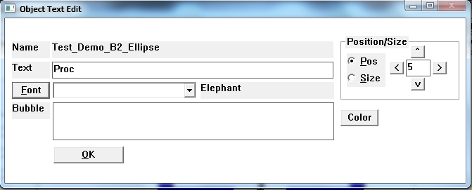

Update the text by entering new text in the Text entry field and press “.

Change the font of the text by selecting the font you’d like to use in the Font dropdown, then press the  button. The chosen font will be shown in the Font text field.

To change the Color of the text press the  button and the standard color selection window will be presented.

To change the Position of the text relative to the associated object select the  radio button, then use the positioning keys ( ^V<>) to move the text. You can change the amount the text moves by updating the positioning value entry field. **Note: you may want to move the Object Text Edit window so you can see the object text as you move it.**

To change the Size of the text select the radio button, then use the sizing keys (<>). If you want to change the rotation angle of the text, use the sizing keys (^V).

If you enter any text in the Bubble entry field, that text will be presented as a bubble whenever the mouse moves over the object when you run the system.

Press the “OK” button to close the window.

#### Control Focus

When a control has Focus, then you can use the keyboard arrow keys to move the object around the Window Canvas also. To change the Focus to an object you can click on the object, use the mouse right button to surround the object then press the  button, or you can select the appropriate object in the Object dropdown then press the  button:



#### Group Selection/Drag

Hold down the left mouse button to drag the current control (in Focus) to the desired position, then release the left mouse button.

If you have a group of controls you’d like to move, position the mouse to the upper right of the controls to move, hold down the right mouse button while you move the mouse to the lower right of the controls to move, release the right mouse button, then drag/drop the group of controls surrounded by the group rectangle using the left mouse drag/drop described above. You can also use the “Pos” radio button and movement buttons to move the group of controls.

#### Undo

To revert a change back to its previous state, press the  button.

#### Refresh

At times you may want to repaint the Window Canvas, to do this press the  button.

#### Control Positioning and Sizing

You can change the size and position of the control by choosing the appropriate  and  radio button, then pressing the sizing buttons . The size or position of the control will be changed by the amount entered in the Sizing entry field which is next to the sizing buttons. You can also change the size of the control by entering a new Height and/or Length then pressing the  button.

#### Window Size

To change the size and position of the window press the  button, then use the  and  radio button functionality (described above for changing the size/pos of a control) to move the window border to the desired location. Be careful to keep the window size large enough to contain all of the controls on the window or they won’t appear when you test the system. When you press the button the button text will change to , so to go back to control maintenance press the same button which now says .

#### Object Position and Size using Mouse Dragging

To move an object, select the  radio button, then left click on the object holding the mouse button down, then drag the object across the screen to the desired location, and let go of the mouse button. You can continue to drag the object that currently has Focus.

To size an object, select the  radio button, then left click on the object holding the mouse button down, then change the size of the object by dragging the mouse, and let go of the mouse button when it’s the size you’d like.

#### Modify Control

To modify a control choose the control from the Control List dropdown, then press the  button. After setting the focus on the appropriate control you can use any of the control positioning capabilities described above, use the  button to change the Control Text, or set actions using the “Button Action” or “Entry Action” buttons.

#### Delete Control

To delete a control choose the control from the Control List dropdown, then press the  button. You’ll be prompted to make sure you want to delete the control prior to the delete.

#### Button Action

You can set the action for push buttons by setting the focus to the appropriate button (by using the “Set Focus” button, or just pressing the Control itself), then pressing the  button, which presents the Button Action window.

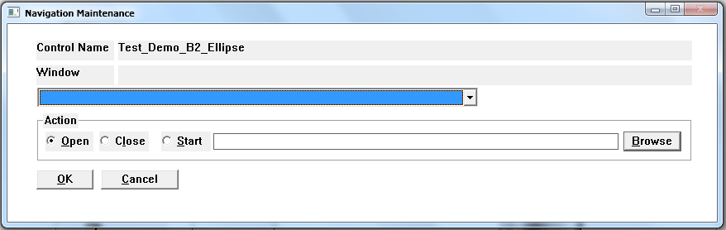

Select the  or  Action radio button, then choose the Window to take the action on from the Window dropdown list (contains a list of all windows currently created in the system), and press the  button. E.g. you might want to “Close” the current window when a “Cancel” button is pressed on that window, or you might want to “Open” a different window when a button is pressed. You can see the navigation you’ve setup by pressing the “View” button on the Window Maintenance window, or by pressing the “Test” button on the Window Maintenance window to actually try the navigation.

If you’d like to start any file when the button is pressed (e.g. XLS, HTTP, JPG, etc…), then select the  radio button, and enter the full path of the file, or use the  button to open the standard browse window and select the appropriate file. When you press the object with this action when running the system the selected file will be opened in the program assigned to the file’s extension.

#### Entry Action

To setup Entry Field actions set the focus on the appropriate entry field using the “Set Focus” button, then press the  button, this will open the Entry Field Action window.

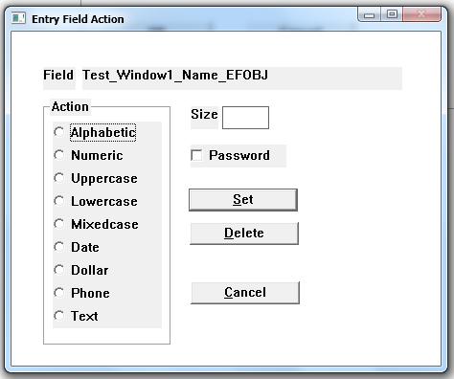

Setting an action on an entry field will cause the generated system to edit the entry field characters as they’re entered (e.g. only numeric digits accepted if an action of “Numeric” has been set), restricting the total number of characters accepted in the entry field based on the Size set, as well as changing the entered text based on the Action that’s been set (e.g. if “forrest Bentley” was entered into an entry field that has an Action set to Mixedcase, then after tabbing out of the entry field the text would be changed to “Forrest Bentley”). Select the appropriate entry field Action from the radio button list, enter the entry field Size, then press the  button.

Press the  button to remove a previously set Action.

Press the  button to close the window without changing any Action for the entry field.

#### Color for Special Objects

If the object with Focus is a Special object you can use the  button to modify the color of the object. Using this button will open the standard color selection window.

#### Duplicate an Object

Pressing the  button will make a duplicate of the current Focus object. A “.number” will be added to the focus object name and used as the new object’s name.

#### Move a Special Object Forward or Backward

If the object with Focus is a Special object, then you can use the  button to move the object to the foreground (in front of all other objects), or use the  button to move the object to the background (behind all other objects).

#### Control Alignment

You can also align the controls within the group selection by pressing the  button, then choosing the appropriate alignment button presented (Left, Right, Top, Bottom, Middle Vertical, Middle , and Horizontal ). You can evenly distribute the controls Vertically by pressing the  button, or Horizontally by pressing the  button.

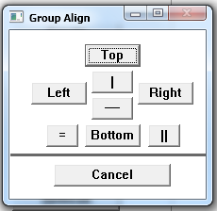

When the group of controls has been positioned properly press the Escape key to remove the group rectangle.

If you want to drag/drop a button control you can click on the button to set the focus, then use the drag/drop mouse controls.

#### Copy Control

To copy a control, or group of controls, set the focus on a control, or select a group of controls using the right mouse button, then press the  button. The control(s) are now saved in an object buffer for later pasting using the  button. This is very useful to copy a group of controls from one window to another. Note: The only objects in the copy buffer will be from the latest press of the  button.

#### Copy Control

After using the Copy feature described above the copy one or more controls, press the  button to paste the latest Copied objects.

#### Connect Objects

To create a connection line between objects you can press the  button to use the latest selected connector, or press the  button to select a new connector which will open the Connection Selection window:

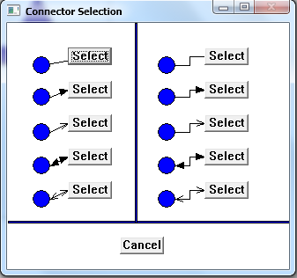

Press the  button for the connection line type you’d like to use, the window will close and now you need to click one object to connect on the Window Canvas, then click on the second object you’d like to connect on the Window Canvas. The connection is made and the selected connection line is drawn between the objects. When you move the objects around on the Window Canvas the connections are maintained. These connections will be maintained in when generating and testing the system.

Press  to close the window without making any connections.

Note: If you press the  button 2 times without connecting any objects, then the connection process will continue until you press the “Esc” key i.e. you’ll be able to connect numerous object pairs without pressing the  button again which is a faster way to connect many objects using the same connection line type.

To disconnect a pair of objects press the  button, then click object A then click object B, and the connection line between the two objects will be removed. If there’s only 1 connection made on an object you can double click that object after pressing the  button and the connection for that object will be removed.

#### Moving between Windows

To move between windows quickly you can select the window to navigate to in the Window dropdown then press the  button. The changes on the current window will be saved, and the navigate to window will be presented.

#### Testing the System

To test the system you’re currently working on press the  button.

#### View the Window Navigation

To view Window navigation that you’ve setup between windows (see B-Act navigation above) press the  button.

#### Code Maintenance

Press the  button to view, or update, the B-Edit code associated with the current control in Focus (e.g. Press a Button you’ve created on the screen that you’ve assigned an Action to, then press the Code button, add additional B-Edit windows commands to give the system more functionality when you Test it. See Code Maintenance above.

#### Save and Close Window Control Maintenance

Press the  button to save all of the changes on the current window, and close the window.

#### Close Window Control Maintenance

Press the  button to close the window.

#### Special Function Keys

Press “F1” to move focus to the Language Interface screen.

Press “F2” to repeat the last Language Interface command.

Press “F3” to move upwards in the list of Language Interface commands used.

Press “F4” to move downwards in the list of Language Interface commands used.

Press “F5” to size the window based on the current control size and position on the screen.

Press “F6” to clear out the Control name, and Text fields.

## Eclipse – Juno

If you have Eclipse installed you can edit the eclipse.bat file located in the c:\bedit\beditwin\builder directory and change the “cd” line to point to the directory where you have Eclipse installed.

## 3090 – Rumba

If you use Rumba this selection will launch Rumba for mainframe access.

## XAMPP

If you have XAMPP installed you can edit the xampp.bat file located in the c:\bedit\beditwin\builder directory and change the “cd” line to point to the directory where you have XAMPP installed.

## Exit

This will exit the B-Edit Analysis System.

# Analysis Tab

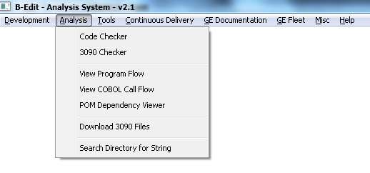

## Code Checker

This selection will open the Code Check window to choose the System and Directory to process.

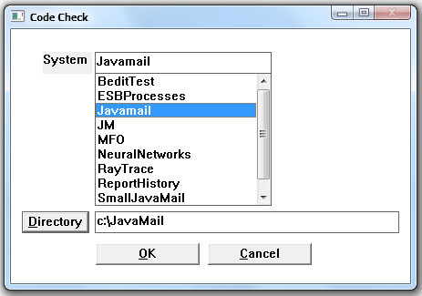

Enter a new System name, or double click an existing System name, then either enter a Directory, or press the  button to browse for the appropriate directory to scan. A System name can be whatever you’d like, and it has a Corresponding Directory that will be scanned by the Code Checker System. Double-clicking a system will automatically load the Directory that was last run for that System, but you can change the Directory if you’d like to run the System for a different directory. After both System and Directory have been entered or selected, press the  button to start the Code Checker system. The Code Checker System will check Internet application and client/server code for GE standards of all files, and sub-directory files, for the Directory entered. The system will begin to read all files in the directory entered, and sub-directories also, and will produce a scan report shown in notepad identifying errors and warnings found in the code.

Press the  button to close the window.

## 3090 Checker

This selection will run the 3090 Code Checker system which will check 3090 COBOL, JCL, COPIES, etc… source files that have been download from the 3090, for standards. Choose the appropriate directory on the Browse window (see Browse Window in the Appendix), and when you push the OK button the 3090 Code Checker system will run using the chosen directory.

The system will begin to read all files in the directory entered, and sub-directories also, and will produce a scan report shown in notepad identifying errors and warnings found in the code.

See the 3090 Code Checker Error and Warning Definitions in the Appendix for a description of the standards that are checked.

## View Program Flow

This selection will read a program file (COBOL, C, B-Edit) and show a graphical representation of the modules within the program. The View Program Flow selection window is shown.

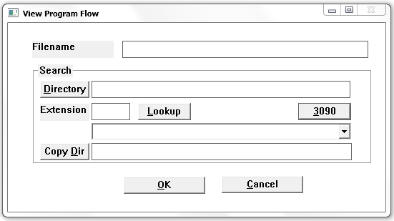

If you know where file is located, enter a fully qualified filename and press the  button. If you want to choose a file from a directory then enter the Directory, and Extension (typically COB for COBOL, C for C, BED for B-Edit files), then press the  button. The files in the Directory that have the Extension entered will be loaded into the Search file names dropdown, select the appropriate file, then press the  button.

Press the  button to browse for the appropriate directory (see Browse Window in the Appendix).

Press the  button to choose the copy files directory if they’re available for scanning.

If you want to process a COBOL file that hasn’t been downloaded from the mainframe press the  button, this will present the Download 3090 COBOL Source window.

Press the  button to close the window.

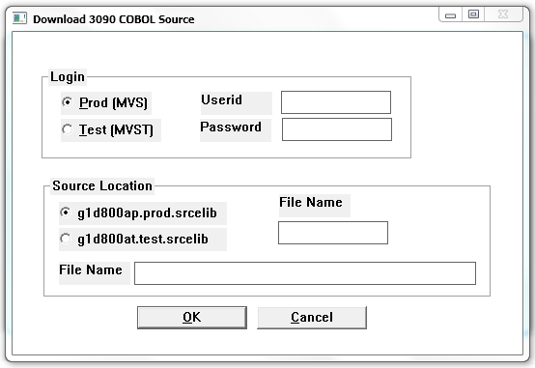

Select MVS or MVST, enter your Userid and Password, select the appropriate Source Location and File Name [or enter a fully qualified File Name in the larger File Name field e.g. ‘g1byfbt.misc.source(d3cofm51)’], then press the  button. The source will be temporarily downloaded for viewing.

After the appropriate source file has been selected using the either the View Program Flow or Download 3090 COBOL Source window, then the Builder Window Viewer window presented showing the graphical representation of all of the modules within the source code. 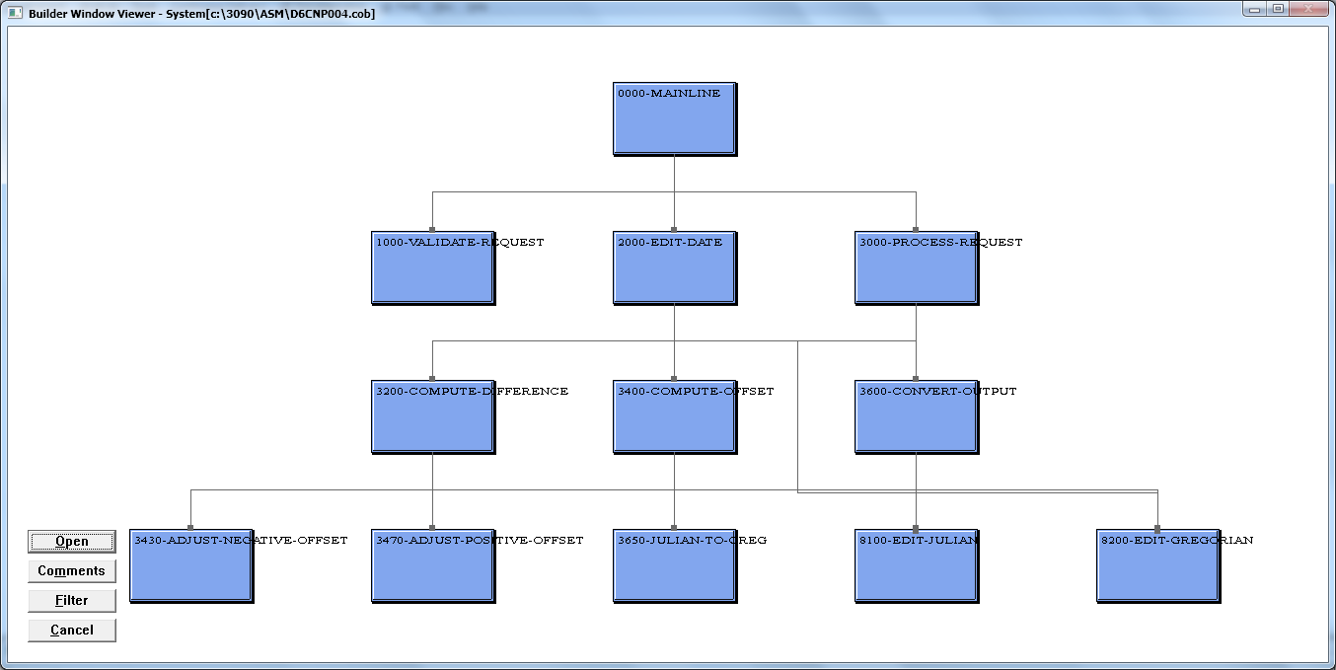

Press the  button to close the View.

Press the  button to open the source file.

Press the  button to show the comments located at the top of the program.

Press  to filter the number of modules/functions shown on the View Window, this will present the Filter window.

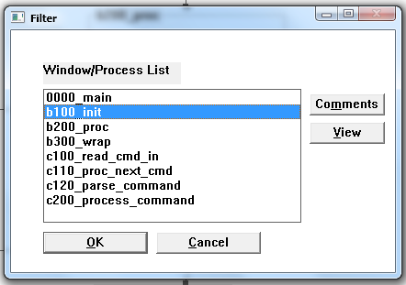

Select a module from the list and press the  button to see any comments that exist in the source code for that module.

Select one or many modules from the list and press the  button to see the source code for the modules selected.

Select a module, or modules, and press the  button to see a View showing only the modules selected, what modules call them, and what modules are called by them.

Press the  button to cancel any filter and show the entire list of modules on the window.

On any View display move the cursor over a partially named box to see the full name. e.g. in this example only 9700 shows in the box, but when you move the cursor over the box the entire name 9700-CONVERT-J-TO-G-LOOP is displayed.

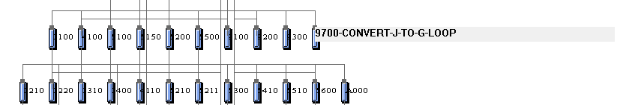

You can also move the mouse over a connector line to see which module is related (calls) another module. If the cursor is over a line that’s connected to multiple modules you can click the left mouse button (without moving the mouse) to display each of the module connection lines for the current connector.

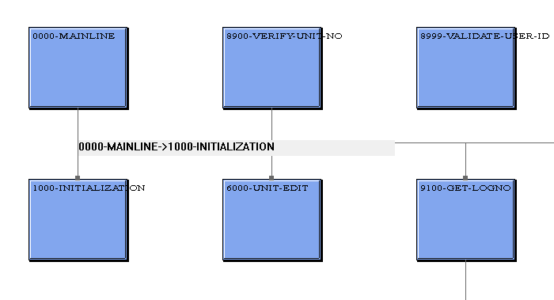

**Quick filter/view features**

To look at just a single module’s relationships click on the module, the module will be shown with all modules that call it, and all modules that it calls. This is a very quick way to navigate through a program to understand what it’s doing. To show all modules click in an open area on the screen.

To look at the code for any module click on it using the right mouse button. If you want to open the code for the entire program, right click in an open area on the screen.

## View COBOL Call Flow

This selection will show a graphical representation of the call hierarchy of all COBOL source code located in a directory. The COBOL Call Flow window will be shown.

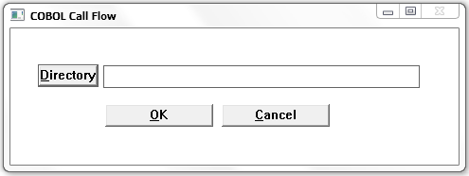

Enter the Directory that contains the COBOL source and press the  button.

Press the  button to browse for the appropriate directory (See Browse Window in the Appendix).

The source code will be scanned looking for all program calls and transfers, and a graphical representation will be rendered. Use the same filtering described for Viewing Program Flow.

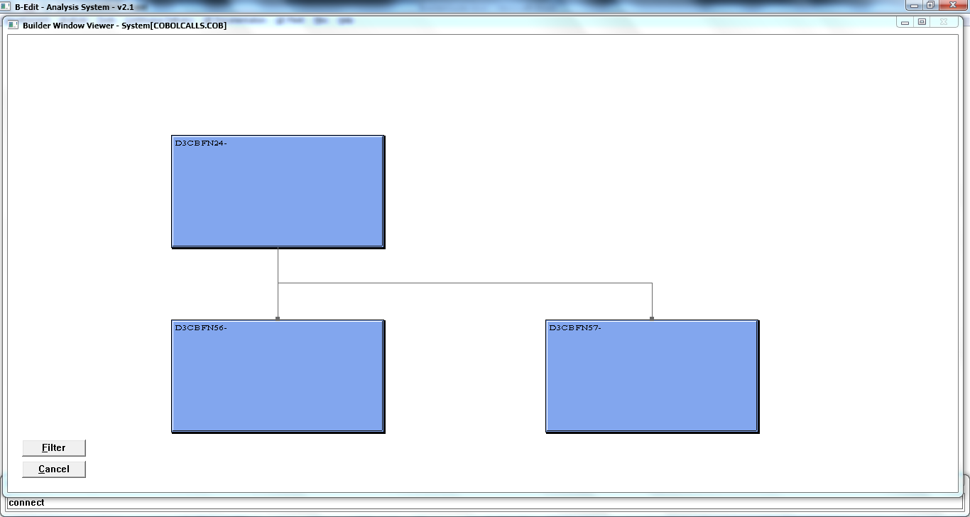

## POM Dependency Viewer

This selection allows you to view all Maven POM dependencies based on the artifacts in the POM files.

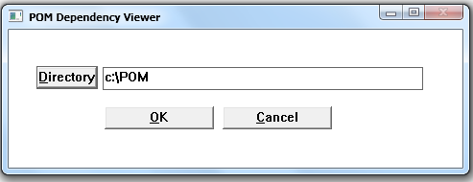

After choosing the appropriate directory, the system will parse all POM files within the directory, and all sub-directories, and display the results in the standard view window.

## Download 3090 Source

This selection allows you to download multiple source files from the 3090.

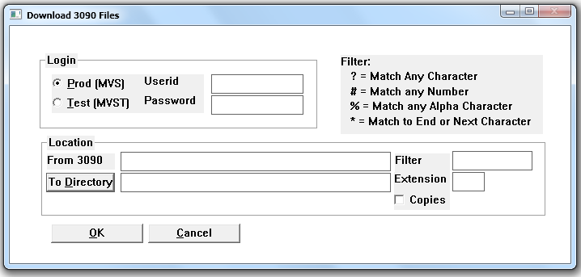

Choose Prod or Test, enter your Userid and Password.

Enter the Location From 3090 (e.g. g1d800ap.prod.srcelib). If you enter a filename enclosed with () you’ll download just a single file (e.g. g1d800ap.prod.srcelib(d3cbf912).

If you don’t want to download all of the files within the From 3090 Location you can filter the files downloaded by entering a program name “Filter”. Use the Filter characters to filter the program names (e.g. If you want to download all programs starting with D3, contain a ‘Z’ in the 4th position, and ‘8’ in the 7th position enter a Filter : D3?Z??8). When you press the “OK” button you’ll receive a prompt indicating how many programs would be downloaded if you proceed.

Enter the To Directory where you want the files downloaded, and enter the Extension that will be added to each of the files downloaded (e.g. COB for COBOL files, or JCL for JCL files). Press the “To Directory” button to browse for the appropriate directory (see Browse Window in the Appendix).

Note: The To Directory must exist before starting the download, this system won’t create the directory.

Click the Copies check box if you’d like to download all of the copies used in the COBOL program(s) downloaded. This is useful if you’re downloading COBOL programs to be run through the 3090 Checker. Keep in mind that there might be a lot of copies used in the program(s) downloaded, so this will extend the time it takes to download, especially if you’re downloading multiple files as described above.

Press the “OK” button and the download will begin, you’ll see progress shown with a progress bar window. When processing is finished all of the files downloaded will be located in the To Directory, which can then be used in the View Program Flow, or View COBOL Call Flow, functions.

## Search Directory for String

This selection allows you to search a directory, and sub-directories, for a string, or set of strings entered.

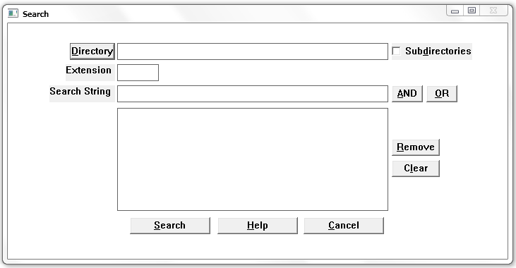

Enter the Directory to search, check the Subdirectories if you want to search all subdirectories under the Directory.

Press the  button to browse for the appropriate directory (See Browse Window in the Appendix).

Enter an “Extension” to restrict which files will be searched (e.g. Use “java” if you want to search all Java programs in the directory structure.

Enter a Search String, and press the  button. All files under the Directory (and subdirectories if desired) will be searched looking for the string entered. If you want to search for multiple Search Strings then press the  or  button after entering a string, then enter additional Search Strings. The compound search will be shown in the list box. Note: you can’t combine AND with OR in a single combination selection. Select a line and press the  button to remove 1 line from the compound search, or press the  button to remove all search lines. Press the  button to see the regular expression search capabilities.

Press  to close the window.

After pressing the  button the results will be presented in the Search Results window.

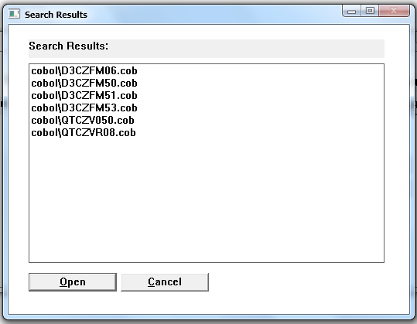

To view a source file select a file in the list and press the  button.

Press the  button to close the Search Results window.

# Tools Tab

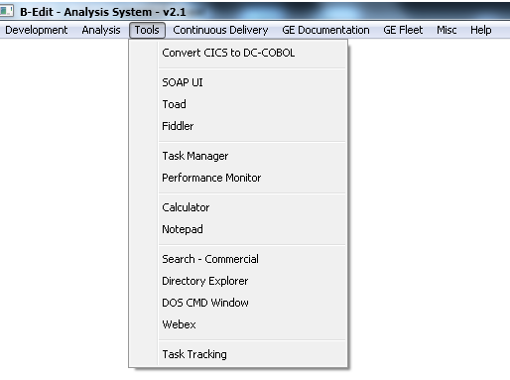

## Convert CICS to DC-COBOL

This function is used by GE Fleet Services to convert CICS Transactions to DC-COBOL Transactions which will be called via MQ.

## SOAP UI

If you have SOAPUI installed you can edit the soapui.bat file located in the c:\bedit\beditwin\builder directory and change the “cd” line to point to the directory where you have SOAPUI installed.

## Toad

If you have Toad installed you can edit the Toad.bat file located in the c:\bedit\beditwin\builder directory and change the “cd” line to point to the directory where you have Toad installed.

## Fiddler

If you have Fiddler installed you can edit the fiddler.bat file located in the c:\bedit\beditwin\builder directory and change the “cd” line to point to the directory where you have Fiddler installed.

## Task Manager

This selection will launch the Windows Task Manager.

## Performance Monitor

This selection will launch the Windows Performance Monitor.

## Calculator

This selection will launch the Windows Calculator.

## Notepad

This selection will launch the Notepad.

## Search - Commercial

If you have a commercial search product installed you can edit the ransack.bat file located in the c:\bedit\beditwin\builder directory to start the product of your choice.

## Directory Explorer

This selection will launch the Windows Directory Explorer.

## DOS CMD Window

This selection will launch a DOS CMD window.

## Webex

This selection will launch Webex in your default browser.

## Task Tracking

This selection will open the Task Tracking system:

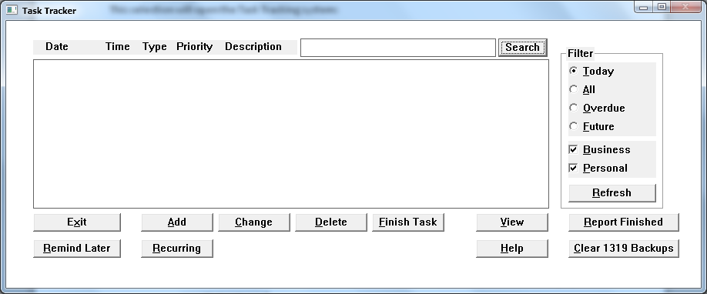

This system allows you to keep track of business and personal tasks. You can create and track tasks, and un-finished will appear in the list. If a task is overdue (older than the current date/time) then it will be marked with a “***” next to the Task Description. Use the Filter controls to filter the display, then press the  button to refresh the filtered list.

Press the:

 button to create a new task, and the Task Details described below window will open

 to change the task (double clicking a task in the list will also change a task), and the Task Details screen described below will open

 to delete the task, or

 to mark the task as finished. After pressing these buttons the “Task Details” window (described below) will be opened.

Press to open the View window to see your tasks at Day, Month, Year time scale.

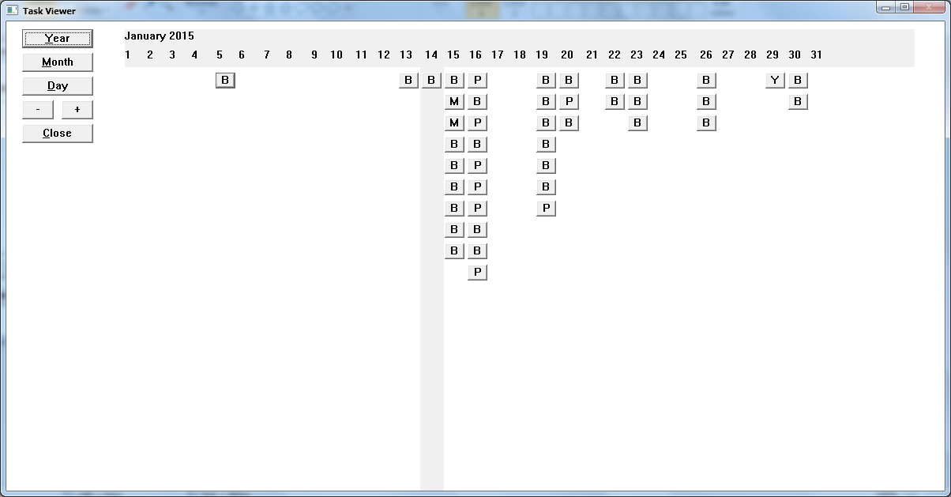

Each task is shown as a  for Business task, or  for Personal task. Move the mouse close to the task and you’ll see a description for that task. Change the time period using the controls on the left side of the screen. The grey bar identifies the current time, day, or month. Press  to close the window.

Press the  button to report on Finished tasks. This will load all of the Finished tasks into Excel to make it easy to present in whatever form you’d like.

When the Task Tracking system starts it will make a backup of task files, which over time will build up, so if you’d like to delete all of the backups press the  button. Note, the buttons include a count of how many backups currently exist.

If an existing task becomes overdue (older than current date/time), then the Task Tracking window will come into focus and warn you that a task is overdue. The system will continue to warn you every 30 seconds until you change the task, or press the  button which will postpone the next warning for 30 minutes.

Press the  button to close the system.

**Task Details Window**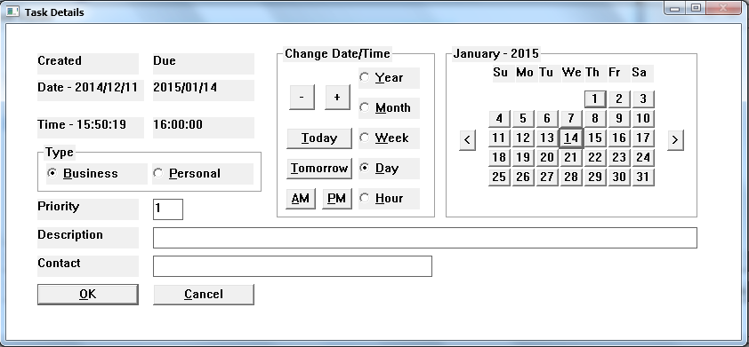

The Date and Time that the task was created, and when it’s due, is located in the upper left on the screen.

You can pick the day for the task using the Calendar on the right side of the screen (use the and  buttons to change the month). Use the Change Date/Time fields in the middle of the screen to change the date/time by selecting the appropriate radio, then use the  or  buttons to modify the date/time shown in the upper left.

You can use the  or  buttons to automatically set the date, and the  button to set the time to 7:00AM, or the button to set the time for 4:00PM.

Choose the Type (Business, or Personal), enter Priority (0-9), and a description of the task, then press the  button to save the new task and present it on the Task List screen.

Press  to close the window.

**Recurring Tasks Window**

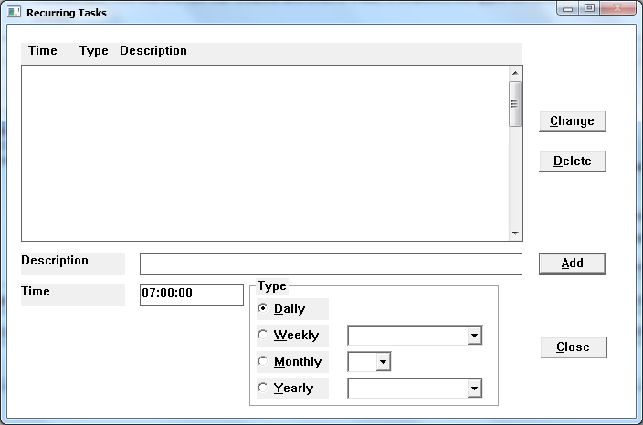

This screen allows you to create tasks that reoccur Daily, Weekly, Monthly, or Yearly. Enter a Description, enter the Time, choose the appropriate radio button and corresponding dropdown (Note: if you choose yearly then you need to choose both a Day of the Month from the Monthly dropdown and a Month from the Yearly dropdown), then press the button. You’ll see your new task appear in the Recurring Task list.

Double click a task to update the controls at the bottom of the screen.

If you want to change a task, click on the task in the list, change anything using the controls at the bottom, then press the  button.

To remove a Recurring Task click the task in the list, then press the  button.

To close the window press the  button.

**Finish Task**

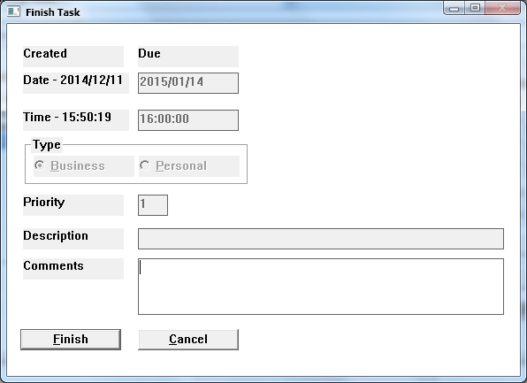

**This window allows you to Finish a task which will remove it from the Task List and place it in the Finished data file for later reporting.**

**Enter any details you want to remember about finishing the task in the Comments field, then press the  button.**

**Press  if you want to close the window without finishing the task.**

# Continuous Delivery

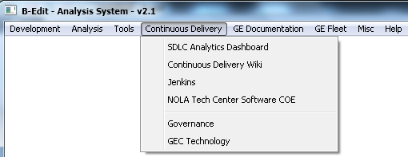

## SDLC Analytics Dashboard

This selection will launch the SDLC Analytics Dashboard in Chrome.

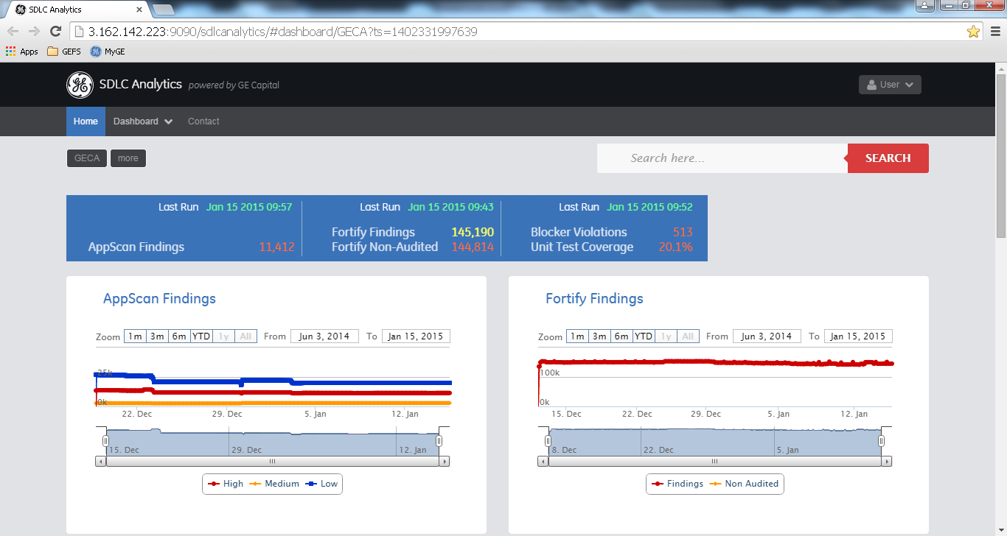

## Continuous Delivery Wiki

This selection will launch the Continuous Delivery Wiki page in the default browser.

## Jenkins

This selection will launch Jenkins in the default browser.

## NOLA Tech Center Software COE

This selection will launch the NOLA page in the default browser.

## Governance

This selection will launch the Governance GE Libraries page in the default browser located at:

GECA IT\Governance

## GEC Technology

This selection will launch the GE Capital Technology tool.

Once started the Login screen will be shown:

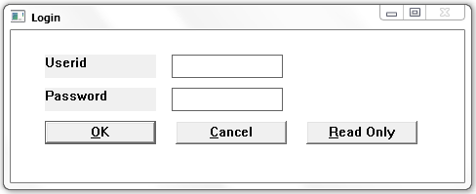

To review the GE Capital technologies press the  button.

If you want to maintain the data enter the Userid and Password, then press the  button.

If you want to close the system press the  button.

After the logging in the

While the data is being rendered on the screen you’ll see the progress window:

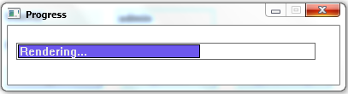

**GEC Technology Display**

Once all of the data has been read and rendered, the GEC Technologies screen will be shown:

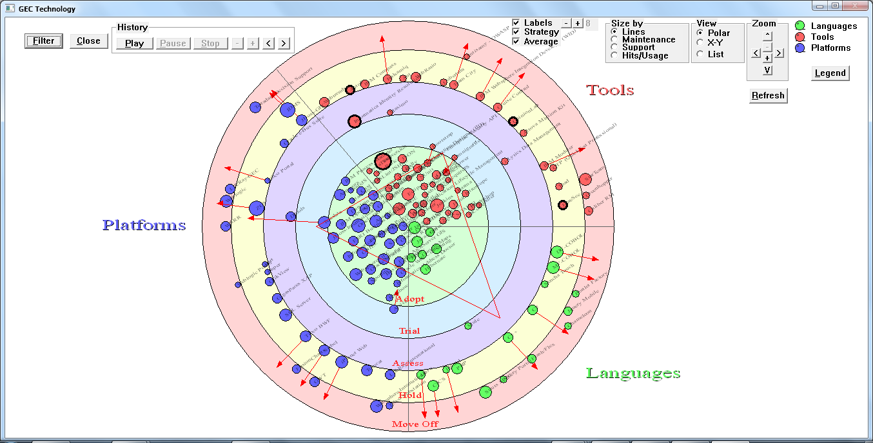

The default view is a Polar chart. Balls on the chart represent technologies, and the size of the ball represents the penetration, which by default is shown by Lines of Code. Each colored ring shows the status for the technologies located in the ring (Adopt, Trial, Assess, Hold, Move Off). Technology balls with an arrow shows the technology Strategy identifying which Status it is moving towards. There’s a triangle in the middle, and each point on the triangle represents the average for all Platforms, Tools, and Languages shown on the chart, which is useful in seeing how well the technologies are doing on the Status rings.

To see a description for each of these status’ press the  button:

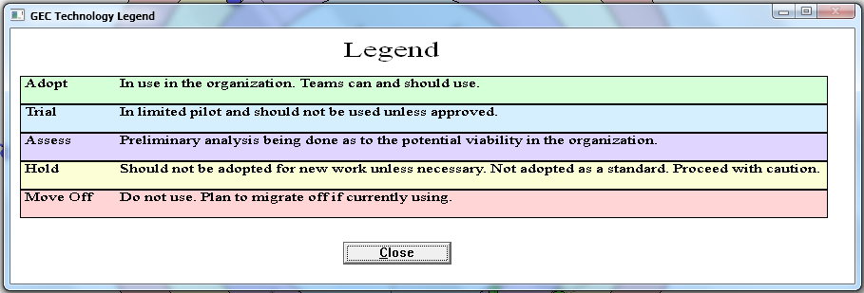

You can control the penetration ball size by selecting the appropriate 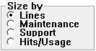 radio button and pressing the  button. At this time Maintenance, Support, and Hits/Usage data hasn’t been loaded, so the default size is by Lines of Code.

The Technology Balls and text may be too small to read, so if you move the mouse over a technology bubble text will appear identifying the Technology. You can also click the Zoom button to zoom in as large as you’d like.

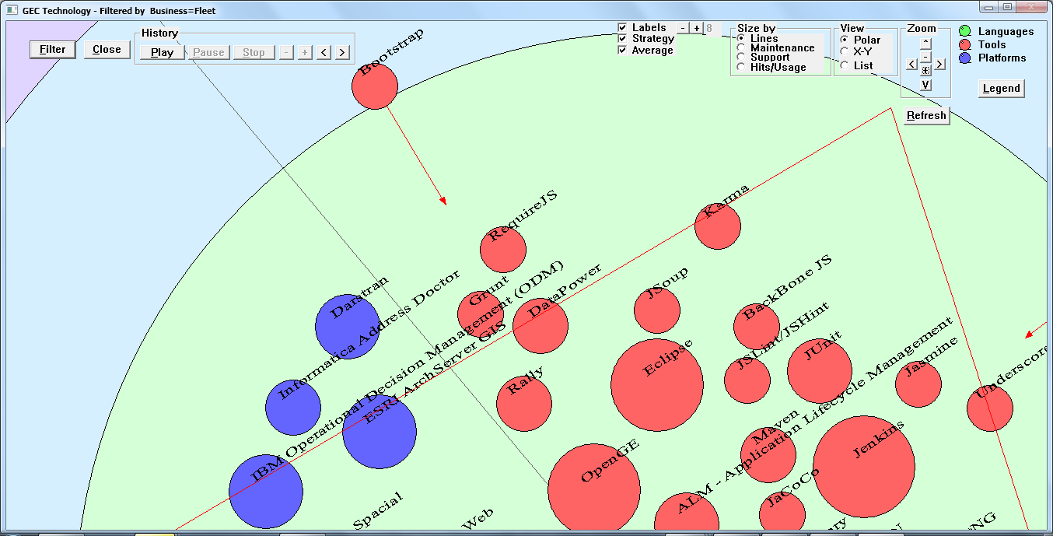

Press the  button to return to the original size. Once zoomed in, if you’d like to move around you can use any of the 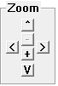 positioning buttons, or you can hold down the left mouse button and drag the image to the desired location, then release the mouse button.

To close the Technology View press the  button.

To filter the technologies shown press the  button and the filter selection controls will be shown:

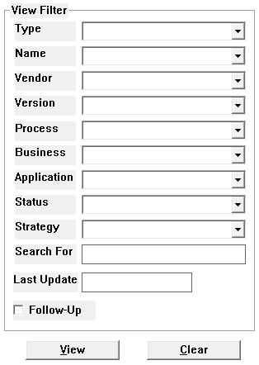

Choose the desired filter criteria using the dropdowns, then press the  button.

You can combine any dropdown selections to filter down to the desired technology list that you’d like.

The Search For entry field is used to enter any filter search text (e.g. “report” for all reporting technologies). You can use the ‘*’ character in the field to ignore any characters between entered text (e.g. use “op*sou” to find all technologies that are “Open Source” ).

You can select technologies based on their Last Update date by entering the Last Update (CCYY/MM/DD format), and all technologies less than or equal to that date will be shown.

Check the Follow-Up checkbox if you want include only technologies that have been marked Follow-Up.

To see details about the technology move the mouse over a Technology Ball, then press the left mouse button and the Technology Details window will be shown:

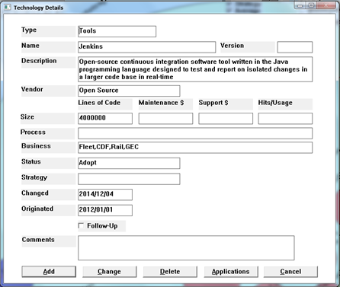

If you’ve logged in you’ll be able to maintain the data.

Field Notes:

* + Type must be “Languages”, “Tools”, or “Platforms”.
  + Size (Lines of Code, Maintenance $, Support $, Hits/Usage) fields contain the approximation for that value.
  + Process represents the business process that this technology supports (e.g. Ordering), multiple processes must be separated with a ‘,’
  + Business should contain a list of each business using that technology, multiple business’ must be separated with a ‘,’
  + Status must be “Adopt”, “Trial”, “Assess”, “Hold”, or “Move Off”
  + Strategy must be blank, “Adopt”, “Trial”, “Assess”, “Hold”, or “Move Off”
  + Changed is the last date changed (CCYY/MM/DD format)
  + Originated is when the technology was first introduced (CCYY/MM/DD format)
  + Follow-Up is used to mark technologies that need some follow-up work, and can be identified by a dark ring around the Technology Ball.

To add a new technology, before opening the Technology Details window, move to an open area on the Technology presentation window, then press the left mouse button to open a blank Technology Details window, then enter all of the details for the technology and press the  button.

To change details for an existing technology, update any of the information on the Technology Details window, then press the  button.

To remove a Technology press the  button.

To close the Technology Details window press the  button.

To maintain, or view, the list of applications that this technology is used by press the  button and the Technology Applications window will be shown:

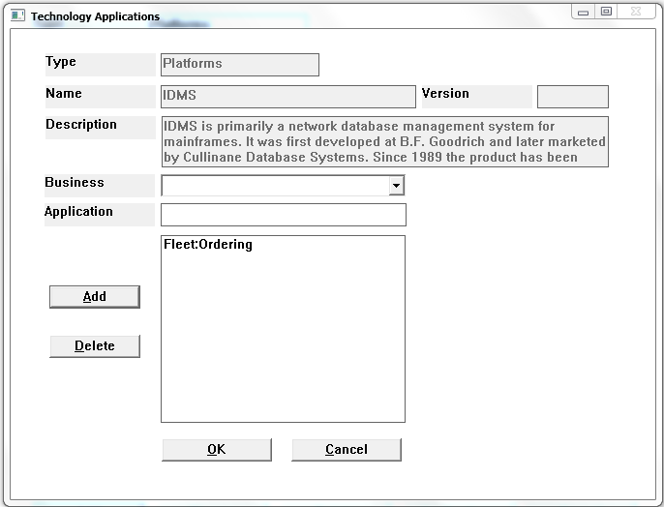

Every business application that uses this technology is shown in the list (Business:Application).

To add a new application to the list select a Business from the dropdown (populated using the Business’ entered on the Technology Details window), enter an Application name, then press the  button.

To remove an application from the list, select the Business:Application list entry, then press the  button.

To accept all changes press the button.

To close the window press the  button.

The default view is a Polar view, you can change the view to X-Y by selecting the  radio button, then press the  button.

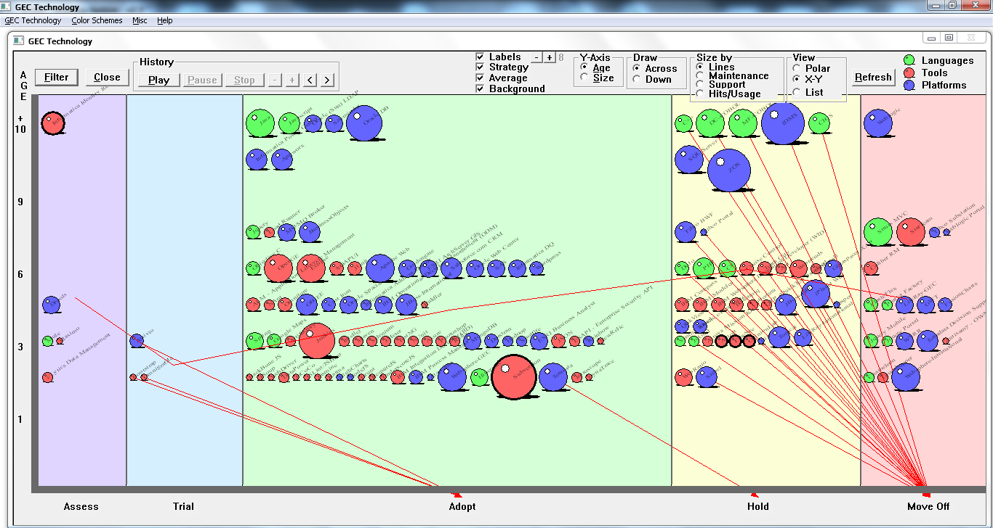

You can also view the data as a list by selecting the  radio button, then press the  button.

In List view you can change the presentation by selecting Y-Axis values to see technologies by Age or by Size, as well as drawing the technologies across or down between the Y-Axis values by selecting the appropriate 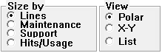 radio buttons and pressing the  button.

You can also change the presentation by selecting the appropriate  check boxes and pressing the  button. To change the size of the text shown for each technology press the appropriate  button, the current font size will be shown to the right of the buttons.

The screen can look cluttered with Strategy lines showing, so you may want to remove them by unchecking the  check box and pressing the  button.

To see a List view of all technologies select the  radio button, then press the  button.

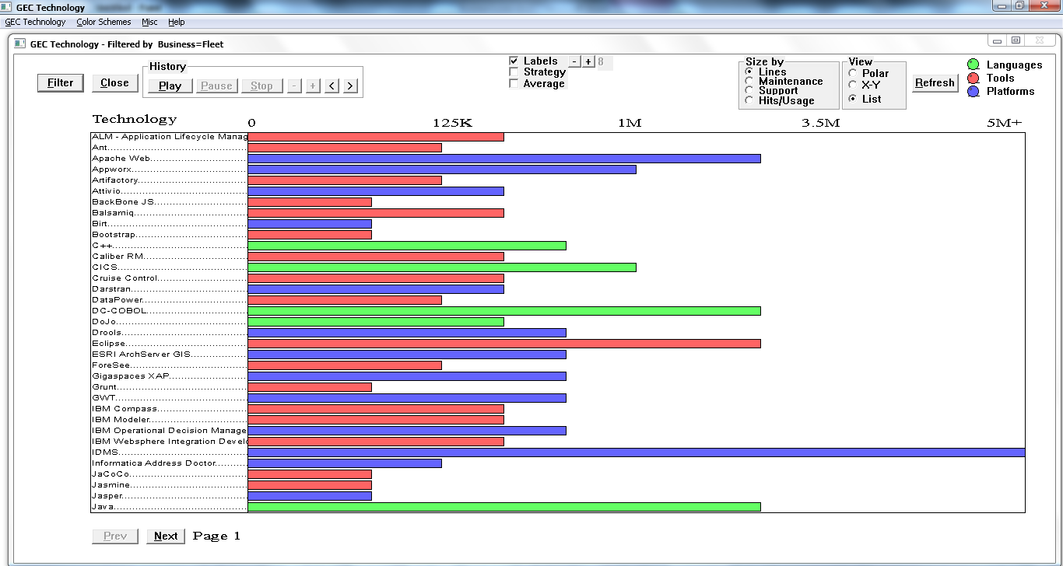

The size of the bars for each technology is based on the Size by radio button selection.

You can move the mouse over any of the technologies and click them to see the details for that technology.

To move to the next page press the  button, and to move backwards one page press the  button.

**Menu Selections**

To export the GEC Technology data to a CSV file, select Export to Excel under the GEC Technology menu selection:

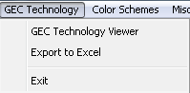

If you’d like to change the color scheme for the Technology Balls, select the desired color scheme under the Color Schemes menu selection:

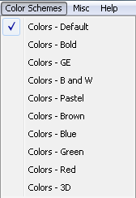

# GE Documentation

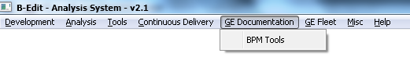

## BPM Tools

This selection will link to the GE Folders that contains documentation for all of the BPM tools available for development

# GE Fleet Tab

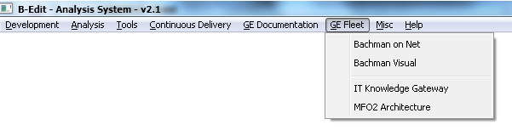

## Bachman on Net

This selection will start the 3090 Bachman on NET for GE Fleet Services system.

## Bachman Visual

This selection will show the 3090 Bachman PDF file showing all IDMS records.

## IT Knowledge Gateway

This selection will present IT Knowledge Gateway folder in GE Folders.

## MFO2 Architecture

This selection will present the My Fleet Office 2 Architecture folder in GE Folders.

# Misc Tab

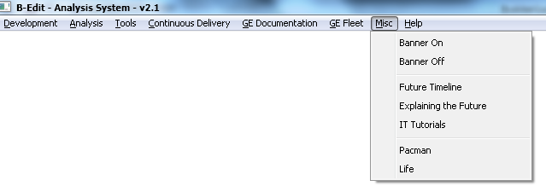

## Banner On

This selection will turn the Banner display on the main window.

## Banner Off

This selection will turn the Banner display off the main window.

## Future Timeline

This selection will start your browser bringing up the Future Timeline home page which is an excellent site for seeing what the future will be like in many areas (technology, medicine, politics, etc…).

## Explaining the Future

This selection will start your browser bringing up the Explaining the Future home page which is an excellent site for seeing what the future will be like in many areas, and how best to cope with the changes that are coming.

## IT Tutorials

This selection will start your browser bringing up The New Boston tutorial site. This site has numerous areas of instruction, and each area is comprised of many YouTube videos, all less than 10 minutes long. The instructor is very “unique”, but he does a very good job explaining things, from simple to very complex, on a wide variety of subjects.

## Pacman

This selection will launch a B-Edit demonstration game program patterned after the classic game Pacman. This is used primarily to show the capabilities of the B-Edit language, but it’s a fun game too, beat my high score if you can!

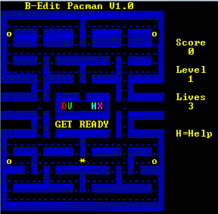

## Life

This selection will launch a B-Edit demonstration program patterned after the classic Game of Life. This is used primarily to show the capabilities of the B-Edit language.

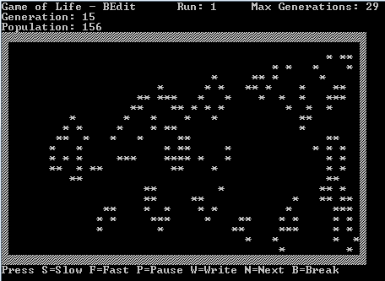

# Help Tab

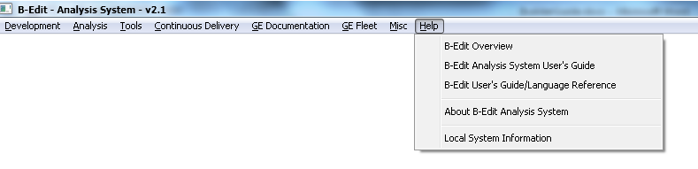

## About B-Edit Analysis System

This selection will show the About window for the B-Edit Control System

## B-Edit Analysis System User’s Guide

This selection will open the B-Edit Analysis System User’s Guide in Word.

## B-Edit Overview

This selection will present a high level overview of B-Edit.

## B-Edit User’s Guide/Language Reference

This selection will open the B-Edit User’s Guide/Language Reference document in Word.

## Local System Information

This selection will open the Windows System Information window.

# Appendix

## Browse Window

This window is used in multiple places within B-Edit Analysis System to simplify entering a directory where needed by browsing and clicking.

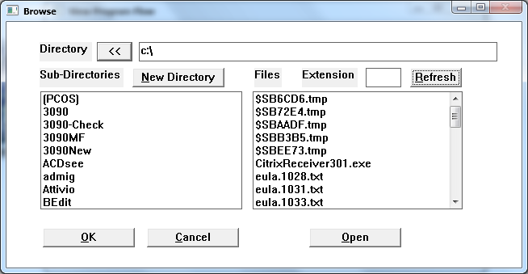

The Directory entry field will be initialized to the current directory location, but you can enter the start of a directory, or enter a drive letter followed by a ‘:’ (e.g. c:), then press the “Refresh” button to show all of the sub-directories under that directory in the Sub-Directories list box. The right side of the window shows a list of all files within the current directory that have an extension that match the “Extension” field.

Press the  button to move back one level in the directory, and the Sub-Directories list will automatically refresh.

Press the  button to create a new directory under the current Directory viewed. This will open a new window which allows you to enter the new directory Name, enter the Name and press  to create the new directory, or press  to close the window.

Enter an extension into the “Extension” field, and press the  button to see list of all of the files that exist in the current Directory with the extension entered.

Double-click a Sub-directory in the list to add it to drill down into that directory.

If the Browse window was launched from the “View Program Flow” window, then you can Double-click a file on the right side of the window and the selected file will be passed back to the “View Program Flow” window and used automatically to present the program flow for that file.

Press the  button when you’ve located the appropriate Directory, and the Directory on the window used to launch the Browse window will be refreshed with the chosen Directory.

Press the  button to close the window.

Select a file in the File, and press the  button to open that file for viewing (the native viewer for the file extension will start and open the file selected).

## Color Selection

The Color Selection window is used to select colors for Objects or Text on the Window Canvas window, or the Text Object Text Edit window, by pressing the  button.

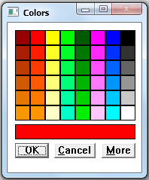

Click on the any of the Standard Colors shown on the screen to select that color, the Colors window will close, and the Object or Text will change to the selected color.

Press the  button to close the Colors window without changing the Object or Text color.

Press the  button to open the detailed Color Selection window:

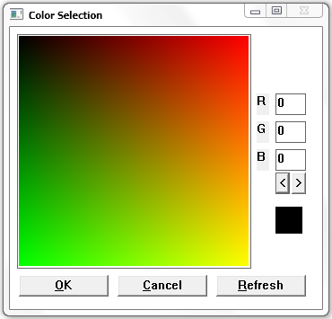

Click anywhere in the shaded color area to select that color at that point, and the color box showing on the right of the window will reflect that color choice.

Press the  button to change the Object or Text to the currently selected color showing in the color box on the right side of the window. If you know the RGB values you’d like to use you can enter them, then press the  button to apply that color’s RGB value to the Object or Text.

Press the  button to close the Color Selection window without changing the Object or Text color.

The colors shown on the screen are combinations of 256 Red by 256 Green using the Blue value indicated in the Blue entry field, so the screen only shows 65,535 colors. To show more colors you need to change the Blue value (0-255) to a different value and press the  button to repaint the colors on the window. You can also press the  or  button to automatically update the Blue value and repaint the screen. Using the combination of all three RGB fields you have the choice of 16,777,216 colors.

## 3090 Code Checker Error and Warning Definitions

|  |  |  |
| --- | --- | --- |
|  | |  |
|  |  |  |
| **Type** | **Error** | **Description** |
| Error | Code Line Errors | If a single program contains > 5000 lines |
|  | IDMS-ABORT Errors | Any COBOL-IDMS program that doesn't contain IDMS-ABORT |
|  | PERFORM THRU diff line Errors | Any THRU that appears on a separate line from the PERFORM |
|  | Comment Line Errors | Any program with less than 4% comments |
|  | Copyright Errors | Any program that doesn't contain: |
|  |  | NO COPIES OF THIS PROGRAM |
|  |  | PROPRIETARY MATERIAL |
|  | OCCURS Errors | Any OCCURS > 5000 |
|  | Sentence Length Errors | Any sentence that contains > 60 lines |
|  | CICS Program Name Errors | Any program missing a PROGRAM-NAME line. |
|  | SYSCTL with RETRIEVAL Errors | Any JCL step using SYSCTL and the program is USAGE-MODE RETRIEVAL |
|  | Missing Move to LS-RETURN-LEN | Any CICS program not using LS-RETURN-LEN and not using L01-RETURN-LEN |
|  | Missing Maintenance Log Errors | Any program that doesn't contain: |
|  |  | R E V I S I O N |
|  |  | REVISION |
|  |  | M A I N T E N A N C E |
|  |  | MAINTENANCE |
|  |  | M O D I F I C A T I O N |
|  |  | MODIFICATION LOG |
|  |  | CHANGE LOG |
|  | Missing WORKING STORAGE start Errors | Any program missing a field at the start of WORKING-STORAGE containing: |
|  |  | WORKING STORAGE BEGIN |
|  |  | WORKING STORAGE START |
|  | IDMS-STATUS Usage Errors | Any COBOL-IDMS or CICS-PROGRAM without an 'IDMS-STATUS =' statement |
|  | AND on same line as IF Errors | Any IF statement containing an AND statement on the same line as the IF |
|  | GOTO Errors | Any GOTO that's not to an EXIT, and not to the current paragraph prefix |
| Warning | Code Line Warnings | If a single program contains > 4000 lines but < 5000 lines |
|  | Comment Line Warnings | Any program with less than 4% comments |
|  | OCCURS Warnings | Any OCCURS > 1000 but < 5000 |
|  | MOVE CORRESPONDING Warnings | Any MORE CORRESPONDING |
|  | Sentence Length Warnings | Any sentence that contains > 30 lines but less than 60 lines |
|  | Area Walk Warnings | Any OBTAIN or FIND, using NEXT, on an AREA |
|  | 01 PIC Warnings | Any 01 level that contains a Picture clause. |