***GE Capital Americas***

***Remote Property Maintenance (RPM)***

***User’s Guide***



**GE Capital Americas**

**1 Capital Drive**

**952-828-1684**

**5/8/2014**

Forrest Bentley

The Remote Property Maintenance B-Edit System provides the ability to compare like files across multiple remote servers to ensure that deployment changes have been done consistently. The system also provides the ability to maintain property changes locally in preparation for U-Deploy to update the remote servers.

Remote Property Maintenance (RPM) User’s Guide

Contents

Remote Property Maintenance User’s Guide 2

Overview 2

Installation 2

Remote Property Maintenance - Main Window 3

Backups 3

Server Maintenance 4

Property Fields Maintenance 8

Compare Property Files 9

Update Property Files 12

Remote Property Maintenance Data Flow 14

# Remote Property Maintenance User’s Guide

# Overview

The Remote Property Maintenance B-Edit System provides the ability to compare like files across multiple remote servers to ensure that deployment changes have been done consistently. This is very useful when property files are maintained on a number of servers using a manual process which is prone to errors. The system also provides the ability to maintain property changes locally in preparation for U-Deploy to update the remote servers.

# Installation

1. The Remote Property Maintenance system can be installed by copying the following files into a directory on your PC (e.g. c:\RPM\...).
   1. BEDITWIN.EXE : B-Edit Interpreter
   2. RPM.BED : B-Edit RPM Code File
   3. RPM.WIN : B-Edit RPM Windows Definition
   4. RPM-MNU : B-Edit RPM Menu Definition
   5. PSFTP.EXE : Putty Secure FTP
2. To run the system create a shortcut on your desktop running “c:\RPM\beditwin.exe call c:\rpm\rpm.bed” using c:\rpm as the run directory.

# Remote Property Maintenance - Main Window

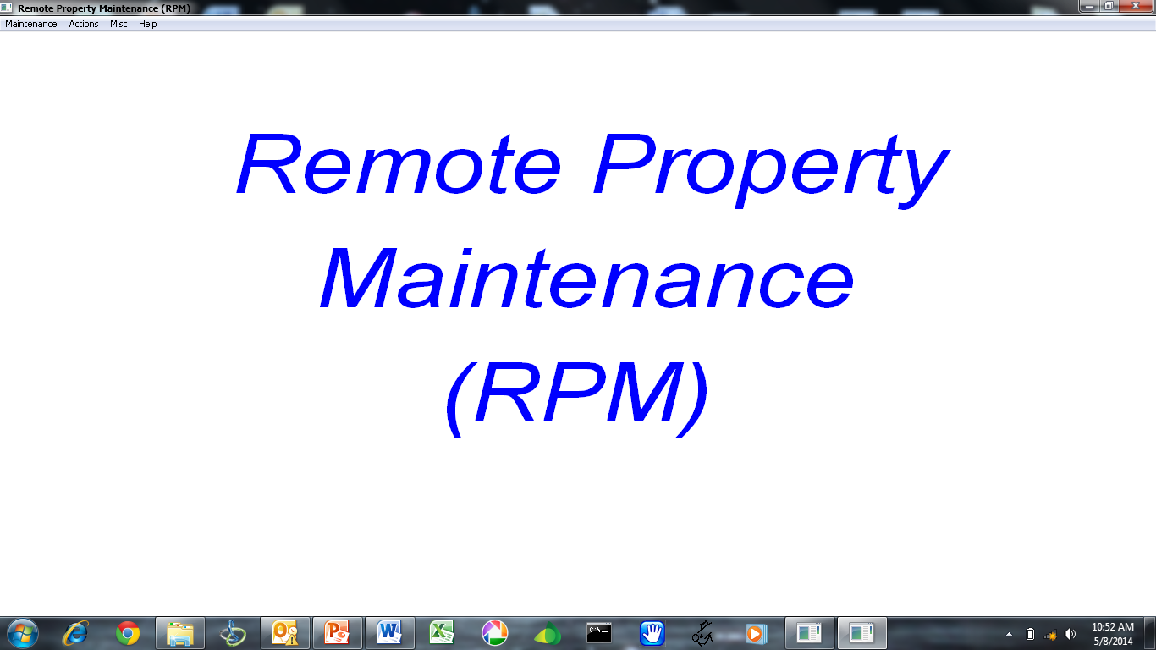

Once the system starts the main window is presented.

## Backups

When the system starts a backup directory containing all of the RPM-data files is created with the name RPM-data\ccyymmdd-hhmmss. If you need to revert some of your data files you can use one of the backup copies. Only the latest 5 backups is retained.

# Server Maintenance

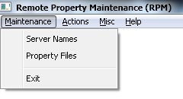

Select “Server Names” to maintain the names of each of the remote servers that contain property files to compare and/or update.

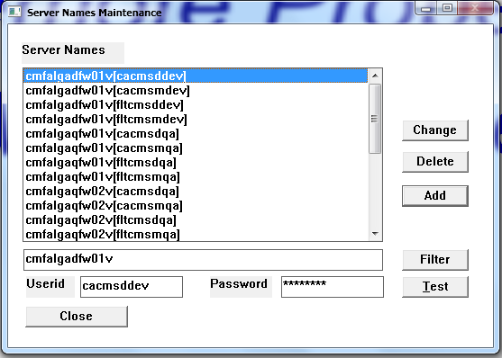

To create a new entry in the Server Names list enter the Server Name, Userid, and Password in the entry fields, then press the “Add” button.

To change an existing entry, double-click one of the server lines in the list (this will populate the entry fields with the line data), make any changes to the data in the entry fields, then press the “Change” button.

To remove an existing server entry from the list, select the appropriate line in the list, then press the “Delete” button.

The Server data is stored under RPM-data\DNS.dat

If you have a lot of Servers entered in the list you can enter a partial server name (or full name) in the entry field, then press the “Filter” button to limit the servers that are shown in the list.

Note: Anywhere a “Filter” button is present and you want to refresh the entire list, clear out the Filter entry field, and press the “Filter” button.

To ensure that the Server Name, Userid, and Password work propertly, you can press the “Test” button to check the access to the server using the Userid and Password entered.

Press the “Close” button to close the window.

**Property File Maintenance**



Select “Property Files” to maintain the property files that exist on the remote servers.

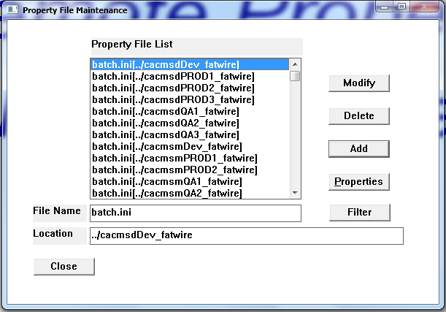

To create a new entry in the Property File list enter the File Name and Location in the entry fields, then press the “Add” button. Note: The file location will be relative to the home location assigned to the userid that’s used to login to the remote server, so you can use ..\ notation to change to the appropriate directory that contains the file.

To change an existing entry, double-click one of the Property File lines in the list (this will populate the entry fields with the line data), make any changes to the data in the entry fields, then press the “Change” button.

To remove an existing Property File entry from the list, select the appropriate line in the list, then press the “Delete” button.

If you have a lot of Property Files entered in the list you can enter a partial Property File name (or full name) in the entry field, then press the “Filter” button to limit the Property Files that are shown in the list.

To assist in file compares you may want to pre-define the properties in the file indicating if they’re Standard (should be the same across all servers), or non-Standard (could be different for each server). To pre-define the properties press the “Properties” button and the Property Field Maintenance screen is presented.

Press the “Close” button to close the window.

The Property file data is stored under RPM-data\File.dat

# Property Fields Maintenance

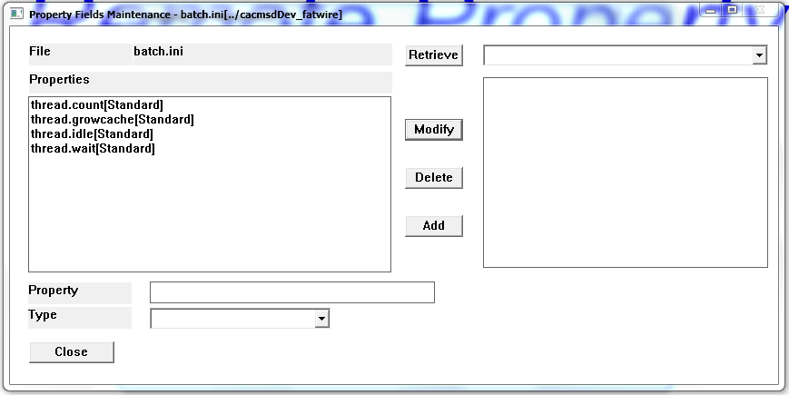

To retrieve a list of all elements within a property file, select the appropriate Server/Userid from the dropdown (must match the current file/location listed in the title of the window), then press the “Retrieve” button. The system will retrieve the property file and fill the property element list on the right side of the screen. Now you can double-click a property element on the right side of the screen to populate the Property entry field.

To create a new entry in the Property Fields list enter the Property Name, select the Type (Standard, non-Standard), then press the “Add” button.

To change an existing entry, double-click one of the Property in the list on the left side, select the Type, then press the “Modify” button.

To remove an existing Property File entry from the list, select the appropriate line in the list, then press the “Delete” button.

Press the “Close” button to close the window.

The Properties data is stored under RPM-data\Prop.dat

# Compare Property Files

To compare the elements within a property file across multiple remote servers select “Action”, then select “Compare” on the main menu.

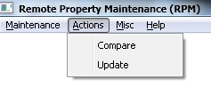

The Compare selection screen will be presented.

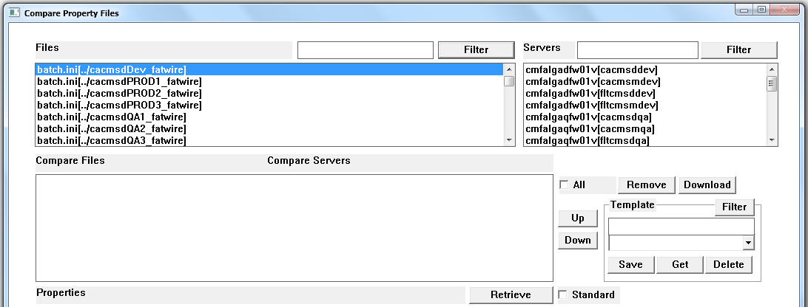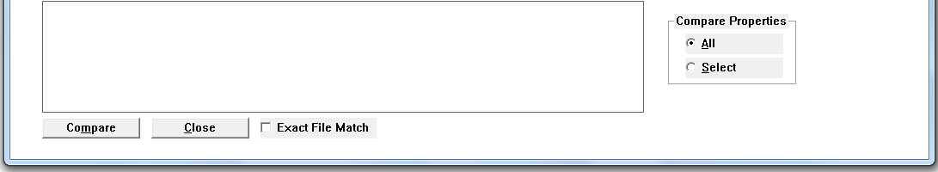

When the screen opens the Files list will be populated with the File data entered on the File Maintenance screen, and the Servers list will be populated with the Server data entered on the Server Maintenance screen. To filter the files shown enter a File in the File Filter entry field and press the File “Filter” button, and to filter the Servers shown enter a Server in the Server Filter entry field and press the Server “Filter” button. Note: You can use regular expression “*” to assist filtering (e.g. you could enter “batch*prod” to filter files down to any line containing “batch” followed by any number of characters, then followed by “prod” in the file name).

To compare files you must connect a File (in the File list) to the appropriate Server (in the Server list). To do this select a File in the list, then double-click a Server in the list. This will create an entry in the Compare Files/Compare Servers list in the middle of the screen.

To remove a Compare Files/Compare Servers association line, select the appropriate line, then press the “Remove” button. Check the “All” checkbox if you’d like to remove all selections.

If you’d like to view a File, select the appropriate Compare Files/Compare Servers association line, then press the “Download” button. Check the “All” checkbox if you’d like to view all files.

The order that the Compare Files/Compare Servers defines the order that these lines will appear in the Excel comparison report, so you may want to re-order the lines. Select a line in the list, and press the appropriate “Up” or “Down” buttons to move the line where you’d like it to appear in the report.

If you want to see the Properties in the file, double-click an entry in the Compare Files/Compare Servers list. The system will read the File from the associated Server and populate the Properties list at the bottom of the screen.

Once you’ve associated a number of Compare Files/Compare Servers, you may not want to go through that process again, so you can save the collection of associations into a “Template”. Enter a Template name and press the “Save” button to save the current list of associated Compare Files/Compare Servers.

When you want to re-use a saved Template, select the appropriate Template name from the dropdown, then press the “Get” button to populate the saved Template Compare Files/Compare Servers associations in the list.

To delete a Template, select the appropriate Template name in the dropdown, then press the “Delete” button.

To retrieve a list of Properties you can double-click a Compare Files/Compare Servers line as described above, or you can select a line in the Compare Files/Compare Servers list, then press the “Retrieve” button. If you check the “Standard” checkbox, then only the Property elements that have been defined as Standard in the Property Maintenance screen will be shown.

To Compare the file across the servers in the Compare Files/Compare Servers list press the “Compare” button. The file from each of the servers will be downloaded, and after all files have been downloaded , each element in the file will be compared, and differences identified. The comparison CSV file is created, and when complete Excel is launched to view the compare CSV report. To quickly identify the differences you can set data filter, and look only at Differences. All property elements will be compared if the “All” radio button is selected, and if you only want to compare specific properties then select the appropriate property elements from the list, and select the “Select” radio button before pressing the “Compare” button. If you want to ensure that the entire file matches exactly check the “Exact File Match” checkbox before pressing the “Compare” button.

Sample Output:

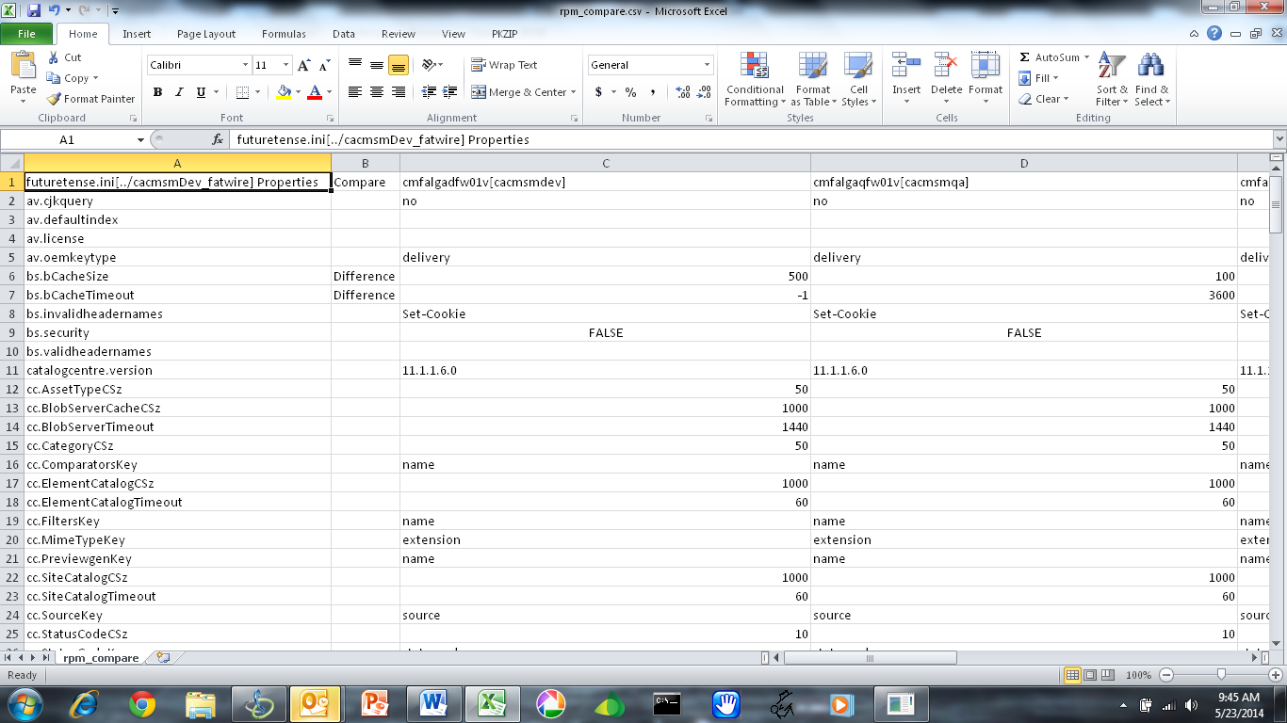

Add a Data Filter, and select “Difference” in the “Compare” column to show all differences: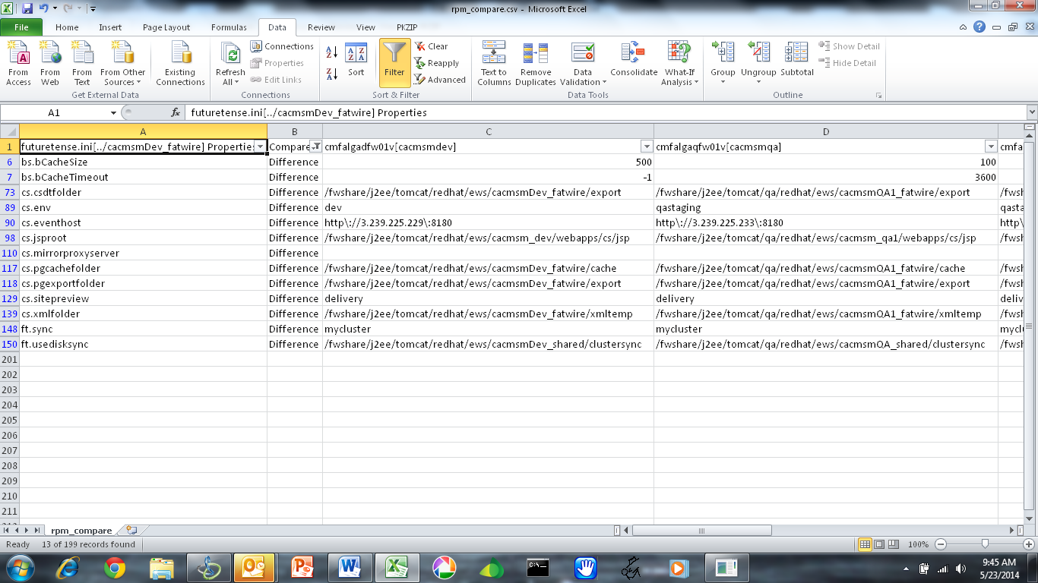

Press the “Close” button to close the window.

The Template data is stored under RPM-data\Template.dat

# Update Property Files

To update the elements within a property file across multiple remote servers select “Action”, then select “Update” on the main menu.



The Update selection screen will be presented.

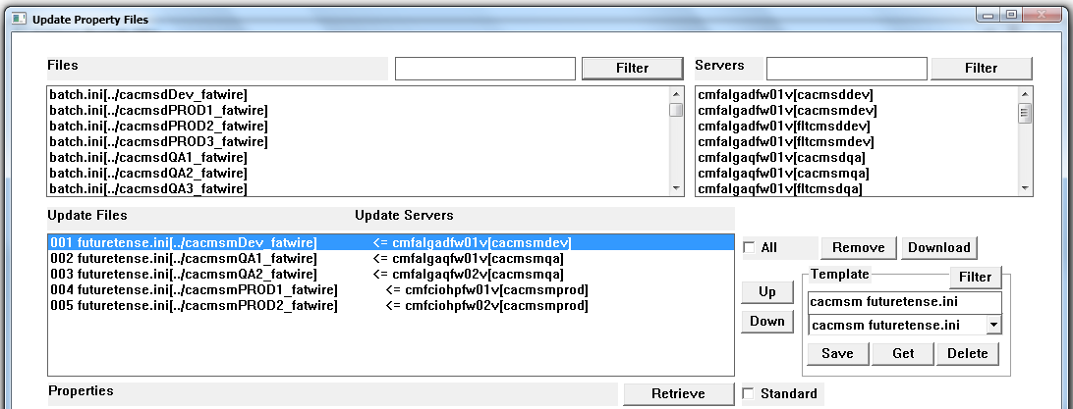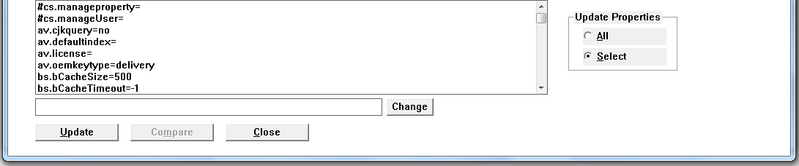

The controls on the Update screen work the same as the Compare screen.

When you double-click an Update Files/Update Servers association line, the property file is read from the server and the property elements are placed in the Properties list at the bottom of the screen, including the property element values separated by an ‘=’ character.

To change a property element value double-click a Property line and the Value will be placed in the entry field below. Make changes to the entry field value, and press the “Change” button to make the change. The change will be reflected in the Properties list.

To save the Changes you’ve made to all of the files, select all of the Property lines in the list you’d like to change, press the “Update” button. This will download each of the files from the servers, and apply the changes to the property elements that are selected. The updated files will be stored under RPM-data\[Servername]\[Username]\[Filename]. You’ll be able to move these files into Source Control, and let U-Deploy move them to the appropriate server.

After you’ve used the Update button to make changes the files will have been downloaded from the servers, so you can use the “Compare” button to compare the property elements within all of the files.

# Remote Property Maintenance Data Flow

