***GE Capital Americas***

***Task Tracker System***

***User’s Guide***



**GE Capital Americas**

**1 Capital Drive**

**952-828-1684**

**4/24/2014**

Forrest Bentley

The Task Tracker B-Edit System allows you to enter, and maintain business and personal tasks. After Finishing a task you can later run a report to show all of your finished tasks, so at the end of the year remembering everything you worked on is much easier.

Task Tracker System User’s Guide

Contents

Task Tracker System User’s Guide 1

Installation 1

Task Tracker - Main Window 2

Task Details 4

Recurring Tasks 5

Finish Task 6

Task Viewer 7

Year View 7

Month View 7

Day View 7

Task Tracker Data Flow 9

# Task Tracker System User’s Guide

# Installation

1. The Task Tracker is contained in the B-Edit installation (see B-Edit installation instructions)

# Task Tracker - Main Window

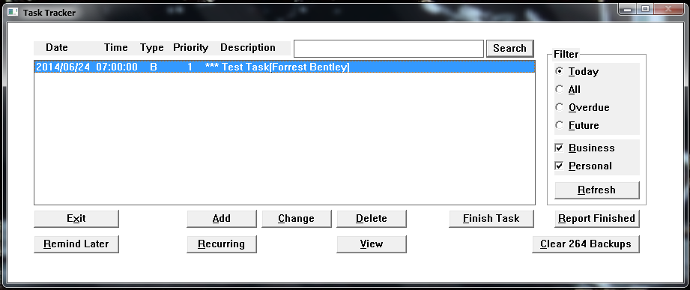

This window shows all of your tasks based on the filtering that you’ve setup.

Tasks are shown in the list box including the Task Due Date, Task Due Time, Type (B=Business, P = Personal), Task Priority (1-9), Task Description (Description [ Contact]).

Enter search criteria for any text in your tasks and press the Search button.

To filter the list click on a Filter Criteria, check either/both Business or Personal check boxes, then press the Refresh button.

To add a new task press the Add button and the Task Details screen will be shown.

To change a task either double-click the task in the list, or select a line then press Change, and the Task Details screen will be shown.

To Delete a task press the Delete button.

To Finish a task press the Finish Task button, and the Finish Task screen will be shown.

To create a CSV report of all tasks that you’ve completed press the Report Finished button. Excel takes a while to open, so give the system time to create the report.

The system creates backups of the Task data in the Task-Backup directory. To clear the backups press the Clear Backups button.

If a task is overdue then the system will notify you every ½ minute. Press the Remind Later button to delay these reminders by 1 hour.

If you have tasks that you’d like to repeat daily, weekly, monthly, or yearly press the Recurring button to setup a recurring task.

Press the “View” button to show a Yearly, Monthly, or Daily view of task data.

Press the Exit button to exit the system.

# Task Details

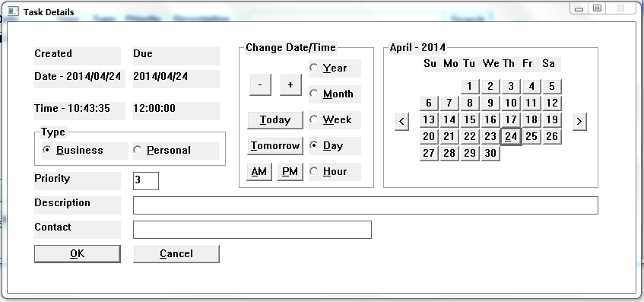

This screen allows you to enter the details of a new task, or changes to an existing task.

Enter the Task Description in the Description entry field. If you’re working on this task for someone else you can enter their name in the Contact entry field.

Choose if this task is for Business, or Personal by choosing the appropriate radio button.

Change the Due Date/Time by selecting the appropriate radio button (Year, Month, Week, Day, Hour), then press either the ‘-‘ or ‘+’ buttons. You’ll see the Due Date text field change, and also the calendar to the right will update based on the action you selected.

To change the Due Date to Today press the Today button

To change the Due Date to Tomorrow press the Tomorrow button.

To change the Due Time to morning press the AM button.

To change the Due Time to evening press the PM button.

To select a specific date use the ‘<’ button to move one month backwards, and the ‘>’ button to move one month forwards, then click the appropriate date in the calendar to apply that date to the Task Due Date.

Press the OK button to save the new task.

Press the Cancel button to cancel the creation or changes to the task.

Press the Cancel button to close the screen.

# Recurring Tasks

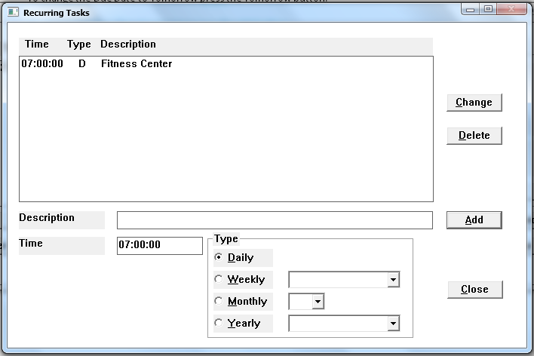

This screen allows you to maintain recurring tasks.

Enter a Task Description, enter the Task Time (HH:MM:SS), and select the appropriate Recurring Task Type (Daily, Weekly, Monthly, Yearly), and that task will appear in the Task List at the appropriate date/time.

If you use Weekly, you must select a day of the week from the dropdown.

If you use Monthly, you must select a day of the month (1-31) from the dropdown.

If you use Yearly, you must select a day of the month (1-31) from the dropdown, and also a Month from the dropdown.

Press the Add button to add a new recurring task.

Double-click the Recurring Task List, and the task details will be updated into the entry fields below. Make changes to the fields, then press the Change button to apply those changes to the selected line.

Select a Recurring Task list line, then press the Delete button to remove that Recurring Task.

Press the Close button to close the screen.

# Finish Task

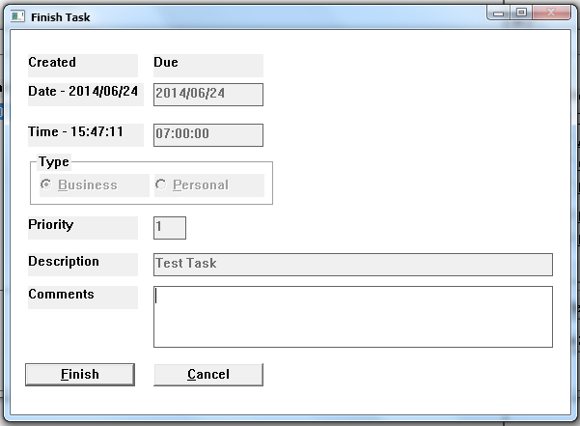

To finish a task, select the appropriate task in the task list on the Task Tracker screen, then click the “Finish Task”, then the Finish Task screen will be presented.

Enter any comments you’d like to be included in the finished task and press the “Finish” button. The data will be written to the TaskComplete.dat file, which is later used to Report Finished tasks.

Press the “Cancel” button if you don’t want to Finish the selected task.

# Task Viewer

## Year View

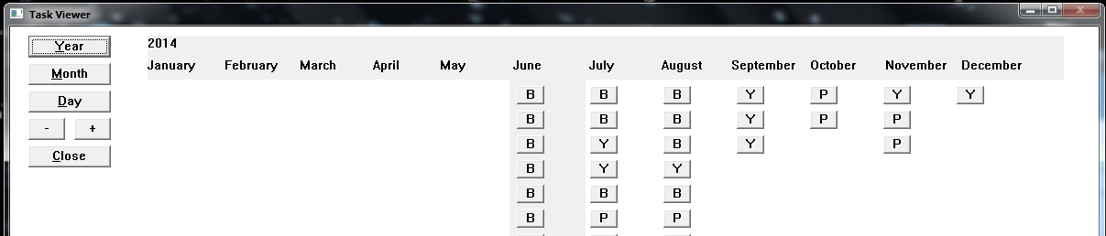

## Month View

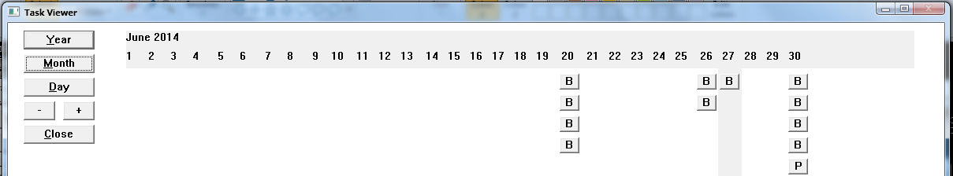

## Day View

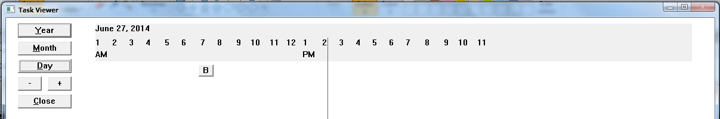

The Task Viewer screen shows all tasks for a chosen Year, Month, or Day. Click the Year button to show all tasks for an entire Year, the Month button to show tasks for an entire month, or the Day button to show all tasks for an entire day. After clicking the button the view will change appropriately and present buttons corresponding to each task for the selection. The heading will show months if the view is yearly, days if the view is monthly, and hours if the view is daily. The task button text will show ‘B’ for a business task, ‘P’ for a personal task, ‘Y’ for a recurring yearly task, ‘M’ for a recurring monthly task, ‘W’ for a recurring weekly task, or ‘D’ for a recurring daily task. Click on any task button to see the details for that task.

Press the ‘-‘ button to move backward in the particular view (e.g. if a monthly view is shown for June, and you press the ‘-‘ button, then May will be presented.

Press the ‘+‘ button to move forward in the particular view (e.g. if a monthly view is shown for June, and you press the ‘+‘ button, then July will be presented.

Move the mouse close to the right side of any of the Task Buttons, and the Task Details are shown in a bubble window.

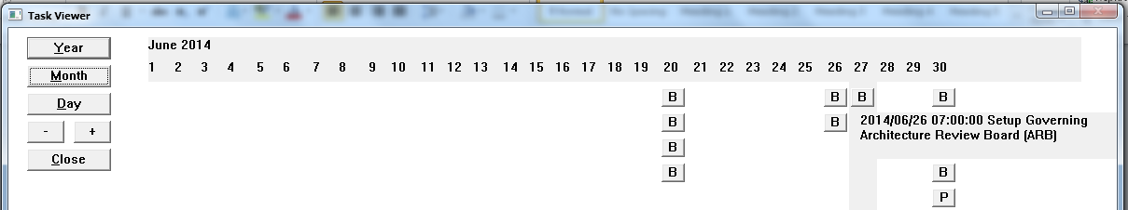

To drag and drop a Task Button to chance when it’s due, left click one of the Task Buttons, then click and hold down the left mouse button and hold it while dragging the button to a new location. When you release the button the task button will move the nearest proper spot, then the screen will be refreshed with the new Task details updated.

Note: If you’re viewing Monthly Tasks, with a Task Due Date of the 31st, and you drag the task to a month with fewer than 31 days, then the new Task Date will become the highest day number in the new month (e.g. If the Task Due Date is July 31st, and is dragged to June, then the new Task Date would be June 30th).

Press the “Close” button to close the View window.

# Task Tracker Data Flow

