
PoleDisplayBlaster
A python GUI program to control a serial port customer pole display.
Available at: https://github.com/ForrestErickson/PoleDisplayBlaster
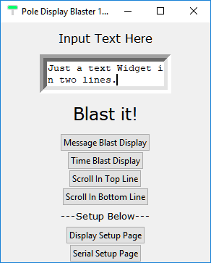
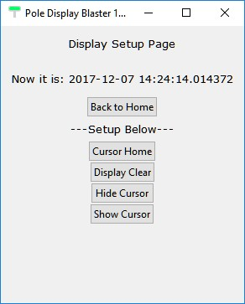
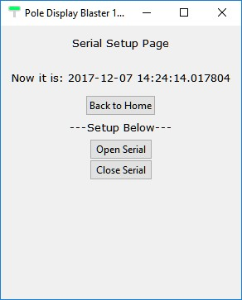
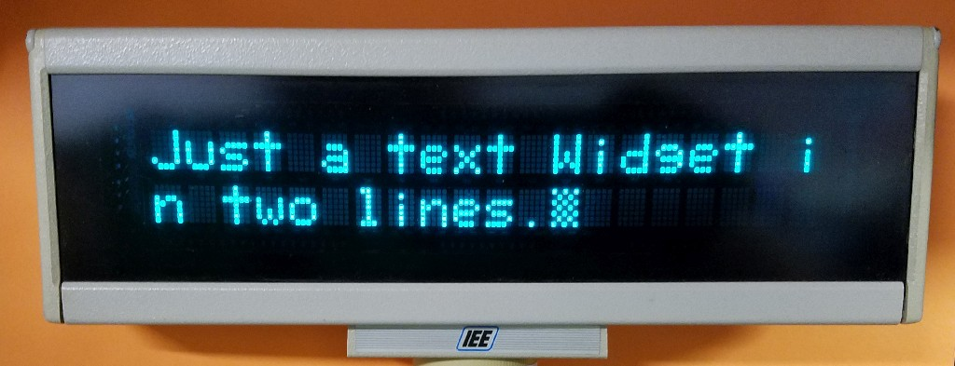
Motivation.
Serial port (USB) displays used in retail are an alternative to nibble or byte interface displays and if you are willing to watch ebay can be purchased very inexpensively. (Caution! Make sure it comes with the wall transformer.)

Pole Display Command Sets
While the common printable ASCII characters from 0x20 to 0x7F are approximately the same for most pole display brands but the control characters or sequences are brand specific. These control sets are referred to as command sets. Common display brands are Logic Controls, Partnertech, IEE, EPSON and Champion. Many models support multiple command sets.

An example. The ASCII character for Form Feed (0x0C) usually causes a terminal to clear and position the cursor at the upper left. Here are some examples of commands showing some of the variety.
Brand | Form Feed (0x0C) | Home | Clear | Reset
ASCII | 0x0C | NA | NA | NA
Logic Controls | Becomes CR |  |  | 0x1F
IEE | End character blink field | 0x16 | 0x15 | 0x14
Partnertech | 0x0C | 0x0B | 0x0C | 0x0B 0x40

Creation of PoleDisplayBlaster.py


I implemented a program to exercise some of the features of the IEE brand pole display and build a Tkinter GUI. For the GUI, I followed the template by “sentdex” from this youtube : https://youtu.be/jBUpjijYtCk

I began this program with out a GUI and it shows. My pole display code is all in one file and I have been contemplating how to go about breaking it into modules.

My code is written for only the IEE pole display command set. So when making modules I should be anticipating using a class object for additional command sets. I have considered that the base class should perhaps be something like the ASCII command set and then the various pole display brands derived from that.

Currently (20171206) there is one sub module: seriallib.py. It is something I wrote for another program, to collect serial port setup and mostly to read serial port data.
- It has lines of code to support COM port on windows computer and ttyUSB ports I have used on my Raspberry Pi. You have to comment out in appropriate lines for your operating system or com port number.
- Additional GUI for managing serial port setup would be good.
- Auto detecting the operating system and then testing for available ports and presenting the user with real options would be good.
- Saving the settings to a file would be good.

In my shop I have several brands of pole displays and I have nine displays my now defunct company purchased directly from china which were purchased with Logic Controls command set, but their implementation of that command set has not been tested by me. I keep hoping that they might be used to help youngsters learn to program.

References:
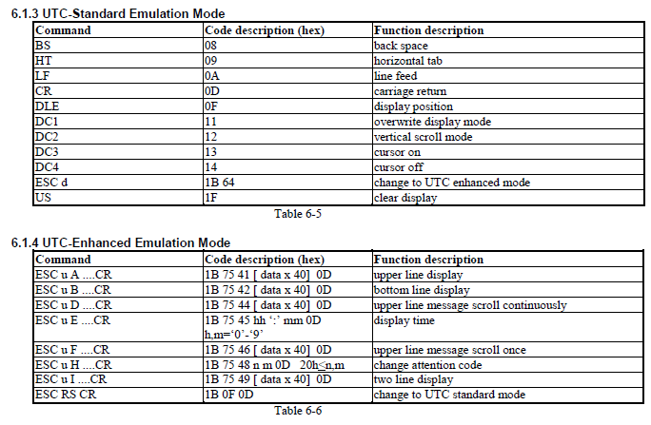
Logic Controls (aka UTC) Command Set

IEE Command Set from:

4.0 OPERATION
4.1 Loading ASCII Character Data
All printing characters are located in standard ASCII code locations from 20 (HEX) to FF (HEX). Control
character assignments are as follows.
4.2 Control Codes
NOTE: CARE SHOULD BE TAKEN NOT TO SEND UNDEFINED CONTROL OR COMMAND CODES TO THE
FLIP DISPLAY MODULE AS THIS MAY CAUSE A SOFTWARE MALFUNCTION OF THE MODULE.
4.2.1 Instructions
DATA (HEX) DESCRIPTION
01 READING THE CHARACTER CAPACITY OF THE DISPLAY
(DISPLAY RESPONDS SENDING 28 (HEX))
02 DISPLAY SOFTWARE CHECKSUM AND SOFTWARE NUMBER
03 READ CURSOR LOCATION VALUE
(DISPLAY RESPONDS WITH 1 BYTE)
01-14 (HEX) FOR LINE 1
21-34 (HEX) FOR LINE 2
04 READ DATA AT PRESENT CURSOR LOCATION
06 BEGIN BLINK FIELD AT CURRENT CURSOR LOCATION
07 END BLINK FIELD AT CURRENT CURSOR LOCATION
08 BACKSPACE CURSOR LOCATION ONE POSITION (cursor stays when at HOME location)
09 ADVANCE CURSOR LOCATION ONE POSITION (cursor wraps around after bottom right
character location)
0A LINE FEED (vertical scroll from bottom line; cursor position does not change)
0C CLEAR THE DISPLAY (cursor stays)
0D CARRIAGE RETURN (returns cursor to left-most character position of the same line; does not
clear display)
0E MAKE CURSOR INDICATOR INVISIBLE (the cursor location counter continues to function
but there is no visible indicator of next character location)
0F + MAKE CURSOR INDICATOR VISIBLE, FLASHING BLOCK.
<10> BOTTOM LINE DATA ENTRY WITH AUTOMATIC CARRIAGE RETURN & LINE FEED (puts cursor at left side bottom row and data enters beginning at the left-most character
position of the bottom row, vertical scroll from bottom line after line has been filled)
<11> + NORMAL DATA ENTRY WITH AUTOMATIC CARRIAGE RETURN AND LINE FEED (data enters beginning at the home position, vertical scroll from bottom line after line has been filled)
<12> OVERWRITE OF RIGHT-MOST CHARACTER ON THE PRESENT LINE/AUTOMATIC CARRIAGE RETURN OFF
<13> HORIZONTAL SCROLL MODE (from right to left on bottom line only, after line has been filled)
14 RESET (all configurations go to default setting and clear all DOWN LOAD CHARACTERS)
15 + DISPLAY CLEAR (puts cursor at left side bottom row in Mode 10 HEX, & home in Modes 11 HEX, 12 HEX, 13 HEX and 1A HEX)
16 + CURSOR HOME (returns cursor to upper left-most position)
19 SET BIT 7 HIGH FOR NEXT BYTE ONLY:
19-00 TO 19-7F: Same as ASCII 80-FF
<1A> WRAP AROUND DATA ENTRY:
(After bottom right character enter, cursor moves to home position)
1B 1B-05-49 IEE SPECIFIC RESPONSE CODE
(Sent without regard for flow control)
D,2,IEE,35980,-01 (CR) (18 BYTES)
1B-26-01-M-N DEFINE DOWN LOAD CHARACTERS
M=BYTE LOCATION TO BEGIN DOWNLOAD (F8 to FF)
N=NUMBER OF CHARACTERS TO BE DOWNLOADED
EACH CHARACTER PATTERN IS 5 BYTES (See 4.4)
1B-3D-N N=01 The display is not selected. All the data from the host is not processed in the display. +N=02 The display is selected. All the data from the host is processed in the
display.
1B-3F-N DELETE DOWNLOAD CHARACTER LOCATION N (N=F8-FF)
1B-40 TERMINATE SELF TEST (all configurations go to default setting
and clear all DOWN LOAD CHARACTERS)
1B
1B-74-N
SELECT CHARACTER SET
+N=01, ASCII AND GENERAL EUROPEAN (fig. 4)
N=02, ASCII AND KATAKANA (fig. 6)
N=03, ASCII AND CYRILLIC (fig. 5)
N=04, ASCII AND HEBREW (fig. 7)
N=05, ASCII AND ISO 8859-1 (fig. 8)
N=06, ASCII AND ISO 8859-2 (fig. 9)
N=07, ASCII AND GREEK (fig. 10)
1D-05 EPSON SPECIFIC RESPONSE CODE DISPLAY RESPONDS
SENDING 05 TO HOST.
1F 1F-24-C-L MOVE CURSOR TO COLUMN 01-14 (HEX)
LINE 01-02 (HEX)
1F-40 EXECUTE SELF TEST (Use 1B-40 to terminate self test)
1F-45-T SET ALL DISPLAY BLINK FIELDS AT INTERVAL T
T x 50 msec, 50% DUTY CYCLE
Tmax = 3F (HEX)
1F-58-N BRIGHTNESS LEVEL; N = LEVEL
01=20%, 02=40%, 03=60%, 04=100% (+)
1F-72-N SELECT/CANCEL REVERSE DISPLAY MODE
N=01 REVERSE; N=00 CANCEL (NORMAL)
20 to 7F MAIN CHARACTER SET
80 to F7 ALTERNATE CHARACTER SET
F8 to FF USER DEFINED CHARACTERS (see Section 4.4)
+ Display automatically defaults to these conditions after power-up or reset.
< > These instructions are mutually exclusive

