Full Minicubator assembly is broken into four parts -- enclosure sub-assembly, electronics sub-assembly, code uploading, and final assembly.

Enclosure Sub-assembly

1. 3D print outer encasement from the enclosed .stl file (shown in **Figure 1**)

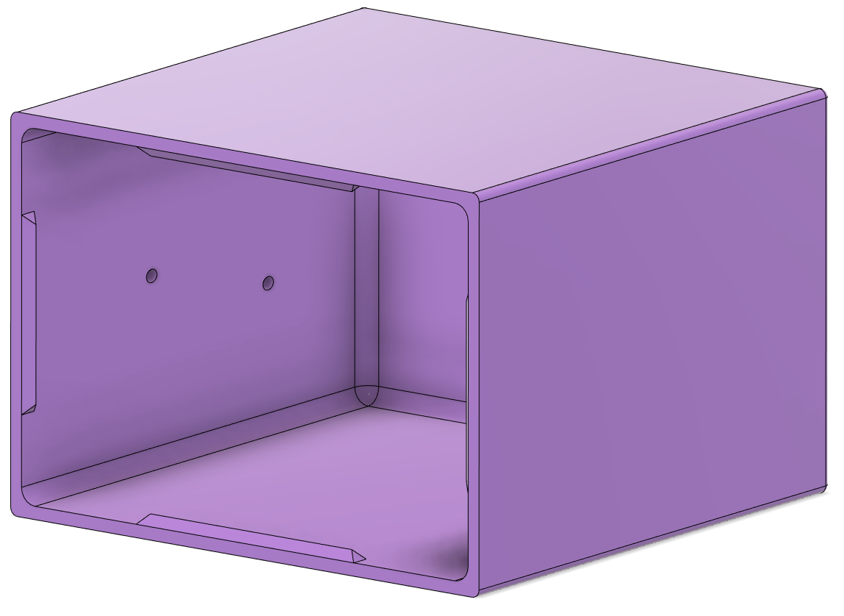

**Figure 1.** Outer encasement 3D print.

1. 3D print peg from the enclosed .stl file (**Figure 2**)

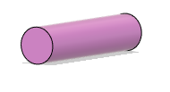

**Figure 2**. Peg to mount inner heating chamber to outer encasement. There is a flat end on each of the two sides.

1. 3D print inner heating chamber from the enclosed .stl file (**Figure 3**)

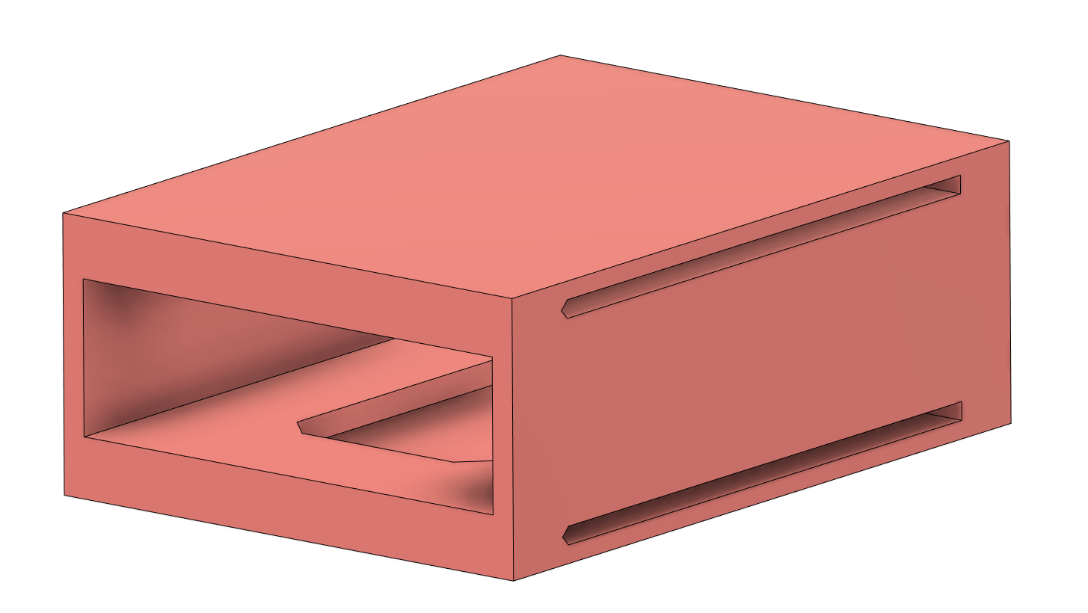

**Figure 3.** Inner heating chamber. Note that this will be a green box representation in future steps.

1. 3D print lid/petrifilm holder from the enclosed .stl file (**Figure 4**)

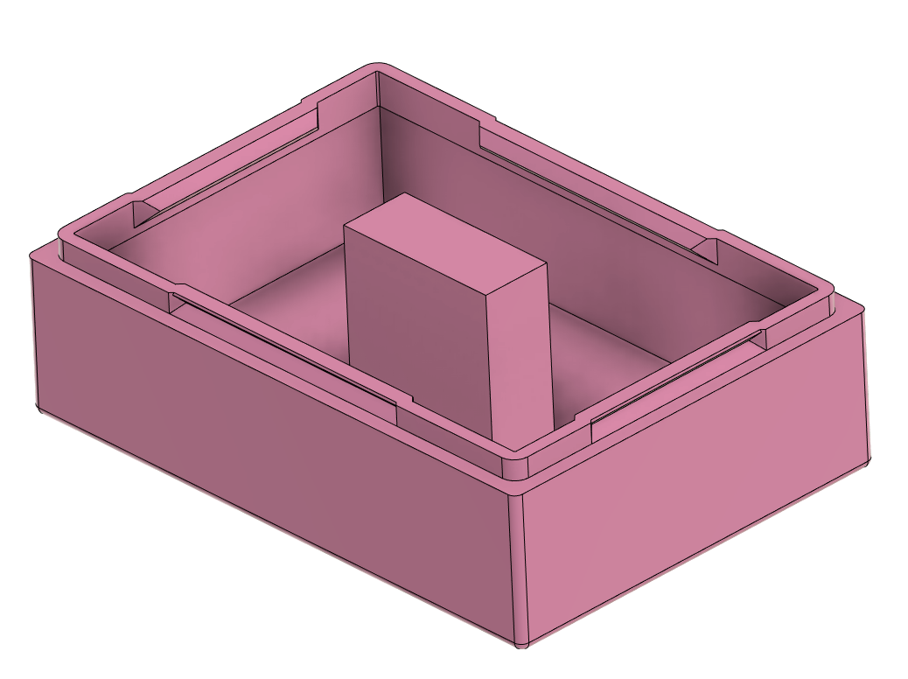 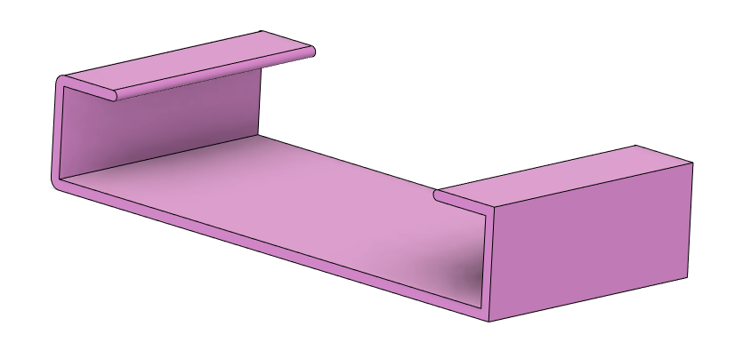

**Figure 4**. Designs of the lid and petrifilm holder.

1. Using super glue, apply a single layer (approximately one pea-sized dab) of superglue or cyanoacrylate (generic superglue) to one of the flat ends of the peg and adhere the peg onto the center of the outer wall of the inner heating chamber (**Figure 5**).

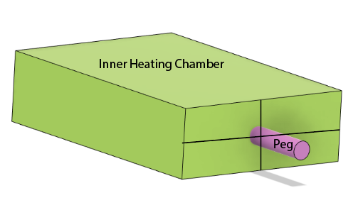

**Figure 5.** Attachment of peg to inner heating chamber. Note that this is the same as the orange print shown in Figure 3.

1. Apply a layer of glue to the other (open) end of the peg and insert into the center of the interior wall of the outer encasement, as depicted below (**Figure 6**).

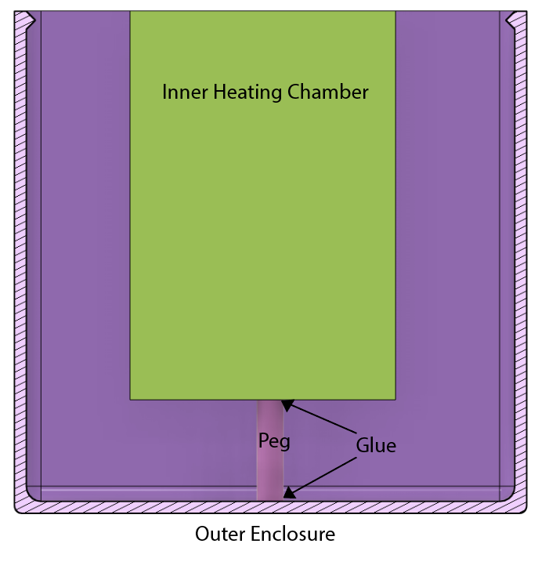

**Figure 6**. Attachment of inner heating chamber and peg to outer encasement.

1. Bond inner heating chamber and outer encasement gap with polyurethane foam.
   1. Hold the 3D print of the inner heating chamber
   2. Aim nozzle of polyurethane foam canister into the gap between inner heating chamber wall and outer encasement. The foam will expand to fill all of the cracks and crevices.

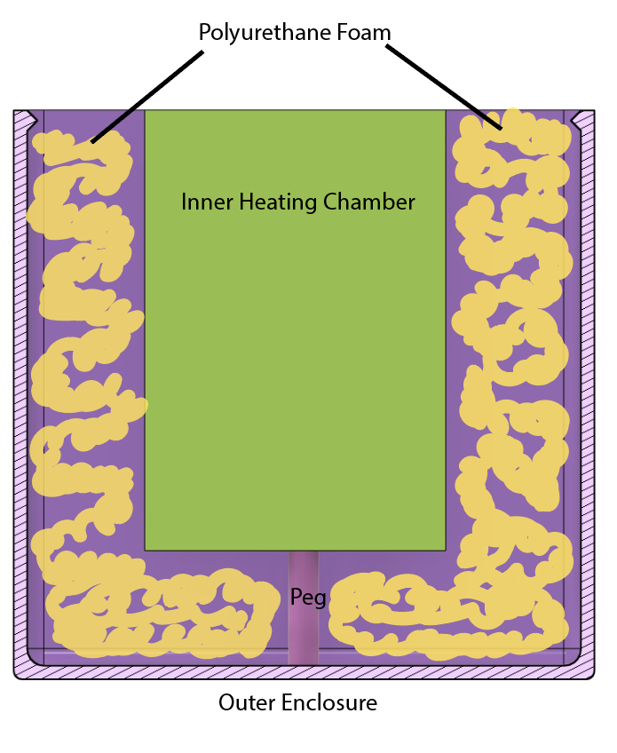

**Figure 7.** Qualitative filling of the inter enclosure space with polyurethane foam.

* 1. Fill with polyurethane by pressing on the nozzle and releasing the polyurethane foam into the intermediate chamber between the inner heating chamber and outer encasement. Move in a circular manner around the intermediate chamber to ensure even spread of foam. Let sit to dry. (**Figure 7**)

1. Fill the lid with polyurethane as done for the outer chamber (**Figure 8**). The polyurethane will expand as before. Once the polyurethane expands, the excess will need to be cut away using a band saw or standard tooth saw.

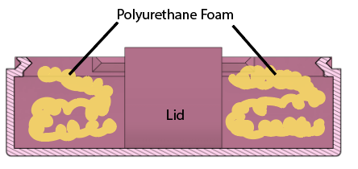

**Figure 8**. Filling of polyurethane foam into the lid material.

1. Glue the petrifilm holder to the top of the lid using approximately 1 mL of superglue or cyanoacrylate (generic superglue), as depicted below. Glue should be applied to the front end of the petrifilm holder as shown below, and adhered to the abutment on the lid.

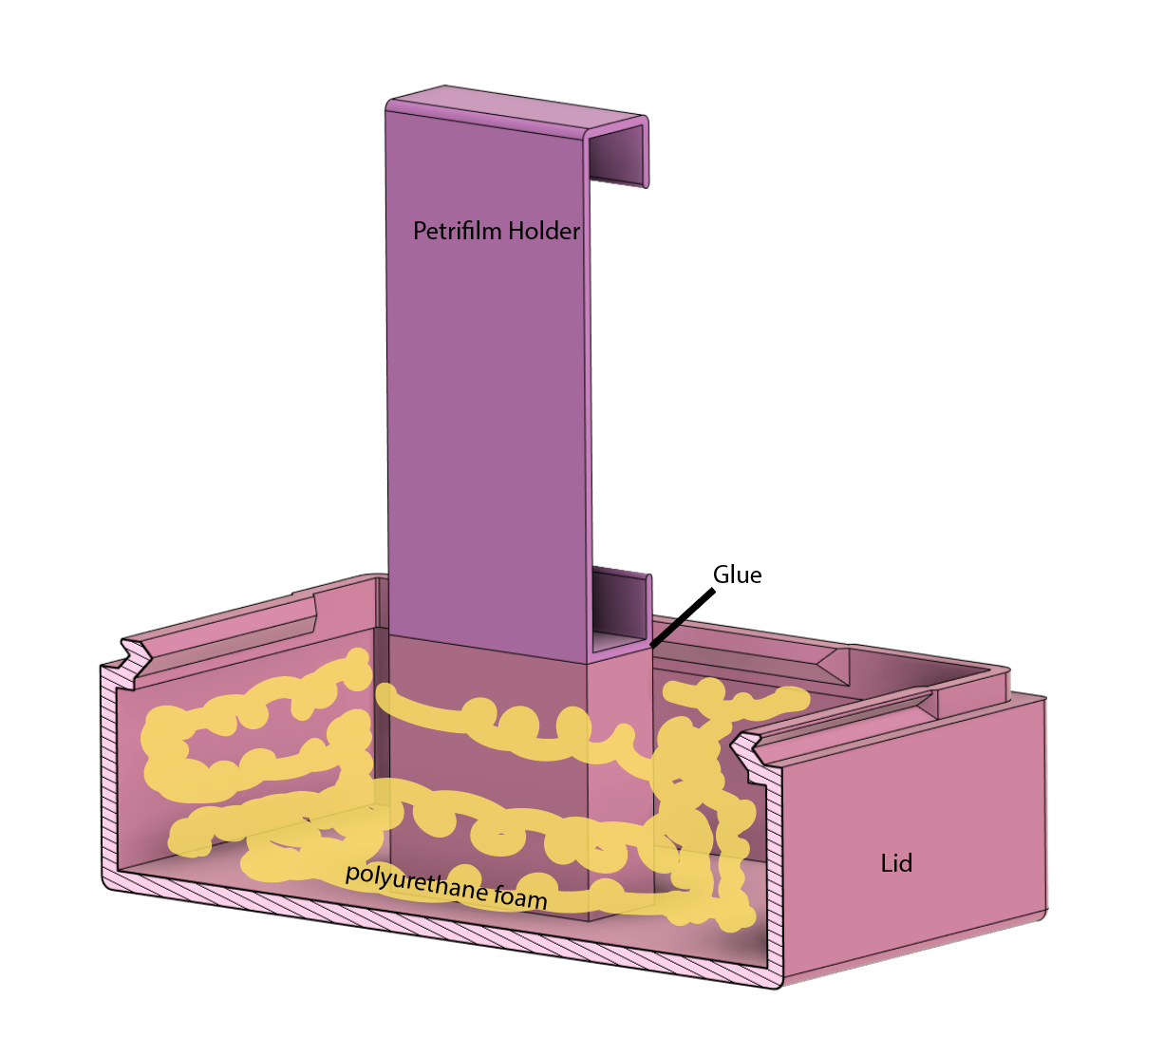

1. Once the petrifilm holder dries and adheres to the lid, then the lid assembly is finished. The lid should now slide into the inner chamber and snap into the enclosure.

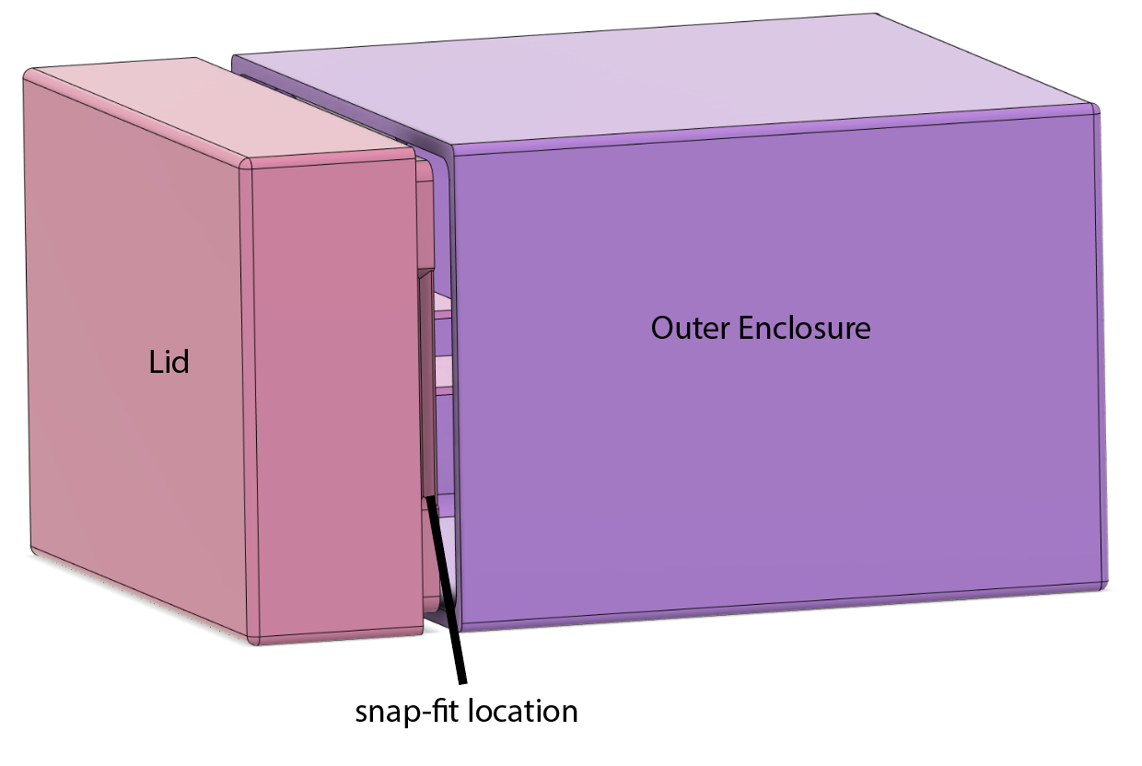

Electronics Assembly

Materials: PCB, Arduino Nano Every, Buttons (x3), Piezo, LED, Heating Pad with wire, Thermistor with wire, MOSFET, OLED breakout board.

1. Remove Arduino Nano Every and the two sets of header pins enclosed with the Arduino Nano Every from packaging.
2. Insert the header pins into the Arduino Nano Every such that the short ends of the pins are inserted into the circular holes embedded on each side of the Arduino, and the long ends of the pins are located on the side opposite that with all circuit elements.
3. Insert Arduino Nano Every into the port for the Arduino in the configuration as denoted in **Figure 9** below, and solder all header pins to the board as well as the arduino. The footprint on the board matches that of the Arduino, so the pins should line up correctly.

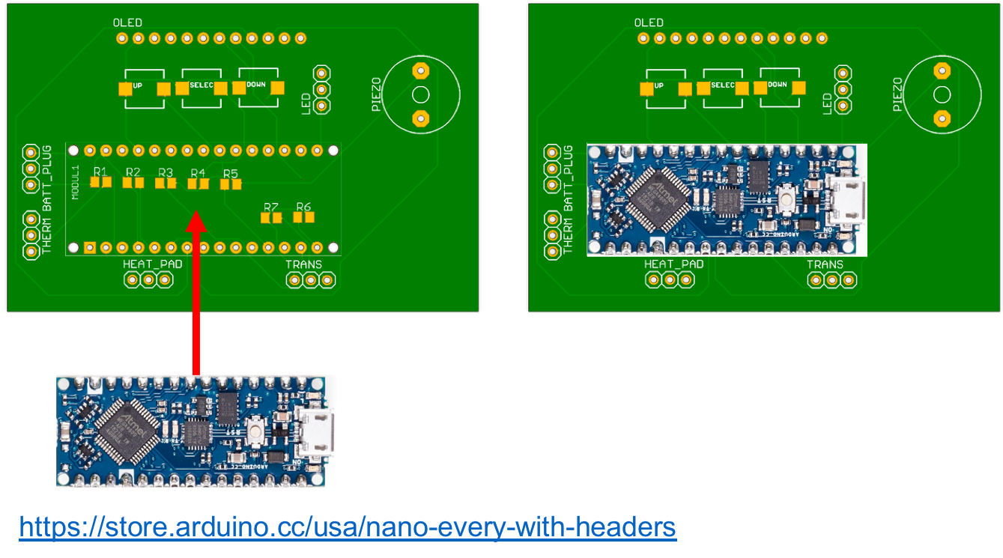

**Figure 9.** Orientation and positioning of the Arduino with the PCB. Arduino from [1].

1. Attach the button to the PCB in the following manner, and solder the buttons in place (**Figure 10**).

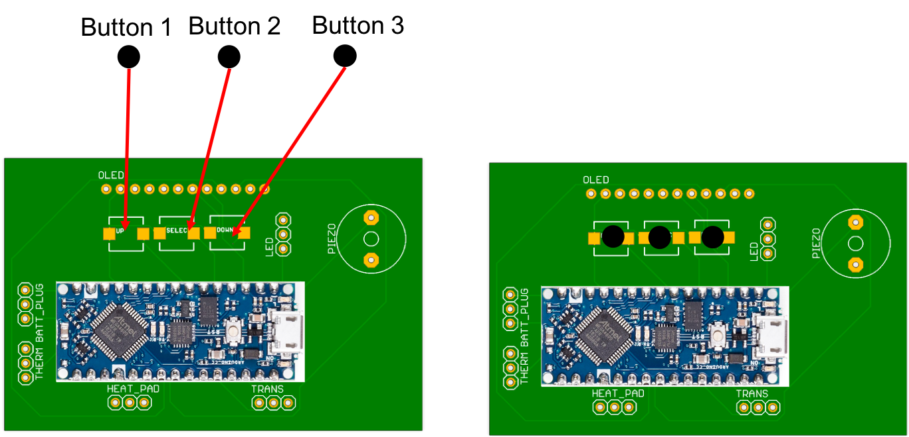

**Figure 10**. Mount of each of the three (indistinguishable) buttons onto the respective locations on the PCB.

1. Attach the piezo on the PCB in the following manner, and solder the piezo in place (**Figure 11**).

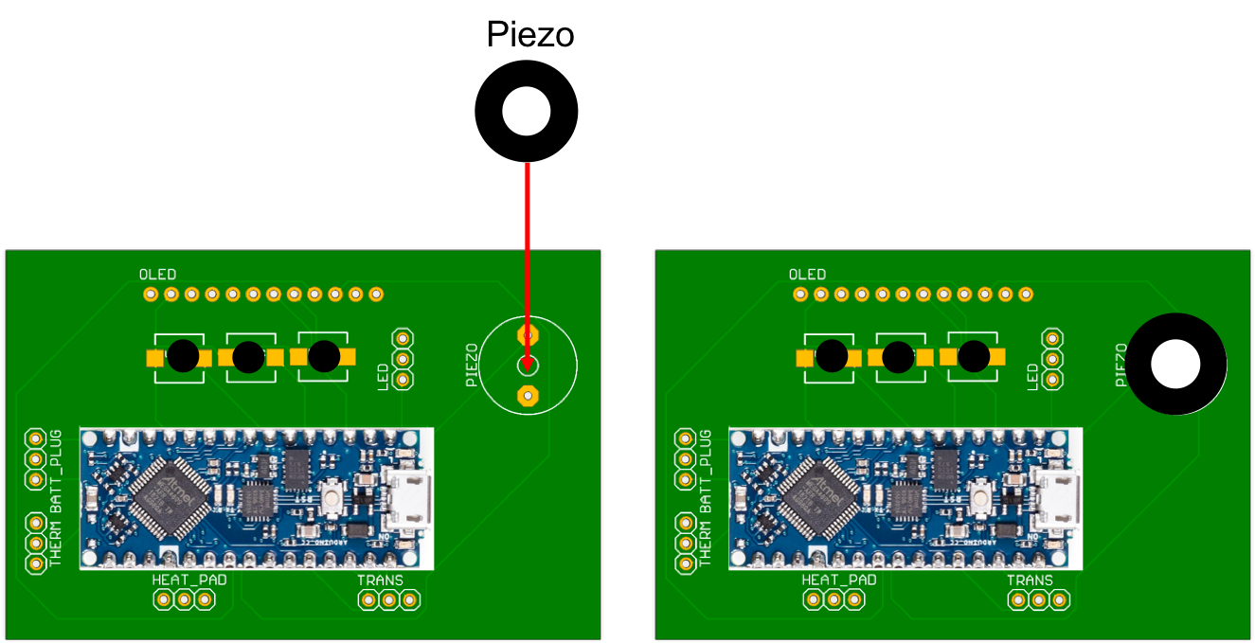

**Figure 11**. Piezo placement.

1. Remove the temperature measurement device and heating pad of the device. Solder them to the following port as follows (**Figure 12**).

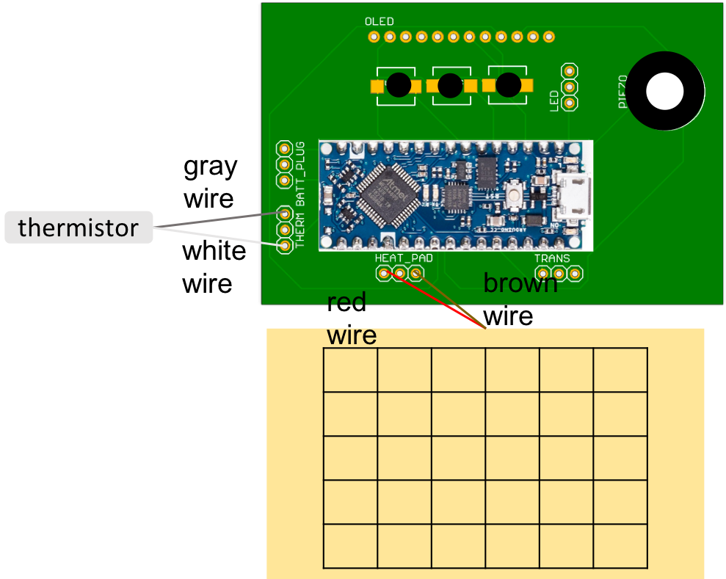

**Figure 12**. Thermistor (gray) and heating pad (goldenrod with grid) placement, with wire color connections to the PCB.

1. Solder the transistor in the following connections, in the shown orientation (**Figure 13**).

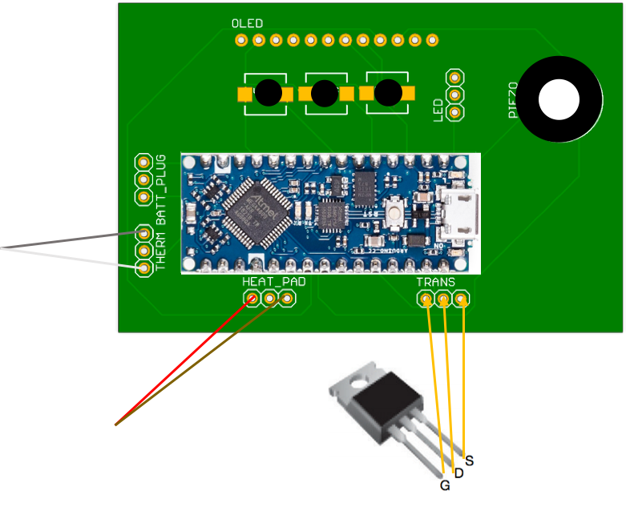

**Figure 13.** Connections of the N-channel transistor to the PCB as shown [2].

1. Remove the OLED and the header pin from its packaging. Attach the header pin into the OLED ports as follows, with the short end of the header pin connecting to the port on the OLED, and solder all pins in place.
2. Solder the long end of the header pin into the board of the PCB (**Figure 14**).

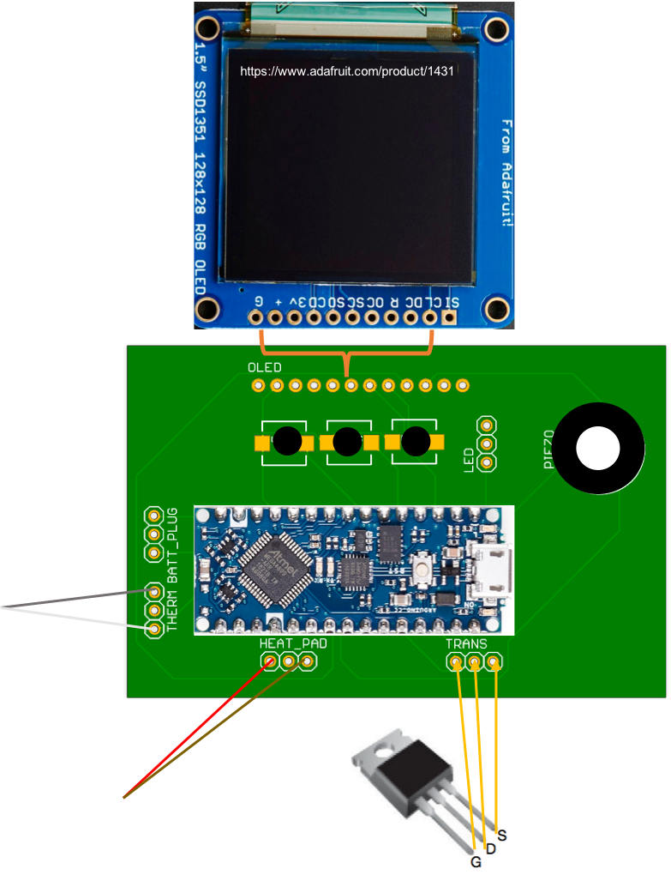

**Figure 14.** Connection of OLED to the PCB. OLED photo taken from [3].

Code Uploading

1. Download the enclosed software onto a personal computer.
2. Using a microUSB-USB adaptor, connect the Arduino to the computer.
3. Open the Arduino code downloaded in (1). Open the Arduino code, and click on “Upload” in the top right corner of the Arduino Interface.
4. Once the upload is complete as signaled by the computer, remove the connection by removing the microUSB from the adaptor of the Arduino.

Full Minicubator Device Assembly:

1. Place the PCB as shown into the mounting plate of the electronics enclosure.
2. Close the electronics enclosure and snap the upper lid shut.
3. Insert the thermistor and heating pad connections into the enclosure through the associated holes (**Figure 15**).

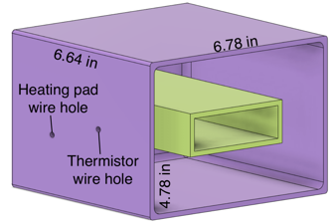

**Figure 15**. Site of insertion of heating pad wire hole and thermistor wire hole.

1. Glue the electronics enclosure onto the top of the main enclosure, as follows using superglue or cyanoacrylate (generic superglue) (**Figure 16**).

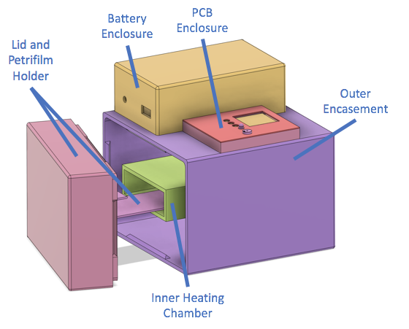

**Figure 16**. Full Assembly rendering.

**References**

[1] “Arduino Nano Every with headers | Arduino Official Store.” https://store.arduino.cc/usa/nano-every-with-headers (accessed May 05, 2021).

[2] “N-channel power MOSFET.” https://www.adafruit.com/product/355 (accessed May 05, 2021).

[3] “OLED Breakout Board - 16-bit Color 1.5" w/microSD holder.” https://www.adafruit.com/product/1431 (accessed May 06, 2021).