Stage Micing — User Manual
Stage and microphone layout for classical concerts
Purpose · Users · Basic functions · Further functions · Notes
This manual describes what Stage Micing is for, who uses it, its basic and further functions, and the points to watch in daily work. The program is a Windows desktop application whose interface is Chinese, English, German or French; it lays an orchestra out in true metric scale, places microphones, routes cables and finally exports the stage plot, the wiring plot and the channel list. One project serves both the recording plan and the conversation with the orchestra.
The text has five chapters. Chapter 1 gives the purpose and the workflow, chapter 2 the users and the prerequisites, chapter 3 the five pages in working order, chapter 4 export, files, the app lock and the common operations. Chapter 5 collects everything that is easy to get wrong. The appendices contain a glossary and the command-line switches.

Software: StageMicing.exe (Windows 10 / 11, 64-bit)
Sources: 功能总览.txt, README.md, docs/CABLING.md, docs/BACKUP-RULES.md and the current source code
Readers: recording and sound-reinforcement staff, orchestra staff, conductors, music students and teachers
Version: November 2026

Contents
Chapter 1 Purpose what the program does, main uses, workflow
Chapter 2 Users recording and sound reinforcement, orchestra and teaching, prerequisites
Chapter 3 Basic functions window, workflow, the five pages as used day to day
Chapter 4 Further functions export, files, app lock, language and display, common operations
Chapter 5 Notes scale, presets, wiring, cable length, flown mics, undo, passcode, files, build, limitations
Appendix A Glossary main microphone, SRA, azimuth, flown microphones
Appendix B Command line the switches

How to read this manual
(1) Page names. The references “01 Project”, “02 Instruments”, “03 Microphones”, “04 Channel list” and “05 Wiring” mean the five tabs in the top bar.
(2) Inspector. The property panel on the right of the window; its content follows the current page and the selected object.
(3) Units. Lengths are in metres (m), angles in degrees (°); one canvas grid square is 0.05 m.
(4) Terms. Microphone techniques and the other technical terms are explained in appendix A.
(5) Notes. Chapter 5 is ordered by the places where things go wrong; read sections 4 and 7 before working on site.

Chapter 1 Purpose
1. What the program does
Stage Micing is a Windows desktop program used to plan the stage layout and the microphone setup of a classical concert. It works in real metric scale: place the orchestra, place the microphones, route the cables, and finally export the stage plot, the wiring plot and the channel list.
One project serves two kinds of readers. Recording and sound-reinforcement staff plan microphones and cable runs with it; orchestra staff, conductors and students use it to check instrumentation, seating and how much of the stage is taken.
2. Main uses
The program serves four uses; they are listed in table 1.
Table 1 The four main uses
Use | Content
Stage layout | Lay the orchestra out in metres, mark position and orientation of every instrument, and check whether the stage has room for it.
Microphones | Place the main microphone and the spot microphones, choose the stereo technique and read the SRA.
Cable routing | Connect microphones to stage boxes, audio interfaces or wireless receivers; the program derives the route and the cable length.
Documents | Export the channel list as PDF and the stage or wiring plot as PNG for the crew and for the archive.

3. Workflow
A complete design follows the sequence above. The five pages can be visited in any order; the data always belongs to the one project.
Table 2 Typical workflow
Step | Page | Work
1 | 01 Project | Fill in the piece, the venue, the conductor and the staff; set stage width, depth and ceiling; optionally pick a venue preset.
2 | 02 Instruments | Load a built-in layout as a starting point or drag instruments out of the library; adjust position, orientation and name.
3 | 03 Microphones | Place the main microphone and choose its technique, read the SRA; place spot microphones and bind them to a section; mark flown microphones.
4 | 05 Wiring | Add stage boxes, audio interfaces or wireless receivers and wire the microphones to them; check channel counts and cable lengths.
5 | 04 Channel list | Check the channel, model, instrument, route and length; reorder rows and add remarks; export PDF and images.
6 | File | Save the project as a .smproj file for reuse and hand-over.

Chapter 2 Users
The program serves the recording side and the orchestra side at once. Both work on the same project; they only look at different pages.
1. Recording and sound reinforcement
Table 3 Users on the recording and sound-reinforcement side
Role | Main use | Pages
Recording engineer | Decides the main-microphone technique and position, reads the SRA, places spot microphones, confirms the channel list | 02, 03, 04
Sound engineer / reinforcement | Plans the route from microphone to stage box, checks the channel count of every box, estimates the cable length | 05, 04
Broadcast and recording planners | Produce the camera and microphone plan and deliver it with the project files | 02, 03, 05
Venue technical manager | Checks connector positions, cable runs and the total amount of cable | 01, 05

2. Orchestra and teaching
Table 4 Users on the orchestra and teaching side
Role | Main use | Pages
Orchestra staff (manager, librarian, stage manager) | Checks instrumentation and seating, confirms the stage size and how the orchestra enters, produces plots for the orchestra | 01, 02
Conductor | Reviews the section layout, instrument orientation and stage occupancy against the rehearsal plan | 01, 02
Music students and teachers | Works through the main-microphone techniques and the SRA against a textbook; does layout and microphone exercises | 02, 03
Production and broadcast coordination | Takes the microphone list, the channel list and the stage plot and plans camera positions and cable runs | 04, 05

3. Prerequisites
(1) Recording and sound-reinforcement staff. Need a working knowledge of instruments and sections, of microphone polar patterns and of the AB, Decca tree, XY, MS, Blumlein, ORTF, NOS and DIN techniques. Orchestra and teaching staff need only drag-and-drop and filling in fields; the microphone terms are explained in appendix A.
(2) System. Windows 10 or Windows 11, 64-bit.
(3) Running the program. Unpack, then run StageMicing.exe; the assets folder must sit next to the executable.
(4) Screen. 1600×900 or more, so that the five tabs and the inspector are fully visible.
Chapter 3 Basic functions
1. Window layout
The window has five regions: the top bar, the library on the left, the stage canvas in the middle, the inspector on the right and the status bar at the bottom. Changing the page changes the canvas and the inspector only.
Table 5 Window regions
Region | Content
Top bar, left | Application mark and subtitle.
Top bar, centre | The five tabs: 01 Project, 02 Instruments, 03 Microphones, 04 Channel list, 05 Wiring.
Top bar, right | From the right: app lock, language (中文 / EN / DE / FR), export (“Export PDF” on the channel list, “Export image” on the other pages), “Presets”, “Simplify”, the SRA read-out and “File”.
Library | Two tabs, “Instruments” and “Microphones”, grouped by category, with a search field and the number of items on top. 30 instruments and 9 microphone items.
Canvas | The stage on a metric grid with width and depth marked; the audience and the off-stage area surround it. Zoom factor and “fit” sit at the lower right.
Inspector | Follows the page and the selection: project fields, stage size, object properties, colour, layer switches, device list.
Status bar | Stage size and object count, the current hint, the zoom factor.

2. Basic workflow
Four steps carry a complete design: lay out the orchestra, place the microphones, wire the devices, produce the documents. The pages are described below in that order.
3. 01 Project
This page is the cover sheet of the project and the one place where stage size and ceiling height are set. An information card sits in the middle of the page.
(1) Project fields. Piece, venue, conductor, system engineer, recording engineer, assistant and remarks. The remarks are printed on the exported PDF and images — a good place for the date, contacts and anything the crew should know.
(2) Stage size. Width, depth and ceiling. The default is 14.0 × 10.0 m, the ceiling 8.0 m (3 to 20 m). The ceiling is used only for the cable of flown microphones; the small note under it reads “flown equipment height”.
(3) Venue presets. Concert hall 18 × 12 m, church 12 × 20 m, salon 9 × 7 m. One click applies the size; the whole layout is shifted by half the difference and stays centred.
(4) Appearance. Two colours, “text” and “stage”, are stored with the project. Instrument and microphone line colours follow section and category; a single object can be coloured on its own, see section 4 of this chapter.
4. 02 Instruments
The library holds 30 instruments in seven groups: keyboard 4 (grand piano, upright piano, harpsichord, celesta), strings 6 (violin I, violin II, viola, cello, double bass, harp), winds 4 (flute, oboe, clarinet, bassoon), brass 4 (horn, trumpet, trombone, tuba), percussion 8 (timpani, snare, bass drum, gong, cymbal, xylophone, glockenspiel, percussion), voice and podium 3 (conductor, solo singer, choir singer) and other 1 (custom).
(1) Adding. Click an instrument in the library: the program selects the matching object already on stage and offers “Add instrument” below the icon. Drag the icon onto the stage to create it where it lands.
(2) Editing. With an object selected the inspector changes name, X, Y and angle; it can also be dragged directly. Several objects move and rotate together; the arrow keys nudge.
(3) Single colour. Every instrument can take a colour of its own that overrides the palette, and the spot microphones, cables and labels bound to it follow; “restore default” brings the palette colour back.
(4) Built-in layouts. “Presets” in the top bar offers several fixed layouts, for example the European three-woodwind layout with 86 players and the American one with 85.
(5) Same-type hint. With three or more instruments of one type (solo singers excluded) the area carries a single label such as “Violin I ×15” instead of individual frames. Select one of them and the inspector offers the whole type in one click.
(6) Layer switches. Four switches in the inspector — show instruments, show microphones, instrument text, microphone text — are stored with the project. “Simplify” replaces the icons by plain, unrotated shapes, which keeps a large orchestra readable.
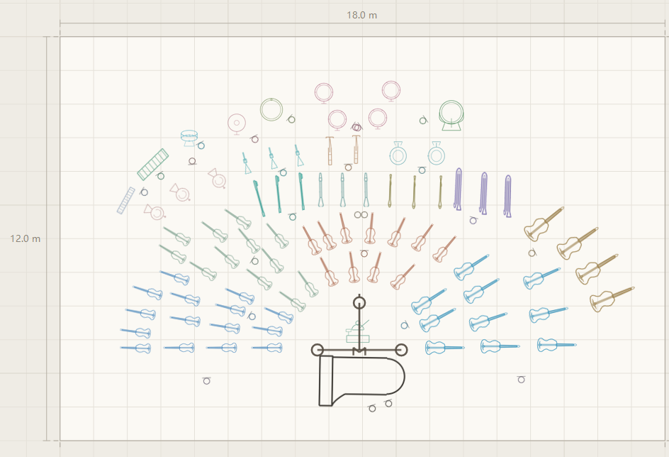
Figure 1 Orchestra layout (18.0 × 12.0 m stage, three-woodwind example)
5. 03 Microphones
Nine microphone items in five groups: main microphone, spot microphone, lavalier, intensity-difference techniques (XY, MS, Blumlein) and mixed techniques (ORTF, NOS, DIN).
(1) Main microphone. One per project. Three techniques: AB, intensity difference, mixed difference (including the Decca tree). Spacing, centre offset, height and the flown flag can be set.
(2) SRA. The stereo recording angle, read in the top bar. AB is computed from a stereo localisation model, the intensity techniques use the standard table (180, 130, 100 and 76 degrees); the canvas draws the two rays that bound the angle.
(3) Spot microphone. A single microphone with height, model and angle, bound to a section, to a specific instrument or to a category. The binding appears in the inspector, in the “instrument” column of the channel list and in the PDF.
(4) Intensity difference. One object on stage that occupies two channels. The inspector takes the L and R models (M and S for MS); this group has no spacing parameter.
(5) Mixed difference. Two ordinary microphones placed and then bound into one group: the appearance stays that of a single microphone, no line is drawn between them, the pair is selected and rotated as a unit and shares one two-channel cable.
(6) Label placement. If the label of a pair does not fit, the left microphone is labelled at its lower left and the right one at its lower right.
(7) Binding targets. 38 in all: the 30 instruments plus 8 groups and channels (surround, height, side extension, ambience, strings, woodwind, brass, percussion).
(8) Two-level picker. Current binding, surround, height, side extension, strings, woodwind, brass, percussion, individual instruments, ambience. Hovering a category opens a second level on the left or right. The harp sits outside the strings group; keyboard and voice are listed individually.
(9) Grouping. A confirmation appears from three microphones up, or when the group spans more than 5 m. The group shares one cable: the members converge on their mean point and one main run leaves it.
(10) Flown microphones. Tick “Flown” and set the height (6.5 m by default); a “FLY” badge appears next to the microphone and the cable is computed in four legs: up to the ceiling, along the side wall, down the wall, across the floor.
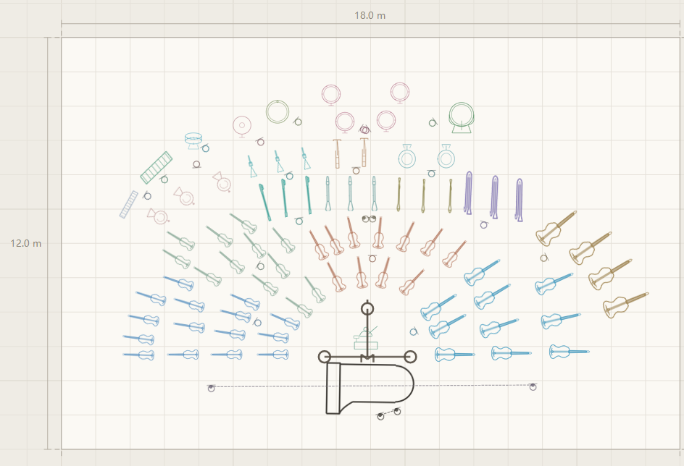
Figure 2 Microphone plot (library and microphone positions on stage)
6. 04 Channel list
The channel list is the main deliverable. Its eight columns are fixed: channel, model, instrument, remark, route, microphone cable length, distance to the main microphone and azimuth. A cable summary block closes the table.
(1) Order. Main microphone, surround, height, side extension, grand piano, upright piano, harpsichord, strings, woodwind, brass, percussion, other instruments, custom, solo voice, choir, ambience, unassigned. Inside a group the microphones bound to a category come first.
(2) Distance to the main microphone. The planar distance to the L and R capsules; the centre capsule is not used. Microphones on the left half are measured to the left capsule and those on the right half to the right one; a group uses its convergence point.
(3) Azimuth. Measured from the midpoint of the L and R capsules, straight upstage towards the audience being 0 degrees, positive to the right and negative to the left.
(4) Microphone cable length. The column head names the current mode: click it to switch between “Recommended” and “Actual”. Recommended rounds the length up to the standard drum sizes, Actual shows the raw length. The mode is saved with the project and the PDF follows it.
(5) Paging. The arrow keys or PageUp / PageDown turn whole pages; the table never scrolls. The head repeats on every page and the toolbar shows “page i of N”.
(6) Editing in place. The model, instrument and remark cells open for typing on every page.
(7) Route column. A click opens the device list; picking one completes the connection with the same rules as the wiring page. This cell never opens a text field.
(8) Read-only columns. Distance and azimuth are read-only; a click only selects the row.
(9) Dragging rows. Holding the grip at the left end of a row moves it, the order is saved with the project and can be undone. “Auto sort” restores the default order and can be undone as well.
(10) Column switches. Eight switches above the table hide columns that are not needed; the PDF follows.
(11) Cable summary. The closing block lists the links between stage boxes and interfaces with channel count and length, which is what the trunk check needs.
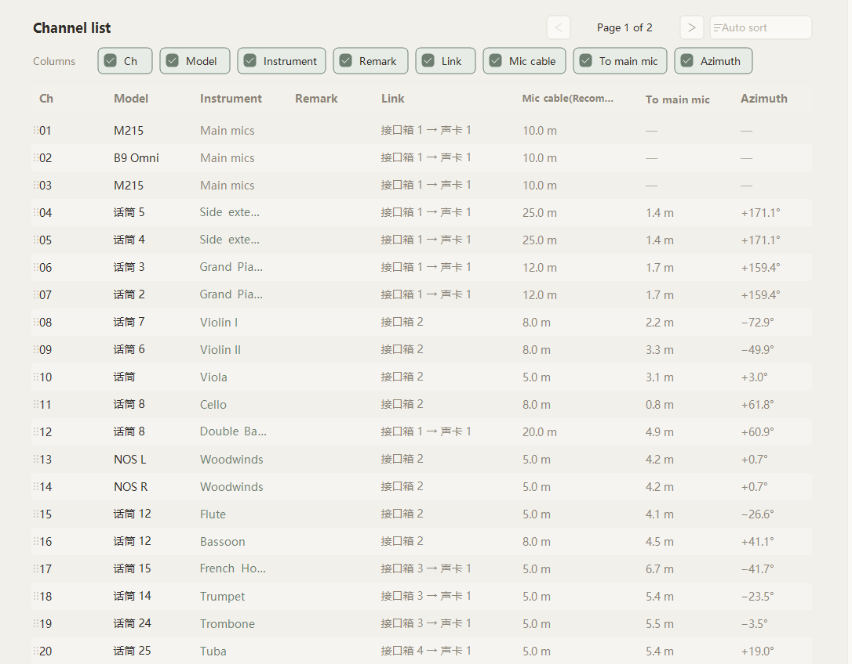
Figure 3 Channel list (eight columns and the column switches)
7. 05 Wiring
This page answers who is connected to whom and how long the cable is. The canvas shows the microphone terminals and three kinds of device; the instruments themselves are not drawn.
Table 6 The three device kinds
Device | Content
Stagebox | The analogue and the digital box are one kind. Its properties are name, input channel count and position; a cable is checked against that count.
Audio interface | Treated as the hub: its inputs are unlimited and it never becomes a capacity limit.
Wireless receiver | Properties are name, channel count and position. A wireless microphone connects to it first and the receiver connects onwards.

(1) Wiring by mouse. Right-click the first object and left-click the target to lay a cable; right-click empty space to cancel. Re-wiring needs no deletion — connect the new target and the old cable is replaced with a note.
(2) Wiring from the inspector. Select a microphone on the wiring page and the “Connect” block appears on the right; click a device to connect it. The old cable is replaced, the step can be undone, and a group is wired as a whole.
(3) Capacity. Stage boxes and receivers are checked against their channel count; an overloaded cable turns red and carries an exclamation mark. Hovering it shows what is required and what is available.
(4) Length rule. A normal microphone is its height plus the floor run; a flown microphone is the sum of height, ceiling leg, wall leg and floor leg; a group is the collector stubs plus one main run.
(5) Cable labels. A microphone cable is labelled with channel number and microphone name, for example 08 话筒 7, 04–05 话筒 5 or 13–14 NOS L; a device-to-device trunk shows “N channels”, a radio link “wireless N channels”, and an overload adds the exclamation mark.
(6) Colour. The microphone symbol, its cable and its label take the colour of the bound section; an unbound microphone stays neutral.
(7) Label layout. All labels are placed in one pass: the hardest first, then relaxed over several rounds, so that they never overlap, never cover a device box and stay close to their own cable.
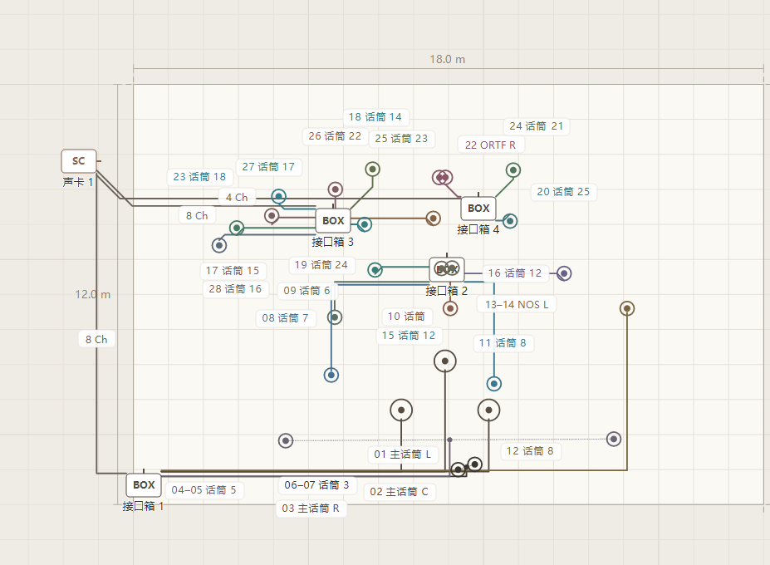
Figure 4 Wiring (devices, cables and labels)
Chapter 4 Further functions
1. Export
(1) PDF. The channel list only. Long lists break over pages, each page repeats the project header and the column head, and the page number sits in the footer; the length mode follows the channel list.
(2) PNG. Exports the plot of the current page. “Export image” first asks for the scale: normal 2×, high 4×, ultra 8×. The image is cropped to the content bounding box and contains everything on stage, including microphones and devices far outside it; the project header is printed in the upper left corner.
(3) Progress. A wait cursor and a progress line such as “exporting image… (4×)” appear during the export; the status bar then reports the file and the elapsed time. An 8× image takes a few seconds.
2. Files and file association
(1) File menu. Save project, save as, open project, register the .smproj association and remove it.
(2) Project file. .smproj is UTF-8 text with one record per line, which keeps backup and versioning simple.
(3) Association. After registration a double click on a .smproj file opens it here. The association is written for the current user and can be removed at any time.
(4) Older projects. Objects the program no longer knows are skipped and the rest loads as usual.
(5) Closing. With unsaved changes the program asks “save changes?” when the window closes and offers save, discard or cancel.
3. App lock
(1) Entry. The padlock at the far right of the top bar, meant to protect a project on site.
(2) Passcode. Four digits. The program stores no plaintext: a random salt and a SHA-256 value go into applock.dat next to the executable.
(3) Locking. Setting or changing the passcode locks at once, and the lock survives a restart.
(4) Read-only. While locked the project can be viewed, paged, zoomed, exported, opened and saved as; anything that would change data is refused.
4. Language and display
(1) Language. Chinese is the base language, and English, German and French are provided as well. Interface text and exported documents follow the choice; the project data does not change.
(2) Zoom. 25% to 500%; “fit” at the lower right brings everything into view.
(3) Palette. 40 colours ordered so that neighbours differ as much as possible; the 38 binding targets each have their own colour.
(4) Simplify. Toggles between simplified shapes and detailed icons; the grand piano keeps its detailed icon.
5. Common operations
Table 7 Mouse and keyboard
Action | Effect
Click an object | Selects it
Ctrl + click | Adds to or removes from the selection
Ctrl + A | Selects everything on the current layer
Ctrl + drag | Rubber-band selection
Drag empty space, middle-drag, space + drag | Pan the view
Wheel | Zoom around the cursor (25% to 500%)
Drag an object | Move it, snapped to 0.05 m
Arrow keys | Nudge 0.05 m; Shift 0.50 m; Ctrl 0.01 m
Delete | Deletes the selection and its cables
Ctrl + Z, Ctrl + Y | Undo, redo (50 steps)
Right-click an object (wiring page) | Starts a cable; left-click the target to finish, right-click empty space to cancel
Arrow keys or PageUp / PageDown | Turn pages in the channel list
Click a library item | Selects the matching object and offers “Add instrument/microphone”
Drag a library item onto the stage | Creates it where it lands

Chapter 5 Notes
1. Dimensions and scale
(1) Coordinates. All lengths are in metres. The origin is the upstage left corner: y = 0 is the back edge, y equal to the depth is the stage front (audience side) and x = 0 is the left side.
(2) Zoom. The canvas zoom changes the view only. Cable length, SRA, distance to the main microphone and azimuth are computed in metres and do not depend on it.
(3) Main microphone. Spacing and centre offset inside the symbol are drawn at 1:1, so zooming in shows the true proportions.
(4) Changing the stage. After shrinking the stage some instruments may fall outside it; they have to be moved by hand.
2. Presets and the stage
(1) Fixed data. The built-in layouts come from measured placements and are fixed data; adjust them after loading as the case requires.
(2) What loading does. Loading a preset replaces every instrument on stage, clears all microphones (including the main microphone and the groups) and their cables and sets the stage to 18 × 12 m. Cabling devices and project fields stay. Save the current project first.
(3) Changing the venue. Switching the venue preset or editing width and depth shifts the layout and keeps it centred; the relative positions do not change.
3. Wiring rules
(1) Route. The router always takes the shortest way. Two crossing cables are a purely visual matter and change neither length nor channel count.
(2) Corners. A 45 degree cut is allowed only in the upstage half (the half away from the audience); the downstage half runs strictly horizontal or vertical. Aligned ends give one straight segment, otherwise exactly one corner.
(3) Detours. The only detour is a device rectangle that the straight line would cross.
(4) Radio links. Wireless links (lavalier and receiver) are dashed, carry no length and are left out of the totals.
(5) Connections. A microphone goes to a stage box or an audio interface; a wireless microphone goes to a wireless receiver first and the receiver onwards.
(6) Capacity. Stage boxes and receivers are checked against their channel count and turn red when overloaded; the audio interface is the hub and has no such limit.
(7) Re-wiring. Connect the new target directly; the old cable is removed without deleting it first.
4. Cable length
Two length conventions appear in different places; check which one you are reading, see table 8.
Table 8 The two length conventions
Convention | Where | Rule
Actual | Labels and totals on 05 Wiring | Height plus floor run; for a flown microphone the sum of the four legs. No reserve.
Recommended | The “microphone cable length” column of 04 Channel list, default | The actual length rounded up to the standard sizes 5, 8, 10, 12, 15, 18, 20, 25 and 30 m; above 30 m the next multiple of 5.
Actual (mode) | The same column after clicking the head | Every row shows its raw length without rounding.

(1) Mode is saved. The length mode is stored with the project and the exported PDF follows it.
(2) Breakdown. Hovering a cable shows the composition, for example “height 1.5 + floor 7.4 = 8.9 m”, or the four legs of a flown cable, which is what the riggers ask for.
5. Flown microphones
(1) Ceiling. A flown height above the ceiling is clamped to the ceiling with a note. The ceiling is entered on 01 Project, 8.0 m by default, and should be updated when the venue changes.
(2) Which wall. The ceiling leg runs to the left or the right side wall only, never to the front or back wall; the side follows the half of the stage the target device sits in.
6. Editing and undo
(1) Undo. 50 steps. Opening a project or loading a preset clears the history, so the step before cannot be reached any more.
(2) Mixed selection. Instruments and microphones selected together cannot be dragged; the program refuses and says so. Select them separately.
(3) Order. The manual order of the channel list is saved with the project; “Auto sort” clears it and can be undone.
(4) Deleting. Deleting a microphone deletes its cables; deleting one member of a group deletes the group.
7. App lock
(1) Lost passcode. There is no reset back door: the passcode cannot be recovered inside the program. Keep it somewhere outside the project data.
(2) Lock file. applock.dat sits next to the executable. Removing it is the same as having never locked, so the file and the passcode belong together.
(3) Read-only scope. While locked, changes are refused; viewing, paging, zooming, export, open and save-as keep working.
8. Files and data
(1) Saving. The project is saved by hand — “Save project” in the file menu. Save once before exporting; closing with unsaved changes asks first.
(2) Editing by hand. A .smproj file can be read in a text editor but should not be edited: a format or encoding mistake makes it unreadable or loses objects.
(3) Older projects. Check the channel list after opening an older project; skipped objects are reported as “ignored N unrecognised objects”.
(4) Moving the program. Move the executable, the assets folder and applock.dat together; copying the executable alone leaves the library without icons.
9. Build and backup
Anyone who modifies or rebuilds the program should follow the conventions of the repository.
(1) Build. cmake -S . -B build -G "Visual Studio 18 2026" -A x64, then cmake --build build --config Release; the script copies the result back to the root folder.
(2) Before building. Close the running program, otherwise the copy of the executable fails.
(3) Sources. The sources are UTF-8 without BOM. Edit the .cpp files in an editor; replacing text with PowerShell handles the Chinese characters as CP936 and corrupts bytes.
(4) Backup. docs/BACKUP-RULES.md: take a green snapshot after each batch of features that compiles cleanly, a before snapshot ahead of a large change, and roll back from the snapshot rather than repair for more than 15 minutes.
10. Known limitations
Table 9 Known limitations of this version
Limitation | Note
Crossings are not avoided | A crossing is a visual matter and changes no data. Move a device or a microphone if a plot becomes hard to read.
45 degree corners only upstage | The downstage half runs horizontally or vertically by design.
A few palette colours are close | Tuba and timpani differ by ΔE 5.5 and are not neighbours; give them their own colour if it matters.
Export is single-threaded | An 8× image takes a few seconds; a wait cursor and a progress line are shown meanwhile.
No passcode back door | Removing applock.dat restores an unlocked state and loses the protection with it.
Narrow windows hide the SRA read-out | The read-out is the first thing dropped when the top bar runs out of room; the data is unaffected.

Appendix A Glossary
Table 10 Glossary
Term | Meaning
Main microphone | The pair (or array) in front of the orchestra that carries the overall image. The program supports AB, intensity difference and mixed difference including the Decca tree.
Spot microphone | A close microphone for one instrument or section, bound to a section, an instrument or a category.
AB | Two microphones at a spacing; the image comes from time and intensity differences.
Decca tree | The classic three-microphone array (left, centre, right), counted as a mixed difference here.
Intensity difference | XY, MS and Blumlein. Two coincident capsules; one object in the program, occupying two channels.
Mixed difference | ORTF, NOS and DIN. Two microphones that combine time and intensity differences; in the program they are two spot microphones bound into a group.
SRA | Stereo recording angle: how wide a stage one main microphone setup covers.
Azimuth | The angle from the midpoint of the L and R capsules, 0 degrees upstage towards the audience, positive to the right.
To main microphone | The planar distance to the L and R capsules, measured left for microphones on the left half and right for those on the right half; a group uses its convergence point.
Flown | A microphone suspended from the ceiling. Its cable runs up to the ceiling, along the side wall and down to the floor.
Stagebox | The stage-side connector box; analogue and digital are one kind here, judged by input channel count.
Audio interface | The recording device; treated as the hub with unlimited inputs.
Wireless receiver | The receiver of a radio microphone; the microphone connects here and the receiver continues to the box or interface.
Channel list | The table of model, instrument, route and length per channel; the central document for the crew.
Actual / recommended length | The two cable-length conventions: what is physically needed, and the same length rounded up to a standard cable size.

Appendix B Command line
The switches are meant for batch work, automation and regression tests; day-to-day use does not need them. They are not case sensitive.
Table 11 Command-line switches
Switch | Effect
--open path | Opens the given .smproj project.
--layer n | Starts on one page: 5 Project, 0 Instruments, 1 Microphones, 3 Channel list, 2 Wiring.
--preset 0-3 | Loads a built-in layout: 0 European three-woodwind, 1 American three-woodwind, 2 European piano concerto, 3 American piano concerto.
--zh, --en, --de, --fr | Sets the interface language.
--zoom factor | Sets the initial zoom (0.25 to 5.0).
--png path | Exports the drawing of the current page as PNG and quits; --pngx sets the scale (1 to 16).
--pdf path | Exports the channel list as PDF and quits.
--select id | Selects the given object.
--register-assoc, --unregister-assoc | Registers or removes the .smproj association.

