• Flight Operations by Descentile and other nerdie gamers
Nope, that is not me in the picture, it’s a good lanning friend from kali, Todd.
The following page’s is from me, Descentile - aka Mike Vitelli and some great friends from the Kali community I have meet over the last three years. I have been playing 3d flying games for over 3 years. I have directed the Tri State Gaming Krib which host’s gaming Fests/Lans for the last year. I have included a few people I know to be the best in Forsaken in the World, virtually unbeatable. There thoughts on the next few pages we make you a better biker, hands down.
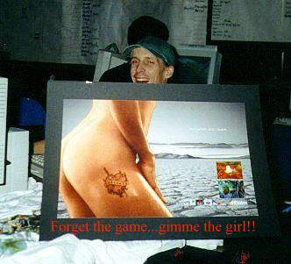
Controls

The 3d flying games are about the contols and your relationship with them. They need to become an extension of your mind.
Sort of like a love/hate type, hate meaning after 20 hours playing Forsaken, my hands are killing me.
I went threw 16 Wingmans Extreme joysticks in one year. Lucky I was able to return them monthly, I use to have to go to 4 differnt Sears stores to return them, it kinda got embarssing after awhile. I now use the 3d sidewinder pro now, it has not broke in 9 months. but the real reason is its very versitile, and has another option/axis called the twist.
At first, i hated it, but now I would never use anything else, matter fact, i hear its going to be replaced by the Precision Pro stick, which iam not comfortable with. I need to stock up on 3d pros, cause the Prescison just dont have the abliity to complete the job. They buttons lack correct spacing, and the stick movemt/ respaonse time appears slower. The most important thing here is what I call Key Economy. You must be able to configure your controls in a way which allows you to perform the maximum amount of maneuvers and actions at the same time. Being humans, we are limited by only having ten fingers, and cannot expect to use anything else unless you use pedals or other kinds of input devices, i hear Spaz does though (a great level maker for games). This is why a Joystick is so important, since it allows input by moving our wrist and not directly using the fingers. You want to be able to slide in 2 directions, turn, pitch, twist, accelerate and fire all at the same time. This might sound like a lot but it is not impossible. There are very few people out there which have managed to achieve pretty good key economy with only a keyboard. But it is limited.

Keyboard: You want to configure keys so that you can use all the fingers of the hand you have on the keyboard. Also try to map your keys close to the left end of the keyboard since you have the numbers in top close by, which are a must in Forsaken at this time. The new egonomic keyboards seem healther on your wrists, its a good idea to use them.

Joystick: The first thing is to get a good joystick. You want a joystick with at least 2 buttons and a hat. Also some joysticks, like the CH Products joysticks, do not allow you to fire and use the hat at the same time, which you want to avoid since it breaks key economy. Thrustmaster joysticks and Wingmans are used by many people, but my favorite so far is the Microsoft SideWinder 3D Pro, to which I am probably building some kind of shrine. What separates this joystick from the rest is its unique ability to move in a 3rd axis, or "twist" as most Sidewinder users call it. This extra axis is of much help since it frees up more fingers to use for other movement/actions. It also has a hat and 4 buttons on the stick which come in very handy. I do not use the slider or the 4 base buttons since i prefer the keyboard for the other hand.

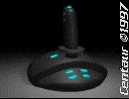
Graphic by Centaur (Dion Hopkins) http://home.earthlink.net/~centaur2/

Other Input Devices: This group include primary devices such as the SpaceOrb and Mouse, and secondary devices, such as a throttle sticks and pedals. First the primaries: Forsakne is not too friendly to mouse users and besides a few exception, mouse will not get you far in Forsaken. As to the SpaceOrb there is not much I can say since I have never tried one myself. One thing that the SpaceOrb allows you to do which can be very helpful is the ability to perform instantaneous 180 degree turns. As to secondary devices, some might be helpful, especially if your joystick doesn't have a 3rd axis or a hat. Many people have done some nice configurations with throttles and pedals.

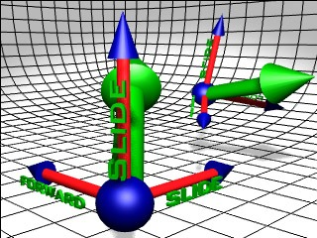
TRIPLE CORDING

Graphic by Centaur (Dion Hopkins) http://home.earthlink.net/~centaur2/

Movement: This probably is the most important element. If you have good flying skills, you are almost there. There are many things which make up a good movement element, these include: basic movement, maneuvers and stealth.

Basic Movement: This is basically being able to move in 3 axis. Pitch (nose up/down), Turning (left/right) and roll are the main movements. Acceleration and reverse, and Sliding (all four directions). Being proficient in ALL of these basic movements is essential. I cannot stress enough the importance of sliding and rolling. You want to be able to fly under different conditions, if you get confused flying upside down, then practice some more. If you stop thinking of the levels as rooms it might help.
Maneuvers: Ok so you can move, now comes the part where we start adding things up. You HAVE to learn to at least double cord, but triple cording is recommended. Cording is adding your movement in different directions to a single common direction, allowing you to move faster, and boy do you. One example of double cording is sliding to one side and moving forward, you move diagonally faster than you would just moving forward or sliding. Descent's 3rd dimension allows you to also triple cord, an example of which is moving forward, sliding to one side, and sliding up or down. Triple cording takes more time to get used to and to master. Triple cording gives you increased mobility, giving you a significant advantage in dogfights. If you have ever wondered how some players manage to get behind you so easily in a dogfight then this is the answer. This is why key economy is so important, you must be able to triple cord and fire at the same time, not to mention other things like using the nitro in Forsaken. Here are some numbers on cording:

Double-Cording: 51% speed increase
Nitro with single direction: 70% speed increase
Triple-Cording: 73% speed increase
Double-Cording with Nitro: 90% speed increase
Triple-Cording with Nitro: 116% speed increase

The Nitro in Forsaken is probably the most influential powerup in the game, one that has contributed in giving Forsaken such a different feel to it. One good advice is use it sapringly. Most people spend all the Nitro energy needlessly to move around when triple cording could do. Always try to keep a little of the energy for emergencies, you never know when it will become handy. When combined to cording, the nitro can give you an edge in dogfights, allowing you to quickly get behind people, which is the key to dogfighting.
I mentioned before how important rolling is in Forsaken, now I will explain myself a bit. Rolling is essential for triple cording as you need to adjust your vertical slide , and it is of great help in turning, as you could cord your way around a corner instead of just turning. One thing I like to do is to twist a lot in dogfights. Occasionally I start to fight upside down then start twirling, which seems to confuse most opponents for a brief moment, which is usually all you need.
Stealth: This is very important if you tend to be more of a tunnel rat, but it is equally essential for the dog fighter. Learn to move around the level without hitting the walls, and try not too open too many doors unless you are trying to trick your opponent.

BIKE MANUVERS

Practice, Practice, and more practice!

The best way to learn these skills is to try them out initially in single player mode, in a nice robot-free environment. Try them out until they're second nature. Then try them out in multi-player combat, where you will quickly learn that they weren't yet second nature after all.

The first few times you try a new maneuver under fire, you're almost guaranteed to blow it and die horribly. Use a different nickname if you plan to practice on kali, many do. It's called learning, and it's good for you, even when it sucks.

BIKER Nitro warping

If you have a nitro, and someone's waiting inside a room or around a corner, you may be able to surprise your opponent with a high-speed slide.

Let's say your opponent is waiting for you just inside a room and to the left. Burn into the room. Just as you get into the room cut your nitro, turn to the left, and slide to the right while firing at your opponent. The momentum from the nitro will continue for a little more than a second, giving you an unusually high-speed slide. It may buy you the edge you need to survive.

BIKER Bob

An advanced maneuver for when you're circling or sliding: bob up and down at the same time.
It's hard to hit an opponent who's sliding to the side, but it's much harder to hit someone who's sliding erratically up and down at the same time as they are sliding to the side. This takes some practice, because it's also harder for you to aim. Well worth the effort to learn this one. It's also useful to bob and slide while you're running down a hallway away from (or at) your opponent. Don't fly in a straight line. A variant of the bob: instead of sliding up and down, roll gently left and right. This will move you up and down (albeit more subtly) and has the advantage of avoiding "dead points" in your bob. When you bob up and down, as you reach the peak and valley your vertical speed slows and then stops for an instant, yielding "dead points" when you're a little easier to hit.

BIKER Circling

A critical, fundamental move, learn this one if you learn nothing else.
The idea: gets your opponent in your sites. Now slide to the left while periodically rotating to the right (or vice-versa) to keep your target in your sites. This is especially easy in a mouse-keyboard or joystick-keyboard combination, where you can use your left hand on the keyboard to continuously slide, while you adjust your aim with the mouse, Orb or joystick. Want to surprise someone? The above describes a horizontal circling action. Try circling your opponent vertically: slide up while nosing down, or vice verse. Experienced players learn to expect horizontal circling, but there's a chance a vertical will catch them by surprise. Note that this maneuver has a very different feel than a horizontal circle.

BIKER Corkscrew

While moving forward or backward, bank right and slide left at the same time, or bank left and slide right. The result will be a controlled corkscrew. Great evasive if you're being chased but you want to keep heading in the direction you were: you'll leave a hole in the middle of your corkscrew, where you used to be, and it'll be very hard for your opponent to keep a lock on you. Outstanding for getting out of those "I'm stuck in a long hallway and they're at the other end shooting at me" situations. As you corkscrew out you'll end up hugging each of the four walls in sequence. This makes it very hard to keep a bead on you, and you may well slip past your opponent. Since this requires three simultaneous keys (forward or backward, bank, and slide) you may not be able to do it if all those keys are on either the numeric keyboard, or the alphanumeric keyboard.

BIKER Dodge-fire

This is a variant on Circling, but is especially suited for a large room where you want to keep a little more distance between you and your opponent. Target your opponent from a good distance, and then turn your bike in any direction while sliding in the opposite direction -- e.g., turn right while sliding left, or turn down while sliding up. Weave around this way, up, down, left, right. You'll be skidding to the side while firing. As with circling, it takes some practice to do this while keeping a bead on your opponent, but it's definitely worth the effort. Especially effective against a "sit-and-shoot" enemy.

If your opponent starts doing this at the same time as you are, be sure to fire Leading Shots by over-turning -- turning past where your opponent is now, so that your shots will meet your opponents ship. Also, practice changing directions mid-way through the slide, to make yourself even harder to hit.

BIKER Invert

Intent: you end up behind your pursuer. Slide up, down, left, or right, while reversing thrust. Either you'll bump into your pursuer or, assuming your pursuer doesn't react quickly, you'll end looking down his/her tailpipe. Neat idea in principle, and a great feeling when it works, but it relies on a slightly lame opponent.
Variation: simply slam it into reverse. In the worst case your opponent will run into you, and probably be at least a little surprised. In the best case you'll end up behind your opponent.

BIKER nitro spin

It's possible to do a 180 degree; turn while maintaining near-full speed. The basic idea is to start turning at full speed, and switch from forward to reverse thrust half way through the turn. If you want to really tweak this you'll side-slide half-way through to keep your speed up... but get the basic maneuver down before trying to get tricky like this.

Note that if you're flying backward and firing at a pursuer, the physics of Forsaken World are working in your favor. Shots move at an absolute speed regardless of your velocity when you fire them. This means that your shots are moving toward your opponent much faster than your opponent's are moving toward you. Another way to look at it: both your shots and your opponents are moving at the same speed... but you're flying away from you opponent's, and your opponent is moving toward yours.

If you're ready to optimize your turn by throwing in a slide, here are directions for a left-turn spin. This description assumes you are using a keyboard for Forward and Reverse:

1.Begin by turning left while still moving forward.
2.About a third of the way through the spin take your finger off the Forward key and do a right slide. This will have you sliding in what was previously your forward direction.
3.When you're about two-thirds through the turn stop sliding, and press the Reverse key.
4.You're now facing backward, and have made the spin without an appreciable loss in velocity.

It's worth your time to spend a few minutes practicing this outside of combat conditions. It will take you a lot longer to get comfortable with the sequence if someone is chucking titan missile your way at the same time as you're practicing. If you want to intimidate and disorient opponents, fly directly at them with your guns blazing then, just as you pass over or under them, execute a full speed spin. Repeat. You'll always be facing them, and they may get a little dizzy.

BIKER spin

While moving forward or backward try the following: turn left while rolling right, or turn right while rolling left. This brings on a pretty wild evasive maneuver. I've found it occasionally, though not always, useful. For example, there are better ways to shake a missile.

BIKER loop

Rotate down and right, or down and left, at the same time while moving forward. In a couple of seconds you'll end up looping back to your original course. If you were being pursued, you may end up on your opponent's tail.

BIKER Rolling up / Roll down

Your bike rotates half as quickly up/down as it does left/right. This means up/down turns are inherently slower and looser than left/right turns, even if you employ a tight turn. The solution? Rotate your ship so you can make a left/right turn instead of an up/down turn.
This move is tricky to master, but will really speed up your vertical turns (and also looks exceedingly slick). The idea: if you want to turn down, roll and turn in the same direction. That is, roll left (counter-clockwise) while you turn left, or roll right (clockwise) while you turn right. To make a quick turn up, roll and turn in opposite direction, e.g., roll right while turning left.
This one takes a lot of practice if you're using it go into a tunnel up or down. It's very easy to over-turn, which means you'll look extremely cool until you smack into a wall instead of making that tunnel. If someone's following you while you do this, and they try to follow you by executing a normal up-turn or down-turn, you have a chance to get behind them since you'll be turning tighter than they will. Once you've rolled 90° relative to your original course, just continue your left or right turn until you wind up behind your opponent.

BIKER Spiral up / Spiral down

Turn right (or left) at the same time as you slide up (or down). Most effective when combined with a continuous stream of fire. It can also be useful if you're going in to the center of a room through the floor or ceiling, and don't know where people are hiding:
The spinning action will give you a quick look at the room; and the 180 degree; firing may surprise (and heck, maybe even hit!) your opponent; and since you're moving up/down at the same time, you're not just sitting in the middle of the room twirling around to scope the place out

BIKER turn

If you want to make a turn so sharp and fast that people will accuse you of cheating and disconnect in anger, slide (strafe) and turn in the same direction at the same time. For example, turn left and slide left. Works up, down, left, and right. You won't actually be turning any faster (it'll take you the same amount of time to do a full 180 degree; turn), but you'll corner much tighter than you will if you turn alone.

BIKER Wide turn (slip turn)

While going around a corner to the right, slide to the left; or vice-versa. It does insure you won't get hung up on the corner, and if someone is waiting in ambush for you above or around the corner it can throw them off long enough to save your butt. You'll also be traveling a little faster (40% faster) since you're moving in two directions at once, forward and sideways, while you turn. Finally, it just feels cool to skid into a turn.

Weapons
My personal preference of a waepon currently is the Trojak. It clearly does the most damage if used correctly.
Sauss gun: This seems to be the dog fighter's weapon of choice in Forsaken. Its high rate of fire and decent traveling speed and damage make it a fairly balanced weapon. In kali try to "spray" the room a bit more that you would in a LAN. You still need to try to calculate the opponent’s position but a little randomness helps in Kali. The Sussgun uses a special type of ammo and fires a spray of these particles in a wide columnar pattern. It can quickly rip an opponent to pieces.
Trojak: For many this is the worst weapon, and for a few it is the best. Some people have mastered the use of this weapon to an art, like Kiln and Gwar, bringing the awesome damage potential of this weapon to full use. I tend to use this weapon alot, cause the damage it inflicts is huge, on a single "pump". But, your aiming has to be precise. The Trojax fires discs of spiraling blue energy. By holding down the trigger, you can build its power level to increase its radius and damage. Even on rapid-fire, each disc packs a powerful punch.
Power Pods are items that strengthen your primary weapons by increasing their damage, speed, rate of fire, spread, or other variables. You can have up to three Power Pods in your possession at any time.
Orbitals are miniature dischargers that circle your ship, firing when you do. You can collect up to four orbitals at one time. The position of an orbital is indicated on your HUD as a tiny circle spinning around the aiming reticle.
The Pulsar is your standard-issue energy-gun; it fires pulses of glowing green plasma. Good aimers love this weapon.
Lasers are powerful beams of light that bore equally through metal, flesh, or bone with little trouble. They have a long-range and reach their target instantly.
The Pyrolite is a flamethrower that can ignite the fuel source of an opponent's cycle as well as cause severe skin irritation. It is best when you are very close to your oppentant, or when you have him/her trapped.
The Transpulse is the big brother of the standard Pulsar; it inflicts greater damage and has the ability to bounce once off walls, heat sinking to there last position no less.
MUGS are standard ordinance dumbfire missiles, and do moderate damage. You start the game with five of these.
The Solaris, as its name implies, is a homing or heat-seeking missile. It is the big brother of the MUGS, and does slightly more damage.
The Gravgon is a gravity field generator: when it explodes, a field is instantiated around the blast point, and anything caught in its wake is sucked mercilessly in and made easy prey for your guns.
The Scatter missile is an effective multiplayer weapon that homes in on players and
scatters their weapon stores on contact, causing light damage in the process. A skilled player can use this missile to leave an opponent defenseless and pick up the opponent's arsenal for himself.
The MFRL is a rocket launcher that fires tiny dumbfire rockets at an incredible rate. It's a bit difficult to aim, but under the guidance of a careful hand, this weapon is downright deadly.
Titan missiles are devices of mass destruction that are loved by the bearer and despised by everyone else. Once fired, the missile travels unguided (or "dumb") until it impacts a surface. Devastation follows, as tiny guided missiles, or shocklets, come shrieking out at a tremendous velocity, aimed for your enemies' heads. Use with caution however; a skilled opponent can make this missile turn on YOU. Shot this huge bombs directly in front of you on the floor or wall, hopefully they will wreck havoc across the room if there placed/fired correctly.
Purge mines are tiny incendiary mines that inflict moderate damage on the player foolish enough to run into them.
Pine mines are intelligent, stationary mines that fire small homing missiles at targets within their range of view. These little buggers need to be placed in spots that corner the oppentent
Quantum mines are devices of devastating destructive power. Avoid running into these suckers, and destroy with extreme prejudice - from a safe distance.

TATICS FOR THE GOODIES

Bomblet corral

In wide corridors or small rooms, fire a Titan missile against one wall and start firing at the opposite wall. Your opponent will likely fly away from the bomblets to dodge them, and so will be flying right into your barrage. Of course, if your opponent doesn't dodge the bomblets you don't have much to worry about.

This can be very effective if you're trading fire with someone around a corner: fire a Titan missile at the outside wall, and slide in behind it, firing down the inside all. You should get some good cheap shots on your opponent as he/she tries to keep from getting fried by the bomblets.

Another varient on this: fire a Titan missile to detonate past your opponent. While the bomblets chase after them on one side, you lay down a pattern of fire on the other to box them in.

Bomblet cover

Once you've detonated a Titan missile, follow behind the locked bomblets and continue to fire at your opponent. Anyone shooting back at you through a swarm of bomblets is either a bigger Weenie than you are (in which case they'll be dead soon), or a true Forsaken God (in which case you'll be dead soon).

Garbage

If you can, avoid shooting monitors and picking up little trinkets you don't need. If your opponent knows the level, you're leaving a trail. The less you pick up or break, the less there is for your opponent to notice.

Deck those halls

If there's a good chance someone will come down a long corridor (or through a distant door) in the next few seconds, send a long stream of primary weapon fire down the hall or toward the door. If you're lucky you'll hit some poor schmuck who stumbles into your stream; in the worst case you've made the hallway or door unusable for a few seconds, which means you can scoot if you want to. This works best on smaller levels with lots of players.

Fade to cover

Think about your Bike's color. If your ship is red, don't try to hide in front of a green wall. Use signs and other off-color objects in a room to camouflage your bike -- if your opponent expects to see a color anomaly there, he's less likely to notice that your ship is there.

Fire around corners

Get an opponent to chase you into a curved corridor. Execute a full spin, fire a scatter or titan missile down the corridor in their direction, and back
out quickly. The missile will curve around the corridor and, with luck, nail them.

Go for the blue thingies

When another bike blows up (who knows, maybe you even had a hand in it), go for the blue Shield Boost power up. These things are life --literally. If you pick up some weapons on the way to or from the shield boost, fine... but grab that life. Be careful not to be so anxious for the Boost, though, that you end up next to the ship while it's exploding. You'll take damage. Wait until it's done exploding to scoop up the Boost.

Always Keep moving

If you learn nothing else, learn this: to pause is to die. Keep moving. The more you move, and the more erratically you move, the harder you are to hit. You may find it's easier for you to take aim at someone while you're sitting still, but remember the converse applies as well. Learn to shoot on the run.

One exception: if you're hiding or cloaked, don't move at all.

Leading shots

This is a good rule of thumb for Forsaken and any similar game: decide where to shoot based on the weapon you're using.

If you're using a very fast weapon like the laser gun or suass gun, shoot directly at your opponent. If you're using a slower weapon like the Trojak, shoot where your opponent is about to be, so that your shot will meet them there.

If you find yourself circling and circling someone but you can't get a shot to land home, you're probably shooting at your opponent. Turn so thatyou're pointing in front of your opponent's flight path.

Let your opponent under-rate you

Don't let them know all you've got until you're in a place to use it on them, but good. You can sometimes sucker an opponent by using lasers for a while to make them think that's all you've got. Always know what your mapped keys are, and always try to switch them when you are to the back of your enemy.

Light and sound

Occasionally when you're sitting in a dark room you may notice a mysterious flash along one of the walls. It's really not mysterious at all. In the world of Forsaken, unlike our world, light and sound aren't always stopped by walls. That flash and muffled thump is one of your opponents firing in another room. Awfully useful if you're trying to find someone. Even more useful if you're trying to avoid someone.

Missile tips

A general note for all of the missiles: you'll be most effective if you fire them at an opponent who's near a wall. Even if you don't make a direct hit, the missile may hit the wall near your opponent and cause blast radius damage.
A note for all missiles with a homing action if you're trying to figure out where an opponent is in a big room, or just beyond an intersection, fire a homing-style missiles and see where the missile (or bomblets) go. They're do their best to point out your target.
Use the missle view side scren at all times.

Mix it up, baby

Bury your opponent in a barrage of primary weapon fire, and in the middle mix in a few homing-type missiles. Often your opponent will be so preoccupied with the primary weapons that the "lock" indicator won't catch their attention. Good way to get a cheap sactter missile hit on someone who would dodge your missiles otherwise.

Mutiny Move

If your opponent is firing an Titan at you, you may be able to make the Titan's shocklets mutiny on your opponent.

Once you see the Titan heading your way, head straight toward your opponent, the faster the better. If you have an nitro, this is the time to use it. Not only will flying toward your opponent help with the shocklet mutiny, but it will help you to dodge the missile itself.

When the Titan detonates behind you, the shocklets will head toward you... and by extension, they'll head toward your opponent too. If you're able to overtake your opponent, and all goes well, the shocklets should nail them instead of you. In the worst case, if the shocklets hit you, with any luck you'll be near enough to your opponent to take him with you.

In your face, man

Some players will run into a room with no exits and "hole up" inside, firing out the door to keep anyone from coming in. If they've gone into a room with a door try the following:

Wait for the door to close, fire a hefty missile at the door, and then fire a primary weapon at the door. If you time it right, your primary weapon shot will open the door an instant before the missile reaches it. You opponent won't hear the missile firing, and won't hear the door open in advance, so by the time the door opens it's too late to avoid the missile.

Note: if you have the laser gun, you're in luck. Since the they are essentially instantaneous, you can wait until just before the missile hits the door to shoot it open.

In a Pinch, help me im a twinkie

Use non-homing secondary weapons like Mug Missiles to briefly force your opponent in one direction, then lead them with your primary weapons. For example, fire a few mug missiles to the left of your opponent, then quickly whip your sights to the right and start firing with primaries. This is one time you can be fairly certain where your opponent is heading in the next split second, so you can fire where they'll be in advance.

This is especially effective with the trojak. The trojack is incredibly slow, but if you make a solid hit you'll pound your opponent into oatmeal. Since it's so slow, it's especially important to lead your opponent when using it. "Leading" really amounts to guessing where you're opponent will be next. And now we know how to do that.

Saturation, baby

If you're chasing someone down a long hallway (or someone is flying toward you down a long hallway), you can saturate the hallway with weapons fire. Switch to a weapon that fires slow shots.

By using slow weapons, you'll maximize the time that shots are drifting down the hallway, waiting for your opponent to slam into them.

Switch weapons

This one may sound obvious, but it's surprising how many people will just grab the weapon they're most comfortable with and stick with it. Each of the weapons has strengths and weaknesses in various situations.

Use your eyes, gosh dam it

If you watch carefully, you can see lighting changes along walls when an opponent is approaching... even if your opponent is on the other side of the wall. As someone gets closer and closer, the walls will get brighter. If you do this right and wait near a door, you can lob a couple of missiles at the door just before your opponent opens it. This is way surprising, especially if you use one of the meatier missiles (titan).

Sound
I only use headphones in games, I strongly believe this is the best weapon of all. Listining to the sounds of doors, others picking up power-ups and bumbing into things are the best offenses one could have. It has won me many matches.

Power Computers
Well I thought it deserved a little mention that with all the different people out there with different computer setups, there are certain advantages and disadvantages to the added computing power.
Users with fast computers clearly have an edge in Forsaken with the added fps. This allows for better aiming, thus allowing better long distance skills. Voodoo 3DFX based card owners have even more help from their computer as the gameplay becomes very smooth, even in heavy fights. The biggest downside to the faster computers is the added tracking ability of all tracking weapons. Read Toms hardware Page for more information on this topic at http://sysdoc.pair.com/

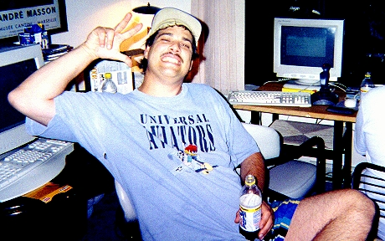

Some final words about all of this: Practice, practice and practice some more. This is the only way to become good in Forsaken. The more you lose, the better you get (well usually). When you play the good Forsaken players, observe and employ. Ask them for tips/hints. The other thing is THINK. You would be amazed how much you could learn from an opponent by just thinking about what they are doing. Try to figure the opponent's fly patterns, most people have very obvious ones, which you can exploit to your advantage. Use demos to learn, thats what there for!!! …AKA Descentile…

Advanced & Tactical Briefings from Champion Players of Forsaken

The following is the list of the top 3d flyers in the world, hands down. You might say, "Hey, I'm better then anyone" All of the below Bikers have proven there skills on the top ladders on the net, most ranking in the top 3 for a period of time. There advanced flying skill are unique, each having there own strong points. These guys are always available for a game via kali or modem. Just ask for a game sometime.
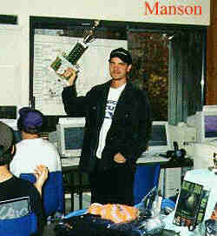
Klye "Manson" - winner of one on one Lanfest 97 in Holmes New York

AND NOW THE BEST OF THE BEST

From Darren "Keyser" Asato

“1. The basics of playing the game in multiplayer mode.

The basic ways of playing in multiplayer mode is self explanatory, you're
gonna be killing someone else, someone real, this is the most exciting
facet of the new generation of games. As computers and the Internet become
more and more popular, the amount of players who seek the challenge of
playing another living, breathing person grows as well. In other words, there
is no limit to the possibilities that multiplayer gaming can offer, replay value
has never been higher......in a word....priceless.

2. Defining the various ways to play multiplayer Forsaken (LAN, Internet, etc.). LAN, or Local Area Networks, offer multiplayer games the way they were made to be played...extremely low latency and loss, fast paced and you can hear the actual screams of your opponents!

But the next best thing, and honestly, the reason these games are popular...
the Internet. On the Internet there are a few different ways to set up a game.

a)Kali (http://www.kali.net ) its a great little program that "tricks" your
computer into thinking that it's hooked up to a LAN...but this LAN isnt "Local" its the
Internet offering thousands of opponents for all types of games and skill levels

b)TCP/IP This is an option that has become more and more popular in newer
games, it essentially does away with the 2nd party program and has the net codes
built into it. While some may argue that this method isnt as sharp as IPX, keep in mind
that games with TCP/IP support built in, were basically made from scratch with the
Internet in mind.

c)Modem to Modem Using your modem, you can dial another computer and play head
to head vs a friend (or foe) While this is probably the best compromise
between lag/loss and cost and convenience...the drawback is that you can only play with 1 other person. Still, for those important one on one matches...even a long distance call is
worth it to some ;)

3. Ladders:

Ladders, clans, tournaments etc, have been a part of multiplayer gaming since the beginning an example of a ladder is Case's Internet Gaming Ladder, the point of a ladder is to give a sense of meaning to playing a one on one game, somethings on the line, it's a competition. How a ladder works is: player are seeded ranked 1-XXX, the lower ranked players must "climb" the ladder by defeating opponents ahead of them (the rules may differ from ladder to ladder) these are fun and add a little more to the game.

Clans: these are for people who play games for the social value...meet
people, make friends and in some cases sort of a team to call your own. Some of these groups actually initiate "wars" against other groups, again to add some meaning to the game.

4. Strategy and tactics for Forsaken multiplayer: including head-to-head, and the variants such as Capture the Flag, bounty hunter,etc For Multiplayer, especially on the net: Dodging is more important than shooting....stay alive longer than your opponent, you'll end up with more kills....simple For Capture the flag, team mode...communication is the most important thing, if you can set up macros to tell your partner(s) things like "im on the left side of the room" or "im in the big tunnel" these will help your partner(s) devise strategies and traps for your opponent.

5. Top 10 lists on survival strategies, sabotage strategies, scooping
pick-ups and blowing away your enemies.

a) If you're gonna die, die with nothing....sell out, use all your weapons,
all mines, all missles, shoot everything!

b)3x chording...learn it...live it...love it. and remember, it's not just
for running, it's extremely useful in a joust with your opponent

c) Rearview, check your "six". How many times can a good player just walk
up on some newbie whos just flying around not knowing that he's got a guy right on his exaust?

d) Knowing when to say when, what i mean by this is: dont go charging into
the middle of a fight to try and grab one energy pod...you'll lose more than you'll gain. Use your head when going for items.

e) On that same note, when you're IN fights, shoot at the powerups, these
are the things that give you a non moving target but most time you KNOW the other guy is gonna go right for em.

f) Knowing your opponents habits: what makes a good player? I mean a really
good player? his ability to adjust and change pace. Now if your opponent gets into a lil pattern, recognize it quickly, it could be that he flies the same way and turns down the same corridor every time...pick up on that, meet him on the other side with guns
blazing!

g) Learn from your mistakes: are you dying the same way everytime? is there
something that your opponent has picked up on? This is why it can be a more mental game than people think....you can actually "trick" someone into thinking you ARE in a pattern and use that against them.

h) Pick up the Nitro first when you die: why? cuz speed kills, gimme nitro
against the best player in the world without it, and ill eat him up. Not only this, after you get it, you can move around the level quicker looking for other powerups.

i) Setup your keyboard so that all hotkeys you could possibly push are in
comfortable and easy to remember spots, Forsaken makes this easy with a very nice keyboard set up, you can map almost any fuction to any key.

j) Use the right weapon for the right job: wide open room? maybe something
with a lil more spread....long room? maybe something with a lil more speed....in close fighting? maybe something on the powerful side.

Keyser out…"

From Joe "Baywatch" Fargo

“Keep in mind that you are in 3d space. The more ways that you move around
the more difficult it will be for your enemy to hit you. You will need to spend some time in the Game to be able to keep yourself oriented and accurately aim you bike.

Controller stick vs. the keyboard and other types of controllers:

As far as "what is the best controller", you will see that all the best players play with a stick. If you want to move in allot of axis's at once you are going to need to use a stick. The keyboard will just not be able to press all those buttons at the same time, and it’s a "all or none" style controller. You cannot ease into a turn with the keyboard. The most common move is the Circle strafe. This is when you circle around your enemy and shoot at him. An advanced maneuver is called "chording". This is when you move in more then one direction at once. For example sliding right and moving backwards. This maneuver is about 25% faster then moving just forward. The most advanced type of chording is triple chording. This is the action of moving in 3 directions at once, for example, sliding right, sliding up and moving forward. This may seam uncontrollable at first, but with practice you will be able to go perfectly straight and 3x chord. Try this, pitch your ship down at about a 45 degree angle. Then roll about 30% to the left. Now press slide up, slide right, and move forward. you will almost straight forward. Pitch and roll to adjust your direction. Soon you will be catching up to missles !!!

Baywatch out . . .”

* Eyes Only
- Illustrated Spy Reports Detailing Enemy Tactics
- Vital Tactical Information on Pioncycle Performance & Weapons Deployment
- Secret Levels

Jeff, didn’t get to play single player mode, they didn’t bring it.

• Multiplayer Forsaken

DEATH OF AN INNOCENT
********************************
I went to FORSAKEN lanfest, Mom, I remembered what you said.
You told me not to lag, Mom, so I bought a 100bt card instead.
I really felt proud inside, Mom, the way you said I would.
I didn't lag and fly, Mom, even though the others said i did.

I know I did the right thing, Mom, I know your always right.
Now DFest is finally ending, Mom, as biker leaves.
As I got into my Bike, Mom, I knew I'd had a successful flight.
Because of the way you raised me, so responsible and polite.

I started to fly away, Mom, but as I pulled out into the levels,
the other Bike lag bursted at me, Mom, and hit me like a load.
As I lay there on the pavement, Mom, I hear the ForsakenFesters say,
It was the other Biker lagging, Mom, and now I'm the one who will pay.

I'm lying here dying, Mom. I wish you'd get here soon..
How could this happen to me, Mom? My Bike just burst like a balloon.
There is blood all around me, Mom, and most of it is mine.
I hear my team mate say, Mom, you'll die in a short while.

I just wanted to tell you, Mom, I swear I didn't lag.
It was the other bikers, Mom. The other connection was bad.
He is on the same level as I, mom, watching as he flies.
The only difference is, Mom, his lag, it wasn't really mine.

Why do people lag, Mom? It can ruin your whole life.
I'm feeling sharp pains now. Pains just like a knife.
The guy who hit me is still flying, Mom, and I don't think it's fair.
I'm lying here dying and all he can do is stare.

Tell my Team mate not to cry, Mom. Tell Daddy to be brave.
And when I go to heaven, Mom, put "Moma's boy" on my grave
Someone should have told him, Mom, not to lag and fly.
If only they had told him, Mom, I would still be alive.

My breath is getting shorter, Mom. I'm becoming very scared.
Please don't cry for me, Mom. When I needed you, you were always there.
I have one last question, Mom, before I say good bye.
I didn't lag and fly, Mom, so why am I the only one to die?

Author unknown

SOMEONE SAY “LAN PARTIES”

This is intended to help people learn about the steps it takes to host
a LAN party, attend one or to help them plan their own.

It came about after a ton of emails I recieved asking the question "How
do I host my own LAN party?" I couldn't answer this question without spending hours and hours writing and researching, so I decided to write something.

What makes a good party?

A good party has one key element: FUN - period!

Novices, seasoned event attendees, organizers, and sponsors will all tell
you the same thing. If it ain't fun, it ain't a fest party.

Your goal in running a LAN party should be to have a well organized, well
advertised, well thought out, Fest event!

------------------------------

Can you do this?

Hosting a LAN party takes considerable amounts of time, money, effort, and
most of all: patience. You will also need to have a staff to help you,
and at least some technical knowledge. Can you do this? Read the rest of
this FAQ and then answer that question yourself!

------------------------------

Definitions

LAN - Local area network. Basically, a bunch of computers all connnected
together.

Party - A social event to which people come to talk, drink, eat, and have
Fun!

------------------------------

What you need:

Home grown networks are not that difficult to setup and enjoy. All it takes is a little time and effort. Before you jump to the setup pages, please read this small glossary of terms:
LAN: Local Area Network. Basically, a bunch of computers connected to each other via network cards and cables.
NIC: Abbreviation for Network Interface Card. A network card you put in your computer.
Hub: A device used to connect multiple computers over a LAN. Picture a bicycle wheel, with the hub at the center, the spokes are network cables, and computers are connected to each spoke. Hubs come in all sizes from 4 ports to 48 ports, and can be interconnected to each other to increase the network size. There our 10 base t and 100 base t hubs, 100 being much faster, but more expensive.
BNC: also known as thin ethernet. This type of network setup uses coax cable to carry the signal between computers, and does not require a hub. It is also the cheapest type of network cabling, and a good place for a startup LAN group. We do not use BNC connections at our lans because we always have at least 30 plus players. It is good for a group of around 8 to 10 people. If you choose to use this type of network cabling, be sure to keep your cable length at under 10 feet or so if possible to keep interference to a minimum. You will also need a "tee" and a terminator.
Twisted Pair: also known as UTP (unsheilded twisted pair) or 10baseT. This network is a better choice for groups larger than 10 people. However, it can be more costly than BNC. You need to use a hub with this type of network, but network performance is greatly enhanced. UTP cables contain 4 pairs of wires, and each pair is twisted together. This twist is what gives the cable its resistance to interference, and also gives the network type its name, twisted pair.

Ok, that's all. I just wanted you to know the terms.

What equipment is required?

FOR BNC:

Network card: any network card that is NE2000 compatible will work. The PCI cards are easiest to setup, but they are more expensive than the ISA versions, and the ISA versions work just fine. Also, you only need a 10 mbit/sec transfer rate, so don't spend the money on a 100 mbit/sec card, this type of network don't support them anyway.
Network cables: Also known as "thin Ethernet" cables. Basically it is a coaxial cable similar to those used by your local cable company. However, there are differences and you cannot use TV cable wire for this network. When you purchase your cable for the home LAN, make sure it says "RJ-58" on the outside. If you purchase your cable pre-made, it will come with the correct connectors on it. If you plan on making your own cable, make sure you get the correct connectors. Again, the package should
make mention of "RJ-58".
"Tee" connector: This should come with your network card. You will also need a terminator. A terminator is installed on the 2 computers at either end of the network. A terminator basically absorbs the signals that hit it, keeping the signals from bouncing around and confusing the network. This may or may not come with the card. If it doesn't come with the card, you will need one, make sure you get it.

Twisted Pair (or 10baseT) is- in my opinion- the only way to go if your group has more than 8 or 10 members. It is faster and has less chance of failure due to cabling, since it uses far less parts than BNC. The only drawback is COST. It can get fairly expensive. Inexpensive equipment can be gotten to start with, with more being added later.
You can expand 10baseT to fit your needs.

10baseT uses hubs and Category 5 cable to connect the network together.

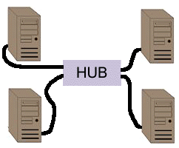
This image shows a typical starter network layout.

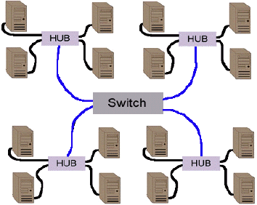
Or:

Of course, there can be from 4 to 48 computers connected to each hub. You can connect hubs together to effectively expand your network should your group grow. Each hub shares bandwidth, so each one takes a portion of your total bandwidth, which is 10 megabits per second. Note- a megabit is 1,048,576 bits. There are 8 bits in a byte. You do the rest of the math.

Finding a Location
-----------------------------

Price range

This is the hardest part in putting together a fest. If it costs too much no one will come, if its too cheap, it wont have anything to offer. There are several places where you could hold a LAN event, but you have to consider cost. Hotels, conference centers, and the like have lots of space and work out very well, but are pricy. Community centers, existing gaming centers, school gyms, and places like that also work out well. I have found using retreat centers hosted by churches to be the best, they are cheap, and suit our needs.

If you are only having a small party, the best option is to have it at your house or apartment. This cuts cost by a LOT, but you also have to be careful about who you invite.

------------------------------

Space

When choosing a location, you have to think about space. Tables, chairs, computers, and people take up a LOT of room. The best way to go about finding enough space for your event is to find the place first, and then limit the amount of entrants. For example, if you are holding the event in your apartment, limit the entrants to 6 or 7. And if you are holding it in a hotel conference room with an occupancy limit of 500 people, limit it to
450 people.

------------------------------

Power

All fest I have attended has had power outages, and its fustrating to calm down upset people in matches at that time. It will happen. Make sure you locate all switch boxes to reset the breakers, and then redistrubiute the power. This is a crucial subject, as anyone who has organized or attended a LAN event will tell you. Power failures are common at major events, and can create quite a big problem. Imagine a room full of 500 people, all of a sudden plunged into darkness. Oh, what fun.

Computers by themselves don't use all that much power, but, the speakers
and the monitors, and the extra peripherals do. Add to this the hubs,
routers, switches that you need and the extra fans to move the air for
circulation. Most people suggest having 3 people to an outlet in an apartment and three
people to a power drop in a business locale.
------------------------------

Tables and chairs

You must make sure that you have enough tables and chairs for all the
participants at your event. Lack of seating space could turn into a very
ugly mess very quickly. You can usually rent tables, or buy them cheaply,
and the same goes for chairs. Furthermore, a lot of conference rooms and
the like already have tables and chairs. Make sure that the number is
sufficient before you assume, though.

Most people suggest that you have 3 people to a banquet sized table. If
you put computers on the floor beneath the table, this setup allows for
a decent amount of space for the gamers.

Policies

Before you book a location, check up on their policies about smoking,
alcohol, people staying over night, and maxium capacity. (There are usually
strict laws about how many people can be in a room at one time, for fire
safety reasons.)

Outside connection

If you are going to have an outside connection to the 'net, make sure that
there are phone lines in the room, for a modem, or that an ISDN or T1 or
other fast connection is accessible.

Choosing Games

When choosing games for your LAN event, you have to consider several
factors.

1. What do the people want? Ask them! Have a poll on your web site,
or find out people's general attitudes before hand.
2. Does everyone have a registered copy? Is a registered copy needed?
3. How many people will be attending? Games where a lot of people can
play at once work well for all kinds of events, games where only two
people can play each other don't work well for most.

4. Will you need special hardware or peripherals? (ie: joysticks)
5. Will you need a dedicated machine for servers? Can you find a
machine for this function?
-------------------------------------------------------------------------

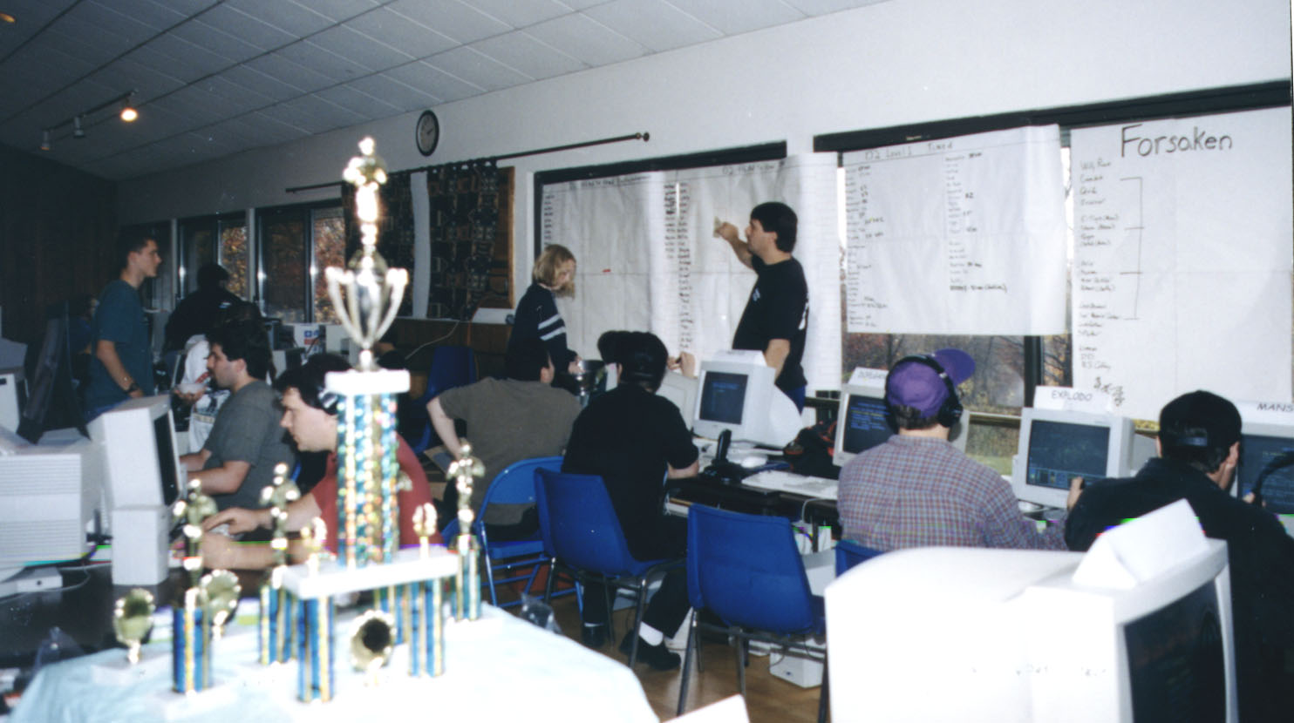
Tournament Styles/Ladder

Below is an example fest we did on Halloween in 1997:
SCHEDULE FOR TRI-STATE D-FEST #1
================================
Saturday
=============
9 AM: Network Setup; Tech Support
10 AM: Sign in; Tech Support; Open Scrimmage
12 PM: Lunch
2 PM: Forasaken Timed Level begin hotshot
3 PM: Forsaken Head to Head Matches begin
6 PM: Dinner
7 PM: Forsaken Player CTF matches begin
8 PM: Forsaken 2 on 2 matches begin
12 PM: R2D297 and Kiln's bed time stories (you can bring your pc's back to your cottage and play all night if your hands are still attached)(there are Guards for safety of theft)

Sunday
===========
8 AM: Breakfest
9 AM: Network Setup; Tech Support
10 AM: Matches not played on Saturday begin; Open Scrimmage
11 AM: Forsaken 4 man "turf wars" Team matches begin
12 PM: All Saturday Results are DUE
3 PM: Official Results Announcement and Award Ceremony
6: PM: Pack up
===============================================================

TOURNAMENT RULES FOR TRI-STATE D-FEST #1

Rules of Engagement

All tournaments will follow a standard double-elimination format. Opon arrival Saturday morning Bikers planning on entering official tournaments will sign in at the Help
table. (ie. look for a big sign that says HELP!) Please try and sign in at least one half hour before the scheduled start time for your tournament, so we can arrange matches and draw up the brackets. Sign in with your full name AND Biker nick; you will be given a flashcard to place on your computer with your nick on it. Please choose one nick that you will use ALL weekend so that people can get to know who you are, and can find you for your matches.

Upon signing up, the first bracket's matches will be chosen by drawing names from a hat. Once the matches are set they will be announced over the PA. When you know who your opponent(s) is/are make an effort to meet them so you can discuss the match.

Matches may be played in any level, as long as the level supports the game mode of the tournament and both sides AGREE on the level. Also any and all weapons are allowable as long as both sides agree. If neither side can agree on a level the default level will be my decision.

Name your official match (either side can start) in the following format: <nick> vs <nick> (ie. watSup vs Stimpy) so we can track the status of the matches if need be.

All matches will be played to a score of 15; it is nessessary to win by 2 points to win a match.

When the results of the match are known either side can come to the HELP table to report the results. As soon as the results are in and both sides are available you are ready to play your next match. Pickup games and open scrimmage will be going on and you are free to
play while you're waiting, just try and begin your next scheduled match within a reasonable amount of time (an hour) so we can keep the tournament moving.

It goes without saying that any form of cheating, of electronic means or otherwise, is pitiful. If you do so, you are just really, really lame. We will catch you, and then we will all laugh at you and dis you. It also goes without saying that you will also forfiet all your match points and be barred from further competition. If you plan on doing it, just dont come.

These rules will be subject to minor changes up until the beginning of the first match, as we find that some things make more sense or are more fair than others. Final decision and arbitration in all matches will be up to the Gamemaster. No lag, no loss, no bursting,
no whining :) Enjoy...

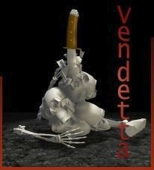
Graphic by Centaur (Dion Hopkins) http://home.earthlink.net/~centaur2/

Where to get more information:

There are several online resources that deal with this subject, and I will
list as many as I can.

http://www.descent.org/forsakened/
http://www.tiac.net/users/acornboy/tinnads_playground.htm
http://www.KoolBear.com/
The LAN Scene - http://lan.gibbed.com
LAN party listings, news, results, and this FAQ!
Blue's News - http://www.bluesnews.com
LAN party listing, as well as game related news
The LAN Times Online - http://www.wcmh.com/lantimes/index.html
Information on LAN related subjects - hardware, software, etc.
LAN Setup - http://www.si.hhs.nl/~v942388/settingup.html
Very user friendly FAQ about LANs
Start Your Own Gaming Group
http://www.teleport.com/~caustic/weekend.shtml
-------------------------------------------------------------------------

Lodging
------------------------------

Hotels, motels, and inns

People will need a place to stay if they are not from the area. The best
way to deal with this is to find out pricing information from local hotels
and motels, and post it on your web page. Getting info from a few sources
is best. Also, you can talk with the management about setting up some
kind of deal. Maybe they'll give you a bunch of rooms for an adjusted rate?

------------------------------

Local players houses

This is another option you may wish to consider. Lots of people would be
happier crashing on someone's floor than spending a lot of cash to get a
hotel room. However, this may not be a good option for a lot of cases.

If you are going to let people crash on your floor, in your spare room, or
anywhere at your place, make sure you know them first! Common sense should
tell us all that letting some strange computer geek sleep in your house is
asking for trouble. You may wake up and find your p200 missing, or find
some freak in their underwear eating ice cream and watching movies of your
wedding.

Basically, be careful. This is a cheap option, but not the safest.

-------------------------------------------------------------------------

Legal stuff

------------------------------

Minors

This is a subject that a lot of people don't agree. Some people's stance
is that minors just shouldn't be allowed attending LAN events. Other people
believe that all people, regardless of age, should be allowed to take part
in the fun.

Whichever way you choose to run your event, make sure that when you
advertise it, you let people know about your policy on minors.

Some of the major events have recently begun using consent forms to allow
minors to attend events. A simple form that minors get their parents to
sign would be a good idea, especially if your event runs over night.

I am not a legal expert, so please consult with your lawyer or local police
department to learn about laws concerning minors attendance of major
events.

------------------------------
Protecting against theft

You may wish to set up some sort of tagging system for a major event, to
protect against theft. Security at the entrance is a good idea as well.
A whole bunch of computers in a large area is a very welcome target for a
lot of would-be thieves.

-------------------------------------------------------------------------

Publicity

------------------------------

How to advertise correctly

Here is my page for example : http://home.earthlink.net/~centaur2/test/index.html
All advertising for a LAN event should be clear and consise and contain
the following information:

1. Location - supply a map if possible
2. Date(s) and times
3. Cost to enter
4. What people need to bring - including money, win95 disks, hardware,
software, power strips, etc.
5. Policies on minors, alcohol, smoking
6. Local lodging and food places
7. Sponsors and prizes
8. Press - cost to enter, free passes, etc
9. Any other information

------------------------------

Where to advertise

There are many places you can advertise a LAN event, and you should take
advantage of as many as possible. One of the biggest problems I've heard
of about planning an event is the difficulty in finding new players. Here
are a few suggestions for places to advertise.

1. A web page. This is essential, as a place where people can view
all the details about your event, as well as a list of players who
are signed up, and a place to view post-event stats.

2. LAN party listings pages and games news pages. Here are a few ones
to get you started:

The LAN Scene - http://lan.gibbed.com
Blue's News - http:///www.bluesnews.com
sCary's Sugar Shack - http://scary.vrgames.net
Redwood's News - http://redwood.stomped.com
The LAN Party Ring - http://www.bangg.org/lanring

3. Word of mouth. This is probably your most valuable resource. And its free, too! Tell all your friends, people on Kali (www.kali.net), newsgroup postings, IRC, ICQ, people at local gaming centers.

4. Newspapers and magazines. This is an expensive option, but an
option none the less. Local computing magazines would be your best
bet, but your local newspaper is an idea as well.

5. Local gaming centers, cyber-cafes, and college game rooms. After
you get permission from the owners, put up flyers at these places.
Gaming freaks from your area will be sure to notice them.

6. "Post Bills Here". If you see that sign anywhere around town, take
advantage of it! Telephone poles, notice boards, and other places
sometimes let you post flyers. Please check to see if it is legal
in your area before doing this, however.

7. Anything else you can think of. If you can afford a blimp, that
might work too!
------------------------------

Press

If you are going to allow press to be at your event, make sure that all
the appropriate people are notified. This includes local press, online
news sites, and radio and realaudio broadcasts.

------------------------------

Post-event

After your event is over, you will want to let the community (and the
world!) know how things went. This increases your chances of having
repeat players, and attracting new ones if you plan on holding another
event. Use all the same resources you used before, but MAKE SURE you post
results, demos, screenshots, pictures, and the like on your web site.
People love that sort of thing.


-------------------------------------------------------------------------

Sponsors and Prizes
------------------------------
Below is an example of a letter I wrote to a few companies, they all continue to donate prizes (over $5000.oo in hardware the last year alone).

“Hi, my name is Descentile, mike for short. I'm the director for the
biggest gaming fest on the east coast (New York), The Tristate Gaming
Krib. We focus primarily with Forsaken and Descent. Although we had small Lan fest's over the last year, over 150 participants, we are planning a big one on 10/31, 11/1, 11/2/1997. We are nonprofit, we all pay for lodging, rooms and food. We are currently
looking for another sponsor. We currently have Microsoft, Acclaim, Interplay and spaceteck, NuVision sponsoring our Fest's.

Most of the gamers/players are on the top of the ladders on the internet, as
well as all belonging to Kali, a multiplaying forum (over 240,000 users). Additionally, some gamers are traveling from accross the country to compete. Our page, since we started, has over 10,000 hits in five months, and we our on Microsofts, Acclaim's, Toms hardware, and Blue news's sites, which generate over millions of hits per month. We plan to grow.

http://home.earthlink.net/~centaur2/test/index.html

We except alot more this time to show, maybe over 200 hard core gamers. We would really like for you guys to become our official co-sponsor, your products enhance our playing. If your interested, please email, or call, mike, 914-xxx-xxxx We are interested in shirts, stickers, hardware to raffle off, or whatever. As I mentioned, your the "real" official sponsor to our fests, now lets make it official.

Thanks for listening.
And we hope you can send some reps, or prizes for us die hard gamers.

Thanks for your time,
Mike/Descentile
xx xxxx ct.
xxxxxx, NY 10000”

*** Network and Computer Setup ***

Tech support staff

This is a *requirement*. You will need at least one person in charge of
computers, servers, the network, and troubleshooting. Big events will need
a significantly larger number of staff.
Every LAN event has tech problems. Everything from newbies trying to
install network cards to server crashes.

------------------------------
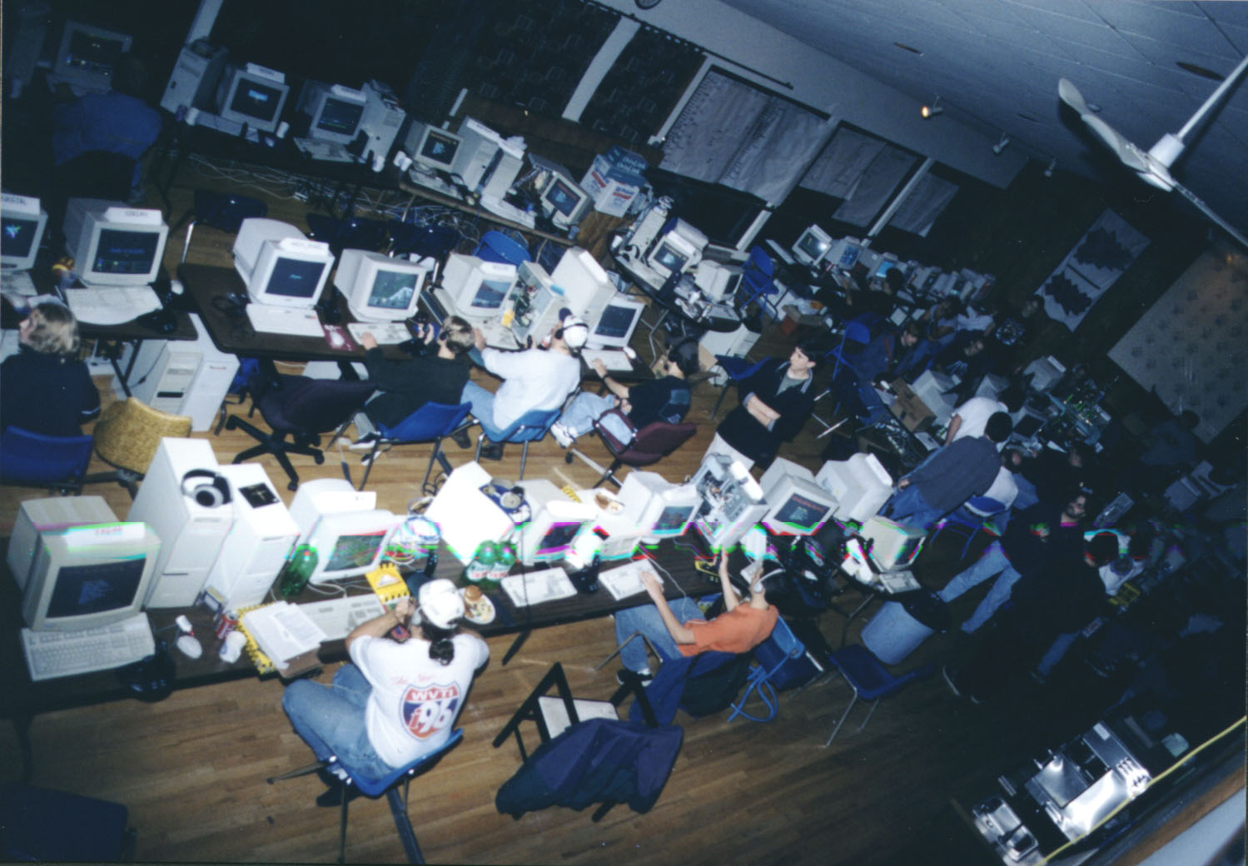
Setting up your network

Operating Systems:
------------------
* All clients should be running Windows 95, preferably the OSR2 (or 2.1)
release. You should have Windows 95 .cab files on hand for all the various
builds of Windows 95.

Sources for technical information

There are so many sites with information on network setup, but I will try
to list as many as possible.

Setting Up Your Network - http://www.si.hhs.nl/~v942388/settingup.html
Very user friendly site.

Simple LAN FAQ - http://home.att.net/~tsatwood/network.html
Basic LAN setup information.

OK, I have the hardware, now what?

If you have a PCI or Plug-and-Play type of card, skip this section. Go to section 3, Plug and Play. Before you insert the card in your system, you need to know what system resources are available for the card to use. Boot your computer into Windows 95. Once you are at your desktop, "right click" on the My Computer icon. Click on Properties, then Device manager. When this screen opens, you should see the Computer icon in the top of the window. Double click on it. This opens up the "Computer Properties"
window. Click on the button that says "Interrupt Request (IRQ)". This window tells you what device is using what IRQ. If an IRQ is used, it will be listed here. If an IRQ is available, it won't be listed. Look and see if anything is using IRQ 9, 10, 11, or 12.
Make a note of the available IRQ's.

Now, click on the button that says "INPUT/OUTPUT (I/O)". There are quite a few listings in here. Just scroll down through and see if anything is using I/O 240, 260, 280, or 300. Again, if any of these are being used, they will be listed. If they are available for use, they won't be. Make a note of an available I/O, and close these windows. Shut down your computer. Why did we have to go through this? You will now see. It's time to install the network card in the system.

Installing the Network card.

Start here if your card in NON Plug-and-Play.
Open the computer case, and locate an available slot for your card. Insert the card. Do not close the case just yet. Now, turn on the computer. When it says "Starting Windows 95" press and hold the "F8" key to get a startup menu. Choose "Command Prompt Only". Now you are at a DOS prompt. Insert the diskette that came with your network card, and run whatever setup program is on the disk (check your documentation). Set the IRQ and the I/O Port to the settings you jotted down. Also, usually these setup programs will let you test the card. Do the test. If everything is OK, save the settings, shutdown the computer, and replace the case. Congratulations, the hard part is over.

Start here if your card is Plug-and-Play.

If your card is Plug-and-Play, you do not need to set the IRQ and I/O, Windows will do it for you. After you have installed the card, simply boot your PC. Windows will prompt you for a drivers disk. Give it to it. Move on to the next section.

Getting the network setup under Windows 95.

Generally, Win 95 will recognize your new network card and will prompt you to insert the Win95 CD or the diskette that came with your card.. For now, we'll assume this to be true. If this is not true, check the Troubleshooting page. After Windows copies some
files to your hard drive, it will ask you to reboot. Do it.

Once you are rebooted, "right click" on the Network Neighborhood icon, and choose Properties. You should see a Window titled Network, and it will have tabs across the top that say Configuration Identification and Access control. Look in the window beneath
the tabs. This lists your network adapter, and some network protocols. OK, now IPX/SPX should be listed. Double click on it. Under NETBIOS, click on "I want to enable NetBIOS". Under Advanced, click on Frame Type. Scroll through the choices, and pick "Ethernet II". We are doing this to make our network compatible with people running DOS IPX drivers. More on that later. For now just do it. :) That's it for IPX networking. If you want to be able to copy files back and forth between computers, click
on "File and Print Sharing". Reboot your computer.

Assuming that you did everything correctly, you will now be able to play IPX games over your brand new network.

Setup
------------------------------
Table, chairs, and computer layout

The best way to deal with layout of the space you are going to be using
is to make a floor plan ahead of time. Find out the specs of the room
or rooms, and calculate how many tables, chairs, desks, computers, etc.
you can fit. When its time to setup your event, stick to this plan as
best you can. There's nothing worse than finding out you don't have room
for all your participants *after* you've already sold them tickets.

------------------------------
Misc.

If you are going to have anything else in the room(s), take this into
consideration when laying out tables and chairs. This means a ticket
desk, tables for food/drinks, spectator chairs and tables, press seating,
and anything else (couches, space for people's stuff).

-------------------------------------------------------------------------

When the players arrive
------------------------------

Setting up computers for the network
This is a subject a lot of LAN organizers disagree about. You can either
insist that people have their computers already setup for the network or
else their out of luck, or have tech support staff on hand to help newbies
or anyone with problems. Its up to you. But in any case, please consider
this *beforehand*, and make sure you mention it to your participants.

------------------------------

Laying down the law

Before the games begin, its best to gather everyone together, or get a
microphone, to announce rules. Tournament rules, the policies of the
place you are having your event at, and rules about conduct. If you
prefer that people not yell, for instance, you should tell them at this
point. LAN events can be quite noisy.

-------------------------------------------------------------------------

Once you've announced the players for the first round of gaming, make
sure that they are all set up and ready to go. Also, at this point, its
a good idea to make sure that observers know where they are allowed and
not allowed to stand/sit.

-------------------------------------------------------------------------

Dealing with problem people

There a kid in the back row that repeatedly yells obscenities after being
warned that its inappropriate? How bout that guy in the corner who is
obviously drunk when you've already told everyone that there is to be no
alcohol consumption at your event? Or worse, the guy you caught trying to
walk out the door with your server?
For minor problems, usually kicking the person out, refunding their money,
and asking them not to come back works. If its a more severe problem,
you may have to call the police. In any case, its best to keep an eye out
on equipment and people who might be a problem.

-------------------------------------------------------------------------

Posting results

You should have a big board, or some very visible place to post results
from matches. Put someone in charge of recording and posting this info.

Also, you should try to find a way to post the results on the web as it
happens. You'd be surprised at how many people will be sitting on your
page hitting reload, hoping to see the latest.

------------------------------
Handing out prizes

This part is fun! Once everything is over, you get to shake people's
hands, give them their prizes, and listen to the crowd cheer.

-------------------------------------------------------------------------

Windup

As the crowd dwindles, make sure you thank people as they leave. A
little bit of manners goes a long way. (And if you impress people, they'll
be more likely to come back the next time!)

Also, keep an eye out for people trying to sneak off with stuff that isn't
theirs. This isn't usually a problem, but a missing computer would be a
BIG hassle.

-------------------------------------------------------------------------

Cleanup

This part is the most fun! (Not) You'll need to disassemble all computers,
rented equipment, tables, chairs, and anything else you brought into the
area. Also, some places require that you cleanup the floors and existing
facilities before you leave.

Some places, however, such as cyber-cafes and conference centers, do not
require cleanup before you leave. They pay people to wash the floors, etc.
If you've been lucky enough to get a location like this, you should be
smiling at this point!

-------------------------------------------------------------------------

Press and sponsors

Remember those pesky people who asked you if they could interview you
after your event? Or those people who wanted to see pictures and demos?

Don't forget! Giving interviews and information to the general public
is great PR.

Also, you should take some time out to thank your sponsors. A letter
or a phone call would be a good idea.

-------------------------------------------------------------------------

Wanna do this again?

Phew. That was a lot of work, but also a lot of fun. Wanna do it again?
First of all, are you brave enough? *grin*

Once you've done it one time, it gets easier. You get a feel of some of
the problems and hurdles associated with planning and running a LAN event,
and you get to experience the fun and games as well.

Keep a list of the people who attended your last event for future
reference. If they came once, they'll probably wanna go again! Also, keep
a list of all the press that attended or covered your party. They'll also
probably wanna join in the fun a second time.
-------------------------------------------------------------------------

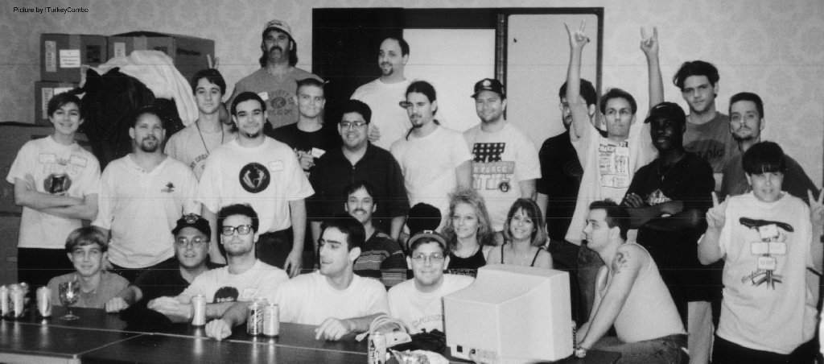
AtLANta Lan fest nerds

Some quotes from one of our fests:
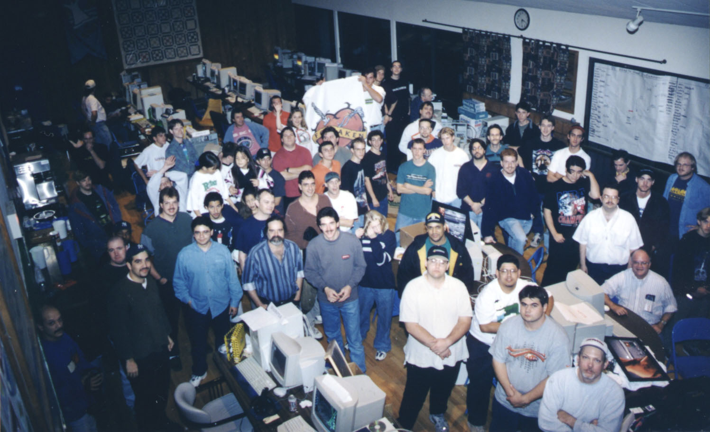

Kiln: "Peart's gonna kick my ass next. Maybe I should retire from one on one."

Sirian: "Whoa! Look at this! The whole atLANta corner is playing Forsaken! Amazing."
Manson: "Yeah, we better get a picture of this." Goes and gets camera to mark historic event.

HolyGhost: "Forsaken is awesome. They obviously designed it to appeal to Descent players."

After Descentile's box was hooked up to a phone line and the Vendetta results were reported to the IDL web page, Manson looked at the standings, looked at his games list, looked at the standings again, then Sirian reported his match with Kiln and browsed the site.
And Manson said, "Sirian, let me see those standings ONE more time."

Kiln to Saline: "What the Hell are you shooting at?"

DelCio before starting his tenth match at the fest, when asked if he was going for the most-matches award: "Hey, I'm gonna win SOMEthing, dammit!" He played 16 matches in all and took the prize. Chipmunk placed second with 11 matches, and Sirian was third with 9 matches.

After most of the head to head matches were played on Saturday, the atLANta boys fired up some Forsaken and invited a couple people to join in. There was an unending Trojack dogfight going on in the big room, and on LAN every second or third shot was pasting somebody, because there was NO LAG. Half the room is watching this game on one monitor or another, and cries of "WHOA!" and "YEAH!" are cranking out constantly, as someone dodges a full power shot of the purple, or someone nails somebody.
Jackhammer charges his trojack up to full power and smacks Sirian in the face from halfway across the level. Doink! Shouts across the room: "YEAH, SIRIAN! EAT TROJACK!!!" Sirian makes his way back into the fight, scrounges up a fusion out of somebody's freshly spinning remains, and cuts loose at Jackhammer. Doink! "Got THAT rat bastid!"
Kiln: "Oooh, Josh. He just smacked you back, dude."
Jackhammer: "Yeah, no shit."

Explodo after the game: "Man there ain't NOTHING like an 8 player LAN FORSAKEN! Nothing."

Kiln and Jackhammer were paired in FORSAKEN teams, and being roommates they have lots of experience at working together effectively. They sat next to each other in the atLANta corner and talked constantly during their team matches.
Kiln: "Josh, Josh. You go high, I'll go low." Result: Doink! *Jackhammer killed DelCio*
Kiln: "OK, I'm guarding the energy center. Where are they? Where are they?" Jackhammer: "Um, we're all out in the big room playing." Everyone watching the game laughs. Kiln: "OK. Bring em this way." Result: Doink! *Kiln killed Aziden*
Jackhammer: "I need some help here!" Kiln: "Where?" Jackhammer: "Up top." Kiln: "OK I'm coming. Hold on." Jackhammer: "Hurry up, dude. They're kicking my ass!" Result: Doink! Doink! *Kiln killed DelCio* *Jackhammer killed Aziden*
Kiln: "Um, I got a problem here. Make that two problems." Jackhammer: "In the big room?" Kiln: "Yep. I'm hiding out in the energy center and shit is flying all over." Result: Doink! *Jackhammer killed DelCio* Kiln: "Let me have his shit. I need stuff."
Kiln: "Oh no. DelCio got the plasma. I'm really scared now." Jackhammer laughs. "Where are you?" Kiln: "Shooting peas at him in the big room." Jackhammer: "Bring him up top." Kiln: "Gotcha." Result: Doink! *Jackhammer killed DelCio*
Jackhammer: "Wait, wait. I need that stuff." Kiln: "Hurry up, grab his shit, we got a date in the back tunnel." Kiln goes one way, Jackhammer goes the other. Result: Doink! Doink! Caught both opponents in the back tunnel amidst some wicked crossfire.
Final score was 30 to 11. Explodo shakes his head: "You see? You see how they are? It's brutal."

Neitzl points at Psion playing Forsaken. "Look at that. He's been there for HOURS."

Kiln to Manson after his D1 match with R2: "Yo, Manson. R2 kicked your ass, man."
Kiln to R2 after his D2 match with Manson: "Yo, R2. Manson kicked your ass, man."

Peartman to Kiln: "If Kiln is PEARTDADDY, who am I?"

R2 to Kiln during the FORSAKEN final when the score reached 30-30 (the game was to be played to 15, but the victor had to win by two.): "Forget this. Let's just call it a tie."
Kiln: "Yeah. My hand's about to fall off."
A tie was declared and they share the FORSAKEN title.

Descentile: "The key to Forsaken becoming a hit is, I think, that they have to make the game the way we want it. It's that simple. They want to take 3D gaming to a new level, and that's why the development team is here: to let us play the game so we can tell them what we like and don't like about it. It doesn't release until early next year, and they are going to make some changes based on input they get from all of us here this weekend."

Manson: "Damn, Sirian. If I had known you were writing this stuff down to tell the whole world, I'd have said something more intelligent."

The big event of the weekend was the final in the Turf Wars: 4 player teams, 8 player team anarchy to 70 team points. One by one the teams were eliminated until only two remained: the atLANta first team and the NY Gaming Krib. The atLANta team included Kiln, Manson, Jackhammer and Neitzl. The Krib team included Descentile, R2, Baywatch and Vipe.
Both teams were highly coordinated, everyone lined up on adjacent computers and calling out warnings or cries for help or directing traffic in whatever form. The NY Krib team talked amongst themselves even more than the atLANta boys, which surprised some.

Baywatch: "There's one downstairs." R2: "OK I'm on him. Coming around behind." Descentile: "I got cover up top." Doink! *R2D297 killed Kiln* Baywatch: "Is everyone OK? Anyone need help?" R2: "Yeah, Kiln's in bad shape." Everyone laughs.
Jackhammer: "They're on me! They're on me!" Kiln: "OK bring em this way." Doink! *Descentile killed Jackhammer* "Shit!" Manson: "Behind you Kiln." Kiln: "I'm taking him down. Cover me." Doink! *Kiln killed Descentile* Doink! *R2D297 killed Kiln* "Fuck!" Doink! *Manson killed R2D297* Kiln: "Way to go, Mans. Make him eat his peas." Manson, "Oh yeah! Lemme grab this sauss gun. Ahh! WEAPONS! Nitro! Oh yeah!"
Baywatch: "They're all downstairs!" Descentile: "R2 help me out here." Baywatch: "SAUSS WHORE, SAUSS WHORE!" Doink! *Manson killed Baywatch* Doink! *Manson killed Vipe!* Descentile: "There's three of em down here! R2 where ARE you??" Doink! *R2D297 killed Kiln* Doink! *R2D297 killed Neitzl* R2: "Right here, D. Calm down." Everyone laughs. Doink! *Descentile killed Manson*
Jackhammer: "Kiln, man, I am really getting my ass kicked in this game." Kiln: "Hold on, guys. We can take em. Neitzl, behind you." Doink! *Baywatch killed Neitzl* Kiln: "Manson, need some help. They're all over us down here." Manson: "Where are all the weapons?" Doink! *R2D297 killed Kiln* Doink! *Jackhammer killed Descentile* Doink! *Vipe! killed Jackhammer* Kiln: "Guys, guys, regroup upstairs"
R2: "All clear down here." Baywatch: "Anyone need help?" Descentile: "I've got one cornered over here." Baywatch: "OK I got him from behind." Doink! *Baywatch killed Neitzl*
Game is to 70. With score at 64 - 55 with Krib leading, Kiln: "Guys we gotta pull this together. We can take em." Jackhammer: "Somebody help me down here." Doink! *Manson killed Descentile* Jackhammer: "Thanks. Lemme have his shit." Kiln: "Everybody go downstairs. We got this in the bag."
Baywatch: "Whoa! There's someone down here! Wait, two of them. Holy shit! They're ALL down here!" Doink! *Kiln killed Baywatch* Doink! *Neitzl killed Descentile* Doink! *Jackhammer killed R2D297*
With the score at 67-64 Krib leading, atLANta was staging a major comeback by guarding the weapons, which were all downstairs where most of the fighting had been. Descentile: "I think their shields are low." R2: "OK, mop em up, D." Doink! *Descentile killed Neitzl* Doink! *Descentile killed Jackhammer* Doink! *Descentile killed Kiln* Baywatch: "YEAH!!! That's game!" Final score: 70-64

After the big game, Descentile to R2: "Tell them atLANta boys to take their butts home and practice FORSAKEN, and to come back for more Turf Wars when they are ready to try again."

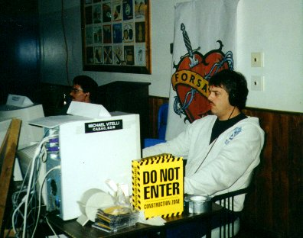
Descentile trying to concentrate . . .

Xciter: "Till next time, guys."

Explodo, pointing over to where R2 is still playing something after everyone else has shut down and half the people have already left: "Look at R2 over there. His ass ain't going nowhere. Like, hey, he's just getting warmed up at this point."

Peartman to Kiln as the atLANta crew heads out: "Hey, no triple chording on the highway, OK?"

Descentile: "To everyone who did not come to the fest, you missed out on something really good. We had a blast! I hope you can make it next time."

Thanks go to Sirian for reporting on the fest, and to Explodo for helping to gather some of the quotes. And of course, to Descentile, who threw one heck of a fine party.
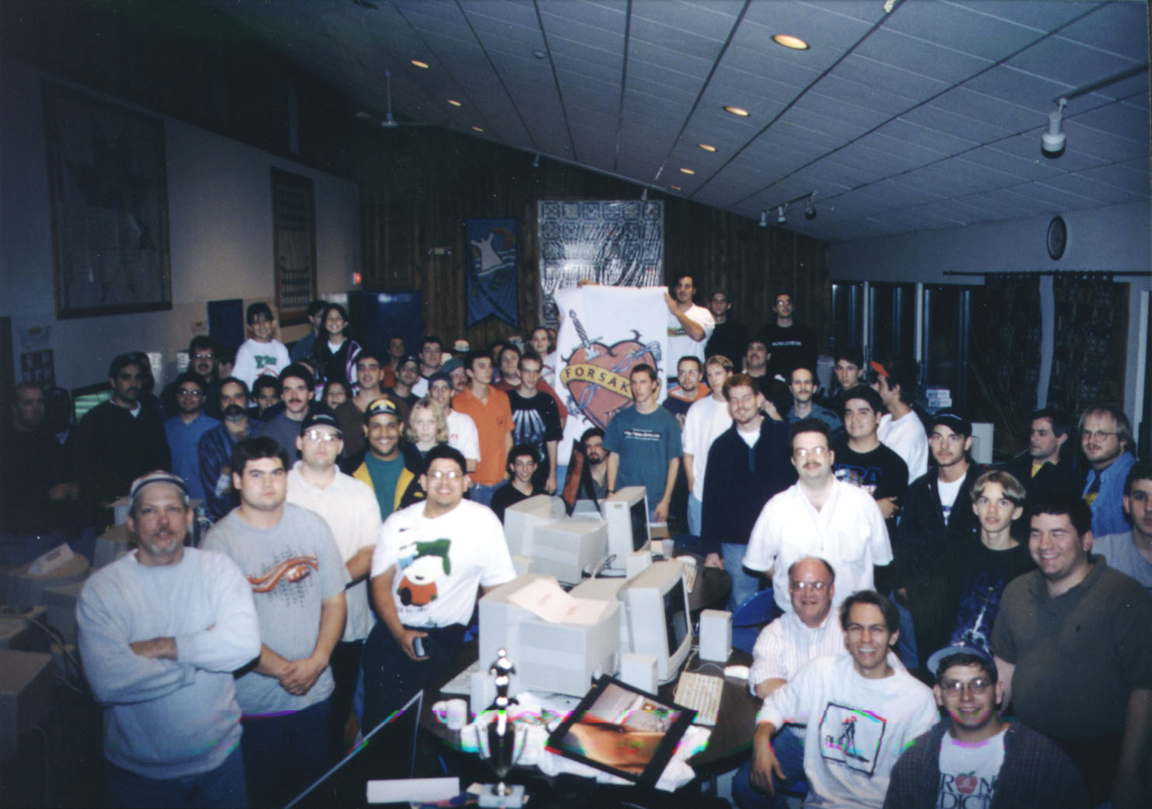

Holmes NY, Holloween night 1997

