Charles Hancock

HW3

**PROBLEM 1**

Added _BaseTex code back in to access a texture that had an alpha and stuff, removed Fresnel, etc., and returned a lerp.

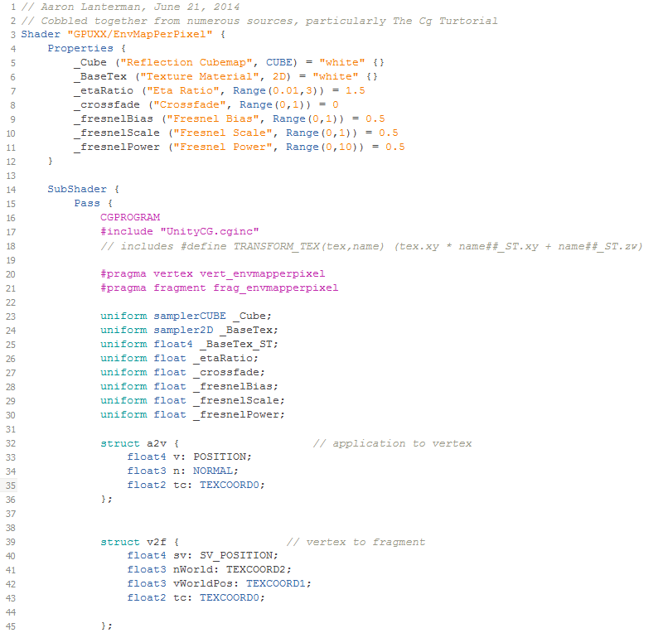

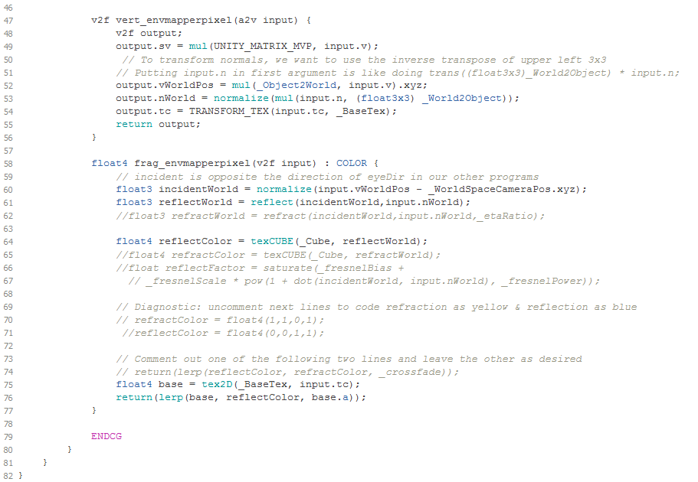

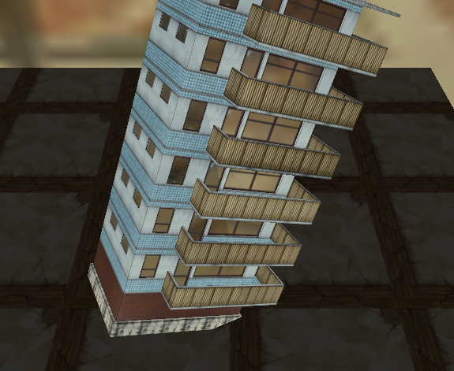

Note the reflections in the windows.

**PROBLEM 2**

Split into three different color channels with three sliders

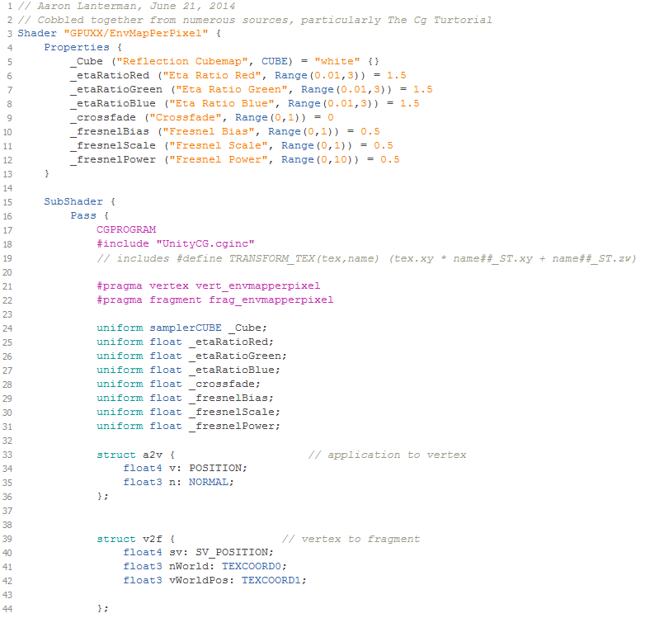

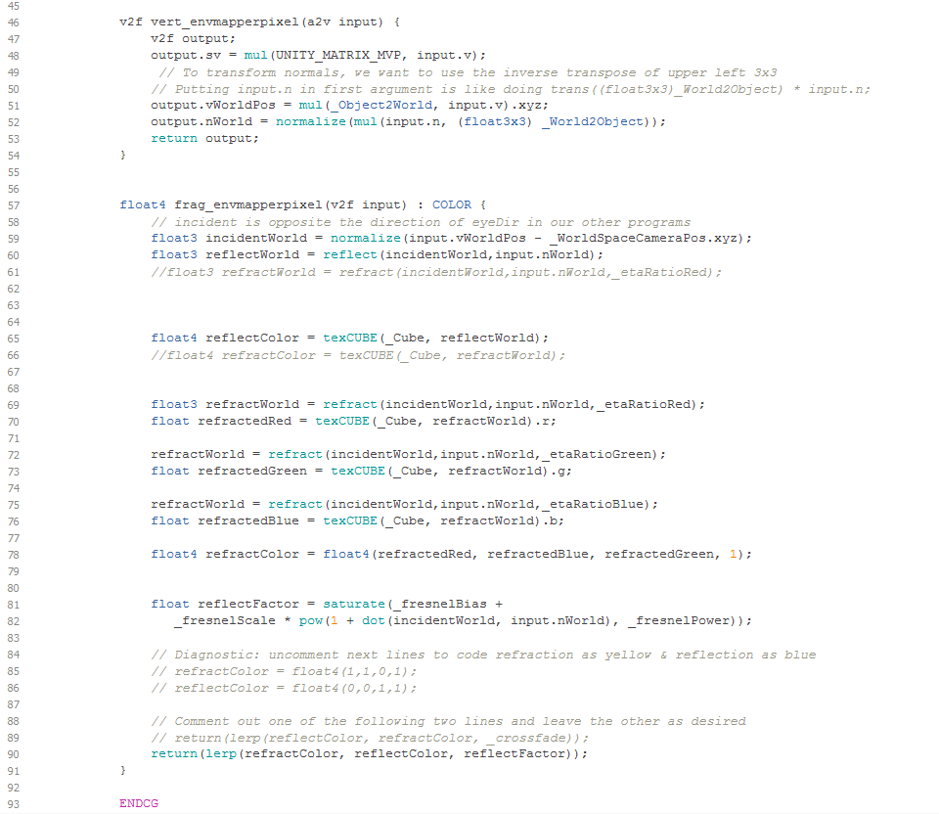

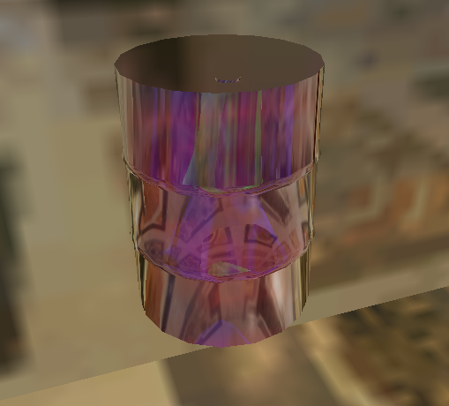

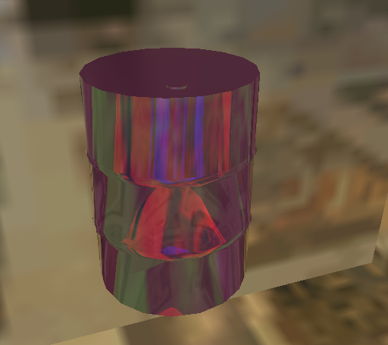

**PROBLEM 3**

All specular and normal map code successfully ported from the GPUXXSpecNormMap.shader file.

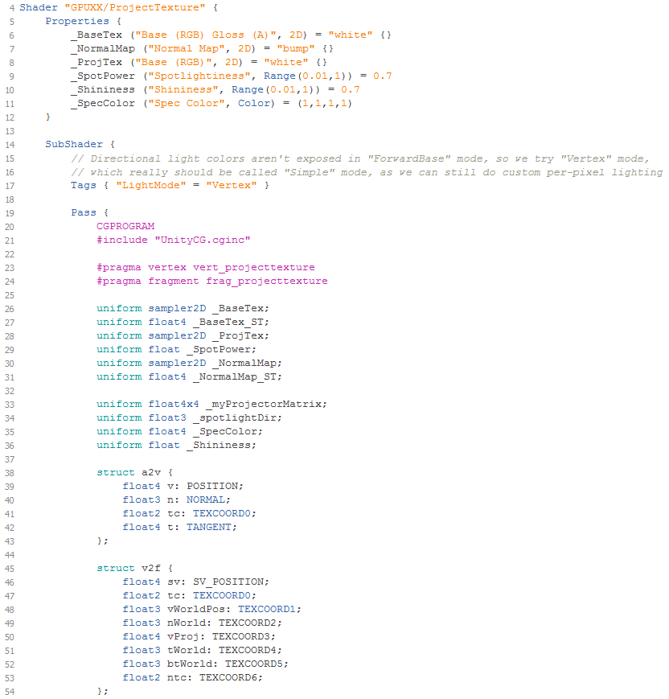

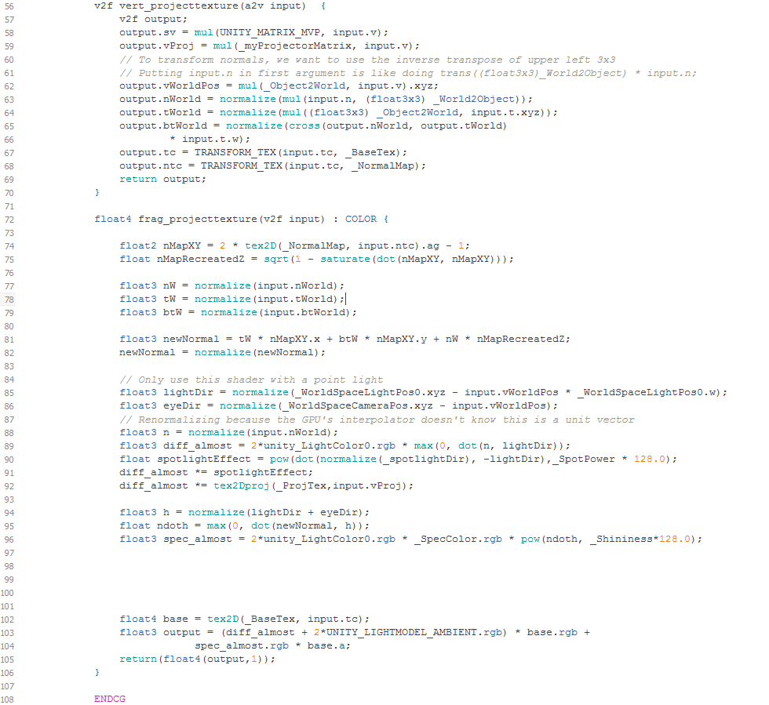

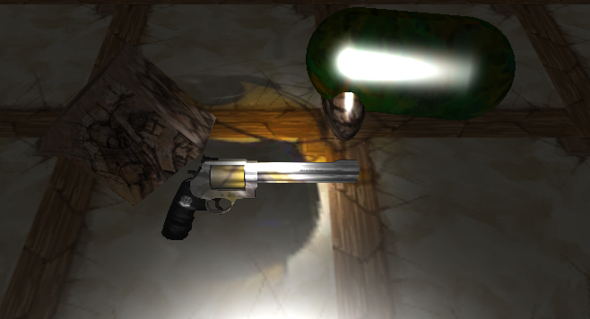

I put the revolver in the example scene to demonstrate that buzz still lights up on it. Below is a picture that better shows the weirdo bump mapping. (Look at the barrel.)

