Income & Expenses app

Individual assignment for Android App Development

Name : Menno Potveer

Studentnumber : 500750033

Content

Think 3

Make 4

Design 5

Copyright 7

# Think

**With the Income and Expenses app you can manage your financial affairs.**

The app will have 3 tabs: income, expenses and an overview.

In your income you can view your income categorically by month in a pie chart. You can also go the edit activity where you can manage it (insert, update and delete).

In your expenses you can view your expenses categorically by month in a pie chart. This way you can see where all your money is spent on. Some example categories are:

* Mortgage
* Utility bills
* Insurances
* Clothing
* Fun / hobby

You can also go the edit activity where you can manage it (insert, update and delete).

In the overview you can compare the total income and expenses for each month in a bar chart.

# Make

|  |  |  |
| --- | --- | --- |
| Test your app | The app does not crash or freeze | Yes |
| Make activities | Using intents | Yes |
| Make fragments | App makes use of navigation component | Yes |
| Make Resources | constraintlayout  Recyclerview (with swipe en click functionalities) | Yes |
| Create local storage | ROOM. | Yes |
| Build user layer | ViewModel is used with Livedata. | Yes |
|  |
| Build data layer | Repository  Create, Retrieve, Update and delete is implemented. | Yes |  |
| Use remote data source | Use external service (1 point)  External database (e.g. firebase)  (1 point) | No (unless the chart library counts) |  |

# Design

For the design I’m using a tab navigation based app. In these tabs there will be charts that display the result for a specific month.

Example charts:

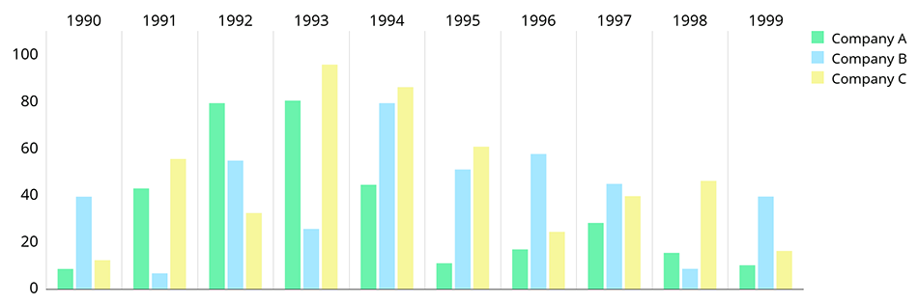

More info: <https://github.com/PhilJay/MPAndroidChart>

Furthermore on the income and expenses there will be an edit icon in the top right which will take you to a RecyclerView where you can delete or edit an item. And there will be a floating action button where you can add an item. At the moment I’m not sure if I will create a separate activity for the insert and update of an income/expense item. For now it is in the same screen.

Example:

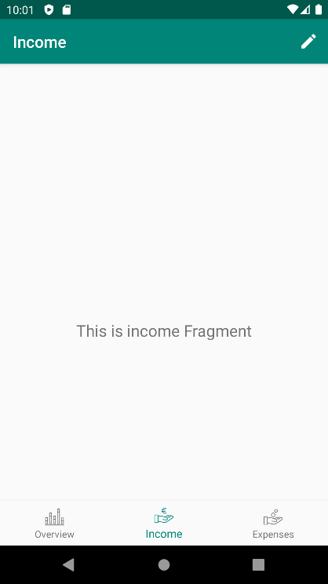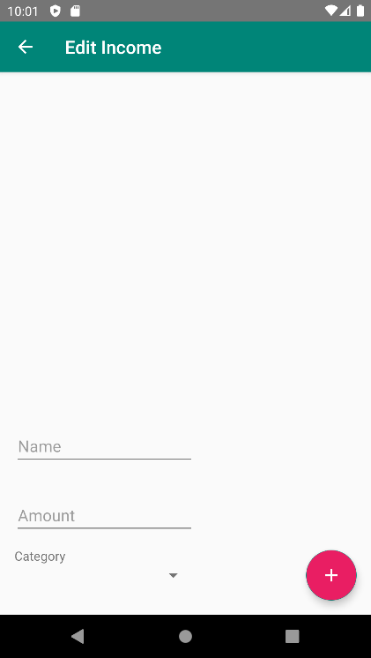

# Copyright

The icons I used are free but require a mention.

Icons are from:

<https://www.flaticon.com>

<https://www.flaticon.com/authors/tomas-knop>

Icons made by Tomas Knop from.flaticon.com