


FORTIZO TECHNOLOGIES

Future Proofer

AI foresight for smarter careers and stronger businesses.

By Fortizo Technologies
Contact: info@fortizotechnologies.com | +220 7330 540

1. Product Overview
Future Proofer is an AI-powered foresight and strategy platform developed by Fortizo Technologies.
It equips individuals, professionals, and organizations in Sierra Leone and the West African region to anticipate risks,
discover opportunities, and strategically plan careers or business trajectories based on localized AI insights.
Mission: Empower Africa’s next generation of thinkers with intelligent foresight.
Vision: Bridge the gap between potential and preparedness using AI insights.
Tagline: “AI foresight for smarter careers and stronger businesses.”

Problem
Individuals and SMEs in Sierra Leone struggle to anticipate economic and career shifts due to scarce access
to localized data, poor digital literacy, and lack of future-ready tools. This results in underemployment and poor business planning.

Solution
Future Proofer leverages AI to analyze regional trends, skill demand, and market shifts to provide actionable
recommendations for users—enabling them to future-proof their careers and businesses. Integrated with Fortizo’s ThinkForge learning
ecosystem, it also offers skill-building masterclasses and AI-driven mentorship.

2. Product Requirements Document (PRD)
Objective: Build a responsive, AI-enabled platform that offers real-time foresight insights to users in the
form of dashboards, forecasts, and personalized learning or strategy paths. The system must combine predictive data modeling with
intuitive UX and strong localization features.
Core Features:
- AI-driven career and business forecasts
- Personalized insights dashboard
- AI Chat Assistant (BusinessMate)
- Skill and learning pathway integration
- Admin analytics console
- B2B and B2C subscription options
Technology Stack:
Frontend: React / Flutter
Backend: Node.js / Python (AI engine)
Database: PostgreSQL
Hosting: AWS or Azure Cloud
Integrations: ThinkForge, BusinessMate APIs

3. Terms of Reference (TOR)
Scope: Develop and deploy a bilingual web and mobile platform that analyzes data to generate user-specific insights.
The platform must include both free and premium versions for individuals and organizations.
Deliverables:
1. Fully functional Future Proofer platform (web + mobile)
2. AI insight engine and API integration
3. Admin dashboard and analytics
4. Visual design and brand integration
5. Training resources and user onboarding manual
Stakeholders:
- Product Owner: Fortizo Technologies
- Team: Developers, Data Scientists, Designers, Marketers
- Partners: NGOs, Innovation Hubs, Universities, SMEs

4. UX / UI Design Specification
Design Language: Modern, minimalist, and empowering. Uses Royal Blue (#0033A0) and Cyan (#00B5E2) accents,
white backgrounds, and open sans-serif typography (Montserrat / Lato). The UI aims to convey clarity and intelligence.

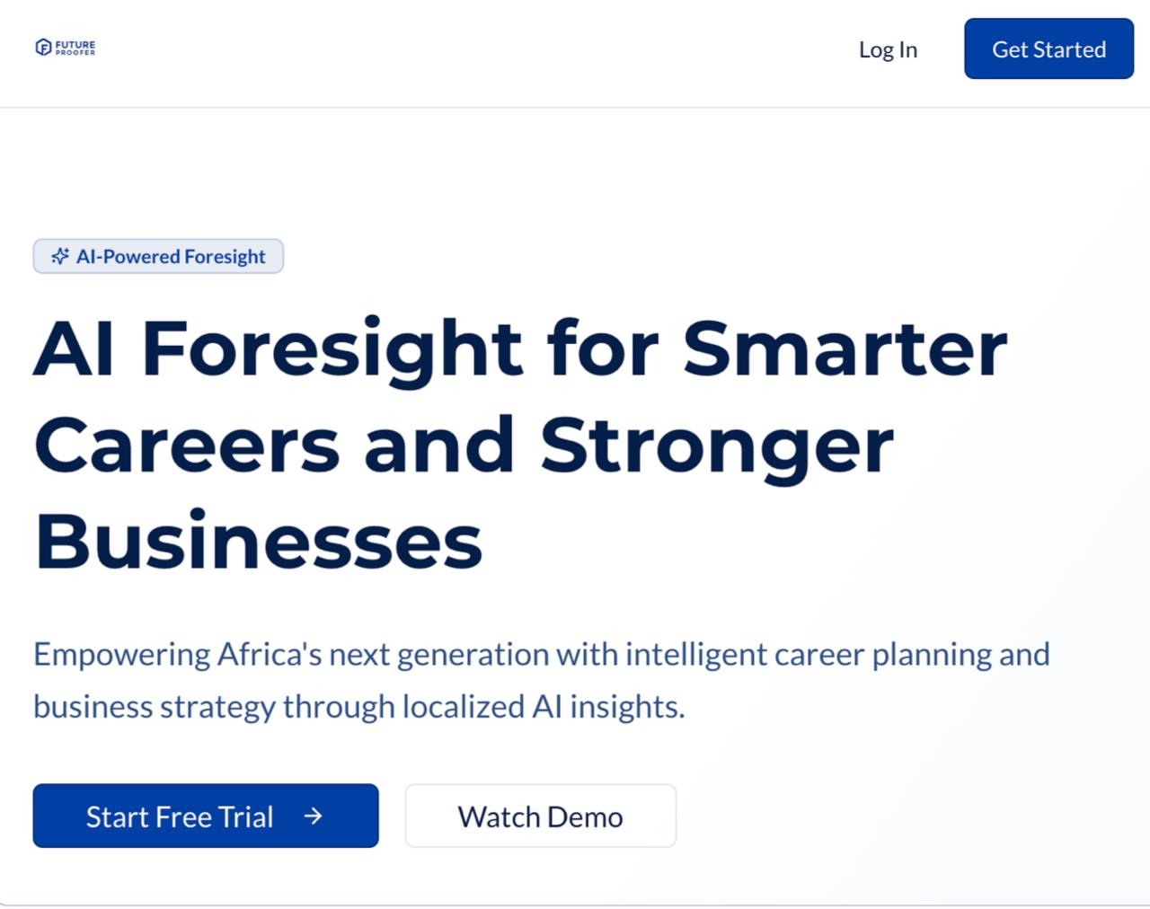
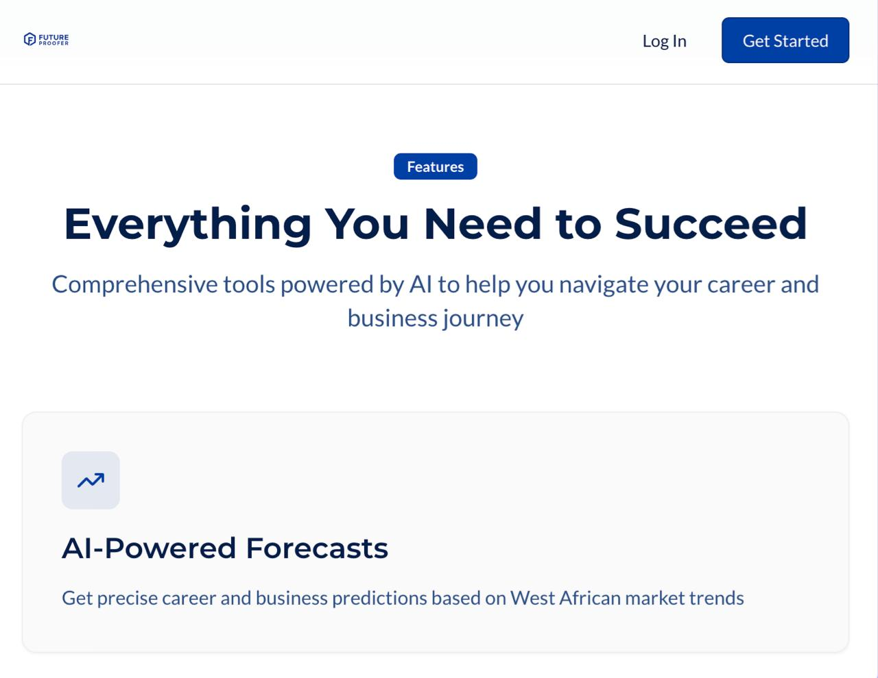
Wireframe Overview:
1. Landing Page – clean CTA, benefit highlights, and signup option.
2. Dashboard (Career Mode) – shows personal insights, AI recommendations.
3. Dashboard (Business Mode) – shows market forecasts and growth tips.
4. Learning Screen – connects user to masterclasses via ThinkForge.
5. Admin Console – data and user management tools.

User Flow
1. Sign Up → Select Focus (Career / Business)
2. Input Personal or Business Info → AI Analyzes Data
3. View Insights Dashboard → Receive Recommendations
4. Engage with Masterclasses → Apply Learnings
5. Subscribe or Share → Continuous AI feedback loop

5. Emotional Journey Map
Stage: Awareness → Emotion: Curiosity → Action: Sees ad → Feeling: Inspired
Stage: Onboarding → Emotion: Excitement → Action: Inputs info → Feeling: Understood
Stage: Insight Delivery → Emotion: Empowerment → Action: Receives plan → Feeling: Clarity
Stage: Retention → Emotion: Trust → Action: Upgrades → Feeling: Loyalty

6. Business Model Canvas
Key Partners: NGOs, Fortizo Technologies, Universities, Ministries
Key Activities: AI analytics, platform development, training delivery
Value Proposition: AI foresight tailored to African markets, social impact mission
Customer Segments: Youth, SMEs, professionals, NGOs
Customer Relationships: Self-service platform, online mentorship
Channels: Web & Mobile, social media, partnerships
Revenue Streams: Subscriptions, B2B licensing, training, grants
Cost Structure: Development, data acquisition, marketing, human resources

7. Market Validation & Research
- Over 60% of Sierra Leone’s youth underemployed.
- SMEs lack predictive data tools for growth.
- Increasing AI awareness in Africa makes this product timely.
- Competitors like Coursera and LinkedIn lack localized foresight tools.
Future Proofer fills this gap with contextual intelligence and integrated learning.

8. True North Metric & KPIs
True North Metric: Number of Active Subscribers
KPIs: Engagement rate, retention, number of insights generated, conversion rate, social reach.

9. Social Impact
Projected Outcomes:
- 10,000 youth trained in digital foresight
- 2,000 SMEs supported with AI-driven insights
- Active presence in 15 ECOWAS nations

10. Future Vision
The platform will expand to integrate regional data intelligence tools, introduce predictive economic indices,
and establish a collaborative ecosystem for career and business foresight across Africa. Integration with Fortizo’s ThinkForge and
BusinessMate products will ensure synergy across learning, innovation, and strategy.

