Chair of Big Geospatial Data Management

TUM School of Engineering and Design

Technical University of Munich

Exploring Asteroids: A Survey

Semesterarbeit: Literature research and implementation of a relative position estimation for landing planning on an asteroid

Guerrero Hernández, Aníbal

October 30, 2024
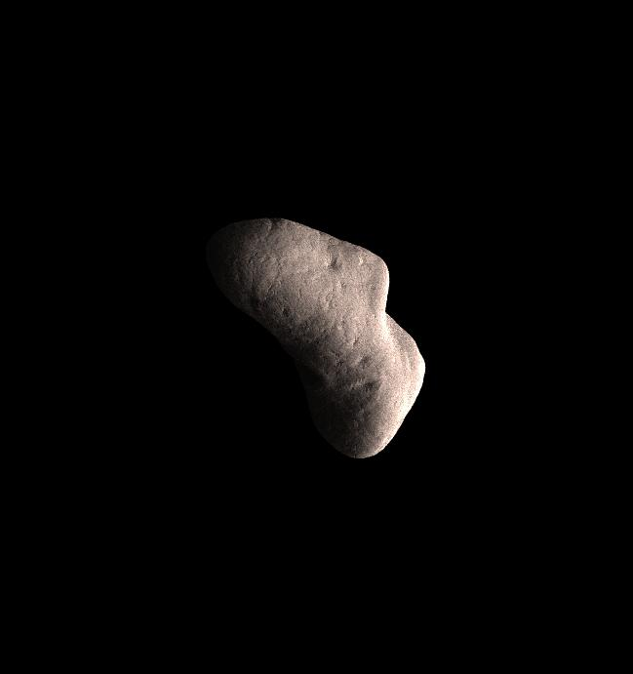

1

2

Abstract - Historically, exploration of asteroids has been reserved for larger missions due to the technological complexity and lack of available a-priori information, leading to a high risk of failure. Effective risk mitigation in such missions arises from adapting quickly to new and unforeseen con-ditions. This dynamic adaptation is driven by per-ception systems that require extensive data for ac-curate parameterization.

This paper proposes a pipeline to generate syn-thetic image datasets by deforming base shape models, generating trajectories, and applying sen-sors. The proposed pipeline enhances the capa-bilities of the Outdoor Artificial Intelligent SYs-tems Simulator (OAISYS) by creating synthetic asteroid models. These models are used to gen-erate RGB-Depth (RGB-D) images, masks, and six-dimensional (6D) pose data, which can train Convolutional Neural Network (CNN) models for detection, pose estimation, and tracking.

1. Introduction

Asteroid mining offers solutions to pressing chal-lenges across domains by diversifying resource extrac-tion beyond Earth, accessing Platinum Group Metals (PGMs) [1], Rare Earth Elements (REEs) [2], and wa-ter [3]. Not only would it ease the strain on Earth’s resources, but also fuel aspirations for sustained space exploration, marking a pivotal step toward space in-dustrialization. Beyond its economic promise, aster-oid mining holds deep scientific significance, as it could shed light on solar system origins and planetary formation.

However, asteroid mining confronts significant technological barriers, requiring complex solutions for operation in space’s harsh environment. Close-proximity navigation systems demand abundant a-priori information of the target [4], a challenge com-pounded by the scarcity of complete and precise image datasets. This lack of comprehensive datasets impedes the development of accurate models needed for effec-tive navigation.

To address these challenges, CNN have emerged as a promising solution due to their adaptability to un-known and dynamic environments. However, for CNN to excel in detection, pose estimation, and tracking tasks, they necessitate substantial datasets for effective training. Compared to the 700,000 asteroids discov-ered [5], existing shape model catalogs such as the 3D Asteroid Catalogue, offer only 1,635 shape models, a

negligible fraction of the asteroids discovered to date, with many models derived from lightcurve-inversion techniques, lacking the detail required for CNN-based approaches [6]. Assumptions like distant observation further limit the applicability of available datasets for tasks such as landing maneuvers.

This study aims to enhance the capabilities of the OAISYS to allow the generation of a comprehensive image dataset from synthetic asteroid shape models. Leveraging Blender’s rendering engine, this initia-tive will create synthetic asteroid models, enabling RGB-D, mask, and 6D pose data collection. By bridg-ing the gap between limited observational data and the needs of CNN-based algorithms, this effort lays the groundwork for advancements in autonomous nav-igation, detection, and pose estimation, benefiting as-teroid mining and broader space exploration goals. The research ensured compatibility with existing Deep Learning (DL) frameworks to enhance training and evaluation processes for DL networks.

Research Trigger The purpose of this research lies in the recognition of the critical role of data in overcoming the challenges of asteroid mining. The scarcity of available data, particularly concerning three-dimensional (3D) asteroid models and asteroid image datasets, limits progress in mission planning and navigation. Synthetic data generation becomes a promising avenue to supplement sparse observational data, enabling the development of robust Machine Learning (ML) algorithms for asteroid exploration.

Research Questions To address these challenges, the following research questions guide this study:
Q1: What methods can be employed to generate a representative and realistic dataset of synthetic aster-oid images suitable for training and evaluating DL net-works?

Q2 : What methodologies can be employed to val-idate the fidelity of the developed pipeline, ensuring the physical validity of the rotational movement of the asteroid?

Q3: How can the synthesis of real 3D asteroid data be optimized to generate a vast number of samples?

2. Related Work

Real asteroid imagery datasets provide insights into surface characteristics of asteroids. However, these of-ten focus on a limited number of specific asteroids. In the context of ML models, these datasets could

3

lead to potential overfitting, resulting unusable in prac-tice. As an example, Astrovision [7] offers a large-scale dataset featuring densely annotated images from observations collected throughout various deep space missions. The dataset consists of 110,000 densely an-notated, real images of sixteen small bodies. Despite its richness, it lacks depth, 6D pose, mask informa-tion, and the dataset’s narrow focus on only 16 aster-oids limits its applicability to broader tasks.

The solution to the scarcity of real imagery datasets is to use real asteroid shape models derived from ob-servational data and produce the images from these. Efforts such as the Database of Asteroid Models from Inversion Techniques (DAMIT) [8] aims to consoli-date these shape models. At the time of this study, DAMIT contains around 200 shape models. How-ever, shape models derived from lightcurve inver-sion techniques lack precision, lose most relevant geospatial information, and are scattered across var-ious sources. Another example is the Planetary Data System (PDS) Small Bodies Node [9]. Similar to the DAMIT database, it is very limited in the total number of small bodies contemplated.

It is assumed that models have uniform, and con-stant density to model their volume. To do so, a Gaus-sian Quadrature over the surface is used to calculate the volume. This is a common assumption and implies that inner cavities, non-constant density distributions, and other structural irregularities are neglected, shift-ing the center of mass. The absence of a-priori infor-mation highlights the impossibility of knowing these internal structures.

The best database available is presented by 3D Asteroid Catalogue [6], an interactive catalogue that contains 1,635 shape models derived from lightcurve inversion, radar measurements, and spacecraft im-agery, orbital and physical parameters, and current orbital position of known minor bodies. It is a compilation of multiple smaller datasets, where most of the radar-based models are taken from the JPL Asteroid RADAR Research page [10], and most of the lightcurve-inversion models are taken from the DAMIT database [8].

Compared to the 700,000 asteroids discovered at the time of writing this study, the 3D Asteroid Catalogue has a very small fraction of all asteroids identified. Additionally, the small sample of shape models avail-able is in its majority, reconstructed from lightcurve-inversion models, which provides a low-detail shape estimation, inadequate for this study.

For this reason, it is reasonable to consider alterna-tive approaches such as synthetic shape model gener-ators. Specialized software like SurRender [11] and Planet and Asteroid Natural Scene Generation Util-ity (PANGU) [12] enables the generation of detailed 3D meshes based on procedural algorithms. However, these models may lack realism and depth compared to observational data, limiting their effectiveness in nav-igation applications.

Alternatively, AstroGen [13] presents a novel algo-rithm for generating highly detailed and physically re-alistic 3D meshes of small celestial bodies. Astro-Gen gains its realism from modeling surface details with physical equations derived from real-world aster-oid data, overcoming traditional shape reconstruction methods’ limitations. Nevertheless, requiring a high computational cost, leading to high execution times, and lacking relevant outputs such as depth maps and masks of the objects processed, as key to building CNN models, makes it an inadequate shape model generator for this study.

With regards to the asteroid, all trajectory simula-tions are taken without asteroid spin instabilities and all orbital families are contemplated. It assumes that observed synthetic asteroids have settled into a rota-tion around the principal axis of inertia due to energy dissipation over millennia, and direct, retrograde, and polar orbits are contemplated as a possibility when generating the asteroid trajectories.

3. Methodology

Given the limitations encountered with previous shape model generators, such as lack of realism, di-versity, and relevant outputs essential for CNN mod-els, OAISYS is chosen as the solution. OAISYS is a cutting-edge simulator designed to tackle the scarcity of high-quality synthetic data in planetary robotics

- Built upon Blender, it enables the creation of diverse planetary outdoor scenes with rich metadata, including semantic and instance annotations. By of-fering automated generation capabilities and high ren-dering quality, OAISYS facilitates the development of realistic datasets for various robotic tasks. Its modu-lar design allows for easy customization, making it a versatile tool for researchers in planetary robotics and beyond.

System This study aims to expand on OAISYS as a foundational layer, enhancing its codebase to facilitate

4

the generation of synthetic asteroid datasets. The fo-cus lies on creating a comprehensive database of syn-thetic asteroid models for training and evaluating DL networks. By simulating realistic asteroid environ-ments, complete with deformed surfaces and dynamic trajectories, this research aims to bridge the gap be-tween sparse observational data and the development of robust ML algorithms for asteroid exploration. The following requirements shall be met for a satisfactory outcome of this mission:

SR01: The OAISYS codebase shall be enhanced to support synthetic asteroid dataset generation.
SR02: A comprehensive database of synthetic as-teroid shape models shall be created to generate ren-dered images, masks, and 6D poses for training and evaluating DL networks.

SR03: The research shall focus on simulating real-istic asteroid environments with deformable surfaces and dynamic trajectories.

SR04: The generated outputs shall be usable with existing DL frameworks for training and evaluation.

Software Pipeline The major steps of the dataset generation process are illustrated in Figure 1, serving as a top-level overview showing how it can be imple-mented for object detection, state estimation, and 3D model reconstruction CNN models.

The model-agnostic image generation pipeline con-sists of four parts. First, the base asteroid model is obtained and fed into the pipeline. Second, the syn-thetic asteroid models are generated by deforming the original base model and providing texture and lighting conditions. Then, trajectories are generated for each model. Lastly, the rendering process obtains mask, RGB-D, and 6D pose data. The different components in the pipeline are described in detail in the following subsections.

Obtaining Base Asteroid Models Base asteroid shape models are obtained from the 3D Asteroid Cata-logue [6]. At the time of extraction, the database con-tains 1,635 asteroid models given in Stanford Triangle Format (PLY) and OBJ. This study only deals with OBJs, extracting the highest resolution option avail-able for each asteroid. The OBJ datatype was selected for simplicity and consistency, as one format had to be chosen. While lightcurve inversion techniques dominate the creation of shape models, few asteroids have been observed using radar or have been visited by spacecraft. Notable examples include Eros [15], Itokawa and Vesta [16], each of which has yielded de-

Figure 1 Overall schematic illustrating the software pipeline needed for image generation from synthetic asteroid models and how it is designed to be implemented into a larger navigation framework.
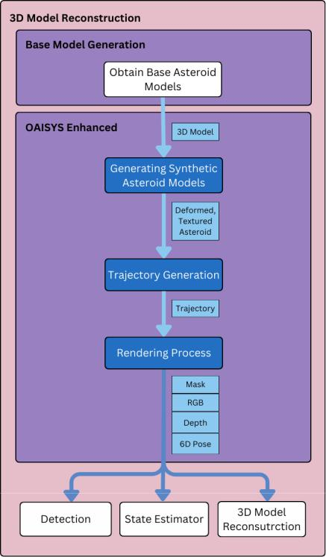
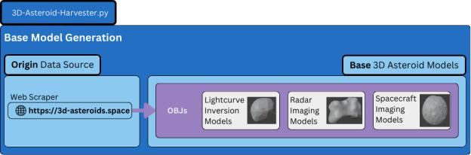

Figure 2 Schematic defining the origin data source used to collect the base asteroid models, and the differ-ent techniques used to reconstruct the Alias Wave-form Format (OBJ)s available.

tailed shape models. Radar observations provide high-resolution data, allowing for the identification of sur-face features such as craters and ridges. Spacecraft missions, such as the NEAR Shoemaker mission to Eros and the Hayabusa mission to Itokawa [17], have provided unprecedented details into these asteroids’ shapes and surface properties. However, these are a minority and would not be sufficient to construct sig-nificant CNN models with, as datasets should gener-ally aim to handle large samples of more than 30,000+.

OAISYS Enhanced Blender is selected as the ren-dering software. It is a powerful open-source, free 3D

5

modeling software, capable of creating and modify-ing 3D models and rendering images from 3D scenes through a Python API. Cinema4D has also been con-sidered as an alternative, but Blender is selected for this study as it presents a superior user interface, tex-turing is a completely node-based system, is free, and requires less computational power [18].
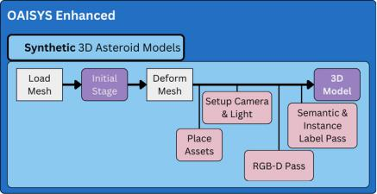

rithm is tested on image sequences representative of three different trajectories, typical of asteroids: di-rect (prograde), retrograde, and polar orbits. For di-rect orbits, the asteroid moves in the same direction as the Earth’s rotation, whereas asteroids following a retrograde orbit move in the opposite direction to the planet’s rotation, and polar orbits show a rotation over the poles. To simulate the different orbits, the sensor’s position is adjusted relative to the origin. For exam-ple, by moving the sensor to the opposite side, an anti-clockwise rotation (direct), can be perceived as clock-wise (retrograde), and polar if moved at 90 .
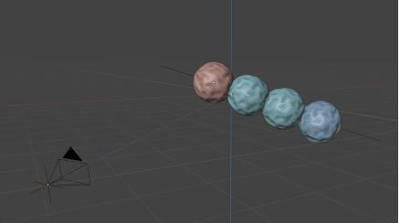

Figure 3 Schematic of how base asteroid 3D models are implemented into OAISYS, generated their trajec-tory, and rendered to produce RGB-D, 6D pose, and mask data.

Generation Synthetic Asteroid Models Due to the high availability of lower resolution shape mod-els reconstructed with lightcurve techniques, OAISYS is implemented to derive synthetic shape models from these base shape models on a large scale. Normally, OAISYS generates an environment by modifying a main mesh known as the stage. However, this study implements a modification where an object (i.e. aster-oid) directly serves as the base shape. The mesh of the shape model is loaded onto an empty stage, where it is deformed using a random noise out of a range such as Voronoi, Musgrave, random noise, and others. De-formation parameters are automatically adjusted after every batch iteration so that all synthetic shape models are different. Additionally, subsurface modifications are applied for fine-detail structures. A single config-uration file governs all simulator parameters.

OAISYS can place objects known as assets, on top of another object’s surface known as stage. In this study, no assets are placed on the synthetic shape model. Then, semantic and instance labels are ren-dered using the diffuse channel to address the draw-backs of object ID rendering, and semantic labels are encoded into RGB values for compatibility.

Moreover, lighting conditions are set with the re-spective module, altering parameters such as sun size and intensity. Then, target objects ensure that the cam-era viewpoint is focused, with adjustable constraints.

Trajectory Generation Once the synthetic shape models are processed, the performance of the algo-

Figure 4 Schematic of a trajectory generated with a de-formed sphere base shape model. The translation of each object is calculated by projecting a line between the initial position and the origin.

Generating a trajectory requires defining initial and final translations and rotations. As shown in Figure 4, the translation is simulated as a linear path, ensuring the shape model remains largely within the camera’s field of view throughout the image sequence to be taken. Rotation parameters are initialized randomly, but the final rotation requires simulating a rotation around an axis. Asteroids spin around their principal axis of inertia due to energy dissipation, resulting in an oblate rotation pattern.

To calculate the principal axis of inertia, the center of mass and the moments of inertia around this center of mass are determined. Since the provided original reference frame does not correspond to the principal axes frame, the inertia matrix is non-diagonal. There-fore, the matrix is diagonalized to obtain the eigen-values and eigenvectors. These eigenvalues form the diagonalized inertia matrix. Figure 5 illustrates the pipeline followed to calculate the rotation and trans-lation generated for each new position.

In the theory of 3D rotation, Rodrigues’ rotation for-mula is an efficient algorithm for rotating a vector in space given an axis and angle of rotation. The formula states that if v is a vector in 3 and k is a unit vector describing an axis of rotation about which v rotates by an angle \, the rotated vector is given by:

6

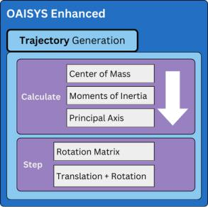

Figure 5 Schematic of how the trajectory is generated for each asteroid shape model processed.

^{v}rot ⁼ ^{v}krot ‚ ^{v}?rot | (1)
- v_{k} ‚ cos„\” v? ‚ sin„\”k v

where the vector v is decomposed into compo-nents parallel and perpendicular to the axis k by using the dot and cross products respectively. Substituting v? = v v_{k} in the last expression gives:

vrot = v cos \ ‚ „1 cos \” „k v”k ‚ sin \ „k v” (2)

In matrix notation, the linear transformation on v is represented by v 7!k v, the cross-product matrix K. This matrix is skew-symmetric and given by:

K = ' | 0 | : _{I} | : _{H} | “
K = ' | : _{I} | 0 | : _{G} | “ |  | (3)
› |  |  |  | fi
« | : _{H} | : _{G} | 0 | ‹
where : _{G} , : _{H} , : _{I} are the components of the unit vec-tor k, corresponding to the principal axis of inertia of each base shape model. That is to say,

k v = Kv k „k v” = K„Kv” = K²v (4)

Substituting those terms in the previous equation gives

The angle of rotation, \ , can be determined from the rotational velocity, l _{A >C} , and the time elapsed, C. The rotational velocity is given by:

^{l}A >C ⁼ | 2c |  | (8)
⁾A>C
where )_{A >C} is the rotation period and corresponds to the time it takes for one complete rotation. The angle of rotation \ after a time period of C hours is:

\ = l C | (9)
To simulate the synthetic asteroid’s motion, rota-tional data is obtained from Figure 6, which is gen-erated based on the methodology outlined in [19], in-volving over 5000 asteroids. Over 95% of the rota-tional periods considered fall within the range of 2.55 to 49.29 hours, with a median rotational period of 8.12 hours. Moreover, the distribution of rotational periods is non-normal, as evidenced by the best-fit distribu-tion being lognormal. For each new asteroid gener-ated, rotational data is randomly sampled from within this range, with the corresponding mean and variance for the lognormal distribution found from the analysis.
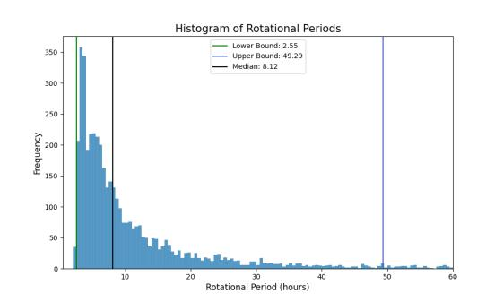

Figure 6 Distribution of periods derived from ATLAS

- data, showing the median, lower, and upper bound.

v_{rot} = v ‚ „sin \”Kv ‚ „1 | cos \”K²v | (5)
Collecting terms allows the compact expression
v_{rot} = Rv |  | (6)
where
R = I ‚ „sin \”K ‚ „1 | cos \”K² | (7)
is the rotation matrix through an angle \ counter-clockwise around the axis k, and I is the 3 3 identity matrix. This matrix R is used to calculate the next po-sition of the synthetic shape model.

Rendering Process Another advantage this simu-lation framework has over other relevant works is that it provides comprehensive instances for RGB-D im-ages, 6D pose data, and mask instances for each syn-thetic shape model generated, as demonstrated in Fig-ure 7. This extensive data collection is crucial for training various CNN models, as these outputs serve as the ground truth, thereby eliminating the need for extensive manual labeling.

The mask is a critical output for instance segmen-tation. The mask is a binary image that highlights the

7

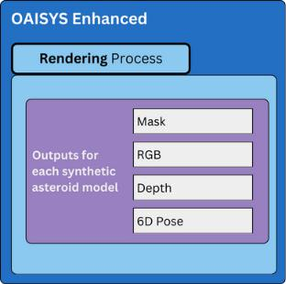

Figure 7 Schematic of all instances obtained for each new position generated.

presence of the object. As shown in Figure 8, the mask can be processed into a bounding box format compati-ble with the YOLO framework [20], essential for vali-dating the performance of ML algorithms in object de-tection tasks. Labels for this format are exported with one text file per image, with one row per object as

„2;0BB G_{24=C4A} H_{24=C4A} F83C 486 C” | (10)

format, where box coordinates must be normalized from zero to one, and class numbers should be zero-index.
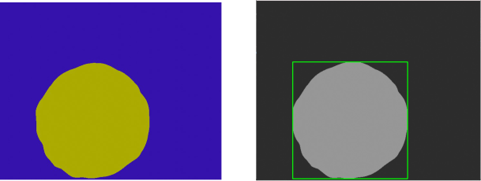

(a) Mask instance (b) Bounding Box

Figure 8 Sample of a YOLO format bounding box gener-ated from an output mask instance.

The RGB and 6D pose data are indispensable for feature tracking as they combine color with geospa-tial information that details the object’s position and orientation in space, using quaternion representation for rotation. The 6D pose throughout the trajectory is stored in one CSV file per shape model generated, with one row per position and a total number of rows cor-responding to the samples generated per batch. The translation and rotation data are stored as

„GHI@_{F}@_{G}@_{H}@_{I}” | (11)
with the „G H I” as the translation components and

- @_{F} @_{G} @_{H} @_{I} ” as the rotation quaternion compo-nents. Furthermore, the sensor’s spatial information is stored in a separate file, following the same format.

One application of the annotated 6D pose is its use as the ground truth for tracking the object’s movement across frames. Additionally, combining the depth out-put with the 6D pose enables the validation of a recon-structed 3D map of the sampled asteroid from monoc-ular 2D observations.

4. Results

Synthetic Asteroid Generation As a form of vi-sual representation, Figure 9 shows the result of pro-cessing a shape model through the enhanced OAISYS. The base shape model has no texture defined. How-ever, the output processed a texture map and an envi-ronment, deformed the base shape model, and all se-mantic and instance passes are processed.
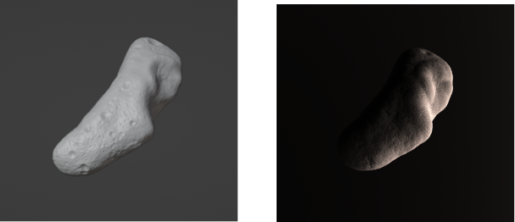

- Base asteroid model(b) Synthetic asteroid model

Figure 9 Outcome of processing asteroid 433 Eros base shape model with the enhanced OAISYS.

Trajectory Simulation Figure 10 illustrates an example trajectory generated with the enhanced OAISYS.

As depicted in Figure 10, the generated trajectory shows the translation and rotation of a synthetic shape model based on asteroid 433 Eros. It follows a direct trajectory. For each position provided in the sequence, a mask, an RGB image, a 6D pose, and a depth map are all stored.

Verification To ensure the accuracy of the gener-ated trajectories, the calculations of the center of mass, moments of inertia, principal axes, and rotation matri-ces must be verified by comparing them to analytical solutions and referencing existing studies. A range of test cases is used to verify results, including a cube, cylinder, sphere, cone, and asteroid 433 Eros.

Calculating the center of mass is the point most prone to error due to the various methods available and the corresponding assumptions required for each. This

8

RGB

Mask

Depth

Pose
Figure 10 | t = �1 | �2 | �3 | �4 | �5 | �6 | �7 | �8
Figure 10 | Sequential example of synthetic asteroid shape model generated with the enhanced OAISYS. |  |  |  |  |  |  | The asteroid’s
direct orbit trajectory simulates a plausible rotation and translation based on the orbital parameters computed with data processed from Figure 6.

study assumes a uniform density throughout all vol-umes, allowing the use of Gaussian quadrature. There-fore, the following table compares the analytical solu-tion for the center of mass of the object to the calcu-lated solution. In the case of a cube, cylinder, sphere and cone, these values can be easily obtained using an-alytical solutions. However, the mass computation for the asteroid is verified using the approach of Chanut et al. [21], which calculates the polyhedral mass proper-ties of 433 Eros using the fast and effective algorithm developed by Mirtich in C [22].
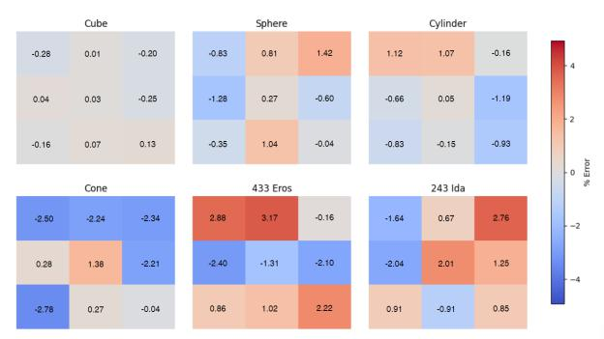

Figure 11 Error matrices in the moment of inertia calcula-tions for sample objects and asteroid shape mod-els.

The inertia matrix is verified against analytical so-lutions. As observed in Figure 11, certain irregulari-ties can be observed as in the case of a sphere. This is due to the simplified mesh’s inability to generate a per-

fectly round sphere. The phenomenon is also present in the cylinder and the cone. Due to the highly irreg-ular shape of the asteroid shape models, these present the highest deviations from theoretical solutions pro-vided in other studies, as deviations from the true cen-ter of mass and density distribution methods signifi-cantly impact the calculations.

Finally, the rotation matrix calculation error is the difference between the theoretical and calculated val-ues and is represented in Figure 12, resulting in 7%, due to a linear combination of all previous errors.
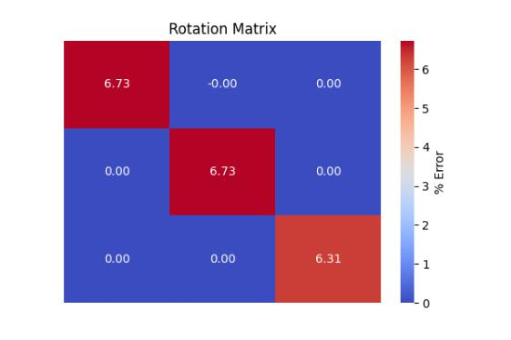

Figure 12 Error matrix in the calculation of the rotation matrix used in the trajectory generation for as-teroid 433 Eros.

9

5. Conclusion & Outlook

The presented research serves as a foundational con-tribution to addressing the critical data limitations in utilizing CNN models for perception tasks within the context of asteroid mining. By generating a compre-hensive image dataset from synthetic asteroid shape models using OAISYS, the research aims to pave the way for more robust ML algorithms applied to asteroid exploration.

Answering the first research question, this study de-veloped a method involving the generation of synthetic asteroid images using OAISYS. This method includes the creation of RGB-D images, 6D pose data, masks, and depth images, which are essential for training and evaluating DL networks effectively.

Secondly, the research integrated three different or-bital trajectories: direct, retrograde, and polar orbits into OAISYS. By adjusting the sensor’s position, the rotational movement is consistently calculated, ensur-ing physical validity and accurate representation of real asteroid trajectories.

Finally, the study focused on leveraging the capabil-ities of OAISYS to create detailed and diverse shape models, optimizing the synthesis of real 3D asteroid data, and generating a vast number of samples. By using OAISYS, the synthesis process can generate nu-merous synthetic asteroid images with varying shapes and textures, which are crucial for building robust CNN models.
Outlook Looking ahead, future improvements could involve improving the physical realism in the synthetic shape models generated. While the current study focuses on generating synthetic asteroid images, future research could implement deforma-tions through physically described equations that model craters and other irregularities present in asteroids. For instance, AstroGen [13], despite its high computational cost and limitations in output formats, demonstrates the potential for achieving high realism by modeling surface details with physical equations. Furthermore, incorporating more sophis-ticated surface texture models and realistic lighting conditions would improve resemblance to real-world observations.

Comparisons with observational data can provide valuable insights into the accuracy and fidelity of the synthetic datasets generated. By comparing synthetic data to actual observations, researchers can assess if they represent the physical characteristics and behav-iors of real asteroids accurately.

Moreover, in the dataset generation process, a base shape model is assumed known, but with limited phys-ical accuracy. The focus of this study is generating a pipeline for synthetic asteroid image datasets. Future studies may develop to improve the physical compara-bility of these models.

Lastly, this dataset generation model could be ex-trapolated to satellite imagery applications beyond. By leveraging the capabilities of OAISYS, synthetic datasets of satellite imagery could be generated to train ML algorithms for tasks such as satellite navigation or detection, broadening the applicability of the re-search.

10

References

- PV Sukumaran. Mining asteroid resources. Ge-ological Society of India, 88(1):125–125, 2016.

- Claire L McLeod and Mark PS Krekeler. Sources of extraterrestrial rare earth elements: to the moon and beyond. Resources, 6(3):40, 2017.

- Conel M O’D Alexander, Kevin D McKee-gan, and Kathrin Altwegg. Water reservoirs in small planetary bodies: meteorites, asteroids, and comets. Space science reviews, 214(1):36, 2018.

- Shota Takahashi and Daniel J Scheeres. Au-tonomous exploration of a small near-earth as-teroid. Journal of Guidance, Control, and Dy-namics, 44(4):701–718, 2021.

- Joseph A. Nuth, Brent Barbee, and Ronald Le-ung. Defending the earth from long-period comets and sneaky asteroids: Short term threat response requires long term preparation. Jour-nal of Space Safety Engineering, 5(3):197–202, 2018.

- 3d asteroids catalogue. https://3d-asteroids. space/. Accessed: January 22, 2024.

- Travis Driver, Katherine A. Skinner, Mehregan Dor, and Panagiotis Tsiotras. Astrovision: To-wards autonomous feature detection and descrip-tion for missions to small bodies using deep learning. Acta Astronautica, 210:393–410, 2023.

- J. Durech, V. Sidorin, and M. Kaasalainen. DAMIT: a database of asteroid models. , 513:A46, April 2010.

- Planetary Data System (PDS) Small Bodies Node. Planetary Data System (PDS) Small Bod-ies Node. https://sbn.psi.edu/pds/. Accessed: April 22, 2024.

- Jet Propulsion Laboratory (JPL). JPL Asteroid RADAR Research. http://echo.jpl.nasa.gov/. Ac-cessed: April 22, 2024.

- Roland Brochard, Jérémy Lebreton, Cyril Robin, Keyvan Kanani, Grégory Jonniaux, Aurore Masson, Noela Despré, and Ahmad Berjaoui. Scientific image rendering for space scenes with the surrender software. arXiv preprint arXiv:1810.01423, 2018.

- Pangu software. https://pangu.software/. Ac-cessed: January 17, 2024.

- Xi-Zhi Li, René Weller, and Gabriel Zach-mann. Astrogen – procedural generation of highly detailed asteroid models. In 2018 15th International Conference on Control, Automa-tion, Robotics and Vision (ICARCV), pages 1771–1778, 2018.

- Marcus G. Müller, Maximilian Durner, Abel Gawel, Wolfgang Stürzl, Rudolph Triebel, and Roland Siegwart. A Photorealistic Terrain Sim-ulation Pipeline for Unstructured Outdoor Envi-ronments. In IEEE/RSJ International Confer-ence on Intelligent Robots and Systems, 2021.

- Changhao Chen, Bing Wang, Chris Xiaoxuan Lu, Niki Trigoni, and Andrew Markham. A sur-vey on deep learning for localization and map-ping: Towards the age of spatial machine intelli-gence, 2020.

- N. Mastrodemos, B. Rush, A. Vaughan, and W. Owen. Optical navigation for the dawn mis-sion at vesta. Advances in the Astronautical Sci-ences, 140:1739–1754, 2011.

- Tatsuaki Hashimoto, Takashi Kubota, Jun’ichiro Kawaguchi, Masashi Uo, Kenichi Shirakawa, Takashi Kominato, and Hideo Morita. Vision-based guidance, navigation, and control of hayabusa spacecraft - lessons learned from real operation -. IFAC Proceedings Volumes, 43(15):259–264, 2010. 18th IFAC Symposium on Automatic Control in Aerospace.

- School of Motion. Blender vs. cinema 4d: A comparison. https://www.schoolofmotion.com/ blog/blender-vs-cinema-4d. Accessed: April 22, 2024.

- J Ďurech, J Tonry, N Erasmus, L Denneau, AN Heinze, H Flewelling, and R Vančo. Aster-oid models reconstructed from atlas photometry.

Astronomy & Astrophysics, 643:A59, 2020.

- Joseph Redmon, Santosh Kumar Divvala, Ross B. Girshick, and Ali Farhadi. You only look once: Unified, real-time object detection. CoRR, abs/1506.02640, 2015.

- Thierry Chanut, O. Winter, and M. Tsuchida. 3d stability orbits close to 433 eros using an effec-tive polyhedral model method. Monthly Notices

11

of the Royal Astronomical Society, 438:56–, 02

2014.

- Brian Mirtich. Fast and accurate computation of polyhedral mass properties. Journal of Graphics Tools, 1(2):31–50, 1996.

12

