

To begin the install run: lutris -i “PATH TO YAML”/ACLutrisInstall.yaml

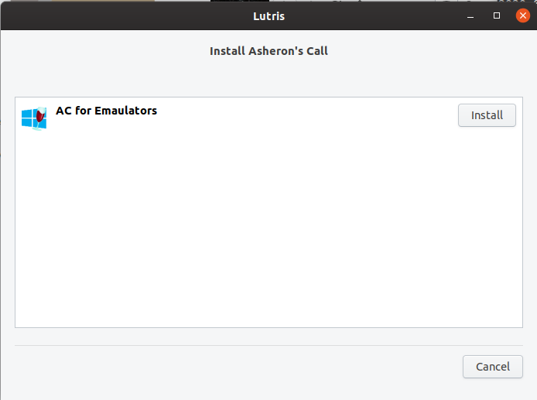

Click install

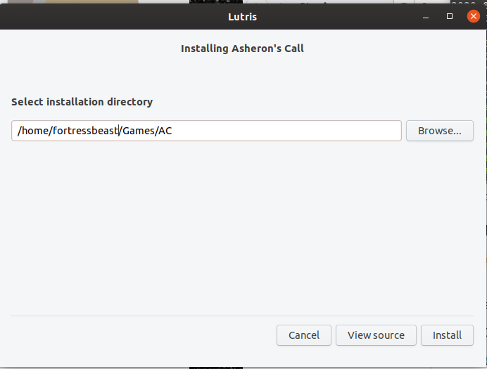

Select where you want the game to be installed to, then click install

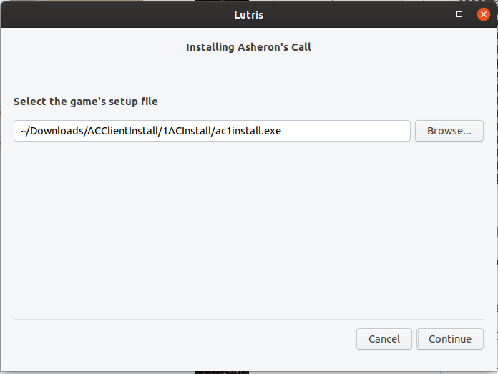

Browse to your install file, select it, then click continue

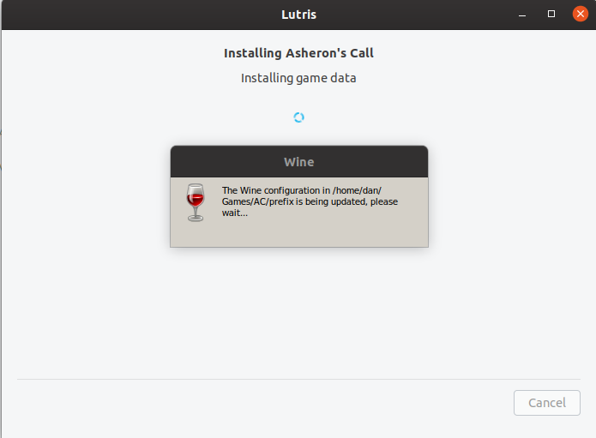

The installer with setup the Wine prefix using the current version. 5.6-2 as of this writing. Once the prefix is set the game installer will begin.

NOTE: If you are on a later version and having issue you may want to try switching back to this one.

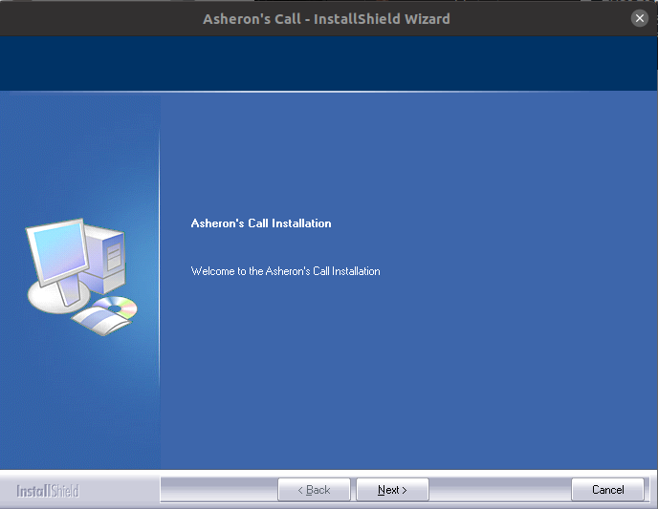

Click next.

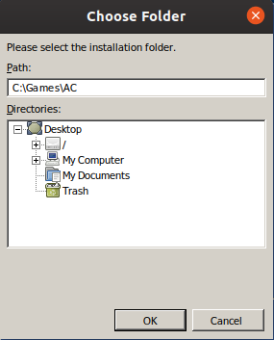

The install expect the files to be installed into C:\Games\AC, if they are not installed here you will have to modify the working folder in the game properties.

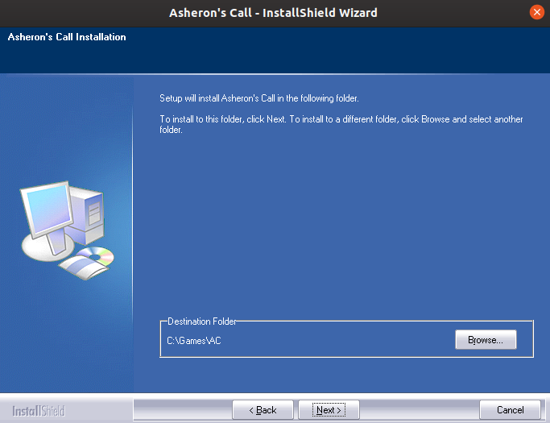

Click next

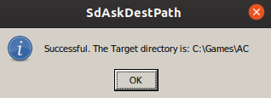

click ok

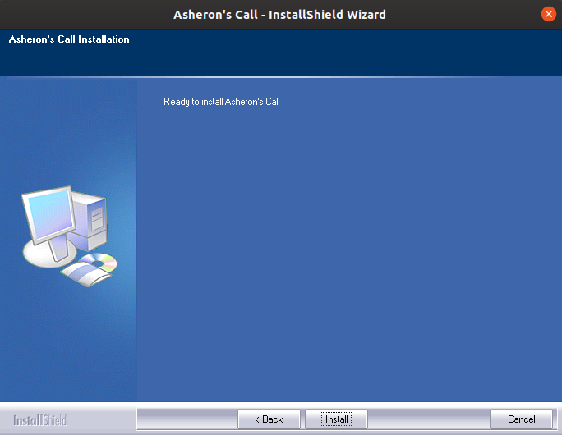

Click install

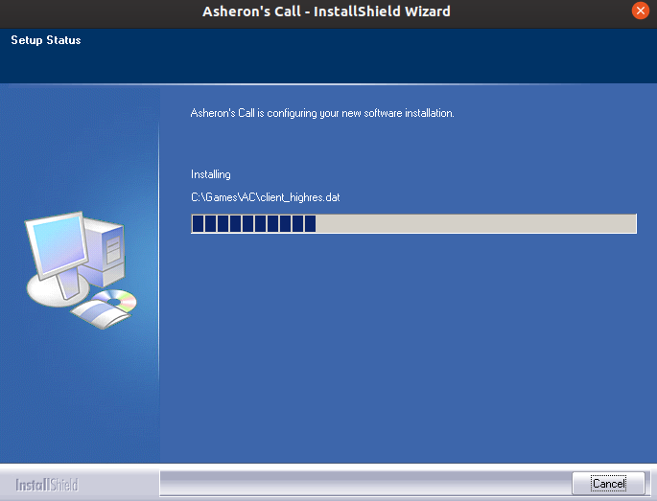

The install will take a minute or two depending on your system specs

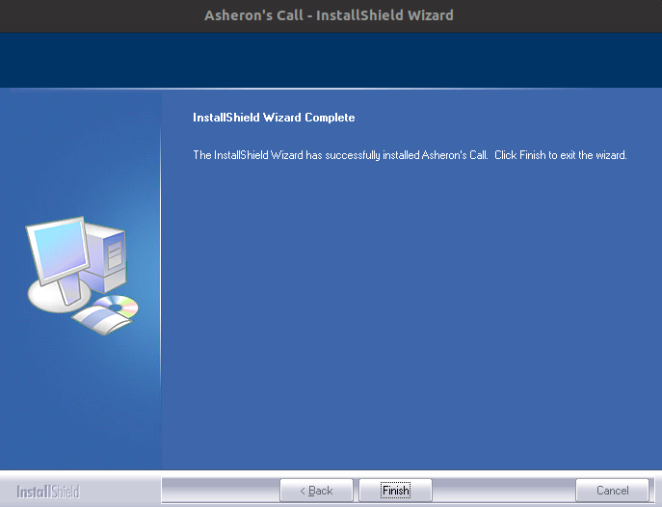

Click Finish

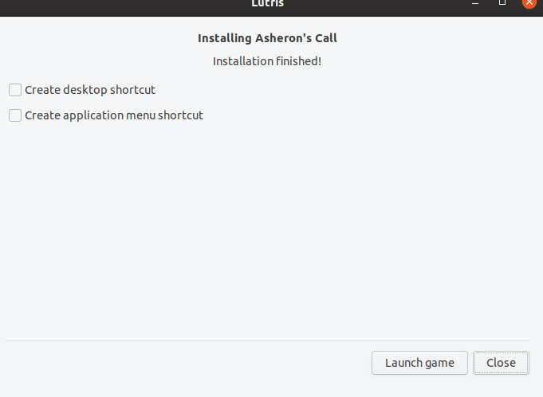

If you installed AC into C:\Games\AC you will get the above message, if not you will get an error that it can not find the executable. Click close

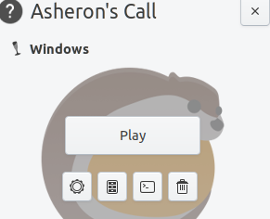

Back in Lutris click the configure icon (Gear)



change to the Game options tab

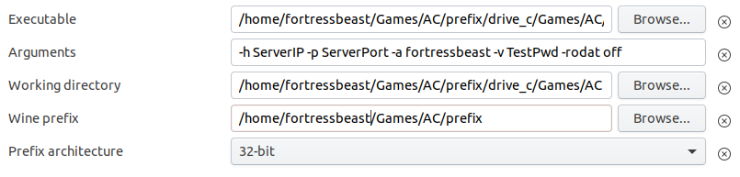

Update the path to your exe, add your connection arguments, and change your working dir, then click save.

NOTE: Before playing you will need to copy your updated \*.dat files and acclient.exe to the game folder.