PAY ATTENTION TO INSTALL LOCATION OR THE SCRIPTS MAY FAIL!!
Decal install:
Open Lutris and select install from local yaml file, and navigate to Decal.yaml

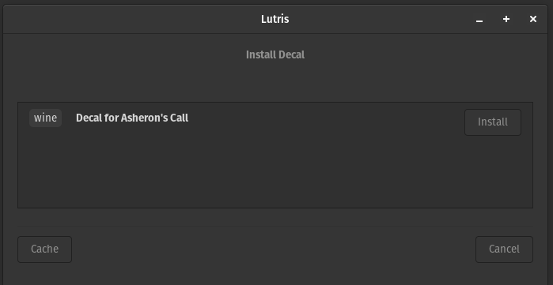

Click install
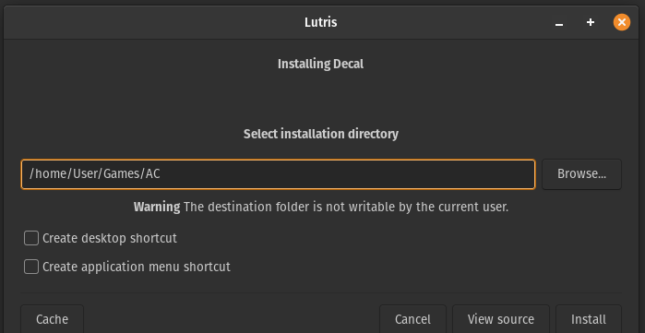

Select the same install location as you picked for AC, then click install

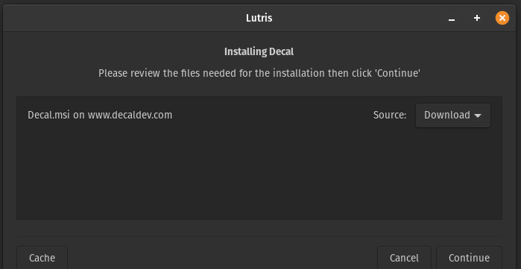

Click continue.

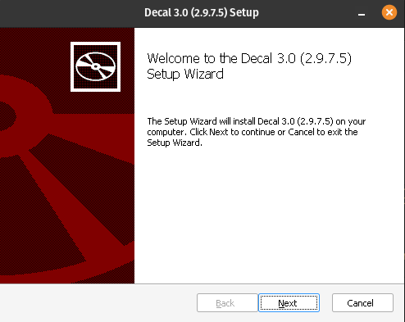

click next

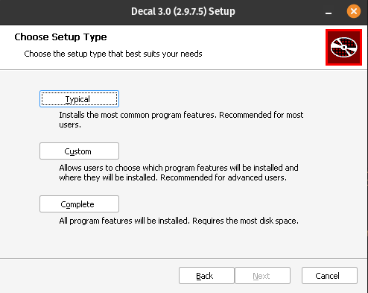

click custom

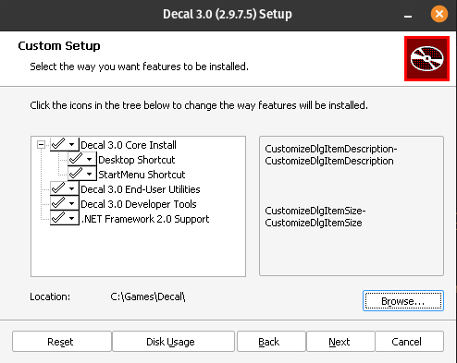

Note: Decal must be installed to C:\Games\Decal
Set install path and click next, then click install

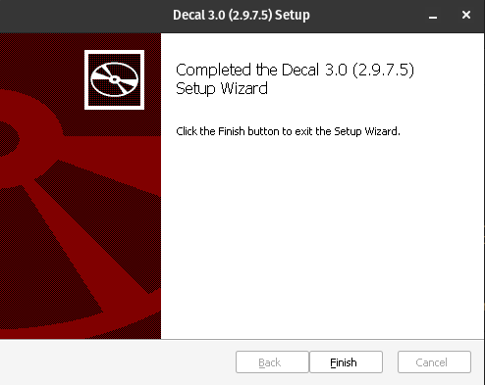
1

Note: You must click finish before selecting the AC install dir.
Click finish

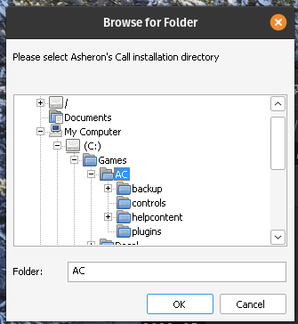
1

Set your install to C:\Games\AC and click okay.

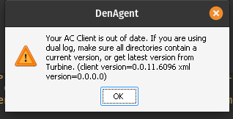

Click okay and and exit decal using the decal tray icon. If you don’t lutris will not finish the install for decal.
Note: Do not try to update the decal dlls until after Lutris has completed the install. If you do it will corrupt decal and you will have to start over.

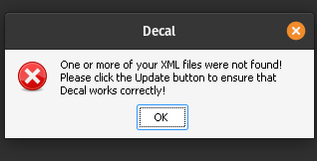

Once Lutris have completed the decal install script you can then launch Decal and update the dlls

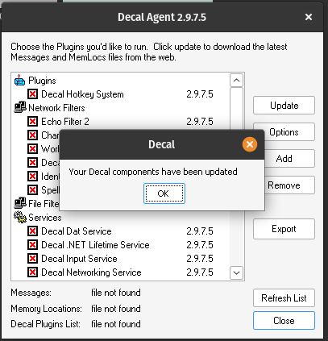

Click update, then click ok.

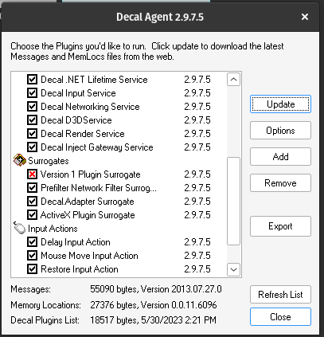
1

All components should have a black check except “Plugin Surrogate”. Close the windows and close down decal.

V.Plugins:

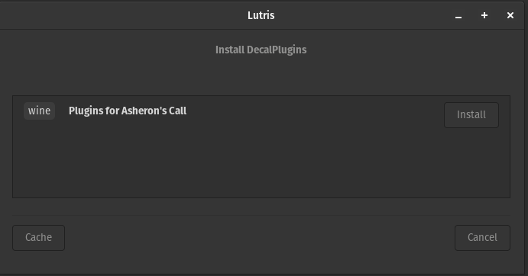
Note: Decal must be completely closed before you install the plugins.
Select the Plugins.yaml script using the “run local yaml file” in Lutris. Then click install

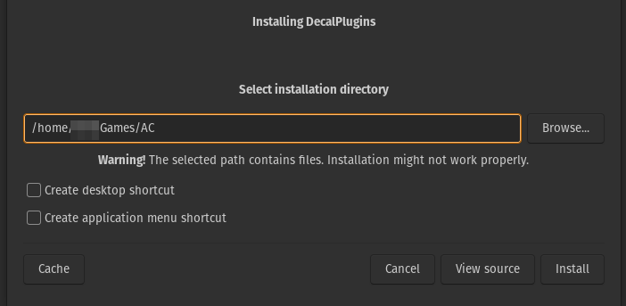

Install to the same path as AC and Decal. You can ignore the warning about existing files.
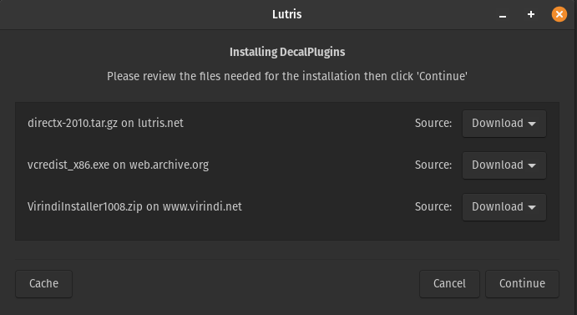
Note: There is a number of things to install and in some places it may seem frozen. Be patient and check the error log if you have concerns, but it has always finished during testing as long as Decal has been closed.
The installer will attempt to download everything needed to complete the process. Click continue.

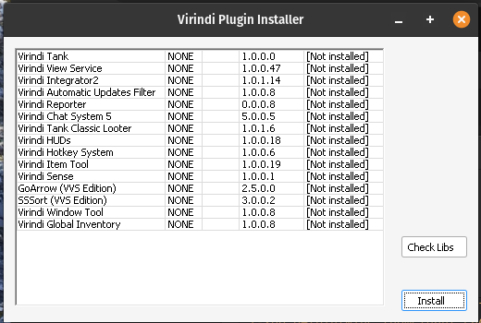

There will be a number of popups as the system installs the needed components, but eventually the Virindi plugin installer will load. Check libs(everything should be loaded), then click install.

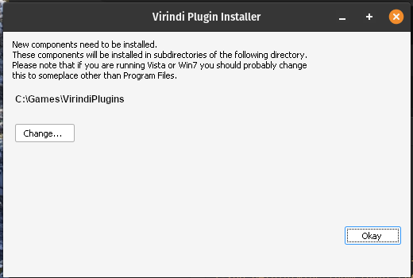

Set the install path to VirindiPlugins (if not selected automatically) and click Okay.

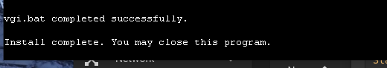

monitor the install window until it says you may close the window. Do so, then close the Lutris install window.
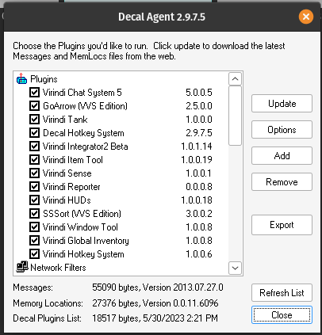

Before moving on to Thwargle, open Decal to verify the plugins are working correctly. If so exit decal completely and continue.

Thwargle installer:
Note: There is an error when installing DotNet 452 that causes it to crash. Still working on this issue. For now simply run the installer a second time and it will complete.
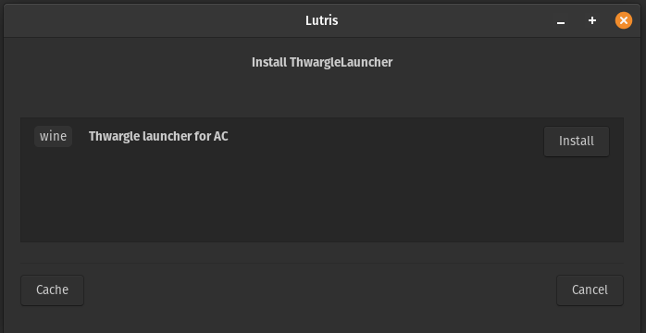
Open Lutris and select install from local yaml, navigate to Thwarg.yaml, and click install

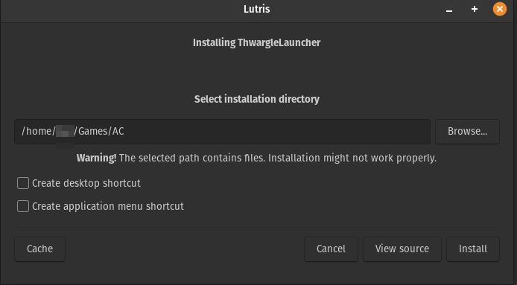
Select the same install folder as the rest and click install.

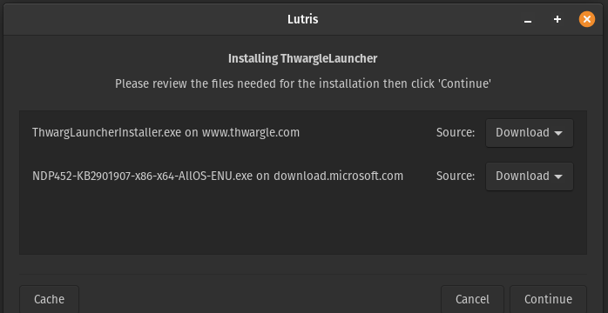
The script will attempt to download the needed files.

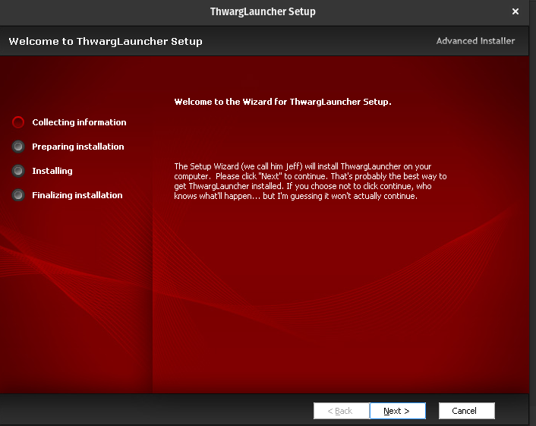

After installing the required fonts, Thwargle installer should start. Click next
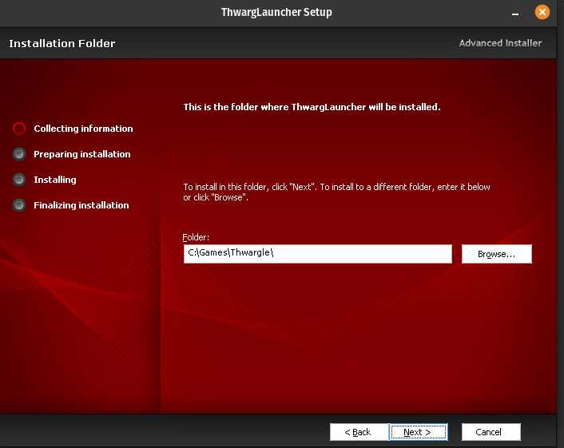

Set the install to C:\Games\Thwargle and click next

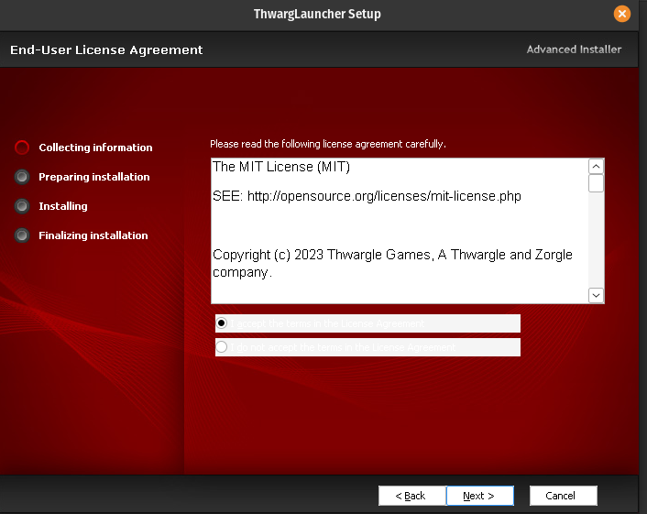

Accept the terms and click next.

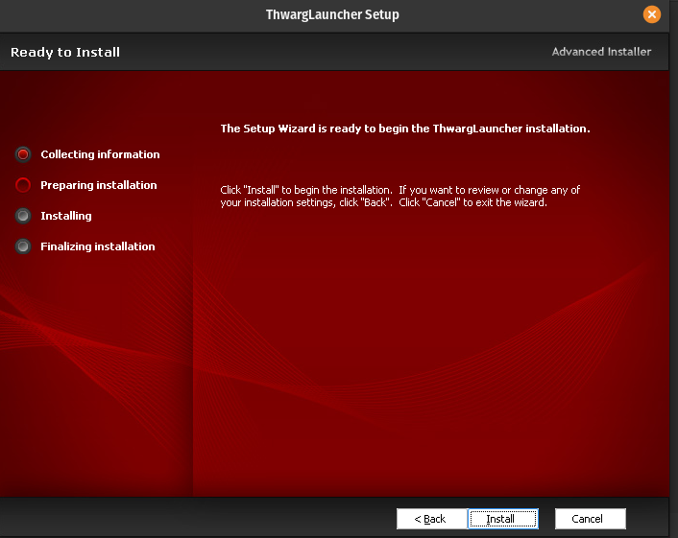

click install

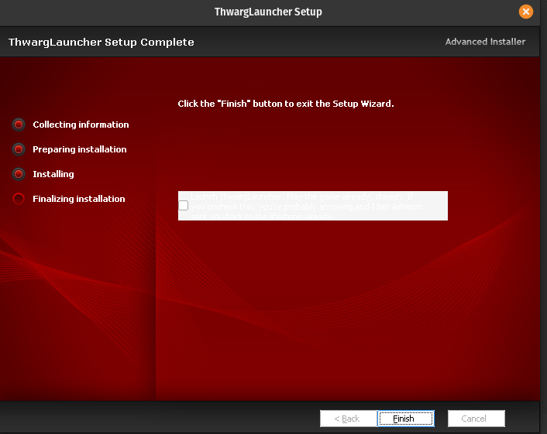

Do not check “Launch now”. Click finish.

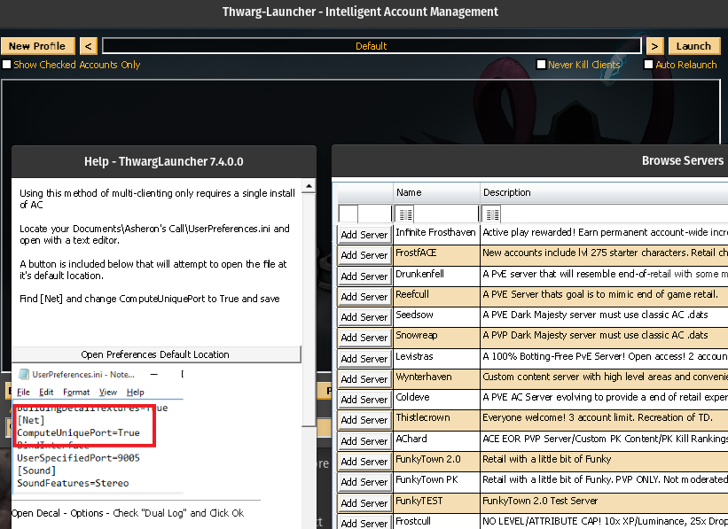
Close out the Lutris script runner, then configure Thwargle launcher as you normally would and play.

There are clearly some minor bugs still and intend to see them through, but life happens so you never know. Thanks to all who continue to support and develop all the things that make AC sill playable.

