

STUDENT DETAILS
STUDENT NAME: JOSEPH RAI
ADMISSION NUMBER: BSCCS/2024/53718
COURSE: COMPUTER SCIENCE
UNIT CODE: BIT3208
LECTURER NAME: MR. MICHAEL NYORO
ACADEMIC YEAR: YEAR 3, SEMESTER 2

PROJECT DETAILS
PROJECT TITLE: SALON MANAGEMENT SYSTEM
SELECTED TECHNOLOGIES:
        - HTML
        - PHP
        - CSS
        - MYSQL
        - JAVASCRIPT

Contents
Week 1: Local Environment Setup 3
Installation and Testing of Local Development Environment 3
Fig 1.1: Xampp Setup and Installation 3
Fig 1.2: Apache and MySQL running 4
Fig 1.3: Database Connection Test 4
Fig 6: Folder structure 4
Student reflection 4
Week 2: Wireframes and GUI Design 5
User Interface Planning and System Design 5
Fig 2.1: Registration & Login wireframe design 5
Fig 2.2: Home screen wireframe design 6
Fig 2.3: Dashboard Layout Design(admin, staff, & customer dashboards) 7
Fig 2.4: Mobile Mockup 7
Fig 2.5: Color Theme and Navigation Structure 8
Fig 2.6: GUI Prototype in Figma 8
Fig 2.7: Folder structure 8
Student reflection 9
Week 3: JavaScript and PHP Basics 9
Frontend Interaction and Backend Foundations 9
Fig 3.1: JavaScript Form Validation 9
Fig 3.2: Password Strength Checker 9
Fig 3.3: PHP Syntax Practice 10
Fig 3.4: Database Connection Script 10
Fig 3.5: Dynamic User Input Handling 10
Fig 3.6: Folder Structure 11
Student reflection: 11
Week 4: Dynamic Backend Processing & Real User Interaction Systems. 11
Fig 4.1: Login form 12
Fig 4.2: Registration form 12
Fig 4.3: Login/Session implementation code 12
Fig 4.4: Registration code 13
Fig 4.5: Folder structure 13
Student reflection: 13
Week 5: Database Operations 14
Fig 5.1 database functionality 14
Fig 5.2 Users data table creation SQL query 14
Fig 5.3 Appointments data table creation SQL query 15
CRUD Operations: 15
Create/Add Operation 15
Fig 5.4: Register (creation of user account) SQL query 15
Read Operation 16
Update Operation 16
Fig 5.6: SQL query to change services data 16
Delete Operation 17
Fig 5.7: SQL query to delete services data 17
Fig 5.8: Login database integration 17
Student reflection: 17

Week 1: Local Environment Setup

Installation and Testing of Local Development Environment
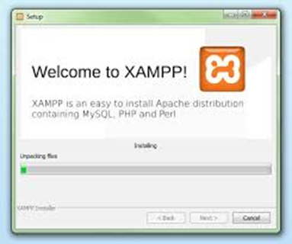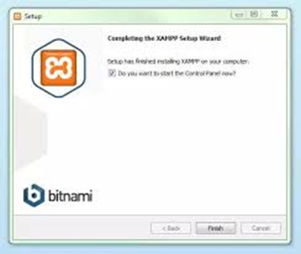

Fig 1.1: Xampp Setup and Installation

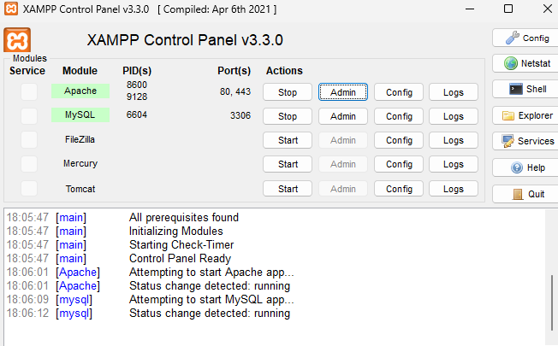

Fig 1.2: Apache and MySQL running

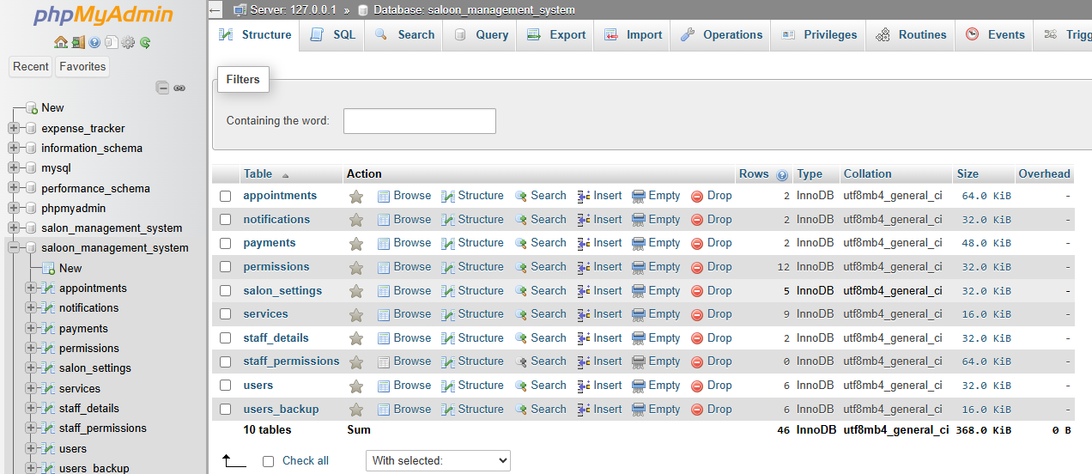

Fig 1.3: Database Connection Test

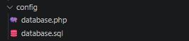

Fig 6: Folder structure

Student reflection
I have learnt on how to configure database on XAMPP. I also learned how Apache and MySQL services work together to support web development and database management.
The technologies used during the practical included XAMPP, Apache Server, MySQL Database, PHP, HTML, and a web browser for testing localhost pages. These technologies helped me understand the interaction between the frontend, backend, and database systems in web development.
One of the challenges I encountered was configuring the server correctly and ensuring that Apache and MySQL services started successfully without port conflicts. At first, I also experienced difficulty connecting the database to the PHP page due to incorrect connection details. However, after troubleshooting and correcting the configuration settings, the connection became successful.

Week 2: Wireframes and GUI Design

User Interface Planning and System Design

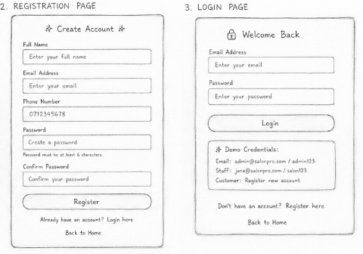

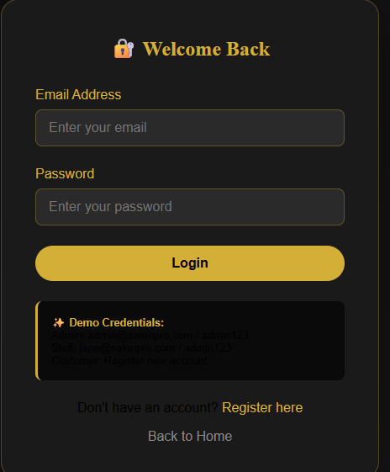
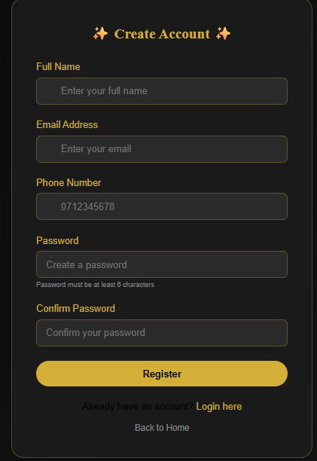

Fig 2.1: Registration & Login wireframe design





Fig 2.2: Home screen wireframe design

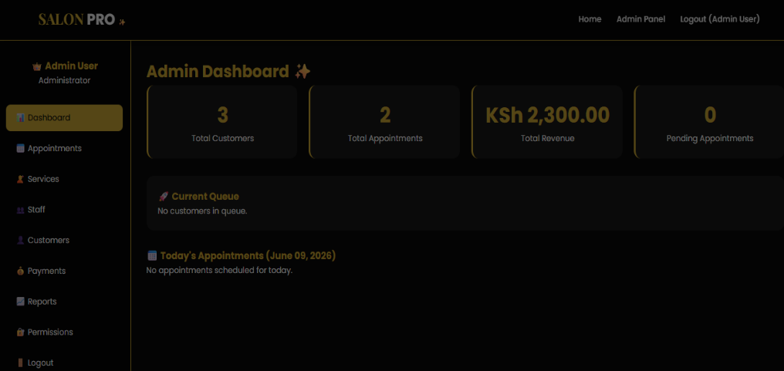
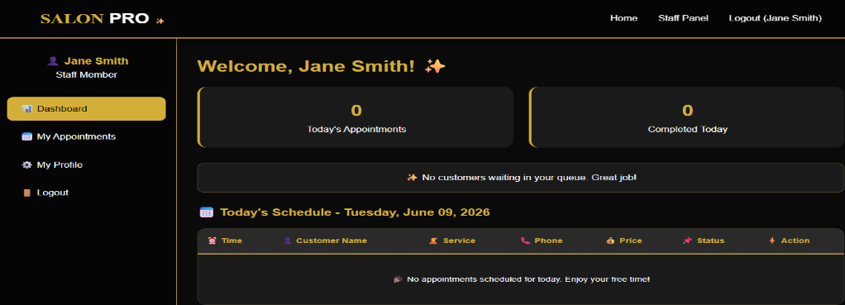
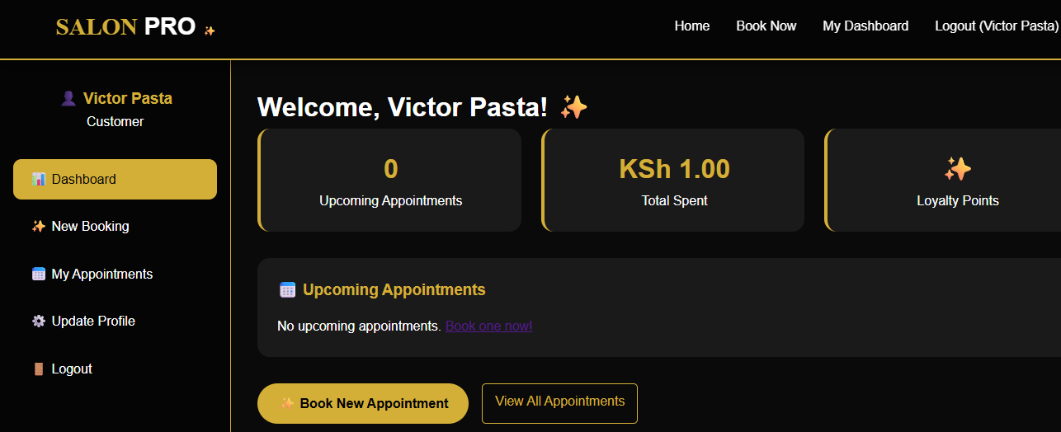

Fig 2.3: Dashboard Layout Design(admin, staff, & customer dashboards)

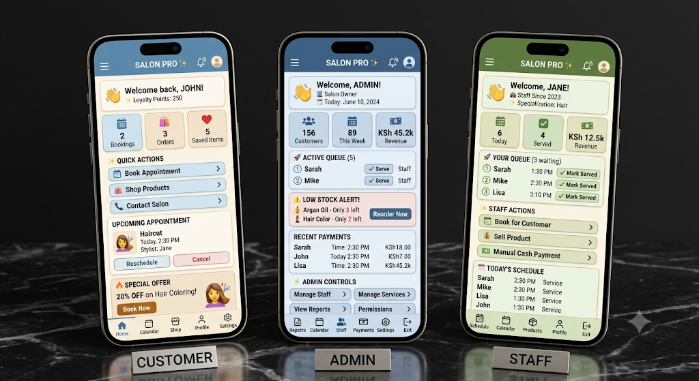

Fig 2.4: Mobile Mockup

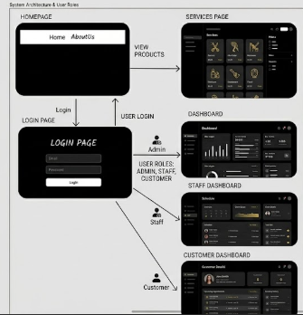

Fig 2.5: Color Theme and Navigation Structure

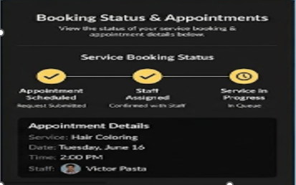

Fig 2.6: GUI Prototype in Figma

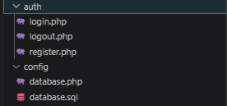

Fig 2.7: Folder structure

Student reflection
I designed the above wireframes based on UI/UX design principles. Which ensures the Graphical User Interface design process produces a simple, clean, reusable, easy to use interfaces that are not only easy to use / navigate through the system but one that captivates and grabs user attention.
The navigation flow was based on UI/UX design principle that ensure smooth navigation through the different pages of the system. The intended users of the system are the customers looking to buy cars and the administrators that manage the site and uploads product.

Week 3: JavaScript and PHP Basics

Frontend Interaction and Backend Foundations
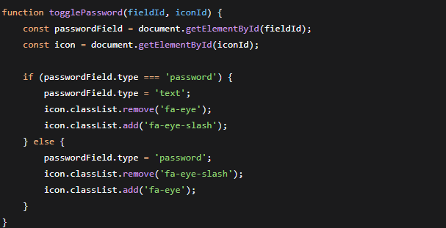

Fig 3.1: JavaScript Form Validation
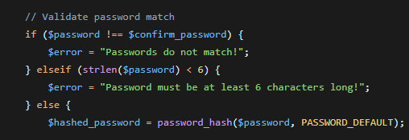

Fig 3.2: Password Strength Checker

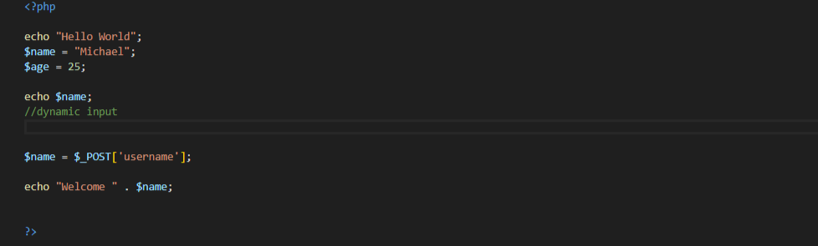

Fig 3.3: PHP Syntax Practice

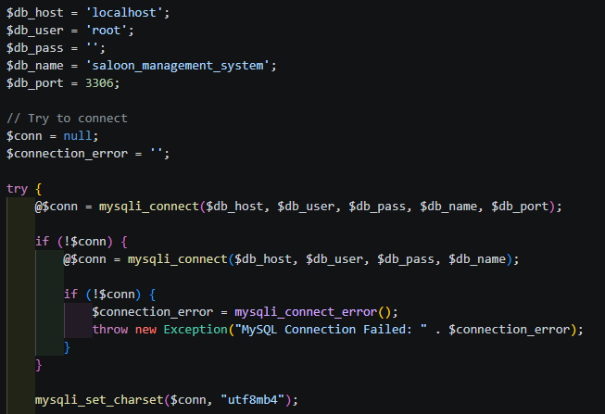

Fig 3.4: Database Connection Script
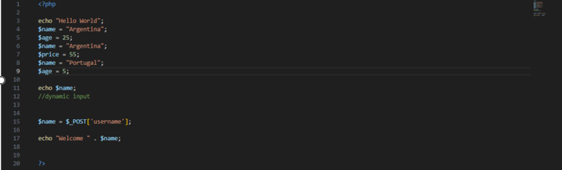

Fig 3.5: Dynamic User Input Handling

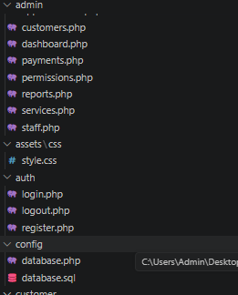

Fig 3.6: Folder Structure

Student reflection:
I have learnt basic PHP syntax from creating variables and dynamic handling of data which taking inputs and using them instead of hard coding them. The form validation helps in making sure that the correct data in entered and complete values and data types are taken to the backend. Password strength checker is key because it helps to make passwords more secure and hard to crack or guess. It provides a standard way of creating secure passwords for the system. This helps prevent fraud or unauthorized access. Database connection is a key process that helps connect frontend and backend. It enables storage of data in the database that is MySQL. It binds frontend and backend.it also enables data retrieval of stored data. A database is a core component of any modern systems.

Week 4: Dynamic Backend Processing & Real User Interaction Systems.

Fig 4.1: Login form

Fig 4.2: Registration form

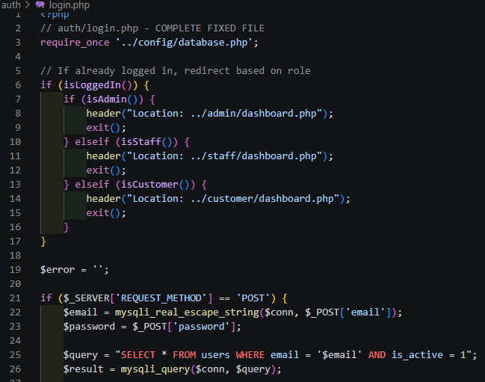

Fig 4.3: Login/Session implementation code

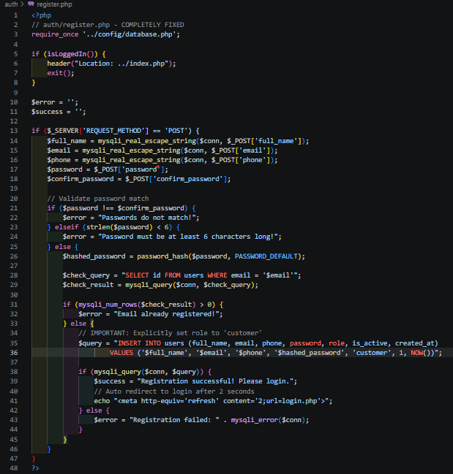

Fig 4.4: Registration code

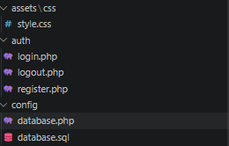

Fig 4.5: Folder structure

Student reflection:
During this practical, I learned how form processing works in web applications using HTML and PHP. I gained experience collecting user input through forms and handling the submitted data on the server side. This helped me understand how information flows between users and web applications.
I also learned the basics of authentication, including how users can log in by providing credentials and how the system verifies their identity. This demonstrated the importance of securing access to web resources.
Additionally, I explored session concepts and understood how sessions help maintain user information across multiple pages. By using sessions, I was able to create personalized experiences such as displaying a logged-in user's name and restricting access to certain pages. Overall, the practical strengthened my understanding of user management and web application security fundamentals.

Week 5: Database Operations
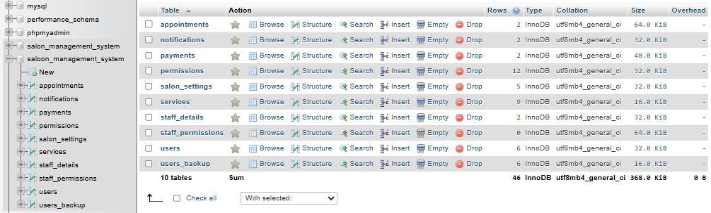

Fig 5.1 database functionality

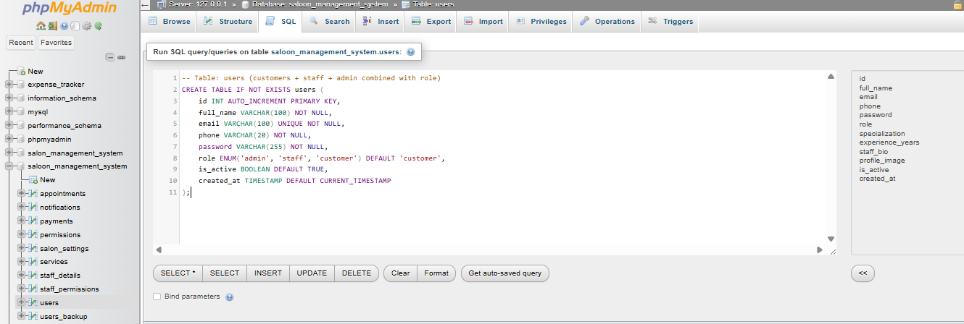

Fig 5.2 Users data table creation SQL query

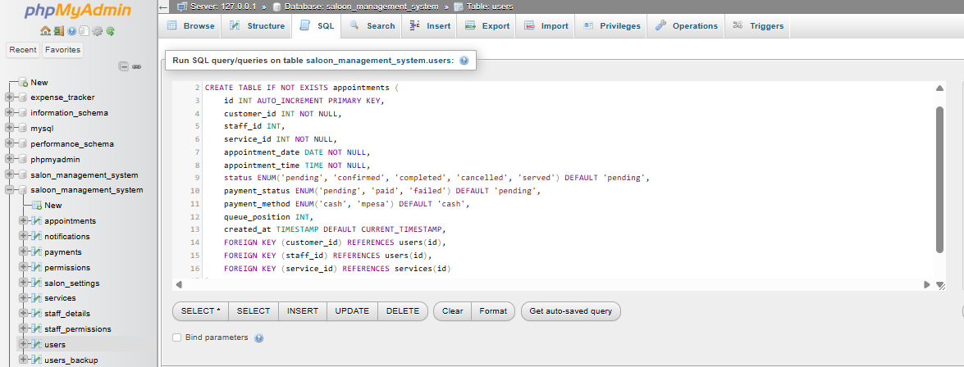

Fig 5.3 Appointments data table creation SQL query

Week 6:

CRUD Operations:

Create/Add Operation
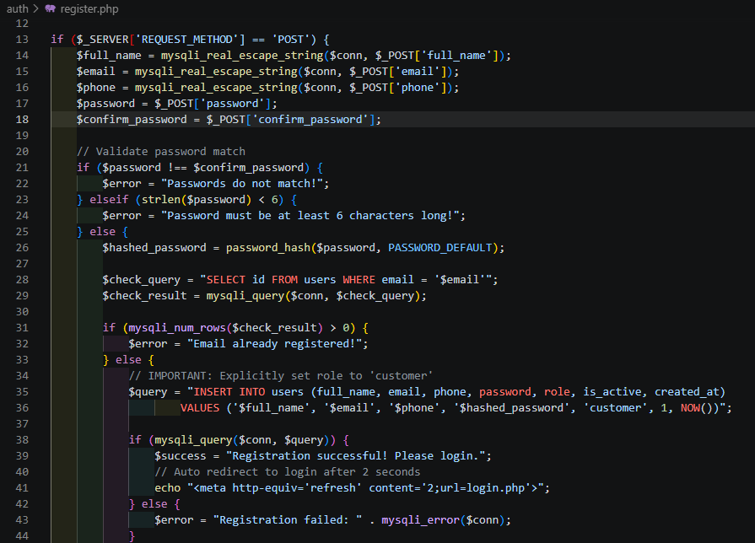

Fig 5.4: Register (creation of user account) SQL query

Read Operation
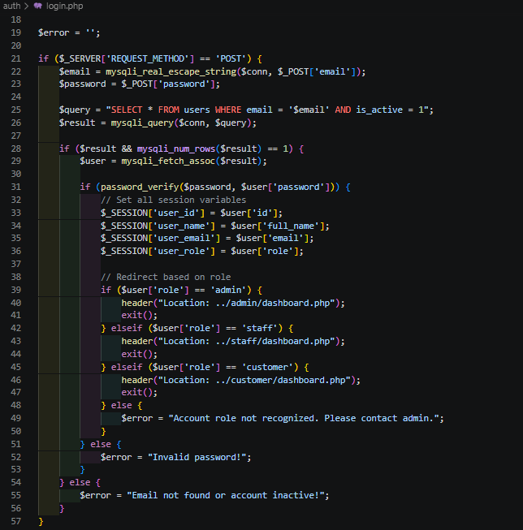Fig 5.5: Login (fetching of user account) SQL query

Update Operation
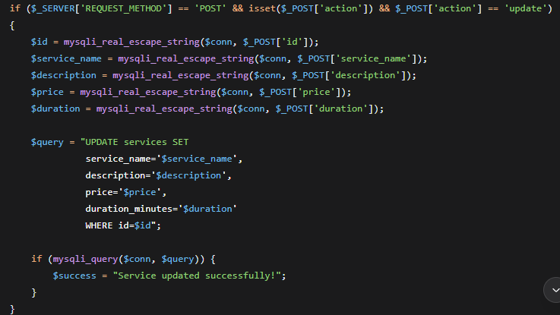

Fig 5.6: SQL query to change services data

Delete Operation
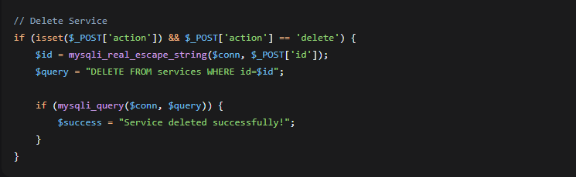

Fig 5.7: SQL query to delete services data

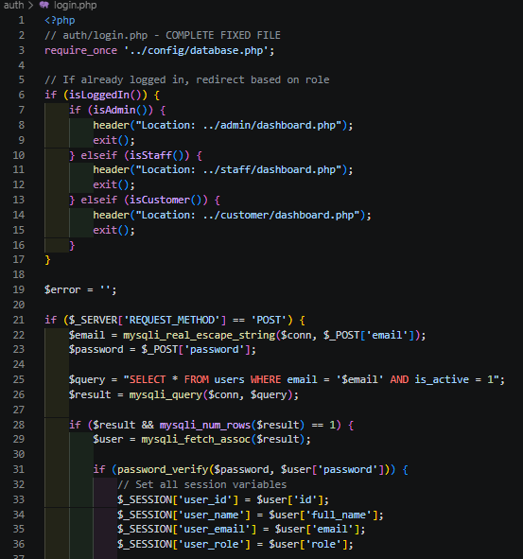

Fig 5.8: Login database integration

Student reflection:
One of the key lessons I learned was how to create and structure database tables using SQL commands. I understood the importance of defining appropriate fields, selecting suitable data types, and assigning primary keys. I also learned how databases store and organize information efficiently. Creating tables helped me understand how data is represented and managed within a relational database system. The CRUD operations enhanced my understanding of how data is inserted, retrieved, updated, and deleted. These operations form the foundation of database interaction in real-world applications. I gained practical experience in writing SQL queries. This improved my ability to manipulate and retrieve data based on different requirements. Another important lesson was learning how PHP can connect to a MySQL database. This allowed me to understand how web applications communicate with databases I also learned how login systems authenticate users by checking credentials stored in a database.

Week 7: User Authentication and Session Management

Customer Authentication:
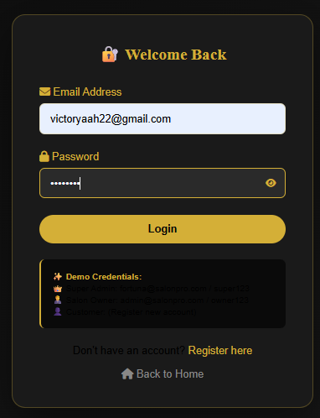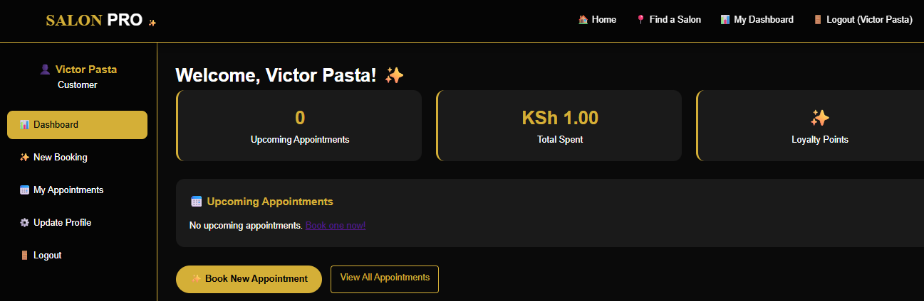

Fig 7.1: User login and dashboard

Admin Authentication
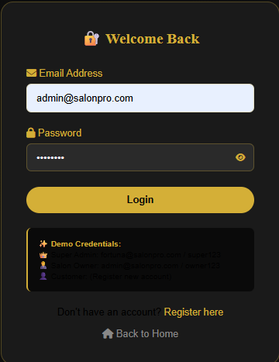
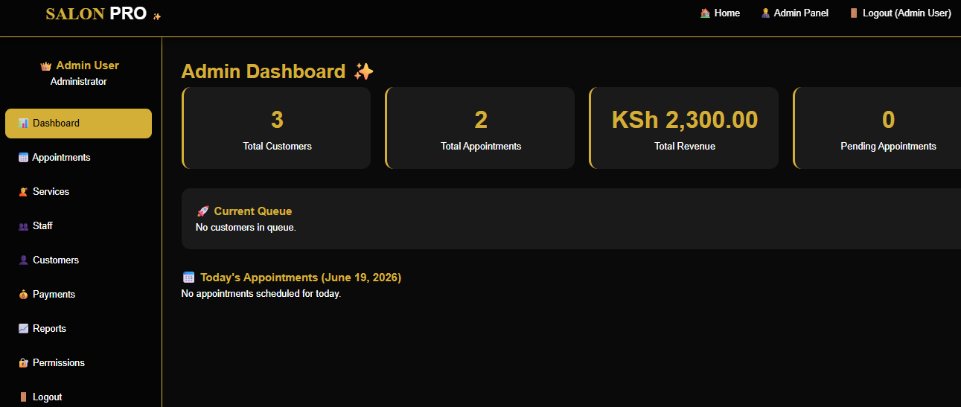

Fig 7.2: Admin authentication and dashboard

