Prerequisite
idealC 2023.3.8 (Be careful, don’t download U - U means ultimate, need pay)

Go to this link and install the exe, to get intellij setup on local
https://youtrack.jetbrains.com/articles/IDEA-A-2100661679/IntelliJ-IDEA-2023.3-Latest-Builds
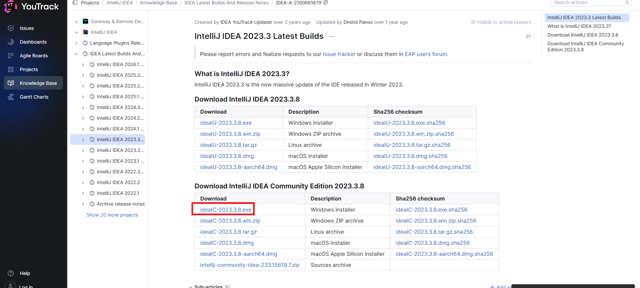

After install - create project
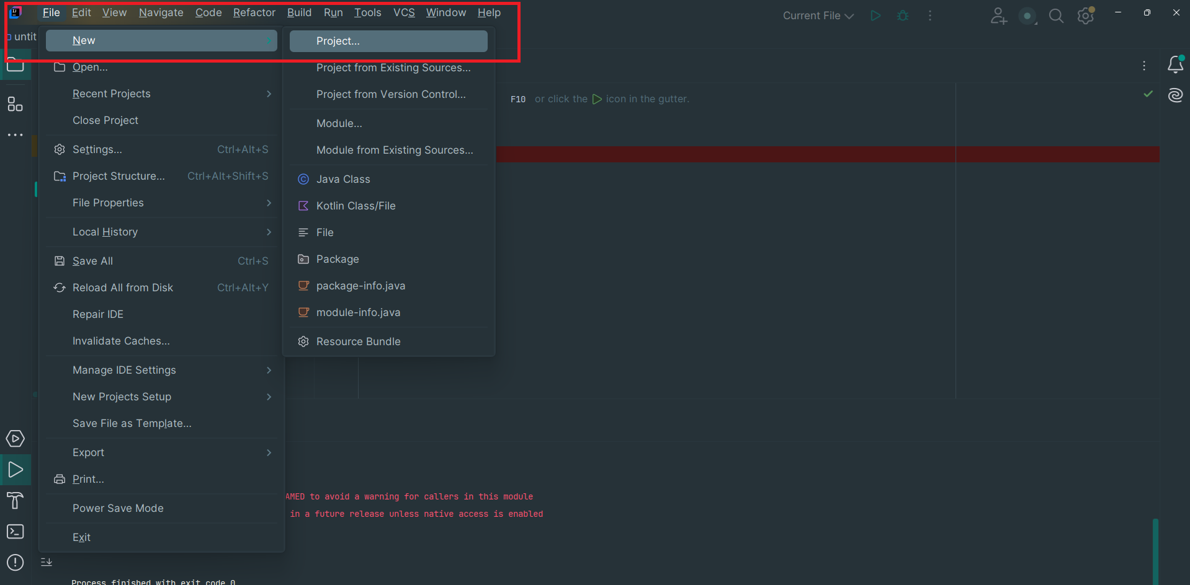

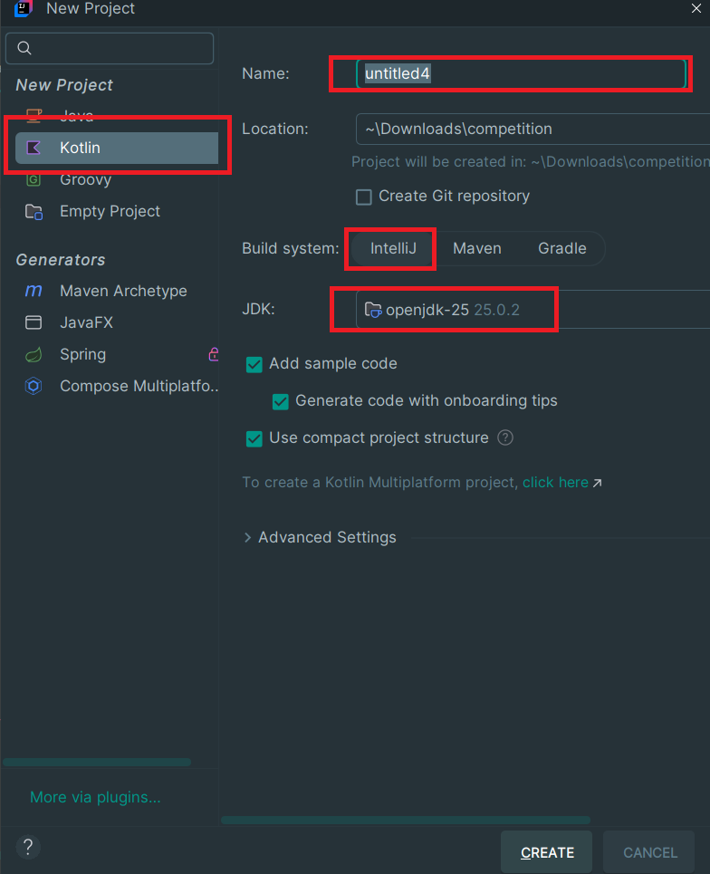

Test run
