國立台灣大學電機資訊學院電子工程學研究所

系統晶片設計實驗  
Soc Design Laboratory

Lab5 Report

|  |
| --- |
| Caravel SOC - Caravel FPGA |

學生： M11202109 蘇柏丞

M11202103 陳泓宇

M11202207 呂彥霖

老師： 賴 瑾

中華民國 112 年 11 月 22 日

1. Block diagram：

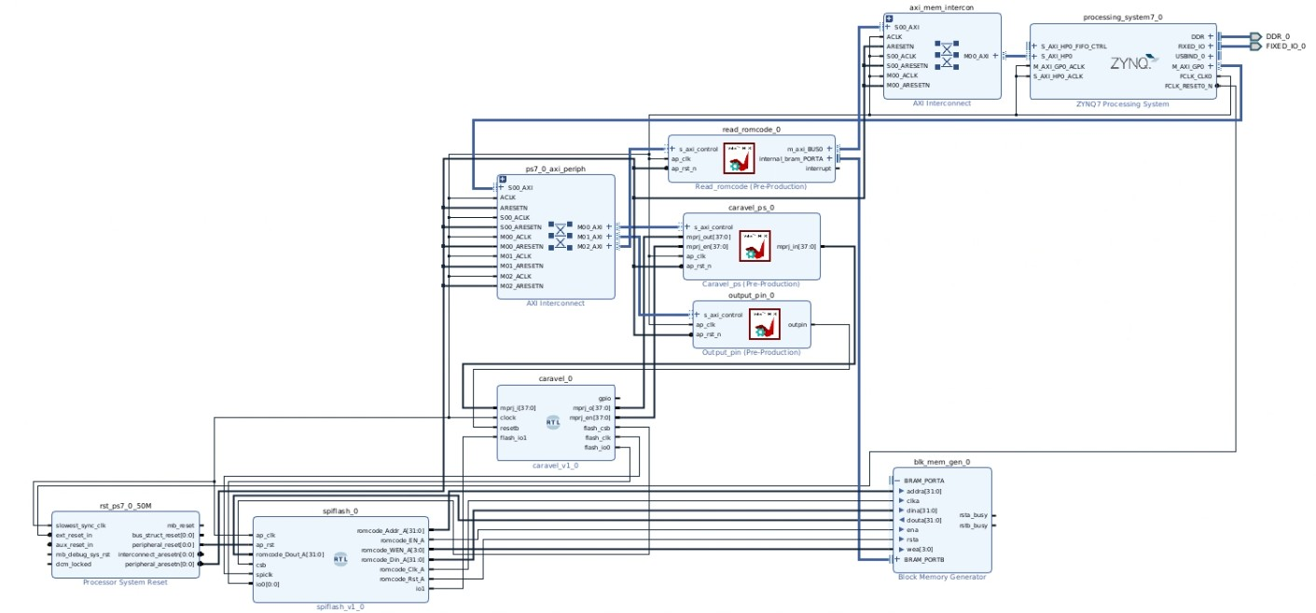

1. FPGA utilization：

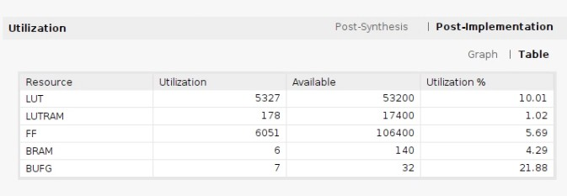

1. Function of IP：
2. Read_romcode

用來將fireware code從DRAM轉移至BRAM，因為我們的BRAM有大小限制，故在設計時fireware code限制在8K以下，並實現axilite的address map，當0x00時是用於控制ap訊號，當0x10和0x14時是控制BRAM buffer的base address訊號，當0x1c時控制data length訊號。  
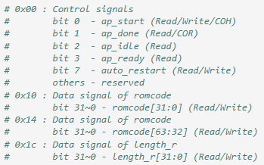

1. ResetControl

用於控制Caravel的reset pin，並實現axilite的 address map控制PS CPU的輸出，當0x10時根據bit 0控制outpin_ctrl，進而控制caravel的reset pin。

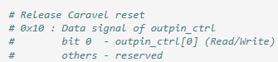

1. Caravel_ps

用來實現GPIO的Monitor，本實驗當中用jupyter code實現MMIO去read Register，進而讀取Caravel產生出來的Signal data是否正確。

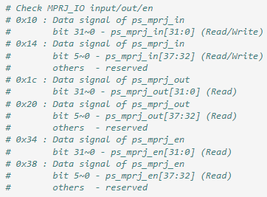

1. Spiflash

用來實現SPI slave device，在本實驗中只用於讀取Caravel傳送過來read指令(0x30)，讀到指令後回傳fireware code回去，當中的fireware code是從BRAM存取。

1. Workload
2. counter_wb.hex

* read workload

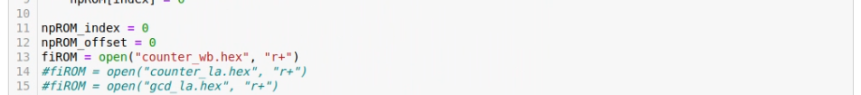

* Check MPRJ_IO after bram has been written

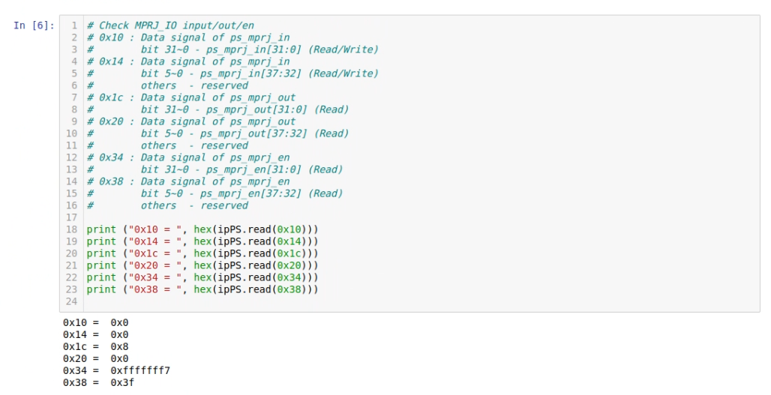

* de-assert Caravel reset pin and Get mprj_i/o/en data

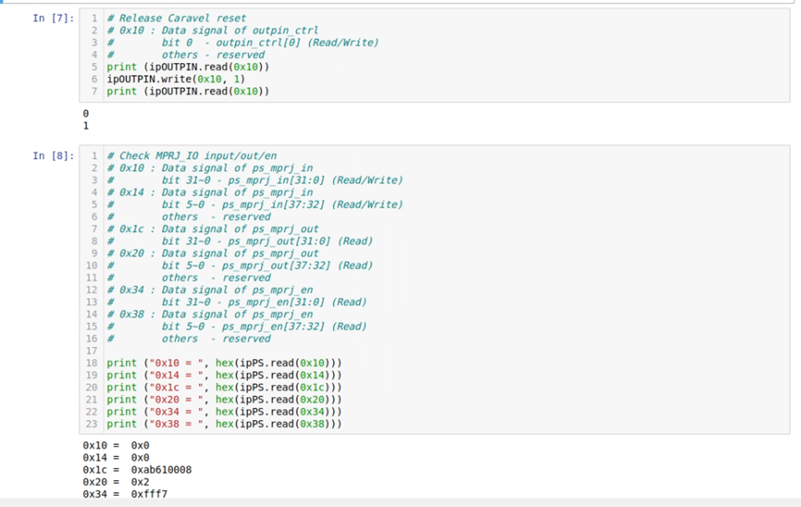

* Compare the mprj_o value with final result in the firmware code

|  |  |
| --- | --- |
| firmware code |  |
| mprj_o |  |

1. counter_la.hex

* read workload



* Check MPRJ_IO after bram has been written

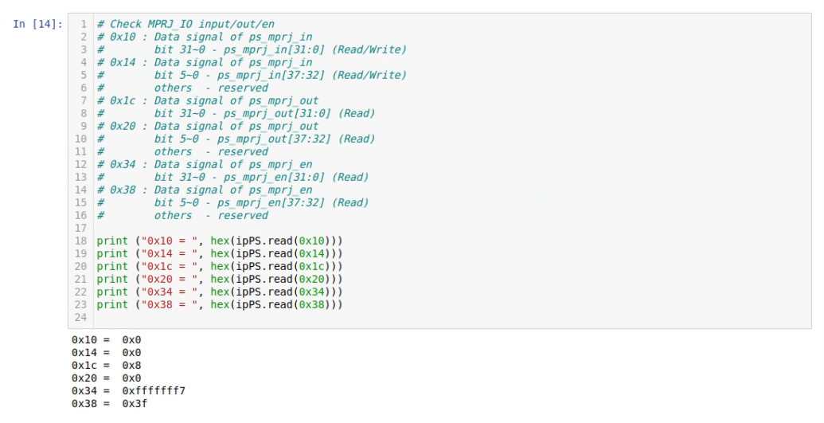

* de-assert Caravel reset pin and Get mprj_i/o/en data

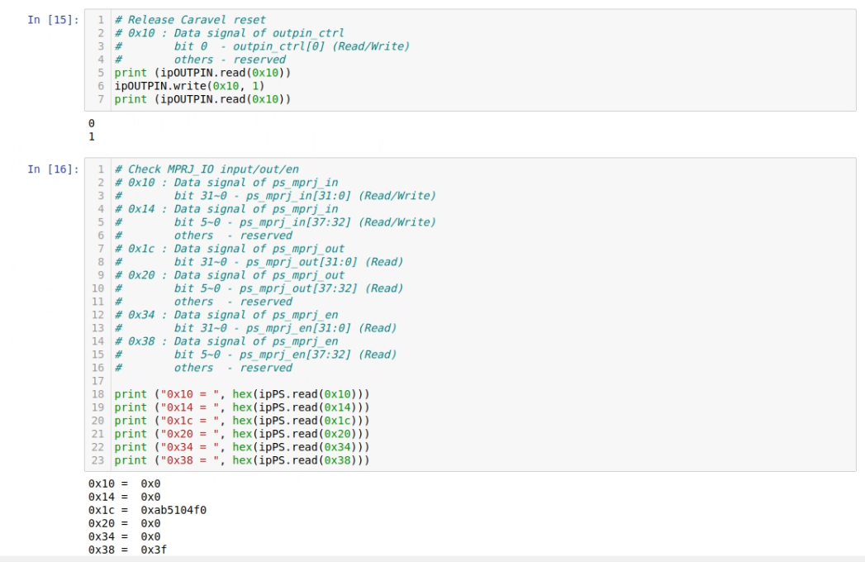

* Compare the mprj_o value with final result in the firmware code

|  |  |
| --- | --- |
| Firware code |  |
| mprj_o value |  |

1. gcd_la.hex

* read workload



* Check MPRJ_IO after bram has been written

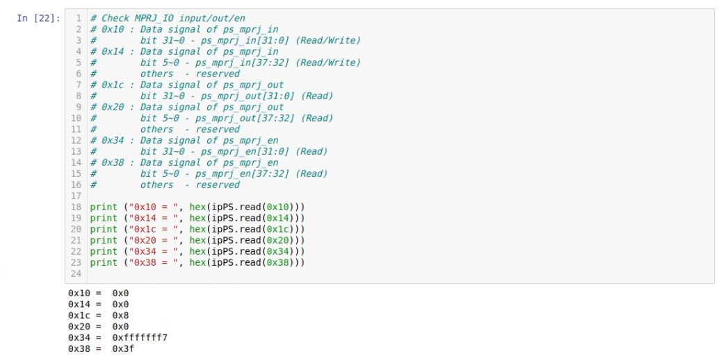

* de-assert Caravel reset pin and Get mprj_i/o/en data

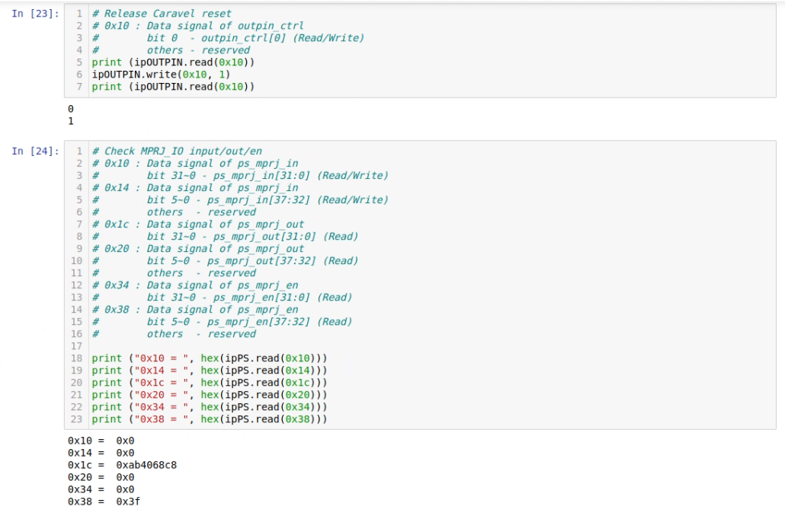

* mprj_o value

