UNIVERSITY OF CAPE COAST

COLLEGE OF DISTANCE EDUCATION (CoDE)

MSC INFORMATION TECHNOLOGY

INF811D: Object-Oriented Programming
Course Lecturer: Dr. Linda Otoo

Technical Report
System developed: Online Examination and Grading System
JavaFX GUI Desktop Application

STUDENT: EMMANUEL FOSU
INDEX NUMBER: MS/ITE/25/0045

- Introduction
The Online Examination and Grading System is a desktop application that digitizes the examination workflow of a tertiary institution. It allows lecturers to author timed assessments, students to sit those assessments under exam conditions, and the system to mark objective answers automatically using the University of Cape Coast grading standard. The application is built entirely with JavaFX and demonstrates the core principles of object-oriented programming.

- Problem Statement
Traditional paper-based examinations are slow to mark, prone to human error during grading, and offer no immediate feedback to students. Manual grade computation also introduces inconsistency in how raw scores map to letter grades. A software system that captures answers electronically, marks them deterministically and applies a single agreed grading scale removes these problems while enforcing exam conditions such as time limits and single attempts.

- Objectives of the System
- Provide secure, role-based access for administrators, instructors and students.
- Allow instructors to create and publish timed examinations with multiple question types.
- Present students with a timed, distraction-free examination interface.
- Grade objective questions automatically and apply the UCC grading scale.
- Give students instant feedback and a persistent record of their results.
- Validate all input and handle errors gracefully.

- Scope of the System
The system covers account registration and authentication, exam authoring, publishing, exam sitting with a countdown timer, automatic grading, result review for both students and instructors, and basic user administration. Data is persisted locally so that it survives between sessions. Out of scope are network/multi-machine operation, essay-style human marking, and integration with an external student information system.
- Methodology
The application follows a layered architecture that separates concerns:
- Model layer: Plain Java objects representing the domain (users, exams, questions, submissions).
- Service layer: Application logic for authentication, user management, exam management and grading.
- Persistence layer: A serialization-backed data store.
- Presentation layer: JavaFX views, one per screen, coordinated by a central navigator.
Development was incremental: the domain model was defined first, then the services and persistence, then the user interface, with a unit test pinning the grading logic.

- System Design
Online Examination and Grading System App
── call ─▶

(Navigator + service wiring)

── use ─▶

Operate on
DataStore
Model
Services
UI views

The presentation layer never touches directly; it goes through the service layer, which in turn holds the only references to the data store. This keeps the UI thin and the business rules testable in isolation.
- Description of Classes and Methods
Model
- User: (abstract) Common identity/credential state; abstract getRole() and getDashboardTitle().
- Student / Instructor / Administrator: Concrete accounts adding role-specific fields.
- Role: (enum) The three account types.
- Gradable: (interface) The grade(String) contract.
- Question: (abstract, implements Gradable) Text and marks; abstract getType() / isAutoGradable().
- MultipleChoiceQuestion / TrueFalseQuestion / ShortAnswerQuestion: Each overrides grade(...) with its own marking rule.
- Exam: A titled, timed collection of questions; computes total marks.
- Submission: A student's answers plus the resulting GradeResult.
- GradeResult: A mutable score/percentage/letter-grade/grade-point value.
Services
- AuthService: login(...), logout(), current-session tracking.
- UserService: register(...), lookups, seedDefaultsIfEmpty().
- ExamService: create/publish exams, add questions, submit and grade attempts, query results.
- GradingService: grade(Exam, Submission) and classify(...) implementing the UCC scale.
Persistence & Utilities
- DataStore: in-memory collections mirrored to serialised .dat files.
- Validator: reusable field checks that throw ValidationException.
- PasswordUtil: salted SHA-256 password hashing and verification.
- IdGenerator: prefixed unique identifiers.

- GUI Design Explanation
The interface uses a consistent visual language defined in a single stylesheet (styles.css): a deep academic-blue top bar, white cards on a soft gradient background, and clearly differentiated primary/ghost/danger buttons. Each role has a dedicated dashboard. The exam-sitting screen is deliberately focused on a header with a live clock, a scrollable list of question cards, and a single submit action; so, students are not distracted during an assessment. The clock turns red in the final minute to signal urgency. All errors are surfaced through modal dialogs with plain language rather than raw exceptions.

- OOP Concepts Implemented
- Encapsulation: All model fields are private and mutated only through methods that can enforce invariants; internal collections are returned as defensive copies (Exam.getQuestions(), Submission.getAnswers()).
- Inheritance: The User and Question hierarchies share state and behaviour from abstract bases, avoiding duplication.
- Polymorphism: GradingService iterates over Question references and calls grade(...) without knowing the concrete type; the exam-taking view renders the correct answer control by pattern-matching on subtype.
- Abstraction: The Gradable interface and abstract classes expose stable contracts (grade, getType) while hiding the specifics.
- Additional practices: Custom exception hierarchy, input validation, event-driven handlers, arrays/collections (List, Map), control structures and operators throughout the grading and validation logic.

- Screenshots and Outputs
The screenshots are in the docs/screenshots/ directory of the repository and are also inserted below:

- 01-login.PNG
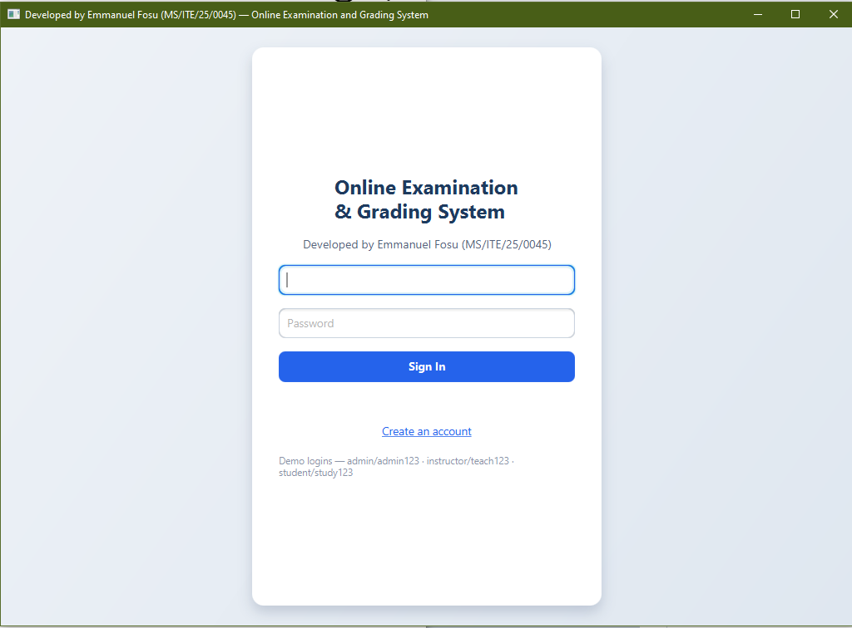

- 02-instructor-dashboard.png: instructor's exam list
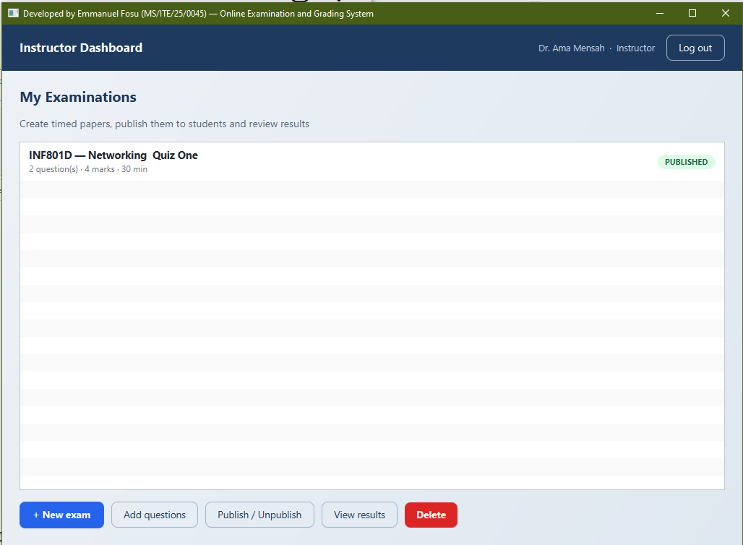

- 03-exam-builder.png: creating the exams or quiz
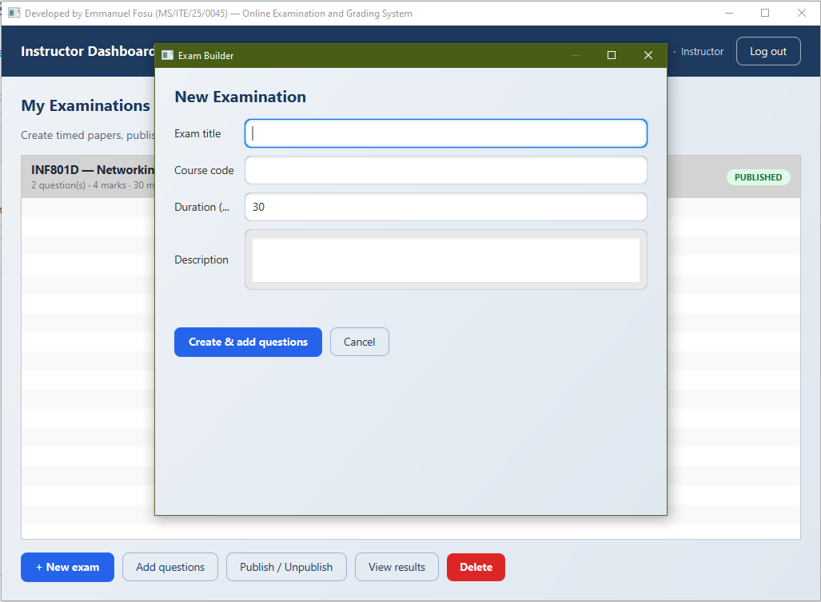

- 04-Exam builder MCQ sample.PNG
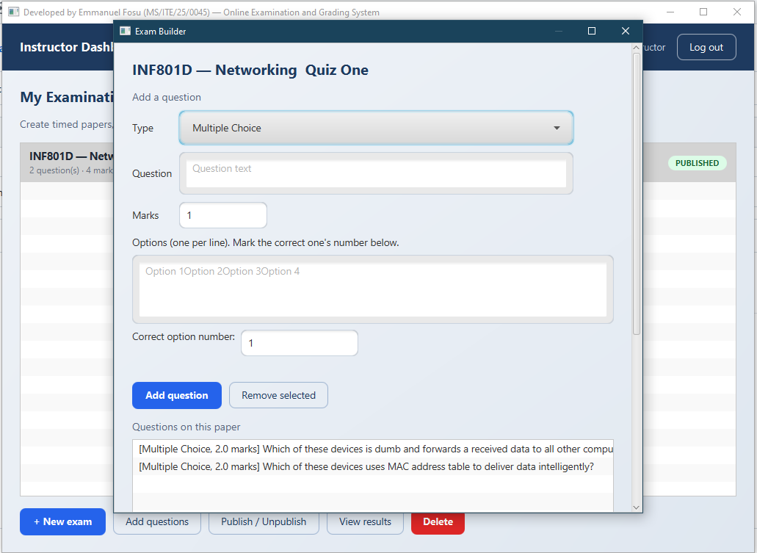

- 05-Exam builder Short Anwer sample.PNG
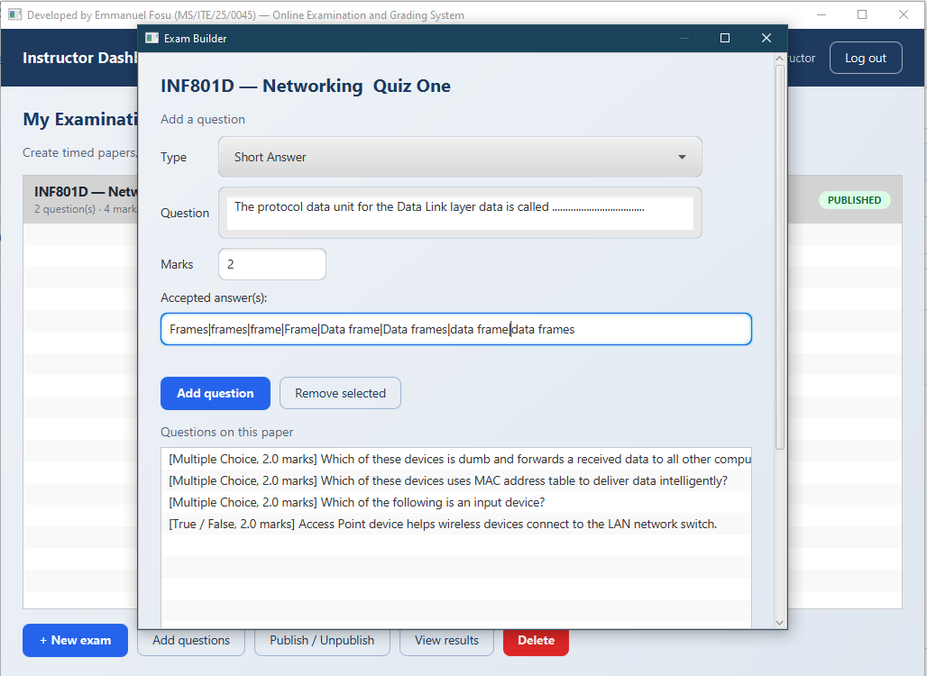

- 06-Exam builder True or False sample.PNG
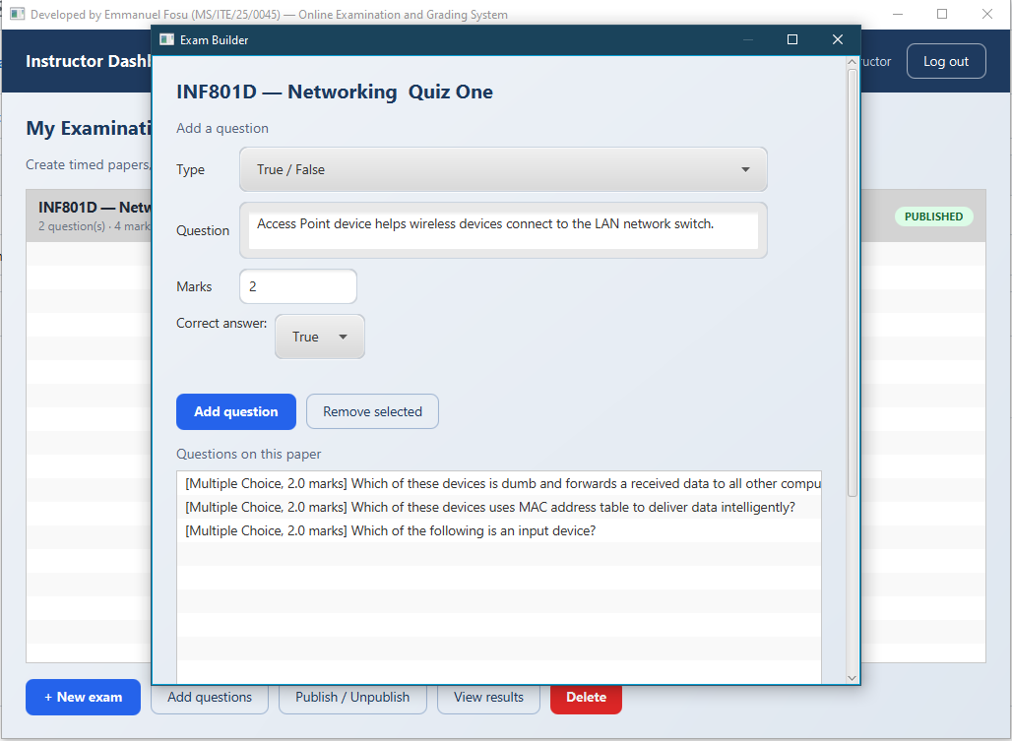

- 07-The system Prompting the Student before Taking the Exams
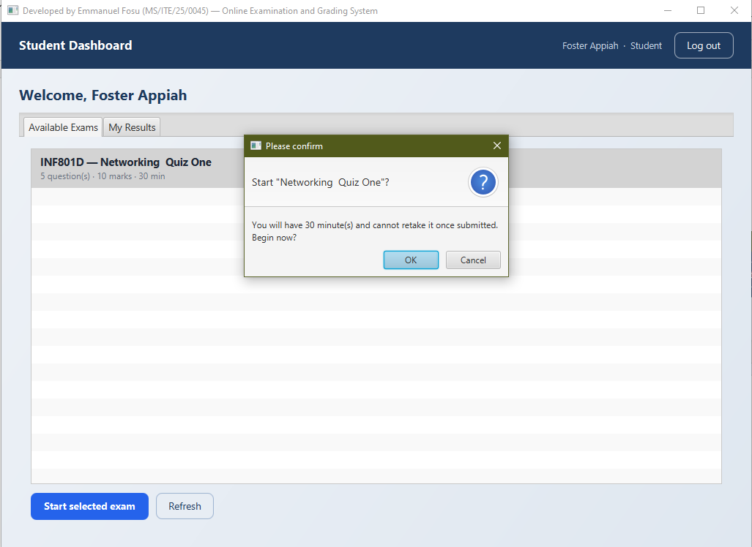

- 08-taking-exam.png: timed exam with countdown
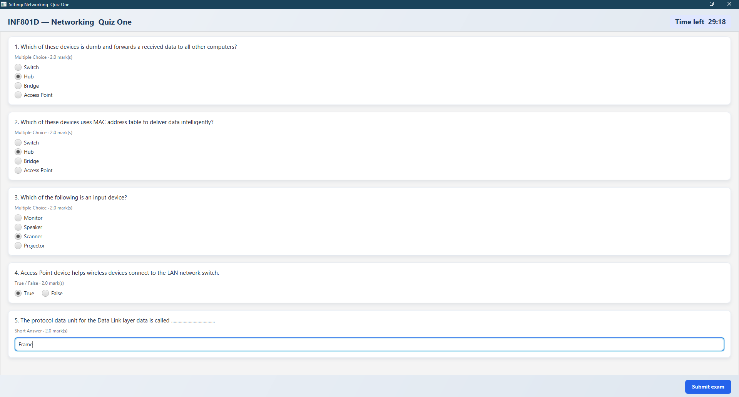

- 09-Instant Feedback for the Student after Completing the Exam
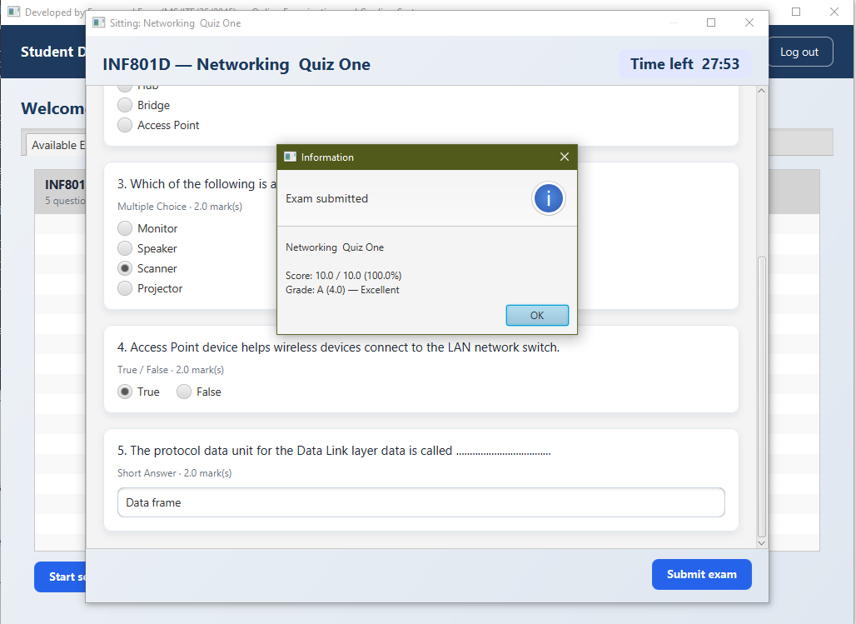

- 10-Student Viewing Records of Results after the exam
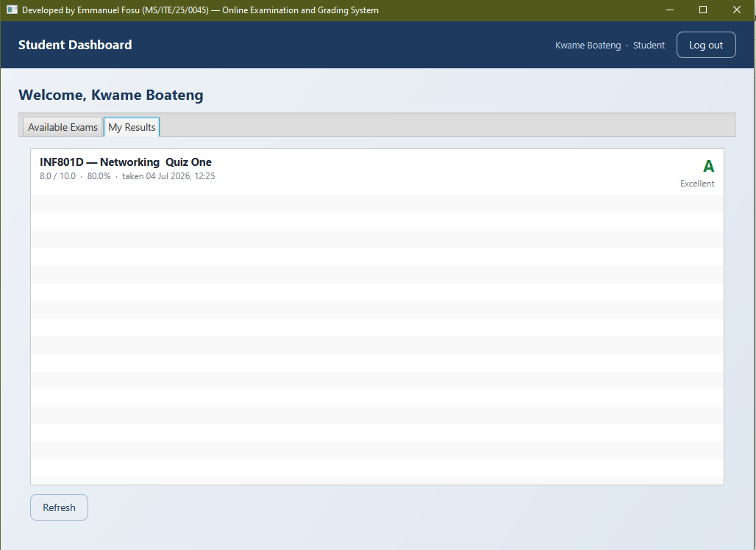

- 11--result.png: Instructor Viewing Scores Records of Students
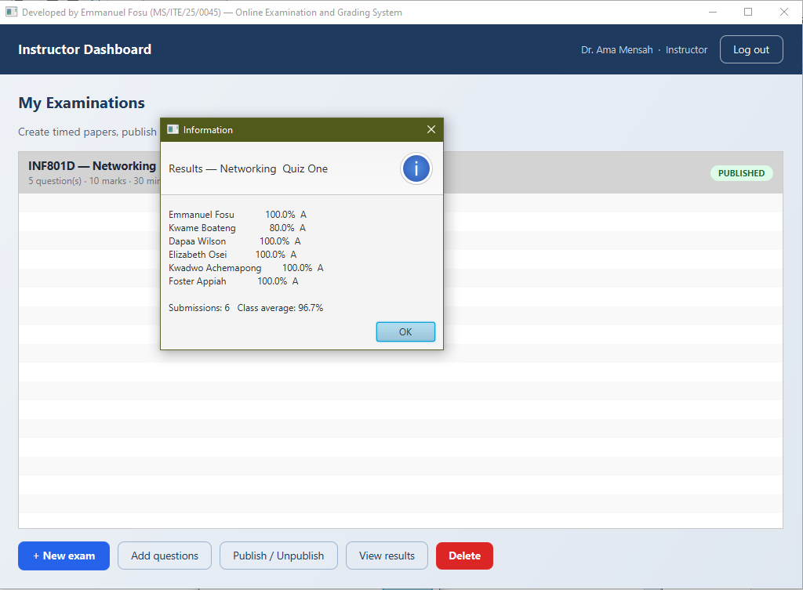

- 12-admin.png: user management
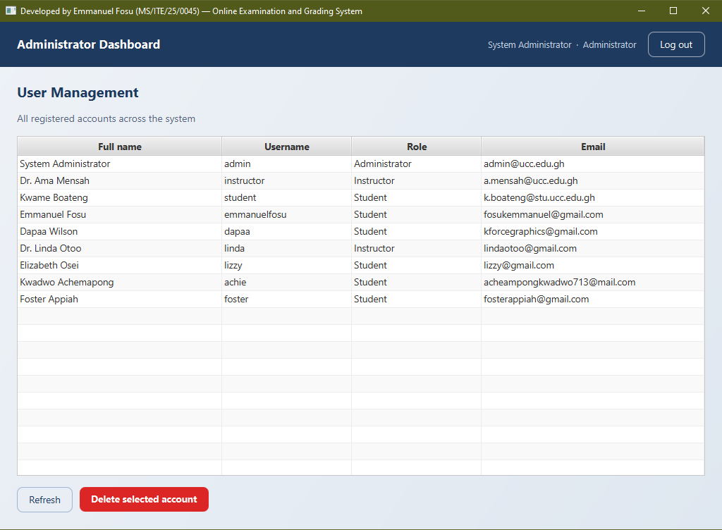

- GitHub Repository Link
https://github.com/Fosukemmanuel/my-online-examination-grading-desktop-software

- Challenges Encountered
- Wiring the countdown timer to auto-submit.
- Mapping percentages to grade boundaries without off-by-one errors.
- Persisting an object graph with serialization.

13. Conclusion
The system meets its objectives: it enforces role-based access (Kabier et al., 2023), administers timed examinations, grades objective answers automatically against the UCC scale, and gives immediate, persistent feedback. Its layered, object-oriented design makes each concern easy to reason about and extend.

14. Recommendations
Future work could add essay questions with instructor marking, question banks with randomized selection, exports of results to PDF/CSV, charts to visualize data, and a networked client–server deployment so multiple students can sit an exam concurrently from different machines.

15. References
Kabier, M. K., Yassin, A. A., Abduljabbar, Z. A., &amp; Lu, S. (2023). Role Based Access Control Using Biometric the in Educational System. Journal of Basrah Research Sciences, 49(1), 85–101. https://doi.org/10.56714/bjrs.49.1.8
Oracle. (n.d.). JavaFX API documentation. Oracle Help Center. https://docs.oracle.com/en/java/java-components/javafx/
W3Schools. (n.d.). Java encapsulation. https://www.w3schools.com/java/java_encapsulation.asp
W3Schools. (n.d.). Java inheritance. https://www.w3schools.com/java/java_inheritance.asp
W3Schools. (n.d.). Java polymorphism. https://www.w3schools.com/java/java_polymorphism.asp
W3Schools. (n.d.). Java abstraction. https://www.w3schools.com/java/java_abstract.asp
University of Cape Coast. (n.d.). Grading system and academic regulations. https://ucc.edu.gh/
University of Cape Coast. (2026). INF811D: Object-oriented programming (Course lecture notes). Department of Computer Science and Information Technology.
Fosu, E. (2026). Online-Examination-and-Grading-System (Version 1.0.0) (Computer software). GitHub. https://github.com/Fosukemmanuel/my-online-examination-grading-desktop-software

