

Lebanese University

Faculty of Engineering – Branch III

**Electronics Project**

**Toy Organ using 555 Timer**

Presenter to: Dr. Taleb Fakih

Presented by:

Fouad Atwi (5180)

Hanane Kteich (5189)

# INTRODUCTION:

A simple electronic toy piano can be easily constructed using the popular 555 timer IC. 555 Timer can be easily wired as an Astable, Monostable or Bistable multivibrator.

We all know that Sound is a Mechanical Wave as it is produced by a to and fro movement of particles in a medium. Displacement of particles are in the same direction as propagation of sound waves, so sound is a Longitudinal Wave.

The to and fro motion of particles in the medium creates compression (high pressure) and rarefactions (low pressure) in the medium, so sound is a Pressure Wave.

A tone is a sound which is produced by a regular vibration. It has only one frequency even though intensity/amplitude can vary. A Loudspeaker is an electronic transducer which converts electric signals to pressure variations to make the sensation of sound by making this diaphragm of the loudspeaker vibrate according to the frequency and amplitude of electric signals. The audible frequency range of humans is from 20Hz to 20KHz, so we are going to generate frequencies in this range using 555 timer and feed it to the loudspeaker.

# Components Required:

555 Timer IC

Speaker 8Ω, 0.5W

Variable resistors 2.2K

Variable Resistor 10K

Electrolytic Capacitor 10μF

Ceramic Capacitor 0.1μF

Ceramic Capacitor 0.01μF

# Circuit principle:

In astable multivibrator mode, the circuit produces accurate free running waveforms which can be adjusted.

2.2k pots are connected in series. When a button is pressed, a unique value of resistance is thus obtained and hence a unique to tone is generated.

The pots are adjusted so that the tones match the music scales, hence we chose to put 12 buttons to represent a whole octave.

When the last one is pressed it delivers a low tone. This is because of the resistance connected to the buttons. The low threshold voltage obtained at the last pin slows the charging and discharging of a 10-microfarad capacitor at the speaker. As the resistance value increases voltage at the threshold pin decreases and low frequency passes through speaker.

# Toy piano circuit diagram:

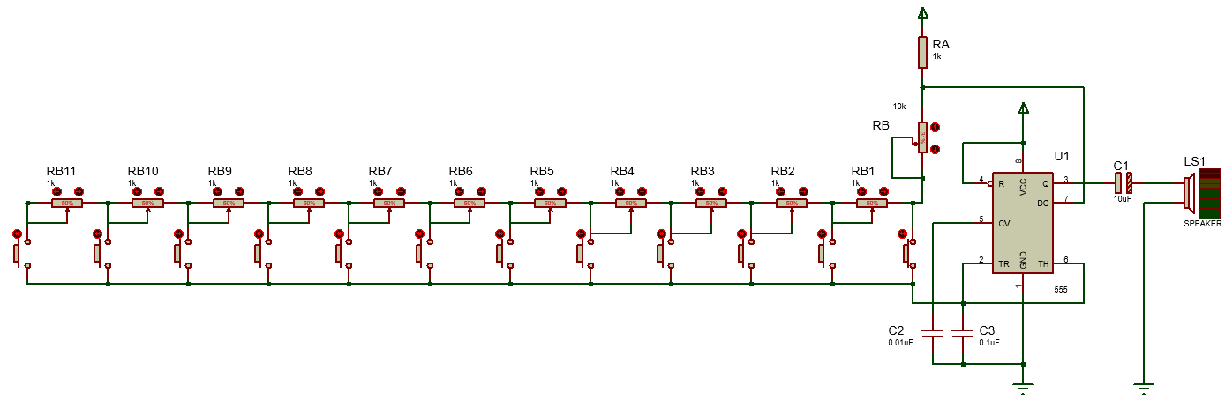

The capacitor C3 and all the resistors in the above circuit determine the frequency of oscillation of the multivibrator. Capacitor C2 is connected to 5th pin to avoid high frequency noises. The capacitor C1 act as a coupling capacitor which will block dc and pass ac signals to the loudspeaker.

You can change the generated tones by varying the variable resistor RB.

Output frequency of astable multivibrator using 555 is given by, F = 1.44/((Ra + 2Rb) * C3). Where Ra and C3 are fixed values, 1kΩ and 0.1μF respectively but the value of Rb is determined by the switch which is pressed as given below.

SW1 – RB

SW2 – RB + RB1

SW3 – RB + RB1 + RB2

SW4 – RB + RB1 + RB2 + RB3

SW5 – RB + RB1 + RB2 + RB3 + RB4

SW6 – RB + RB1 + RB2 + RB3 + RB4 + RB5

. . .

SW12 – RB + RB1 + RB2 + RB3 + RB4 + RB5 + … + RB11

So, pressing each switch will generate a corresponding frequency, by which speaker will generate different tones (single frequency sound) for each switch.

Where RB1 to RB11 are variable resistor to tune the piano (0 – 2.2kΩ)

# The PCB form:

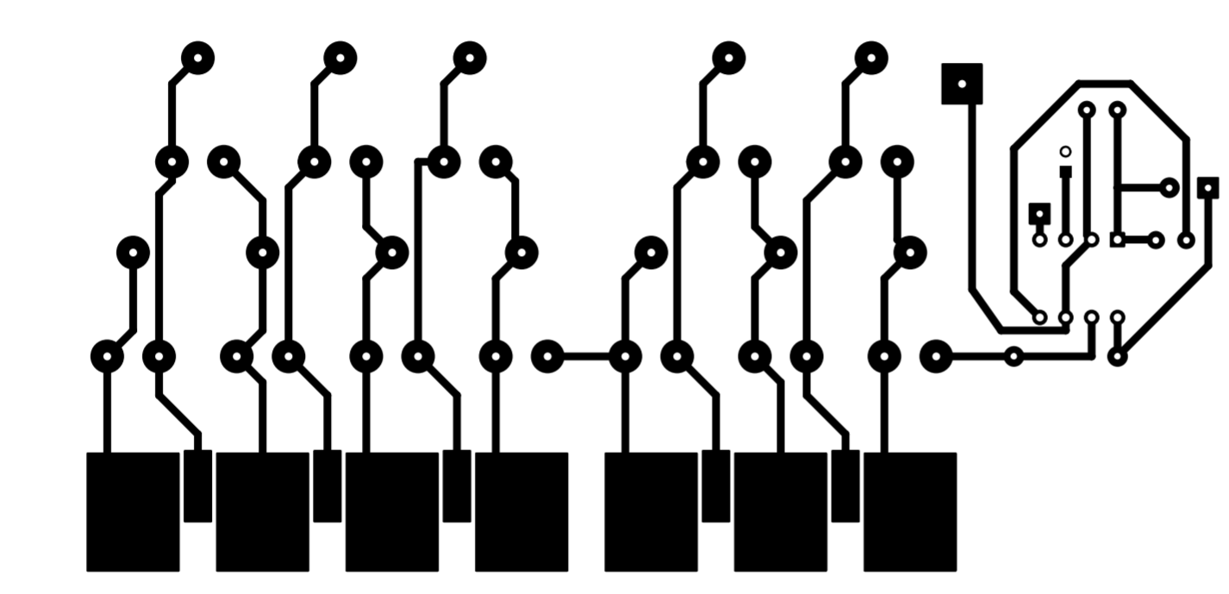

The switches are replaced by large copper pads on the PCB which the user can use to complete the circuit and simulate button pressing.