43-STM32Fxxx_MPU9250_EKF
Software layers, function calls and data exchange

Attitude estimation (roll, pitch, yaw, gyro bias) with an MPU9250 9-axis IMU, an Extended Kalman Filter and an SSD1306 OLED display on STM32Fxxx, built on the TM STM32Fxxx HAL libraries.

Item | Value
Project folder | 43-STM32Fxxx_MPU9250 _EKF in stm32_utilities
Reference target | NUCLEO-F411RE, STM32F411 Cortex-M4F at 100 MHz (HSE 8 MHz, PLLN 400, PLLP 4)
Toolchain | Keil uVision 5 (MDK-ARM), optimisation -O1
Author | Fouad El khiati
Document version | 1.1, 17 October 2026 (adds chapter 8: algorithms)

Contents

1. Introduction

1.1 Purpose
This document describes how the firmware in 43-STM32Fxxx_MPU9250 _EKF is split into software layers, which functions each layer calls in the layer below, and what data crosses each boundary: the structures, buffers, units and return codes. Chapter 8 links each mathematical algorithm to the function and layer that implements it. The document is meant as a reference for maintaining the project, porting it to another MCU or sensor, and reviewing changes.

1.2 Source files
File | Origin | Role
User/main.c | Project | Board bring-up, filter configuration, main loop, display formatting
User/imu_port.c/.h | Project | Hardware adaptation layer: MPU9250 access, unit conversion, magnetometer calibration lifecycle
User/ekf.c/.h | Project | Multiplicative attitude EKF, 6 error states (3 attitude, 3 gyro bias). No platform dependency
User/magcal.c/.h | Project | Hard/soft-iron magnetometer calibration by least-squares ellipsoid fit
User/Gauss_elimination.c/.h | Project | Dense linear solver used by magcal (pivoting, determinant, back substitution)
User/defines.h | Project | Compile-time configuration for the TM libraries (NUCLEO_F411)
User/stm32fxxx_it.c | Project | Interrupt handlers, including SysTick_Handler
tm_stm32_mpu9250, tm_stm32_ssd1306, tm_stm32_fonts, tm_stm32_disco | 00-STM32_LIBRARIES | Device drivers
tm_stm32_i2c, tm_stm32_delay, tm_stm32_rcc, tm_stm32_gpio | 00-STM32_LIBRARIES | Peripheral libraries
stm32f4xx_hal_*.c, CMSIS startup | 00-HAL_DRIVERS | ST HAL and register-level support
attitude_ekf_magcal_paper, mekf_verification.m, magcal_verification.m | MATLAB-Octave-verification repository | Derivation of the algorithms and MATLAB/Octave ports used to verify them (chapter 8)

1.3 Execution model
The firmware is a single-threaded super-loop with no RTOS. Every call described in this document is synchronous and blocking: an I2C transfer returns only when the bytes are on the wire or the 1000 ms HAL timeout expires. The only asynchronous path is the 1 ms SysTick interrupt, which advances the time base read by TM_DELAY_Time() and HAL_GetTick() (section 9).

2. Layered architecture
The code is organised in five software layers above the hardware. A layer calls only functions of the layers below it; data comes back up through return values and through structures that the caller passes by pointer.
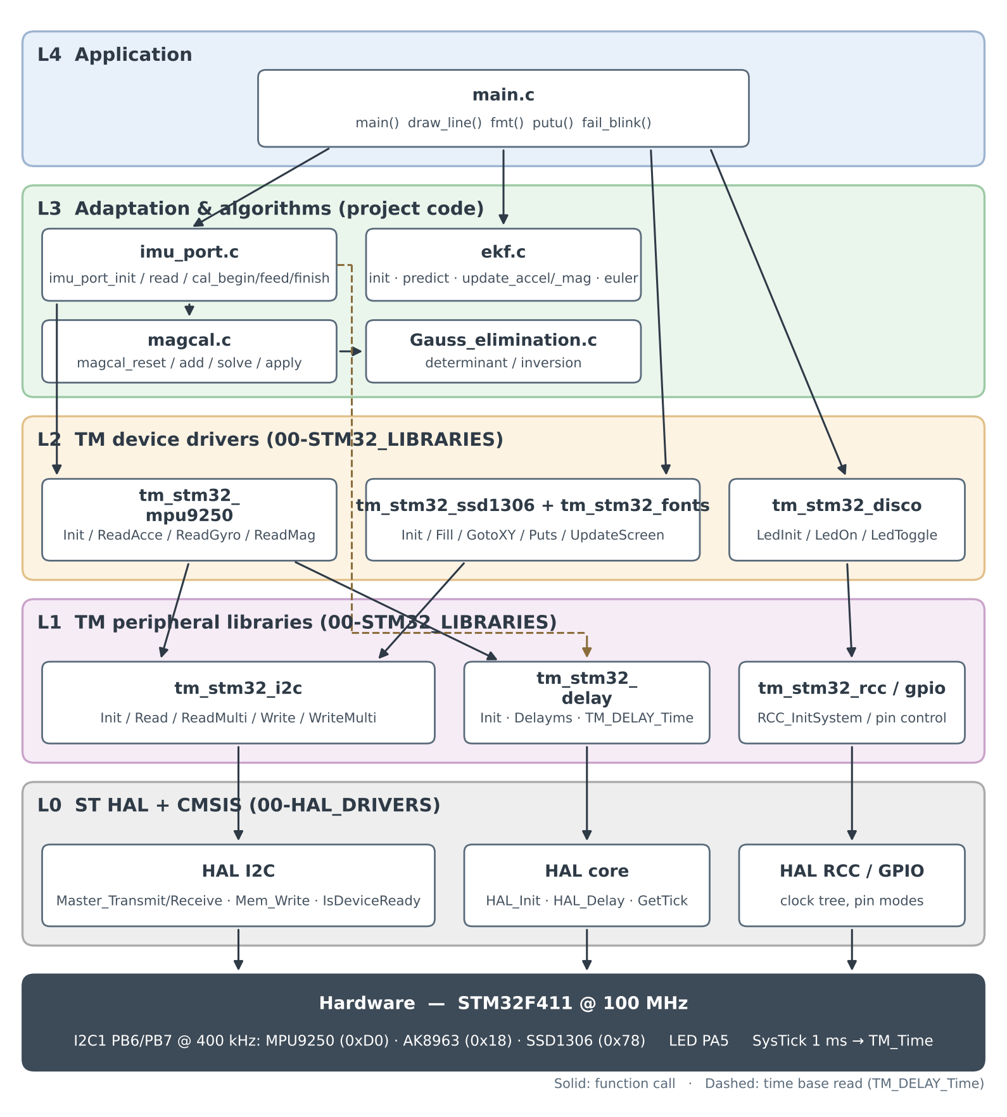
Figure 1. Software layers and call dependencies
Layer | Modules | Responsibility | Knows about
L4 Application | main.c | Startup order, filter tuning, loop pacing, display formatting (fixed-point, no stdio) | L3 public APIs; TM display, LED and delay APIs
L3 Adaptation | imu_port.c | Turns MPU9250 registers into SI units in imu_sample_t; measures dt; owns the calibration lifecycle | TM MPU9250 and delay; magcal
L3 Algorithms | ekf.c, magcal.c, Gauss_elimination.c | Attitude estimation, ellipsoid fit, linear algebra | Only math.h and string.h. Compiles on a PC
L2 Device drivers | tm_stm32_mpu9250, tm_stm32_ssd1306 + tm_stm32_fonts, tm_stm32_disco | Register maps, sensor scaling, frame buffer and font rendering, LED | TM I2C, delay, GPIO
L1 Peripheral libraries | tm_stm32_i2c, tm_stm32_delay, tm_stm32_rcc, tm_stm32_gpio | I2C handles and pin packs, time base, clock tree, pins | ST HAL
L0 HAL + CMSIS | stm32f4xx_hal_i2c, _rcc, _gpio, _cortex, startup | Register access, peripheral state machines, SysTick | Hardware

2.1 Layering rules
- imu_port.c is the only project file that includes tm_stm32_mpu9250.h. Changing the IMU or the MCU means rewriting this one file.
- ekf.c, magcal.c and Gauss_elimination.c include no STM32 header and can be compiled and unit-tested on a PC.
- main.c never touches the sensor. It receives a finished imu_sample_t and hands arrays of float to the filter.
- Display and LED access stay in main.c. No algorithm module draws or blinks.

3. Data exchanged between layers
Table 1 lists every structure or buffer that carries data across a layer boundary, who owns its storage, who writes it and who reads it.
Data | Defined in / storage | Written by | Read by | Contents and units
imu_sample_t sample | imu_port.h / static in main.c | imu_port_read() | main() → ekf_*() | gyro[3] rad/s, acc[3] g, mag[3] (unit vector if calibrated, else 0.1 µT counts), dt s, mag_valid 0/1
ekf_cfg_t cfg | ekf.h / local in main() | main() | ekf_init() (copied) | gyro_noise, bias_noise, accel_noise, mag_noise, mag_ref[3]
ekf_t ekf | ekf.h / static in main.c | ekf_init, ekf_predict, ekf_update_* | ekf_euler(); main() reads ekf.bias[] directly | q[4] quaternion w,x,y,z body→nav; bias[3] rad/s; P[36] 6×6 covariance; cfg copy (200 bytes)
magcal_t cal | magcal.h / static in imu_port.c | magcal_reset/add/solve | magcal_apply(), imu_port_read() | ata[36], atb[6] double accumulators; count; offset[3], scale[3]; valid (368 bytes)
TM_MPU9250_t dev | tm_stm32_mpu9250.h / static in imu_port.c | TM_MPU9250_Init/Read*() | imu_port.c | Ax..Az g, Gx..Gz °/s, Mx_Raw..Mz_Raw int16, multipliers AMult, GMult, MMult, I2C addresses
float A[36], aug[36], v[6] | locals in magcal_solve() | magcal_solve, then Gauss functions in place | magcal_solve() | Normal matrix (destroyed), identity → inverse, right-hand side → solution
SSD1306_Buffer[1024] | static in tm_stm32_ssd1306.c | Fill, Puts, DrawPixel | TM_SSD1306_UpdateScreen() | 128×64 monochrome frame, 8 pages of 128 bytes
char buf[24] | local in draw_line() | fmt(), putu() | TM_SSD1306_Puts() | ASCII such as R:-12.34
TM_Time (uint32_t) | tm_stm32_delay.c | HAL_IncTick() from SysTick ISR | TM_DELAY_Time(), HAL_GetTick() | Milliseconds since startup
I2C_HandleTypeDef | tm_stm32_i2c.c (one per I2Cx) | TM_I2C_Init() | every TM_I2C_* call | HAL state of I2C1; shared by the MPU9250 and the SSD1306
Table 1. Data crossing layer boundaries

3.1 Passing conventions
- Structures are passed by pointer and filled in place. No function allocates memory; every buffer is static or on the stack.
- Vectors are float[3] in X, Y, Z order. Matrices are row-major float arrays (P[i*6 + j]).
- Status comes back as int (1 = success, 0 = rejected or failed) in the project layers, and as enum result codes (TM_I2C_Result_t, TM_MPU9250_Result_t, HAL_StatusTypeDef) in the libraries.

4. Function interfaces by layer
For every function the tables give its caller, inputs, outputs, and the functions it calls in the layer below.

4.1 L4: main.c
Function | Inputs | Outputs / effect | Calls
main(void) | none | never returns | startup chain (section 5), loop chain (section 6)
draw_line(y, label, value) | row in pixels, label string, value in degrees | text in the frame buffer | fmt, TM_SSD1306_GotoXY, TM_SSD1306_Puts
fmt(dst, label, val) | float value | dst = label + signed value with 2 decimals; clamps to 9999, handles NaN/inf | putu
putu(p, v) | uint32_t | decimal digits written at p; returns the new end pointer | none
fail_blink(void) | none | toggles the LED every 80 ms forever | TM_DISCO_LedToggle, Delayms

4.2 L3: imu_port.c
Function | Called by | Inputs → outputs | Calls
imu_port_init(void) | main | → 1 if the MPU9250 answered, else 0. Resets cal, stores last_ms | TM_MPU9250_Init, magcal_reset, TM_DELAY_Time
imu_port_read(imu_sample_t *s) | main (every loop) | → fills *s; returns 1 if 0 < dt < 0.5 s | TM_DELAY_Time, TM_MPU9250_ReadAcce/ReadGyro/ReadMag, read_mag_raw, magcal_apply
read_mag_raw(out[3]) (static) | imu_port_read, imu_port_cal_feed | dev.M*_Raw × dev.MMult → out in 0.1 µT | none (reads dev)
imu_port_cal_begin(void) | application (not wired yet) | clears the accumulators | magcal_reset
imu_port_cal_feed(void) | application (not wired yet) | → running sample count | TM_MPU9250_ReadMag, read_mag_raw, magcal_add
imu_port_cal_finish(void) | application (not wired yet) | → 1 if the fit succeeded; from then on imu_port_read applies it | magcal_solve

4.3 L3: ekf.c
Function | Inputs | Outputs / state changes | Internal calls
ekf_init(f, cfg) | ekf_cfg_t* | q = identity, bias = 0, P = diag(0.1, 0.1, 0.1, 0.01, 0.01, 0.01), cfg copied | memset
ekf_predict(f, gyro, dt) | gyro[3] rad/s, dt s | q integrated with bias-corrected rate; P = Φ P Φᵀ + Q | quat_mul, quat_normalize, memcpy
ekf_update_accel(f, acc) | acc[3] g | returns 0 if |acc| is outside 0.85–1.15 g; otherwise corrects q, bias, P toward gravity [0, 0, 1] | vector_update
ekf_update_mag(f, mag) | mag[3] calibrated | corrects q, bias, P toward cfg.mag_ref | vector_update
ekf_euler(f, &r, &p, &y) | ekf_t* | roll, pitch, yaw in rad (NULL pointers skipped) | atan2f, asinf
vector_update(...) (static) | measurement, nav reference, noise | innovation y = z − Rᵀref; gain K = P Hᵀ S⁻¹; multiplicative correction; P −= K H P; re-symmetrise | normalize3, quat_to_R, R_transpose_mul, inv3x3, quat_mul, quat_normalize

4.4 L3: magcal.c and Gauss_elimination.c
Function | Inputs | Outputs / state changes | Calls
magcal_reset(c) | magcal_t* | zeroes the accumulators; scale = 1 | memset
magcal_add(c, mx, my, mz) | raw sample | adds row [y² z² x y z 1] and target −x² (scaled by 1/50) into ata, atb; count++ | none
magcal_solve(c) | accumulated sums | → 1 and sets offset, scale, valid; → 0 if count < 100, singular, or not an ellipsoid | determinant, inversion, sqrtf
magcal_apply(c, raw, out) | raw float[3] | out = (raw − offset) × scale | none
determinant(a, b, tb, n) | n×n a, identity b, RHS tb | a made upper-triangular; same row operations on b and tb; returns det or 0 | partial_pivot → ligne_swap → swap; matrix_elimination
inversion(a, b, tb, n) | output of determinant | b = A⁻¹, tb = solution x | none

4.5 L2 and L1: TM libraries used
Function | Inputs → outputs | Calls down to
TM_MPU9250_Init(&dev, Device_0) | → Result_Ok / DeviceNotConnected; sets AMult = 2/32768, GMult = 250/32768, MMult = 10·4912/32768 | TM_DELAY_Init, TM_I2C_Init, TM_I2C_IsDeviceConnected, TM_I2C_Read, TM_I2C_Write, Delayms
TM_MPU9250_ReadAcce(&dev) | 6 bytes from 0x3B → Ax_Raw.., Ax..Az in g | TM_I2C_ReadMulti
TM_MPU9250_ReadGyro(&dev) | 6 bytes from 0x43 → Gx_Raw.., Gx..Gz in °/s | TM_I2C_ReadMulti
TM_MPU9250_ReadMag(&dev) | ST1 from AK8963; if data ready, 7 bytes from 0x03 → Mx_Raw..Mz_Raw (kept if overflow) | TM_I2C_Read, TM_I2C_ReadMulti
TM_SSD1306_Init() | → 1 / 0; sends the init command sequence | TM_DELAY_Init, TM_I2C_Init, TM_I2C_IsDeviceConnected, TM_I2C_Write
TM_SSD1306_Fill, GotoXY, Puts | colour, cursor, string + TM_Font_7x10 → frame buffer | TM_SSD1306_Putc → TM_SSD1306_DrawPixel (RAM only)
TM_SSD1306_UpdateScreen() | frame buffer → display | 8 × (3 × TM_I2C_Write + TM_I2C_WriteMulti 128 B)
TM_DISCO_LedInit/On/Toggle | LED id | TM_GPIO_* → HAL_GPIO_*
TM_I2C_Init(I2C1, PinsPack_1, 400000) | PB6/PB7 alternate function, 400 kHz | TM_GPIO_InitAlternate, HAL_I2C_Init
TM_I2C_Read, TM_I2C_ReadMulti | device, register, buffer, count → TM_I2C_Result_t | HAL_I2C_Master_Transmit (register) then HAL_I2C_Master_Receive (data)
TM_I2C_Write | device, register, 1 byte | HAL_I2C_Master_Transmit (2 bytes)
TM_I2C_WriteMulti | device, register, buffer, count | HAL_I2C_Mem_Write
TM_I2C_IsDeviceConnected | device address | HAL_I2C_IsDeviceReady
TM_DELAY_Init, Delayms, TM_DELAY_Time | ms | DWT counter enable; HAL_Delay; reads TM_Time
TM_RCC_InitSystem | PLL defines from the Keil target | HAL_RCC_OscConfig, HAL_RCC_ClockConfig

5. Startup sequence
The order is fixed. TM_DELAY_Init must run before imu_port_init because imu_port takes its time base from TM_DELAY_Time. The SSD1306 is initialised before the MPU9250 because both share I2C1.
# | Call chain (top → bottom layer) | Data exchanged | Purpose
1 | main → TM_RCC_InitSystem → HAL_RCC_OscConfig / ClockConfig | PLL constants (compile-time) | SYSCLK = 100 MHz
2 | main → HAL_Init → SysTick configuration | none | 1 ms SysTick interrupt
3 | main → TM_DELAY_Init | none | enables the DWT cycle counter; TM_Time starts counting
4 | main → TM_DISCO_LedInit → TM_GPIO_Init → HAL_GPIO_Init | LED pin PA5 | status LED
5 | main → Delayms(300) → HAL_Delay | 300 ms | power-up time for both modules
6 | main → TM_SSD1306_Init → TM_I2C_Init → HAL_I2C_Init; then TM_I2C_IsDeviceConnected and init commands via TM_I2C_Write | ← 1 / 0 | brings up I2C1 and the display. On 0: fail_blink()
7 | main → TM_SSD1306_Fill/GotoXY/Puts/UpdateScreen | "Starting..." | user feedback
8 | main → imu_port_init → TM_MPU9250_Init → TM_I2C_* → HAL_I2C_* | ← 1 / 0 | WHO_AM_I check (0x71), wake-up, DLPF 41 Hz, ODR 200 Hz, ±250 °/s, ±2 g, AK8963 16-bit at 8 Hz. On 0: "MPU9250 FAIL" and halt
9 | imu_port_init → magcal_reset(&cal); last_ms = TM_DELAY_Time() | magcal_t, uint32_t | calibration inactive; first dt reference
10 | main fills ekf_cfg_t cfg → ekf_init(&ekf, &cfg) | ekf_cfg_t copied into ekf_t | level attitude, zero bias, initial covariance
11 | main → TM_DISCO_LedOn | none | steady LED = running

6. Main loop: call chains and data flow
Figure 2 shows one iteration. The steps below follow the same order and give the full depth of each call chain.
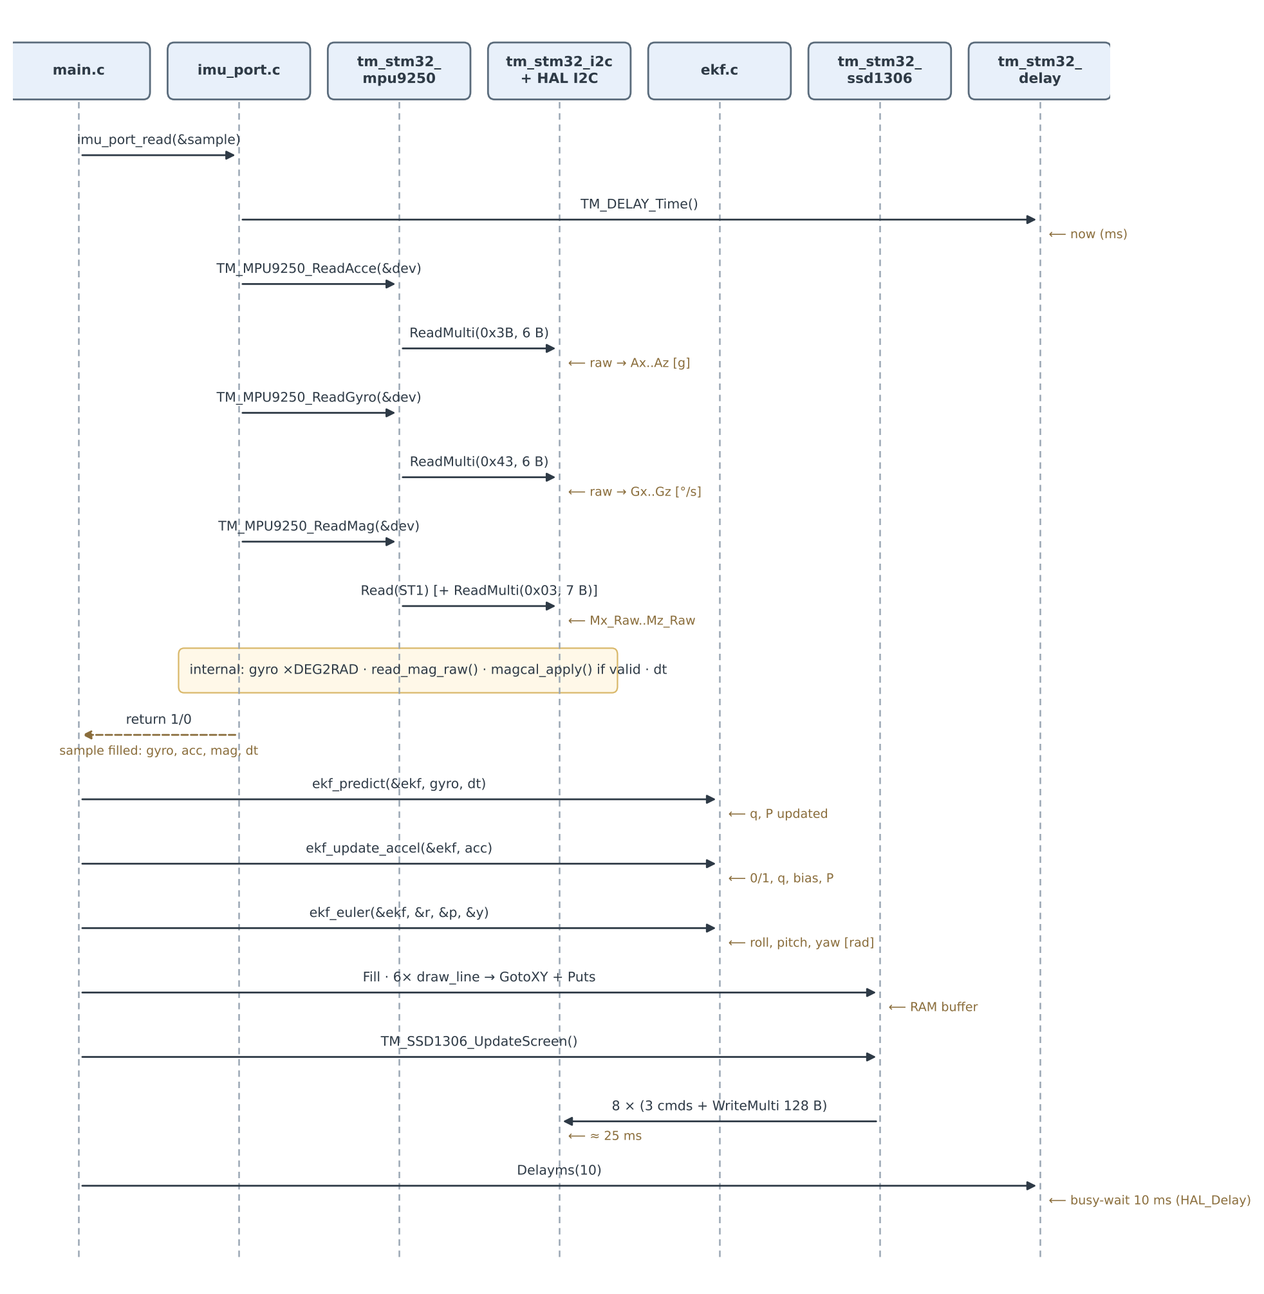
Figure 2. One iteration of the main loop

6.1 Sensor acquisition
main()
└─ imu_port_read(&sample) [L3]
├─ TM_DELAY_Time() → now (ms) [L1]
├─ TM_MPU9250_ReadAcce(&dev) [L2]
│ └─ TM_I2C_ReadMulti(I2C1, 0xD0, 0x3B, data, 6) [L1]
│ ├─ HAL_I2C_Master_Transmit(reg 0x3B) [L0]
│ └─ HAL_I2C_Master_Receive(6 bytes) [L0]
├─ TM_MPU9250_ReadGyro(&dev) same chain, register 0x43
├─ TM_MPU9250_ReadMag(&dev)
│ ├─ TM_I2C_Read(0x18, ST1) → data-ready bit
│ └─ TM_I2C_ReadMulti(0x18, 0x03, 7 bytes) only if ready
├─ read_mag_raw(raw) → dev.M*_Raw × MMult
├─ magcal_apply(&cal, raw, s->mag) only if cal.valid
└─ return (0 < dt < 0.5 s)

Data returned to main in sample: gyro = dev.G* × DEG2RAD (rad/s), acc = dev.A* (g), mag = calibrated vector or raw values, dt = (now − last_ms) × 0.001 s, mag_valid. If imu_port_read returns 0 the iteration skips the filter and the display.

6.2 Estimation
main()
├─ ekf_predict(&ekf, sample.gyro, sample.dt)
│ ├─ quat_mul(q, dq) → quat_normalize(q) attitude propagation
│ └─ Φ·P·Φᵀ + Q (two 6×6×6 products) covariance propagation
├─ ekf_update_accel(&ekf, sample.acc) returns 0 if |acc| ∉ [0.85, 1.15] g
│ └─ vector_update(f, acc, {0,0,1}, accel_noise)
│ ├─ normalize3 → quat_to_R → R_transpose_mul predicted gravity in body frame
│ ├─ H, P·Hᵀ, S = H·P·Hᵀ + R → inv3x3(S) 3×3 innovation covariance
│ ├─ K = P·Hᵀ·S⁻¹, dx = K·(z − h)
│ ├─ quat_mul(q, δq) → quat_normalize; bias += dx[3..5]
│ └─ P −= K·H·P, re-symmetrise
├─ ekf_update_mag(&ekf, sample.mag) compiled only if EKF_USE_MAG = 1
└─ ekf_euler(&ekf, &roll, &pitch, &yaw) → radians

The filter exchanges data only through its arguments and the ekf_t structure. Nothing in ekf.c reads a global or calls a library function apart from math.h, memset and memcpy.

6.3 Display
main()
├─ TM_SSD1306_Fill(BLACK) memset of the 1024-byte buffer
├─ draw_line(y, "R:", roll × RAD2DEG) × 6 lines (R, P, Y, bx, by, bz)
│ ├─ fmt() → putu() float → "R:-12.34" (no stdio)
│ ├─ TM_SSD1306_GotoXY(0, y)
│ └─ TM_SSD1306_Puts(buf, &TM_Font_7x10)
│ └─ Putc → DrawPixel 70 pixels per character, RAM only
└─ TM_SSD1306_UpdateScreen()
└─ for page 0..7:
├─ TM_I2C_Write ×3 (0xB0+page, 0x00, 0x10) → HAL_I2C_Master_Transmit
└─ TM_I2C_WriteMulti(0x40, 128 bytes) → HAL_I2C_Mem_Write

The bias lines read ekf.bias[] directly from the filter structure. This is the only place where main.c reaches inside a lower-layer structure instead of going through a function.

6.4 Loop pacing
Delayms(10) → HAL_Delay(10) busy-waits on HAL_GetTick(). The real loop period is the sum of all the steps above (section 11), not 10 ms.

7. Magnetometer calibration path
The calibration functions are implemented and exported by imu_port.h, but main.c does not call them yet. The intended sequence, and the full call chain it triggers, is:
imu_port_cal_begin()
└─ magcal_reset(&cal) zero ata[36], atb[6], count

repeat while the board is rotated in all orientations:
imu_port_cal_feed() → returns cal.count
├─ TM_MPU9250_ReadMag(&dev) → TM_I2C_Read / ReadMulti → HAL_I2C_*
├─ read_mag_raw(raw)
└─ magcal_add(&cal, raw[0], raw[1], raw[2]) fold one row into the 6×6 normal equations

imu_port_cal_finish() → 1 on success
└─ magcal_solve(&cal)
├─ copy double ata/atb → float A[36], v[6]; aug = identity
├─ determinant(A, aug, v, 6)
│ ├─ partial_pivot → ligne_swap → swap row swaps on A, aug and v
│ └─ matrix_elimination zero below each pivot
├─ inversion(A, aug, v, 6) back substitution → v = [B C P Q R D]
└─ centre (x0, y0, z0), K, offset[3], scale[3], valid = 1

Once cal.valid is 1, every following imu_port_read() routes the raw magnetometer vector through magcal_apply() and sets sample.mag_valid = 1. Only then should EKF_USE_MAG be set to 1 so that main calls ekf_update_mag().

8. Mathematical algorithms mapped to functions and layers
This chapter links each mathematical algorithm of the project to the C function that implements it, the software layer that function belongs to, and the call path that reaches it from main(). The mathematics follow the companion paper attitude_ekf_magcal_paper and its MATLAB/Octave ports in the repository MATLAB-Octave-verification-of-the-STM32-MPU9250-EKF-algorithms. Equation numbers (8.x) are local to this chapter.

8.1 Overview
# | Algorithm | C function(s) | File | Layer | Equations
A1 | Quaternion product and normalisation | quat_mul, quat_normalize | ekf.c | L3 Algorithms | 8.1–8.3
A2 | Quaternion → rotation matrix, nav → body | quat_to_R, R_transpose_mul | ekf.c | L3 Algorithms | 8.4–8.5
A3 | Gyro integration of the attitude | ekf_predict | ekf.c | L3 Algorithms | 8.6–8.7
A4 | Error-state model and covariance propagation | ekf_predict | ekf.c | L3 Algorithms | 8.8–8.11
A5 | Vector-observation measurement update | vector_update, normalize3, inv3x3 | ekf.c | L3 Algorithms | 8.12–8.17
A6 | Gravity correction with acceleration gate | ekf_update_accel | ekf.c | L3 Algorithms | 8.18
A7 | Magnetic heading correction | ekf_update_mag | ekf.c | L3 Algorithms | 8.19
A8 | Euler angle extraction | ekf_euler | ekf.c | L3 Algorithms | 8.20
A9 | Degrees and fixed-point display formatting | fmt, putu, draw_line | main.c | L4 Application | 8.21
A10 | Ellipsoid model and incremental least squares | magcal_add | magcal.c | L3 Algorithms | 8.22–8.26
A11 | Gaussian elimination with partial pivoting | determinant, partial_pivot, matrix_elimination, ligne_swap, swap | Gauss_elimination.c | L3 Algorithms | 8.27–8.29
A12 | Back substitution (inverse and solution) | inversion | Gauss_elimination.c | L3 Algorithms | 8.30–8.31
A13 | Hard-iron centre, soft-iron scale, validity checks | magcal_solve | magcal.c | L3 Algorithms | 8.32–8.35
A14 | Applying the calibration | magcal_apply | magcal.c | L3 Algorithms | 8.36
A15 | Sensor unit conversion and Δt gate | imu_port_read, read_mag_raw | imu_port.c | L3 Adaptation | 8.37–8.38
Table 2. Algorithms, functions and layers
All estimation and calibration mathematics live in layer L3 and use only math.h and string.h. The adaptation layer (imu_port.c) contributes only unit conversion, and the application layer (main.c) only the conversion to degrees for display. No mathematics runs in the TM libraries or the HAL beyond the drivers' fixed scale factors.

8.2 A1–A2: Quaternion attitude representation
The attitude is a unit Hamilton quaternion, scalar first, rotating vectors from the body frame to the navigation frame (ENU-like, gravity reads +1 g on Z when the board is level).
$$q={\left[\begin{matrix}w & x & y & z\end{matrix}\right]}^{T}, ∥q∥=1 \left(8.1\right)$$
$$r=a⊗b: \left[\begin{matrix}r_{0} \\ r_{1} \\ r_{2} \\ r_{3}\end{matrix}\right]=\left[\begin{matrix}a_{0}b_{0}−a_{1}b_{1}−a_{2}b_{2}−a_{3}b_{3} \\ a_{0}b_{1}+a_{1}b_{0}+a_{2}b_{3}−a_{3}b_{2} \\ a_{0}b_{2}−a_{1}b_{3}+a_{2}b_{0}+a_{3}b_{1} \\ a_{0}b_{3}+a_{1}b_{2}−a_{2}b_{1}+a_{3}b_{0}\end{matrix}\right] \left(8.2\right)$$
After every product the quaternion is renormalised, which removes the error of the first-order integration and floating-point drift:
$$q←\frac{q}{∥q∥} \text{if} ∥q∥>{10}^{−9}, \text{otherwise} q={\left[\begin{matrix}1 & 0 & 0 & 0\end{matrix}\right]}^{T} \left(8.3\right)$$
The equivalent rotation matrix, and the mapping of a navigation-frame reference into the body frame, are:
$$R\left(q\right)=\left[\begin{matrix}1−2\left(y^{2}+z^{2}\right) & 2\left(xy−wz\right) & 2\left(xz+wy\right) \\ 2\left(xy+wz\right) & 1−2\left(x^{2}+z^{2}\right) & 2\left(yz−wx\right) \\ 2\left(xz−wy\right) & 2\left(yz+wx\right) & 1−2\left(x^{2}+y^{2}\right)\end{matrix}\right] \left(8.4\right)$$
$$v_{b}=R{\left(q\right)}^{T} v_{nav} \left(8.5\right)$$
Implemented in | Layer | Call path from main()
quat_mul (8.2) | L3 ekf.c (static) | main → ekf_predict / ekf_update_accel / ekf_update_mag → vector_update → quat_mul
quat_normalize (8.3) | L3 ekf.c (static) | same callers as quat_mul, immediately after it
quat_to_R (8.4) | L3 ekf.c (static) | main → ekf_update_* → vector_update → quat_to_R
R_transpose_mul (8.5) | L3 ekf.c (static) | vector_update → R_transpose_mul

8.3 A3–A4: Time update (prediction)
Each gyro sample is first corrected by the current bias estimate, then integrated with a first-order (small-angle) quaternion increment:
$$ω=ω_{meas}−\hat{b} \left(8.6\right)$$
$$δq=\left[\begin{matrix}1 \\ 1/2ω_{x}Δt \\ 1/2ω_{y}Δt \\ 1/2ω_{z}Δt\end{matrix}\right], q_{k+1}=normalize\left(q_{k}⊗δq\right) \left(8.7\right)$$
The Kalman filter does not carry the quaternion itself. Its state is the 6-element error δx = [δθ, δb] (attitude error and bias error), whose linearised dynamics are:
$$δ\dot{θ}=−\left[ω×\right] δθ−δb, δ\dot{b}=0 \left(8.8\right)$$
$$\left[ω×\right]=\left[\begin{matrix}0 & −ω_{z} & ω_{y} \\ ω_{z} & 0 & −ω_{x} \\ −ω_{y} & ω_{x} & 0\end{matrix}\right] \left(8.9\right)$$
With the first-order discretisation Φ ≈ I + F·Δt, the state-transition matrix assembled in the array Phi[36] and the covariance propagation are:
$$Φ≈I_{6}+F Δt=\left[\begin{matrix}I_{3}−\left[ω×\right] Δt & −Δt I_{3} \\ 0_{3} & I_{3}\end{matrix}\right] \left(8.10\right)$$
$$P^{−}=Φ P Φ^{T}+Q, Q=diag\left(q_{g},q_{g},q_{g},q_{b},q_{b},q_{b}\right), q_{g}=σ_{gyro}^{2} Δt, q_{b}=σ_{bias}^{2} Δt \left(8.11\right)$$
Q converts the continuous noise densities cfg.gyro_noise and cfg.bias_noise into per-step variances (variance ≈ PSD × Δt). The bias is modelled as a random walk.
Implemented in | Layer | Call path from main()
ekf_predict (8.6–8.11) | L3 ekf.c (public) | main → ekf_predict(&ekf, sample.gyro, sample.dt); gyro and dt come from imu_port_read (8.37–8.38)

8.4 A5: Vector-observation measurement update
The accelerometer and magnetometer corrections share one implementation, vector_update. A known unit reference r_nav is rotated into the body frame with the current attitude (the predicted measurement) and compared with the normalised sensor reading:
$$v_{b}=R{\left(q\right)}^{T} r_{nav}, z=\frac{m}{∥m∥} \left(8.12\right)$$
A small attitude error rotates the predicted vector by δθ × v_b, so the measurement is linear in the error state with Jacobian:
$$H=\left[\begin{matrix}\left[v_{b}×\right] & 0_{3}\end{matrix}\right]∈R^{3×6} \left(8.13\right)$$
The innovation covariance is 3×3 and is inverted in closed form by inv3x3 (adjugate over determinant), which is cheaper than the general Gaussian elimination used for the 6×6 calibration system:
$$S=H P H^{T}+σ^{2} I_{3}, S^{−1}=\frac{adj\left(S\right)}{detS} \left(\text{rejected if }\left|detS\right|<{10}^{−12}\right) \left(8.14\right)$$
$$K=P H^{T} S^{−1}, y=z−v_{b}, δx=K y=\left[\begin{matrix}δθ \\ δb\end{matrix}\right] \left(8.15\right)$$
The correction is injected multiplicatively into the quaternion and additively into the bias. The error state is then implicitly reset to zero:
$$q←normalize\left(q⊗\left[\begin{matrix}1 \\ 1/2δθ\end{matrix}\right]\right), \hat{b}←\hat{b}+δb \left(8.16\right)$$
Because the gain is exact, the simple covariance update is used. Since P is symmetric, H·P is taken as (P·Hᵀ)ᵀ instead of being recomputed, and P is re-symmetrised to suppress single-precision round-off:
$$P←P−K{\left(P H^{T}\right)}^{T}, P←1/2\left(P+P^{T}\right) \left(8.17\right)$$
Implemented in | Layer | Call path from main()
vector_update (8.12–8.17) | L3 ekf.c (static) | main → ekf_update_accel or ekf_update_mag → vector_update
normalize3 (z in 8.12) | L3 ekf.c (static) | vector_update → normalize3; returns 0 if |m| < 10⁻⁶
inv3x3 (8.14) | L3 ekf.c (static) | vector_update → inv3x3; returns 0 if S is singular

8.5 A6–A7: Accelerometer and magnetometer corrections
The accelerometer observes gravity, which corrects roll and pitch only, since gravity does not change under rotation about the vertical axis. The update is skipped when the magnitude shows significant linear acceleration:
$$0.85 g≤∥a∥≤1.15 g, r_{nav}=g_{nav}={\left[\begin{matrix}0 & 0 & 1\end{matrix}\right]}^{T}, σ^{2}=σ_{acc}^{2} \left(8.18\right)$$
The magnetometer observes the local field direction, cfg.mag_ref, which makes yaw observable:
$$r_{nav}=r_{mag}, σ^{2}=σ_{mag}^{2} \left(8.19\right)$$
Implemented in | Layer | Call path from main()
ekf_update_accel (8.18) | L3 ekf.c (public) | main → ekf_update_accel(&ekf, sample.acc) → vector_update
ekf_update_mag (8.19) | L3 ekf.c (public) | main → ekf_update_mag(&ekf, sample.mag) → vector_update; compiled only when EKF_USE_MAG = 1

In the current firmware EKF_USE_MAG is 0, so only (8.18) runs. The component of the gyro bias along gravity is then unobservable, and yaw drifts at that rate (section 12).

8.6 A8–A9: Euler angles and display conversion
Roll, pitch and yaw (Z-Y-X convention) are extracted from the quaternion. The arcsin argument is clamped to guard against round-off near ±90° pitch:
$$\left[\begin{matrix}ϕ \\ θ \\ ψ\end{matrix}\right]=\left[\begin{matrix}atan2\left(2\left(wx+yz\right), 1−2\left(x^{2}+y^{2}\right)\right) \\ arcsin\left(clip\left(2\left(wy−zx\right), −1, 1\right)\right) \\ atan2\left(2\left(wz+xy\right), 1−2\left(y^{2}+z^{2}\right)\right)\end{matrix}\right] \left(8.20\right)$$
The application layer converts each angle α (and each bias) to degrees and formats it with two decimals in integer arithmetic, without stdio. Values ≥ 9999 and NaN are clamped to 9999:
$$N=\left\lfloor 100⋅\frac{180}{π} \left|α\right|+0.5\right\rfloor , \text{text}=sign\left(α\right) ⌊N/100⌋ . \left(N mod 100\right) \left(8.21\right)$$
Implemented in | Layer | Call path from main()
ekf_euler (8.20) | L3 ekf.c (public) | main → ekf_euler(&ekf, &roll, &pitch, &yaw)
fmt, putu, draw_line (8.21) | L4 main.c (static) | main → draw_line → fmt → putu, then TM_SSD1306_Puts (L2)

8.7 A10: Ellipsoid model and incremental least squares
Hard-iron effects shift the centre of the sphere traced by the raw magnetometer, and soft-iron effects stretch it into an ellipsoid. The calibration fits the axis-aligned ellipsoid (the x² coefficient is fixed to 1, since the equation is defined up to scale):
$$x^{2}+B y^{2}+C z^{2}+P x+Q y+R z+D=0 \left(8.22\right)$$
Samples are first divided by MAG_SCALE = 50, so that the fourth-order terms in the normal matrix stay of order one:
$$x=\frac{m_{x}}{50}, y=\frac{m_{y}}{50}, z=\frac{m_{z}}{50} \left(8.23\right)$$
Each sample adds one row of the linear least-squares problem in the six unknowns:
$$a_{i}=\left[\begin{matrix}y_{i}^{2} & z_{i}^{2} & x_{i} & y_{i} & z_{i} & 1\end{matrix}\right], w_{i}=−x_{i}^{2}, v={\left[\begin{matrix}B & C & P & Q & R & D\end{matrix}\right]}^{T} \left(8.24\right)$$
$$\min_{v} ∥Av−w∥^{2} ⇔ \left(A^{T}A\right)v=A^{T}w \left(8.25\right)$$
The design matrix A is never stored. Each sample is folded into the 6×6 normal matrix and 6×1 right-hand side, in double precision, so memory is constant whatever the number of samples:
$$A^{T}A←A^{T}A+a_{i}^{T}a_{i}, A^{T}w←A^{T}w+a_{i}^{T} w_{i} \left(8.26\right)$$
Implemented in | Layer | Call path from main()
magcal_add (8.22–8.26) | L3 magcal.c (public) | imu_port_cal_feed (L3 adaptation) → TM_MPU9250_ReadMag (L2), read_mag_raw, then magcal_add(&cal, ...)
magcal_reset | L3 magcal.c (public) | imu_port_init / imu_port_cal_begin → magcal_reset (clears ata, atb, count)

8.8 A11–A12: Gaussian elimination solver
magcal_solve converts the accumulators to float and solves the 6×6 system with Gauss_elimination.c. The matrix A is augmented with the identity B and the right-hand side t. For each pivot column p, partial pivoting brings the largest-magnitude candidate (row m) onto the diagonal, searching only downward so rows already eliminated are not disturbed:
$$m=arg\max_{j≥p} \left|a_{jp}\right|, \text{swap rows }p↔m \text{in} A, B, t, s←s+1 \left(8.27\right)$$
The column below the pivot is then eliminated, with the same row operation applied to B and t:
$$ℓ_{j}=\frac{a_{jp}}{a_{pp}}, {\text{row}}_{j}←{\text{row}}_{j}−ℓ_{j} {\text{row}}_{p}, j=p+1,…,n−1 \left(8.28\right)$$
The determinant is the product of the pivots, with the sign flipped once per row swap. It doubles as the singularity test:
$$detA={\left(−1\right)}^{s}\prod_{i=0}^{n−1}{u_{ii}}, \text{singular if }\left|u_{pp}\right|<{10}^{−6} \left(8.29\right)$$
inversion completes the back substitution from the last row upwards, normalising each pivot row and eliminating above it (Gauss–Jordan). This leaves the inverse in B and the solution v̂ in t:
$$i=n−1,…,0: {\text{row}}_{i}←\frac{{\text{row}}_{i}}{u_{ii}}, {\text{row}}_{k}←{\text{row}}_{k}−u_{ki} {\text{row}}_{i} \left(k<i\right) ⇒ B=A^{−1}, t=A^{−1}b \left(8.30\right)$$
$$\hat{v}={\left(A^{T}A\right)}^{−1}A^{T}w={\left[\begin{matrix}B & C & P & Q & R & D\end{matrix}\right]}^{T} \left(8.31\right)$$
Implemented in | Layer | Call path from main()
determinant (8.29) | L3 Gauss_elimination.c | magcal_solve → determinant(A, aug, v, 6)
partial_pivot (8.27) | L3 Gauss_elimination.c | determinant → partial_pivot → ligne_swap → swap
matrix_elimination (8.28) | L3 Gauss_elimination.c | determinant → matrix_elimination
inversion (8.30–8.31) | L3 Gauss_elimination.c | magcal_solve → inversion(A, aug, v, 6), only if the determinant is not 0

8.9 A13–A14: From ellipsoid coefficients to calibration
Completing the square on each axis gives the centre (the hard-iron offset) and the constant K:
$$x_{0}=−\frac{P}{2}, y_{0}=−\frac{Q}{2B}, z_{0}=−\frac{R}{2C}, K=x_{0}^{2}+B y_{0}^{2}+C z_{0}^{2}−D \left(8.32\right)$$
$${\left(x−x_{0}\right)}^{2}+B {\left(y−y_{0}\right)}^{2}+C {\left(z−z_{0}\right)}^{2}=K \left(8.33\right)$$
The fit is rejected if a quadratic coefficient is not positive (the surface is a hyperboloid, meaning the samples did not cover enough orientations) or if K is not positive (a degenerate fit):
$$B>{10}^{−6}, C>{10}^{−6}, K>{10}^{−9} \left(8.34\right)$$
The semi-axis lengths give the soft-iron scale factors that map the ellipsoid onto the unit sphere. Both results are scaled back to raw units by MAG_SCALE:
$$a_{x}=\sqrt{K}, a_{y}=\sqrt{K/B}, a_{z}=\sqrt{K/C}, \text{offset}=50 \left(x_{0}, y_{0}, z_{0}\right), {\text{scale}}_{i}=\frac{1}{50 a_{i}} \left(8.35\right)$$
Every later raw sample is corrected by the affine map:
$${\text{out}}_{i}=\left({\text{raw}}_{i}−{\text{offset}}_{i}\right)⋅{\text{scale}}_{i}, i∈\{x,y,z\} \left(8.36\right)$$
Implemented in | Layer | Call path from main()
magcal_solve (8.31–8.35) | L3 magcal.c (public) | imu_port_cal_finish (L3 adaptation) → magcal_solve → determinant, inversion, sqrtf
magcal_apply (8.36) | L3 magcal.c (public) | main → imu_port_read → magcal_apply(&cal, raw, s->mag) when cal.valid

8.10 A15: Unit conversion in the adaptation layer
imu_port.c contains no estimation mathematics. It fixes the units the algorithms expect, combining the driver's scale factors (L2) with its own conversions:
$$ω=\frac{π}{180}⋅\frac{250}{32768} g_{raw}, a=\frac{2}{32768} a_{raw}, m=\frac{10⋅4912}{32768} m_{raw} \left(8.37\right)$$
$$Δt={10}^{−3} \left(t_{k}−t_{k−1}\right), \text{sample valid}⇔0<Δt<0.5 \text{s} \left(8.38\right)$$
Implemented in | Layer | Call path from main()
TM_MPU9250_ReadAcce/Gyro (scale factors) | L2 tm_stm32_mpu9250 | imu_port_read → driver; AMult = 2/32768, GMult = 250/32768
imu_port_read (8.37–8.38) | L3 imu_port.c | main → imu_port_read; gyro × π/180, Δt from TM_DELAY_Time()
read_mag_raw (m in 8.37) | L3 imu_port.c (static) | imu_port_read / imu_port_cal_feed → read_mag_raw; MMult = 10·4912/32768

8.11 Numerical safeguards
Safeguard | Where | Layer | Protects against
Quaternion renormalisation after every product | quat_normalize in ekf_predict and vector_update | L3 | norm drift from first-order integration and rounding
Multiplicative error state (3 angles, not 4 quaternion components) | ekf_t design, vector_update | L3 | singular covariance from the unit-norm constraint
Covariance re-symmetrisation | end of vector_update | L3 | asymmetry accumulating in single precision
Closed-form 3×3 inverse with determinant test | inv3x3 | L3 | cost of general elimination; division by ~0
Acceleration gate 0.85–1.15 g | ekf_update_accel | L3 | linear acceleration corrupting roll and pitch
arcsin argument clamped to [−1, 1] | ekf_euler | L3 | domain error near ±90° pitch
Pre-scaling by 50 and double-precision accumulation | magcal_add | L3 | loss of precision in fourth-order sums
Partial pivoting and pivot test 10⁻⁶ | partial_pivot, determinant | L3 | growth of rounding error; singular normal matrix
B, C, K positivity checks | magcal_solve | L3 | hyperboloid or degenerate fits from poor coverage
Δt gate 0 < Δt < 0.5 s | imu_port_read | L3 adaptation | first sample after init and stalls
NaN/inf clamp to 9999 | fmt | L4 | garbage on the display

8.12 Verification in MATLAB/Octave
The repository MATLAB-Octave-verification-of-the-STM32-MPU9250-EKF-algorithms ports the C functions line by line into MATLAB/Octave and tests them against synthetic ground truth, without STM32 hardware. Table 3 maps the C functions to their MATLAB counterparts.
C function (layer) | MATLAB/Octave function | Script
quat_mul, quat_normalize, quat_to_R (L3) | quat_mul, quat_normalize, quat_to_R | mekf_verification.m
first-order integration in ekf_predict (L3) | quat_integrate | mekf_verification.m
ekf_predict (L3) | mekf_predict | mekf_verification.m
vector_update via ekf_update_accel / ekf_update_mag (L3) | mekf_update (with the 0.85–1.15 g gate) | mekf_verification.m
ekf_euler (L3) | euler_from_q | mekf_verification.m
determinant + inversion (L3) | gauss_jordan_solve | magcal_verification.m, part A
magcal_add / magcal_solve / magcal_apply (L3) | inline pipeline | magcal_verification.m, parts B and C
Table 3. C functions and their MATLAB/Octave ports
Results reported in the verification repository:
- MEKF: starting from a 30° attitude error and zero bias, the filter reaches 0.65° RMS steady-state attitude error, and the gyro bias is recovered to within 0.0012 rad/s.
- Gauss–Jordan solver (part A): agrees with MATLAB's built-in solver on 200 random 6×6 symmetric positive-definite systems, with relative error around 10⁻¹⁴.
- Ellipsoid fit (part B): on about 1500 samples spread over the full sphere, the offset is recovered within 0.01 raw units and the scale within 0.03 %, and the calibrated vectors have norm 1.0000 ± 0.003.
- Degenerate sweep (part C): samples confined to a 10° cone are correctly rejected as singular or hyperboloid.
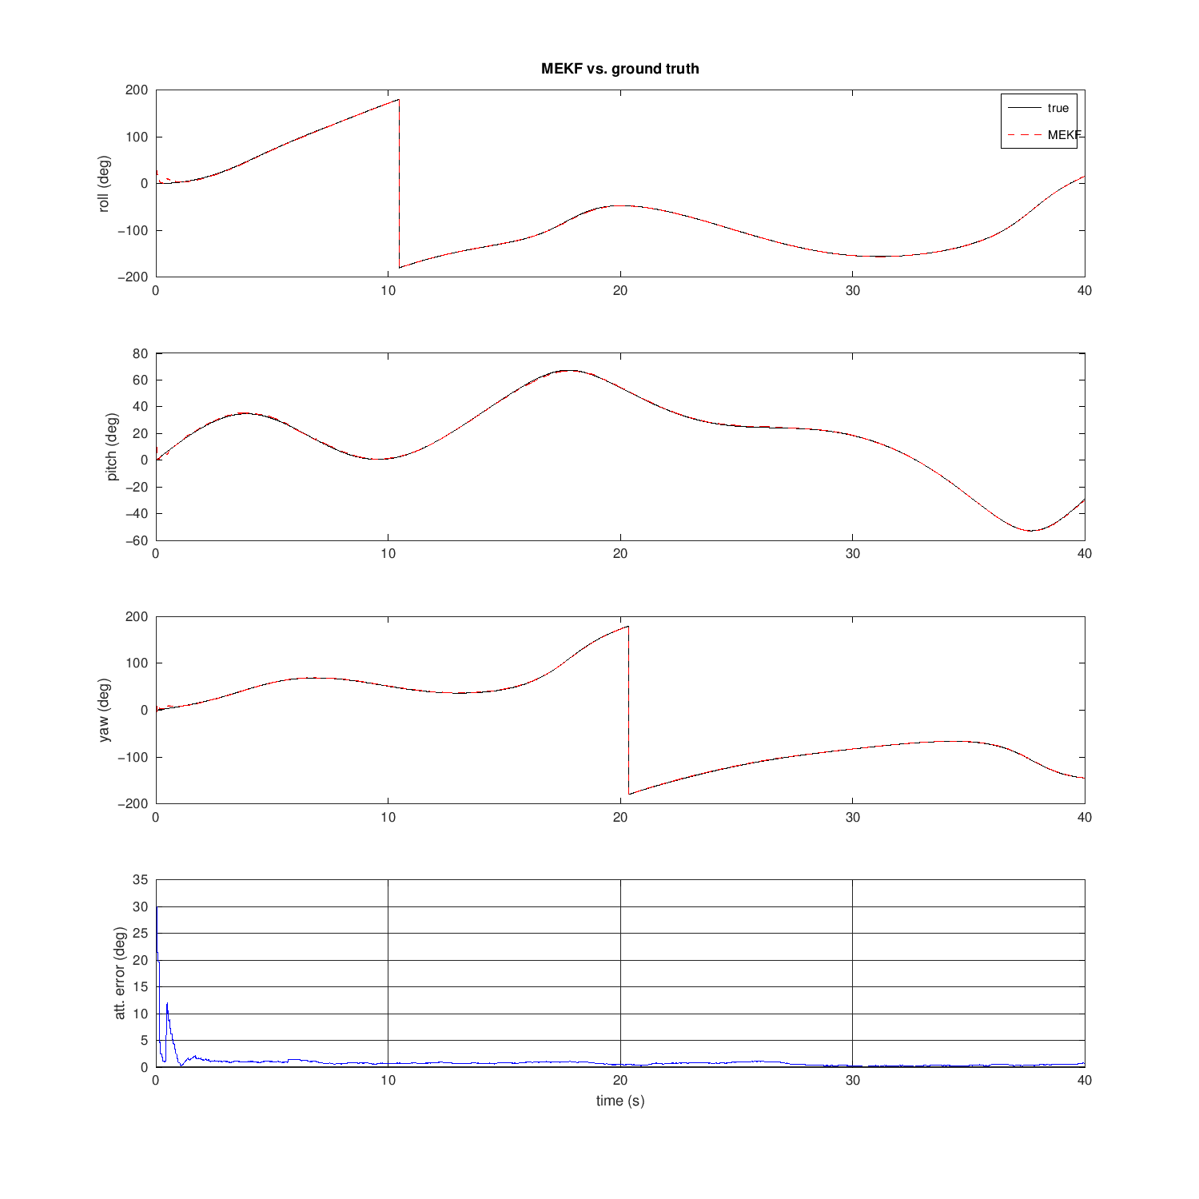
Figure 3. MEKF port vs ground truth: roll, pitch, yaw and total attitude error (from mekf_verification.m)
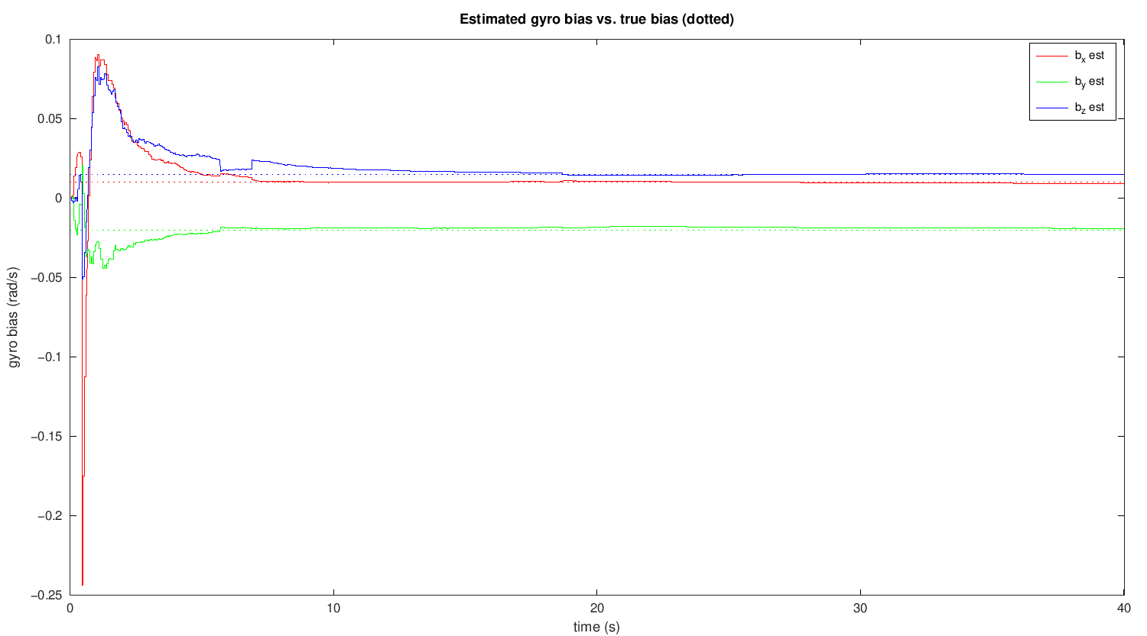
Figure 4. Gyro bias estimates converging to the true values, shown dotted (from mekf_verification.m)
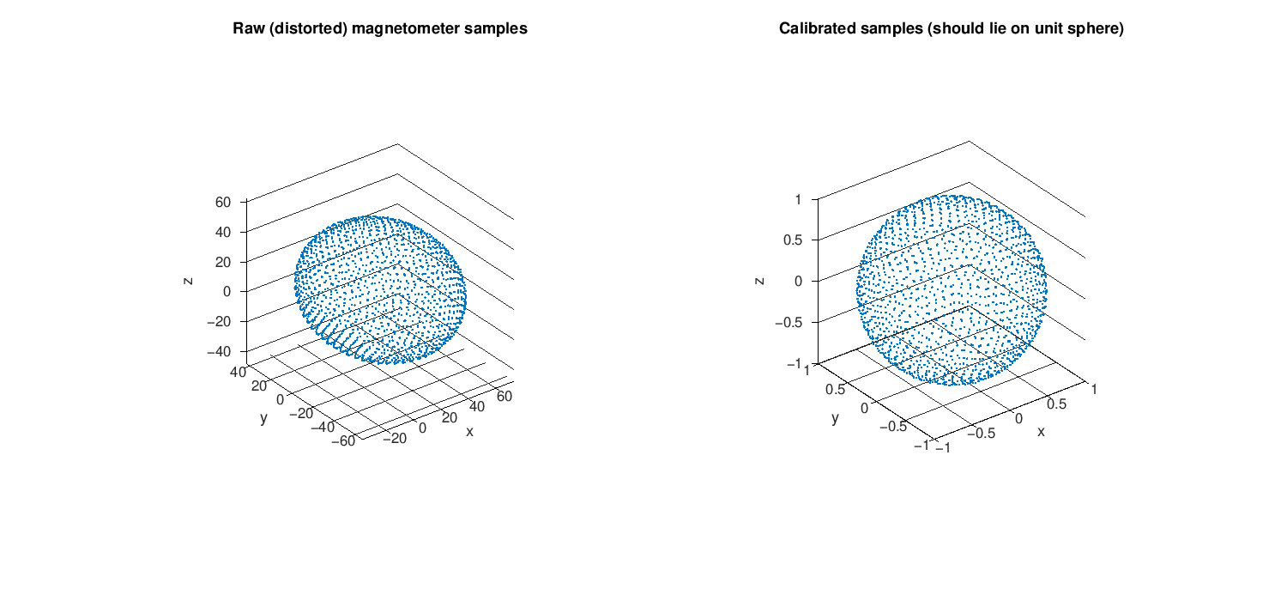
Figure 5. Raw distorted magnetometer samples (left) and the same samples after calibration (right) (from magcal_verification.m)

Test conditions compared with the firmware
The MATLAB test confirms the mathematics. Its conditions are more favourable than the current firmware configuration, which explains why it shows full bias convergence and no yaw drift:
Parameter | MATLAB verification | Firmware as built
Gyro rate / prediction step | 200 Hz (Δt = 5 ms) | ≈ 27 Hz (Δt ≈ 37 ms, limited by the display)
Correction rate | accel + mag every 10 steps (20 Hz) | accel every step; mag disabled
Magnetometer update (8.19) | enabled, ideal calibrated field, mag_ref = [1, 0, 0.6]/‖·‖ matches the simulated field | EKF_USE_MAG = 0; mag_ref = [1, 0, 0] placeholder; AK8963 axes not remapped
Bias observability | all three axes (gravity + field) | only the components perpendicular to gravity
Noise settings | gyro_noise 0.003, accel_noise 0.02, mag_noise 0.02 | gyro_noise 0.01, accel_noise 0.05, mag_noise 0.10

A separate host-side test of the C code (section 12) adds one case the MATLAB suite does not cover: a calibration sweep rotated only in the horizontal plane is accepted by magcal_solve (it passes 8.34) while the Z semi-axis comes out about 19 % too short. The checks in (8.34) catch a sweep confined to a narrow cone, but not one confined to a plane.

9. Time base and interrupt path
The SysTick interrupt is the only asynchronous data path. The TM delay library overrides two weak HAL functions so that the HAL and the TM libraries share one counter:
SysTick (1 ms) → SysTick_Handler() [stm32fxxx_it.c]
└─ HAL_IncTick() overridden in tm_stm32_delay.c → TM_Time++
HAL_GetTick() overridden in tm_stm32_delay.c → returns TM_Time
TM_DELAY_Time() macro → TM_Time

- imu_port_read() reads TM_Time to compute dt with a resolution of 1 ms. The rounding errors cancel over successive samples, so the integrated time stays exact.
- HAL_Delay(), and every HAL I2C timeout, are measured against the same counter.

10. Unit conversions along the data path
Stage | Layer | Variable | Type / unit | Conversion
Register read | L0/L1 | data[6] | uint8_t, big-endian (MPU) / little-endian (AK8963) | bytes from the bus
Driver raw | L2 | Ax_Raw, Gx_Raw, Mx_Raw | int16_t counts | (hi << 8) | lo
Driver scaled | L2 | Ax..Az | float g | × AMult = 2/32768 (±2 g range)
Driver scaled | L2 | Gx..Gz | float °/s | × GMult = 250/32768 (±250 °/s range)
Port | L3 | sample.gyro | float rad/s | × DEG2RAD = 0.017453292
Port | L3 | sample.acc | float g | unchanged
Port | L3 | raw magnetometer | float, 0.1 µT | Mx_Raw × MMult = 10 × 4912/32768 (≈ 1.5 per count)
Port | L3 | sample.mag | float, ≈ unit length | (raw − offset) × scale when calibrated
Port | L3 | sample.dt | float s | (now − last_ms) × 0.001
Filter | L3 | q, bias | float, rad/s for bias | measurements normalised internally
Filter output | L3 | roll, pitch, yaw | float rad | ekf_euler()
Application | L4 | displayed value | float °, then fixed point ×100 | × RAD2DEG = 57.29578, then fmt()
Display | L2 | frame buffer | bits, 1 per pixel | TM_Font_7x10 glyphs

11. Time spent in each layer
Estimated from the bus protocol at 400 kHz (22.5 µs per byte including ACK) and from the operation count of the filter at 100 MHz with -O1. These are calculated figures, not measurements on hardware.
Step | Layers involved | Time per loop | Share
TM_SSD1306_UpdateScreen() | L2 → L1 → L0 → I2C | ≈ 25 ms | ≈ 68 %
Delayms(10) | L1 → L0 | 10 ms | ≈ 27 %
Text rendering (Fill, Puts) | L2, RAM only | ≈ 0.5–1 ms | ≈ 2 %
imu_port_read() (3 sensor reads) | L3 → L2 → L1 → L0 → I2C | ≈ 0.5–0.7 ms | ≈ 2 %
ekf_predict + ekf_update_accel + ekf_euler | L3 only | ≈ 70 µs | < 0.2 %
Total loop period |  | ≈ 37 ms (≈ 27 Hz) | 100 %

The display transfer through the I2C stack sets the filter rate. The estimation layer itself uses a negligible share of the CPU.

12. Observations at layer boundaries
Boundary | Observation | Consequence | Suggested change
L2 → L3 (MPU9250 driver) | TM_MPU9250_ReadAcce/Gyro/Mag are declared to return TM_MPU9250_Result_t but have no return statement | imu_port cannot detect a failed read; stale values look valid | Add return statements and propagate status in imu_port_read
L1 → L2 (I2C) | TM_I2C_* error results are ignored by the drivers | a bus fault can block up to 1 s per call, silently | Check results; add bus recovery
L2 → L3 (magnetometer) | ReadMag writes only M*_Raw; Mx/My/Mz stay empty | worked around by read_mag_raw() in imu_port | Fix the driver, or keep the workaround documented
L3 (imu_port) | AK8963 axes are not aligned with the accel/gyro axes, and no remapping is done | a wrong heading correction once EKF_USE_MAG = 1 | Remap mag X↔Y and negate Z in imu_port_read
L3 → L4 | imu_sample_t has no flag telling whether the magnetometer sample is new (AK8963 at 8 Hz) | the same reading would be fused several times | Add a mag_new flag
L4 → L3 | main.c reads ekf.bias[] directly | couples the application to the filter's internal layout | Add ekf_bias() accessor
L4 → L2 (display) | A full-screen update every loop | limits the filter to ≈ 27 Hz | Refresh at 5–10 Hz, or use tm_stm32_i2c_dma
L3 (ekf.c) with EKF_USE_MAG = 0 | Only gravity is observed (8.18); the bias component along gravity is unobservable | yaw drifts; host test: ≈ 28° in 60 s with 0.5 °/s bias along g. The displayed bx, by, bz absorb part of it | Enable (8.19) once the magnetometer is calibrated, remapped and has a measured mag_ref
L3 (magcal.c) | Checks (8.34) do not test how well the sweep covers each axis | host test: horizontal-only sweep accepted with Z semi-axis ≈ 19 % short | Reject fits whose sample spread on any axis is too small
L1 (I2C1 sharing) | TM_MPU9250_Init calls TM_I2C_Init again on the bus the display already set up | harmless today; breaks if the pin packs differ | Keep both on TM_I2C_PinsPack_1 in defines.h

