Digital Signal Processing from Zero
A beginner's course built around the TP DSP lab: sampling, quantisation, FIR and IIR filters, and how a DSP runs them

This course explains, from the very beginning, every idea used in the lab report Digital filtering on the TMS320C6000. No previous knowledge is assumed: if you know what a graph is and how to multiply two numbers, you can follow it.
How to read it. The chapters are in the order you need them: each one only uses ideas explained before it. Read them in order the first time. Every chapter has:
- plain explanations, then the precise definition and formula;
- analogies from everyday life;
- worked examples with real numbers you can check with a calculator;
- connection boxes that tell you how the idea links to the other chapters;
- in the lab boxes that show where the idea appears in the programs and in the report;
- a few check yourself questions (answers at the end).
A glossary at the end gives a one-line definition of every technical word, with the chapter where it is explained.

Contents

(If the table of contents looks empty, right-click it in Word and choose Update Field.)

The map of the course
Everything in this course is connected. The map below shows the order of the chapters and which ideas feed into which. Come back to it whenever you feel lost.
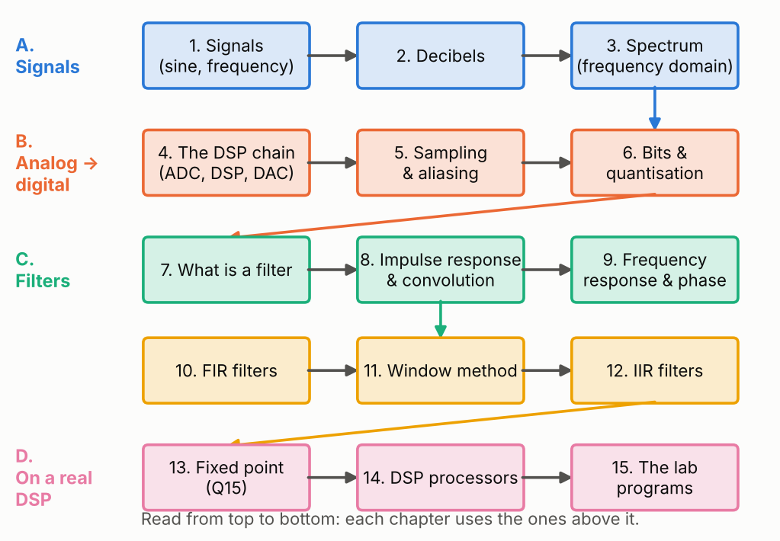
Figure 1. Map of the course. Part A gives the language (signals, decibels, spectrum); part B explains how sound becomes numbers; part C is about filters; part D is about running filters on a real DSP.

1. Signals and sine waves
In this chapter: what a signal is, analog and digital signals, the sine wave and its amplitude, period, frequency and phase.

1.1 What is a signal?
A signal is any quantity that changes over time and carries information. When you speak, the air pressure in front of your mouth goes up and down very quickly: that pressure variation is a sound signal. A microphone turns it into an electrical voltage that goes up and down in the same way. A loudspeaker does the opposite.
We draw a signal as a graph: time on the horizontal axis, the value (pressure, voltage, or later a number) on the vertical axis. We write it x(t): "the value of x at time t".

1.2 Analog and digital
- An analog signal exists at every instant and can take any value: the voltage from a microphone is analog.
- A digital signal is a list of numbers: one number every fixed interval of time, each number written with a fixed number of bits. A computer or a DSP can only work with digital signals.
Turning analog into digital needs two steps, sampling (chapter 5: choosing the instants) and quantisation (chapter 6: writing each value with a limited number of bits).

1.3 The sine wave: the atom of all signals
The simplest signal is the sine wave (a pure tone, like a tuning fork). It is described by three numbers:
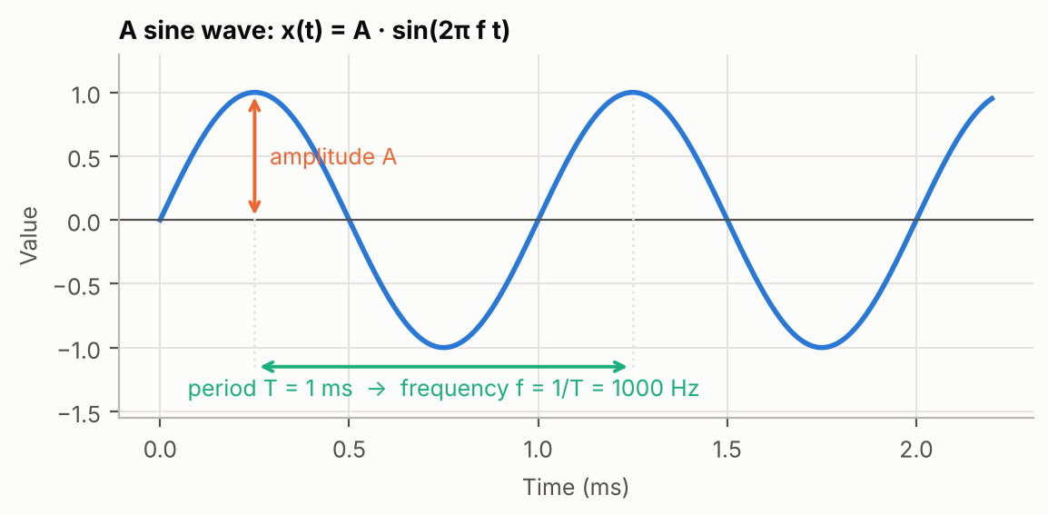
Figure 2. Anatomy of a sine wave. The amplitude is the height of the peaks, the period is the duration of one cycle, and the frequency is the number of cycles per second.
- the amplitude A: the height of the peaks (how loud);
- the period T: the time of one complete cycle, in seconds (s) or milliseconds (ms, 1 ms = 0.001 s);
- the frequency f = 1/T: the number of cycles per second, in hertz (Hz). 1 kHz (kilohertz) = 1000 Hz.
x(t) = A · sin(2π f t + φ) (1.1)
The factor 2π is there because a full cycle of the sine function is an angle of 2π radians (one full turn of a circle). The angle φ (phi) is the phase: it says where the sine is in its cycle at t = 0. Two sines with the same frequency but different phases are the same wave shifted in time. You will often see ω = 2πf, the angular frequency, in radians per second.
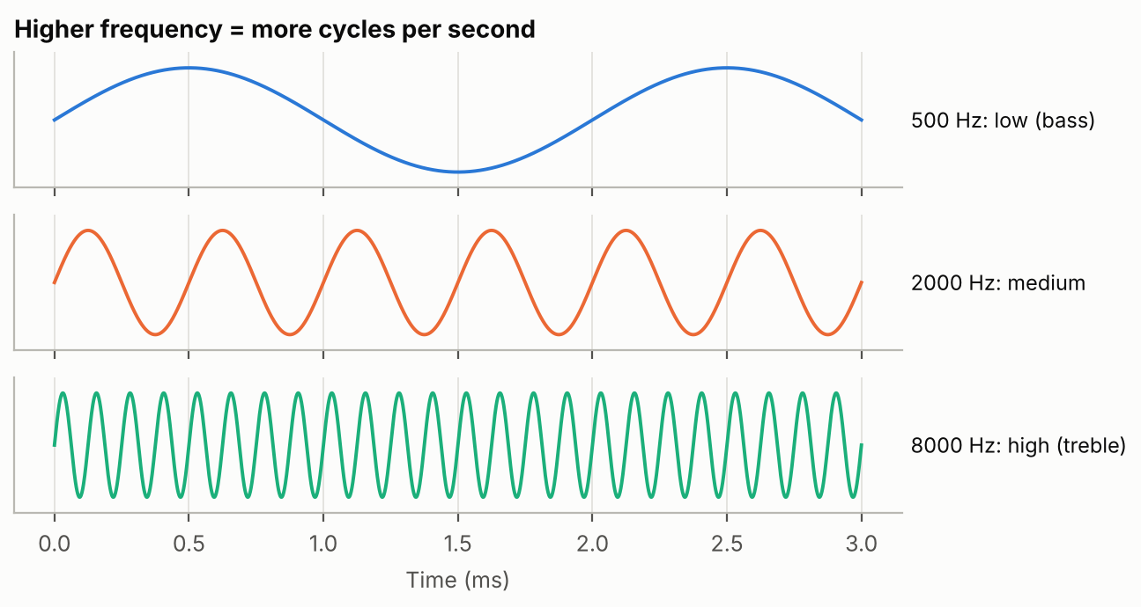
Figure 3. Three sine waves of the same amplitude. The higher the frequency, the more cycles fit in the same time.
Low frequencies sound deep (bass), high frequencies sound sharp (treble). Human hearing goes roughly from 20 Hz to 20 kHz. The lab uses tones such as 500 Hz, 1 kHz and 3 kHz, and filters with cut-offs of 1200 Hz and 2000 Hz.
KEY IDEA Frequency and period are two ways of saying the same thing: f = 1/T. A 1000 Hz sine has a period of 1 ms; a 2000 Hz sine has a period of 0.5 ms.
CONNECTION Chapter 3 shows that every signal is a sum of sine waves. That is why the whole course keeps talking about sines: if you know what a system does to each sine, you know what it does to any signal.

Check yourself
1.1 What is the period of a 2 kHz sine?
1.2 A sine repeats every 0.25 ms. What is its frequency?
1.3 Two sines have the same frequency and amplitude but one is shifted in time. Which parameter differs?

2. Decibels
In this chapter: why engineers measure gains in decibels, the formula, the values to remember (+6, −3, −6, −20, −40 dB) and why decibels add up when filters are chained.

2.1 Gain: how much a system amplifies or reduces
When a signal goes through a system (an amplifier, a filter), its amplitude can change. The gain is the ratio:
gain = output amplitude / input amplitude (2.1)
A gain of 2 doubles the amplitude, 0.5 halves it, 0.01 reduces it 100 times. Filters have gains that range from 1 down to 0.0001 or less, which makes linear numbers hard to read and to plot. Decibels solve this.

2.2 The decibel (dB)
gain in dB = 20 · log10(amplitude ratio) (2.2)
log10 is the base-10 logarithm: log10(10) = 1, log10(100) = 2, log10(0.1) = −1. It counts "how many times 10". Multiplying by 20 gives decibels for amplitudes. (For powers, which are proportional to the square of the amplitude, the formula is 10·log10; both give the same number of dB for the same signal.)
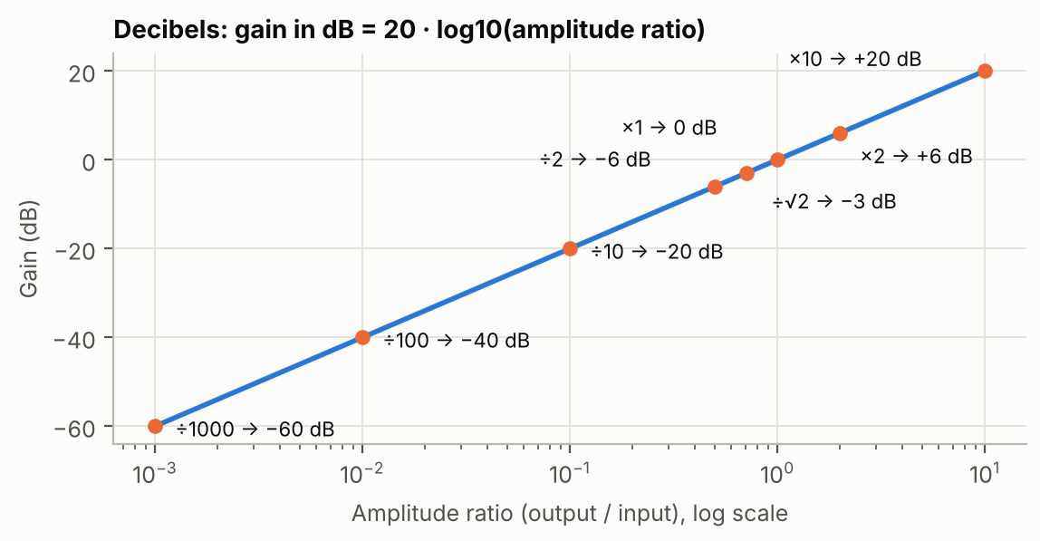
Figure 4. From amplitude ratio to decibels. Every ×10 adds 20 dB; every ×2 adds about 6 dB.
Amplitude ratio | In dB | What to remember
× 10 | +20 dB | ten times bigger
× 2 | +6 dB | double
× 1 | 0 dB | unchanged
÷ √2 = × 0.707 | −3 dB | half the power: the usual definition of a filter's cutoff
÷ 2 = × 0.5 | −6 dB | half the amplitude
÷ 10 | −20 dB
÷ 100 | −40 dB
÷ 1000 | −60 dB

A negative number of dB means the signal is reduced: we also say it is attenuated. "40 dB of attenuation" means the amplitude is divided by 100.

2.3 Why decibels are so convenient
Because log(a × b) = log(a) + log(b), gains multiply but decibels add. When signals go through several systems one after the other (a cascade), you just add their dB.
WORKED EXAMPLE Two filters each have a gain of 0.5 at 3 kHz. In cascade the total gain is 0.5 × 0.5 = 0.25.
In decibels: −6 dB + −6 dB = −12 dB, and indeed 20·log10(0.25) = −12.04 dB.
Engineers also use dB full scale (dBFS): the level of a signal relative to the largest value the system can represent (32767 for 16-bit numbers). 0 dBFS is the maximum; −6 dBFS is half of it.
CONNECTION Decibels are used everywhere next: the signal-to-noise ratio of quantisation (chapter 6), the cutoff frequency at −3 dB (chapter 7), the frequency response plots (chapter 9), and the stopband attenuation of windows (chapter 11).

Check yourself
2.1 What is a gain of 0.01 in dB?
2.2 A filter has a gain of −20 dB. By how much is the amplitude multiplied?
2.3 Three filter sections are each at −3 dB at 2 kHz. What is the total gain there?

3. The spectrum: looking at frequencies
In this chapter: the idea of Fourier (every signal is a sum of sines), the spectrum, the FFT and harmonics.

3.1 Every signal is a sum of sine waves
In 1807 Joseph Fourier showed that any signal can be built by adding sine waves of different frequencies, amplitudes and phases. Even a square wave, which has sharp corners, is a sum of sines:
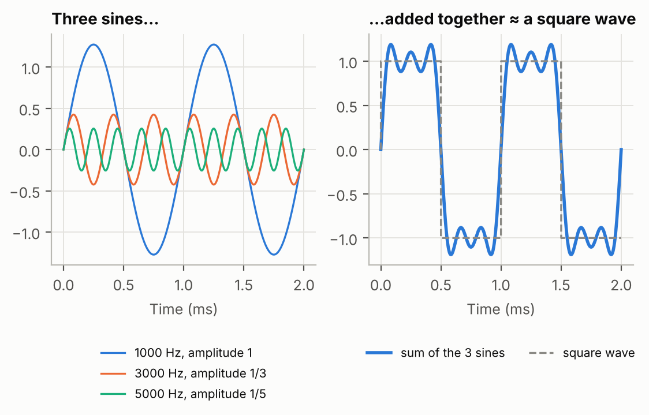
Figure 5. A 1 kHz square wave is (almost) the sum of sines at 1, 3, 5 kHz… with amplitudes 1, 1/3, 1/5… Adding more of them makes the corners sharper.
The extra sines at 3, 5, 7 kHz… are called harmonics: multiples of the basic (fundamental) frequency. The sharper the corners of a signal, the more high-frequency harmonics it contains.

3.2 Time domain and frequency domain
A signal can be described in two equivalent ways:
- in the time domain: its value at each instant, x(t). This is what an oscilloscope shows;
- in the frequency domain: which sine waves it contains and how strong each one is. This is the spectrum X(f).
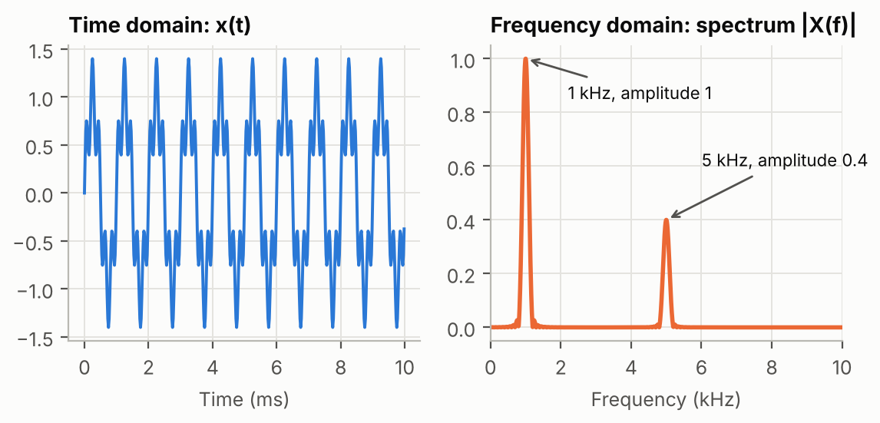
Figure 6. The same signal seen in time (left) and in frequency (right). In time it looks complicated; its spectrum shows immediately that it contains a 1 kHz sine and a weaker 5 kHz sine.
ANALOGY A piece of music written as a recording is the time domain. The same piece written as sheet music (which notes, how loud) is the frequency domain. The bars of an audio equalizer are a live spectrum.

3.3 The FFT
For digital signals the spectrum is computed with the DFT (Discrete Fourier Transform), and almost always with a fast algorithm for it called the FFT (Fast Fourier Transform). The FFT of N samples gives the strength of N/2 frequencies equally spaced between 0 and Fs/2 (Fs is the sampling frequency, chapter 5). The spacing between them, the frequency resolution, is Fs/N.
A pure sine gives one sharp peak in the spectrum only if a whole number of its periods fits into the analysed samples. Otherwise its energy spreads to neighbouring frequencies: this is called spectral leakage, and it explains the "floor" visible in some plots of the report.
KEY IDEA A very short signal (a single impulse) contains all frequencies with the same strength: its spectrum is flat. That is why we feed an impulse into a filter to see how it treats every frequency at once (chapters 8 and 9).
CONNECTION The frequency domain is the natural way to describe filters: a low-pass filter is simply a system that keeps the left part of the spectrum (chapter 7).

Check yourself
3.1 What does the spectrum of a pure 3 kHz sine look like?
3.2 A 1 kHz square wave contains which frequencies?
3.3 An FFT of 512 samples at 48 kHz: what is its frequency resolution?

4. The digital signal processing chain
In this chapter: the path from microphone to speaker, the codec (ADC and DAC), what a DSP is, real time, and the DSK board.
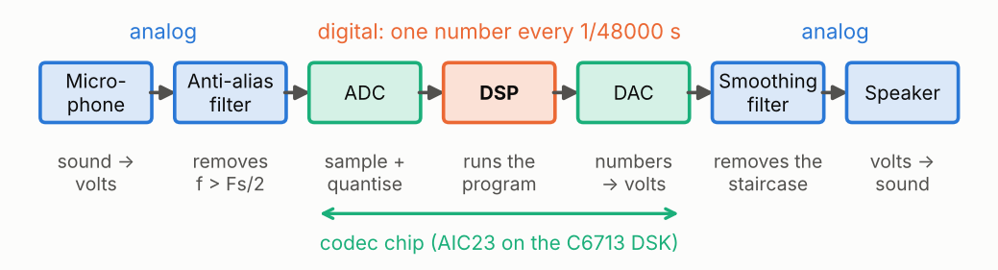
Figure 7. The complete chain. Everything between the ADC and the DAC is numbers; the lab programs live in the DSP block.

4.1 The blocks
- Microphone: turns sound into a voltage.
- Anti-aliasing filter: an analog low-pass filter that removes frequencies the sampler cannot handle (chapter 5 explains why).
- ADC (Analog-to-Digital Converter): measures the voltage at regular instants (sampling) and writes each measure as a number (quantisation).
- DSP (Digital Signal Processor): a processor specialised in computing on streams of numbers; it runs the lab program.
- DAC (Digital-to-Analog Converter): turns each output number back into a voltage.
- Smoothing (reconstruction) filter: removes the small steps the DAC produces.
The ADC and DAC of both channels (left and right, for stereo) are in one chip called a codec (coder-decoder). On the C6713 board it is the AIC23; on the C5416 board it was the PCM3002. The lab programs talk to it with functions such as DSK6713_AIC23_read() and DSK6713_AIC23_write().

4.2 Real time
At Fs = 48 000 samples per second, a new sample arrives every 1/48000 s = 20.8 µs (microseconds). Real time means the DSP must finish all its work on one sample before the next one arrives, forever. If it is late even once, a sample is lost and you hear a click.
WORKED EXAMPLE The C6713 runs at 225 MHz: 225 million clock cycles per second.
Cycles available per sample = 225 000 000 / 48 000 = 4687 cycles. Every instruction of the program must fit in this budget (chapter 14).

4.3 The board and the tools
- DSK (DSP Starter Kit): the teaching board with the DSP, the codec, audio jacks, 4 DIP switches and 4 LEDs.
- DIP switches: 4 small on/off switches. Read together they give a number from 0 to 15 (4 bits), which the lab programs use to choose the processing.
- LEDs: used as a bargraph showing the output level.
- CCS (Code Composer Studio): the program used to write, compile, load and debug code on the DSP.
- BSL (Board Support Library): ready-made functions to use the codec, switches and LEDs.
IN THE LAB Every lab program has the same loop: read the left sample, write the left output, read the right sample, write the right output, read the switches, compute the next outputs. This loop runs 48 000 times per second.

Check yourself
4.1 How much time separates two samples at 48 kHz?
4.2 What two converters does a codec contain?
4.3 With 4 DIP switches, how many different settings are possible?

5. Sampling and aliasing
In this chapter: sampling period and frequency, the Nyquist–Shannon theorem, aliasing and frequency folding, anti-aliasing and reconstruction, and the sampling_rate program.

5.1 Sampling
Sampling means measuring the analog signal at regular instants. The time between two measures is the sampling period Te (in s); the number of measures per second is the sampling frequency Fs = 1/Te (in Hz, or samples per second).
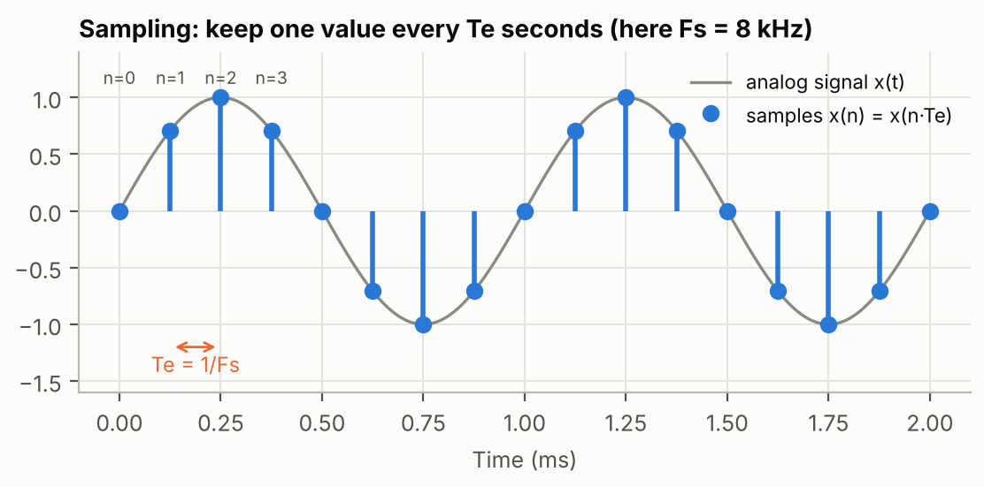
Figure 8. Sampling a 1 kHz sine at Fs = 8 kHz: one value every Te = 125 µs. The dots are all the DSP will ever know about the signal.
Each measure is called a sample. We number them with an integer n = 0, 1, 2… and write x(n) for the n-th sample: x(n) = x(n·Te). In the digital world, time is counted in samples, not in seconds.

5.2 How fast must we sample? The Nyquist–Shannon theorem
Fs > 2 · fmax equivalently fmax < Fs/2 (5.1)
A signal can be rebuilt exactly from its samples only if it contains no frequency above Fs/2. Fs/2 is called the Nyquist frequency. At 48 kHz it is 24 kHz, just above the limit of hearing: that is why audio uses 44.1 or 48 kHz.

5.3 Aliasing: when frequencies disguise themselves
What happens if a frequency above Fs/2 gets in? Its samples are exactly the same as those of a lower frequency, and nothing after the ADC can tell the difference. This is aliasing, and the lower frequency is called the alias.
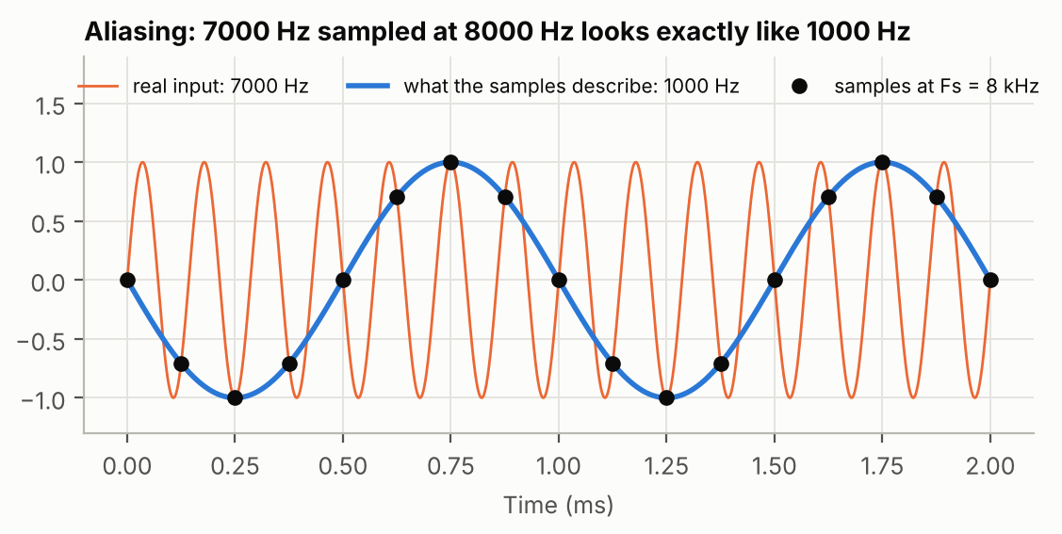
Figure 9. A 7 kHz sine sampled at 8 kHz (dots) gives exactly the same samples as a 1 kHz sine. After sampling, the 7 kHz has become 1 kHz.
ANALOGY In films, car wheels sometimes seem to turn slowly backwards. The camera takes 24 pictures per second; if the wheel turns almost one full turn between two pictures, the eye sees a small backwards step. The camera is sampling too slowly for the wheel: that is aliasing.
The frequency you get is found by "folding" the frequency axis around Fs/2 and its multiples:
f_alias = | f − k · Fs |, k chosen so the result is between 0 and Fs/2 (5.2)
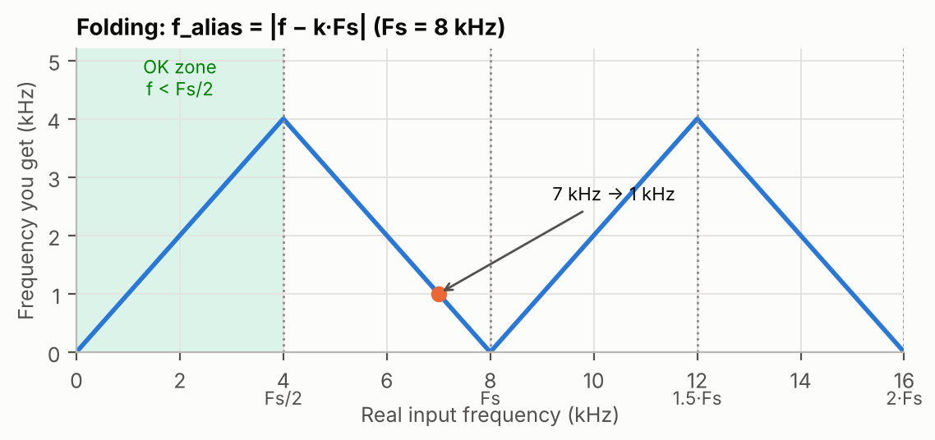
Figure 10. Frequency folding at Fs = 8 kHz. Frequencies in the green zone are kept; above 4 kHz they fold back and down, then up again, in a zig-zag.
WORKED EXAMPLE Fs = 8 kHz, input 7 kHz: k = 1 → |7 − 8| = 1 kHz.
Fs = 2 kHz, input 3 kHz: k = 2 → |3 − 4| = 1 kHz (the case measured in the lab, report Figure 4).
Fs = 4.8 kHz, input 3 kHz: k = 1 → |3 − 4.8| = 1.8 kHz.
KEY IDEA Aliasing cannot be undone after sampling: a 1 kHz alias and a real 1 kHz tone give identical samples. The only cure is to remove frequencies above Fs/2 before sampling, with an analog anti-aliasing filter.

5.4 From samples back to sound: the zero-order hold
The DAC holds each output value constant until the next one: the output is a staircase. This is called a zero-order hold. The steps contain high-frequency components (images of the signal around multiples of Fs), which the analog smoothing filter removes.
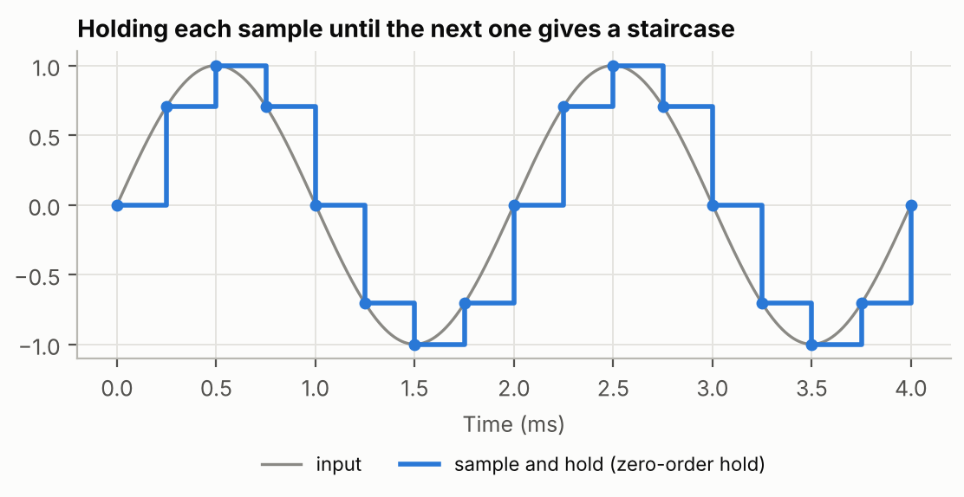
Figure 11. Sample-and-hold. The staircase follows the sine but contains extra high frequencies due to the steps.

5.5 Lowering the sampling rate: the sampling_rate program
The codec always samples at 48 kHz, so its anti-aliasing filter is set for 24 kHz. The program then keeps only one sample out of k and holds it (switch 12: k = 24). This is like sampling at Fs' = 48 kHz / k without a new anti-aliasing filter, so any frequency above Fs'/2 aliases. Reducing the sampling rate of a digital signal is called decimation or downsampling; done properly, it needs a digital low-pass filter first.
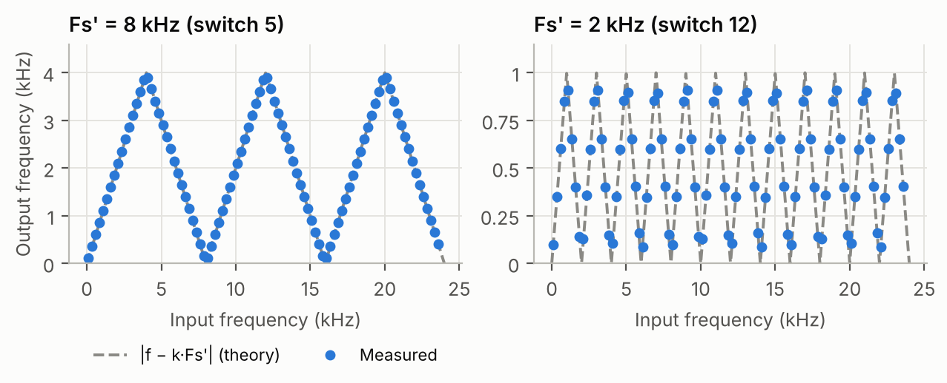
Figure 12. Measured in the lab code: output frequency against input frequency at Fs' = 8 kHz and 2 kHz. Every measured dot lies on the folding formula (5.2).
CONNECTION Sampling turns time into an integer n. Everything that follows (impulse, convolution, filters) works with x(n), the list of samples. Quantisation (next chapter) is the other half of the analog-to-digital conversion.

Check yourself
5.1 What is the highest frequency that can be represented at Fs = 48 kHz?
5.2 Fs = 8 kHz and the input is 5 kHz. What frequency comes out?
5.3 Why is the anti-aliasing filter analog and placed before the ADC?

6. Bits, binary numbers and quantisation
In this chapter: bits and levels, binary and hexadecimal, negative numbers (two's complement), the quantisation step and error, signal-to-noise ratio, and rounding versus truncation.

6.1 Bits and levels
A bit is a 0 or a 1. With N bits you can write 2^N different numbers: 8 bits give 256, 16 bits give 65 536. The ADC of the lab writes every sample on 16 bits.

6.2 Binary and hexadecimal
Numbers in a computer are written in binary (base 2). Each position is worth twice the one to its right: 1, 2, 4, 8, 16… For example 1101 in binary = 8 + 4 + 0 + 1 = 13.
Long binary numbers are hard to read, so programmers group bits by 4 and write each group as one hexadecimal digit (base 16: 0–9 then A=10, B=11, … F=15). In C and assembly, hexadecimal numbers start with 0x.
Hexadecimal | Binary (16 bits) | Unsigned value | Signed value (16-bit)
0x0001 | 0000 0000 0000 0001 | 1 | 1
0x0400 | 0000 0100 0000 0000 | 1024 | 1024
0x4000 | 0100 0000 0000 0000 | 16384 | 16384
0x7FFF | 0111 1111 1111 1111 | 32767 | 32767 (largest)
0x8000 | 1000 0000 0000 0000 | 32768 | −32768 (smallest)
0xFFFF | 1111 1111 1111 1111 | 65535 | −1

6.3 Negative numbers: two's complement
Sound goes above and below zero, so samples must be signed. Processors use two's complement: the leftmost bit (the MSB, most significant bit) is the sign (1 = negative), and a 16-bit number ranges from −32768 to +32767. To get −x: invert all bits and add 1. You do not need to compute it by hand; just remember the range and that 0x8000 is −32768 and 0xFFFF is −1.
The rightmost bit is the LSB (least significant bit): the smallest possible change of a number. In the lab, "an offset of −12 LSB" means the output is 12 units too low.

6.4 Quantisation
The exact voltage has infinitely many possible values; the ADC must choose one of its 2^N levels. This rounding is quantisation. The distance between two levels is the quantisation step q (one LSB).
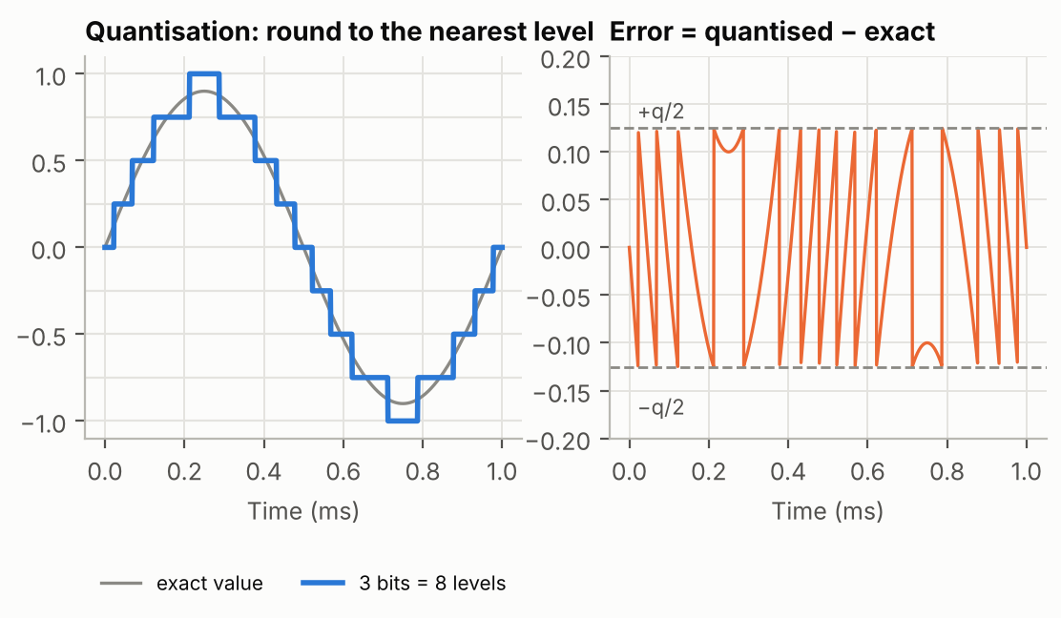
Figure 13. Quantisation with only 3 bits (8 levels) to make it visible. Left: the signal becomes a staircase. Right: the error stays between −q/2 and +q/2.
The difference between the stored value and the exact value is the quantisation error. It changes erratically from sample to sample and sounds like a faint hiss, so it is also called quantisation noise.

6.5 Signal-to-noise ratio (SNR)
The SNR compares the power of the signal with the power of the noise, in decibels. For a full-scale sine quantised on N bits:
SNR ≈ 6.02 · N + 1.76 dB (6.1)
Why 6 dB per bit? Adding one bit doubles the number of levels, so the step q is halved, the error is halved, and halving an amplitude is −6 dB of noise (chapter 2).
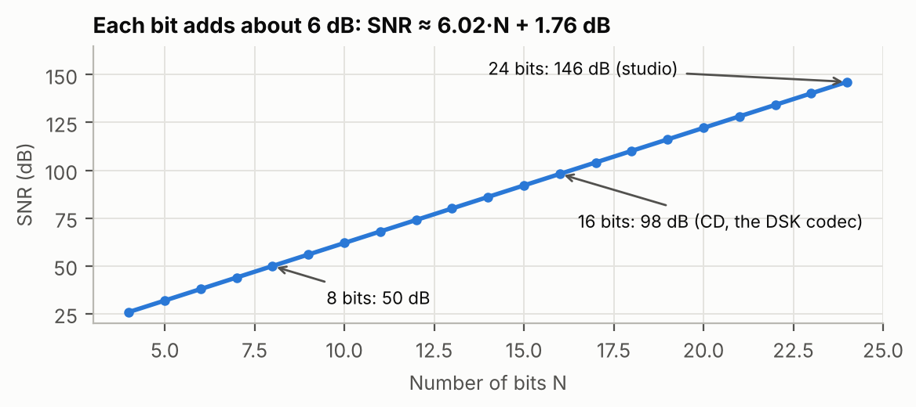
Figure 14. Each extra bit adds about 6 dB of SNR. 16 bits (the codec) give about 98 dB.

6.6 Rounding and truncation
There are two ways to drop the low bits of a number:
- Rounding: go to the nearest level. The error is between −q/2 and +q/2 and is zero on average.
- Truncation: always go down (towards −∞). The error is between −q and 0, so on average the value is q/2 too low: a small DC offset (a constant shift).
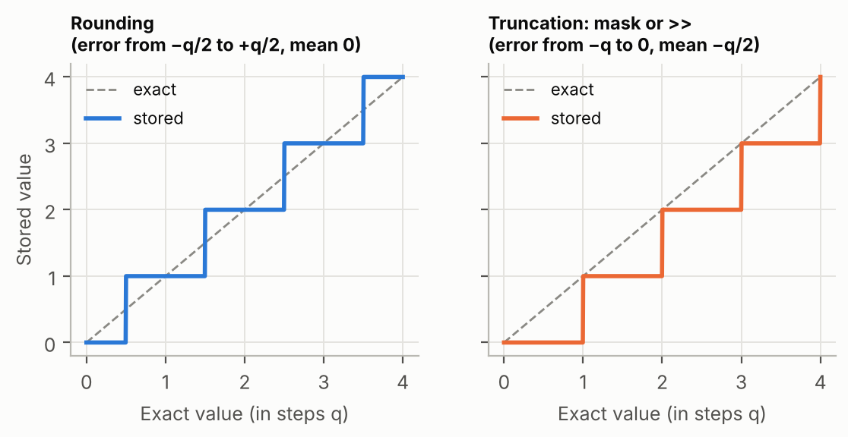
Figure 15. Rounding (left) and truncation (right) of a slowly rising value. Truncation always rounds down.
In C, two operations truncate: the bit mask (x & 0xFF00 clears the 8 low bits) and the right shift (x >> 15 divides by 2^15 and rounds down). Both are used in the lab, which is why small negative offsets appear (chapters 12 and 13).
IN THE LAB sampling_bits keeps N bits with a mask: switch 8 does left_input & 0xFF00 (8 bits, q = 256).
Measured with the lab code: 49.6 dB at 8 bits, 32.1 dB at 5 bits, exactly 6 dB per bit, and a mean error of −128.6 at 8 bits ≈ −q/2 (report Table 3).
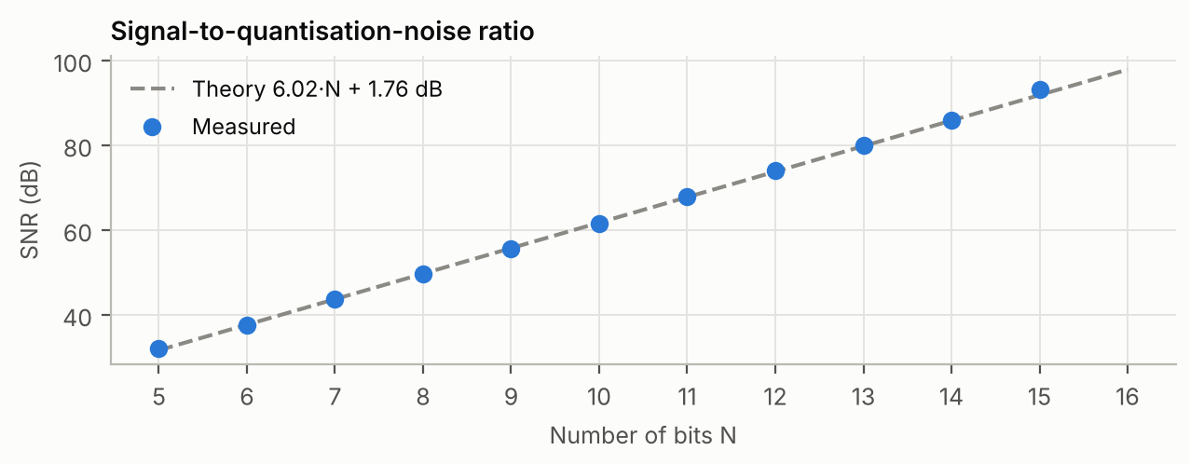
Figure 16. Measured SNR of the sampling_bits program against the formula 6.02·N + 1.76 dB.
CONNECTION Quantisation also happens inside the DSP after every multiplication: the result must be brought back to 16 bits. Chapter 13 (fixed point) is the same idea applied to computations.

Check yourself
6.1 How many levels does an 8-bit converter have?
6.2 What SNR do you expect with 12 bits?
6.3 What is the signed 16-bit value of 0xC000?
6.4 What does x & 0xFFF0 do, and what is the error range?

7. What is a filter?
In this chapter: what filters are for, the four basic types, and the vocabulary used to describe a real filter: passband, stopband, transition band, cutoff, ripple, attenuation and order.

7.1 The idea
A filter is a system that lets some frequencies through and reduces others. Because every signal is a sum of sines (chapter 3), a filter can remove the parts of a signal we do not want, such as noise, hum or the treble, and keep the rest.
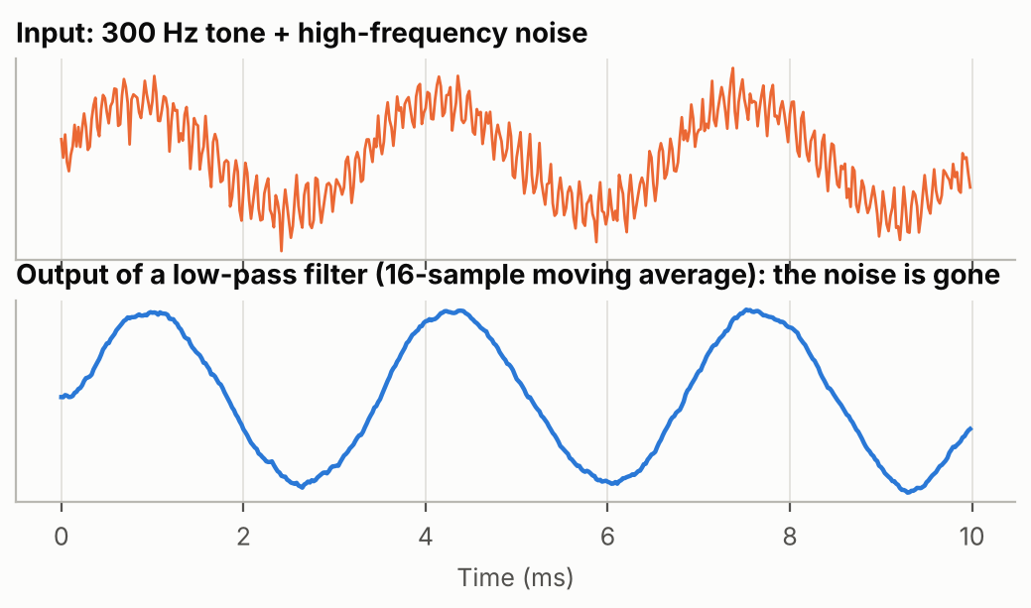
Figure 17. A low-pass filter removes the high-frequency noise and keeps the 300 Hz tone.
ANALOGY A sieve keeps big stones and lets sand through; a low-pass filter keeps slow variations (low frequencies) and stops fast ones. The bass and treble knobs of a hi-fi are filters.

7.2 The four basic types
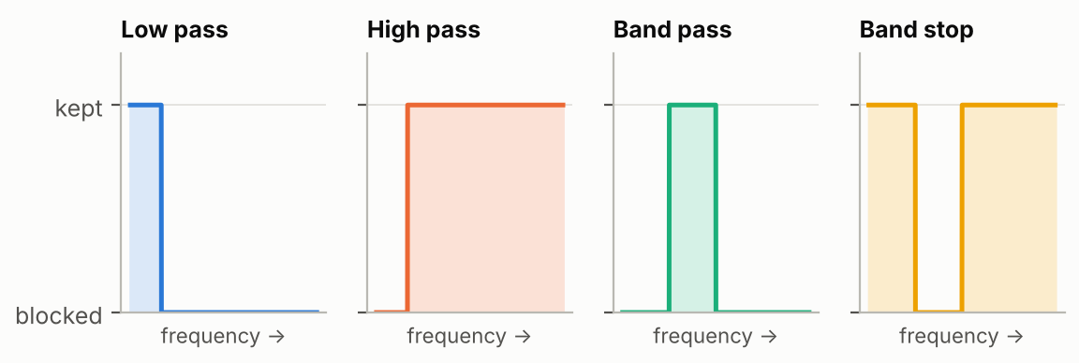
Figure 18. Ideal shapes of the four basic filters (gain against frequency).
- Low pass (LP): keeps frequencies below the cutoff.
- High pass (HP): keeps frequencies above the cutoff.
- Band pass (BP): keeps a band between two frequencies.
- Band stop (BS) or notch: removes a band.

7.3 Real filters and their vocabulary
A real filter cannot jump from "kept" to "blocked" at one exact frequency. Its response has three regions:
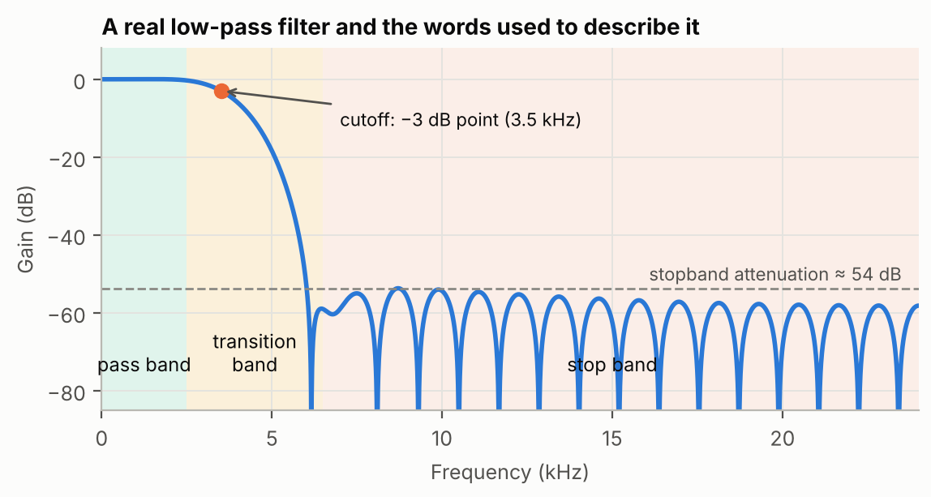
Figure 19. A real low-pass filter with its regions and the words used to describe them.
- Passband: frequencies that are kept (gain close to 0 dB). Small wiggles of the gain there are called ripple.
- Stopband: frequencies that are blocked. The stopband attenuation says by how many dB they are reduced (at least).
- Transition band: the region in between. Its width says how selective (steep) the filter is.
- Cutoff frequency fc: the frontier, usually defined as the frequency where the gain is −3 dB (half power). For FIR filters designed with windows it is the −6 dB point (chapter 11).
- Order: a number that measures the complexity of the filter; higher order means a steeper slope (chapters 10 and 12).
KEY IDEA The perfect "brick-wall" filter does not exist: it would need an infinitely long computation. Every real filter is a compromise between steepness, stopband attenuation, ripple, delay and computing cost. Chapters 10 to 12 are about these compromises.
IN THE LAB fir_windows builds 1200 Hz high-pass and low-pass filters; IIR_order builds 2000 Hz low-pass and high-pass filters of order 1 to 5; switch 11 of fir_windows sends the low pass to one speaker and the high pass to the other, like a loudspeaker crossover (a tweeter for the treble, a woofer for the bass).

Check yourself
7.1 You want to remove a 50 Hz hum from a recording. Which filter type?
7.2 What is the gain of a filter at its −3 dB cutoff, as an amplitude ratio?
7.3 A filter has 60 dB of stopband attenuation. By how much are those frequencies divided?

8. Impulse response and convolution
In this chapter: systems, linearity and time invariance (LTI), the impulse and the step, the impulse response, convolution with a full worked example, and the moving average.

8.1 Systems and the LTI property
A system takes an input signal x(n) and produces an output y(n). The filters of this course are LTI systems:
- Linear: if you double the input, the output doubles; if the input is the sum of two signals, the output is the sum of the two outputs.
- Time-invariant: the system behaves the same today and tomorrow: delaying the input just delays the output.
These two properties are what make filters predictable, and they allow the beautiful result of this chapter.

8.2 Two test signals: the impulse and the step
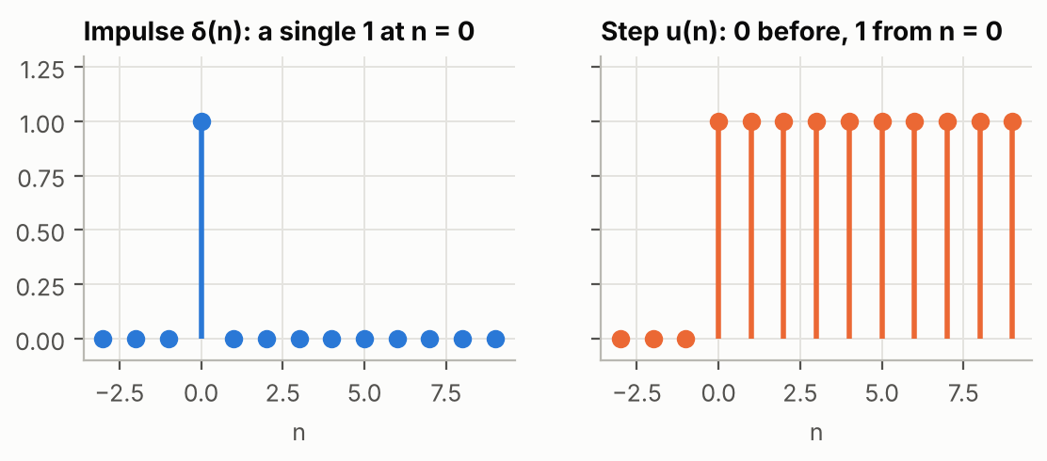
Figure 20. The unit impulse (a single 1) and the unit step (0 then 1 forever).
- The impulse δ(n) (delta) is 1 at n = 0 and 0 everywhere else: a single click.
- The step u(n) is 0 before n = 0 and 1 from n = 0 on: switching something on.

8.3 The impulse response h(n)
The impulse response h(n) is the output of the system when the input is an impulse. For an LTI system it contains everything about the system: once you know h(n), you can compute the output for any input.
Why? Any input is a sequence of samples, and each sample is just an impulse with a height and a position: x(n) = x(0)·δ(n) + x(1)·δ(n−1) + … By linearity and time invariance, each of these impulses produces a copy of h, scaled by the sample value and shifted to its position. The output is the sum of all these copies.
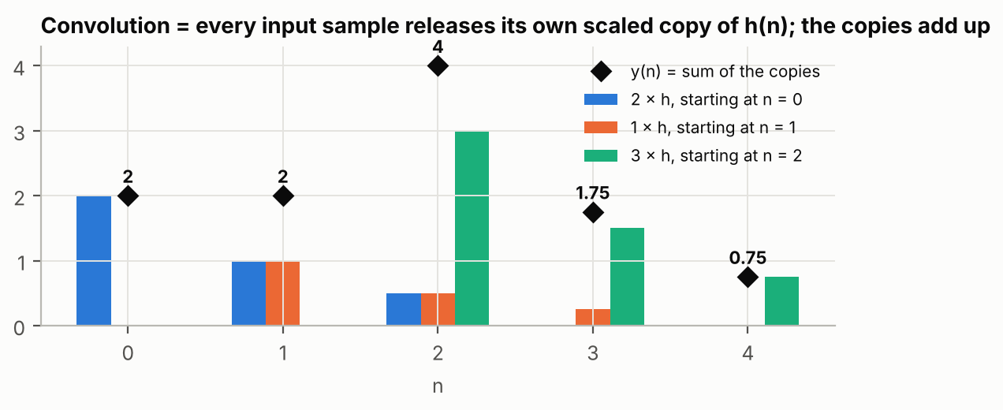
Figure 21. Convolution seen as a sum of copies. Each input sample (2, 1, 3) launches its own copy of h(n) = 1, 0.5, 0.25, scaled and shifted; the black diamonds are the sums.

8.4 Convolution
This sum of copies is called the convolution of x and h, written y = x * h:
y(n) = Σ h(k) · x(n − k) (8.1)
Read it as: "the output now = h(0) × the input now + h(1) × the input one sample ago + h(2) × the input two samples ago + …". The impulse response is the list of weights given to the present and past inputs.
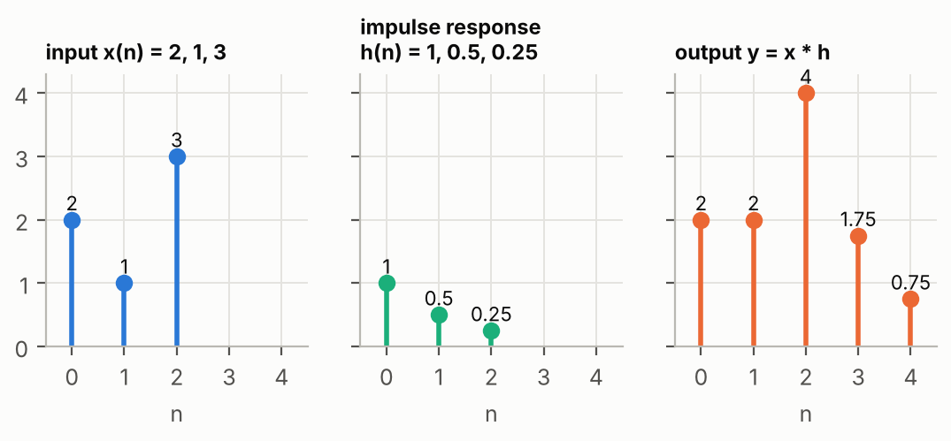
Figure 22. The worked example below: input, impulse response and output.
WORKED EXAMPLE Input x = 2, 1, 3 and impulse response h = 1, 0.5, 0.25. Compute y(n) = h(0)·x(n) + h(1)·x(n−1) + h(2)·x(n−2), with x = 0 outside n = 0…2:
y(0) = 1×2 = 2
y(1) = 1×1 + 0.5×2 = 2
y(2) = 1×3 + 0.5×1 + 0.25×2 = 4
y(3) = 0.5×3 + 0.25×1 = 1.75
y(4) = 0.25×3 = 0.75
The output has 3 + 3 − 1 = 5 samples, as in Figure 22.

8.5 The step response and the DC gain
The output for a step input is the step response. Because a step is a sum of impulses at n = 0, 1, 2…, the step response is the running sum of h(n). Its final value is the sum of all h(n), which is the gain at frequency 0, the DC gain (DC = direct current = a constant signal).

8.6 A first filter: the moving average
If h(n) = 1/N for N samples, the output is the average of the last N inputs: a moving average. Averaging smooths fast variations, so it is a (simple) low-pass filter; the noisy-signal example of section 7.1 used one with N = 16.
IN THE LAB firmacd2 is exactly this: 16 coefficients of 0x400 = 1/32. Fed with infir.dat (an impulse of 0x4000 = 16384), it outputs 16 samples of 512 = 16384 × 1/32: the impulse response is the list of coefficients.
Fed with a step of 0x4000, the output climbs in 16 steps to 8192: the DC gain is 16 × 1/32 = 0.5 = −6 dB (report Figure 1).
A system whose output does not depend on future inputs (h(n) = 0 for n < 0) is called causal. Real-time filters must be causal: they cannot use samples that have not arrived yet.
CONNECTION Convolution is exactly what an FIR filter computes (chapter 10), and the impulse response is how we measure a filter: its FFT is the frequency response (chapter 9).

Check yourself
8.1 Compute the convolution of x = 1, 1 with h = 1, 2.
8.2 The impulse response of a system is 0.5, 0.5. What is its DC gain?
8.3 Why is the impulse response enough to describe an LTI system?

9. Frequency response, phase and delay
In this chapter: what a filter does to a sine, gain and phase, how to measure a frequency response, the transfer function and z⁻¹, delay, linear phase and group delay.

9.1 Sine in, sine out
Feed a sine into an LTI system and you always get a sine of the same frequency out. The system can only change two things: its amplitude and its timing.
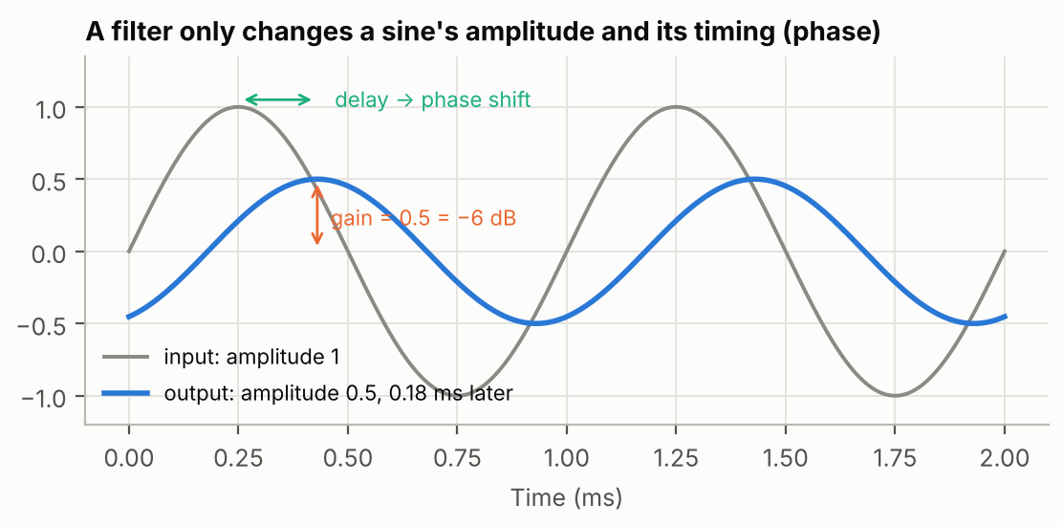
Figure 23. A filter multiplies a sine by a gain (here 0.5, −6 dB) and delays it (a phase shift).
- The amplitude ratio is the gain |H(f)| at that frequency (often in dB).
- The time shift, expressed as an angle, is the phase of H(f). A delay of D samples at frequency f is a phase of −2π·f·D/Fs radians.
The frequency response H(f) is the gain and phase for every frequency. When people say "the response of a filter" they usually mean the gain curve in dB, like the plots of the report.

9.2 Two ways to measure it
- Sine by sine (lab question 11): send a sine of frequency f, measure the output amplitude on an oscilloscope, divide by the input amplitude; repeat for many frequencies.
- Impulse + FFT: send one impulse, record h(n), compute its FFT. The frequency response is the Fourier transform of the impulse response.
Both give the same curve; the report used both and found agreement within 0.5 dB.
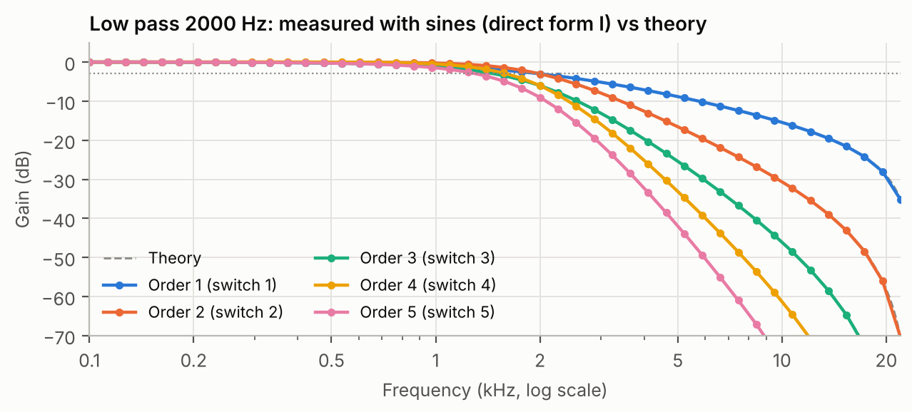
Figure 24. Frequency responses of the lab's IIR low-pass filters, measured sine by sine (dots) and computed from the coefficients (dashed).

9.3 The transfer function and z⁻¹
Engineers write filters with the z-transform. Do not be scared by it: the only thing to know is that z⁻¹ means "delayed by one sample". The transfer function H(z) is the impulse response written with these delays:
H(z) = h(0) + h(1)·z⁻¹ + h(2)·z⁻² + … (9.1)
Replacing z by e^(j2πf/Fs), a point on a circle of radius 1 called the unit circle, gives the frequency response H(f). Chapter 12 uses this circle to explain poles and stability.

9.4 Delay, linear phase and group delay
If a filter delays every frequency by the same number of samples, the phase grows in a straight line with frequency: the filter has linear phase. The waveform keeps its exact shape, only delayed. If different frequencies are delayed differently, the shape is distorted.
The group delay is the delay, in samples, applied to each frequency. It is constant for a linear-phase filter.
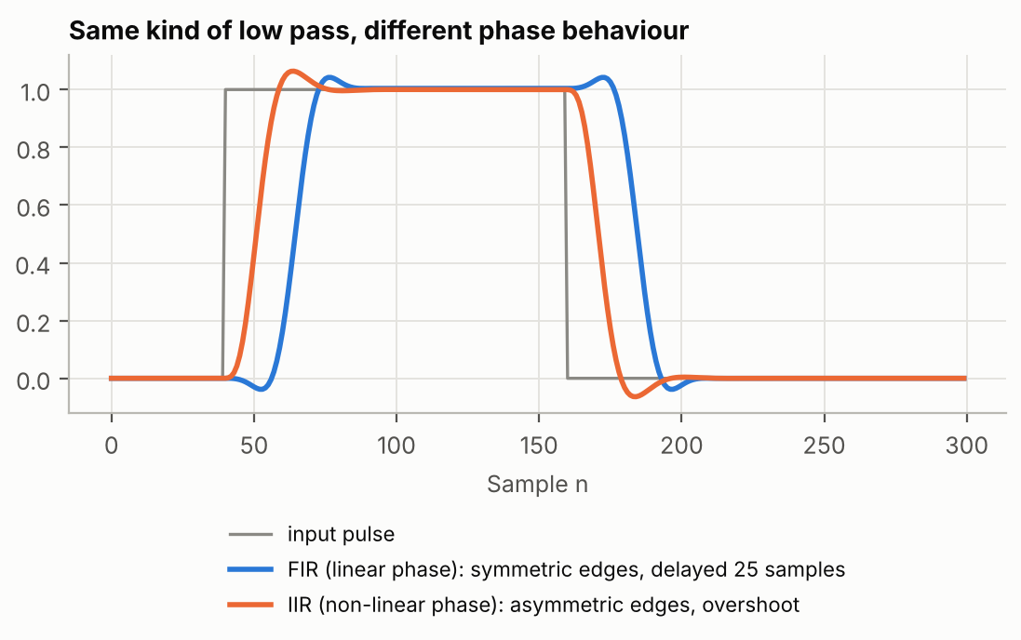
Figure 25. A pulse through two low-pass filters. The linear-phase FIR (blue) keeps symmetric edges and is delayed by 25 samples; the IIR (orange) responds faster but distorts the shape (asymmetric edges, overshoot).
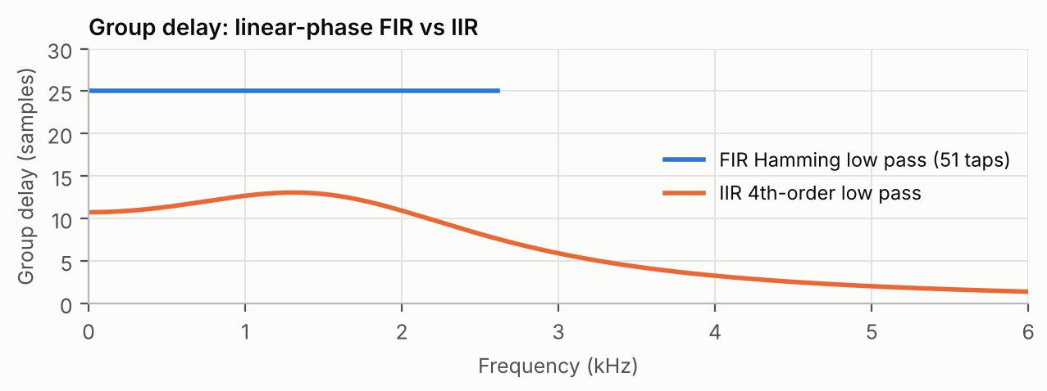
Figure 26. Group delay measured from the lab coefficients: constant 25 samples for the FIR, variable for the IIR.
KEY IDEA Gain says how much of each frequency comes through; phase (delay) says when it comes out. Linear phase means "everything arrives at the same time".
CONNECTION Chapter 10 shows that symmetric FIR filters have linear phase; chapter 12 shows that IIR filters do not.

Check yourself
9.1 A 1 kHz sine of amplitude 2 comes out with amplitude 1. What is the gain in dB?
9.2 What does z⁻¹ mean in a block diagram?
9.3 A filter delays all frequencies by 25 samples at 48 kHz. How long is that, and what kind of phase is it?

10. FIR filters
In this chapter: the FIR equation and block diagram, taps and coefficients, stability, symmetry and linear phase, the cost in multiply-accumulates, and how the delay line is stored in memory.

10.1 Definition
A FIR filter (Finite Impulse Response) computes each output as a weighted sum of the present and the N − 1 previous inputs:
y(n) = b(0)·x(n) + b(1)·x(n−1) + … + b(N−1)·x(n−N+1) (10.1)
The numbers b(k) are the coefficients (or taps); N is the length, and N − 1 is the order. Comparing with equation (8.1): the coefficients are the impulse response. Feed an impulse and the output is b(0), b(1), b(2)… then zeros: the response is finite, hence the name.
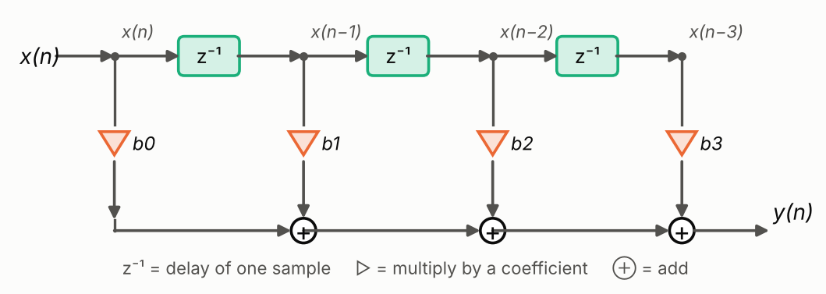
Figure 27. Block diagram of a 4-tap FIR filter. The z⁻¹ boxes form a delay line that holds the previous inputs; each one is multiplied by its coefficient and the products are added.

10.2 Properties
- Always stable: there is no feedback, so the output can never grow out of control.
- Linear phase when the coefficients are symmetric (b(k) = b(N−1−k)). The delay is then exactly (N−1)/2 samples.
- Cost: N multiplications and N additions per output sample. A sharp filter needs many taps (51 in the lab).
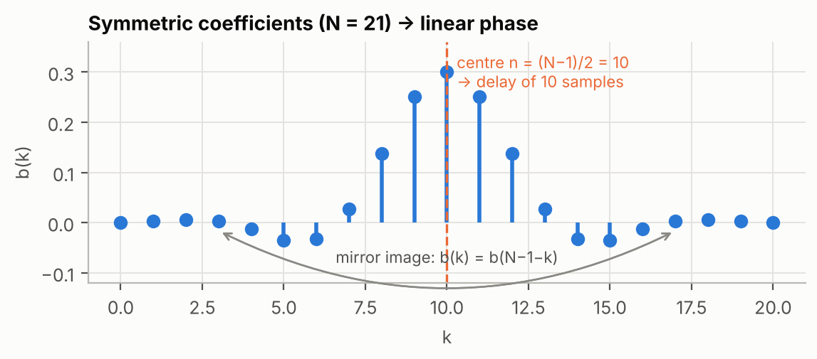
Figure 28. Symmetric coefficients: the filter is a mirror image around its centre, which gives a constant delay of (N−1)/2 samples.

10.3 The multiply-accumulate (MAC)
Equation (10.1) is a repetition of one operation: multiply a coefficient by a sample and add the product to a running sum. This is the MAC (multiply-accumulate), and DSPs are designed to do one or more per clock cycle. The running sum is kept in a wide register called the accumulator.
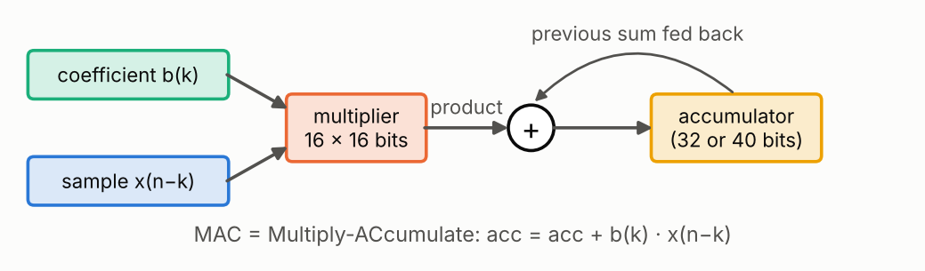
Figure 29. The MAC unit at the heart of every DSP.

10.4 Storing the past inputs
The filter needs the last N inputs. Two methods exist, and the lab uses both:
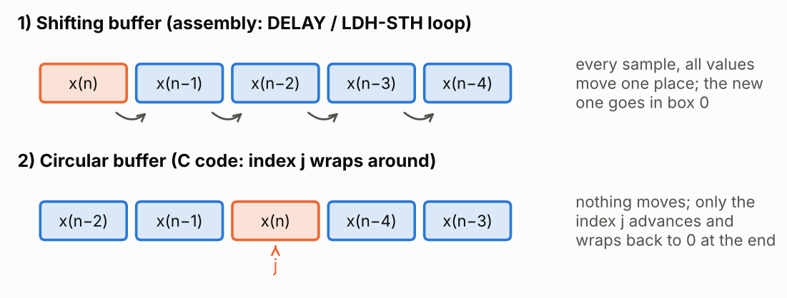
Figure 30. Two ways to keep the delay line in memory.
- Shifting buffer: at each new sample, every stored value moves one place and the new one enters at position 0. Simple, but it costs N moves per sample. The C54 assembly does it for free with the MACD instruction (multiply, accumulate and move data in one instruction) or with DELAY; the C6000 version uses a load/store loop.
- Circular buffer: nothing moves; an index j points to the oldest value and wraps around to 0 at the end. The C version FIR_filter() works this way.
IN THE LAB The C version and the assembly version of fir_windows give the same gain curve (report Figure 10), but the C output appears 2 samples later: the C function stores the new sample after computing, and its circular index starts one place later.
One call of FIR_filter_asm (51 taps) takes 1534 cycles, measured on an instruction-level model of the C6000: about a third of the 4687 cycles available per sample.
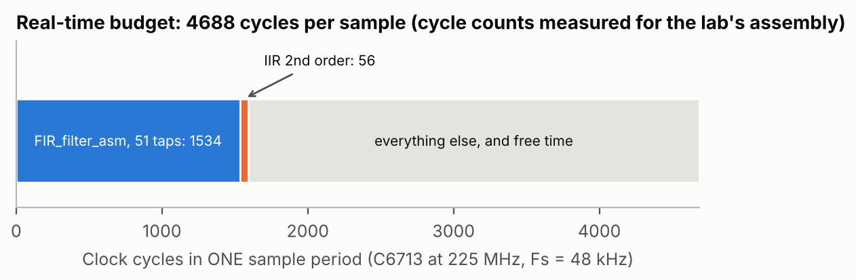
Figure 31. Real-time budget of one sample period on the C6713.
CONNECTION Chapter 11 explains how to choose the 51 coefficients (the window method). Chapter 13 explains how the products are computed with integers (Q15).

Check yourself
10.1 A FIR filter has 51 coefficients. What is its order, and its delay if the coefficients are symmetric?
10.2 Why can a FIR filter never become unstable?
10.3 How many MAC operations per second does a 51-tap FIR need at 48 kHz?

11. Designing FIR filters with the window method
In this chapter: the ideal filter and the sinc function, truncation and the Gibbs phenomenon, windows and their trade-off (main lobe, side lobes), the transition width, spectral inversion and complementary filters.

11.1 Start from the ideal filter
The ideal low-pass filter (a brick wall at fc) has a known impulse response, the sinc function:
hd(n) = (2fc/Fs) · sinc(2fc·n/Fs), sinc(x) = sin(πx)/(πx) (11.1)
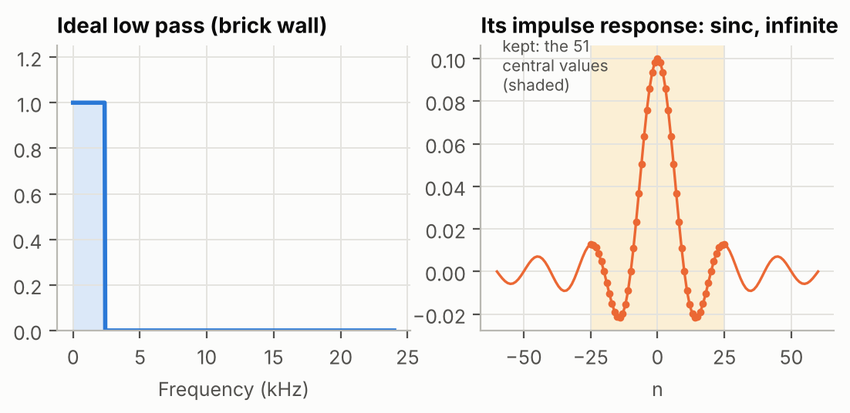
Figure 32. The ideal low pass (left) has an impulse response (right) that extends forever in both directions. We can only keep a finite part.
Two problems: it is infinite, and it starts before n = 0 (not causal). The fix: keep only N values around the centre and shift them by (N−1)/2 samples so that they start at n = 0. This shift is the delay of 25 samples of the lab's 51-tap filters.

11.2 Truncation and the Gibbs phenomenon
Simply cutting the sinc is the same as multiplying it by a rectangular window (1 inside, 0 outside). The abrupt cut creates ripples in the frequency response, near the cutoff and in the stopband: the Gibbs phenomenon. Making N larger does not remove the first ripple (about 9 % overshoot); it only makes it narrower.
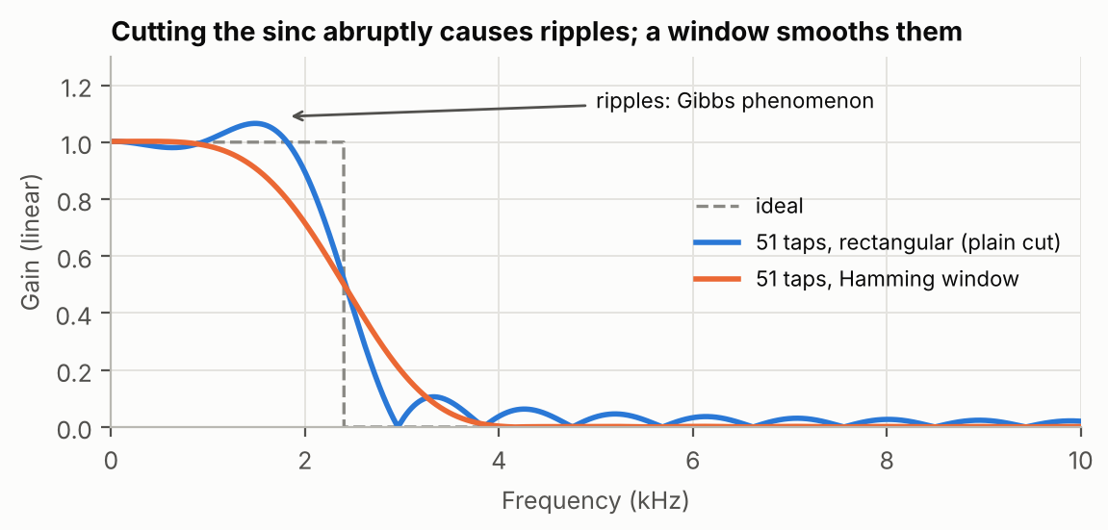
Figure 33. Plain truncation (blue) causes ripples; a Hamming window (orange) removes them at the cost of a slower transition.

11.3 Windows
A window w(n) is a shape that goes smoothly to zero at both ends. The coefficients are the sinc multiplied by it:
h(n) = hd(n − (N−1)/2) · w(n), n = 0 … N−1 (11.2)
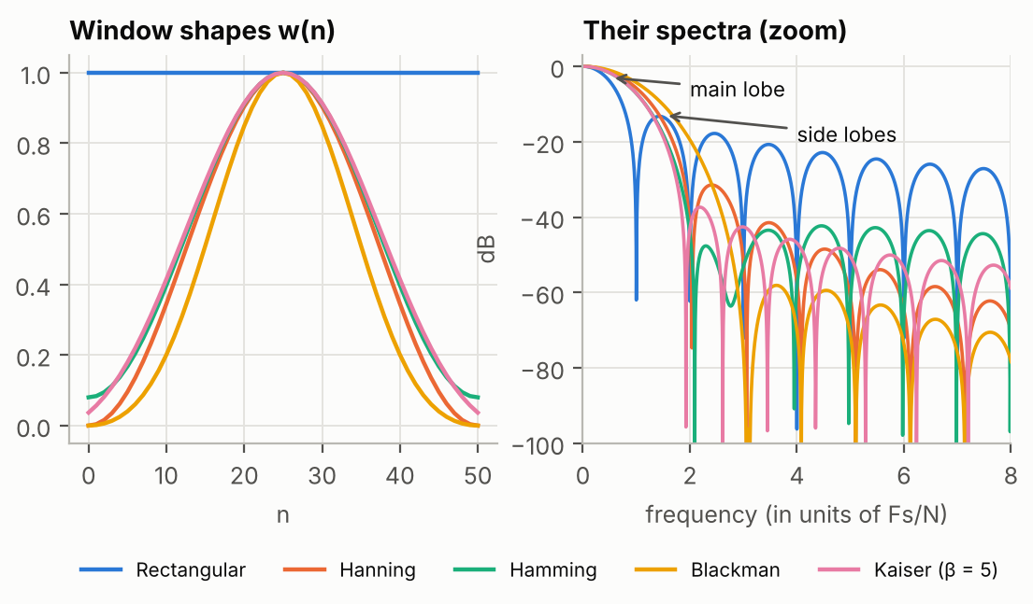
Figure 34. Left: the window shapes. Right: their spectra; the main lobe is the central bump, the side lobes are the smaller bumps.
Multiplying in time is equivalent to blurring the ideal response by the spectrum of the window. Two features of that spectrum matter:
- the main lobe width sets the transition width: wide main lobe = slow transition;
- the side lobe level sets the stopband attenuation and the ripple: low side lobes = good attenuation.
Window | Highest side lobe | Stopband attenuation | Transition width
Rectangular | −13 dB | ≈ 21 dB | ≈ 0.9 · Fs/N
Hanning (Hann) | −31 dB | ≈ 44 dB | ≈ 3.1 · Fs/N
Hamming | −41 dB | ≈ 53 dB | ≈ 3.3 · Fs/N
Blackman | −57 dB | ≈ 74 dB | ≈ 5.5 · Fs/N
Kaiser | adjustable with β | adjustable | adjustable

KEY IDEA There is no free lunch: a window that attenuates more (Blackman) has a wider transition. The only way to get both is a longer filter (larger N), which costs more computation.
WORKED EXAMPLE Lab filters: N = 51, Fs = 48 kHz, so Fs/N = 941 Hz.
Hamming transition ≈ 3.3 × 941 ≈ 3.1 kHz. That is more than twice the 1200 Hz cutoff: the high-pass filters of the lab never fully reach their stopband (report section 3.4).
To get a 1.2 kHz transition with Hamming you would need N ≈ 3.3 × 48000 / 1200 ≈ 132 taps.

11.4 High pass by spectral inversion
A delay δ(n−25) lets every frequency through (gain 1). Subtracting a low pass from it leaves the high frequencies:
hHP(n) = δ(n − 25) − hLP(n) (11.3)
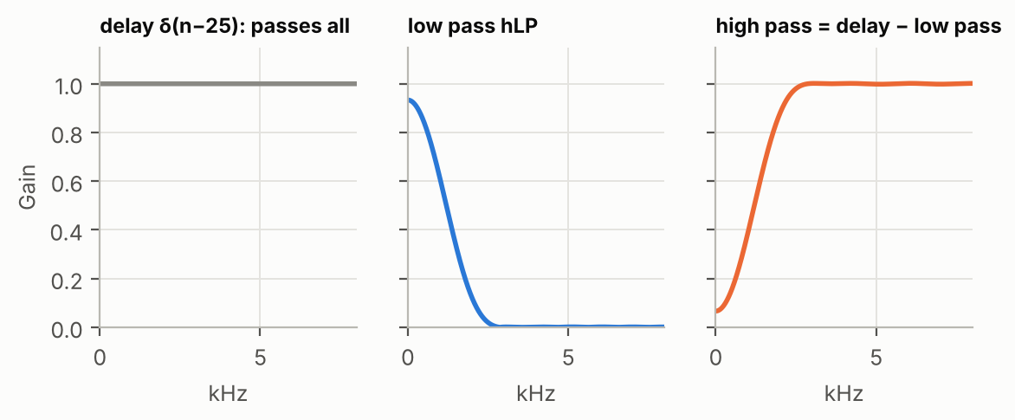
Figure 35. Spectral inversion: all-pass delay minus low pass gives high pass.
This is why the lab's high-pass coefficients have a big centre value h[25] = 1 − 2fc/Fs = 1 − 2400/48000 = 0.95, surrounded by small negative values.

11.5 Two filters for the price of one
The lab's dual filter computes the high-pass output y_HP and also returns x(n−25) − y_HP, which is the low pass (spectral inversion in reverse). The two outputs are complementary: added together they give back the input, delayed.
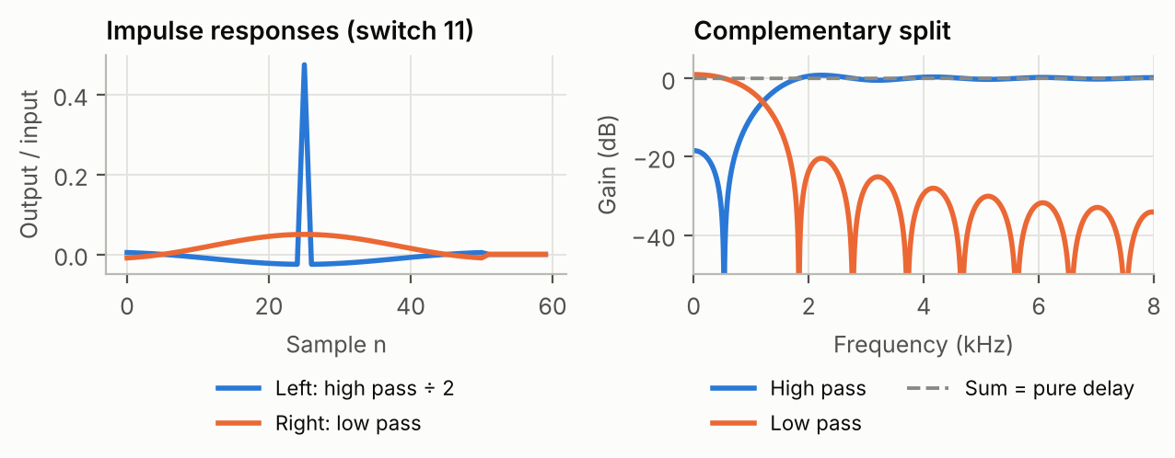
Figure 36. Switch 11 of fir_windows: high pass (left speaker) and low pass (right speaker); their sum is flat.
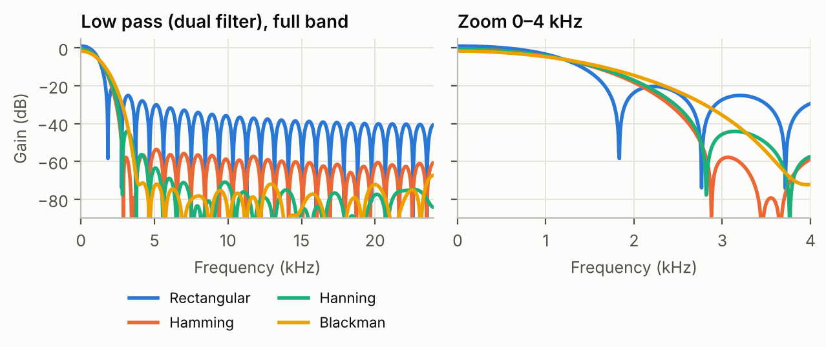
Figure 37. Measured low-pass filters made with each window. The rectangular window has the highest side lobes; Hamming, Hanning and Blackman go much lower.
IN THE LAB The coefficient files Rectangular_..., Hamming_..., Hanning_..., Blackman_... were computed with Matlab's fir1 function (see FIR_Window_1.m).
The file Kaiser_High_Pass_Filter_1200Hz.h of the lab actually contains the rectangular coefficients (the report points this out).

Check yourself
11.1 Why must the sinc be shifted by (N−1)/2 samples?
11.2 Which window would you choose for the best stopband attenuation, and what do you pay?
11.3 What does the centre coefficient h[25] = 0.95 of the lab's high pass come from?

12. IIR filters
In this chapter: feedback and recursion, infinite impulse responses, the transfer function with poles and zeros, stability, order and slope, Butterworth filters and the bilinear transform, cascades of biquads, and direct forms I and II.

12.1 Feedback
An IIR filter (Infinite Impulse Response) re-uses its own previous outputs. The simplest one is:
y(n) = b0 · x(n) − a1 · y(n − 1) (12.1)
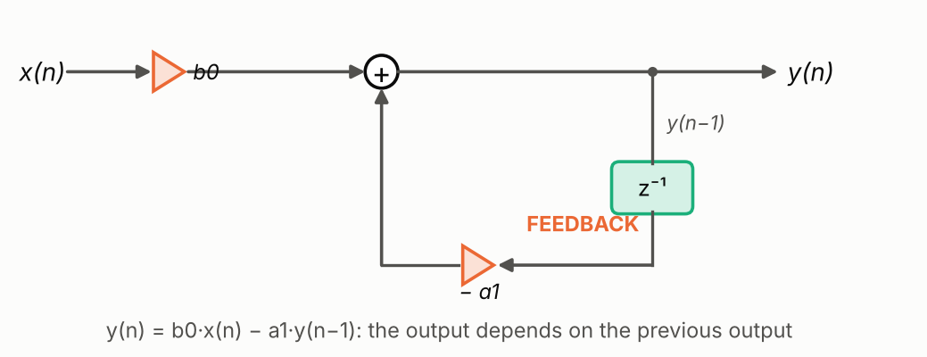
Figure 38. A first-order IIR filter: part of the output is fed back through a one-sample delay.
WORKED EXAMPLE Take b0 = 0.15 and a1 = −0.85, and an impulse at the input (x(0) = 1, then 0).
y(0) = 0.15; y(1) = 0.85 × 0.15 = 0.1275; y(2) = 0.85 × 0.1275 = 0.108; …
Each output is 0.85 times the previous one: the response decays like 0.85^n but never becomes exactly zero. The response is infinite.
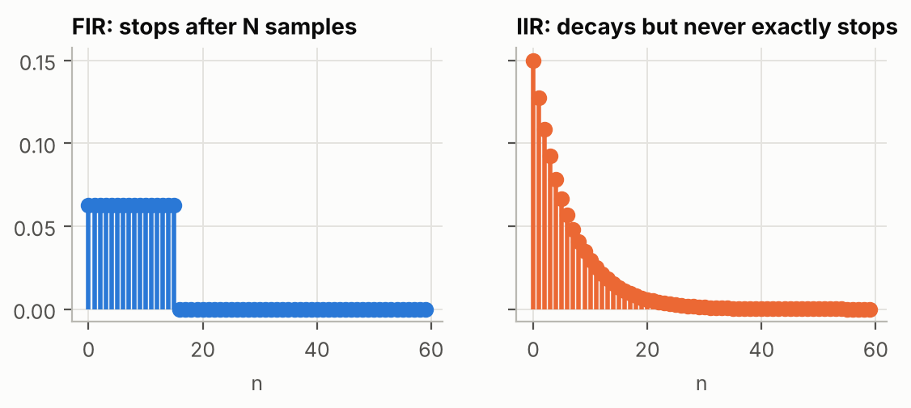
Figure 39. FIR impulse response (finite) compared with IIR impulse response (infinite, decaying).

12.2 The general equation and the transfer function
y(n) = Σ b(k)·x(n−k) − Σ a(k)·y(n−k) H(z) = B(z) / A(z) (12.2)
The b(k) act on inputs (the feed-forward part, like a FIR), the a(k) on past outputs (the feedback part). With z⁻¹ = one-sample delay, the transfer function is a fraction of two polynomials.

12.3 Poles, zeros and stability
The zeros are the values of z where the numerator B(z) is 0: frequencies near them are blocked. The poles are where the denominator A(z) is 0: frequencies near them are boosted. They are drawn in the complex plane together with the unit circle (chapter 9).
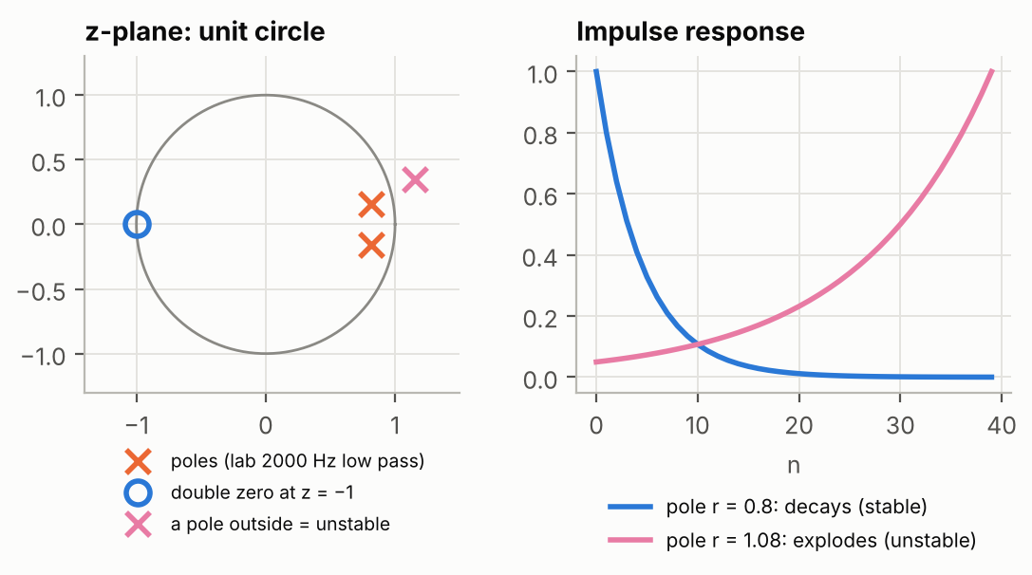
Figure 40. Left: poles (×) and zeros (o) of the lab's second-order 2 kHz low pass, and a pole outside the circle. Right: a pole inside the circle gives a decaying response (stable); outside, the response explodes (unstable).
KEY IDEA An IIR filter is stable only if all its poles are strictly inside the unit circle. The lab's second-order low pass has poles at a distance 0.83 from the centre: stable. A FIR filter has no poles (except at the origin), so it is always stable.

12.4 Order and slope
The order of an IIR filter is the number of poles (the highest power of z⁻¹ in A(z)). Far from the cutoff, each order adds about 6 dB per octave (20 dB per decade) of slope. An octave is a doubling of frequency, a decade a multiplication by 10.
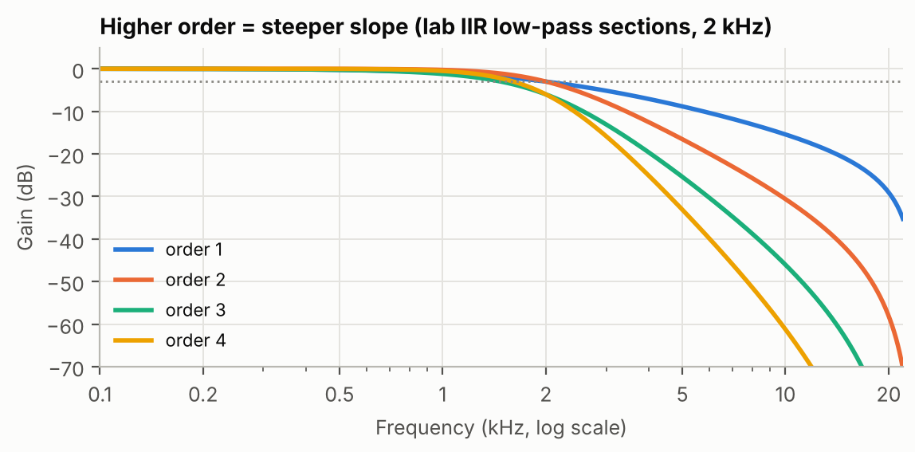
Figure 41. Higher order, steeper slope: the lab's 2 kHz low-pass sections and their cascades.

12.5 Butterworth filters and the bilinear transform
The lab's coefficients come from Butterworth filters: a classic analog design whose passband is as flat as possible (no ripple), with exactly −3 dB at the cutoff. A second-order Butterworth low pass overshoots by about 4.3 % on a step (the lab measured 4.4 %).
The bilinear transform (BLT) is the recipe that turns an analog filter (designed with capacitors and resistors in mind) into digital coefficients. It maps the whole analog frequency axis onto 0 … Fs/2, slightly compressing high frequencies (this is called frequency warping, and designers pre-correct for it).

12.6 Cascades of biquads
High-order IIR filters are built as a chain of small sections: first-order sections and second-order sections called biquads (two poles and two zeros). Small sections are much less sensitive to the rounding of coefficients than one big high-order filter.
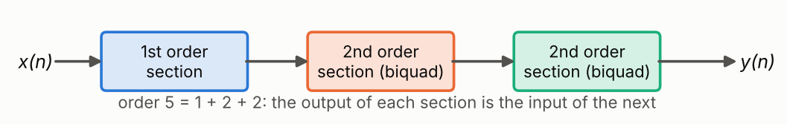
Figure 42. Order 5 built as 1 + 2 + 2.
In the lab, order 3 = 1st + 2nd order, order 4 = the same biquad twice, order 5 = 1st + 2nd + 2nd. Because each section is already −3 dB at 2000 Hz, the cascade is −6 or −9 dB there: its −3 dB point moves (to 1607 Hz for the 4th-order low pass). A true 4th-order Butterworth would use two different biquads.

12.7 Direct form I and direct form II
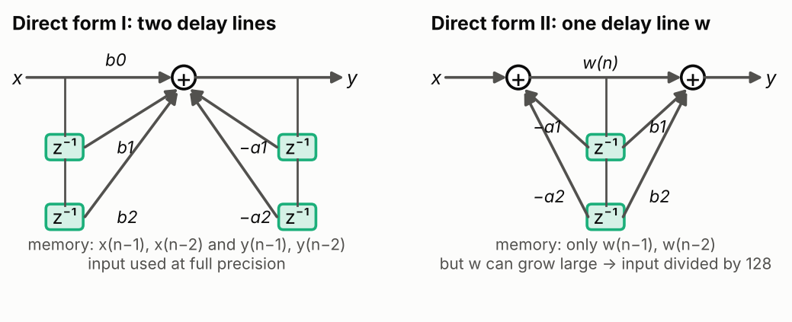
Figure 43. Two ways to wire the same second-order filter.
- Direct form I computes equation (12.2) literally: one delay line for the inputs, one for the outputs.
- Direct form II first computes an internal signal w(n) through the feedback, then applies the b(k): only one delay line is needed.
On paper they are identical. With integers they are not: in direct form II the internal signal w(n) can become much larger than the input (the poles amplify it), so the lab code divides the input by 128 first to avoid overflow, and loses 7 bits of precision.
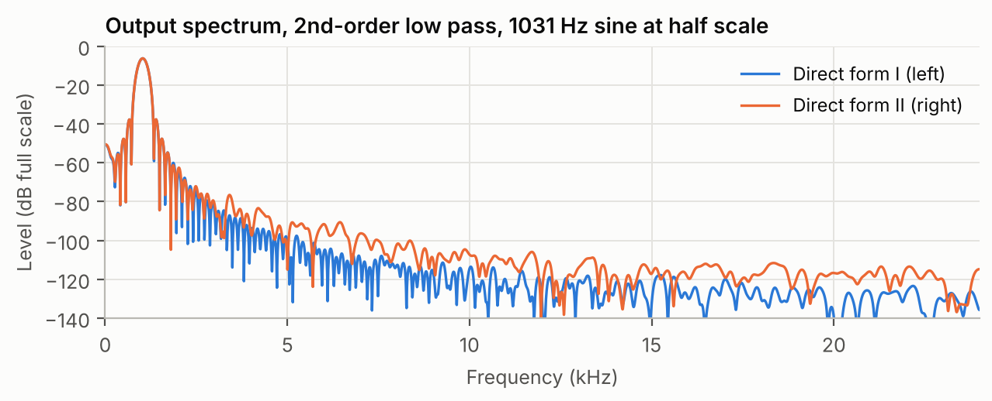
Figure 44. Measured in the lab code: direct form II (orange) has a higher noise floor than direct form I (blue).

12.8 FIR or IIR?
 | FIR | IIR
Impulse response | finite | infinite (decaying)
Feedback | no | yes
Stability | always stable | only if poles inside the unit circle
Phase | linear if symmetric (constant delay) | not linear (shape distortion)
Cost for a steep filter | many taps (51 and more) | few coefficients (5 per biquad)
Sensitivity to rounding | low | higher (feedback amplifies errors)
Design | window method (fir1) | analog prototype + bilinear transform

IN THE LAB The lab coefficients are stored as b1/2 and a1/2 (and the code adds the product twice), because a1 of a biquad can reach −2, which does not fit in the Q15 range −1 … +1 of chapter 13.

Check yourself
12.1 In y(n) = 0.2·x(n) + 0.8·y(n−1), what is the response to an impulse, and is it stable?
12.2 How much attenuation per octave does a 4th-order filter have far from its cutoff?
12.3 Why does the lab divide the input by 128 in direct form II?

13. Fixed-point arithmetic (Q15)
In this chapter: how fractions are written with integers, multiplication and scaling, the accumulator, overflow and saturation, and rounding inside computations.

13.1 Why integers?
Fixed-point DSPs such as the C54 have no hardware for decimal (floating-point) numbers: they compute with integers only, which is faster, cheaper and uses less power. (The C6713 can also do floating point, but the lab code uses integers, as on the C54.) Filters need fractional coefficients like 0.95 or −0.05, so we use a convention to write fractions with integers.

13.2 The Q15 format
In Q15, a 16-bit integer v represents the real number v / 32768 (32768 = 2^15). The range is −1 to just under +1.
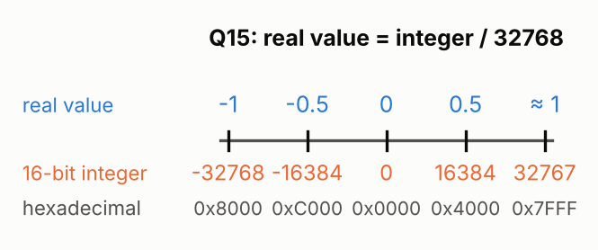
Figure 45. The Q15 number line: real values (top) and the integers that store them (bottom).
WORKED EXAMPLE 0x4000 = 16384 → 16384/32768 = 0.5.
0x0400 = 1024 → 0.03125 = 1/32 (the firmacd coefficients).
To store 0.95 → 0.95 × 32768 ≈ 31130.
1.0 cannot be stored exactly: the largest value is 32767 ≈ 0.99997.

13.3 Multiplying Q15 numbers
The product of two 16-bit numbers needs 32 bits. Two Q15 numbers give a Q30 product (value = integer / 2^30). To get back to Q15 we shift right by 15 bits (divide by 32768):
(a × b) >> 15 (13.1)
WORKED EXAMPLE 0.5 × 0.5 in Q15: 16384 × 16384 = 268 435 456.
Shift right by 15: 268 435 456 / 32768 = 8192 = 0.25 in Q15. Correct.
The C54 has a mode called FRCT (fractional) that shifts every product left by 1, so that the Q15 result lands directly in the upper 16 bits of the accumulator. The C6000 instruction SMPY does the same.

13.4 The accumulator and guard bits
A filter adds up many products: 51 for the lab's FIR. Their sum can be larger than any single product. DSPs therefore accumulate in a wider register: the C54 accumulators have 40 bits, i.e. 8 extra guard bits above the 32-bit product. The C code of the lab instead shifts each product right by 5 before adding (divide by 32) to make room, then by 10 at the end (5 + 10 = 15).

13.5 Overflow and saturation
If a result is too big for its register, two things can happen:
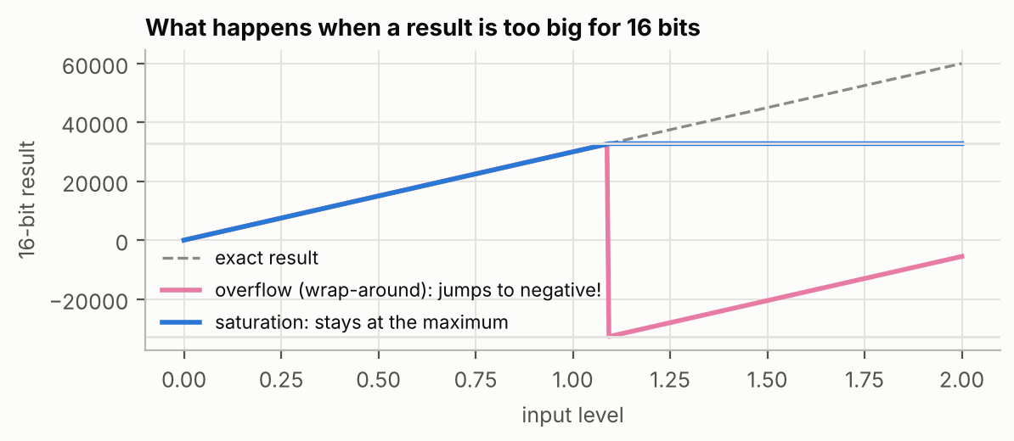
Figure 46. Overflow wraps around to a large negative value (a loud click); saturation clips at the maximum (a gentle distortion).
- Overflow (wrap-around): the extra bits are lost and the number jumps from +32767 to −32768. In audio this is a violent crack.
- Saturation: the result is clamped at the largest or smallest value. On the C54 this is the OVM mode; on the C6000 the SADD instruction. The IIR C code of the lab does it by hand with if (temp > 32767) temp = 32767.

13.6 Rounding inside the computations
Shifting right (>> 15) truncates (chapter 6): every result is rounded down, so a long chain of computations, and especially IIR feedback, accumulates a small negative offset. The lab's IIR high-pass filters settle at −5 to −13 instead of 0 for this reason. Adding half a step (0x8000) before the final shift turns truncation into rounding: that is what the C54 instruction MACR and the C6000 code do.
IN THE LAB On the C54, int is 16 bits and long is 32 bits; on the C6000, short is 16, int is 32 and long is 40 bits. That is why porting the lab to the C6000 required changing every 16-bit int into short: the arithmetic of this chapter depends on exact sizes.
The IIR coefficient a1/2 trick (chapter 12) exists because a1 can be close to −2, outside the Q15 range.

Check yourself
13.1 What real value does the Q15 integer 0x2000 represent?
13.2 Compute 0.25 × 0.5 in Q15.
13.3 Why is saturation better than wrap-around for audio?

14. DSP processors: the C54 and the C6000
In this chapter: what makes a DSP special, the TMS320C54x and the TMS320C6000 families, real-time budget, C versus assembly, and the development tools.

14.1 What makes a DSP different from a PC processor?
- Hardware multiplier and MAC in one cycle (chapter 10).
- Harvard architecture: separate buses for program and data, so an instruction, a coefficient and a sample can be read at the same time.
- Address generators with post-increment (*AR3+) and circular addressing, so pointers move through buffers without extra instructions.
- Zero-overhead loops (RPT, RPTZ on the C54): repeat one instruction N times with no loop cost.
- Saturation and rounding built into the arithmetic (OVM, MACR, SADD).

14.2 The TMS320C54x (the original lab)
A 16-bit fixed-point DSP. It has two 40-bit accumulators (A and B), a 17 × 17-bit multiplier, eight auxiliary registers AR0–AR7 used as pointers, and mode bits: FRCT (fractional shift), OVM (saturation), SXM (sign extension). Its star instruction for filters is MACD: multiply, accumulate and shift the delay line in one cycle, repeated with RPTZ.

14.3 The TMS320C6000 (the port)
A VLIW (Very Long Instruction Word) DSP. It has 8 functional units (.L, .S, .M, .D on two sides) that can execute up to 8 instructions in the same cycle, and 32 registers of 32 bits (A0–A15, B0–B15). The C6713 runs at 225 MHz and also has floating-point hardware. Its instructions have delay slots: the result of a load (LDH) is available 4 cycles later, a multiply 1 cycle later, and a branch takes effect after 5 cycles. The ported assembly fills these slots with NOPs to stay simple; an optimised version would overlap them (software pipelining) and be several times faster.
 | C5416 (C54x) | C6713 (C6000)
Data size | 16-bit fixed point | 32-bit, fixed and floating point
Clock (DSK) | 160 MHz | 225 MHz
Accumulators / registers | 2 × 40 bits (A, B) + AR0–AR7 | 32 × 32-bit registers
Instructions per cycle | 1 (with parallel operands) | up to 8
Filter instruction | MAC, MACR, MACD | SMPY + SADD (or MPY + ADD)
Saturation | OVM mode bit | SADD / SSUB instructions
C int size | 16 bits | 32 bits

14.4 C or assembly?
C is easier to write and to read; the compiler translates it to instructions. Hand-written assembly gives full control of the hardware (MACD, circular buffers) and can be faster. The lab writes the same filters in both to compare them: they give the same results (report Figure 10).

14.5 The tools
- Project: the list of source files and settings; Build compiles it into an executable (.out).
- Load / Run / Halt: send the program to the DSP and execute it.
- Breakpoint: a line where execution stops. Probe point: a line where CCS reads or writes a data file automatically (used with infir.dat and outfir.dat).
- Graph: CCS draws a memory area as a time signal or its FFT.
- Simulator: software that imitates the DSP when no board is available (the course's results were obtained with a simulated board).

Check yourself
14.1 What is the advantage of a Harvard architecture for a FIR filter?
14.2 On the C6000, why are there NOPs after a load?
14.3 How many cycles are available per sample on a 225 MHz C6713 at 48 kHz?

15. Putting it all together: the lab programs
In this chapter: how every program of the lab uses the ideas of the course, and what to look for when you run it.
Program | What it does | Chapters
firmacd2 | 16-tap moving average in C54 / C6000 assembly (MACD), tested with an impulse file | 8, 10, 13, 14
sampling_bits | keeps 16 down to 5 bits of each sample with a mask | 6, 2
sampling_rate | keeps one sample out of k (Fs' = 48 kHz / k) without anti-aliasing | 5, 3
fir_windows | 51-tap FIR filters designed with 5 windows, in C and assembly, high pass, low pass and crossover | 7, 9, 10, 11
IIR_order | IIR low and high pass of order 1 to 5, direct form I and II | 9, 12, 13

firmacd2: the FIR in assembly
Feed infir.dat (one impulse of 0x4000) and look at out: you see the coefficients (16 × 512), that is the impulse response (chapter 8). Feed a step and you see the running sum up to 8192 (DC gain 0.5). The frequency response is a sinc-shaped low pass with zeros every 3 kHz = Fs/16. The second filter at the end of the file is a band pass around 9.85 kHz.
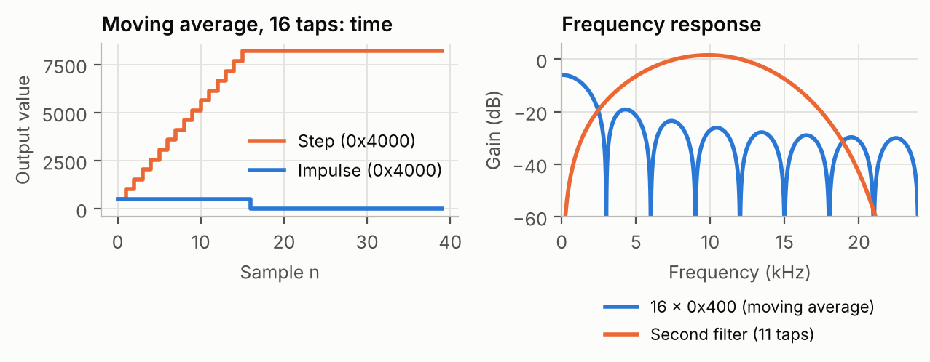
Figure 47. firmacd2 results: impulse and step responses, and frequency responses.

sampling_bits: quantisation
Lower the number of bits with the switches: the staircase becomes visible on an oscilloscope and the noise audible. Every bit removed costs 6 dB of SNR (chapter 6).

sampling_rate: aliasing
Lower the sampling rate and sweep the input frequency: above Fs'/2 the output frequency goes down instead of up (chapter 5). A 3 kHz tone at Fs' = 2 kHz comes out at 1 kHz.
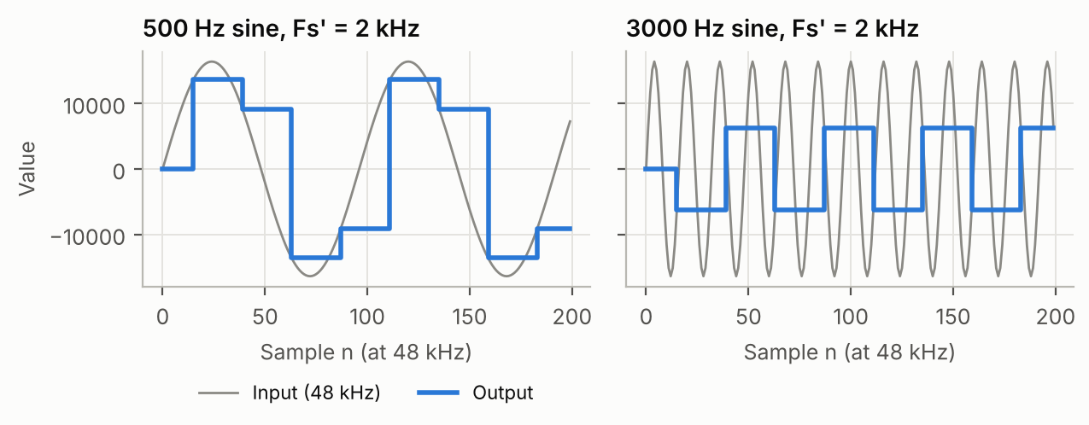
Figure 48. A 500 Hz sine correctly sampled at 2 kHz (left) and a 3000 Hz sine aliased to 1000 Hz (right).

fir_windows: windows, C and assembly, crossover
Switches 1–5 compare windows in high pass (left = assembly, right = C), 6–10 the same windows in low pass, 11 the low/high crossover. Measure the frequency response with sines (chapter 9) or with an impulse and the CCS FFT graph. Expect: −6 dB at 1200 Hz, a transition about 3 kHz wide, and side lobes that drop from rectangular to Blackman (chapter 11).

IIR_order: order and structure
Switches 1–5 give low pass of order 1 to 5, 6–10 high pass, 11–15 a crossover on the mono signal. Left = direct form I, right = direct form II. Expect: about 6 dB/octave more slope per order, overshoot on steps, and more noise on the direct form II channel (chapter 12).
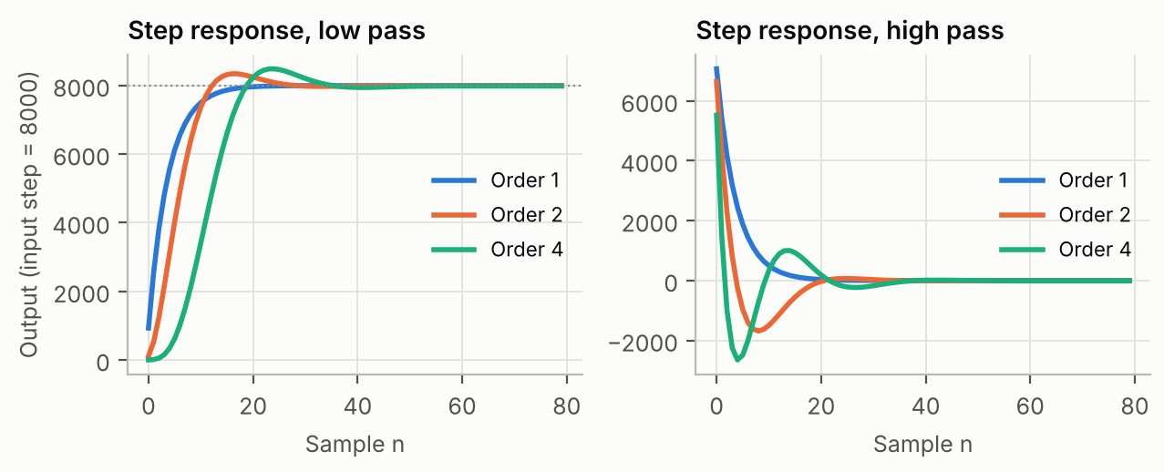
Figure 49. Step responses of the lab's IIR filters of order 1, 2 and 4.
KEY IDEA The whole lab is one story: sound is sampled (chapter 5) and quantised (6) into numbers; a filter is a convolution (8) that shapes the spectrum (3, 9); FIR filters (10) are designed with windows (11), IIR filters (12) with feedback; and a DSP (14) computes them in fixed point (13) fast enough for real time.

Answers to the check-yourself questions
Question | Answer
1.1 | T = 1/f = 1/2000 = 0.0005 s = 0.5 ms.
1.2 | f = 1/T = 1/0.00025 = 4000 Hz = 4 kHz.
1.3 | The phase φ.
2.1 | 20·log10(0.01) = 20 × (−2) = −40 dB.
2.2 | 10^(−20/20) = 10^(−1) = 0.1: it is divided by 10.
2.3 | −3 −3 −3 = −9 dB (amplitude × 0.354).
3.1 | A single peak at 3 kHz.
3.2 | 1 kHz and its odd harmonics: 3, 5, 7 kHz… with decreasing amplitudes.
3.3 | 48000 / 512 = 93.75 Hz.
4.1 | 1/48000 s ≈ 20.8 µs.
4.2 | An ADC (analog to digital) and a DAC (digital to analog).
4.3 | 2⁴ = 16 (values 0 to 15).
5.1 | Fs/2 = 24 kHz (the Nyquist frequency).
5.2 | |5 − 8| = 3 kHz.
5.3 | Because once sampled, an alias cannot be separated from a real signal of the same frequency; the unwanted frequencies must be removed before sampling.
6.1 | 2⁸ = 256.
6.2 | 6.02 × 12 + 1.76 ≈ 74 dB (measured in the lab: 74.0 dB).
6.3 | 0xC000 = 49152 unsigned; as a signed 16-bit number 49152 − 65536 = −16384 (= −0.5 in Q15).
6.4 | It clears the 4 low bits (keeps 12 bits, step 16). The error is between −15 and 0 (truncation).
7.1 | A band-stop (notch) at 50 Hz, or a high pass if nothing useful is below 50 Hz.
7.2 | 1/√2 ≈ 0.707.
7.3 | By 1000 (10^(60/20)).
8.1 | y(0) = 1, y(1) = 1×1 + 2×1 = 3, y(2) = 2×1 = 2 → 1, 3, 2.
8.2 | 0.5 + 0.5 = 1 (0 dB).
8.3 | Because every input is a sum of scaled, shifted impulses; by linearity and time invariance the output is the same sum of scaled, shifted impulse responses.
9.1 | 20·log10(1/2) = −6 dB.
9.2 | A delay of one sample: the output is the input of the previous sample.
9.3 | 25/48000 = 0.52 ms; it is a linear phase.
10.1 | Order 50; delay (51−1)/2 = 25 samples.
10.2 | It has no feedback: the output is a finite sum of inputs, so a bounded input always gives a bounded output.
10.3 | 51 × 48 000 = 2 448 000 MACs per second (per channel).
11.1 | To make the filter causal: the kept part of the sinc must start at n = 0, so it is shifted by half its length.
11.2 | Blackman (lowest side lobes); you pay with the widest transition band.
11.3 | Spectral inversion: δ(n−25) − hLP, and the centre of the low pass is 2fc/Fs = 0.05.
12.1 | 0.2, 0.16, 0.128, …: 0.2 × 0.8^n. Stable (the pole is at 0.8, inside the unit circle).
12.2 | About 4 × 6 = 24 dB per octave.
12.3 | To keep the internal signal w(n), amplified by the poles, from overflowing 16 bits; the price is 7 bits of lost precision (more noise).
13.1 | 0x2000 = 8192 → 8192/32768 = 0.25.
13.2 | 8192 × 16384 = 134 217 728; >> 15 = 4096 = 0.125. Correct.
13.3 | Wrap-around turns a too-large positive value into a large negative one (a loud crack); saturation only clips it at the maximum.
14.1 | Program, coefficients and data can be read in the same cycle, so one MAC per cycle is possible.
14.2 | The loaded value is only available 4 cycles later (delay slots); NOPs wait for it.
14.3 | 225 000 000 / 48 000 ≈ 4687.

Glossary
Term | Meaning | Chapter
Accumulator | Wide register where a DSP adds up products (40 bits on the C54). | 10, 13
ADC | Analog-to-Digital Converter: samples and quantises a voltage. | 4
Alias, aliasing | A frequency above Fs/2 that appears as a lower one after sampling. | 5
Amplitude | Height of a signal's peaks. | 1
Analog | Continuous in time and value. | 1
Anti-aliasing filter | Analog low pass placed before the ADC to remove frequencies above Fs/2. | 5
Attenuation | Reduction of amplitude, usually given in dB. | 2, 7
Band pass / band stop | Filter that keeps / removes a band of frequencies. | 7
Bilinear transform (BLT) | Method that turns an analog filter into digital coefficients. | 12
Biquad | Second-order IIR section (two poles, two zeros). | 12
Bit, LSB, MSB | Binary digit; least / most significant bit. | 6
Butterworth | Classic filter design with a maximally flat passband, −3 dB at the cutoff. | 12
Cascade | Systems connected one after another; their dB gains add. | 2, 12
Causal | Uses only present and past inputs. | 8
Circular buffer | Memory used as a ring, with an index that wraps around. | 10
Codec | Chip containing the ADC and DAC (AIC23, PCM3002). | 4
Coefficients / taps | The weights b(k), a(k) of a filter. | 10, 12
Convolution | y(n) = Σ h(k)·x(n−k): output of an LTI system. | 8
Cutoff frequency | Limit between passband and stopband, usually at −3 dB. | 7
DAC | Digital-to-Analog Converter. | 4
dB, decibel | 20·log10 of an amplitude ratio. | 2
dBFS | Level in dB relative to the full scale of the numbers. | 2
DC, DC gain | Constant (0 Hz) signal; gain at 0 Hz = sum of h(n). | 8
Delay slot | Cycles before a C6000 instruction's result is available. | 14
Direct form I / II | Two ways to wire an IIR filter (two delay lines / one). | 12
DSK | DSP Starter Kit: the lab board. | 4
DSP | Digital Signal Processor (or Digital Signal Processing). | 4, 14
Dual filter | Lab function returning a high pass and its complementary low pass. | 11
FFT / DFT | (Fast) algorithm computing the spectrum of samples. | 3
FIR | Finite Impulse Response filter: weighted sum of inputs, no feedback. | 10
Fixed point | Integer arithmetic used to represent fractions. | 13
Folding | Mirroring of frequencies above Fs/2 back into 0…Fs/2. | 5
FRCT, OVM, SXM | C54 modes: fractional shift, saturation, sign extension. | 13, 14
Frequency (f), Hz | Number of cycles per second. | 1
Frequency response H(f) | Gain and phase of a system for every frequency. | 9
Gain | Output amplitude / input amplitude. | 2
Gibbs phenomenon | Ripples caused by abruptly truncating an impulse response. | 11
Group delay | Delay (in samples) applied to each frequency. | 9
Guard bits | Extra accumulator bits that absorb sums of products. | 13
Harmonics | Multiples of a fundamental frequency. | 3
Harvard architecture | Separate program and data buses. | 14
Hexadecimal (0x…) | Base-16 notation, 4 bits per digit. | 6
High pass / low pass | Filter keeping high / low frequencies. | 7
IIR | Infinite Impulse Response filter: uses feedback. | 12
Impulse δ(n) | A single 1 at n = 0. | 8
Impulse response h(n) | Output for an impulse input; describes an LTI system completely. | 8
Linear phase | Same delay for all frequencies; shape preserved. | 9, 10
LTI | Linear and time-invariant system. | 8
MAC, MACD, MACR | Multiply-accumulate; with data move (C54); with rounding. | 10, 14
Main lobe / side lobes | Central bump / smaller bumps of a window's spectrum. | 11
Moving average | FIR whose output is the mean of the last N inputs. | 8
Nyquist frequency | Fs/2: the highest frequency a sampled signal can hold. | 5
Order | Complexity of a filter: N−1 for a FIR, number of poles for an IIR. | 10, 12
Overflow | Result too big for its register; wraps around. | 13
Passband / stopband / transition band | Regions kept / blocked / in between. | 7
Period (T) | Duration of one cycle, T = 1/f. | 1
Phase | Position in the cycle; time shift of a sine. | 1, 9
Poles / zeros | Roots of the denominator / numerator of H(z). | 12
Probe point | CCS feature that reads/writes a file at a code line. | 14
Q15 | Format where a 16-bit integer v means v/32768. | 13
Quantisation, step q | Rounding a value to one of 2^N levels; distance between levels. | 6
Real time | Processing each sample before the next one arrives. | 4
Ripple | Small oscillations of the gain in passband or stopband. | 7, 11
Rounding / truncation | To nearest level / always down (mask, >>). | 6, 13
Sample, x(n) | One measured value; n is its number. | 5
Sampling frequency Fs, period Te | Samples per second; time between samples, Te = 1/Fs. | 5
Saturation | Clamping a result at the largest or smallest value. | 13
Sinc | sin(πx)/(πx): impulse response of the ideal low pass. | 11
SNR | Signal-to-noise ratio in dB; ≈ 6.02N + 1.76 for quantisation. | 6
Spectral inversion | High pass = delay − low pass. | 11
Spectrum | Frequency content of a signal. | 3
Stability | Bounded input gives bounded output; IIR poles inside the unit circle. | 12
Step u(n), step response | 0 then 1; the system's output for it. | 8
Transfer function H(z) | Filter written with z⁻¹ delays; B(z)/A(z) for an IIR. | 9, 12
Two's complement | Standard way to write negative binary numbers. | 6
Unit circle | Circle of radius 1 in the z-plane, where H(z) gives H(f). | 9, 12
VLIW | Very Long Instruction Word: several instructions per cycle (C6000). | 14
Window (rectangular, Hanning, Hamming, Blackman, Kaiser) | Shape multiplying the ideal impulse response in FIR design. | 11
z⁻¹ | Delay of one sample. | 9
Zero-order hold | Holding each sample until the next: staircase. | 5

