Digital filtering on the TMS320C6000
Lab report: theory, tests and results of the TP DSP programs ported from the TMS320C5416

Programs studied: firmacd2 (assembly FIR with MACD), sampling_bits, sampling_rate, fir_windows and IIR_order, in their TMS320C6713 version.
How the results were obtained: each program was compiled unchanged and run with a simulated board (sim/sim_board.c, pc_test folder). The simulated codec feeds a test signal at 48 kHz and records every output sample, so every figure below comes from the lab code itself, not from a separate model.
Date: 23 October 2026

1. Purpose and test method
The lab explores how a DSP turns the theory of sampling and digital filtering into real-time code. Five programs are studied: a 16-tap FIR written in assembly, two programs that degrade the signal on purpose (fewer bits, lower sampling rate), a set of FIR filters designed with the window method, and IIR filters of order 1 to 5.
On the board, the DIP switches select the processing and the result is heard or seen on an oscilloscope. Without a board, the same code was run with a simulated codec. Each test is defined by two numbers, exactly like on the board:
- the switch value (0 to 15), which selects the filter or the processing;
- the test signal: an impulse (one sample of 0x4000, then zeros), a step (0x4000 or 8000 held), a sine, white noise or a sweep.
The output of an impulse is the impulse response h(n) of the system, and its Fourier transform is the frequency response H(f). This is how most figures were made. For the IIR filters the response was also measured the way the lab handout suggests (question 11): one sine at a time, measuring the output amplitude, which gives the gain at that frequency.
Table 1. Test programs and what the two output channels contain
Program | Switch values used | Left output | Right output
firmacd2 | (none, assembly loop) | out (one channel) | -
sampling_bits | 0 to 11 | input on 16 to 5 bits | same
sampling_rate | 0 to 12 | input held at 48 kHz / k | same
fir_windows | 1 to 5 | high pass, assembly | high pass, C
fir_windows | 6 to 10 | low pass (dual filter, assembly) | same
fir_windows | 11 | high pass ÷ 2 | low pass
IIR_order | 1 to 5 / 6 to 10 | low / high pass order 1 to 5, direct form I | same filter, direct form II

2. Theory

2.1 Sampling and aliasing
A DSP only sees the signal at the instants t = n·Te, with Te = 1/Fs. On the DSK the codec samples at Fs = 48 kHz. The Shannon–Nyquist theorem says a signal can be reconstructed from its samples only if it contains no frequency above Fs/2, the Nyquist frequency (24 kHz here).
A sine of frequency f above Fs/2 produces exactly the same samples as a sine of lower frequency. That frequency, the alias, is:
f alias = | f − k·Fs |, k integer such that f alias is in [0, Fs/2] (1)
This is why every ADC has an analog anti-aliasing low-pass filter in front of it. The sampling_rate program lowers the sampling rate in software (it keeps one sample every k and holds it), after the codec's anti-aliasing filter, so aliasing becomes audible and measurable.

2.2 Quantisation
Each sample is stored on N bits. Rounding it to the nearest level adds an error e(n) that behaves like white noise, uniform over one step q. For a full-scale sine the signal-to-quantisation-noise ratio is:
SNR ≈ 6.02·N + 1.76 dB (2)
Each bit removed costs about 6 dB. sampling_bits removes bits by clearing the low bits with a mask (for example left_input & 0xFF00 for 8 bits). A mask does not round: it truncates towards −∞, so the error is always negative, between −q and 0, with a mean of −q/2. The noise power is the same as for rounding, but a small DC offset appears.

2.3 Digital filters, convolution and frequency response
A linear time-invariant (LTI) filter is completely described by its impulse response h(n). The output is the convolution of the input with h:
y(n) = Σ h(k) · x(n − k) (3)
Its z-transform H(z) is the transfer function, and on the unit circle z = e^(j2πf/Fs) it gives the frequency response H(f): the gain |H(f)| and the phase arg H(f) applied to a sine of frequency f. The step response is the running sum of h(n); its final value is the DC gain H(0).

2.4 FIR filters
A finite impulse response (FIR) filter uses only present and past inputs:
y(n) = Σ b(k) · x(n − k), k = 0 … N − 1 (4)
The coefficients b(k) are the impulse response itself. An FIR filter is always stable (no feedback) and, when its coefficients are symmetric (b(k) = b(N − 1 − k)), it has a linear phase: every frequency is delayed by the same (N − 1)/2 samples, so the waveform is not distorted. For the 51-tap filters of the lab this delay is 25 samples, 0.52 ms at 48 kHz. The price is the number of operations: one multiply-accumulate (MAC) per coefficient and per sample, which is exactly what a DSP is built for (MAC/MACD on the C54, SMPY + SADD on the C6000).

2.5 FIR design with the window method
The ideal low-pass filter with cutoff fc has the infinite impulse response hd(n) = (2fc/Fs) · sinc(2fc·n/Fs). The window method keeps N samples of it, centred on n = 25, and multiplies them by a window w(n):
h(n) = hd(n − (N − 1)/2) · w(n), n = 0 … N − 1 (5)
Multiplying in time is a convolution in frequency: the ideal "brick wall" response is smoothed by the spectrum of the window. Two properties of that spectrum set the filter quality:
- the width of its main lobe sets the transition band (how fast the gain falls from pass to stop);
- the level of its side lobes sets the stopband attenuation and the ripples (Gibbs phenomenon).
The rectangular window (plain truncation) has the narrowest main lobe but high side lobes. The tapered windows (Hanning, Hamming, Blackman) reduce the side lobes at the cost of a wider transition. The Kaiser window has a parameter β that sets this trade-off continuously. A high-pass filter is obtained by spectral inversion: hHP(n) = δ(n − 25) − hLP(n), which explains the large centre coefficient of the lab's high-pass filters (h[25] = 1 − 2fc/Fs = 0.95).
Table 2. Classic textbook values for the window method (N taps, Fs sampling rate)
Window | Highest side lobe | Min. stopband attenuation | Transition width
Rectangular | −13 dB | about 21 dB | ≈ 0.9·Fs/N
Hanning | −31 dB | about 44 dB | ≈ 3.1·Fs/N
Hamming | −41 dB | about 53 dB | ≈ 3.3·Fs/N
Blackman | −57 dB | about 74 dB | ≈ 5.5·Fs/N

With N = 51 and Fs = 48 kHz, Fs/N is 941 Hz, so a Hamming transition is about 3.1 kHz wide: more than twice the 1200 Hz cutoff. This will matter in the results.

2.6 IIR filters
An infinite impulse response (IIR) filter also uses past outputs (feedback):
y(n) = Σ b(k)·x(n − k) − Σ a(k)·y(n − k), H(z) = B(z) / A(z) (6)
with k = 0 … M in the first sum and k = 1 … M in the second, M being the order.
The roots of A(z) are the poles; the filter is stable only if they are inside the unit circle. The lab's coefficients come from analog Butterworth prototypes (cutoff 2000 Hz) transformed with the bilinear transform (BLT). An IIR filter reaches a given selectivity with far fewer coefficients than an FIR (here 3 to 6 instead of 51), but its phase is not linear.
High orders are built by cascading sections: order 3 = first order + second order, order 4 = the same second-order section twice, order 5 = first + second + second. Each section of order m adds about 6·m dB per octave of slope. Note that cascading identical sections is not the same as designing a true higher-order Butterworth filter: each section is already −3 dB at 2000 Hz, so the cascade is −6 dB or −9 dB there and its −3 dB frequency moves away from 2000 Hz.

Direct form I and direct form II
Direct form I applies equation (6) literally, with one delay line for x and one for y. Direct form II (canonic) first computes an internal signal w(n) = x(n) − Σ a(k)·w(n − k), then y(n) = Σ b(k)·w(n − k): it needs only one delay line. Mathematically they are identical. In fixed point they are not: in direct form II the internal signal w(n) passes through the poles first and can become much larger than the input, so the lab code divides the input by 2, 128 or 64 to prevent overflow and multiplies the output back. Those divided-out bits are lost precision.

2.7 Fixed-point (Q15) arithmetic
The C54 and the C6000 lab code work in Q15: a 16-bit integer v represents v/32768, so 0x4000 = 0.5 and 32767 ≈ 1. The product of two Q15 numbers is a Q30 number in 32 bits; shifting it right by 15 brings it back to Q15. The C54 does this shift with its FRCT mode (product shifted left by 1, result read in the high word); the C6000 does it with SMPY. Sums that exceed the 32-bit range are saturated (OVM on the C54, SADD on the C6000). Truncating with >> 15 always rounds down, which creates small negative offsets; MACR (C54) or adding 0x8000 before the shift (C6000) rounds to the nearest value instead.

3. Results

3.1 FIR in assembly with MACD (firmacd2)
What is tested. The first part of the lab: a 16-tap FIR filter, all coefficients equal to 0x400 = 1/32, applied to the file infir.dat (an impulse of 0x4000) and to a step. The C6000 version replaces the single C54 MACD instruction with a LDH / STH / MPY / ADD loop. Its output is identical to the outfir.dat file recorded on the C5416.
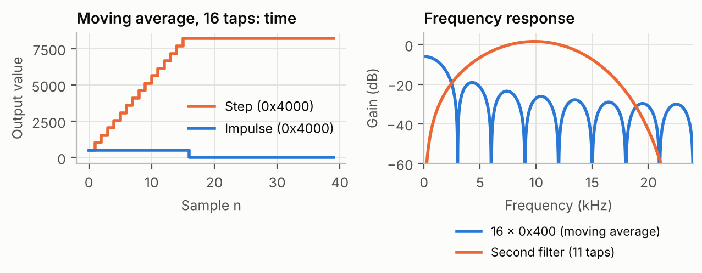
Figure 1. firmacd2. Left: impulse and step responses (input 0x4000). Right: frequency response of the 16-tap filter and of the second filter given at the end of firmacd.asm.
What it means.
- Impulse response: 16 samples of 512 (0x200), then zeros. The impulse response of an FIR filter is its list of coefficients: 0x4000 × 0x400 × 2 / 65536 = 512. This answers question 5 of the handout.
- Step response: a ramp of 16 steps of 512 up to 8192 = 0x4000 × 0.5. The filter is a moving average over 16 samples; its DC gain is 16 × 1/32 = 0.5, that is -6.02 dB (question 7).
- Frequency response: a low pass with a sinc shape (|sin(16πf/Fs) / sin(πf/Fs)|), with zeros every Fs/16 = 3 kHz and a first side lobe only 13 dB below the DC gain. A moving average is a crude low pass: very simple, but not selective.
- Second filter (794, 1082, −4324, …): its coefficients are symmetric, so it has linear phase, and they sum to zero, so its gain at DC is zero. It is a band pass centred on about 9.8 kHz (gain +1.5 dB), with −3 dB points at 6.8 and 12.9 kHz (question 8).

3.2 Number of bits (sampling_bits)
What is tested. A 1031 Hz sine of amplitude 32000 (almost full scale) goes through the program with switch values 0 to 11, which keep 16 down to 5 bits.
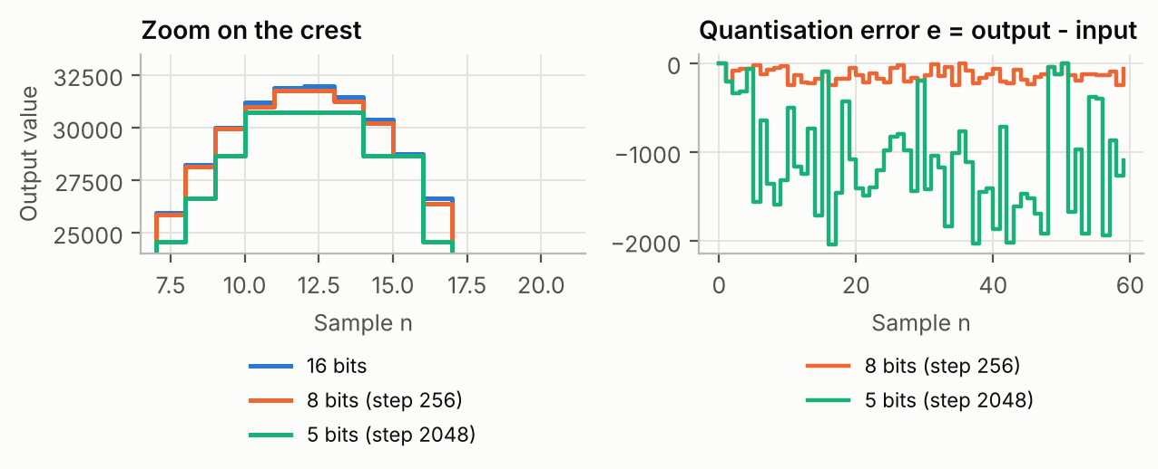
Figure 2. sampling_bits. Left: the crest of the sine with 16, 8 and 5 bits. Right: quantisation error e(n) = output − input for 8 and 5 bits.
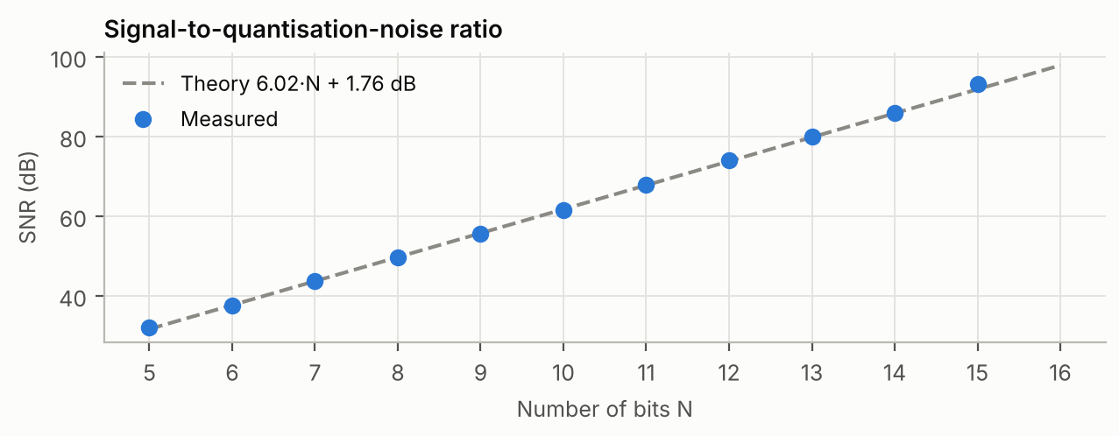
Figure 3. Measured signal-to-noise ratio for each number of bits, compared with 6.02·N + 1.76 dB (corrected for the amplitude 32000 / 32768).
Table 3. Quantisation: step size, measured SNR and mean error
Bits N | Switch | Step q | SNR measured | SNR theory | Mean error
15 | 1 | 2 | 93.1 dB | 91.9 dB | -0.5
12 | 4 | 16 | 74.0 dB | 73.8 dB | -7.1
10 | 6 | 64 | 61.6 dB | 61.8 dB | -31.3
8 | 8 | 256 | 49.6 dB | 49.7 dB | -128.6
6 | 10 | 1024 | 37.5 dB | 37.7 dB | -500.6
5 | 11 | 2048 | 32.1 dB | 31.7 dB | -1036.6

What it means.
- The SNR falls by 6 dB per bit removed, exactly as equation (2) predicts: 74 dB at 12 bits, 50 dB at 8 bits, 32 dB at 5 bits. On the crest of the sine, the 5-bit signal is a visible staircase of steps of 2048.
- The error is always negative and its mean is close to −q/2 (−128.6 for q = 256). This is the signature of truncation by a mask instead of rounding: the noise power is the same, but a DC offset of half a step is added.
- For a pure tone, quantisation noise is not really random: it is correlated with the signal and appears as harmonics. This is why very low bit depths tend to sound harsh rather than just noisy (question 10).

3.3 Sampling rate and aliasing (sampling_rate)
What is tested. The program keeps one input sample every k (k = 2 to 24) and holds it, which is equivalent to sampling at Fs' = 48 kHz / k followed by a zero-order hold. Sines of 500 Hz and 3000 Hz were applied, then 95 frequencies from 100 Hz to 23.6 kHz at Fs' = 8 kHz and 2 kHz, measuring the main output frequency each time.
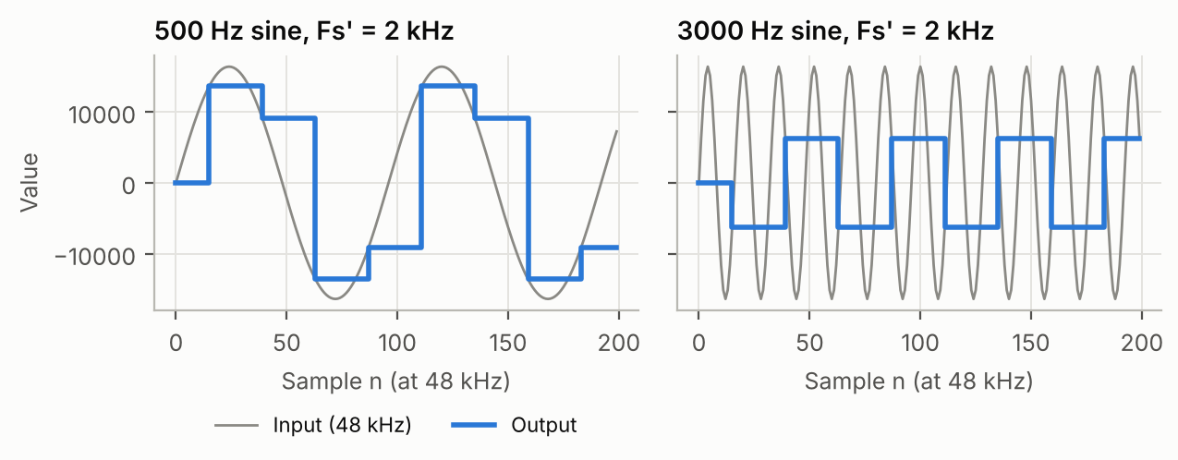
Figure 4. sampling_rate, switch 12 (Fs' = 2 kHz). Left: a 500 Hz sine is correctly represented (staircase). Right: a 3000 Hz sine becomes a 1000 Hz signal.
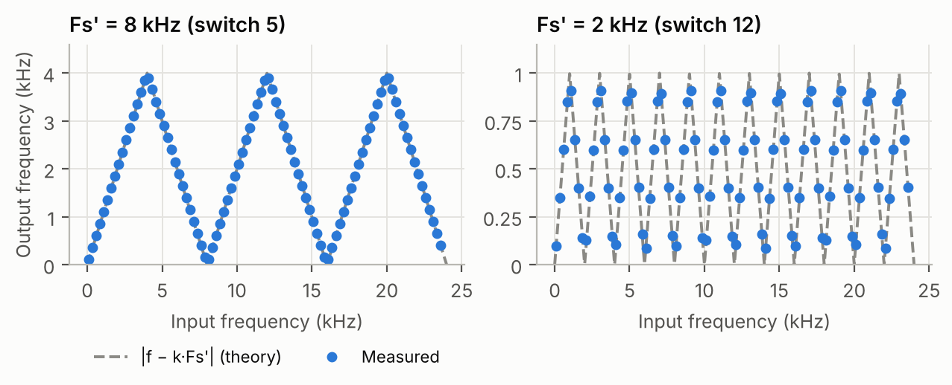
Figure 5. Output frequency versus input frequency for Fs' = 8 kHz and 2 kHz. The dots are measured, the dashed line is equation (1).
Table 4. Main output frequency for a 500 Hz and a 3000 Hz input
Switch | Fs' | Input 500 Hz | Input 3000 Hz | Expected for 3000 Hz
0 | 48 kHz | 498 Hz | 3000 Hz | 3000 Hz
1 | 24 kHz | 498 Hz | 3000 Hz | 3000 Hz
3 | 12 kHz | 498 Hz | 3000 Hz | 3000 Hz
5 | 8 kHz | 498 Hz | 3000 Hz | 3000 Hz
9 | 4.8 kHz | 498 Hz | 1799 Hz | 1800 Hz
12 | 2 kHz | 504 Hz | 1002 Hz | 1000 Hz

What it means.
- As long as f < Fs'/2, the frequency is preserved; the hold only adds a staircase (images around multiples of Fs').
- When f > Fs'/2 the output frequency folds back: 3000 Hz becomes 1800 Hz at Fs' = 4.8 kHz and 1000 Hz at Fs' = 2 kHz. Figure 5 shows the characteristic zig-zag: the output rises from 0 to Fs'/2, falls back to 0 at Fs', rises again… every measured point lies on equation (1).
- The amplitude of the alias also depends on the sampling phase: on Figure 4 (right) the 3000 Hz sine is always sampled close to a zero crossing, so the 1000 Hz output is small (about 6300 instead of 16384).
- This is why the anti-aliasing filter must act before sampling: once folded, an alias cannot be separated from a real signal at the same frequency.

3.4 FIR filters designed with windows (fir_windows)

Coefficients
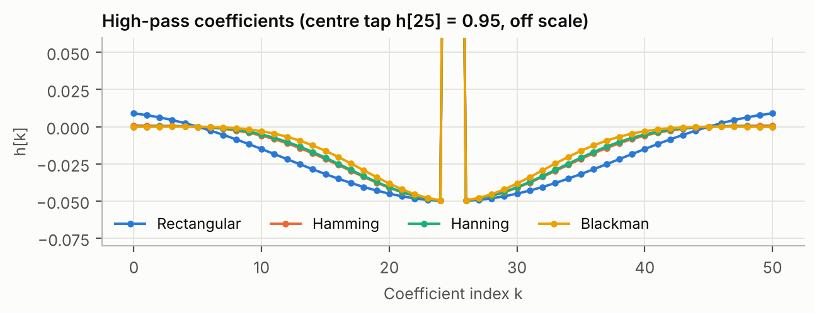
Figure 6. The 51 coefficients of the 1200 Hz high-pass filters. The tapered windows bring the ends smoothly to zero; the rectangular window cuts them abruptly.
Kaiser filter. In the lab files, Kaiser_High_Pass_Filter_1200Hz.h contains exactly the same 51 values as Rectangular_High_Pass_Filter_1200Hz.h (already in the original C54 files), although its header describes a Kaiser design. Switches 5 and 10 therefore give the same results as switches 1 and 6, and the Kaiser window is not shown separately.

High-pass filters (switches 1 to 4)
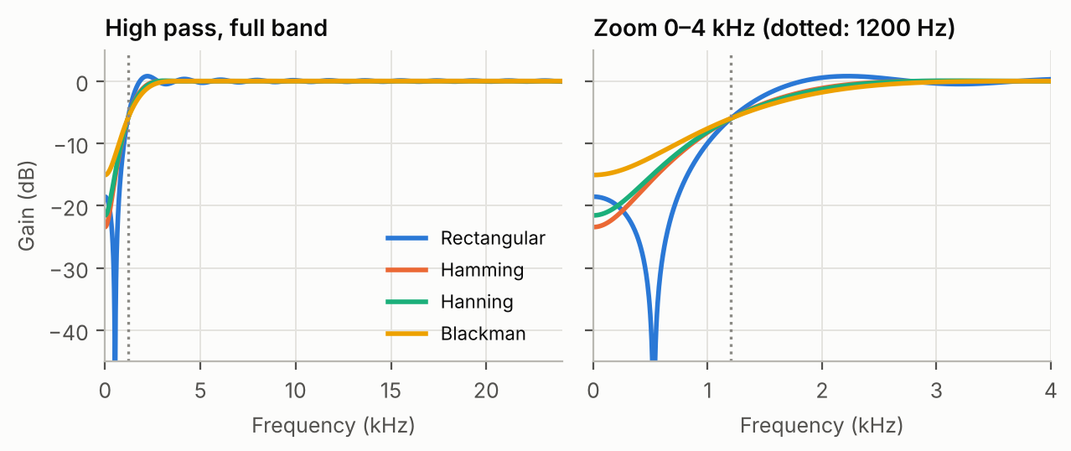
Figure 7. Frequency response of the 1200 Hz high-pass filters (assembly channel, impulse method). Right: zoom on 0–4 kHz.
Table 5. High-pass filters: measured characteristics
Window | −6 dB point | −3 dB point | Gain at 0 Hz | Passband ripple
Rectangular | 1217 Hz | 1448 Hz | -18.5 dB | ≈ ±1 dB
Hamming | 1205 Hz | 1589 Hz | -23.5 dB | < 0.1 dB
Hanning | 1205 Hz | 1612 Hz | -21.6 dB | < 0.1 dB
Blackman | 1201 Hz | 1697 Hz | -15.1 dB | < 0.1 dB

What it means.
- All four filters cross −6 dB at 1200 Hz: with the window method the cutoff frequency is the half-amplitude point, whatever the window.
- The transition is wide (from about 0.5 to 2.5 kHz) and the attenuation at low frequency is only 15 to 24 dB. With 51 taps at 48 kHz the transition width (≈ 3 kHz for Hamming, Table 2) is larger than the cutoff itself, so the stopband [0, 1200 Hz] is entirely inside the transition. The windows cannot show their stopband quality here; the Blackman filter, which has the widest main lobe, is even the worst at 0 Hz. Reaching about 50 dB below 600 Hz with a Hamming window would need roughly 130 taps (N ≈ 3.3·Fs/Δf with Δf ≈ 1.2 kHz).
- The rectangular window gives the steepest slope and a deep notch near 500 Hz, but ripples (overshoot of about +1 dB around 2.2 kHz): the Gibbs phenomenon.

Low-pass filters from the same coefficients (switches 6 to 10)
The dual filter computes the high-pass output yHP(n) and returns, in the low 16 bits, x(n − 25) − yHP(n): the delayed input minus the high pass. By spectral inversion this is a 1200 Hz low pass, obtained without a second set of coefficients.
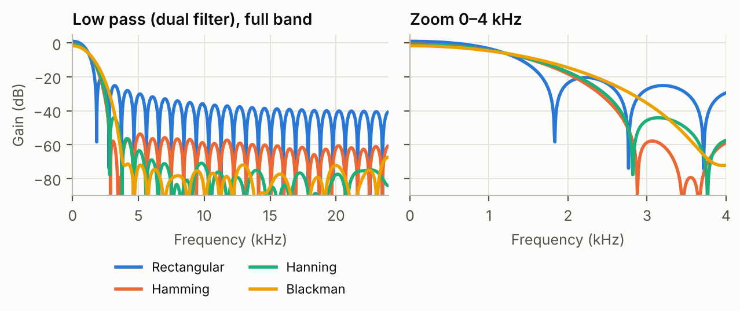
Figure 8. Low-pass filters obtained with the dual filter (switches 6 to 9). Left: full band. Right: zoom on 0–4 kHz.
Table 6. Low-pass filters: measured characteristics
Window | −3 dB point | Gain at 0 Hz | Highest side lobe above 5 kHz
Rectangular | 866 Hz | 0.97 dB | −31.1 dB
Hamming | 912 Hz | -0.60 dB | −53.1 dB
Hanning | 919 Hz | -0.76 dB | −62.7 dB
Blackman | 1001 Hz | -1.68 dB | −65.7 dB

What it means. In the low pass the stopband is far from the cutoff, so the windows show their textbook behaviour: the rectangular window has side lobes at −20 dB near 2.2 kHz and still −31 dB above 5 kHz; Hamming reaches −53 dB, Hanning −63 dB and Blackman −66 dB, close to the values of Table 2. In return the transition widens from rectangular to Blackman (Figure 8, right). Blackman's floor is also limited by the 16-bit coefficients and samples.

Low pass and high pass at the same time (switch 11)
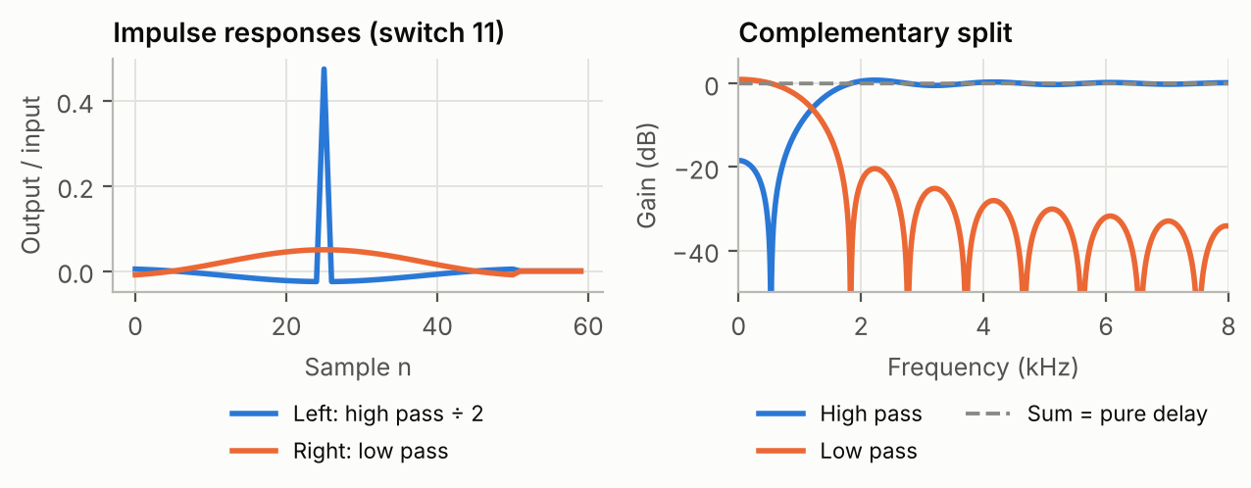
Figure 9. Switch 11: the left channel receives the high pass (divided by 2), the right channel the low pass. Their sum is a pure delay of 25 samples (flat 0 dB).
What it means. The two outputs are complementary: their sum is exactly the input delayed by 25 samples. This is the principle of a two-way loudspeaker crossover: the tweeter receives the high pass, the woofer the low pass, and together they reproduce the original signal. The program divides the high pass by 2 to attenuate the treble.

Assembly versus C (switches 1 to 5)
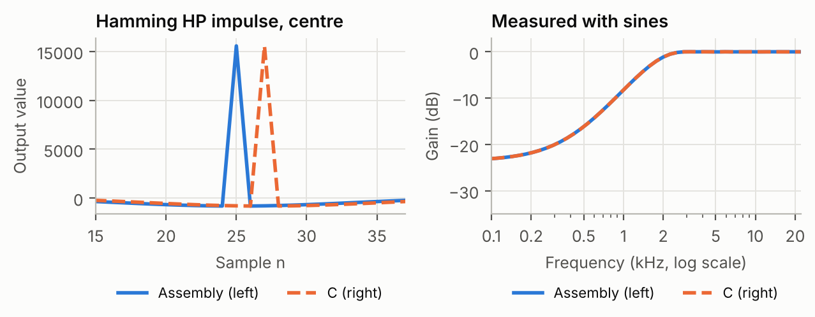
Figure 10. Hamming high pass: assembly routine (left channel) versus C function FIR_filter() (right channel). Left: centre of the impulse response. Right: gain measured with sines.
What it means. Both versions compute the same convolution with the same precision: the measured gains are identical within 0.01 dB (0.16 dB for the rectangular filter), and both give an SNR of about 88 dB on a sine. The difference is in time: the C function stores the new sample after computing the output, and its circular buffer starts one place later, so its output is y(n) = h(0)·x(n−1) + Σ h(k)·x(n−2−k) (k = 0 … 49). The impulse response appears 2 samples later (peak at n = 27 instead of 25). This answers question 15: the C code computes the convolution with a circular buffer and an index j that wraps around, where the assembly shifts the whole buffer (DELAY on the C54, LDH/STH on the C6000) and uses the multiply-accumulate loop.

3.5 IIR filters of order 1 to 5 (IIR_order)

Frequency responses
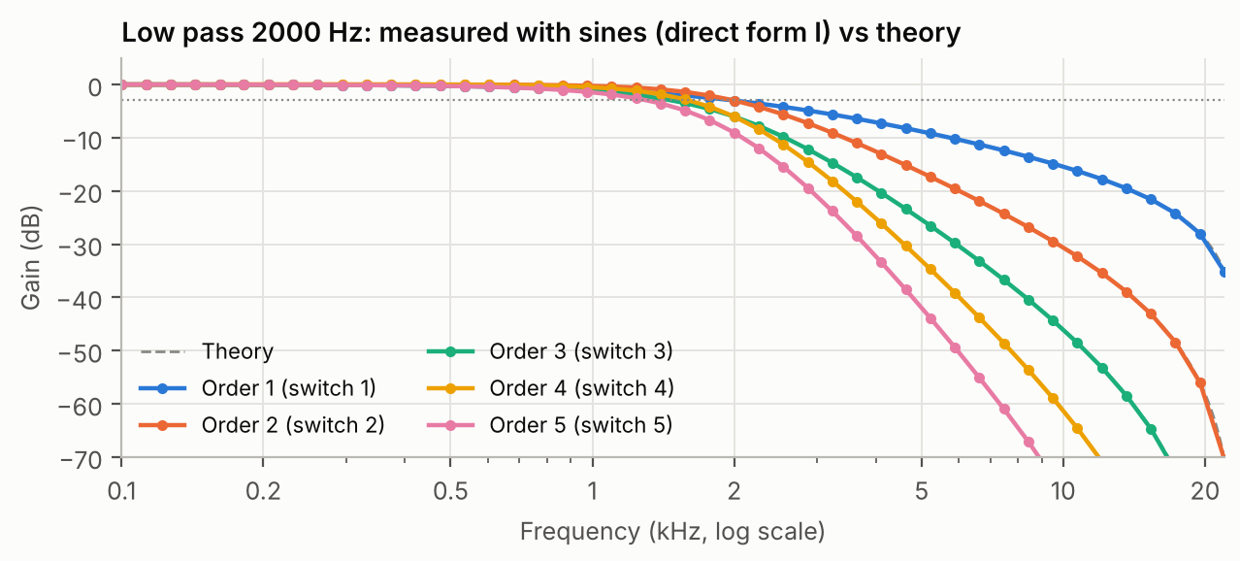
Figure 11. IIR low-pass filters, cutoff 2000 Hz, orders 1 to 5. Dots: gain measured with sines on the direct form I channel. Dashed: theoretical response computed from the coefficients.
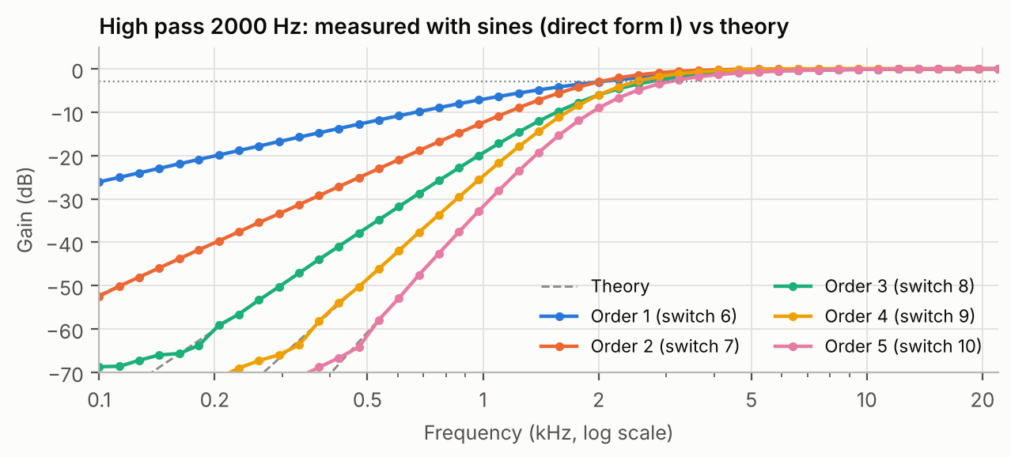
Figure 12. IIR high-pass filters, cutoff 2000 Hz, orders 1 to 5 (direct form I, measured with sines) and theory.
Table 7. IIR filters: −3 dB frequency and attenuation (theory, confirmed by measurement within 0.5 dB)
Order | Low pass: switch | −3 dB | Gain at 8 kHz | High pass: switch | −3 dB | Gain at 500 Hz
1 | 1 | 1995 Hz | -13.1 dB | 6 | 2005 Hz | -12.4 dB
2 | 2 | 1998 Hz | -25.7 dB | 7 | 2002 Hz | -24.3 dB
3 | 3 | 1477 Hz | -38.7 dB | 8 | 2703 Hz | -36.6 dB
4 | 4 | 1607 Hz | -51.4 dB | 9 | 2487 Hz | -48.5 dB
5 | 5 | 1312 Hz | -64.4 dB | 10 | 3037 Hz | -60.9 dB

What it means.
- The measured gains agree with the theoretical responses within 0.5 dB for every filter: the fixed-point implementation reproduces the designed filters.
- Each order adds about 12 to 13 dB of attenuation at 8 kHz (low pass) or 500 Hz (high pass), that is about 6 dB per octave per order (8 kHz is two octaves above 2 kHz): −13 dB for order 1, −26 dB for order 2, −51 dB for order 4.
- Orders 1 and 2 have their −3 dB point at 2000 Hz as designed. The cascades do not: order 4 is the same second-order section twice, so it is −6 dB at 2000 Hz and its −3 dB point moves to 1607 Hz (low pass) or 2487 Hz (high pass). A true 4th-order Butterworth at 2000 Hz would need two different sections.
- The cost is very low: the 4th-order filter needs 14 multiplications per sample in direct form I, the FIR filters 51. This efficiency is the main reason for using IIR filters.

Step responses
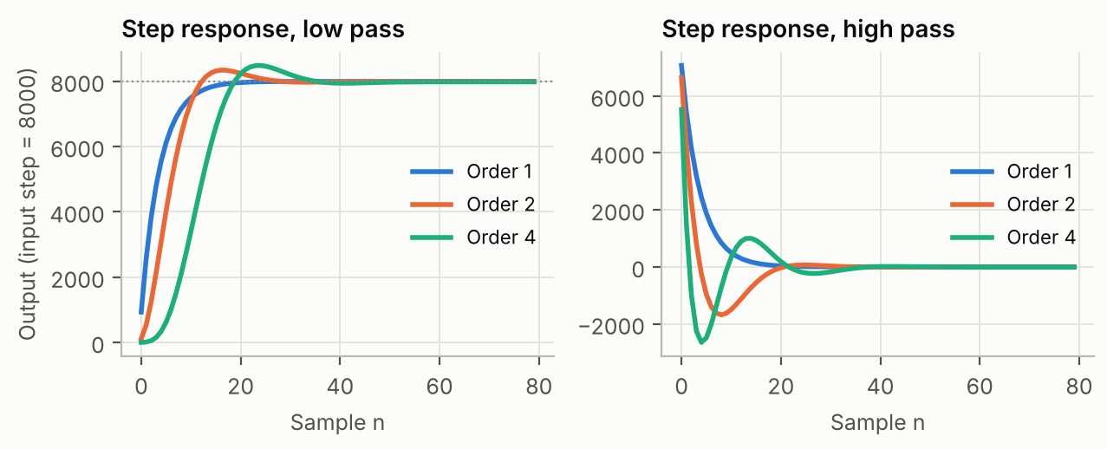
Figure 13. Step responses (input step of 8000) of the low-pass (left) and high-pass (right) filters of order 1, 2 and 4.
What it means. The first-order low pass rises exponentially without overshoot. The second-order section overshoots by 4.4 %, which is the classic value for a Butterworth filter (4.3 %), and the 4th-order cascade by 6.3 %. Higher orders are more selective in frequency but ring longer in time. The high-pass filters let the edge through and then return to zero: a high pass has zero gain at DC. Their final value is −5 to −13 instead of 0: a small offset caused by truncation (>> 15 rounds down).

Direct form I versus direct form II
The left channel uses direct form I and the right channel direct form II with the same coefficients. Their gains are identical, but their noise is not.
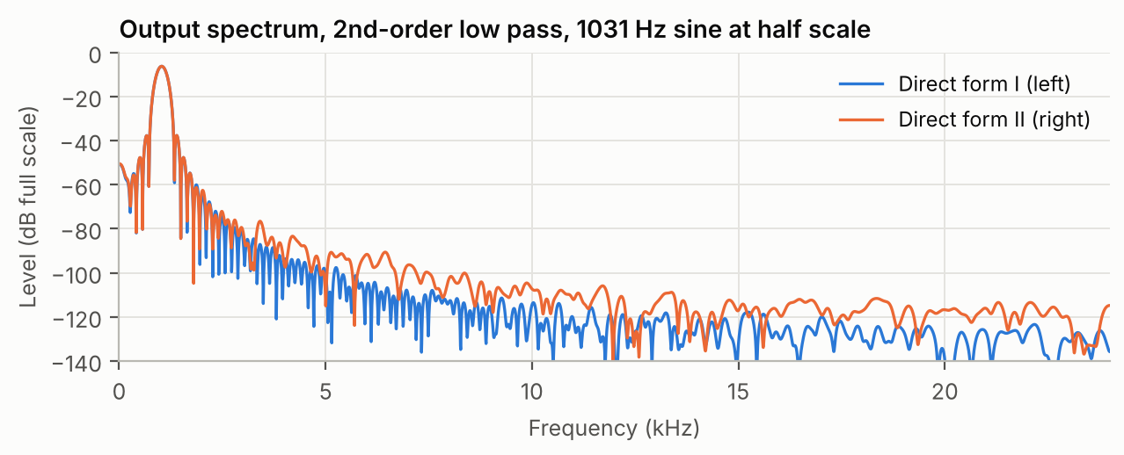
Figure 14. Output spectrum of the second-order low pass (switch 2) for a 1031 Hz sine at half scale. Direct form II has a higher noise floor.
Table 8. Output signal-to-noise ratio of the two structures (sine input)
Filter | Input level | SNR direct form I | SNR direct form II | DC offset I / II
2nd-order low pass (switch 2) | half scale | 77.2 dB | 60.2 dB | -8 / -65
2nd-order low pass (switch 2) | −30 dB | 54.2 dB | 37 dB | -9 / -63
4th-order low pass (switch 4) | half scale | 75.8 dB | 65 dB | -17 / -65
2nd-order high pass (switch 7) | half scale | 78 dB | 50.4 dB | -9 / 0
2nd-order high pass (switch 7) | −30 dB | 53.2 dB | 26 dB | -8 / 0
4th-order high pass (switch 9) | half scale | 76.1 dB | 53.5 dB | -10 / -1

What it means. Direct form II is 9 to 28 dB noisier than direct form I and, for the low pass, adds an offset of about −65 LSB. In direct form II the input is divided by 128 (second order) before the recursion to avoid overflow of w(n), which throws away 7 bits of the input; the truncation errors inside the loop are then amplified by the poles and by the final ×128. Direct form I keeps the full input precision and uses a 32-bit accumulator, so its noise stays near the 16-bit limit (about 76 dB here). Direct form II saves memory, but in fixed point direct form I is more accurate.

Phase: FIR versus IIR
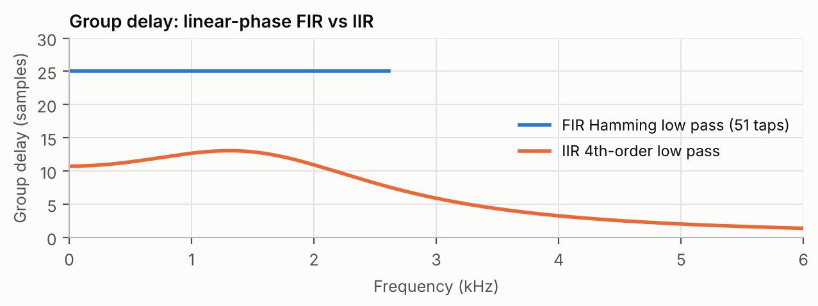
Figure 15. Group delay (delay of each frequency, in samples) of the 51-tap Hamming FIR low pass and of the 4th-order IIR low pass. The FIR curve is shown only where its gain is above −40 dB.
What it means. The symmetric FIR delays every frequency by exactly 25 samples (0.52 ms): its phase is linear and the waveform keeps its shape. The IIR delays frequencies by 11 to 13 samples in the passband and less above: its phase is not linear, so a complex signal is slightly distorted (different frequencies arrive at different times). For audio this is usually inaudible; for data transmission or measurement, the FIR's linear phase can be essential.

4. Conclusions
- Sampling: a frequency above Fs/2 folds back to |f − k·Fs|, exactly as measured on 95 frequencies. The anti-aliasing filter must act before sampling.
- Quantisation: each bit is worth 6 dB of SNR (measured 32 dB at 5 bits, 74 dB at 12 bits). Truncating with a mask adds a −q/2 offset.
- FIR filters: the impulse response is the coefficient list, the phase is linear (delay 25 samples), and the window sets the trade-off between transition width and stopband attenuation (rectangular −31 dB, Hamming −53 dB, Blackman −66 dB in the low pass). With 51 taps at 48 kHz, a 1200 Hz cutoff is too low for the high pass to reach a real stopband.
- IIR filters: a few coefficients give a steep response (−51 dB at 8 kHz for order 4), at the cost of a non-linear phase, an overshoot and a sensitivity to fixed-point effects. Direct form I is 9 to 28 dB less noisy than direct form II in this code.
- Implementation: the C and assembly versions compute the same filters with the same precision; the assembly versions are the efficient form for real time (one MAC per coefficient), and in our tests the C6000 port gives the same output as the C5416 code, sample for sample.

Appendix: how to reproduce the figures
In WSL (Ubuntu), in the TPC6000/pc_test folder: run make once, then one command per test, then python3 plot.py to plot sim_output.csv. Arguments: switch value, signal (0 impulse, 1 step, 2 sine, 3 noise, 4 sweep), sine frequency in Hz.
Figure | Command
2, 3 | ./sampling_bits 8 2 1031 (switches 0 to 11)
4 | ./sampling_rate 12 2 500 and ./sampling_rate 12 2 3000
5 | ./sampling_rate 5 2 <f> and ./sampling_rate 12 2 <f>
7 | ./fir_windows 1 0 … ./fir_windows 4 0
8 | ./fir_windows 6 0 … ./fir_windows 9 0
9 | ./fir_windows 11 0
10 | ./fir_windows 2 0 (left = assembly, right = C)
11, 12 | ./IIR_order 1 2 <f> … ./IIR_order 10 2 <f>
13 | ./IIR_order 1 1, 2 1, 4 1, 6 1, 7 1, 9 1 (step)
14 | ./IIR_order 2 2 1031

The report used an amplitude of 32000 for Figures 2 and 3 and a step of 8000 for Figure 13; pc_test uses 0x4000 by default (change sim_amplitude at the top of sim/sim_board.c to match). The other figures use 0x4000 (16384).
Figure 1 uses the firmacd2 data (infir.dat and a step file); its frequency responses and Figure 15 are computed from the coefficients.

