Fouchger Homelab
User Manual (v0.1) | 25 January 2026
This manual explains how to install and operate the fouchger_homelab interactive CLI application on Debian/Ubuntu hosts (including Ubuntu 24.04+ LXC on Proxmox).

1. What the application does
fouchger_homelab is an interactive, menu-driven CLI that helps you bootstrap and manage common tooling for a homelab environment. It provides guided flows for Git and GitHub configuration, a development server bootstrap path, an Ubuntu App Manager for selecting and applying packages and tools, and a debug area for session capture.

2. Prerequisites
- A Debian/Ubuntu-based system. Ubuntu 24.04+ is the primary target for the App Manager flows.
- Network access for package installs and any third-party installers you choose to run.
- sudo access (or run as root) for installing packages and writing system-level changes.
- A terminal that can display dialog-style interfaces (the UI uses dialog under the hood).

3. Installation
There are two common ways to run the tool: directly from a cloned repository, or via the one-liner installer referenced in the repo README.

3.1 Install from the repository
- Clone the repository to your target host.
- From the repo root, run: make menu
- If you do not have make installed, install it first (sudo apt-get install -y make) or run the entry point directly: ./bin/homelab

3.2 Install via installer script
The README references a curl-based installer. Treat this as a privileged action and review the script before running it in production environments.
Command: bash -c "$(curl -fsSL https://raw.githubusercontent.com/Fouchger/fouchger_homelab/main/install.sh)"

4. First-run quick start
- Launch the application (make menu or ./bin/homelab).
- Select 'Git & Github Management' to configure your git identity and authenticate GitHub CLI (gh).
- Select 'Bootstrap Development Server (admin01)' if you are standing up a dev box and want Code-Server and baseline tooling.
- Open 'Debug' to enable session capture if you want full terminal recording (optional).
- Use 'Ubuntu App Manager' to pick a profile, adjust selections, and then apply installs.

5. Navigating the menus
The current menu map is below. Menu options may be gated by feature flags stored in your state file.
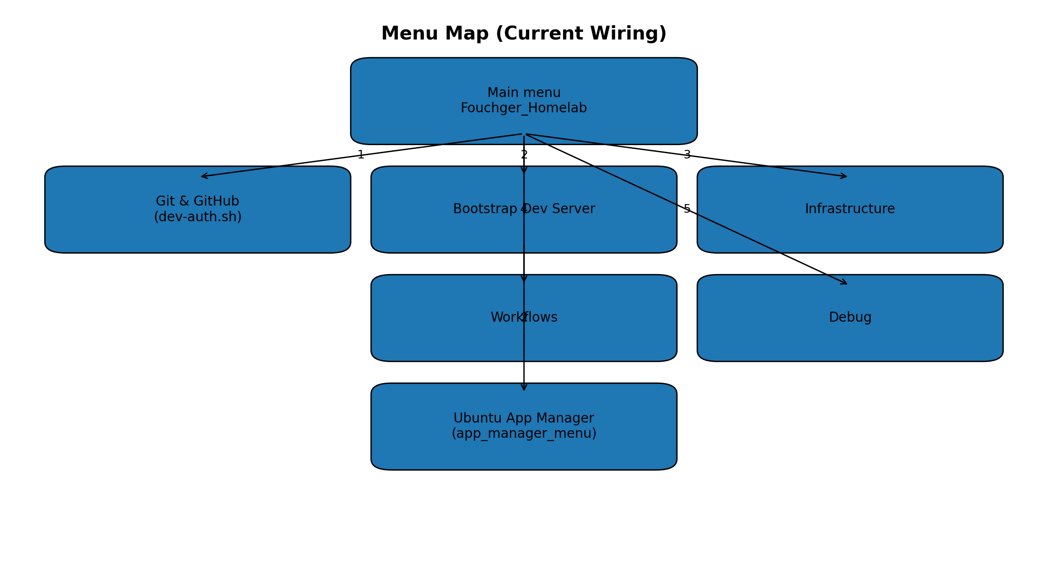

6. Main menu options

6.1 Git & GitHub Management
Runs the developer authentication helper to set global git identity (safe-by-default) and authenticate GitHub CLI (gh).
Tip: For non-interactive runs, supply environment variables such as GIT_USER_NAME, GIT_USER_EMAIL, and GITHUB_TOKEN.

6.2 Bootstrap Development Server
Provides a guided flow for bootstrapping a dev server. One option downloads and runs a third-party Code-Server installer. The second option leads into the Ubuntu App Manager to install baseline tooling.
Control: the tool will prompt before running third-party scripts.

6.3 Infrastructure and Workflows
These menu areas are wired for future capability modules (Proxmox templates, MikroTik integration, DNS services, questionnaires). They are feature-flagged and may display enablement instructions if disabled on the host.

6.4 Debug
Includes controls for Layer 2 session capture via ptlog (Pentest-Terminal-Logger). When enabled, the tool will attempt to start ptlog automatically on next launch and provide status views and log tails.

7. Ubuntu App Manager (step-by-step)
The App Manager helps you maintain a repeatable set of packages and tools for Ubuntu 24.04+ hosts, especially LXC containers. It stores selections and version pins in an env file and tracks installed-by-tool items using marker files.

7.1 Apply a profile (replace selections)
- Open: Bootstrap Development Server (admin01) then 'Bootstrap server - Configs and Setup' to enter the App Manager menu.
- Choose 'Apply profile (replace selections)'.
- Select a profile (for example Basic, Dev, Automation, Platform).
- Confirm the action. This overwrites prior selections in app_install_list.env with the profile defaults.
- Optionally adjust selections using 'Change selections' before applying.

7.2 Apply a profile (add to selections)
- Choose 'Apply profile (add to selections)'.
- Select a profile. The profile apps will be added to your current selection set.
- Review the updated selection list if prompted, then continue.

7.3 Change selections
- Choose 'Change selections'.
- Tick or untick apps using the checklist.
- Save and return to the App Manager menu.

7.4 Edit version pins
- Choose 'Edit version pins'.
- Set versions to 'latest' or a specific value (where supported).
- Save. Version pins are written to app_install_list.env and used by installers that support pinning.

7.5 Apply install/uninstall
- Choose 'Apply install/uninstall'.
- The tool will compute the delta between selected apps and currently installed-by-tool markers.
- Confirm to proceed. Package installs use nala when available (apt-get fallback).
- When complete, review the log file if anything failed.

7.6 Audit which apps are installed
Choose 'check which apps are installed' to see what the App Manager believes is installed, based on markers and strategy checks.

8. Where files are stored
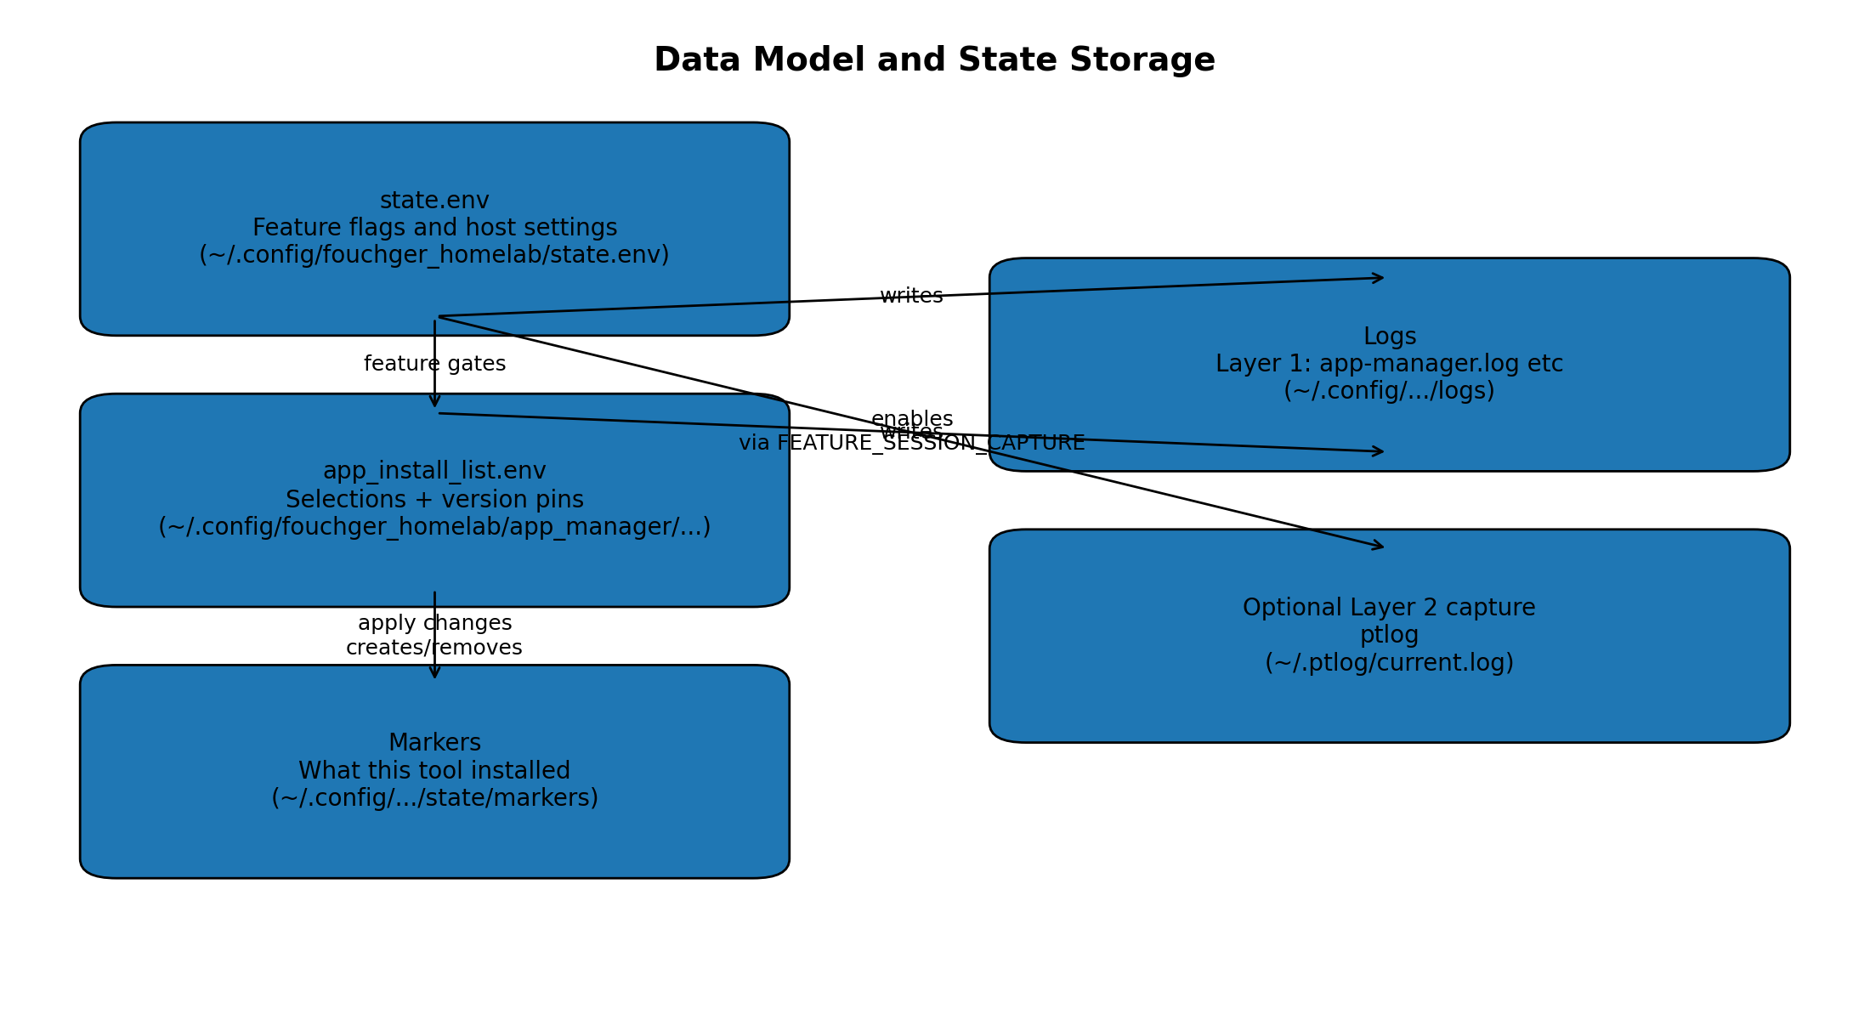
Key paths (defaults):
- ~/.config/fouchger_homelab/state.env (feature flags, host settings)
- ~/.config/fouchger_homelab/app_manager/app_install_list.env (selections and version pins)
- ~/.config/fouchger_homelab/app_manager/app-manager.log (Layer 1 logs)
- ~/.config/fouchger_homelab/state/markers (installed-by-tool markers)
- ~/.ptlog/current.log (optional Layer 2 session capture log)

9. Troubleshooting
- The UI does not open: Ensure dialog is installed and you are in an interactive terminal. If needed, install dialog: sudo apt-get install -y dialog.
- Installs fail due to permissions: Run as root or ensure sudo is available and your user is in the sudo group.
- GitHub auth fails: Check gh is installed and your token has appropriate scopes for your workflow. For GHES, ensure GH_HOST is set.
- Session capture does not start: Install ptlog and enable the feature flag: state_set FEATURE_SESSION_CAPTURE 1, then relaunch the app.

10. Operational guardrails
The tool aims to be safe-by-default, but it can install packages and run scripts with elevated privileges. In a corporate environment, treat it like any other automation: review changes, pin versions when stability matters, and apply in lower environments first.
Document generated from repository snapshot: fouchger_homelab-main (25 January 2026).

