FOUAD HAMMANI
Software Engineer | Full‑Stack Developer

✉Fouadhammani94@gmail.com| ☎ +1 613 302 6686 | Ottawa, Ontario, Canada (Avaible for relocation)
Links:  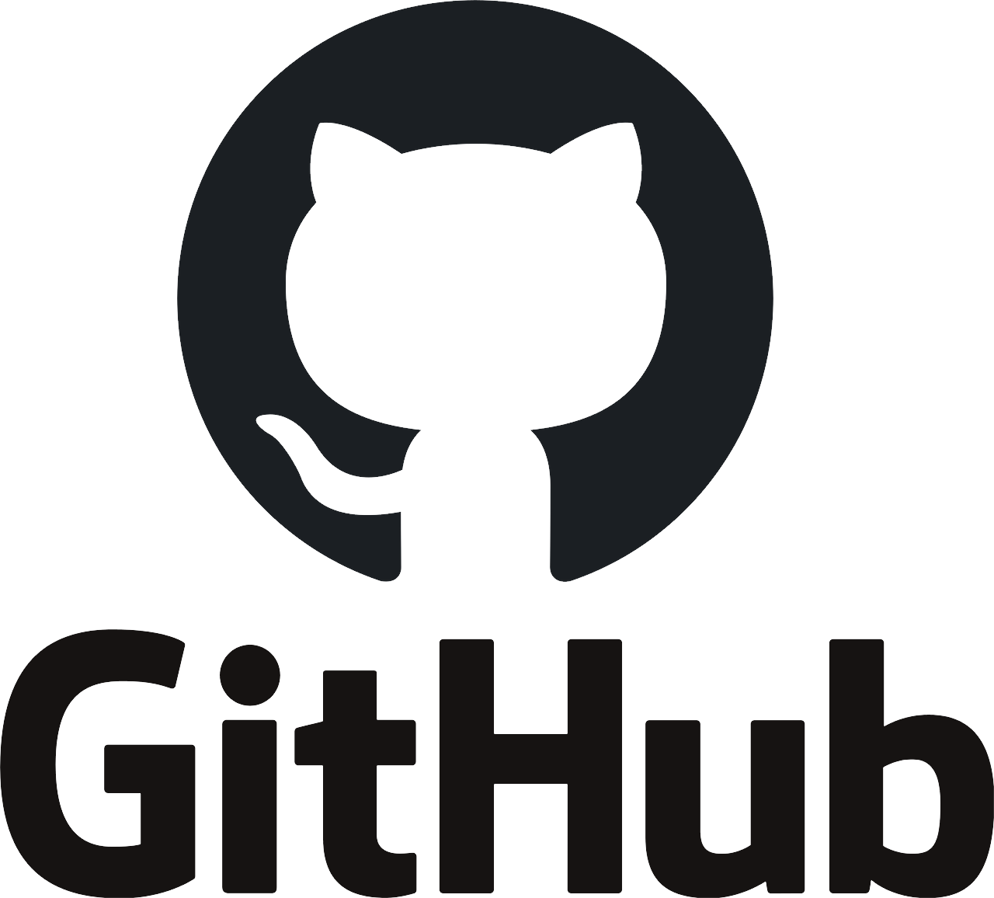 Portfolio
PROFESSIONAL SUMMARY
MSc Solution‑oriented Software Engineer with 3+ years of experience in full‑stack development, 2 years as commercial and technical support and 3 years in data analysis, automation, and AI integration. Strong background in Python, React, Django, and Laravel, with proven delivery of scalable ERP, SaaS, and AI‑powered systems in B2B and B2C contexts. Seeking impactful software roles in Canada.

TECHNICAL SKILLS
- Languages & Frameworks: Python, JavaScript, TypeScript, PHP, React, Django, Django REST, Laravel, Next.js, React Native (basic), Kivy, Electron, Inertia.js, Tailwind CSS
- Databases & Data: PostgreSQL, MySQL, SQLite, MongoDB, SQLAlchemy, Pandas
- AI & Automation: Selenium, Playwright, Ollama (local LLMs), Hugging Face
- DevOps & Tools: Docker, Git, GitHub, Linux, Nginx, Gunicorn, CI/CD, REST APIs, AWS & Azure (basic)
- Security & Architecture: JWT, OAuth2, OWASP, CSRF/XSS Protection, MVC, Microservices, Agile/Scrum
PROFESSIONAL EXPERIENCE
Full‑Stack Developer — ACI (Agro Consulting International) | Jan 2025 – Present
- Designed and deployed a full ERP platform using Laravel, React, Inertia.js, MySQL, and Docker.
- Improved inventory and supplier operations by 30% through automation and dashboards.
- Converted the web platform into a desktop application using Electron.
- Deployed secure HTTPS services and modularized monolithic architecture into APIs.
Full‑Stack Developer (Freelance) — Remote | Jan 2024 – Present
- Built a secure e‑commerce platform with Django, OAuth2/JWT authentication, admin dashboards, and PostgreSQL, deployed on Linux VPS with Docker.
- Developed a Streamlit global statistics app handling 10k+ data points.
- Created a local AI assistant using Kivy UI and Ollama LLM.
- Extended web platforms to mobile using React Native and Expo.
Showroom Commercial Manager — Samsung (B2B/B2C) | Jul 2023 – Jan 2024
- Trained sales teams on ERP (Odoo) and product demos, increasing conversions by 20%.
- Expanded B2B partnerships by onboarding 15 new clients.
Technical & Commercial Support — Free Telecom / WebHelp / Concentrix | Jul 2022 – Jul 2023
- Managed CRM systems and technical incidents with 95% customer satisfaction KPIs.
- Ranked commercial leader for 8 consecutive months through upselling strategies.
Data Analyst Assistant — Bouzar Pharma | May 2019 – Jun 2022
- Managed pharmaceutical stock and analytics using Excel, CSV pipelines, and Power BI.
- Reduced supply shortages by 25% through data‑driven purchasing insights.
EDUCATION
MSc in Software Engineering — GoMyCode / Woolf University (Online) | Expected 2026
Bachelor in Computer Science (Databases) — INSFPTB | 2021
L1 Science & Technology — Houari Boumédiène University | 2017
CERTIFICATIONS & TRAININGS
• Python & Django Certification — W3Schools
• Full‑Stack Web Developer Training — Sonelgaz
• Soft Skills & Canadian Workplace Culture — SOPA Pre‑Arrival Program
• B2 English Certification — Islington Centre
LANGUAGES
English (Upper‑Intermediate) | French (Native) | Arabic (Native)

