Section 1: theoretical model
We want to study parallel algorithm (sum of N numbers), the final model is:
T_p= T_{comp}*(P -1 + n/P) + T_{read} + 2(P-1)*T_{comm}
with:
T_{comp} =2*10^{-9}
T_{read}= 1*10^{-4}
T_{comm}= 1*10^{-6}

For which values of N do you see the algorithm scaling ? For N>>1000
For which values of P does the algorithm produce the best results ?
In the following plots you find the values of P that work to the best
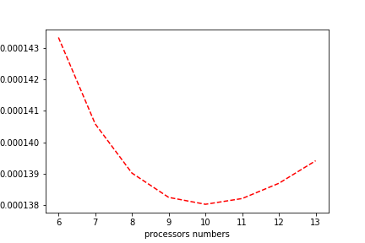
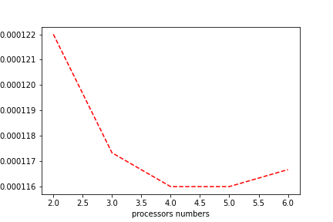

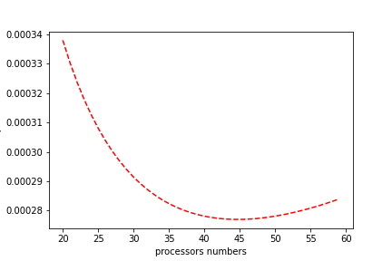
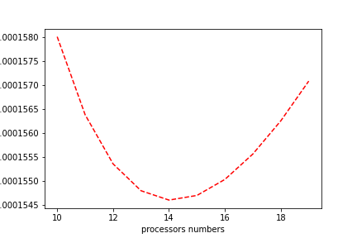
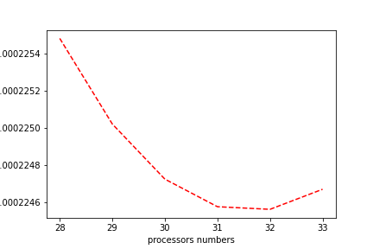

N, best P naive algorithm, best P for enhanced algorithm if any

20000, 4, xxx

100000, 10, xxx

200000, 14, xxx

1000000, 32, xxx

20000000, 45, xxx

Section 2 : play with MPI program

