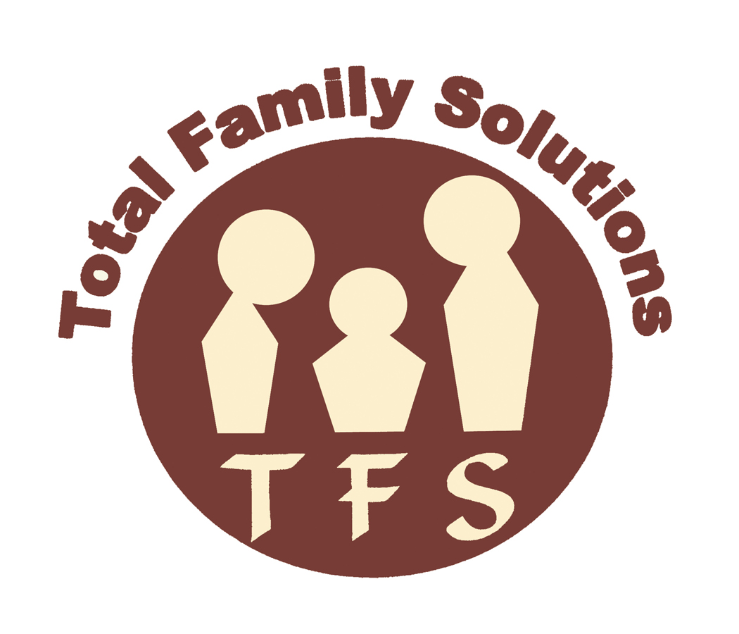

Phone number: (856) 772-5809

221 Laurel Road Suite 102
Voorhees, NJ 08034
“Where Solutions Are the Focus”

WELCOME PACKET FOR FAMILIES

We sincerely appreciate the opportunity to serve you and look forward to working closely with you and your family! Thank you for allowing us to enter the privacy of your home. At Total Family Solutions (TFS), we are committed to providing the highest quality of services, developed individually for you and your family. We will work closely with all professionals who may already be serving your child.

You may be authorized for one or more of the following services:

- Behavioral Assistance
- Intensive In-Home therapy provided by a NJ licensed clinician
- Needs Assessment provided by a licensed clinician

Please take the time to review the enclosed materials in this packet. There are several forms your worker will ask you to sign that must be returned to our office. There is a copy of each of these forms for your records.

Professionalism and Standards

Total Family Solutions Professionals are expected to:

- Treat clients and families with dignity and respect
- Clearly explain all services and their own role and function
- Be a positive role model for your child
- Arrive on time and to work all approved hours
- Provide services related to the plan of care
- Focus on your child and family’s strengths
- Attend and participate fully in child/family team meetings
- Call family if they are unable to keep an appointment or if late
- Dress appropriately and professionally
- Document services in a Daily Progress Note written after each session with your child
- Complete a NJ Service Delivery Form and obtain the parent/guardian signature prior to leaving the home
- Attend supervision to acquire the training and knowledge
- Call their supervisor if they are unsure about a situation or in any emergency
- Call 911 in an extreme emergency; submit and incident report within 24 hours to TFS
- Obtain approval from supervisor for using any media (DVD, videos) or before taking your child to a movie
- Report any incidents of suspected abuse or neglect to the Department of Child Protection & Permanency(DCPP) after consulting with their supervisor or TFS
- Report any behaviors or thought processes that potentially may be harmful to your child, family, or any other individual
- Obtain an appropriate Release of Information prior to speaking with any agency or individual about your child

Professionalism and Standards (continued)

Total Family Solutions Professionals are NOT permitted to:
- Ask the guardian to sign a Service Delivery Form that does not accurately list the start time, end time, and length of time of your session
- Have your child sign the Service Delivery Form unless 14 or older, and with your permission
- Baby-sit, tutor, or teach school subjects to children
- Transport the child unless it has been preauthorized and is part of the plan of care
- Transport the child without the parent/guardian knowing destination, purpose, and time of return
- Take the child anywhere that is not authorized
- Work with more than one child at a time, unless proper authorization has been obtained
- Work before or after the authorized dates of service
- Sell or solicit goods or services to the family
- Included travel time to/from appointments or time required to write notes as part of the session
- Smoke cigarettes at any time during sessions
- Accept personal phone calls during session with your child, nor drive while using a cell phone
- Work another job or engage in personal errands while in session with your child
- Use inappropriate language
- Report to child’s home, meetings, etc. under the influence of drugs or alcohol. If you suspect that the TFS worker is engaging in such activities, please call TFS immediately at (856) 772-5809
- Pay for your child’s recreational activities or meals
- Borrow or accept money from (or loan/give money to) children, youth, families, or school personnel
- Respond to a crisis in the home (when not present) or be on-call. For emergencies, call Perform Care at 877-652-7624
- Reveal personal information about themselves to your child
- Reveal any information about your child or family to anyone, unless you have signed a Release of Information form
- Bring other children or adults to sessions
- Accept gifts or donations
- Maintain contact with your child or family upon termination of services

Quality Assurance

Please be advised that in order to provide the best services, our Quality Assurance department will make random calls to your home.

- Quality Assurance calls will be made at anytime during the period of time services are being provided

- We may also randomly send In-Community Service Documentation Forms for you to verify dates, times, and signatures
- It is critical that you return calls to the Quality Assurance department, so we can maintain open communication with you

- You will receive a survey at the end of services which will help us determine if services were effective

Emergencies and Additional Information about Services

For emergencies or to obtain information about services for your child call PerformCare at 877-652-7624

Phone number: (856) 772-5809

221 Laurel Road Suite 102
Voorhees, NJ 08034

Service Delivery Forms

TFS staff are required to have you sign an In-Community Service Delivery Documentation Form after each session. Below you will find instructions for completing the Service Delivery Documentation Form properly. It is extremely important that you and our staff fill out the form correctly.

- Make sure the “Date of Service,” “Time Started,” and “Time Ended” sections are filled in correctly by the TFS worker before you sign the form. Your TFS worker will inform you as to how many hours and the authorization period they are to work with you and your child.

- Please sign the form at the END of each visit.

- Do not sign form after several visits have taken place, this form must be signed at the end of each session.

- Do not accept Service Delivery Documentation Forms that are not thoroughly and accurately completed.

- Please ensure the day, date, and time match the actual day, date, and time of service(s) provided.

- Remember that Quality Assurance personnel will call to review these forms with you and may randomly return a form for signature verification.

- Please sign the attached form that states you have read the policy for Service Delivery Documentation Forms.

- If the Service Delivery Documentation Forms are not satisfactory to you, please report it to us immediately at (856) 772-5809.

Phone number: (856) 772-5809

221 Laurel Road Suite 102
Voorhees, NJ 08034

AGREEMENT FOR SERVICES Family Copy

I, _______________________________ hereby give my consent for my son/daughter/foster child/ward/family, ______________________________, to be involved with Total Family Solutions’ In-home Program.

I acknowledge that this is a voluntary program and that I have the option to terminate services, if I so desire.

I understand that there may be occasions when agency workers may need to transport my son/daughter/foster child/ward for activities related to program goals. I hereby authorize TFS worker(s) to transport ______________________________.

During the course of services, periodic calls will be made by the Quality Assurance Department at Total Family Solutions.

_________________________________________ _________________
Parent/Guardian Date

_________________________________________ _________________
Witness Date

_________________________________________
Print Child/Client Name

Notice of Privacy Practices Family Copy

This notice describes how information about your care at Total Family Solutions may be used and is shared with others. It also describes how you can get access to this material. Please read this material carefully.

Information regarding your care, including payment for the care, is protected by two federal laws: The Health Insurance Portability and Accountability Act of 1996 (HIPAA), 42 U.S.C. 1320d et seq., 45 C.F.R. Parts 160 & 164 and the Confidentiality Law, 42 U.S.C. 290 dd-2, 42 C.F.R., Part 2. On March 26, 3013 the Health Information Technology for Clinical Health (HITECH) Act revised the privacy and security protections established under HIPAA. Under these laws, Total Family Solutions may not inform anyone outside of Total Family Solutions that you or your family are participating in any program operated by the organization or disclose any protected information except as permitted by federal law.

Total Family Solutions must obtain your written consent before disclosing information about you for payment purposes. Generally, you must also sign a written consent before Total Family Solutions can share information for treatment purposes. However, federal law permits the disclosure of a client’s information in the following circumstances:

- To report a crime on TFS property, to TFS personnel, or on a client’s property
- To appropriate authorities to report suspected child abuse or neglect
- The client threatens suicide or harm to themselves
- The client threatens harm to another person(s), including murder, assault, or other physical damage
- The client reports abuse of the elderly
- The client reports sexual exploitation by a therapist
- The therapist has a duty to warn appropriate institutions, agencies, and/or persons in these instances

The use and disclosure of psychotherapy notes is prohibited without your written authorization.

The use and disclosure of protected health information for marketing purposes is prohibited without your written authorization.

Disclosures that constitute a sale of protected health information require your written authorization.

Before Total Family Solutions can disclose any information about you or your care in a manner, which is not described above, we must first obtain your specific written consent allowing us to make the disclosure. You may revoke any such written consent, at any time, in writing.

YOUR RIGHTS Family Copy

- To request restrictions on how TFS uses or shares your information with others. You have the right to ask us how we use and share your information. We will consider any request you may have to restrict this disclosure. However, we do not have to agree to your request if “routine operations” are impeded in any manner. If we agree to your request, we will put our agreements in writing and follow them, except in emergency situations. We cannot agree to limit the use of sharing information as required by law.
- To choose how TFS contacts you. You have the right to request that we communicate with you in a certain way or in a certain location, if using standard means of communication may endanger you. For example, you may request that we contact you only at your work place. You must make your request in writing. We will agree to your request, as long as it is reasonable to do so.
- To inspect and copy your record. You can submit a written request to see your record and possibly copy your protected information. If we deny your request, we will give you a written reason for the denial and explain your rights to an appeal. In some situations, we may deny access to certain parts of your protected information and you may not appeal that decision. We will not proved access to information collected for legal action. These situations may not be appealed.
- To request changes or corrections to your protected information. If you believe there is a mistake or missing information in you file, you may submit a written request that we change or add to your record. We may deny these requests, if we determine that the information cannot be disclosed. If we deny a request, we will explain the denial, in writing, as well as your right to have your request, our denial, and any statement of disagreement made part of your record.
- To find out what disclosures have been made. You have the right to request a list of disclosures of your information made on and after January 1, 2004.
- To be notified if a breach of your unsecured protected health information occurs.
- To restrict the disclosure of protected health information to a health plan if you have paid out of pocket the full cost of services by submitting a written request.
- To decline receiving fundraising material from Total Family Solutions by placing an “X” on the line below.
______ I do not wish to be contacted for future Total Family Solutions fundraising events.
- Any and all requests must be made in writing.

How to complain about our privacy practices:

If you think that we have violated your privacy rights, you may contact our compliance official, Debbie Riddle, at (856) 772-5809. You may also file a written complaint with the Secretary of the US Department of Health & Human Services Office of Civil Rights, Region II, Jacob Javits Federal Building, 26 Federal Plaza, Suite 3312, New York, NY 10278. We will not discriminate against you in any way for filing any complaint pertaining to this matter.
Effective Date: January 1, 2004

By signing below, I hereby acknowledge that I have received a copy of the Total Family Solutions Notice of Privacy Practices.

Phone number: (856) 772-5809

221 Laurel Road Suite 102
Voorhees, NJ 08034

CLIENT BILL OF RIGHTS Family Copy

- The individuality of each client and their family, shall be respected by all workers. Services will be conducted in a manner that acknowledges each client and their family’s individuality.
- You have the right to privacy and dignity. All information that has been communicated by you or your family to agency workers will be respected, safeguarded, and held in the strictest of confidence.
- You have the right to fully participate in your Plan of Care and will be encouraged to do so.
- You have the right to review your file.
- In the event that medication is recommended, prescribed, or being monitored by our agency, you will receive a written medication information fact sheet for each prescribed medication.
- You have the right to the least restrictive conditions necessary to achieve the goals of the Plan of Care.
- You will not be exposed to non-standard outpatient services, experimentation, or research procedures.
- This agency prohibits discrimination due to race, religion, sex, nationality, sexual orientation, and the ability to pay. Clients are assured the right of exercising civil and religious liberties.
- Clients are not required to perform services for the agency. Clients are not deprived of any constitutional, civil, and/or legal rights solely because of receiving services from this agency.
- Clients who act in aggressive or threatening manner may be terminated from services.
- Services are rendered by appointment only.

CLIENT GRIEVANCE PROCEDURE Family Copy

- All clients have a right to have grievances reviewed in an impartial, non-judgmental manner. Grievances should be initially discussed between the client/family and the TFS worker. If no resolution is reached the client has 10 working days to submit a written grievance to the TFS worker’s supervisor. The supervisor will respond within 5 working days. When these steps do not meet the client’s need, you may request a meeting with the Clinical Director (within 60 days of the filed grievance) 856-772-5809.
- COMPLAINTS ALSO MAY BE LODGED WITH:
  - The Contracted Systems Administrator, Perform Care 877-652-7624
  - DCPP to report abuse or neglect 1-877-NJ Abuse
  - Medicaid Fraud Hotline (888) 937-2835

Phone number: (856) 772-5809

221 Laurel Road Suite 102
Voorhees, NJ 08034

AGREEMENT FOR SERVICES TFS Copy

I, _______________________________ hereby give my consent for my son/daughter/foster child/ward/family, ______________________________, to be involved with Total Family Solutions’ In-home Program.

I acknowledge that this is a voluntary program and that I have the option to terminate services, if I so desire.

I understand that there may be occasions when agency workers may need to transport my son/daughter/foster child/ward for activities related to program goals. I hereby authorize TFS worker(s) to transport ______________________________.

During the course of services, periodic calls will be made by the Quality Assurance Department at Total Family Solutions.

_________________________________________ _________________
Parent/Guardian Date

_________________________________________ _________________
Witness Date

_________________________________________
Print Child/Client Name

Phone number: (856) 772-5809

221 Laurel Road Suite 102
Voorhees, NJ 08034

Child’s Name: ______________________________

Notice of Privacy Practices TFS Copy
This notice describes how information about your care at Total Family Solutions may be used and is shared with others. It also describes how you can get access to this material. Please read this material carefully.

Information regarding your care, including payment for the care, is protected by two federal laws: The Health Insurance Portability and Accountability Act of 1996 (HIPAA), 42 U.S.C. 1320d et seq., 45 C.F.R. Parts 160 & 164 and the Confidentiality Law, 42 U.S.C. 290 dd-2, 42 C.F.R., Part 2. On March 26, 2013 the Health Information Technology for Economic and Clinical Health (HITECH) Act revised the privacy and security protections established under HIPAA. Under these laws, Total Family Solutions may not inform anyone outside of Total Family Solutions that you or your family are participating in any program operated by the organization or disclose any protected information except as permitted by federal law.

Total Family Solutions must obtain your written consent before disclosing information about you for payment purposes. Generally, you must also sign a written consent before Total Family Solutions can share information for treatment purposes. However, federal law permits the disclosure of a client’s information in the following circumstances:
- To report a crime on TFS property, to TFS personnel, or on a client’s property
- To appropriate authorities to report suspected child abuse or neglect
- The client threatens suicide or harm to themselves
- The client threatens harm to another person(s), including murder, assault, or other physical damage
- The client reports abuse of the elderly
- The client reports sexual exploitation by a therapist
- The therapist has a duty to warn appropriate institutions, agencies, and/or persons in these instances
The use and disclosure of psychotherapy notes is prohibited without your written authorization.

The use and disclosure of protected health information for marketing purposes is prohibited without your written authorization.

Disclosures that constitute a sale of protected health information require written authorization.
Before Total Family Solutions can disclose any information about you or your care in a manner, which is not described above, we must first obtain your specific written consent allowing us to make the disclosure. You may revoke any such written consent, at any time, in writing.

Signature______________________________________ Date__________________________

Phone number: (856) 772-5809
221 Laurel Road Suite 102
Voorhees, NJ 08034

YOUR RIGHTS TFS Copy Child’s Name: ______________________________

- To request restrictions on how TFS uses or shares your information with others. You have the right to ask us how we use and share your information. We will consider any request you may have to restrict this disclosure. However, we do not have to agree to your request if “routine operations” are impeded in any manner. If we agree to your request, we will put our agreements in writing and follow them, except in emergency situations. We cannot agree to limit the use of sharing information as required by law.
- To choose how TFS contacts you. You have the right to request that we communicate with you in a certain way or in a certain location, if using standard means of communication may endanger you. For example, you may request that we contact you only at your work place. You must make your request in writing. We will agree to your request, as long as it is reasonable to do so.
- To inspect and copy your record. You can submit a written request to see your record and possibly copy your protected information. If we deny your request, we will give you a written reason for the denial and explain your rights to an appeal. In some situations, we may deny access to certain parts of your protected information and you may not appeal that decision. We will not proved access to information collected for legal action. These situations may not be appealed.
- To request changes or corrections to your protected information. If you believe there is a mistake or missing information in you file, you may submit a written request that we change or add to your record. We may deny these requests, if we determine that the information cannot be disclosed. If we deny a request, we will explain the denial, in writing, as well as your right to have your request, our denial, and any statement of disagreement made part of your record.
- To find out what disclosures have been made. You have the right to request a list of disclosures of your information made on and after January 1, 2004.
- To be notified if a breach of your unsecured protected health information occurs.
- To restrict the disclosure of protected health information to a health plan if you have paid out of pocket the full cost of services by submitting a written request.
- To decline receiving fundraising material from Total Family Solutions by placing an “X” on the line below.
______ I do not wish to be contacted for future Total Family Solutions fundraising events.
- Any and all requests must be made in writing.

How to complain about our privacy practices:
If you think that we have violated your privacy rights, you may contact our compliance official, Debbie Riddle, at (856) 772-5809. You may also file a written complaint with the Secretary of the US Department of Health & Human Services Office of Civil Rights, Region II, Jacob Javits Federal Building, 26 Federal Plaza, Suite 3312, New York, NY 10278. We will not discriminate against you in any way for filing any complaint pertaining to this matter.
Effective Date: January 1, 2004

By signing below, I hereby acknowledge that I have received a copy of the Total Family Solutions Notice of Privacy Practices.

_________________________________________ _________________
Client/Guardian Date

Phone number: (856) 772-5809
221 Laurel Road Suite 102
Voorhees, NJ 08034

Child’s Name: ______________________________

CLIENT BILL OF RIGHTS TFS Copy

- The individuality of each client and their family, shall be respected by all workers. Services will be conducted in a manner that acknowledges each client and their family’s individuality.
- You have the right to privacy and dignity. All information that has been communicated by you or your family to agency workers will be respected, safeguarded, and held in the strictest of confidence.
- You have the right to fully participate in your Plan of Care and will be encouraged to do so.
- You have the right to review your file.
- In the event that medication is recommended, prescribed, or being monitored by our agency, you will receive a written medication information fact sheet for each prescribed medication.
- You have the right to the least restrictive conditions necessary to achieve the goals of the Plan of Care.
- You will not be exposed to non-standard outpatient services, experimentation, or research procedures.
- This agency prohibits discrimination due to race, religion, sex, nationality, sexual orientation, and the ability to pay. Clients are assured the right of exercising civil and religious liberties.
- Clients are not required to perform services for the agency. Clients are not deprived of any constitutional, civil, and/or legal rights solely because of receiving services from this agency.
- Clients who act in aggressive or threatening manner may be terminated from services.
- Services are rendered by appointment only.

CLIENT GRIEVANCE PROCEDURE TFS Copy

- All clients have a right to have grievances reviewed in an impartial, non-judgmental manner. Grievances should be initially discussed between the client/family and the TFS worker. If no resolution is reached the client has 10 working days to submit a written grievance to the TFS worker’s supervisor. The supervisor will respond within 5 working days. When these steps do not meet the client’s need, you may request a meeting with the Clinical Director (within 60 days of the filed grievance) 856-772-5809.
- COMPLAINTS ALSO MAY BE LODGED WITH:
  - The Contracted Systems Administrator, PerformCare 877-652-7624
  - DCPP to report abuse or neglect 1-877-NJ Abuse
  - Medicaid Fraud Hotline (888) 937-2835

_________________________________________ _________________
Client/Guardian Date

Phone number: (856) 772-5809

221 Laurel Road Suite 102
Voorhees, NJ 08034

Acknowledgement of Instructions for Service Delivery Documentation Forms
TFS Copy

I, _______________________________, was instructed on how to fill out a Service Delivery Documentation Form and understand that, as part of our Quality Assurance, TFS may randomly return a form for my signature verification.

_________________________________________ _________________
Parent/Guardian Date

_________________________________________ _________________
Witness Date

_________________________________________
Print Child/Client Name

