UNIVERSITY JOSEPH KI-ZERBO
MASTER'S RESEARCH PROGRAMME IN INFORMATICS FOR CLIMATE CHANGE (MRP-ICC)

CHANGES AND VARIABILITY IN MALI'S ANNUAL TEMPERATURE CYCLE
Historical Analysis (1960–2014) and Future Projections (2015–2050) under CMIP6 Scenarios

Presented by: Founè BERTHÉ
Supervisor: SAWADOGO Windmanagda
Academic Year: 2026

1. INTRODUCTION
Climate change affects temperature, rainfall, agriculture, water resources and human activities. Mali, like other countries in West Africa, is exposed to climate variability and rising temperatures. Analysing past temperature changes and possible future conditions is important for climate planning and adaptation.
This study uses daily mean air temperature (tas) from two CMIP6 climate models, ACCESS-CM2 and MPI-ESM1-2-HR. It examines 1960–2014 and future projections for 2015–2050 under SSP126, SSP245 and SSP585.
The main objective is to analyse historical temperature trends and assess possible future temperature changes over a selected geographical domain covering Mali. The study considers annual mean temperature, TGx and TGn.

2. DATA AND METHODOLOGY

2.1 Data and geographical domain
Daily CMIP6 tas data for ACCESS-CM2 (ACCESS) and MPI-ESM1-2-HR (MPI) were provided by the course supervisor. Historical data cover 1960–2014; future data cover 2015–2050 under SSP126, SSP245 and SSP585. Temperature values were converted from Kelvin to degrees Celsius.
The selected rectangular domain extends from 12.5°W to 4.5°E and from 10°N to 25°N. It is an approximate domain covering Mali, not an exact mask of the national borders.

2.2 Processing and indicators
CDO and Python were used to extract the domain and calculate annual spatial means. For annual mean tas, daily values were averaged over each year and then spatially averaged. TGx and TGn were calculated at each grid cell as the annual maximum and minimum, respectively, of daily mean tas; the spatial mean was calculated afterwards. Thus, these indicators are based on tas, not tasmax or tasmin.
The ensemble mean is the arithmetic average of the two model results: (ACCESS + MPI) / 2. Linear regression was used to estimate trends in °C per decade. A p-value below 0.05 was considered statistically significant.

3. HISTORICAL TEMPERATURE ANALYSIS (1960–2014)
All three indicators show an overall increase during the historical period. ACCESS has stronger estimated trends than MPI for mean temperature, TGx and TGn.
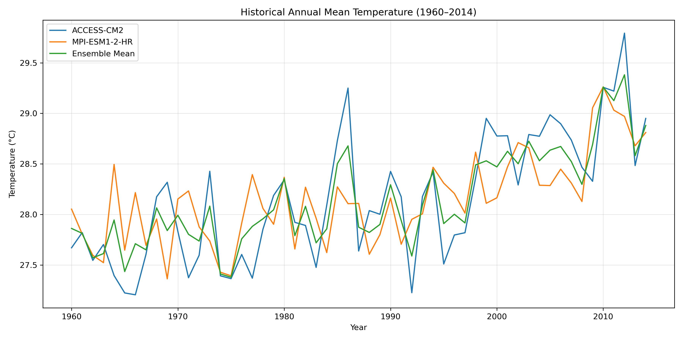Historical_Temperature_Comparison.png

3.1 Annual mean temperature
Figure 1. Historical annual mean temperature (1960–2014).
Trends are +0.2772°C/decade for ACCESS, +0.1860°C/decade for MPI and +0.2316°C/decade for the ensemble mean.

3.2 TGx : Annual maximum of daily mean tas
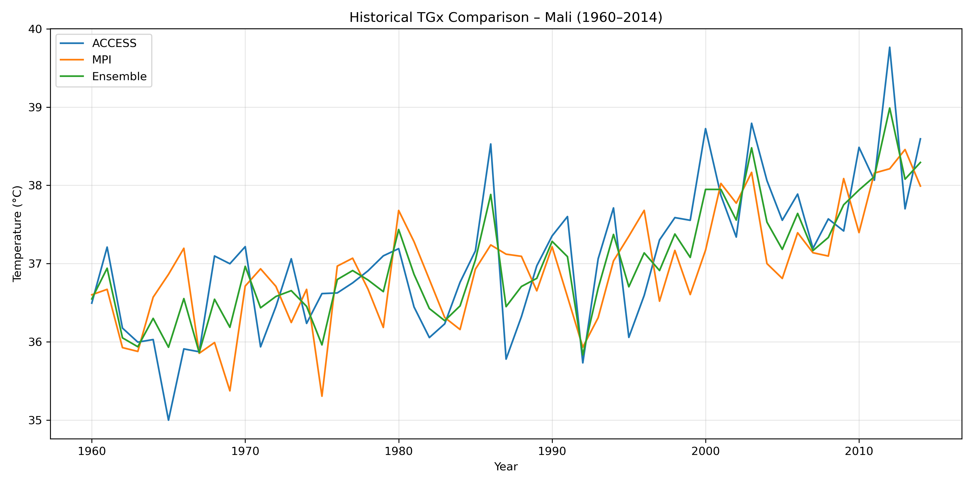
TGx_Comparison_1960_2014.png
Figure 2. Historical TGx (annual maximum of daily mean tas).
TGx trends are +0.3958°C/decade for ACCESS, +0.2954°C/decade for MPI and +0.3456°C/decade for the ensemble mean.

3.3 TGn : Annual minimum of daily mean tas
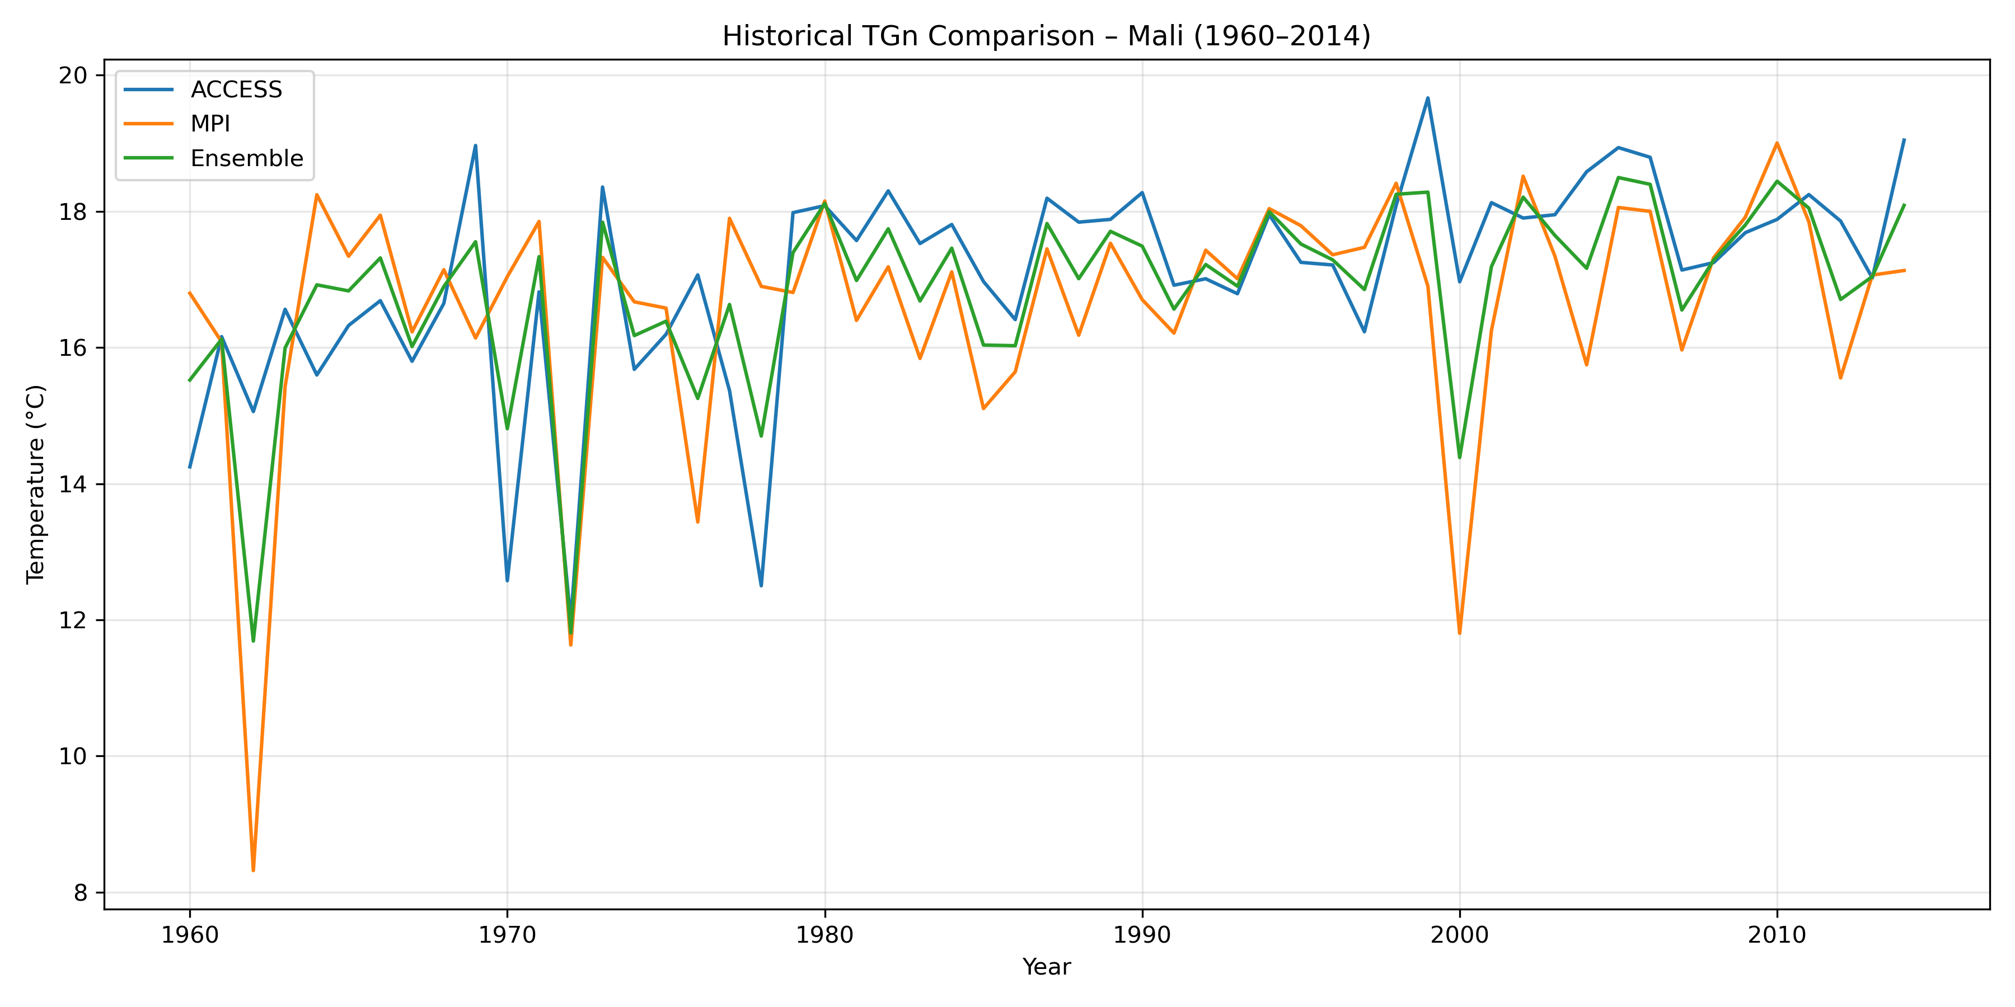
TGn_Comparison_1960_2014.png
Figure 3. Historical TGn (annual minimum of daily mean tas).
TGn trends are +0.5299°C/decade for ACCESS, +0.2935°C/decade for MPI and +0.4117°C/decade for the ensemble mean. The MPI TGn trend is not statistically significant at 5% (p = 0.0549).

Indicator | ACCESS | MPI | Ensemble
Mean temperature | +0.2772 | +0.1860 | +0.2316
TGx | +0.3958 | +0.2954 | +0.3456
TGn | +0.5299 | +0.2935 | +0.4117

Note: All trends are in °C per decade.
4. FUTURE TEMPERATURE PROJECTIONS (2015–2050)
The future plots compare ACCESS, MPI and their ensemble mean under SSP126, SSP245 and SSP585. Increasing trends are found for all ensemble indicators, but their magnitude differs by indicator and scenario.

4.1 Annual mean temperature
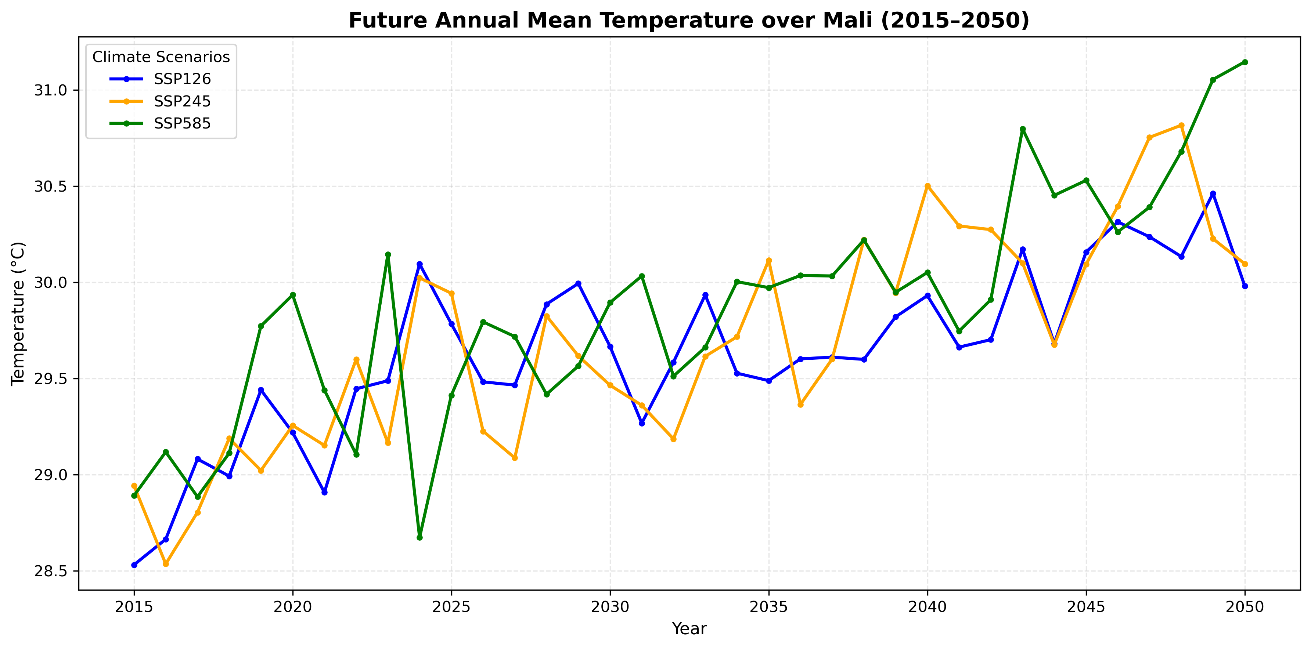
Future_Temperature_Comparison_2015_2050.png

Figure 4. Future annual mean temperature under SSP126, SSP245 and SSP585.
Ensemble trends are +0.3328°C/decade under SSP126, +0.4392°C/decade under SSP245 and +0.4665°C/decade under SSP585. The strongest trend is under SSP585.

4.2 TGx : Annual maximum of daily mean tas
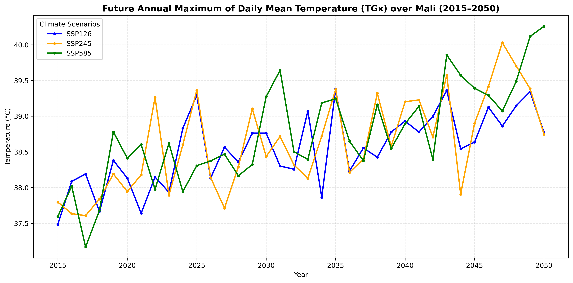
Future_TGx_Comparison_2015_2050.png
Figure 5. Future TGx under the three CMIP6 scenarios.
Ensemble TGx trends are +0.3231°C/decade under SSP126, +0.4160°C/decade under SSP245 and +0.5305°C/decade under SSP585. The strongest trend is under SSP585.

4.3 TGn : Annual minimum of daily mean tas
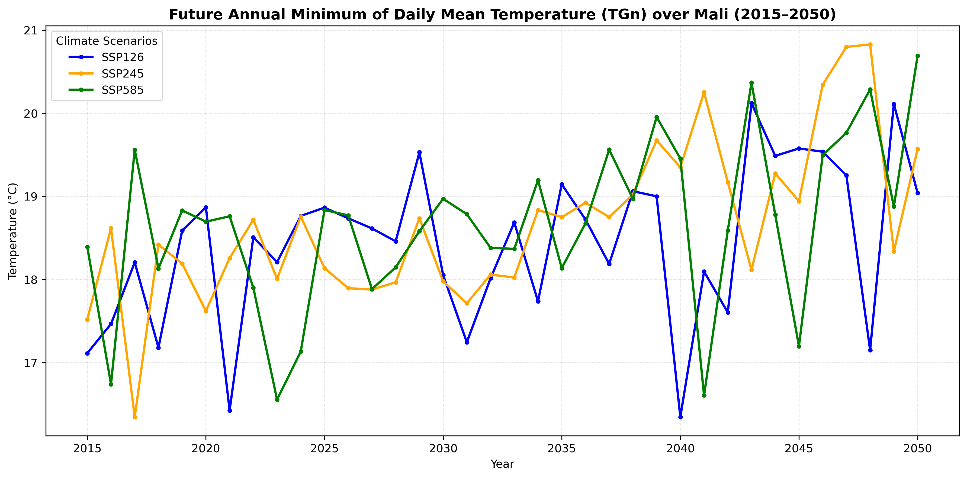Future_TGn_Comparison_2015_2050.png

Figure 6. Future TGn under the three CMIP6 scenarios.
Ensemble TGn trends are +0.3568°C/decade under SSP126, +0.6302°C/decade under SSP245 and +0.4252°C/decade under SSP585. The strongest ensemble trend is under SSP245. MPI TGn trends under SSP126 and SSP585 are not statistically significant at 5%.

Indicator | SSP126 | SSP245 | SSP585
Mean temperature | +0.3328 | +0.4392 | +0.4665
TGx | +0.3231 | +0.4160 | +0.5305
TGn | +0.3568 | +0.6302 | +0.4252

Note: Ensemble trends are in °C per decade.

5. HISTORICAL–FUTURE PERIOD MEAN COMPARISON
The ensemble future-period averages (2015–2050) are higher than the historical-period averages (1960–2014) for all three indicators. The values below are future-period mean minus historical-period mean; they are not the projected temperature specifically in 2050.
Indicator | SSP126 | SSP245 | SSP585
Mean temperature | +1.49°C | +1.55°C | +1.72°C
TGx | +1.55°C | +1.63°C | +1.75°C
TGn | +1.59°C | +1.81°C | +1.82°C

6. CONCLUSION

The analysis shows increasing historical trends in annual mean temperature, TGx and TGn over the selected domain. ACCESS generally gives stronger historical trends than MPI. Future projections also indicate warming under all three scenarios. For the ensemble mean, annual mean temperature and TGx have their strongest trends under SSP585, while TGn has its strongest trend under SSP245.
The comparison of period averages indicates increases in all three indicators. Results should be interpreted with caution because the analysis uses a rectangular domain rather than an exact Mali boundary mask, and only two climate models were included. A precise national mask and additional models could strengthen future analyses.

7. REFERENCES
Eyring, V., et al. (2016). Overview of the Coupled Model Intercomparison Project Phase 6 (CMIP6) experimental design and organization. Geoscientific Model Development, 9, 1937–1958. https://doi.org/10.5194/gmd-9-1937-2016
IPCC. (2021). Climate Change 2021: The Physical Science Basis. Contribution of Working Group I to the Sixth Assessment Report of the Intergovernmental Panel on Climate Change. Cambridge University Press.
Climate data: Daily CMIP6 tas datasets for ACCESS-CM2 and MPI-ESM1-2-HR, provided by the course supervisor for the MRP-ICC research project.

