CEN 591 – Object Oriented Programming Languages Laboratory File

BTech Computer Engineering
Vth Semester

Submitted by:
Aiman Fatima (20BCS008)

Submitted to:
Dr. Wakar Ahmad

Department of Computer Engineering,
Faculty of Engineering & Technology,
Jamia Millia Islamia, New Delhi
2022
Index

Sr No | Name of Program | Page No | Date
1. | Write a program to implement STUDENT class consisting of name, enrollId and marks as class data members. Create three objects for the class using the concept of array of objects. Write member functions to read and display the student information. Also write the main program to create objects and call the member functions from the class. |  | 20/07/22
2. | Write a C++ program handling the following details for students and staff using  inheritance.  • Student Details: name, address, percentage marks  • Staff Details: name, address, salary  Create appropriate base and derived classes. Input the details and output them. |  | 27/07/22
3. | Write a C++ program to perform the addition of two time objects in hour and minute format, display the result in hour: minute format using object as a function argument. |  | 17/08/22
4. | Write a C++ program based on following scenario:  Consider an example of a bookshop which sells books and video tapes. These two classes are inherited from the base class called media. The media class has command data members such as title and publication. The book class has data members for storing a number of pages in a book, and the tape class has the playing time in a tape. Each class will have member functions such as read() and show(). In the base class, these members have to be defined as virtual functions. Write a program which models the class hierarchy for the bookshop and processes objects of these classes using pointers to the base class. |  | 31/08/22
5. | Server-Client with Substitution Cipher |  | 31/08/22
6. | Client-Server-Multiple Client Broadcasting |  | 07/09/22
7. | Check the Datatype of Input from the Client on Server |  | 12/10/22
8. | Server-Client with Rail-Fencing Cipher |  | 19/10/22
9. | Server-Client with Vigenère Cipher |  | 12/11/22
10. | Play-Fair Cipher |  | 19/11/22

------------------------------- Program 1 ----------------------------------

// Write a program to implement STUDENT class consisting of name, enrollment_Id and
// marks as class data members. Create three objects for the class using the concept
// of array of objects. Write member functions to read and display the student
// information. Also write the main program to create objects and call the member
// functions from the class.

#include <bits/stdc++.h>
using namespace std;
class Student
{
private:
string name;
int enrollment_Id;
vector<int> marks;

public:
Student()
{
}
Student(string name_value, int id, vector<int> marks_value)
{
this->name = name_value;
this->enrollment_Id = id;
int ss = marks_value.size();
marks.resize(ss);
this->marks = marks_value;
}
void getData()
{
cout << "Name : \t" << name << endl;
cout << "Enrollment Id : " << enrollment_Id << endl;
for (int i = 0; i < marks.size(); i++)
{
cout << "Marks of Subject " << i + 1 << " : " << marks[i] << endl;
}
}
};

int main()
{
cout << "\n____20BCS008 Aiman Fatima____\n";
cout << "\n----Enter details of three students----\n";
Student *s = new Student[3];
vector<int> S;
for (int i = 0; i < 3; i++)
{
cout << "\n|| Enter data of Student " << i + 1 << " ||" << endl;
cout << "Enter Name: ";
string name;
cin >> name;
cout << "Enter Id: ";
int id;
cin >> id;
cout << "Enter No. of subjects: ";
int sub;
cin >> sub;
S.resize(sub);
for (int i = 0; i < sub; i++)
{
cout << "Enter marks of Subject " << i + 1 << " : ";
cin >> S[i];
}
s[i] = Student(name, id, S);
S.clear();
}
cout << "\n----Getting details of the students----\n";
for (int i = 0; i < 3; i++)
{
cout << "\n|| Student " << i + 1 << " ||" << endl;
s[i].getData();
}
delete[] s;
return 0;
}

________ Output ________
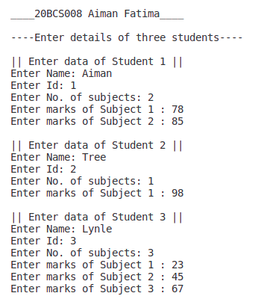

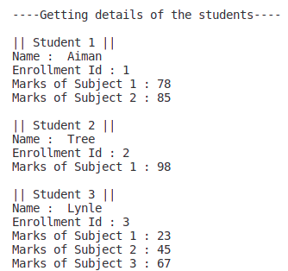

------------------------------- Program 2 ----------------------------------

// Write a C++ program handling the following details for
// students and staff using inheritance.
//• Student Details: name, address, percentage marks
//• Staff Details: name, address, salary
// Create appropriate base and derived classes. Input the details and output them.

#include <bits/stdc++.h>
using namespace std;
class School
{
private:
string name;
string address;

public:
School()
{
}
void getDetails()
{
cout << "Enter School name : ";
cin >> name;
cout << "Enter address : ";
cin >> address;
}
void showDetails()
{
cout << "School Name : " << name << endl;
cout << "Address : " << address << endl;
}
};

class Student : public School
{
string name;
string roll_no;
float percentage;

public:
Student()
{
}
void getDetails()
{
School::getDetails();
cout << "Enter roll no : ";
cin >> roll_no;
cout << "Enter name : ";
cin >> name;
cout << "Enter percentage : ";
cin >> percentage;
}
void printStudent()
{
cout << "\n----Details of the student----\n";
School::showDetails();
cout << "Name : " << name << endl;
cout << "Roll_no : " << roll_no << endl;
cout << fixed;
cout << "Percentage : " << setprecision(2) << percentage << endl;
}
};

class Staff : public School
{
string name;
string staff_id;
float salary;

public:
Staff()
{
}
void getDetails()
{
School::getDetails();
cout << "Enter staff id: ";
cin >> staff_id;
cout << "Enter name: ";
cin >> name;
cout << "Enter salary: ";
cin >> salary;
}
void printStaff()
{
cout << "\n----Details of the Staff----\n";
School::showDetails();
cout << "Name : " << name << endl;
cout << "Staff Id : " << staff_id << endl;
cout << fixed;
cout << "Percentage : " << setprecision(2) << salary << endl;
}
};

int main()
{
cout << "\n____20BCS008 Aiman Fatima____\n";
Student student;
Staff staff;
cout << "\n----Enter details of the student----\n";
student.getDetails();

cout << "\n----Enter details of the staff----\n";
staff.getDetails();
student.printStudent();
cout << endl;
staff.printStaff();
return 0;
}

________ Output ________
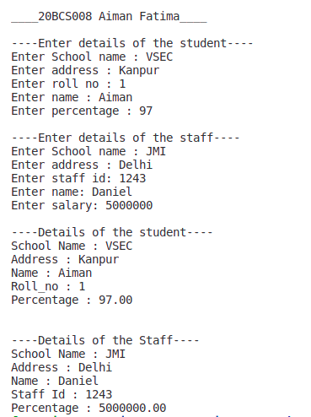

------------------------------- Program 3 ----------------------------------

// Write a C++ program to perform the addition of two time
// objects in hour and minute format, display the result in
// hour: minute format using object as a function argument.
#include <bits/stdc++.h>
using namespace std;

class AddTime
{
private:
int hr;
int min;

public:
AddTime()
{
}
AddTime(int h, int m)
{
this->hr = h;
this->min = m;
}
AddTime Add(AddTime &a)
{
int hh = a.hr;
int mm = a.min;
AddTime A;
int tot_hr = hh + hr;
int tot_min = mm + min;
if (tot_min >= 60)
{
tot_min -= 60;
tot_hr += 1;
}
A = AddTime(tot_hr, tot_min);
return A;
}
void gettime()
{
cout << hr << ": ";
if (min >= 0 && min < 10)
{
cout << "0";
}
cout << min;
}
};
int main()
{
int h, m;
cout << "\n____20BCS008 Aiman Fatima____\n";
cout << "\n----Enter time 1----\n";
cout << "Enter hour : ";
cin >> h;
cout << "Enter minute : ";
cin >> m;
AddTime A(h, m);
cout << "\n----Enter time 2----\n";
cout << "Enter hour : ";
cin >> h;
cout << "Enter minute : ";
cin >> m;
AddTime B(h, m);
cout << "\n|| Displaying time ||\n";
cout << "Time 1 -> ";
A.gettime();
cout << "\nTime 2 -> ";
B.gettime();
AddTime C = A.Add(B);
cout << "\n\n|| Resultant Time -> ";
C.gettime();
cout << " ||\n\n";
return 0;
}

________ Output ________
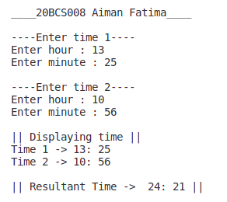

------------------------------- Program 4 ----------------------------------

/*Write a C++ program based on following scenario:
Consider an example of a bookshop which sells books and video tapes. These two classes are
inherited from the base class called media. The media class has command data members such as
title and publication. The book class has data members for storing a number of pages in a book, and the tape class has the playing time in a tape. Each class will have member functions such as read() and show(). In the base class, these members have to be defined as virtual functions. Write a program which models the class hierarchy for the bookshop and processes objects of these classes using pointers to the base class.*/

#include <bits/stdc++.h>
#include <iostream>
using namespace std;

// base class
// pure virtual function
class Media
{
protected:
string title;
string publication;

public:
virtual void read() = 0;
virtual void show() = 0;
};

// derived class
class Book : public Media
{
private:
int pages;

public:
void read()
{
cout << "Enter title: ";
cin >> title;
cout << "Enter publication: ";
cin >> publication;
cout << "Enter number of pages: ";
cin >> pages;
}
void show()
{
cout << "Title: " << title << endl;
cout << "Publication: " << publication << endl;
cout << "Number of pages: " << pages << endl;
}
};

// derived class
class Tape : public Media
{
private:
int playingTime;

public:
void read()
{
cout << "Enter title: ";
cin >> title;
cout << "Enter publication: ";
cin >> publication;
cout << "Enter playing time: ";
cin >> playingTime;
}
void show()
{
cout << "Title: " << title << endl;
cout << "Publication: " << publication << endl;
cout << "Playing time: " << playingTime << endl;
}
};

int main()
{
Media *base_ptr;
// Media k;
cout << "\n____20BCS008 Aiman Fatima____\n";
cout << "\n|| Accessing the details using pointer of base class ||\n";
cout << "\nEnter details of a book " << endl;
Book b;
base_ptr = &b;
base_ptr->read();
cout << "\nEnter details of a tape " << endl;
Tape t;
base_ptr = &t;
base_ptr->read();
cout << "\nDetails of the book " << endl;
base_ptr = &b;
base_ptr->show();
cout << "\nDetails of the tape " << endl;
base_ptr = &t;
base_ptr->show();
return 0;
}

________ Output ________
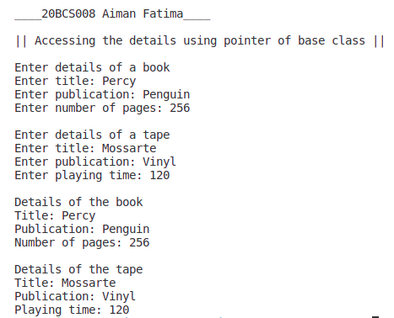

------------------------------- Program 5 ----------------------------------

/*Write a C++ program to overload [] operator for the following scenario:
Create a class AccountBook that contains account holder details such as name and account number. Take input for 5 account holders in the account table. When we enter account number, then the program prints account holder name while entering of account holder name, it prints account number of holder.*/

#include <iostream>
#include <string.h>
using namespace std;

class AccountBook
{
private:
string name;
int accountNumber;

public:
void read();
void display();
string operator[](int);
int operator[](string);
};

void AccountBook::read()
{
cout << "\nEnter name: ";
getchar();
getline(cin, name);
cout << "Enter account number: ";
cin >> accountNumber;
}

void AccountBook::display()
{
cout << name << "\t" << accountNumber << endl;
}

string AccountBook::operator[](int accountNumber)
{
if (this->accountNumber == accountNumber)
return name;
else
return "Not found";
}

int AccountBook::operator[](string name)
{
if (this->name == name)
{
return accountNumber;
}
else
{
return -1;
}
}

int main()
{
cout << "\n____20BCS008 Aiman Fatima____\n";
AccountBook accountBook[5];
int choice;
while (1)
{
cout << "\n_____Menu_____\n";
cout << "1. Read 5 details" << endl;
cout << "2. Display" << endl;
cout << "3. Search by account number" << endl;
cout << "4. Search by name" << endl;
cout << "5. Exit" << endl;
cout << "Enter your choice : ";
cin >> choice;
switch (choice)
{
case 1:
for (int i = 0; i < 5; i++)
{
cout << "\n---- Details of customer " << i + 1 << " ----";
accountBook[i].read();
}
break;
case 2:
cout << "\n---- Displaying Details ----\n";
cout << "\nName\tAccount Number" << endl;
for (int i = 0; i < 5; i++)
{
accountBook[i].display();
}
cout << endl;
break;
case 3:
{
int accountNumber;
cout << "\nEnter account number: ";
cin >> accountNumber;
bool found = false;
for (int i = 0; i < 5; i++)
{
if (accountBook[i][accountNumber] != "Not found")
{
cout << "Name: " << accountBook[i][accountNumber] << endl;
found = true;
}
}
if (!found)
{
cout << "\nAccount number not found" << endl;
}
cout << endl;
break;
}
case 4:
{
string name;
cout << "\nEnter name: ";
cin >> name;
bool found = false;
for (int i = 0; i < 5; i++)
{
if (accountBook[i][name] != -1)
{
cout << "Account number: " << accountBook[i][name] << endl;
found = true;
}
}
if (!found)
{
cout << "\nName not found" << endl;
}
cout << endl;
break;
}
case 5:
cout << "\nThe End.\n\n";
return 0;
default:
cout << "\nWrong choice!!\n";
}
}
return 0;
}

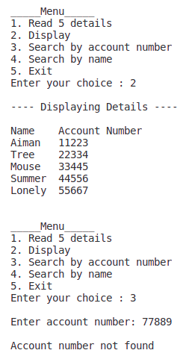
________ Output ________
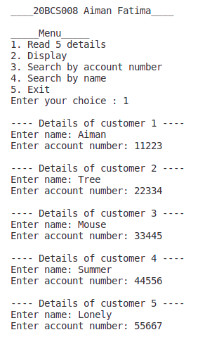
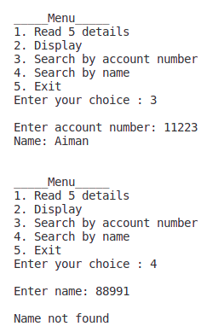

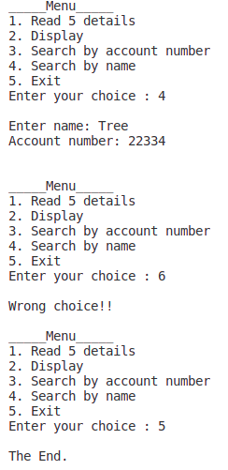

------------------------------- Program 6 ----------------------------------

/*Write a C++ Program to implement Complex class representing complex numbers. A complex number in mathematics is defined as x + iy where x defines the real part of the number and y is the imaginary part. The letter i represents the square root of -1 (which means i2 is -1). Include operator functions to overload the operators +=, -=, *=, /= and the << operator for the class. Here << operator should be used for printing the results of complex number operation.*/

#include <bits/stdc++.h>
using namespace std;

class Complex
{
float real;
float img;

public:
Complex()
{
real = img = 0;
}
// += operator overloading
void operator+=(Complex c)
{
real = real + c.real;
img = img + c.img;
}
// -= operator overloading
void operator-=(Complex c)
{
real = real - c.real;
img = img - c.img;
}
// *= operator overloading
void operator*=(Complex c)
{
real = real * c.real - img * c.img;
img = real * c.img + img * c.real;
}
// /= operator overloading
void operator/=(Complex c)
{
float denominator = c.real * c.real + c.img * c.img;
real = (real * c.real + img * c.img) / denominator;
img = (img * c.real - real * c.img) / denominator;
}
// Input stream Operator overloading
friend istream &operator>>(istream &In, Complex &c)
{
cout << "Enter Real Part : ";
In >> c.real;
cout << "Enter Imaginary Part : ";
In >> c.img;
return In;
}
// Output stream Operator overloading
friend ostream &operator<<(ostream &Out, Complex &c)
{
Out << fixed;
Out << "Resulatnt Complex Number : (" << setprecision(2) << c.real;
Out << " + i(" << setprecision(2) << c.img << "))" << endl;
return Out;
}
};

int main()
{
Complex c1, c2, c3;
cout << "\n____20BCS008 Aiman Fatima____\n";
cout << "\n|| Arithmetic Assignment Operators and Stream Operators overloading ||\n";
cout << "\nEnter Complex Number c1\n";
cin >> c1;
cout << "Enter Complex Number c2\n";
cin >> c2;
c3 = c1;
c3 += c2;
cout << "\n----| Addition : c1 + c2 |----\n";
cout << c3;
c3 = c1;
c3 -= c2;
cout << "\n----| Substraction : c1 + c2 |----\n";
cout << c3;
c3 = c1;
c3 *= c2;
cout << "\n----| Multiplication : c1 + c2 |----\n";
cout << c3;
c3 = c1;
c3 /= c2;
cout << "\n----| DivisionI : c1 + c2 |----\n";
cout << c3;
}

________ Output ________
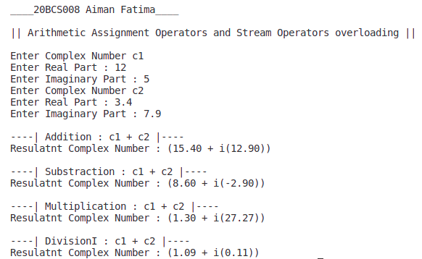

------------------------------- Program 7 ----------------------------------

/*Design classes such that they support the following statements: Rupee rl, r2; Dollar dl, d2; dl = r2; // converts rupee (Indian currency) to dollar (US currency) r2 = d2; // converts dollar (US currency) to rupee (Indian currency) Write a complete program which does such conversions according to the world market value.*/

#include <bits/stdc++.h>
#include <iostream>
#include <vector>
#include <iomanip>
#include <string>
using namespace std;

// current value of 1 USD in INR is 81.79 INR
const float VAL = 81.79;

// class rupee
class rupee
{
float r;

public:
rupee()
{
r = 0.0;
}

void inINR(float a)
{
r = a;
}

rupee(float dlr)
{
r = dlr;
}

void printinr()
{
cout << fixed;
cout << "\nValue in INR : " << setprecision(2) << r << endl;
}
float getInr()
{
return r;
}
};

// class dollar
class dollar
{
float d;

public:
dollar()
{
d = 0.0;
}

void inDlr(float a)
{
d = a;
}

dollar(rupee rr)
{
d = rr.getInr() / VAL;
}

operator rupee()
{
return (rupee(d * VAL));
}
void printdlr()
{
cout << fixed;
cout << "\nValue in Dollar : " << setprecision(2) << d << "\n"
<< endl;
}
};

// main function
int main()
{
rupee r1, r2;
dollar d1, d2;
float a, b;
cout << "\n____20BCS008 Aiman Fatima____\n";
cout << "\n<Current value of 1 USD in INR is 81.79>\n";
cout << "\nEnter value in dollar(s) : ";
cin >> a;
d1.inDlr(a);
cout << "\n----Operator overloading in source class----";
r1 = d1; // operator overloading in source class
r1.printinr();
///////////////
cout << "\nEnter value in rupee(s) : ";
cin >> b;
r2.inINR(b);
cout << "\n----Constructor in destination class----";
d2 = r2; // constructor in destination class
d2.printdlr();
return 0;
}

________ Output ________

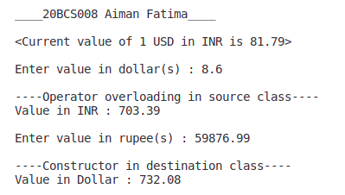

------------------------------- Program 8 ----------------------------------

// Write suitable C++ program to implement following OOPS concepts:
// (a) Pure Virtual Function
// (b) Pointers to Derived Class Object
// (c) Virtual Destructor
// (d) Overloading through friend function
#include <bits/stdc++.h>
using namespace std;

class Base
{
public:
Base()
{
cout << "\nBase class created\n";
}
// Virtual Destructor
virtual ~Base()
{
cout << "\nBase class destructor!" << endl;
}
// Pure virtual function
virtual void DisplayAction()
{
cout << "\nDispay function of Base class called\n";
}
};

class Derived : public Base
{
public:
Derived()
{
cout << "\nDerived class created" << endl;
}

~Derived()
{
cout << "\nDerived class destructor!" << endl;
}

void DisplayAction()
{
cout << "\nDisplay of Derived class called!" << endl;
}
};

class Overloading_Through_Friend
{
private:
int number;

public:
Overloading_Through_Friend(int r = 0)
{
number = r;
}
void Display()
{
cout << number;
}
friend Overloading_Through_Friend operator+(Overloading_Through_Friend c1, Overloading_Through_Friend c2);
};

Overloading_Through_Friend operator+(Overloading_Through_Friend c1, Overloading_Through_Friend c2)
{
Overloading_Through_Friend temp;
temp.number = c1.number + c2.number;
return temp;
}

int main()
{
cout << "\n____20BCS008 Aiman Fatima____\n";
Base *obj;
// pointer to derived class
obj = new Derived();
obj->DisplayAction();

Overloading_Through_Friend C1(4), C2(8), C3;
cout << endl;
C1.Display();
cout << " + ";
C2.Display();
cout << " = ";
C3 = C1 + C2;
cout << "\n";
C3.Display();
obj->~Base();
cout << endl;
return 0;
}

________ Output ________
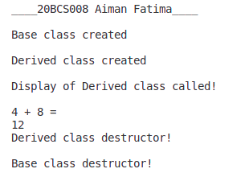

------------------------------- Program 9 ----------------------------------

import java.util.Scanner;

abstract class Shape {

int a, b;

abstract void printArea();
}

class Rectangle extends Shape {

void printArea() {
System.out.println("\nArea of Rectangle: " + (a * b));
}
}

class Triangle extends Shape {

void printArea() {
System.out.println("\nArea of Triangle: " + (0.5 * a * b));
}
}

class Circle extends Shape {

void printArea() {
System.out.println("\nArea of Circle: " + (3.14 * a * a));
}
}

public class P9_abstract_class {

public static void main(String[] args) {
Scanner sc = new Scanner(System.in);
Rectangle r = new Rectangle();
Triangle t = new Triangle();
Circle c = new Circle();

System.out.println("\nEnter the length and breadth of rectangle: ");
r.a = sc.nextInt();
r.b = sc.nextInt();
System.out.println("\nEnter the base and height of triangle: ");
t.a = sc.nextInt();
t.b = sc.nextInt();
System.out.println("\nEnter the radius of circle: ");
c.a = sc.nextInt();
r.printArea();
t.printArea();
c.printArea();
sc.close();
}
}

________ Output ________
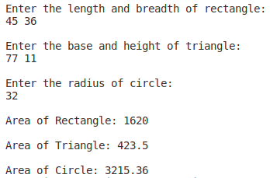

------------------------------- Program 10 ----------------------------------

________ Output ________

