Contents

Use Case Diagram 2

Hierarchy Diagram 3

Algorithms 5

Register Algorithm 5

Login Algorithm 5

Air Pollution Algorithm 6

Weather Algorithm 7

Advice Generation Algorithm 8

Wireframes 8

User Pages 8

User Features Page 9

Weather Forecast Page 10

Air Quality Dashboard Page 11

All Advice Page 11

Saved Advice Page 12

Advice Details Page 13

Management Pages 13

Management Features Page 14

Manage Advice Page 14

Delete Advice Pages 15

Universal Pages 16

Welcome Page 16

Register Page 17

Log In Page 17

Report Bug Page 18

# Use Case Diagram

The use case diagram is intended to illustrate each of the roles in the web application, what features they have access to and how each of the features are hosted. In this solution, there are only 2 roles planned – user and management. However, should Health Advice Group require more roles and stricter permissions, we will modify the permissions and access to features as needed.

# Hierarchy Diagram

The hierarchy diagram below is designed to show the flow of the website. User and management will have access to different features or different parts of a system, which is why the hierarchy diagram splits into 2 different paths. As of right now, users have read only access to the advice system, weather forecasting and air quality systems. However, management will have read and write access to the advice system and will have access to a dashboard to measure user interactivity with advice and the solution in general.

# Algorithms

## Register Algorithm

To register a user, the data entered must be accurate as per data protection regulations. This means that data entered must undergo rigorous validation. Attached below is the decision-making process for whether a user signing up is valid, or if details are invalid or need to be re-entered.

START

WHILE TRUE

GET first_name FROM KEYBOARD

IF first_name > 2 AND first_name < 20 THEN

BREAK

WHILE TRUE

GET last_name FROM KEYBOARD

IF last_name > 2 AND last_name < 20 THEN

BREAK

WHILE TRUE

GET email_address FROM KEYBOARD

IF email_address CONTAINS “@” THEN

IF email_address CONTAINS “.” THEN

BREAK

WHILE TRUE

GET password FROM KEYBOARD

IF LENGTH(password) >= 8 THEN

IF password CONTAINS characters.lowercase AND password CONTAINS characters.uppercase AND password CONTAINS characters.numbers AND password CONTAINS characters.symbols THEN

BREAK

WHILE TRUE

IF confirm_password EQUALS password THEN

BREAK

END

## Login Algorithm

In order to protect against security risks such as brute force attacks, the login system must still check against multiple values and conditions before a user can access their account and the platform. Below is the decision-making process behind whether a user will be granted access to the system.

START

WHILE TRUE

GET email_address FROM KEYBOARD

GET password FROM KEYBOARD

HASH password WITH SHA256

GET FROM UsersDB

IF lockout_enabled IS NOT TRUE

IF email_address IN DB

IF hashed_password IN DB

BREAK

END

## Air Pollution Algorithm

This indicates how we will interact with an air pollution API to input data and output results for display to the user. It relies on the user to enable their location so we can send their latitude and longitude to the API.

START

GET latitude FROM USER LOCATION

GET longitude FROM USER LOCATION

CONNECT TO OPEN WEATHER API

SET API DATA TO latitude, longitude

DISPLAY pollutants TO USER

FOR EACH value IN POLLUTANTS DO

PLOT value TO GRAPH

COMPARE value TO pollutant_range

DISPLAY COMPARISON FROM pollutant_range TO USER

DISPLAY GRAPH TO USER

END

## Weather Algorithm

This indicates how we will interact with a current weather API to input data and output results for display to the user. It relies on the user to enable their location so we can send their latitude and longitude to the API.

START

GET latitude FROM USER LOCATION

GET longitude FROM USER LOCATION

CONNECT TO OPEN WEATHER API

SET API DATA TO latitude, longitude

GET FROM AdviceDB

DISPLAY current_temperature, location, condition, sunrise, sunset TO USER

FOR EACH advice IN AdviceDB DO

IF advice.temperature – current_temperature < 5 AND IF advice.temperature – current_temperature > -5

DISPLAY advice FROM TO USER

END

## Advice Generation Algorithm

Whilst there are multiple variations of advice being generated, for instance when the temperature matches that of a condition, when a user is searching for advice which matches a title, or when a user is accessing saved advice, this is the simplest version which will unconditionally fetch all advice.

START

GET FROM AdviceDB

IF AdviceDB IS NULL DO

SEND “NO CURRENT ADVICE” TO DISPLAY

ELSE DO

FOR EACH advice IN advice_db DO

generate_article(advice)

END

# Wireframes

In order to assist in the development process, I have added design documents to showcase the layout of the website and roughly where each option will be.

## User Pages

These are the pages which the user will be able to see should they be logged in and assigned the “user” role.

### User Features Page

This is the page which the user will see initially after logging into the system, and it is intended to list all the features available to them.

### Weather Forecast Page

This is the page the user will see after clicking the “weather” option. It will by default use the user’s current location, but it can also work with an entered location.

Search Another Location Page

This is the form the user will need to fill out if they want to access the weather at another location. This will be translated into a latitude and longitude by the API.

### Air Quality Dashboard Page

This is the page the user will see after clicking the “weather” option. It will by default use the user’s current location, but it can also work with an entered location.

### All Advice Page

This is the page the user will see after clicking the “advice” option. It will show the most recently added advice first by default.

### Saved Advice Page

This will show the advice that a user has saved, for quick and easy navigation.

Health Tracker Page

This is the page the user will see after clicking the “health tracker” option. It is designed for adding steps, calories, or water as the day progresses and keeps a cumulative total.

Advice Details Page

By default, the details / description of advice will not be in on the page to keep the initial advice page clean. Should a user want to see more details, they can click the details button and it will lead them to a page which looks somewhat like this:A screenshot of a video player

## Management Pages

These are the pages which the trustees will be able to see should they be logged in and assigned the “management” role.

### Management Features Page

This is the page which the user will see initially after logging into the system, and it is intended to list all the features available to them.

### A screenshot of a computer Description automatically generatedManage Advice Page

This is what a management user would see upon clicking the “manage advice” page. It has a similar view to the user, with the addition of the edit and delete buttons for each advice article.

### Add / Edit Advice Page

Editing and adding advice will use roughly the same form and have a similar layout.

### Delete Advice Pages

## Universal Pages

These are pages that both “user” and “management” roles share or pages which can be accessed before signing in.

### Welcome Page

For data protection, monitoring, and performance purposes, users cannot access any features until they have registered and / or signed in. This is roughly what an unauthenticated user will see upon opening the site.

### Register Page

When a user wants to create an account for the service, this is the data they will have to enter.

### Log In Page

Once a user has registered, these are the details which they will need to enter to access their account and successfully be authenticated to access the service.

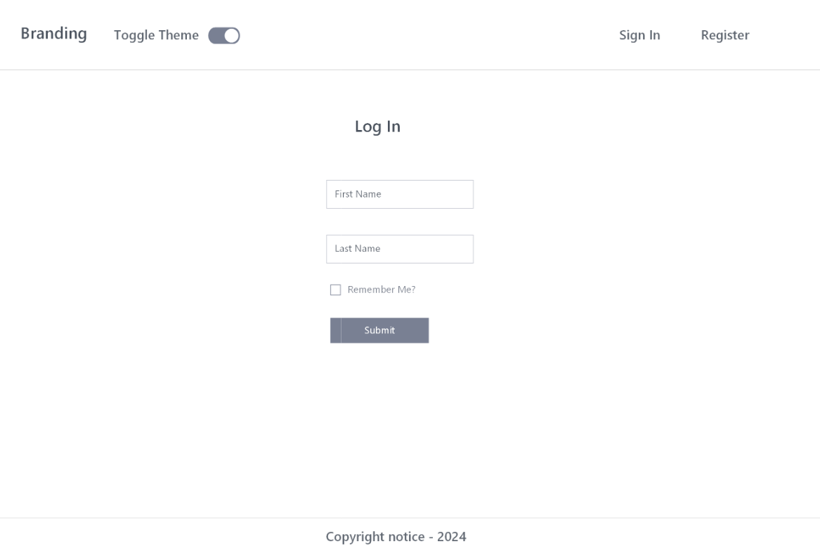

Report Bug Page

Should a user need to report a fault with the system, these are the details which they would need to enter.