# Development Lifecycle

The purpose of this documentation is to broadcast how design choices and factors have been implemented and how this has changed over time. Whilst this document may show some functionality, this is not its sole purpose, but instead to show how we have designed these features and the solution. In the future, observations and videos to showcase this functionality. Additionally, the test log will showcase some functionality, primarily of validation mechanisms.

To simplify this document, each feature will be split into iterations. Each iteration is constituted by significant change to the layout, appearance, or functionality of the feature or page. Additionally, what has been changed / improved will be suffixed with a corresponding abbreviation. I have attached a table below which defines each suffix.

|  |  |
| --- | --- |
| Abbreviation | Definition |
| A | Improvements in accessibility |
| S | Improvements in security |
| U | Improvements in usability |
| L | Legal compliance |

Contents

Development Lifecycle 1

Navbar 2

Iteration 1 2

Iteration 1B 2

Iteration 2 | U 2

Iteration 2B | L 2

Iteration 3 | A 3

Iteration 3B | A 3

Landing Page 3

Iteration 1 3

Iteration 2A | S 3

Iteration 2B | U 4

Iteration 2C | U 4

Forecast Page 5

Iteration 1 5

Iteration 2 | U 5

Air Quality Page 6

Iteration 1 6

Iteration 2 | U 6

Create Advice 7

Iteration 1 7

Iteration 2 | U 8

Iteration 3 | U 8

All Advice 9

Iteration 1 9

Iteration 2 | A 9

Iteration 3A | U 10

Iteration 3B | U 10

# Navbar

The navbar is designed to provide quick access to important features and commonly used pages such as home pages, account related pages, and pages related to legal statements.

## Iteration 1

In the first iteration, there are only a few options, none of which give users access to the account system. By default, most of this iteration is generated by ASP.NET MVC by default.



## Iteration 1B

In the first iteration, when signed in, the user sees a message which greets them by their username, which is the same as their email, which could be considered sensitive data. This will be addressed in subsequent iterations. Additionally, the user can log out of the system.





## Iteration 2 | U

In the second iteration, when the user is signed out, more options have been added for the user to select from. Namely, the user now has access to links which will allow them to log in or sign up for access to the solution. This improves usability by adding quick access to common features which are needed to access the solution. Additionally, I have placed an icon next to the health advice group title. This can be replaced with the group’s branding at any point.



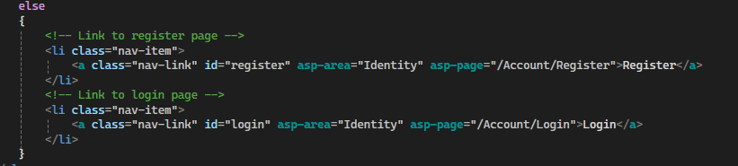

## Iteration 2B | L

In the second iteration, when the user is signed out, the greeting message has been changed. It will now address the user by their first and last name, rather than their email address. This is to avoid broadcasting any sensitive or personal information and comply with regulations regarding personal data.



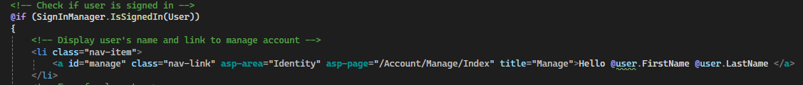

## Iteration 3 | A

In the third iteration, when the user is signed out, a “toggle theme” button has been added. This will allow users to switch between a light and dark theme to reduce eye strain in light or darker viewing environments. Additionally, this makes use of local storage, so it does not require any data to be stored on the database. Finally, the icon has been replaced.



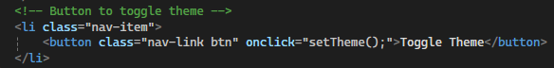

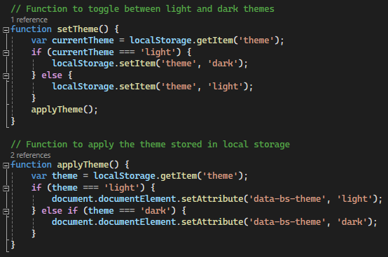

## Iteration 3B | A

In the third iteration, when the user is signed in, the “toggle theme” button has also been added to the navbar for similar reason as iteration 3.





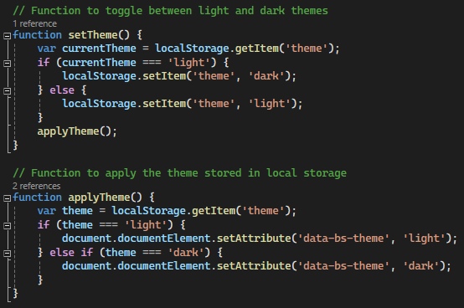

# Landing Page

This is the page that the user will see first upon visiting our website. Hence it is important that it provides quick access to important features such as creating an account or key features if the user is signed in.

## Iteration 1

This is the original landing page which ASP.NET generates. However, it does not give much information, branding, or warnings that the user must be signed in first. This will be addressed in subsequent iterations.

## Iteration 2A | S

In this iteration, should the user not be signed in, they will see a message and a link which will prompt them to log in or create an account to access features. This improves security by restricting access to resource intensive features and advice provided by Health Advice Group behind an authorised account.



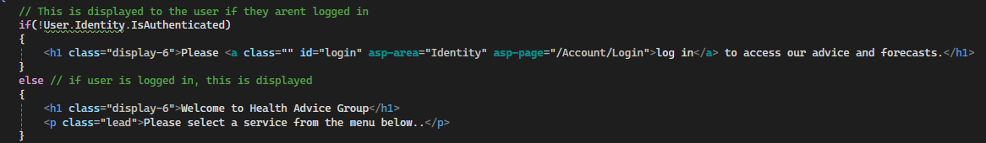

## Iteration 2B | U

In this iteration, if the user is given the role “User”, they will receive a dashboard page which lists features relevant to a user. This improves usability by quickly providing access to in-demand features and allowing users to navigate and make health decisions with as little downtime as possible.

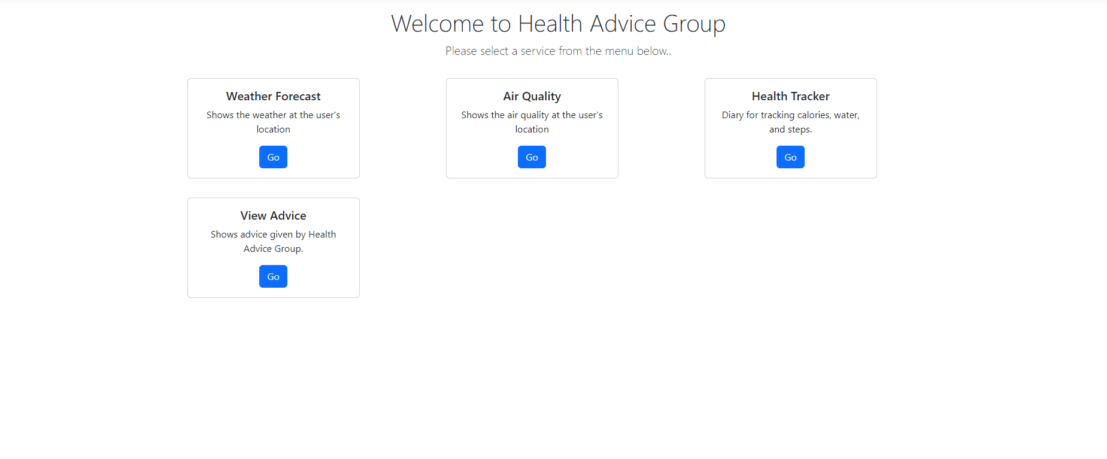

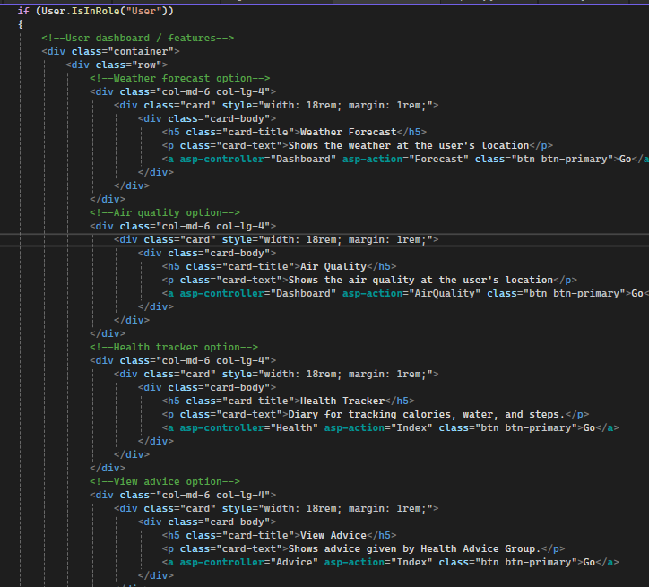

## Iteration 2C | U

In this iteration, if the user is given the role “Management”, they will receive a dashboard which lists features relevant to management. This improves usability by providing quick access to systems which will allow management to make resources or decisions with minimal downtime.

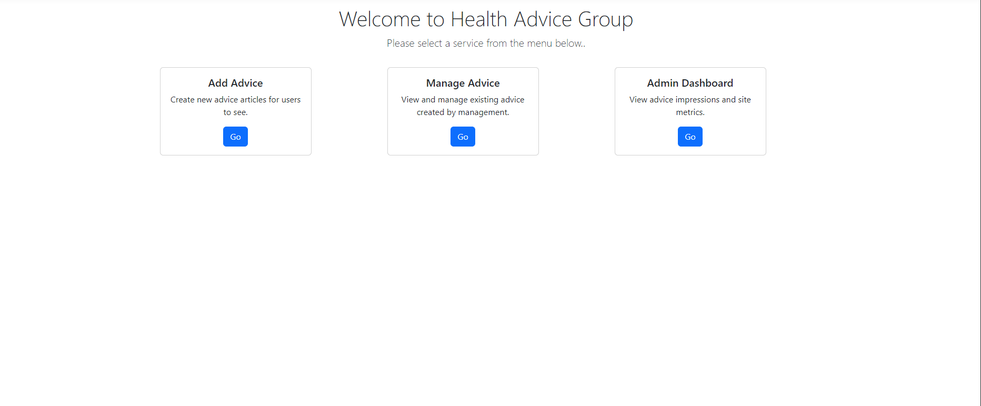

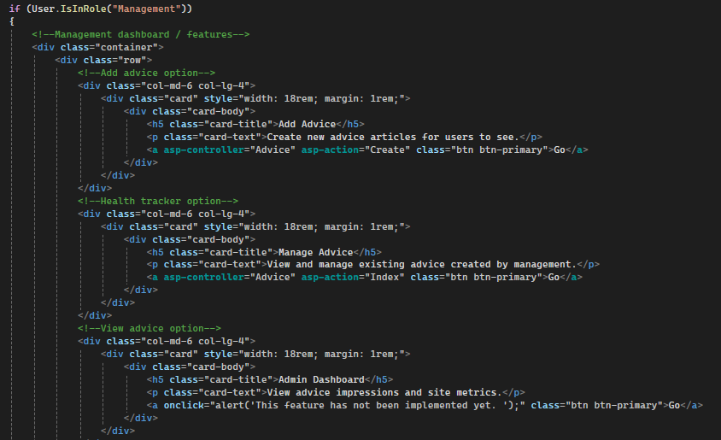

# Forecast Page

This page shows the current weather at the user’s location. It is intended to show metrics which will allow users to make health decisions.

## Iteration 1

In the first iteration, all the metrics which we intend to record regarding the weather have been added to the layout. However, we have not pulled any data through yet hence all the metrics display “Loading”, this will be addressed in subsequent iterations.

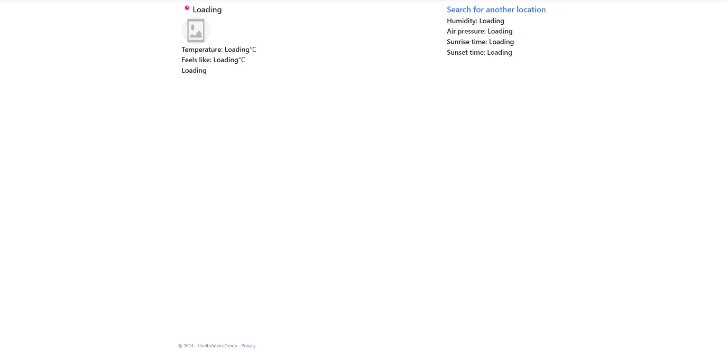

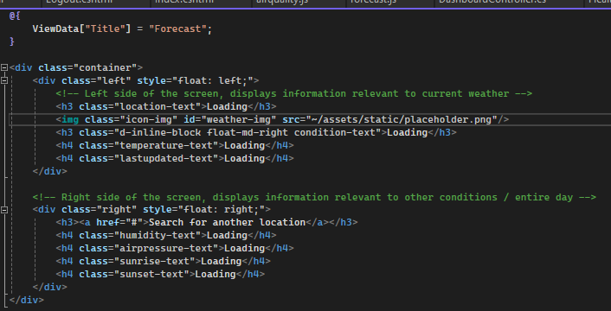

## Iteration 2 | U

In the second iteration, we pull data from the API and display it next to their respective metric. This will improve usability by allowing users to inform their decision-making regarding health on real and accurate data.

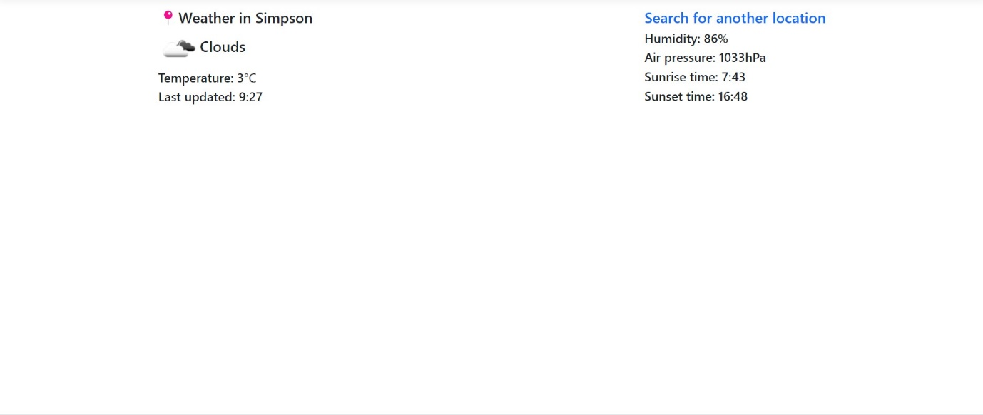

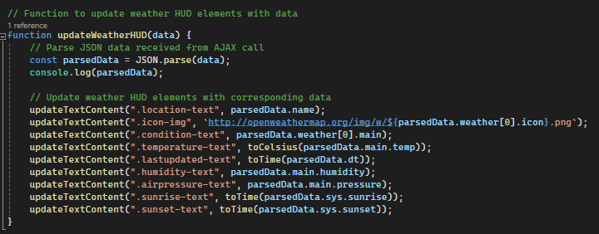

# Air Quality Page

This page shows the air pollution at the user’s location. It is intended to show the concentration of pollutants which will allow users to make health decisions.

## Iteration 1

In the first iteration, all the metrics which we intend to record regarding the air pollution have been added to the layout. However, we have not pulled any data through yet hence all the metrics display “Loading”, this will be addressed in subsequent iterations.

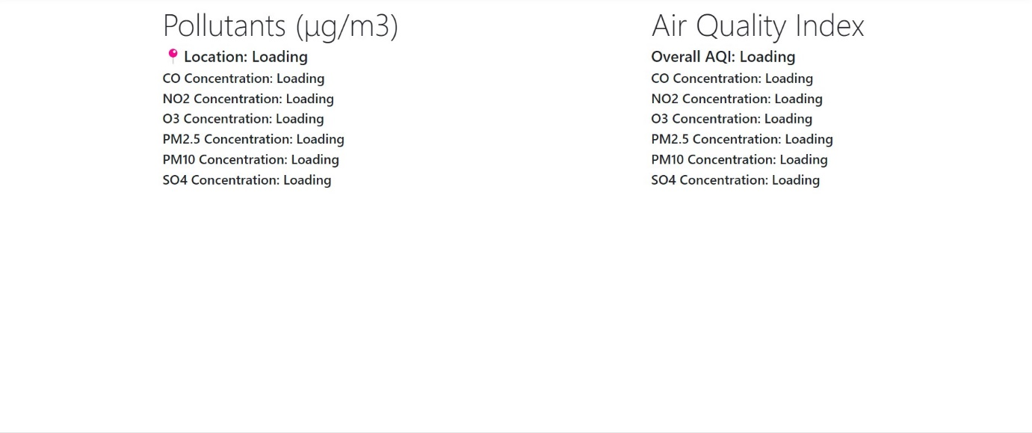

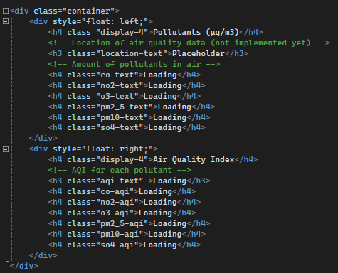

## Iteration 2 | U

In the second iteration, we pull data from the API and display it next to the corresponding concentration. This will improve usability by displaying the real air pollution at the user’s location which will inform their health decision-making process.

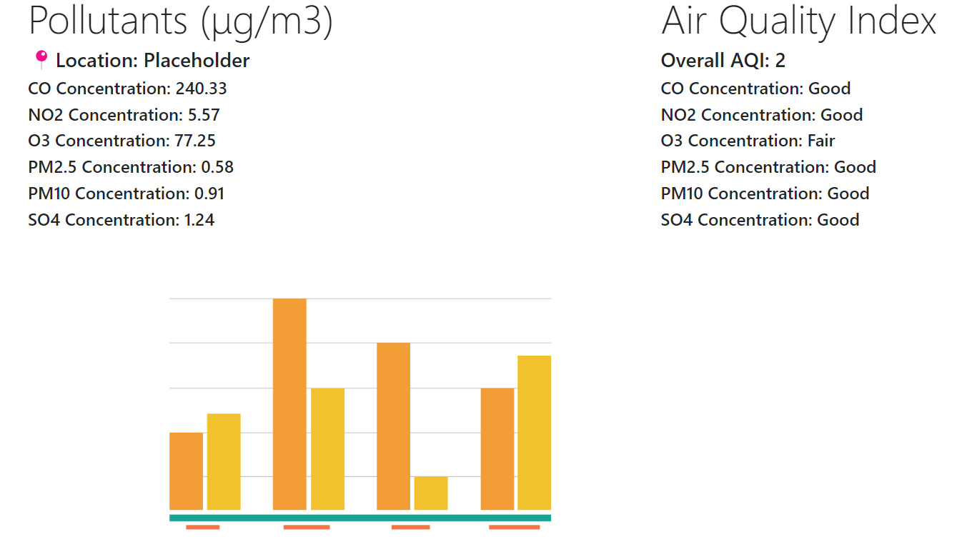

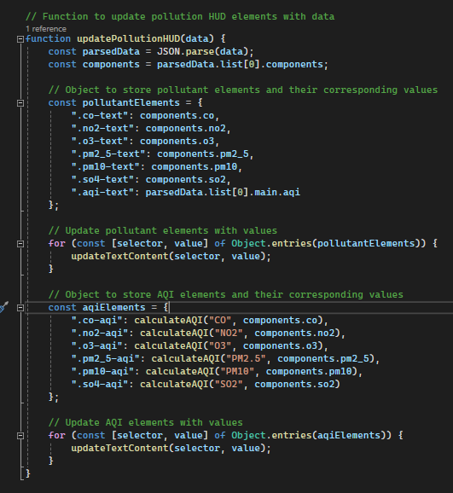

# Create Advice

This page is a collection of forms which allows a user with the “management” role to create articles of advice which will be displayed to other users.

## Iteration 1

In the first iteration, the user will be able to upload an image file, a title for the advice, and a description of the advice. However, it does not account for some fields.

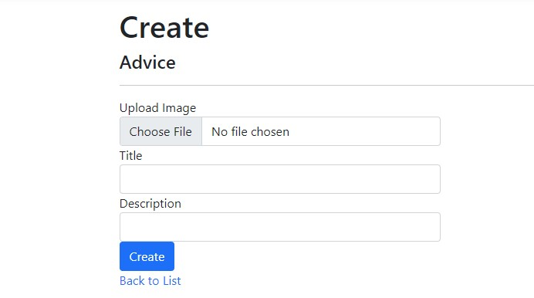

## Iteration 2 | U

In the second iteration of the page, the forms have been updated to account for the “temperature” field. This is the temperature that a condition starts to occur at. However, this field can be left blank if it is not applicable or if an accurate figure cannot be provided. This improves usability as in the future, users may be able to navigate by another metric (temperature).

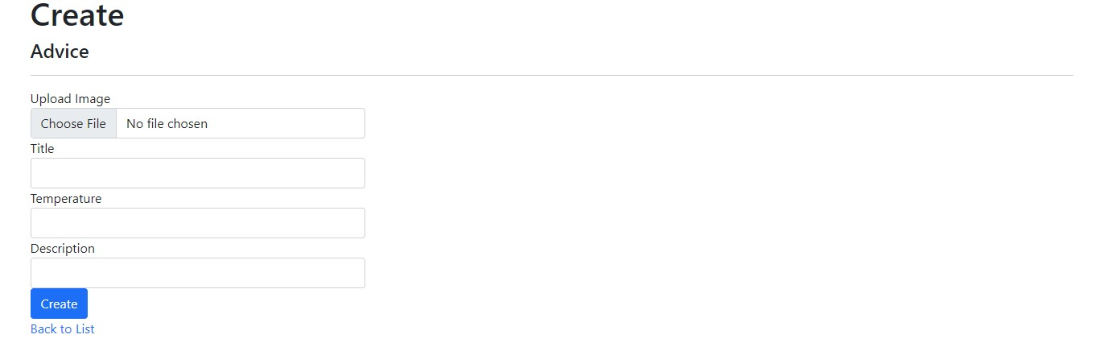

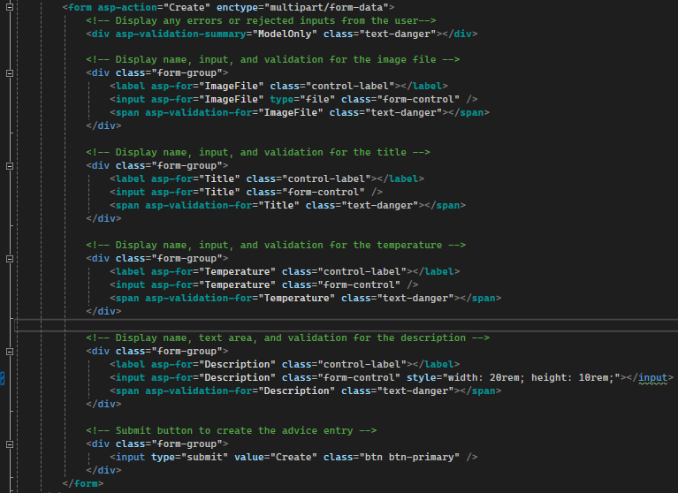

## Iteration 3 | U

In the third iteration, the “description” form has been updated to a text box. This improves usability by giving users more space to write out and proofread the description / advice. This also reduces the likelihood of spelling or grammatical errors.

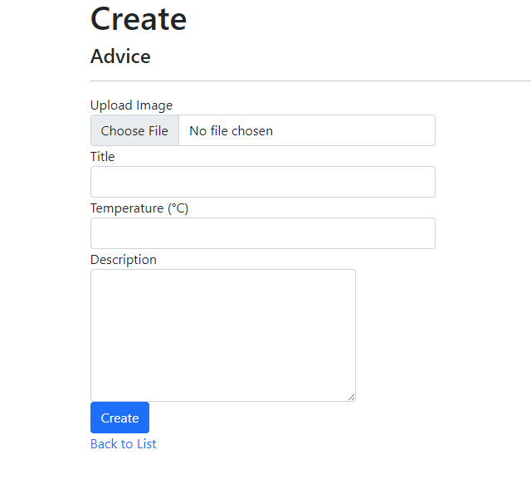



# All Advice

This page is designed to show the advice created by management to the users who have the default “user” roles.

## Iteration 1

The first iteration is a table which is already generated by ASP.NET. While it does display all pieces of information, it may be difficult to navigate should the fields (namely description) have large amounts of text. This will be addressed in future iterations.



## Iteration 2 | A

The second iteration makes use of the bootstrap grid and card system to lay out pieces of advice in clean and concise tiles. This improves accessibility by clearing clutter and by removing unnecessary information with excessive text, which may make it easier for people with visual impairments to navigate advice.

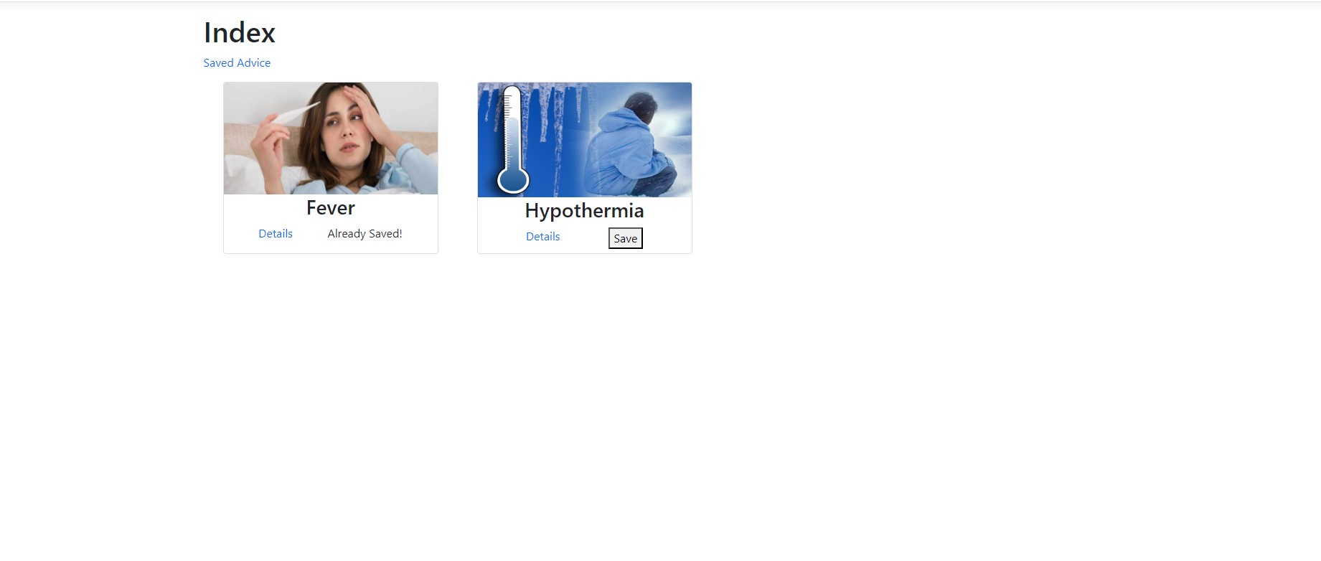

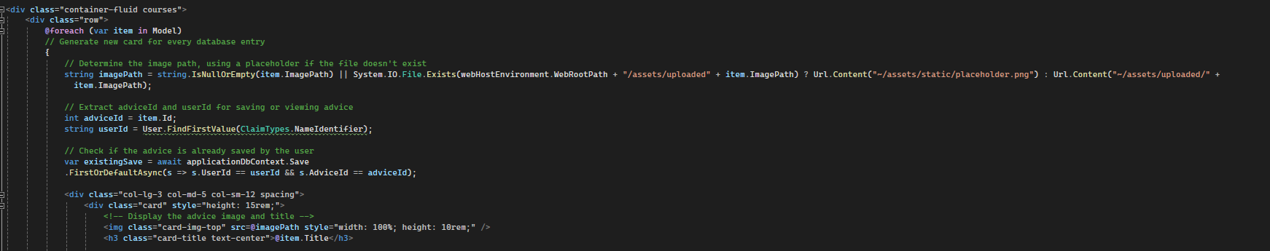

## Iteration 3A | U

In this iteration, users will be able to interact with the advice. Should users have the “user” role, they will have the ability to save advice or view more details about a piece of advice. This improves usability as it will allow users to create their own collection of advice for quick access.

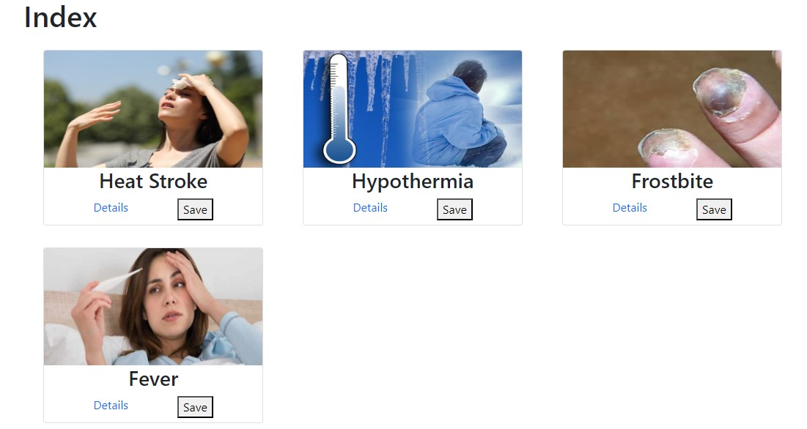

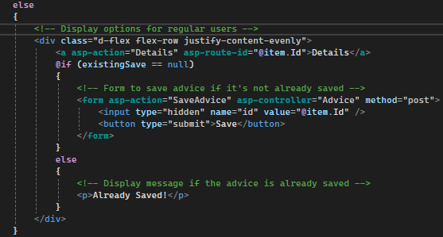

## Iteration 3B | U

In this iteration, users will be able to manage the device. Should users have the “management” role, they will have the ability to view, edit, or delete advice articles. This improves usability as it allows for quick changes to existing advice to be made without having to access the database itself.

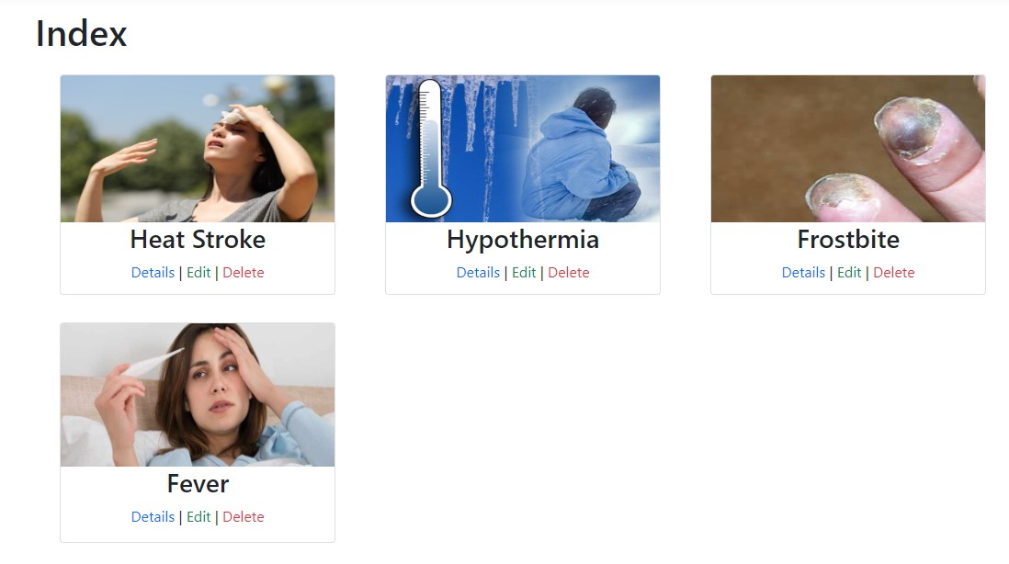

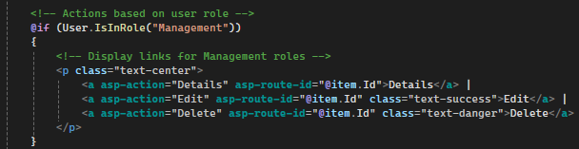

# My Advice

This page is designed to show all the advice that the user has saved to allow for quick access to needed advice.

## Iteration 1

In the first iteration, I have reused the card system from the “all advice” page. However, as the advice has already been saved, the save button has been omitted.



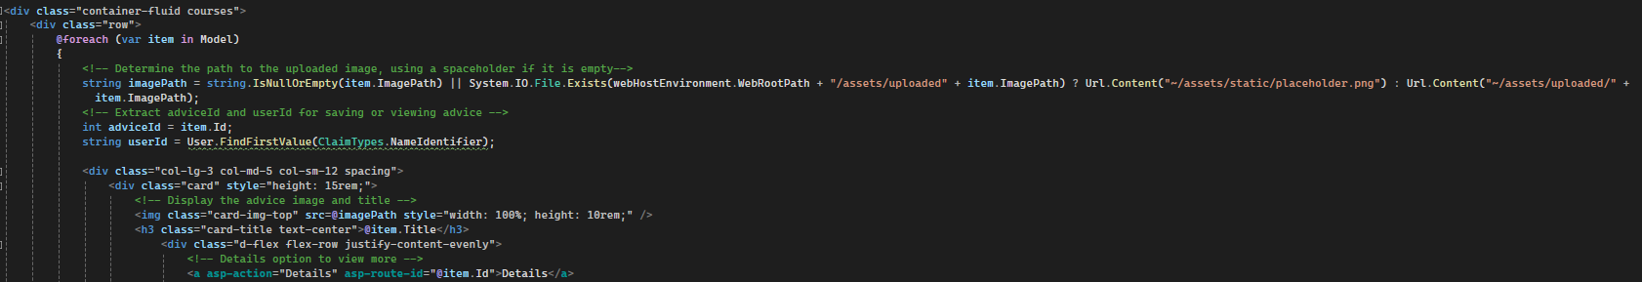

## Iteration 2 | U

In the second iteration, I have added an unsave button to the card system to improve usability. This is because it will allow users to clear unused advice they have saved or allow them to correct a mistake if they save the wrong piece of advice, rather than having to make another account.

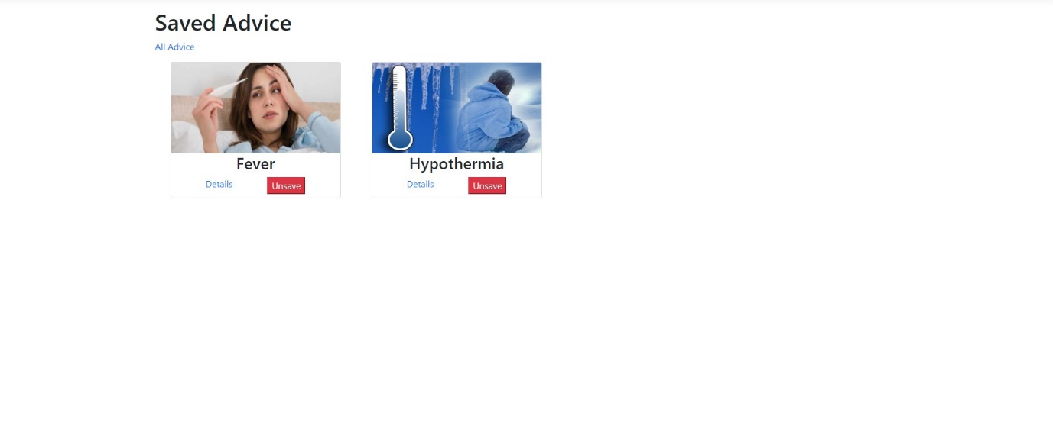



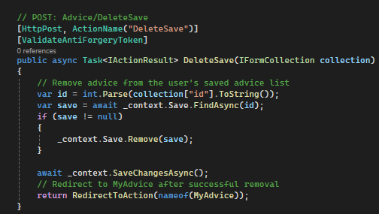

# Advice Details

As we have hidden some details from the “all advice” page, each piece of advice will have a respective details page which shows all details about a specific article.

## Iteration 1

In the first iteration, ASP.NET generates us a default “advice” page, however, some pieces of information are not being displayed correctly. For example. The ImagePath property will display the location to the image but not the image itself. This will be addressed in subsequent iterations.

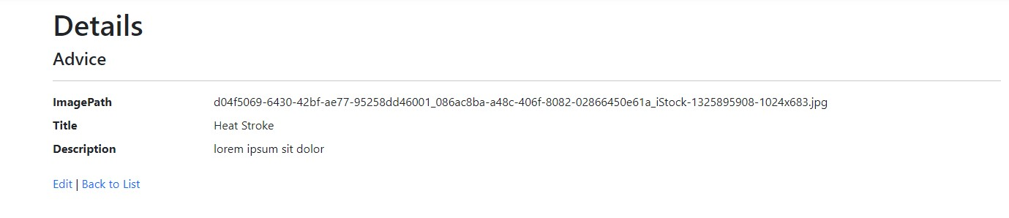

## Iteration 2 | A

In the second iteration, the ImagePath displays the image at the specified location. This can improve accessibility as it will allow for people with problems or impairments with reading to visually identify what the advice is about.

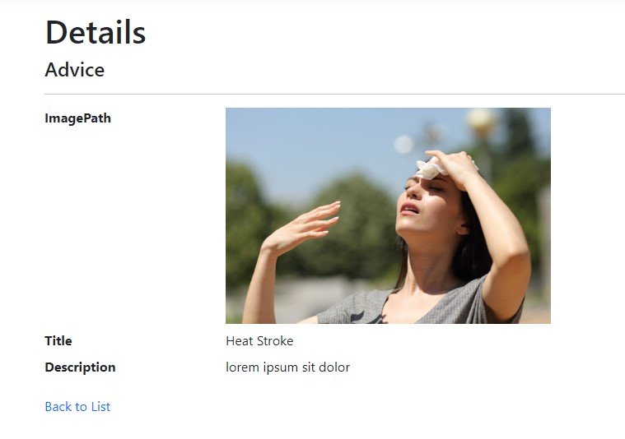

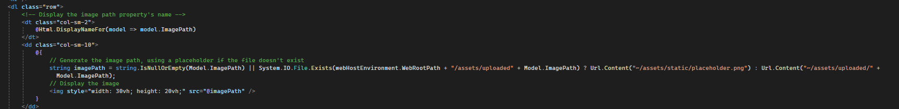

# Health Tracker

This page is designed to allow users to track and input metrics related to their health daily, namely calories, steps, and cups of water. This should allow users to inform short-term health decisions.

## Iteration 1

In the first iteration, a table is generated by ASP.NET. In order to ensure that the user only has access to their own data, this is tracked by user ID. This column would be redundant and unnecessary information as the only user ID in the table will match that of the current user’s ID. This will be addressed in subsequent iterations.

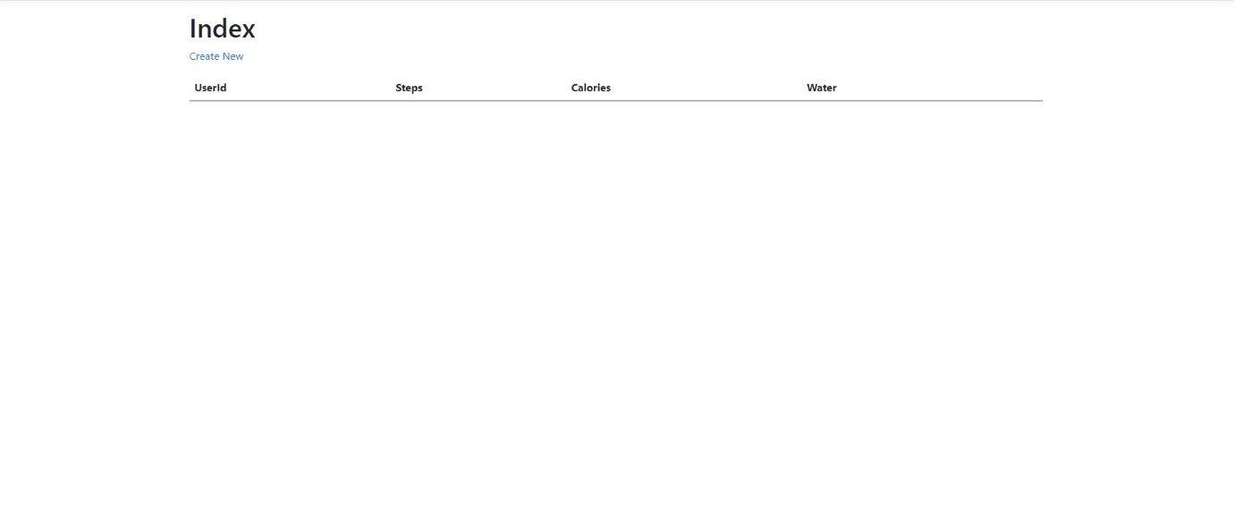

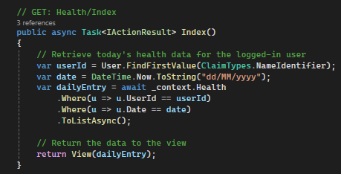

## Iteration 2 | U

In the second iteration, we have removed the userID field from the table. This improves usability by reducing the amount of redundant information displayed to the user.

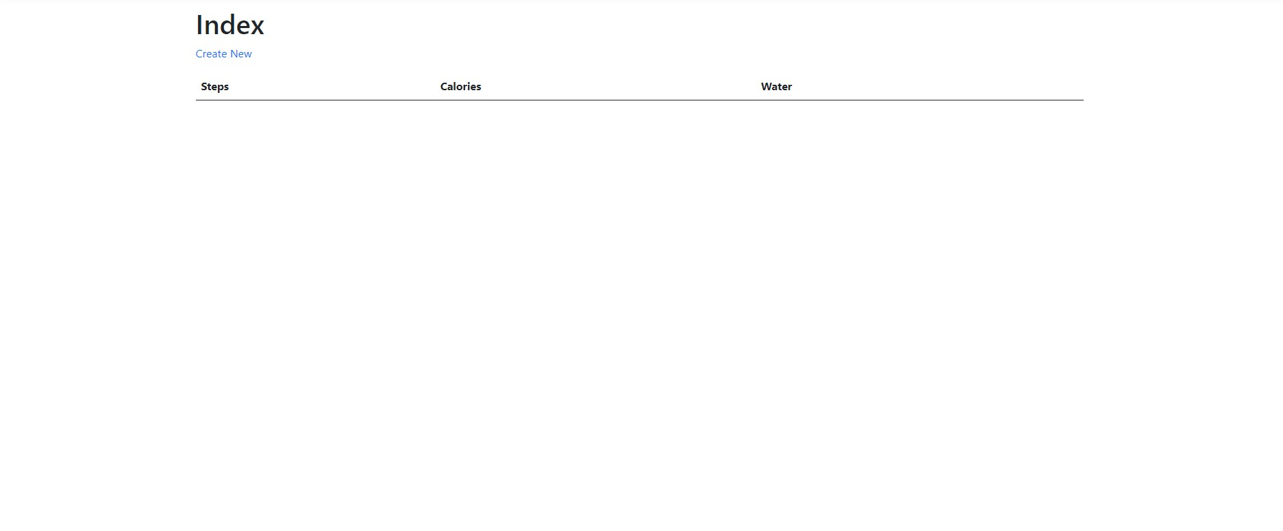

## Iteration 3 | U

In the third iteration, I have switched from a table system to a grid system and displayed each metric individually using the bootstrap card system. This has been done with the goal of giving the health tracker more of a “dashboard” layout. This improves usability by providing a clearer layout for tracking daily entries which will reset back to 0 daily.

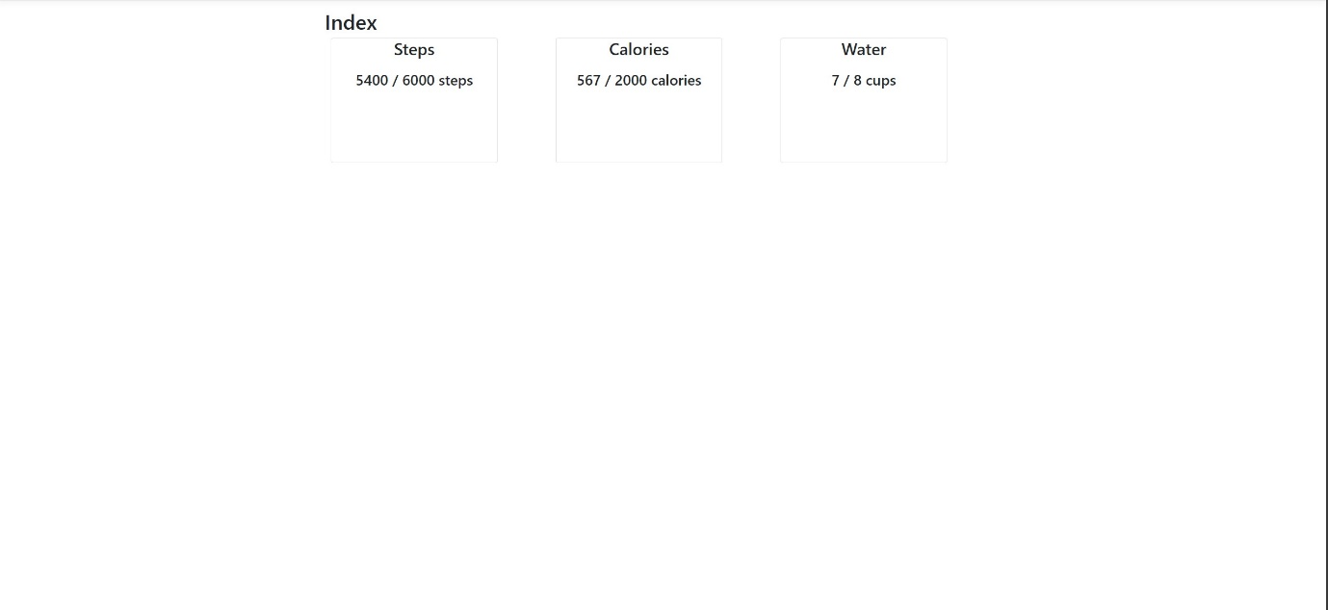

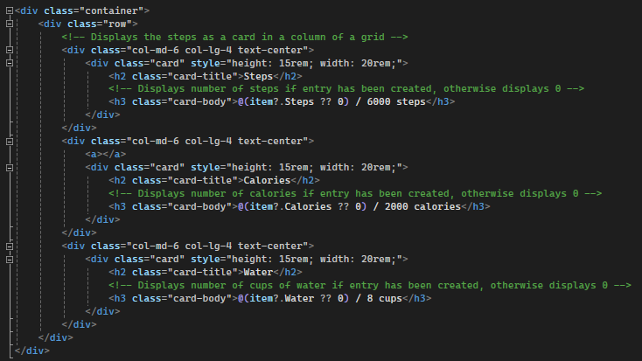

## Iteration 4 | U

In the fourth iteration, I have added checks to see if the user has already made an entry for today. If they have, they will be able to edit the entry, otherwise, they will be able to create an entry, I have also added a link to a feature which will allow them to see all entries. Usability has been improved by adding links which provide quick access to features needed to track or create the daily entry.

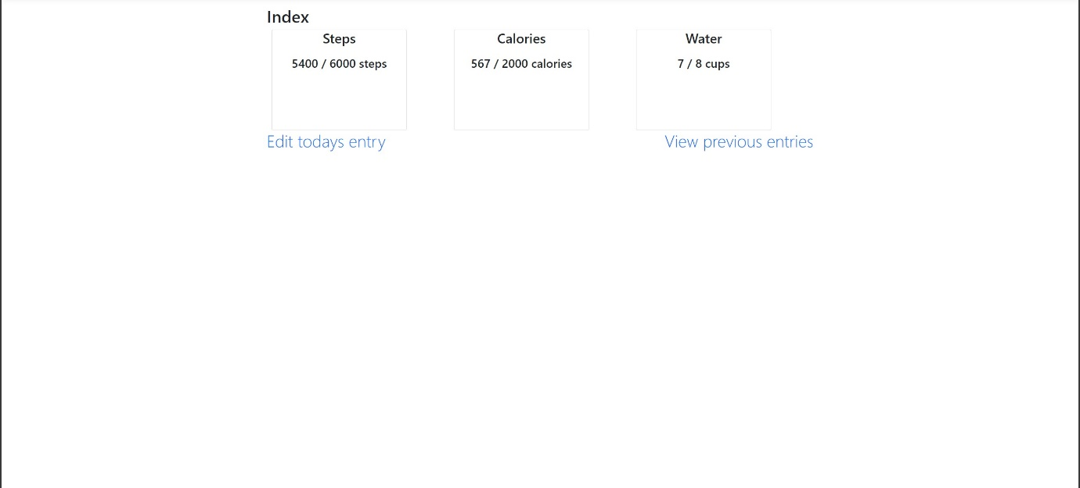

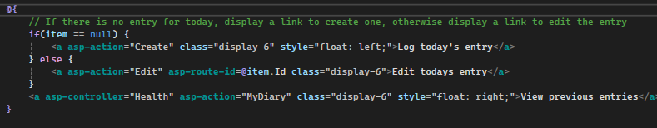

# Create / Edit Entry

This page will be used for entering daily metrics used in the health tracker such as calories, steps, and cups of water. As creating and editing entries will share the same form, they will be documented under 1 set of iterations.

## Iteration 1

The default forms which are provided contain input fields for these metrics, however, it also asks for some information which is difficult for the user to obtain, namely the user ID field. This will be addressed in subsequent iterations.

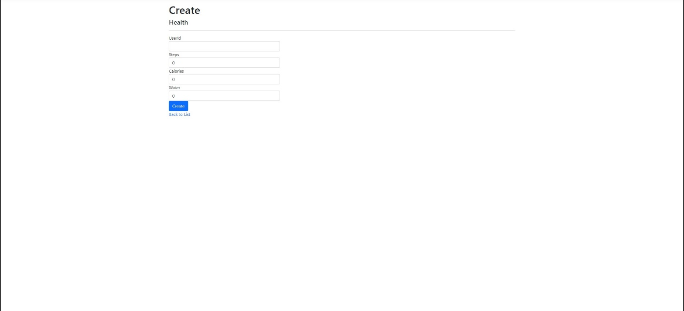

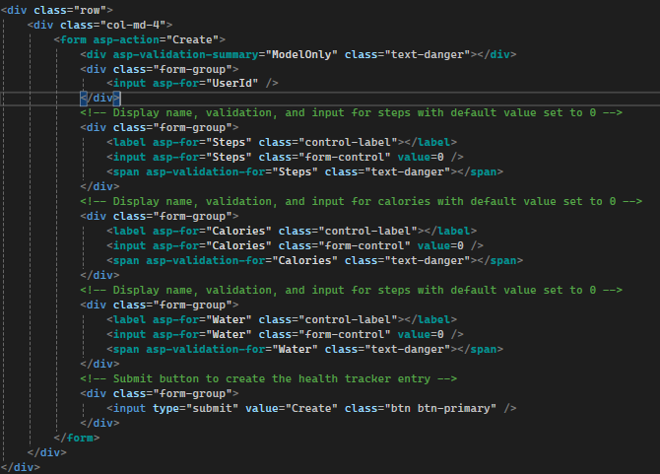

## Iteration 2 | U

In this iteration, the server will automatically retrieve the user ID and date. These inputs will be hidden from the user so they cannot be modified or read. Additionally, the “water” field has been renamed to Cups of Water for clarity. This improves usability as it reduces the confusion – users do not have to worry about their ID or the format of the date.

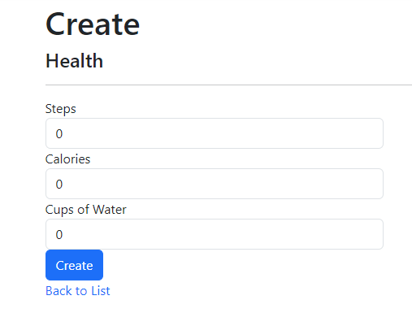

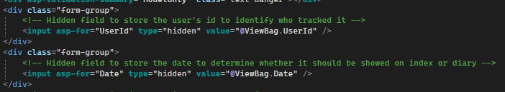

# All Entries

This page shows all previous diary entries created by the user. They will also have the option to edit or delete these entries from this page.

## Iteration 1

As we are showing a large number of diary entries, the grid that is generated is sufficient and displays data appropriately.

