**Method one:**

**Docker image build and push use jenkins ( Run as jenkins )**

**Dependencies:**

sudo apt update

sudo apt install docker.io -y

sudo systemctl start docker

sudo systemctl enable docker

usermod -aG docker [jenkinsuser]

**create credentials in jenkins server:**

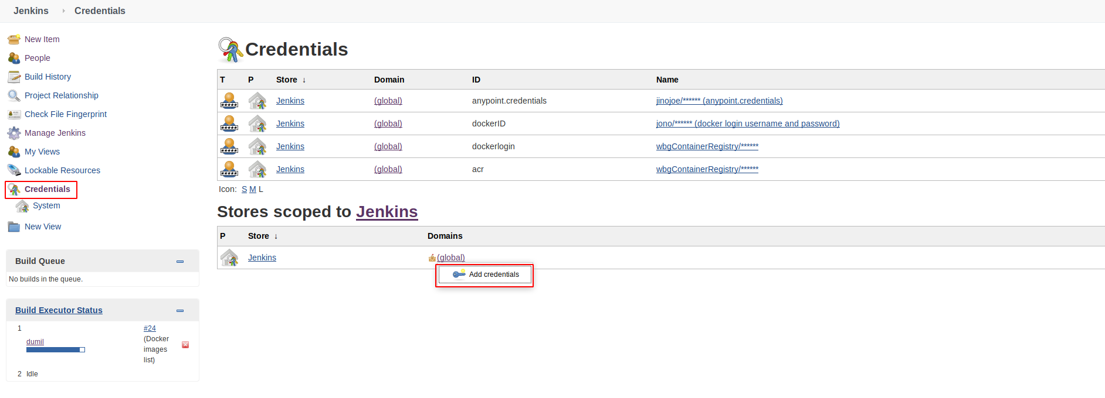

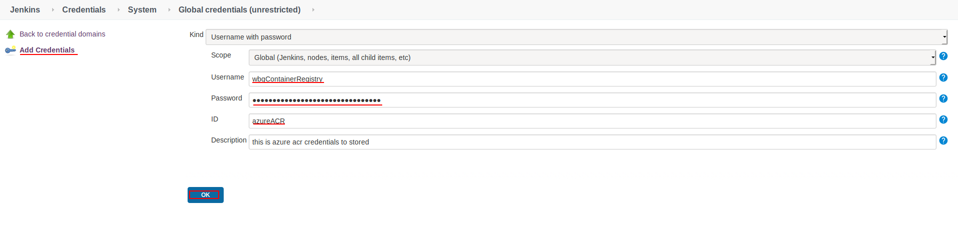how to get acr details → login portal.azure.com → go to container registries

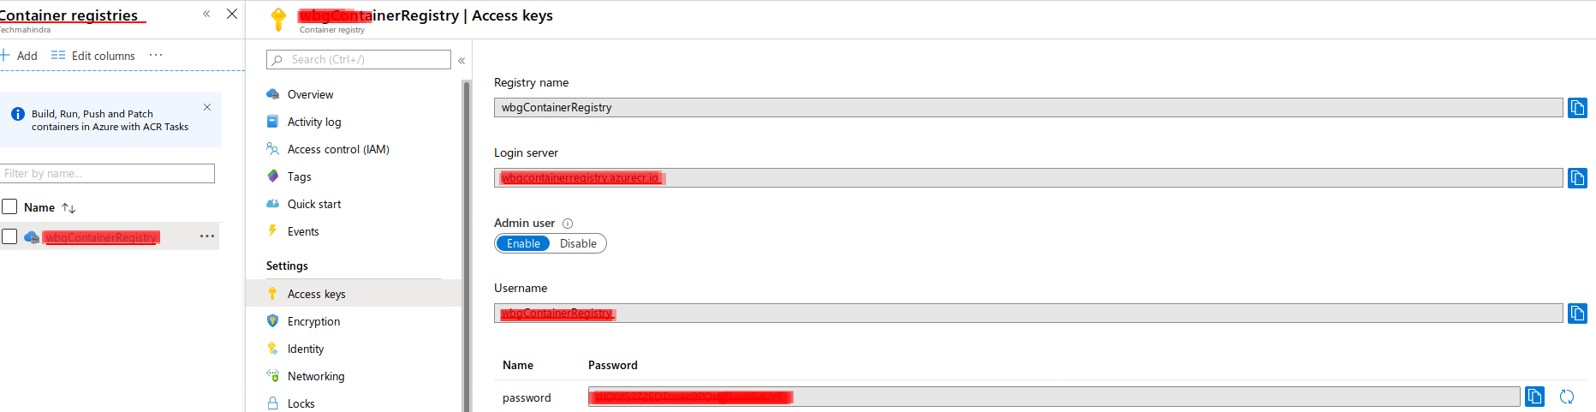

create Jenkinsfile

pipeline {

agent any

environment {

dockerhost = 'containerregistry.azurecr.io'

}

stages {

stage('docker login process') {

steps {

script {

withCredentials([

usernamePassword(credentialsId: 'azureACR',

usernameVariable: 'username',

passwordVariable: 'password')

]) {

sh '''

docker login $dockerhost -u $username -p $password

'''

}

}

}

}

stage('Docker image build') {

steps {

sh 'docker build -t $dockerhost/test:latest .'

}

}

stage('Docker images list') {

steps {

sh 'docker push $dockerhost/test:latest '

sh 'docker logout $dockerhost '

}

}

}

post {

always {

echo 'One way or another, I have finished'

deleteDir() /* clean up our workspace */

}

success {

echo 'I succeeeded!'

}

unstable {

echo 'I am unstable :/'

}

failure {

echo 'I failed :('

}

changed {

echo 'Things were different before...'

}

}

}