**Alerts Creation**

Azure Monitor maximizes the availability and performance of your applications and services by delivering a comprehensive solution for collecting, analyzing, and acting on telemetry from your cloud environments.

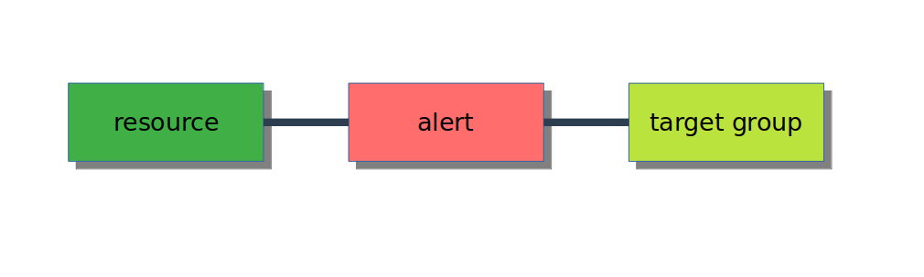

Requirements:

1. Action group

2. Alert Rule

3. Resources

Create Action Group Details:

Go to Alerts → Manage actions

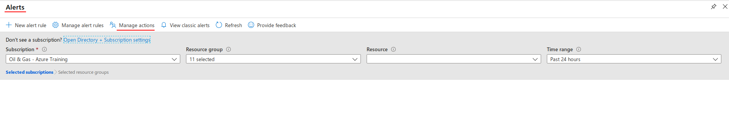

Add Action group →

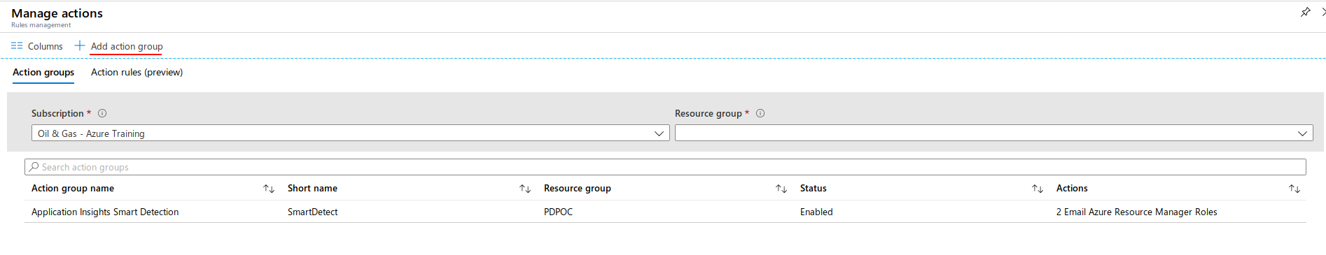

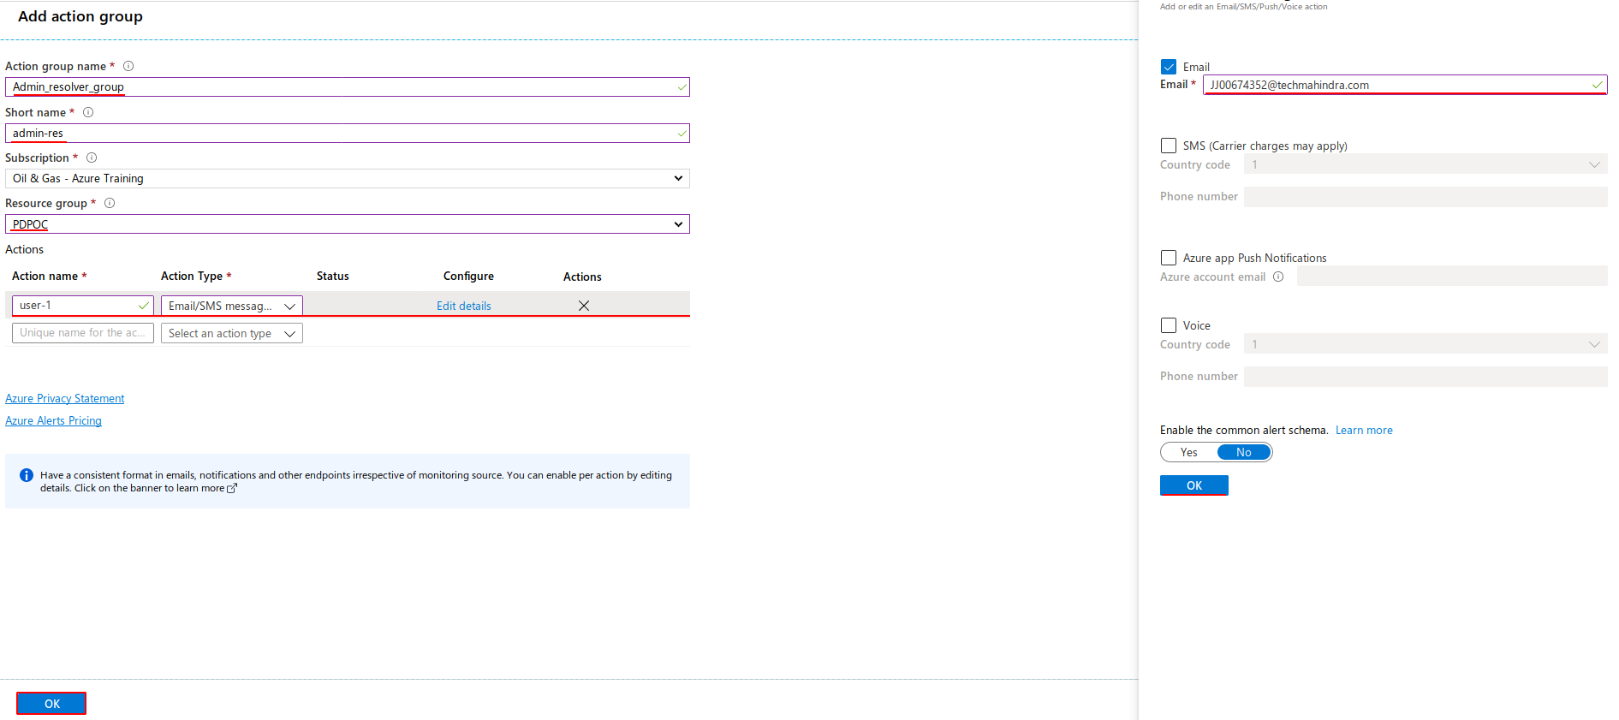

Create Alerts for resource monitor

Go to Resource Group → SELECT Resource

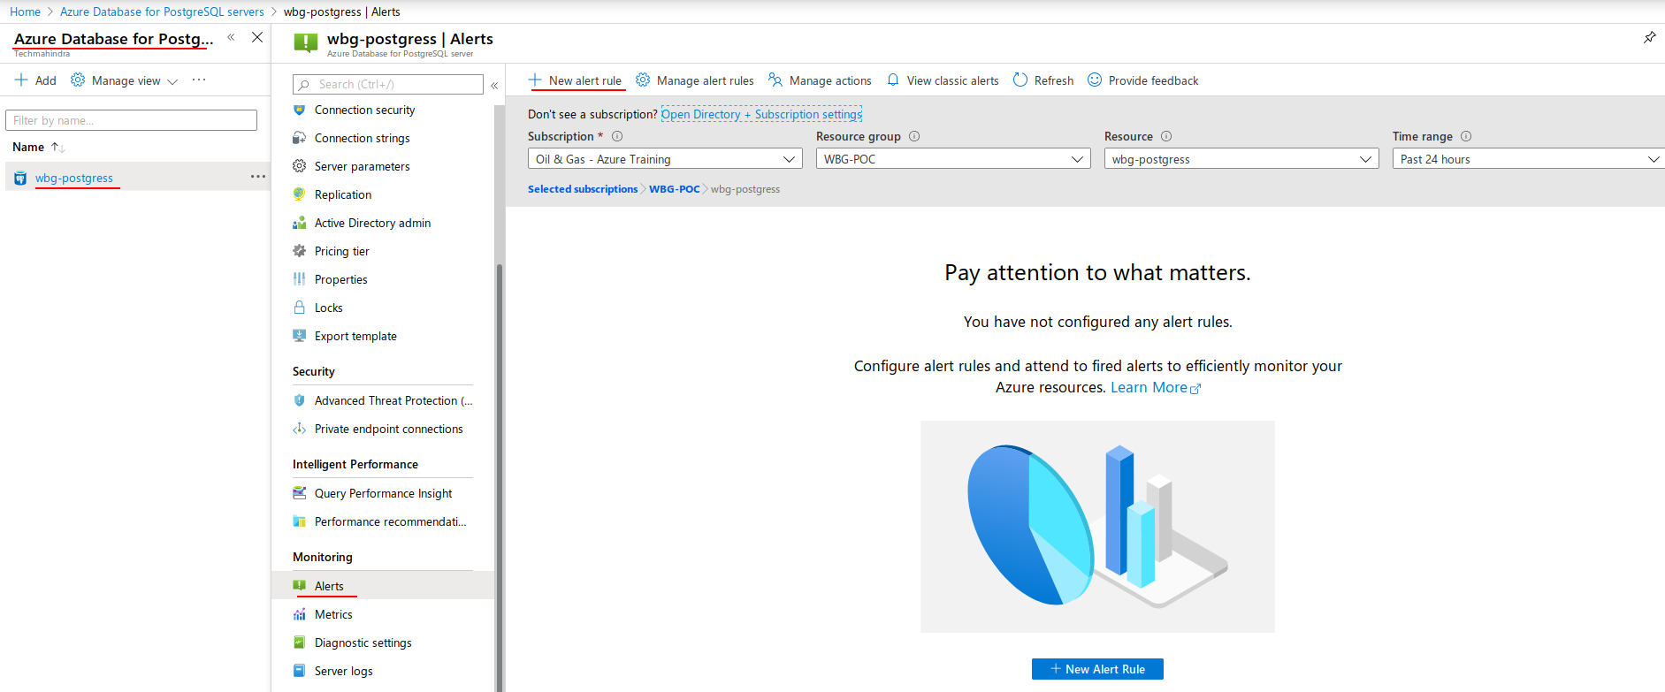

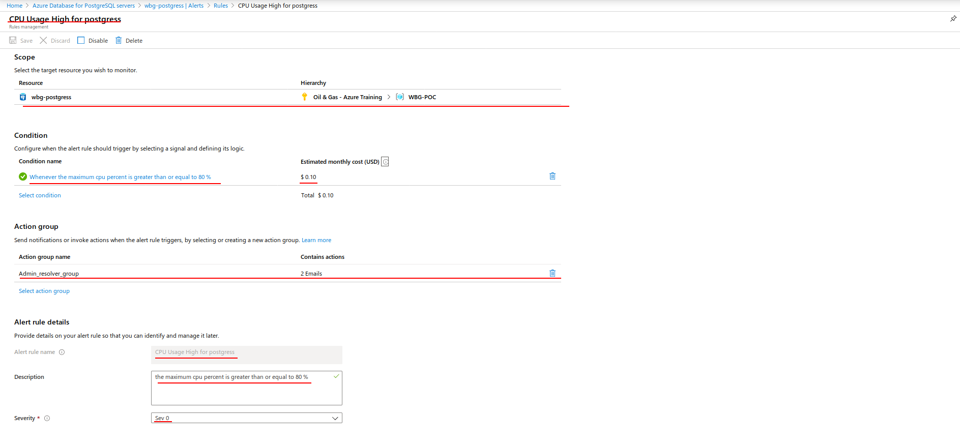

after rule creation details:

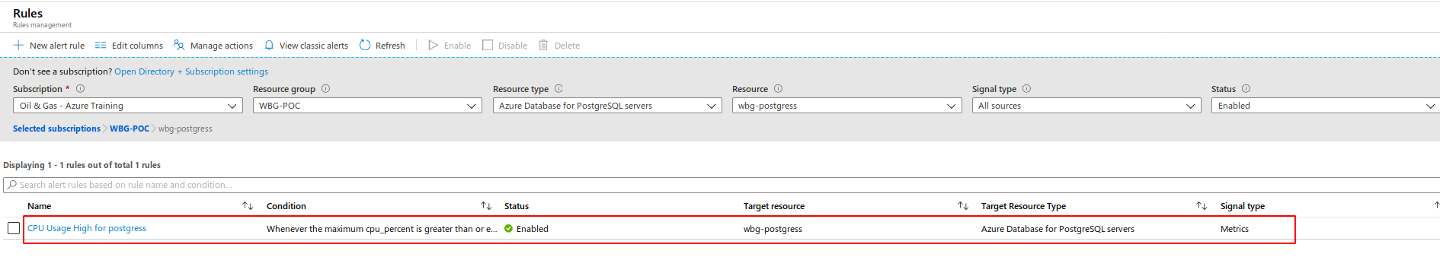

Notification Pricing details:

1. Per Rule have default price → $0.10/month

2. Total Cost

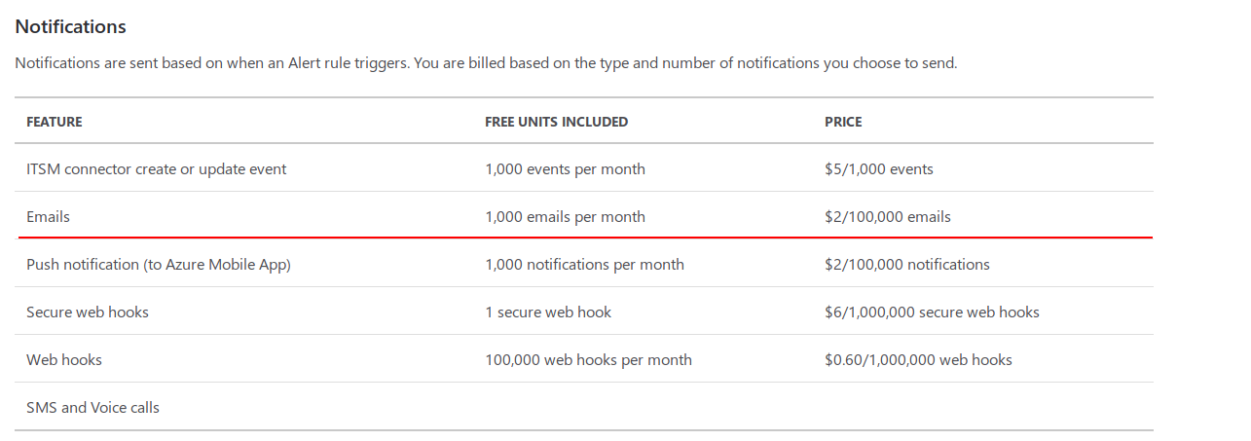

Refer: <https://azure.microsoft.com/en-us/pricing/details/monitor/>