Create ami for Azure windows use packer

Requirements

create app register for packer auth

create resource group

create shared image gallery inside the resource group

create image definition inside the shared image gallery

Here →

→ cache poc → Resource group name

→ ino → Shared image gallery name

→ image definition name → Packerimg

Resource Group

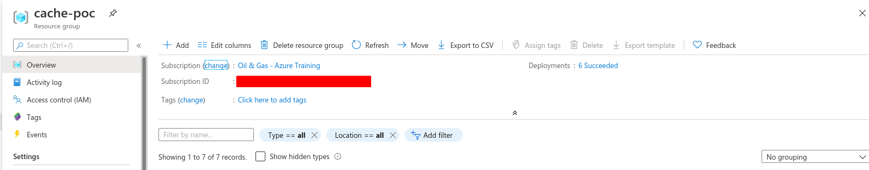

Shared image gallery

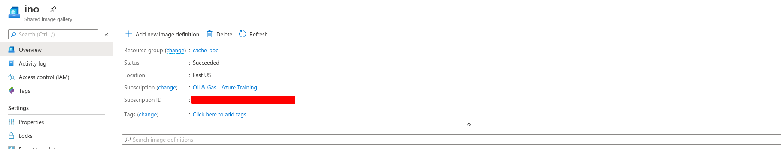

Image definition

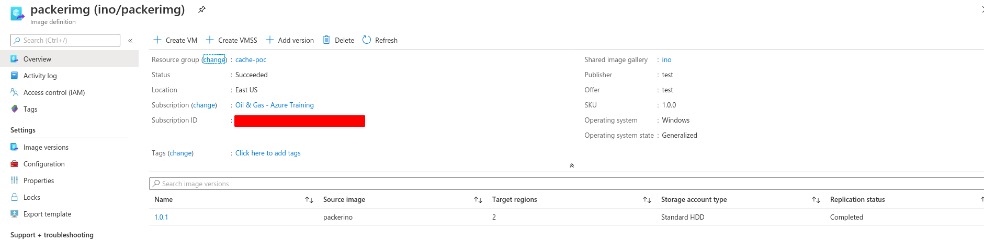

Reference:

→ <https://docs.microsoft.com/en-us/azure/virtual-machines/windows/shared-images-portal>

Environment Setup:

need to install packer in our local system

Reference → https://www.packer.io/downloads/

For Linux :

# <https://releases.hashicorp.com/packer/1.6.0/packer_1.6.0_linux_amd64.zip>

# tar -xzvf [packer_1.6.0_linux_amd64.zip](https://releases.hashicorp.com/packer/1.6.0/packer_1.6.0_linux_amd64.zip)

# mv packer /usr/local/bin

# packer --version

To create Packer json file:

reference →

<https://github.com/FourTimes/Packer/blob/master/Azure-images/windows.json>

script file location →

<https://raw.githubusercontent.com/FourTimes/Packer/master/Azure-images/script.ps1>

Note: this script download from blob storage zip file and extract to some location after set environment variable.

Download from above the link

# packer validate windows.json

# packer build windows.json

Build example:

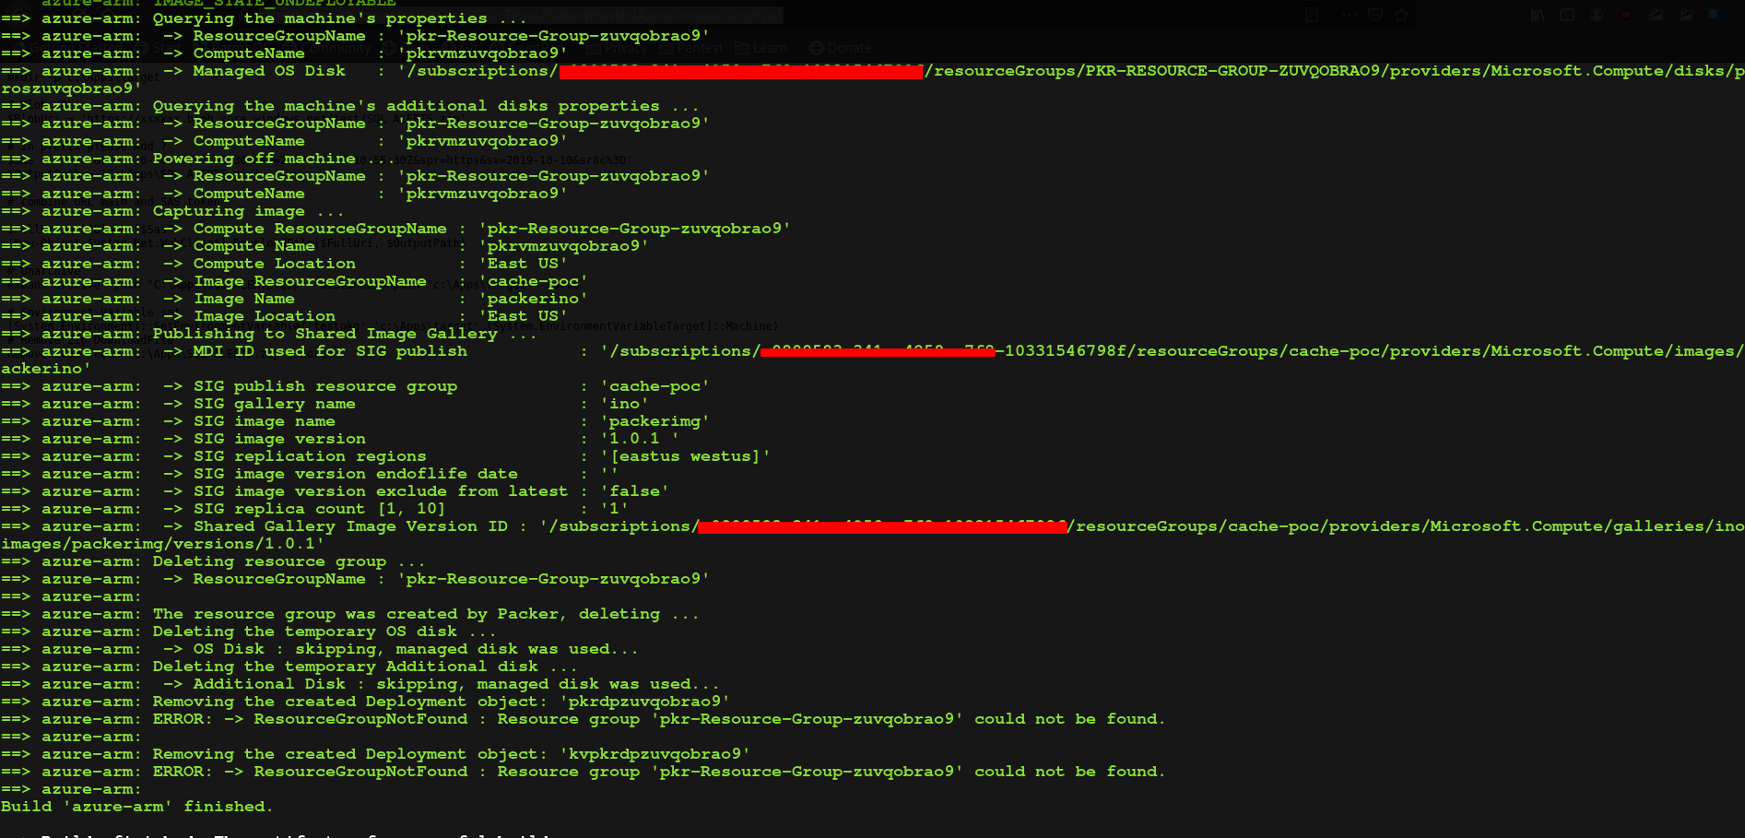

Result:



After create vm

