EEE414: Mobile Communications

Propagation assignment

**Name: Zhipeng Ye**

**ID number: 1926908**

Catalogue

EEE414: Mobile Communications 1

Propagation assignment 1

Abstract 1

Introduction 2

Antenna Gain calculation 8

Effect of end reflections 9

Beer can antenna data 10

Short Backfire antenna data 14

Conclusion 17

Reference 18

# Abstract

This report introduces the background of wireless mobile communication and ordinary propagation models. According to the experiment, I also compare data between measured data and simulation. Finally, I analyze the result and conclude this experiment.

# Introduction

## Radio waves and mobile communications

Wireless transmission is a method of data transmission using wireless technology. With the development of science and technology, high-performance, highly reliable wireless transmission systems have become possible. In the past, it was hard to imagine that when people were away from work, they could use their mobile phones to remotely control household appliances. When in a foreign country, you can use wireless communication to make phone calls with your family. On high-speed trains, you can watch wonderful TV videos. Not only that, with the development of wireless communication technology, telemedicine, autonomous driving, Augmented Reality will become a reality. 5G and WIFI-6 will greatly improve people's living standards.

## Free space propagation model

The wireless signal propagation model is the theoretical basis of wireless communication technology. Wireless communication technology comes from Maxwell's equations. As mentioned in [1] , this theorem reveals the relationship between electric and magnetic fields.

Where is the electric field and the magnetic field, is the vacuum permittivity, is the vacuum permeability, is the charge density, and is the current density.

Changing electric fields can produce magnetic field changes. Magnetic fields are radio waves. Light is also a type of radio wave, so scientists and engineers now plan to use optical communication Li-Fi.

The electric and magnetic fields are orthogonal to each other in Euclidean space and advance in a spiral manner, as shown in Figure 1.

|  |
| --- |
|  |
|  | Figure |

Since the divergence of the electromagnetic wave per unit time is constant, the electromagnetic wave is scattered outside in free space (vacuum). The energy will be uniformly dispersed on the sphere with the translation over time, as shown in Figure 2.

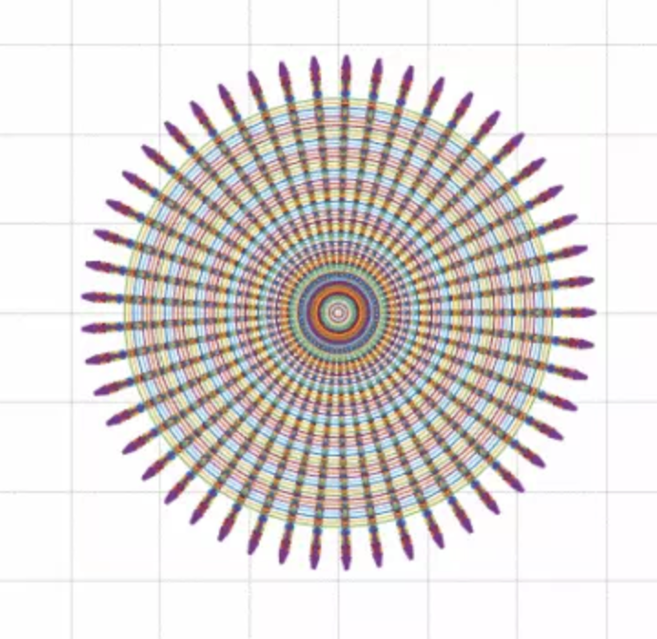

Figure

|  |
| --- |
|  |
|  |  |

So the electromagnetic wave energy per unit area is inversely proportional to the distance.

According to Rappaport [2], this defines the Friis transmission equation.

|  |
| --- |
|  |
|  |  |

Free space loss

|  |
| --- |
|  |
|  |  |

However, a vacuum environment cannot be provided in daily life, and radio wave transmission is also affected by the transmission environment.   
From the alternative form of the Friis equation, it can be seen that there is also a loss in the transmission medium 。

|  |
| --- |
|  |
|  |  |

In addition to the reflection of electromagnetic wave in the propagation process, different reference models must be established according to the propagation environment in engineering practice

## Indoor propagation

Indoor wireless is characterized by less transmission power, coverage distance is closer, the environment changes more, for different buildings, indoor layout, material structure, building scale and application type and other factors change more, which makes the communication environment has a great difference.

## Outdoor propagation

In the outdoor environment of mobile communication systems, electromagnetic waves usually travel in irregular, non-single environments. When estimating channel loss, we should consider the topographical features on the propagation path, as well as obstacles such as buildings, trees, electromagnetic poles, etc. Experiments show that with the increase of distance, the intensity of the receiving signal decreases gradually, but the rate of attenuation is different. The attenuation rate of propagation at the time of the sight is the lowest, followed by the largest rate of attenuation in open areas and suburbs. Therefore, different transport models should be selected in different environments for predictive analysis.

## 2-ray interference model

The 2-ray interference model is an electromagnetic wave propagation model. Taking into account the effects of multiple transmissions, the receiving end of the radio receives a signal that is reflected back from the ground. Scientists and engineers have built 2-ray interference model based on this phenomenon. As shown in Figure 3:

The accepting signal consists of two components:

1. Direct or LOS component - The transmit signal travels through free space and reaches the receiving end.

2. Emission components - The transmit signal is reflected by the ground and reaches the receiving end.

|  |
| --- |
|  |
|  | Figure 2-ray interference model |

## Polarization

As mentioned in [2] , according to Maxwell's equation, the direction of the electric field and the direction of the magnetic field are perpendicular to each other. As shown in Figure4:

|  |
| --- |
|  |
|  | Figure Electromagnetic wave polarization |

### Best launch and reception with polarization

In radio technology, the optimal transmission and reception of radio signals can be realized by using different polarized electromagnetic waves to transmit different propagation characteristics, combined with the polarization characteristics of transceiver antennas. For example, a medium-wave broadcast uses a vertically polarized wave.

### Increase communication capacity with polarization technology

In communication, in order to maximize the number of available channels within the limited frequency band, increase channel capacity, increase frequency utilization, reduce inter-wave interference, one of the frequency multiplexing techniques widely used is on the same transmission link, using the orthogonal polarization isolation of the radio waves, the two adjacent channels of orthogonal polarization are arranged in the same band, This doubles the frequency utilization.

## Measurement experiment

**Describe the types of measurements undertaken in the anechoic chamber & CG13W. Explain the choice of these rooms. What distance above the floor was used? What equipment was used?**

The type of measurements in the anechoic chamber is a free space propagation model and the type of measurements in CG13W is an indoor propagation model. The reason for why we use this rooms is that the room is big enough we can measure many points. Furthermore, there is a little furniture in the room, therefore, there is a little interference and a little reflection. We use 40 meters to measure 80 points.

Here are some equipments which are used.

|  |  |  |  |  |  |  |
| --- | --- | --- | --- | --- | --- | --- |
| Name | RF Module | Antenna | Oscilloscope | Ruler | Go-cart | Absorber |
| Number | 1 | 2 | 1 | 1 | 1 | N |

# Antenna Gain calculation

According to Balanis [3] equation 17-15, I find this formula to calculate the Gain of both antenna types from the data measured in the anechoic chamber.

Here is the result that I calculate in Matlab.

Therefore, the Gain of faxe can is at 6.2529 - 6.5995 dBi and the Gain of SBA is at 14.2763 - 14.8720 dBi.

Comparing to the FEKO simulation result given in Lecture 2 Slides 56 & 57, the Gain of faxe can is 7.86dBi and the Gain of SBA is 16.17dBi.

The measured data is similar to simulation data.

**Were any of the data measured within the near field zone of either antenna type? What was the effect, if any?**

Yes, there is some data measured within the near field. The data measured within the near field can avoid 2-ray interference model and reduce other interference.

# Effect of end reflections

**Compare measured V-V beer can antenna data from 2019/09/26 and 2019/10/17. The latter measurements had an absorber barrier at the far corner of room CG13W. Did it have any effect?**

|  |
| --- |
|  |
|  | Figure Comparison with absorber and no-absorber |

Absorber barrier at the far corner of room CG13W can enhance the impact of reflection.

# Beer can antenna data

**Measured data from 2019/10/17 and 2019/10/31 were done with the beer can antennas, with the absorber barrier at the far corner of room CG13W. What was the difference between the V-V & H-H datasets?**

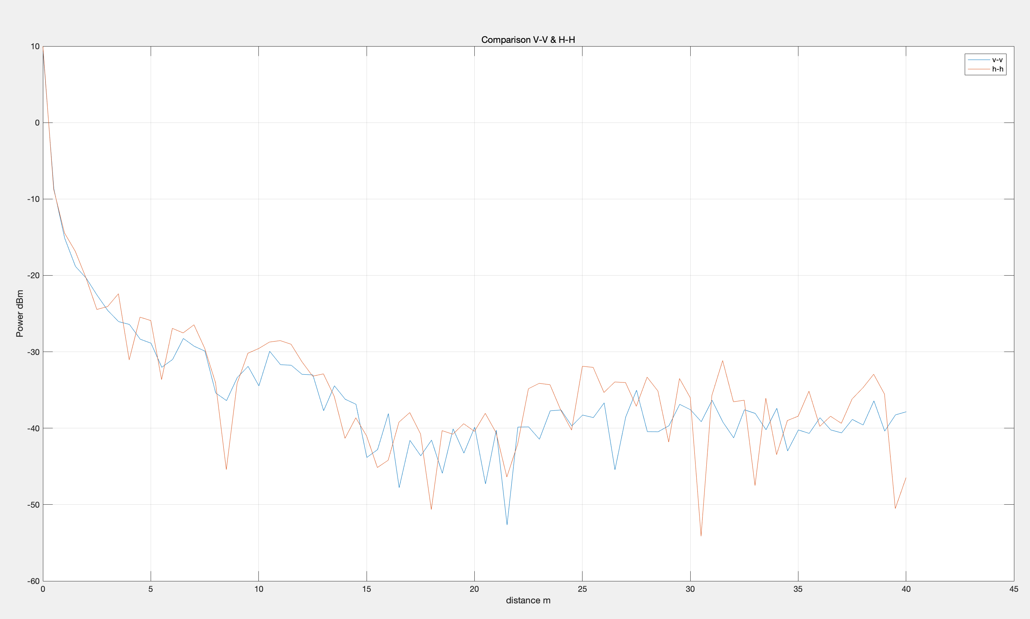

Figure Comparison V-V and H-H

The curve of H-H is steeper than that of V-V and the shape of V-V is smoother that that of H-H.

|  |
| --- |
|  |
|  |  |

**How do these measured results compare to the predictions from the 2- ray interference theory & the FEKOTM simulation results?**

**Compare with theory**

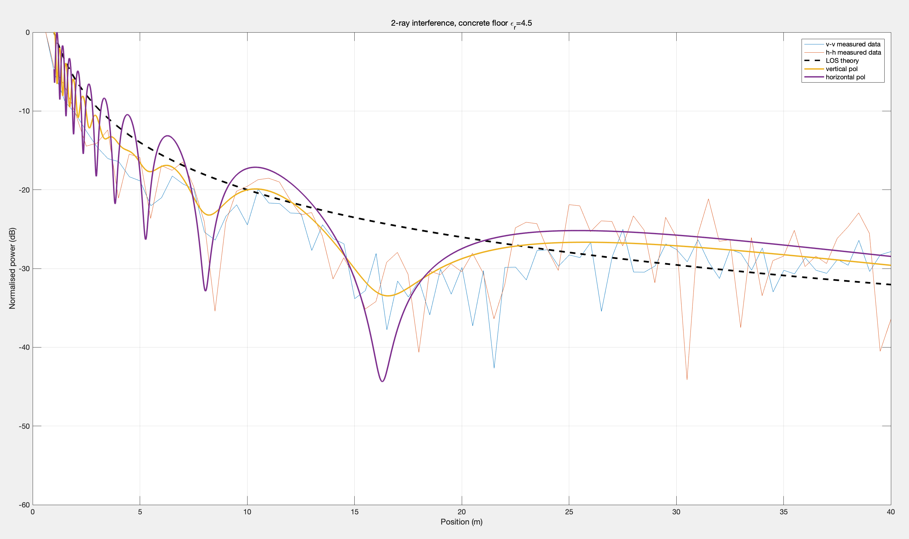

Figure Comparison between measured data and theory 4.5

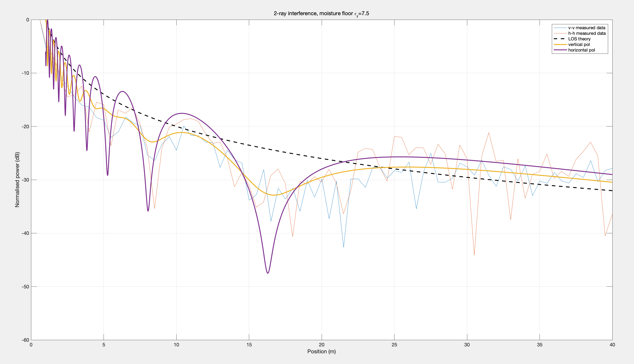

Figure Comparison between measured data and theory 7.5

**Compare with simulation**

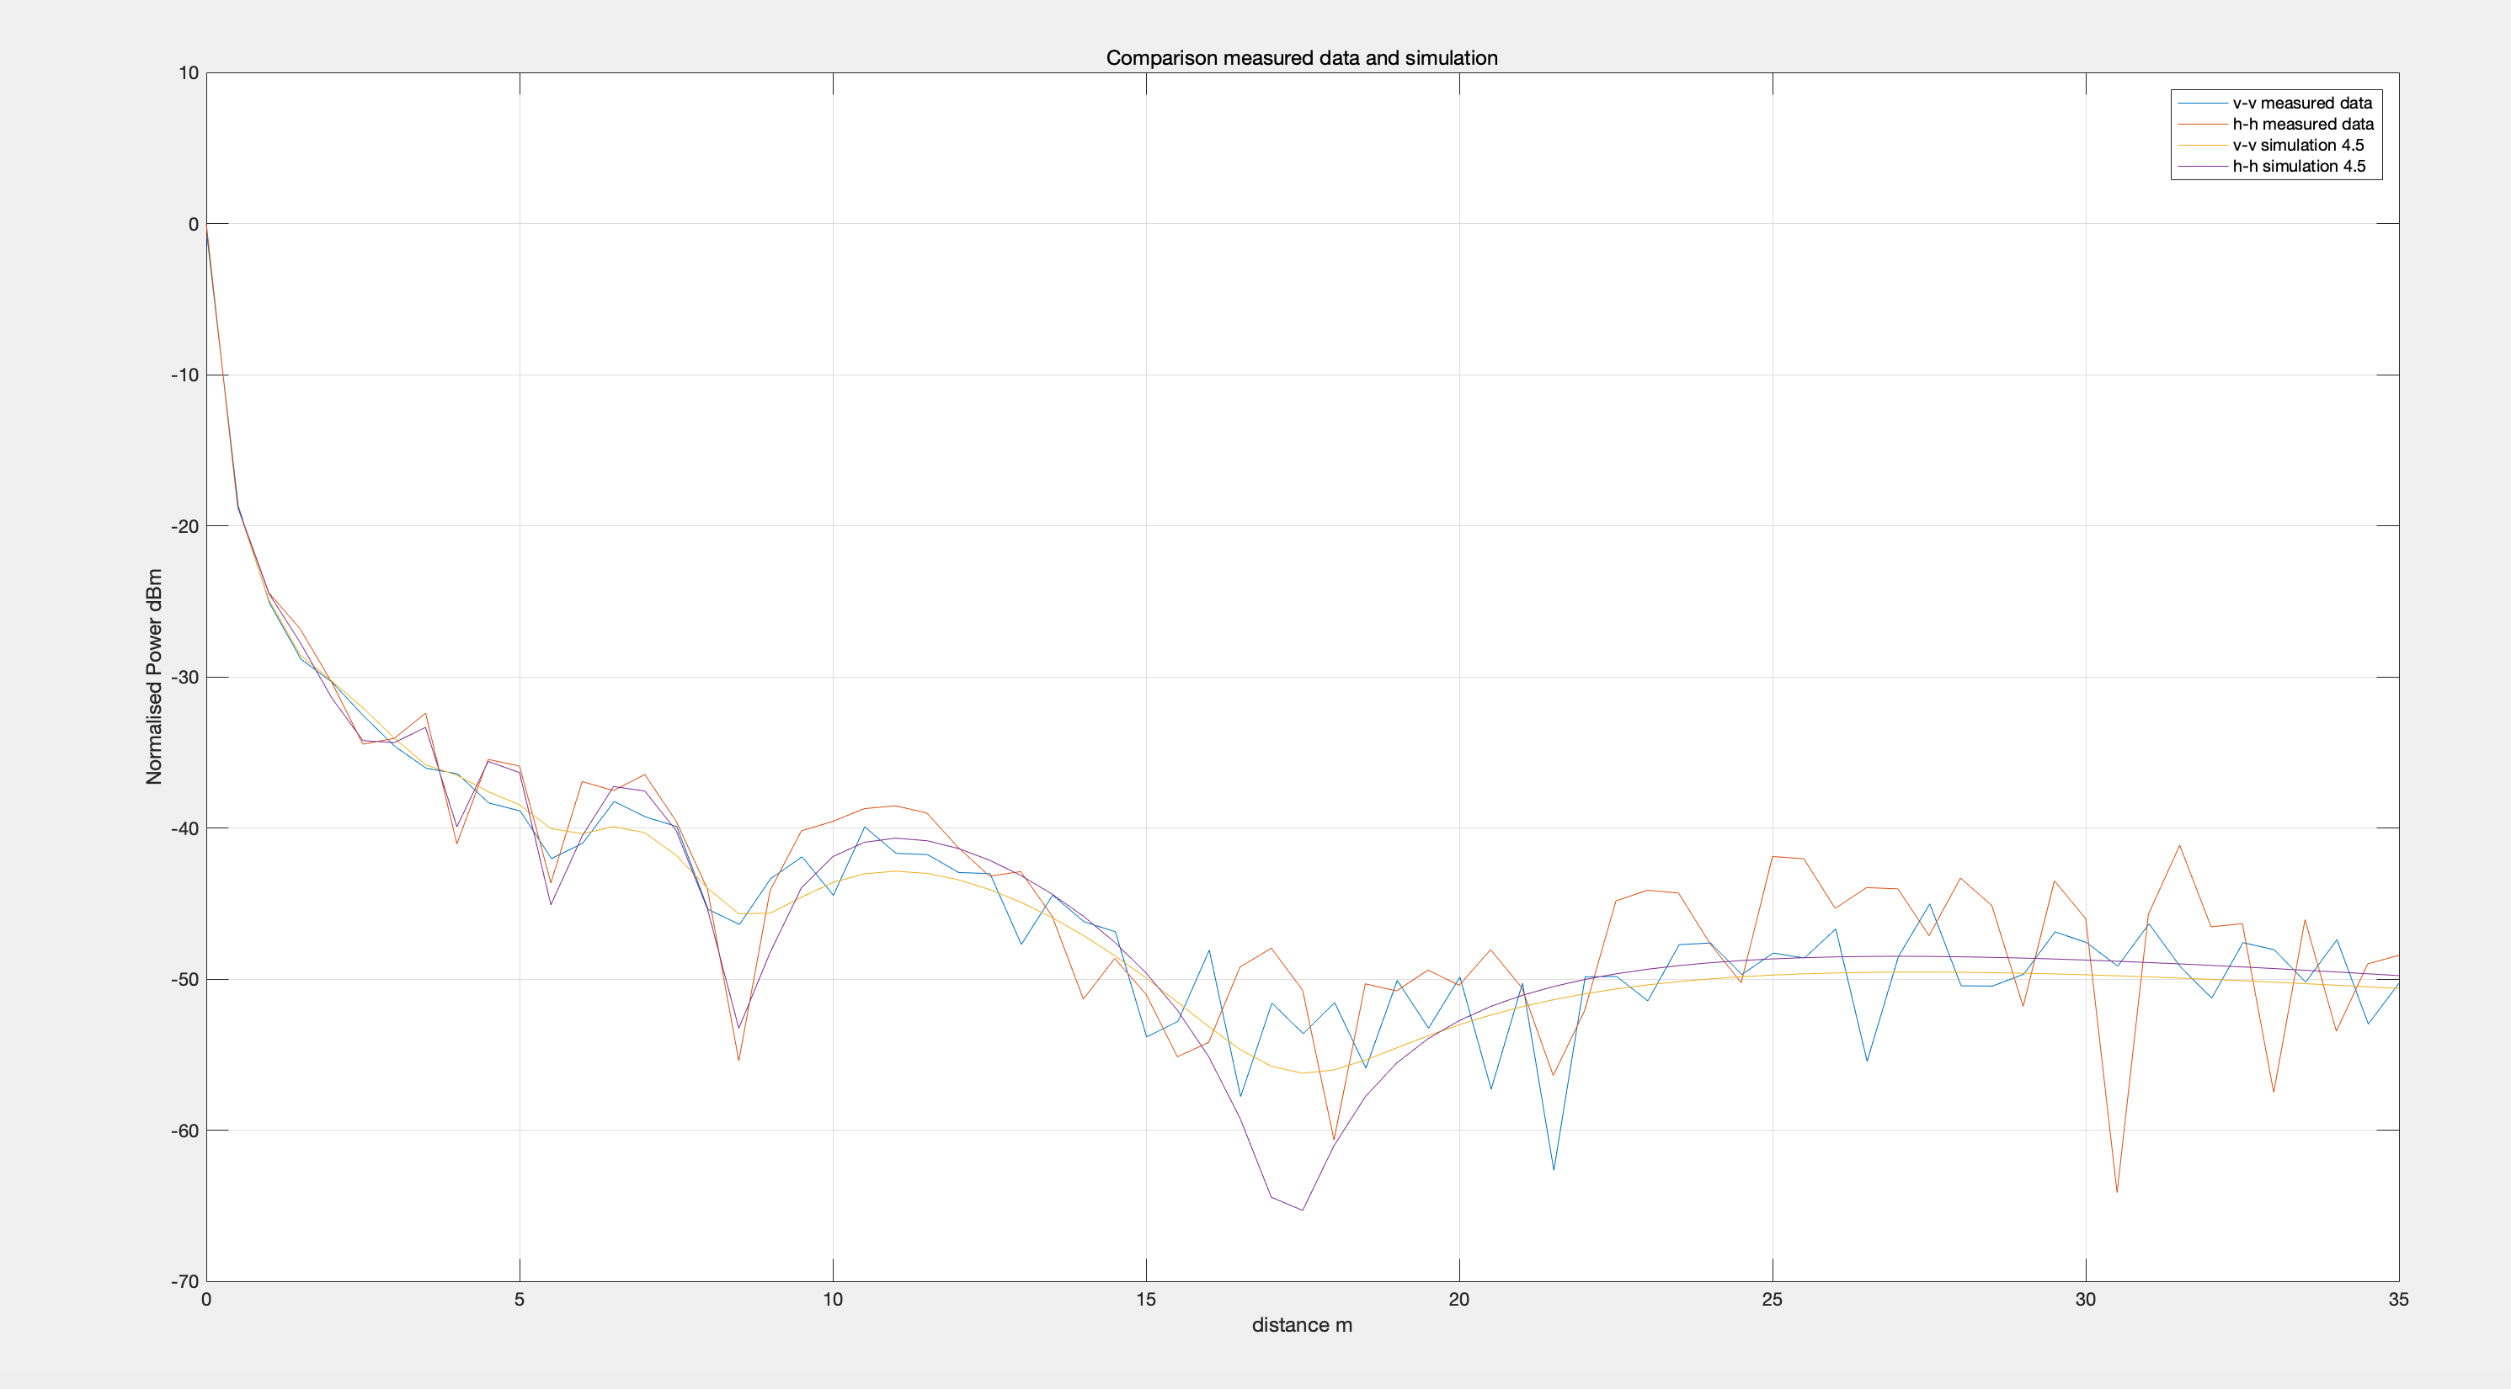

Figure Comparison between measured data and simulation 4.5

|  |
| --- |
|  |
|  | Figure Comparison between measured data and theory 7.5 |

**Were there any significant differences between the 3 for V-V and H-H?**

Yes, the curve of V-V is smoother than the curve of H-H, moreover the shape of H-H is more precipitous and cliffy than that of V-V, because of the direction of polarization.

**Can you determine the relative permittivity of the floor?**

According to figure we got, I think the relative permittivity is nearly at 5 in 2019/10/17 and the permittivity is nearly at 3.5 in 2019/10/31.

# Short Backfire antenna data

**Measured data from 2019/11/14 and 2019/11/28 were done with the Short Backfire cake tin antennas, with the absorber barrier at the far corner of room CG13W. What was the difference between the V-V & H-H datasets?**

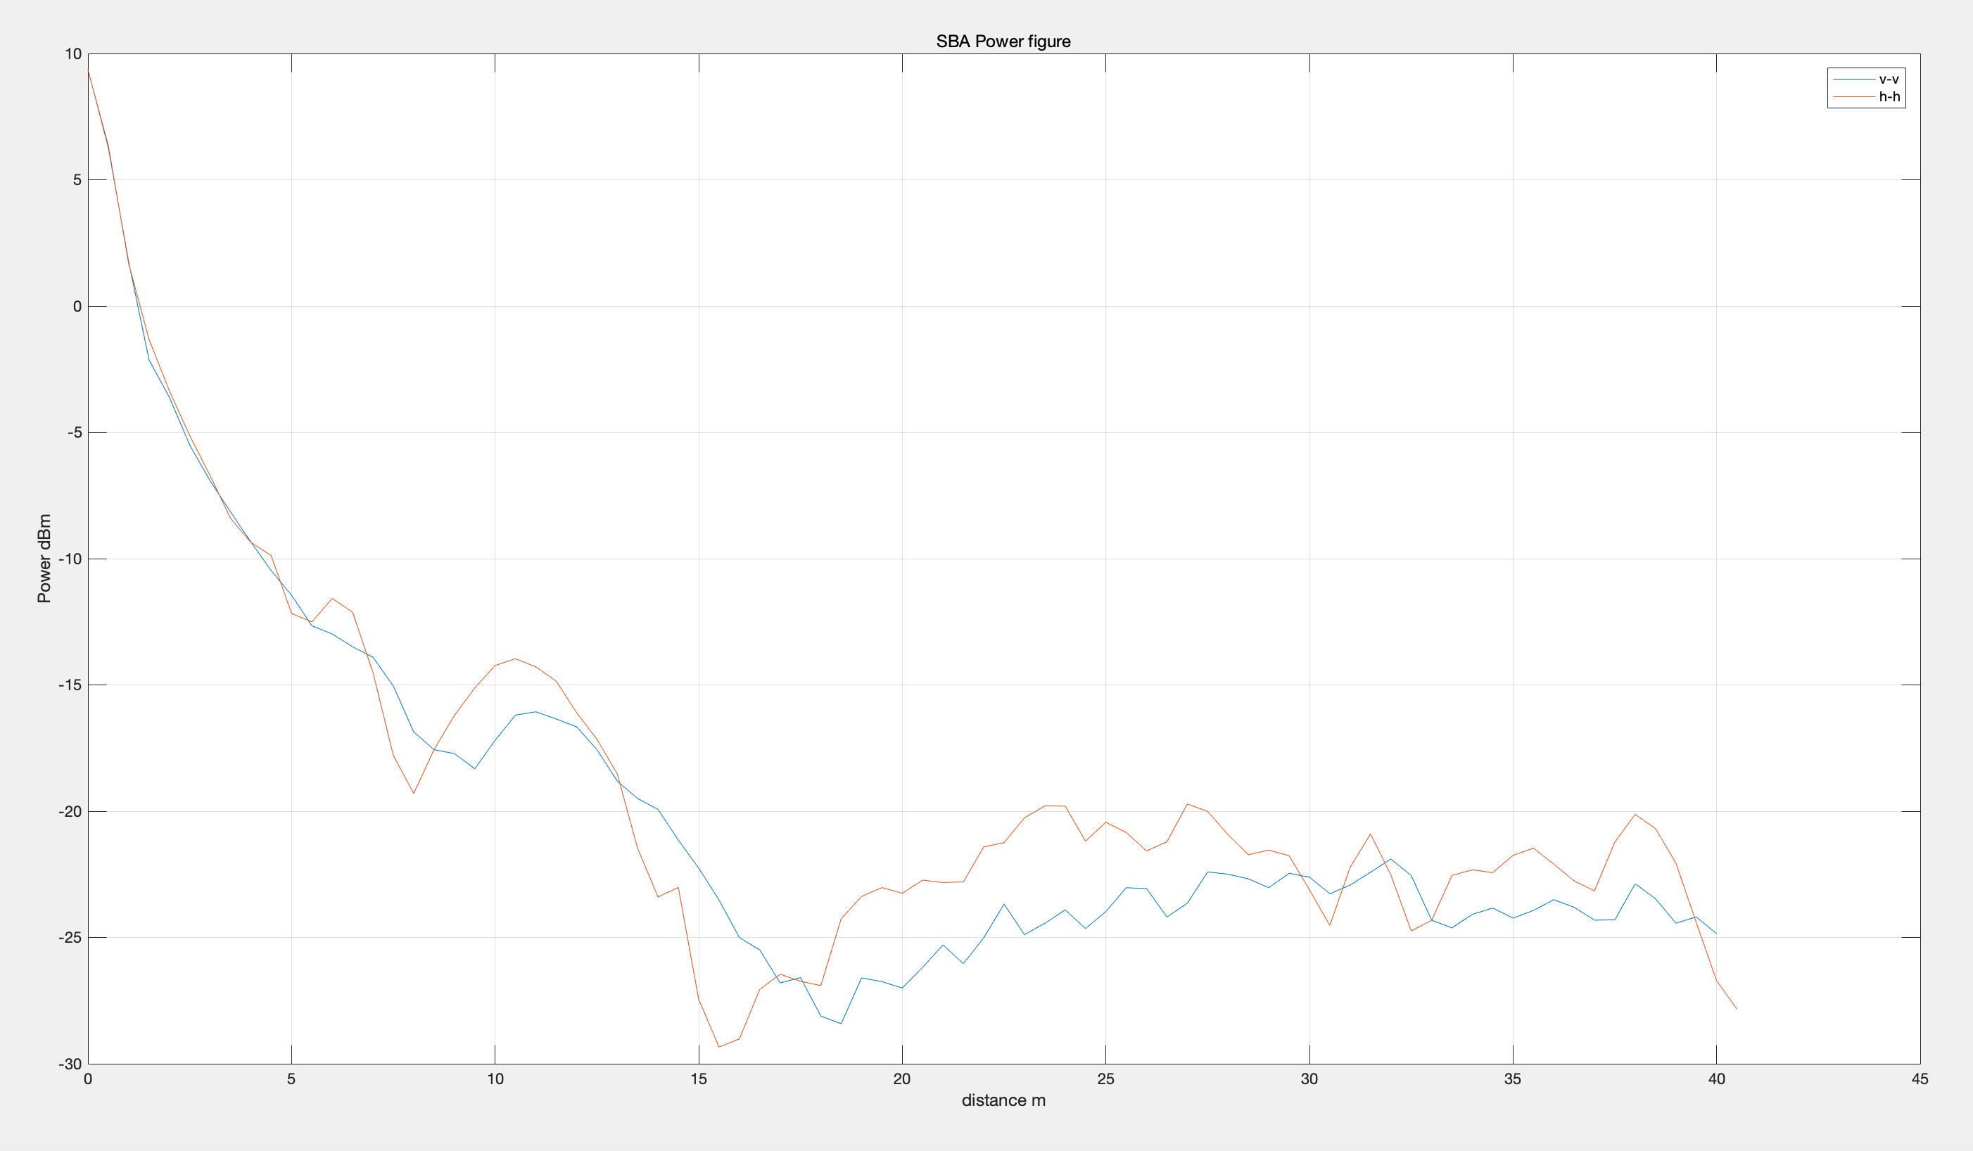

Figure Comparison V-V and H-H

**How do these measured results compare to the predictions from the 2-ray interference theory & the FEKOTM simulation results?**

**Compare with theory**

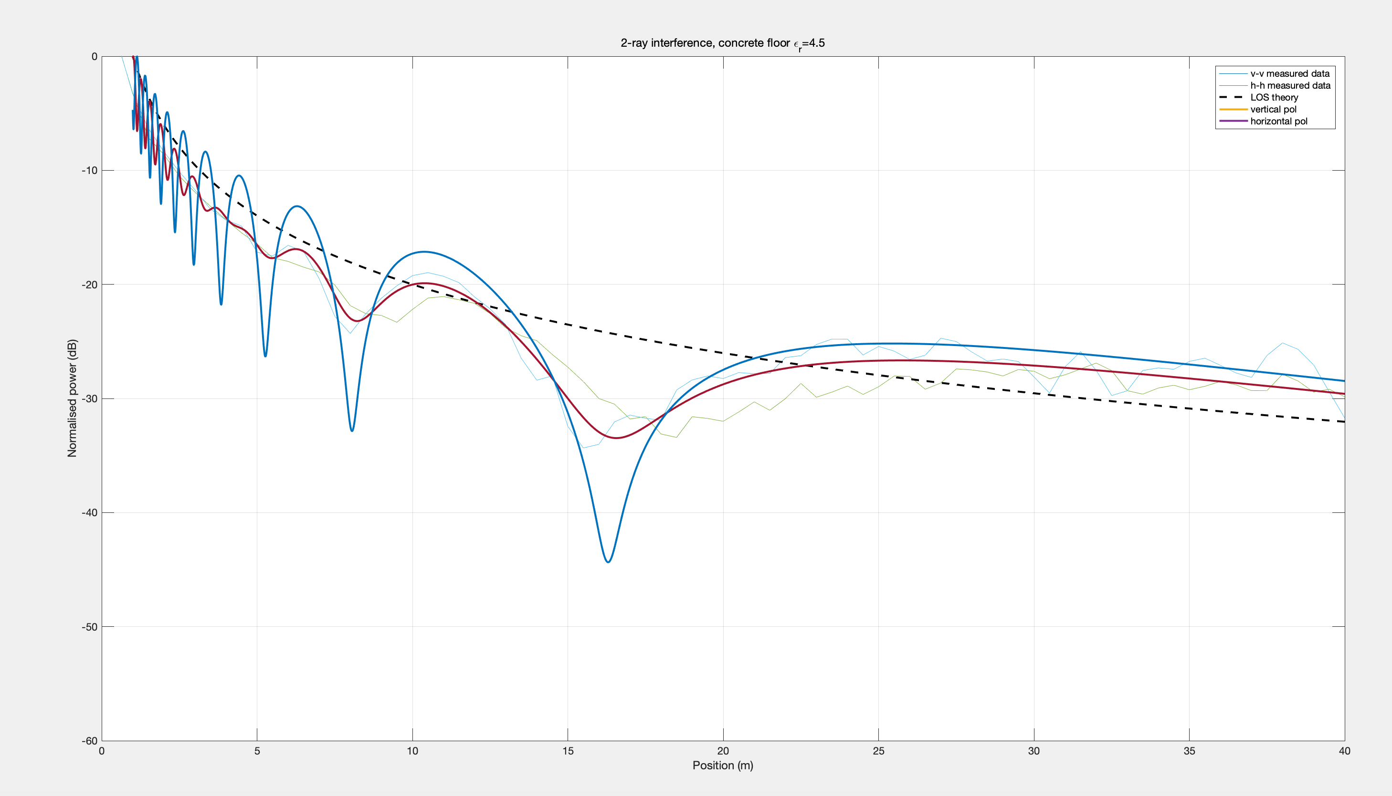

Figure Comparison between measured data and theory 4.5

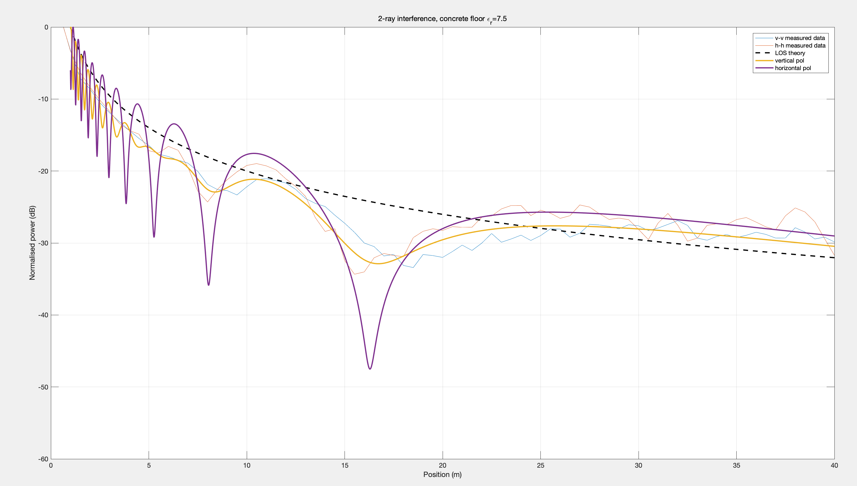

Figure Comparison between measured data and theory 7.5

**Compare with Feko**

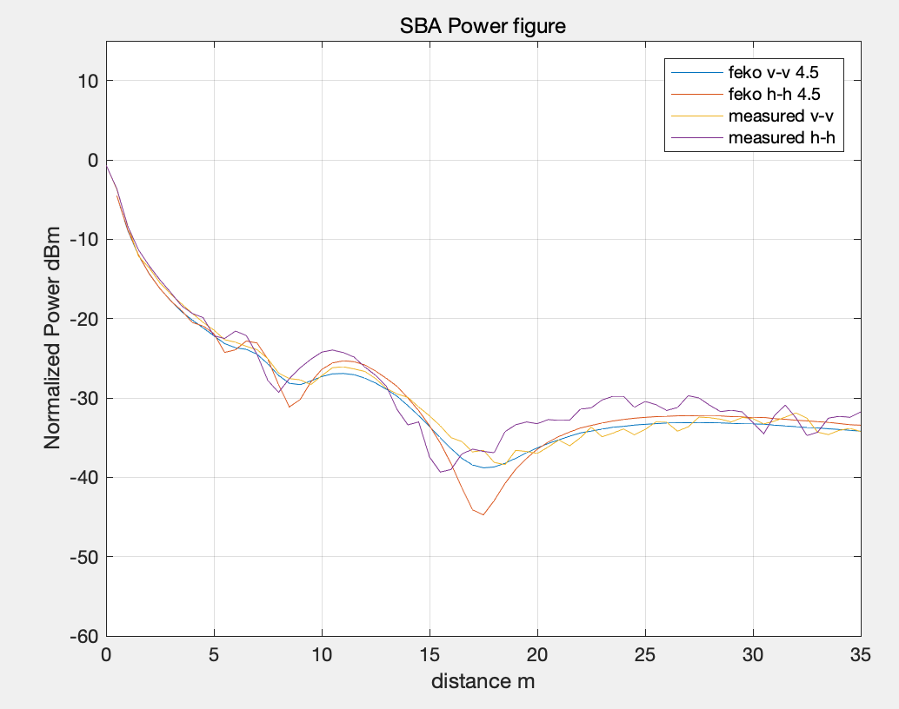

Figure Comparison between measured data and Feko 4.5

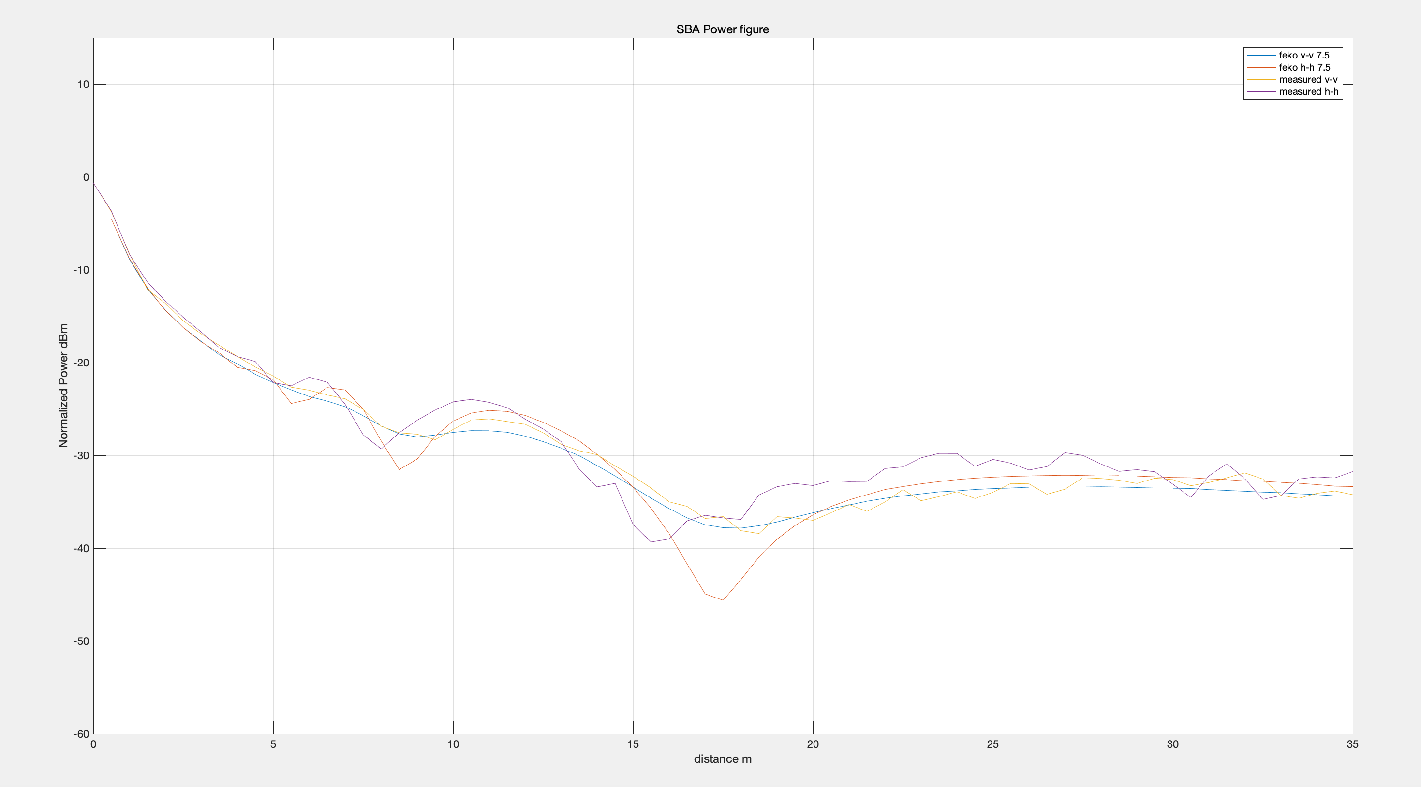

Figure Comparison between measured data and Feko 7.5

**Were there any significant differences between the 3 for V-V and H-H?**

Yes, the curve of V-V is smoother than the curve of H-H, moreover, the shape of H-H is more precipitous and cliffy than that of V-V.

**Can you determine the relative permittivity of the floor?**

According to figure we got, I think the relative permittivity is nearly at 4.5 in 2019/11/14 and the relative permittivity in 2019/11/28 is nearly at 3.5.

# Conclusion

In general, the measured data is corresponding to theoretical value. There is a gap between experimental curve and theoretical curve & Feko simulation curve, because of the system error and the influence of environment. Therefore, I normalize the measured data to compare with theoretical and simulation curve.

Because of polarization, the measured data is affected by relative permittivity. Here are the relative permittivity I determine.

|  |  |  |  |  |
| --- | --- | --- | --- | --- |
| Date | 2019/10/17 | 2019/10/31 | 2019/11/14 | 2019/11/28 |
| Relative permittivity | 5 | 3.5 | 4.5 | 3.5 |

I determine relative permittivity by comparing the measured data and theoretical curve, because the different relative permittivity have different shape. I change the in theoretical curve to fit measured data. Consequently, I got these results.

There is a system error in the experiment because of the influence of environment. Therefore, I normalize the measured data to compare theoretical curve and simulation curve.

In addition, I found an interesting phenomenon, the curve of H-H become more cliffy with the increase of relative permittivity , however the curve of V-V become more smoother with the increase of relative permittivity . The reason for this is influence of polarization.

# Reference

[1] R. R. Freeman, J. King, (Senior scientist), & G. P. Lafyatis. “Electromagnetic radiation”. Oxford University Press. 2019. Retrieved from http://search.ebscohost.com/login.aspx?direct=true&db=cat01010a&AN=xjtlu.0001416146&site=eds-live&scope=site

[2] T. S. Rappaport. “Wireless communications : principles and practice” = Wu xian tong xin yuan li yu ying yong. Publishing House of Electronics Industry (Wireless communications : principles and practice = 无线通信原理与应用 / Theodore S. Rappaport著). 2009. Available at: http://search.ebscohost.com/login.aspx?direct=true&db=cat01010a&AN=xjtlu.0000031720&site=eds-live&scope=site

[3] C. A. Balanis. “Advanced engineering electromagnetics”. Wiley. 2012. Available at: http://search.ebscohost.com/login.aspx?direct=true&db=cat01010a&AN=xjtlu.0001298082&site=eds-live&scope=site