EEE414: Mobile Communications

Propagation assignment

Name: Zhipeng Ye

ID number: 1926908

# Abstract

This report introduce the background of wireless mobile communication and ordinary propagation models. According to the experiment, I also compare data between measured data and simulation. Finally, I analyze the result and make a conclusion about this experiment.

# Introduction

## Radio waves and mobile communications

Wireless transmission is a method of data transmission using wireless technology. With the development of science and technology, high-performance, highly reliable wireless transmission systems have become possible. In the past, it was hard to imagine that when people were away from work, they could use their mobile phones to remotely control household appliances. When in a foreign country, you can use wireless communication to make phone calls with your family. On high-speed trains, you can watch wonderful TV videos. Not only that, with the development of wireless communication technology, telemedicine, autonomous driving, Augmented Reality will become a reality. 5G and WIFI-6 will greatly improve people's living standards.

## Free space propagation model

The wireless signal propagation model is the theoretical basis of wireless communication technology. Wireless communication technology comes from Maxwell's equations. This theorem reveals the relationship between electric and magnetic fields.

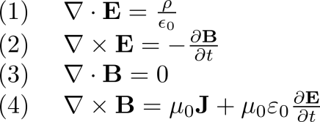

Where is the electric field and the magnetic field, wpsofficeis the vacuum permittivity, wpsoffice is the vacuum permeability, wpsoffice is the charge density, and wpsoffice is the current density.

Changing electric fields can produce magnetic field changes. Magnetic fields are radio waves. Light is also a type of radio wave, so scientists and engineers now plan to use optical communication Li-Fi.

The electric and magnetic fields are orthogonal to each other in Euclidean space and advance in a spiral manner, as shown in Figure 1.

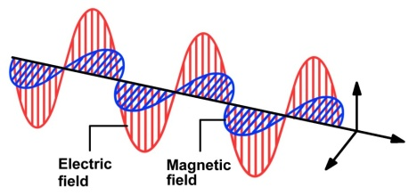

Picture 1

Since the divergence of the electromagnetic wave per unit time is constant, the electromagnetic wave is scattered outside in free space (vacuum). The energy will be uniformly dispersed on the sphere with the translation over time, as shown in Figure 2.

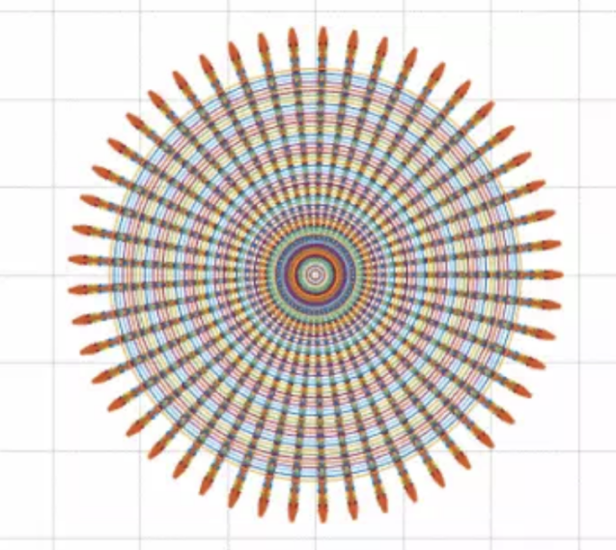

Picture 2

So the electromagnetic wave energy per unit area is inversely proportional to the distance. This defines the Friis transmission equation.

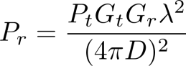

Free space loss

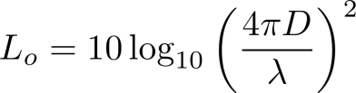

However, a vacuum environment cannot be provided in daily life, and radio wave transmission is also affected by the transmission environment.   
From the alternative form of the Friis equation, it can be seen that there is also a loss in the transmission medium wpsoffice。



In addition to the reflection of electromagnetic wave in the propagation process, different reference models must be established according to the propagation environment in engineering practice

## Indoor propagation

Indoor wireless is characterized by less transmission power, coverage distance is closer, the environment changes more, for different buildings, indoor layout, material structure, building scale and application type and other factors change more, which makes the communication environment has a great difference.

Even in different locations of the same building, the environment of transmission varies greatly, or even varies greatly. For example, the signal level depends heavily on whether the doors inside the building are open or closed. Walls and obstacles made of different materials have different barriers to signals, so the path loss attenuation index changes are relatively large, and even the number of building windows affects the loss between floors. Incoming losses of walls and floors vary depending on building materials, from 3dB of lightweight braids to 13-20dB of concrete brick structures.

The internal structure of a building causes the reflection of radio waves, bypassing, transmission and scattering, that is, causing the transmitted signal to reach the receiving end through more than one channel, which is the phenomenon of multi-transmission.

## Outdoor propagation

In the outdoor environment of mobile communication systems, electromagnetic waves usually travel in irregular, non-single environments. When estimating channel loss, we should consider the topographical features on the propagation path, as well as obstacles such as buildings, trees, electromagnetic poles, etc. Experiments show that with the increase of distance, the intensity of the receiving signal decreases gradually, but the rate of attenuation is different. The attenuation rate of propagation at the time of sight is the lowest, followed by the largest rate of attenuation in open areas and suburbs. Therefore, different transport models should be selected in different environments for predictive analysis.

In the outdoor propagation model, the macrocell model and the microcell model can be divided into macrocell model s In a macrocell scene, the base station can transmit power of tens of watts, covering a radius of several kilometers to tens of kilometers. In the microcell scenario, the coverage is smaller, always 200 to 1000 meters, the base station height is 3m to 10m, the transmit power is 10mw to 1kw, the predicted area is urban streets and other densely populated areas.

The most commonly used outdoor propagation environment models include, Okumura Model, Hata Model, Car Propagation Model, Double Line Model, Lee Model, Malllatton Propagation Model, Berg Model.

## 2-ray interference model

The 2-ray ineo model is an electromagnetic wave propagation model. Taking into account the effects of multiple transmissions, the receiving end of the radio receives a signal that is reflected back from the ground. Scientists and engineers have built 2-ray inone modelbased on this phenomenon. As shown in Figure 3:

The accepting signal consists of two components:

1. Direct or LOS component - The transmit signal travels through free space and reaches the receiving end.

2. Emission components - The transmit signal is reflected by the ground and reaches the receiving end.

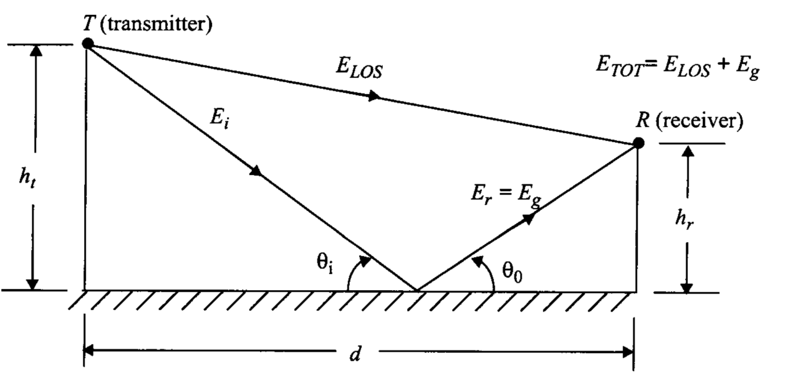

Picture 3 2-ray interference model

## Polarization

According to Maxwell's equation, the direction of the electric field and the direction of the magnetic field are perpendicular to each other. As shown in Figure4:

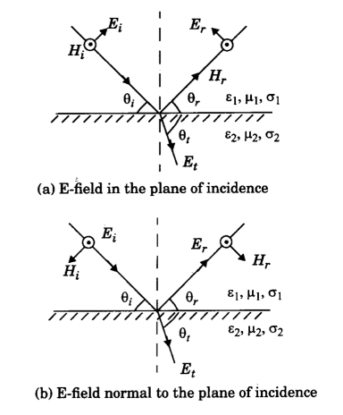

Picture 3 Electromagnetic wave polarization

Best launch and reception with polarization

In radio technology, the optimal transmission and reception of radio signals can be realized by using different polarized electromagnetic waves to transmit different propagation characteristics, combined with the polarization characteristics of transceiver antennas. For example, a medium-wave broadcast uses a vertically polarized wave.

### Increase communication capacity with polarization technology

In communication, in order to maximize the number of available channels within the limited frequency band, increase channel capacity, increase frequency utilization, reduce inter-wave interference, one of the frequency multiplexing techniques widely used is on the same transmission link, using the orthogonal polarization isolation of the radio waves, the two adjacent channels of orthogonal polarization are arranged in the same band, This doubles the frequency utilization.

### Application of polarization in radar target identification, detection and imaging

In addition to amplitude, phase information, there is an important information resource ——— polarization information in the radar echo signal, and the polarization state of the electromagnetic wave will change after the target is irradiated, which is related to the shape, structure, material and attitude of the target, and is also related to the polarization state of the target, therefore, You can use the polarization characteristics in the target echo to identify the target. [2]

### The Application of Polarization in Anti-Jamming

Communication, radar, navigation and other information and electronic equipment often encounter interference from other devices. For single-polarization interference, in general, as long as the polarization of the receiving antenna is changed to orthogonal with the interference radio wave polarization, interference can be greatly suppressed.

### Measurement experiment

Describe the types of measurements undertaken **in the anechoic chamber** & CG13W. Explain the choice of these rooms. What distance above the floor was used? What equipment was used?

The type of measurements in the anechoic chamber is a free space propagation model and the type of measurements in CG13W is a indoor propagation model. The reason for why we use this rooms is that the room is big enough we can measure many points. Furthermore, there is a little furniture in the room, therefore, there is a little interference and a little reflection. We use 40 meters to measure 80 points. Here are some equipments which are used.

|  |  |  |  |  |  |
| --- | --- | --- | --- | --- | --- |
| Name | RF Module | Antenna | Oscilloscope | Ruler | Go-cart |
| Number | 1 | 2 | 1 | 1 | 1 |

# Antenna Gain calculation

According to Balanis equation 17-15, I find this formula to calculate the Gain of both antenna types from the data measured in the anechoic chamber.



Here is the result that I calculate in Matlab.

Therefore, the Gain of faxe can is at 6.2529 - 6.5995 dBi and the Gain of SBA is at 14.2763 - 14.8720 dBi.

Comparing to the FEKO simulation result given in Lecture 2 Slides 56 & 57, the Gain of faxe can is 7.86dBi and the Gain of SBA is 16.17dBi.

### Were any of the data measured within the near field zone of either antenna type? What was the effect, if any?

Yes, there is some data measured within the near field. The data measured within the near field can avoid 2-ray interference model and reduce other interference.

# Effect of end reflections

Compare measured V-V beer can antenna data from 2019/09/26 and 2019/10/17. The latter measurements had an absorber barrier at the far corner of room CG13W. Did it have any effect?

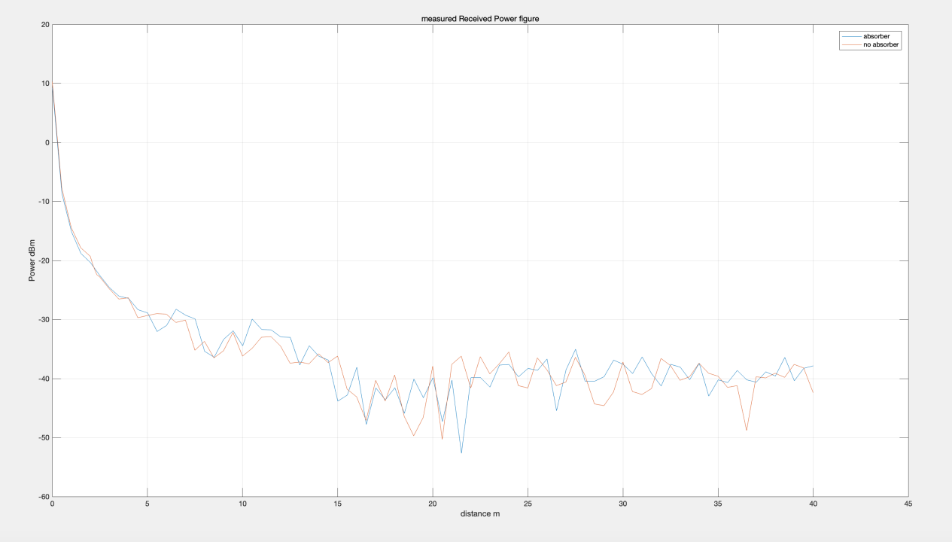

Picture 4

Absorber barrier at the far corner of room CG13W can enhance the impact of reflection.

# Beer can antenna data

Measured data from 2019/10/17 and 2019/10/31 were done with the beer can antennas, with the absorber barrier at the far corner of room CG13W. What was the difference between the V-V & H-H datasets?

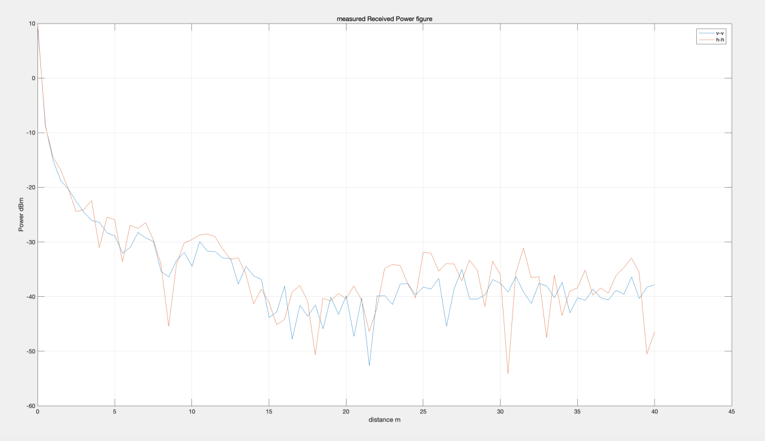

Picture 5

How do these measured results compare to the predictions from the 2- ray interference theory & the FEKOTM simulation results?

Compare with theory

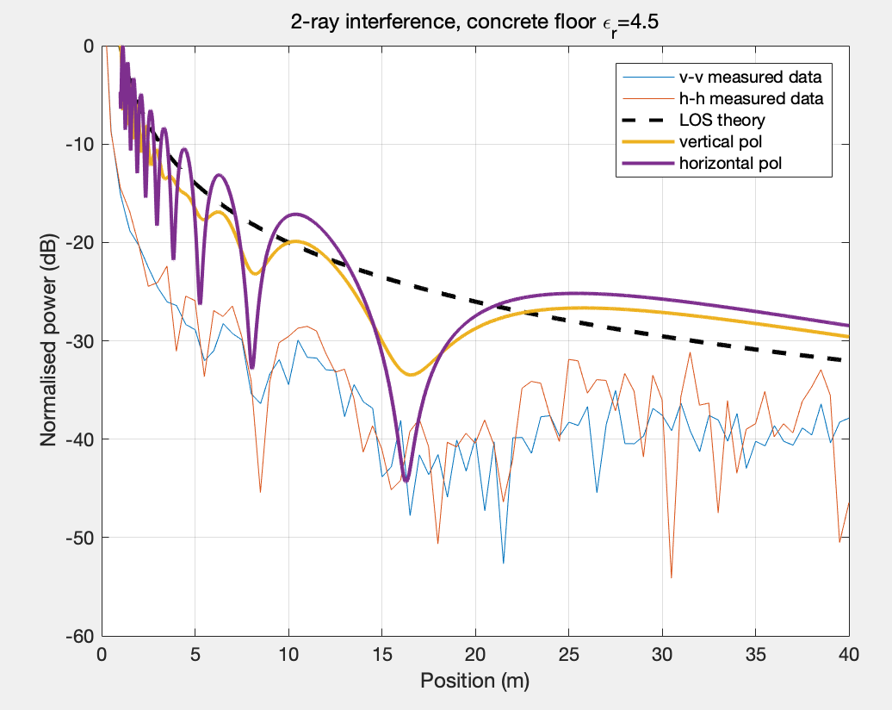

Picture 6

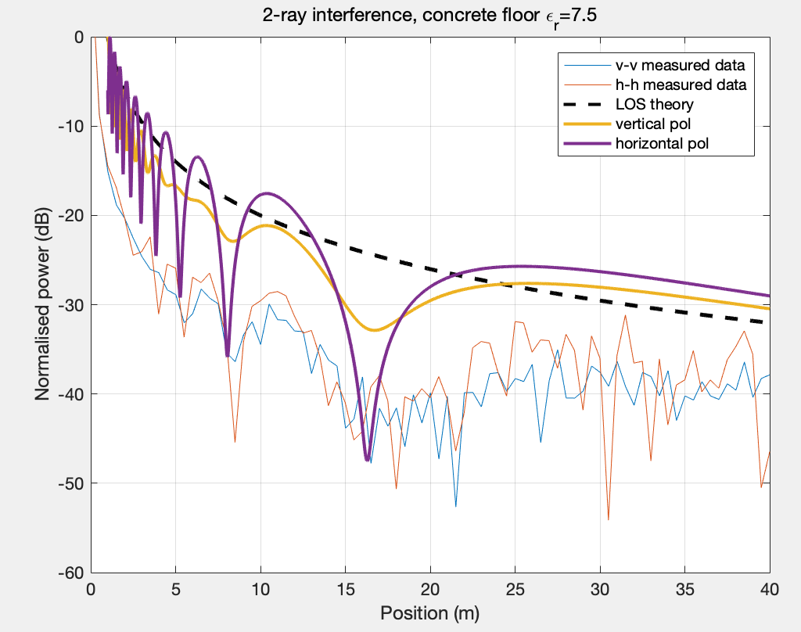

Picture 7

Compare with simulation

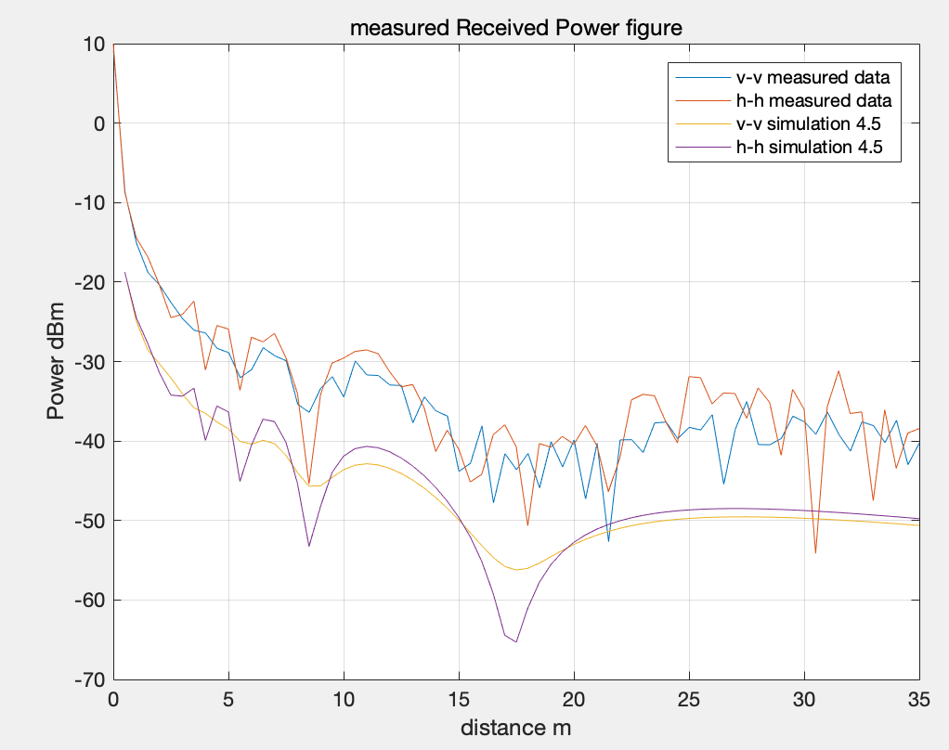

Picture 8

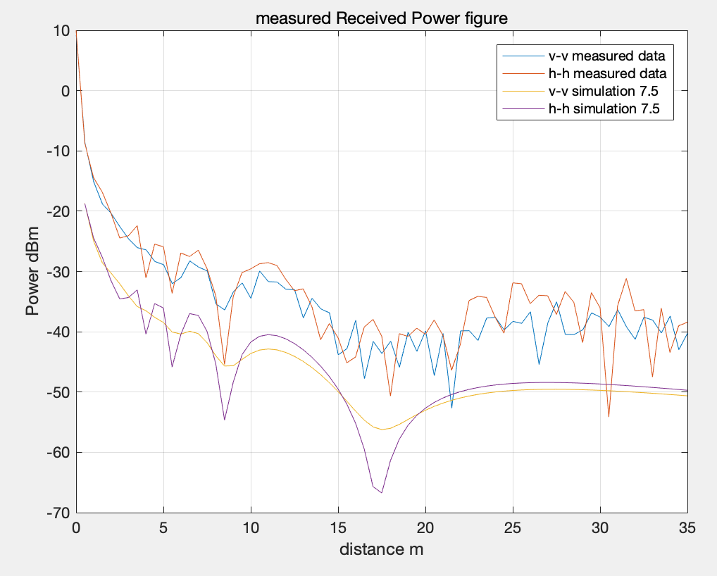

Picture 9

Were there any significant differences between the 3 for V-V and H-H?

Yes, the curve of V-V is smoother than the curve of H-H, moreover the shape of H-H is more precipitous and cliffy than that of V-V.

Can you determine the relative permittivity wpsofficeof the floor?

According to figure we got, I think the relative permittivity is nearly at 6.

# Short Backfire antenna data

Measured data from 2019/11/14 and 2019/11/28 were done with the Short Backfire cake tin antennas, with the absorber barrier at the far corner of room CG13W. What was the difference between the V-V & H-H datasets?

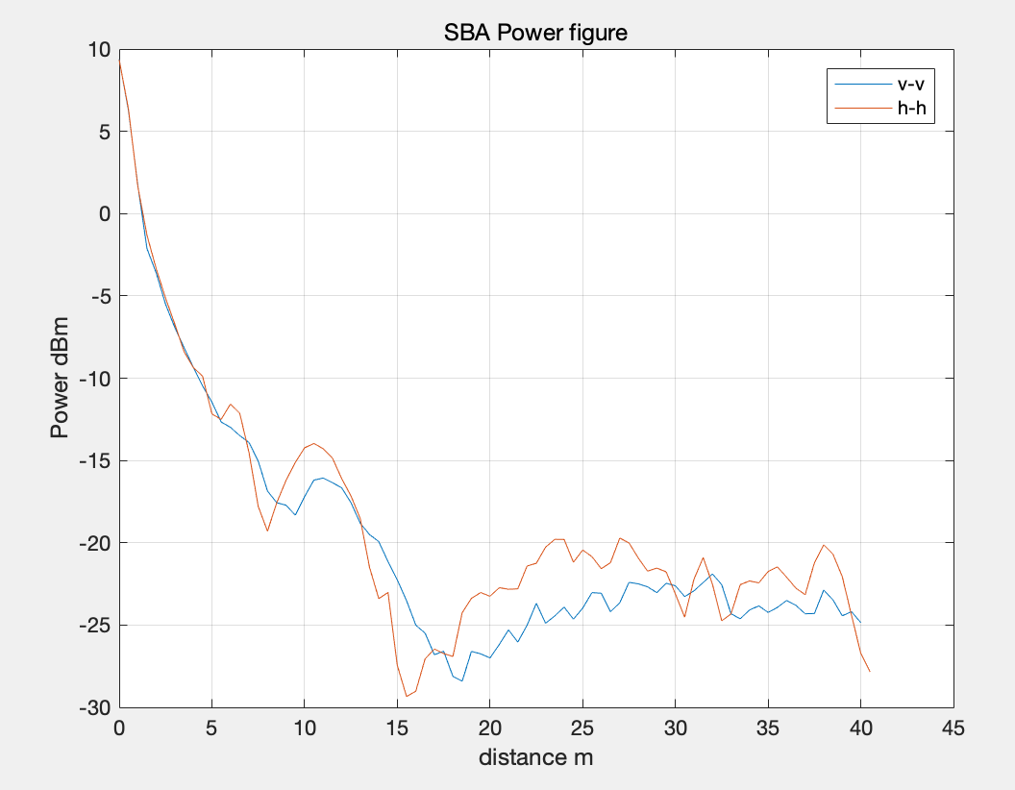

Picture 10

How do these measured results compare to the predictions from the 2-ray interference theory & the FEKOTM simulation results?

Compare with theory

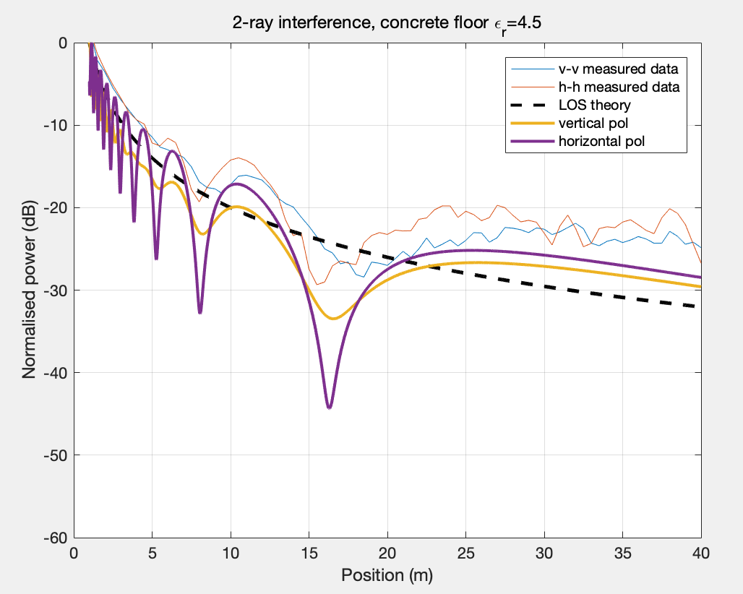

Picture 11

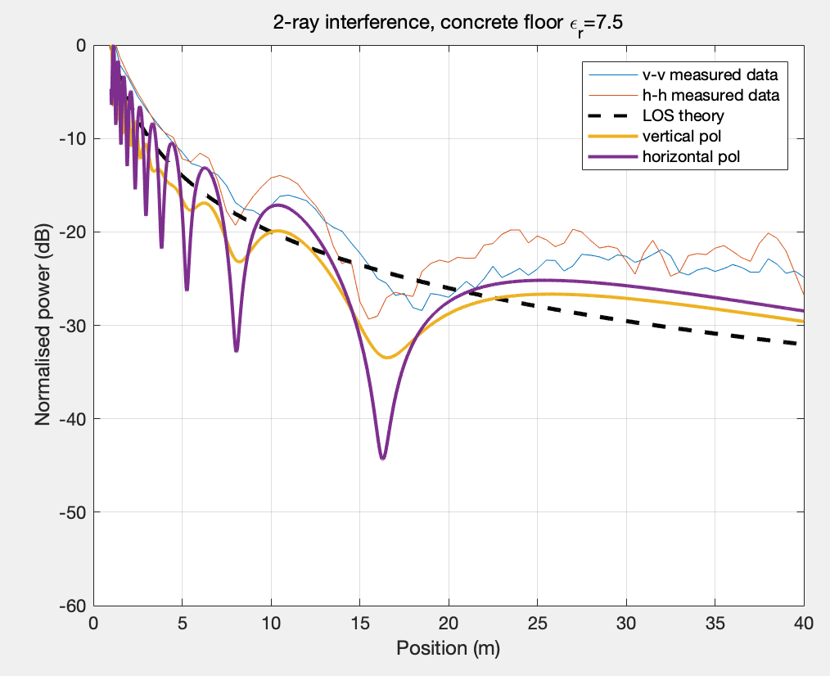

Picture 12

Compare with Feko

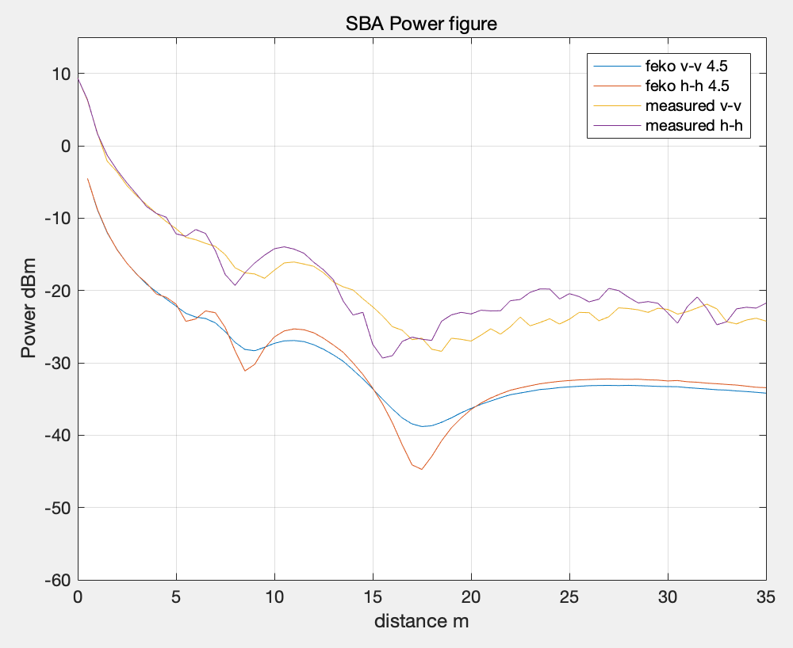

Picture 13

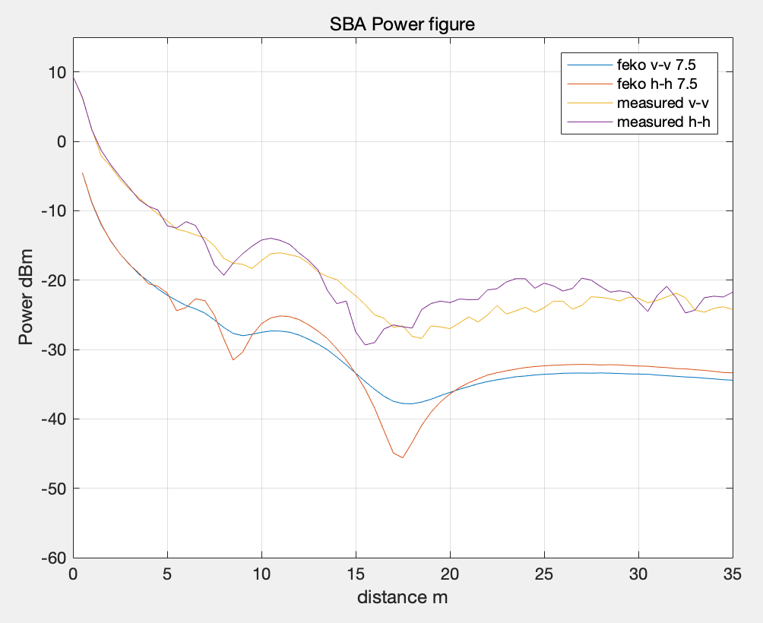

Picture 14

Were there any significant differences between the 3 for V-V and H-H?

Yes, the curve of V-V is smoother than the curve of H-H, moreover the shape of H-H is more precipitous and cliffy than that of V-V.

Can you determine the relative permittivity er of the floor?

According to figure we got, I think the relative permittivity is nearly at 6.

# Conclusion

Conclusions on agreement & differences between the theory, simulation & measured data. How do your 4 estimates of the floor relative permittivity compare? Any other observations on the entire exercise.