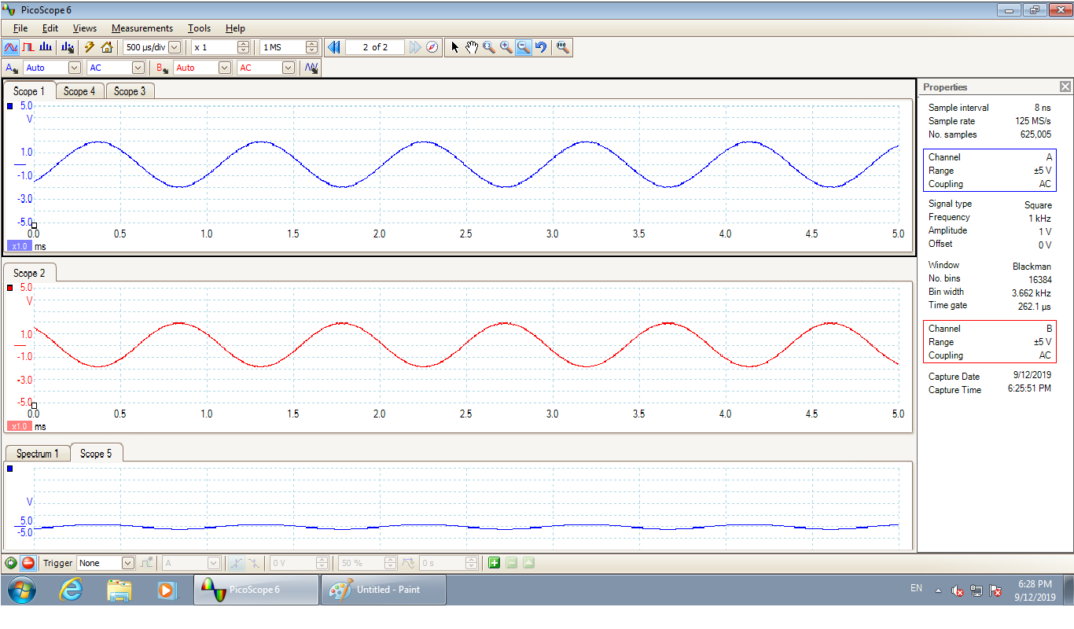

Figure 1 Signals input to the Adder

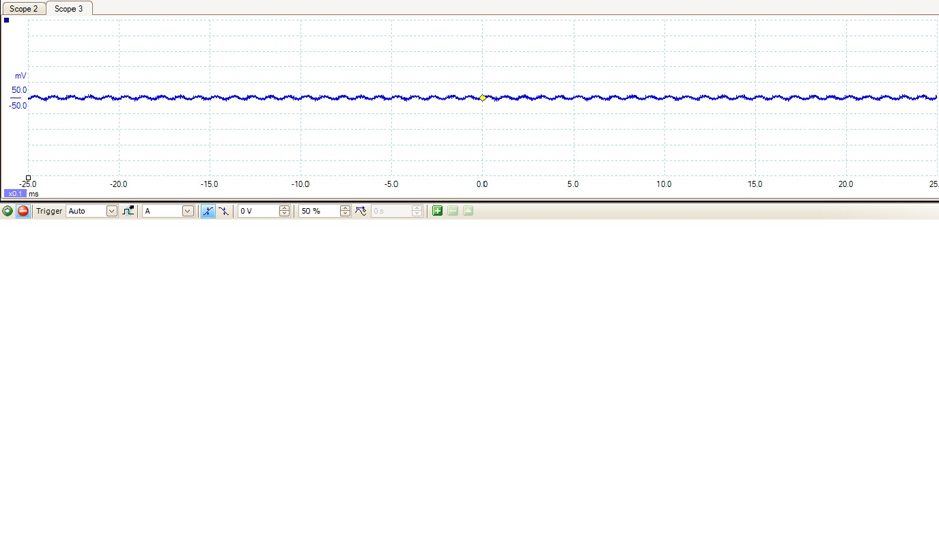

Figure 2 Output from the Adder

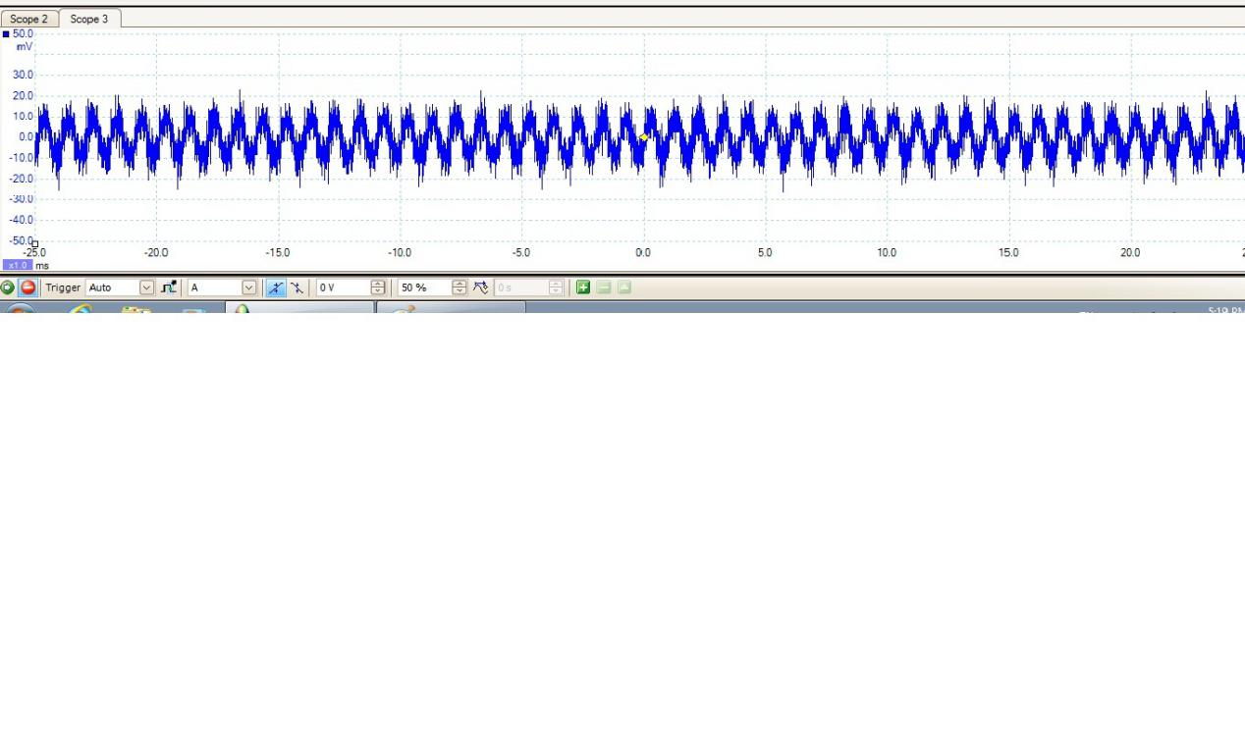

Figure 3 Output from the Adder (Zoomed)