**安装好后,登入Database Control – orcl (SYS 123)**

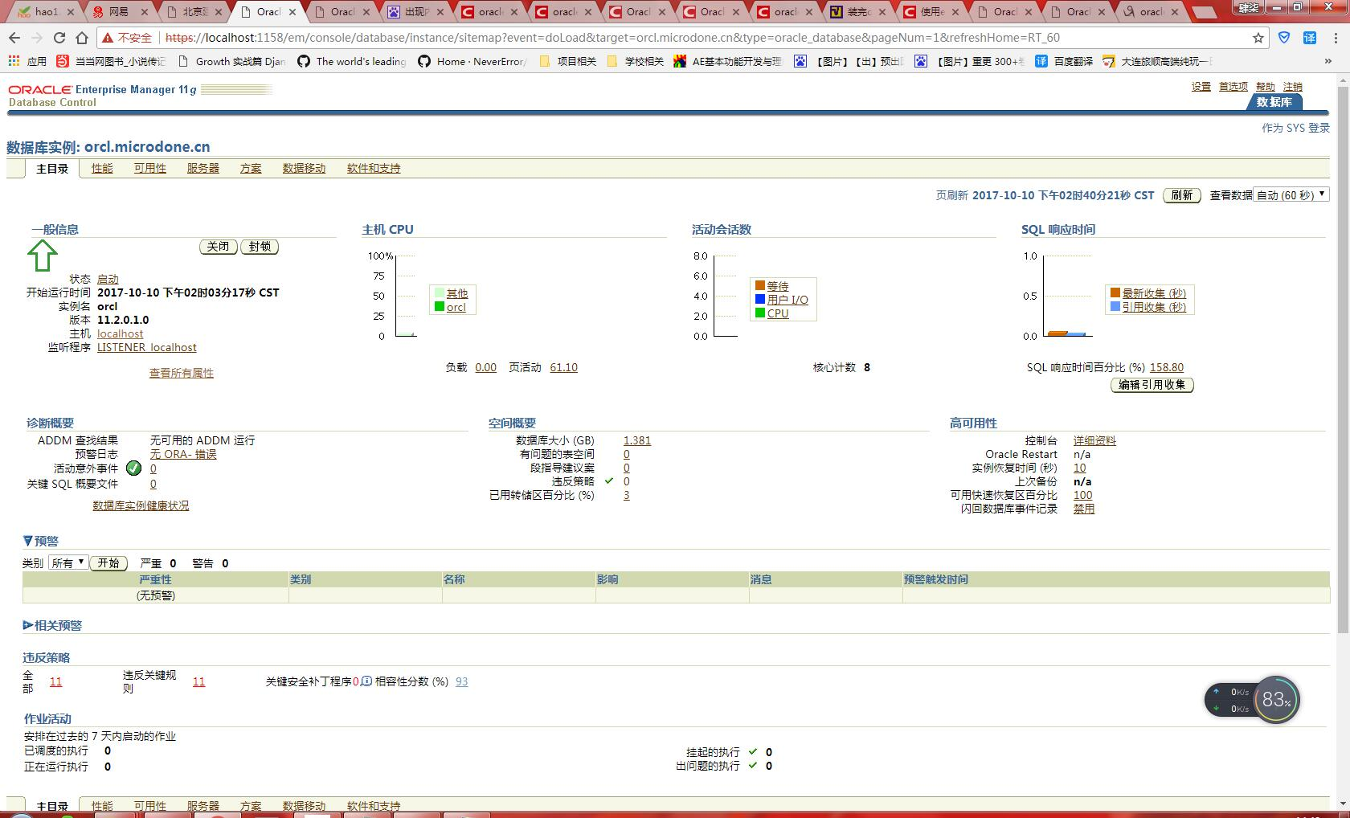

**创建test数据库遇到问题，如下：**

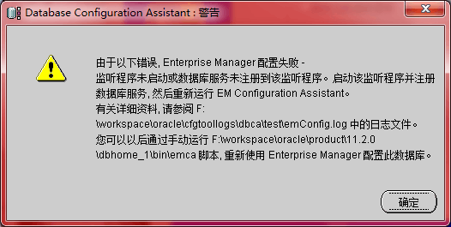

**解决方案：http://blog.csdn.net/hupoling/article/details/42123475**

**解决成功~创建好了test**

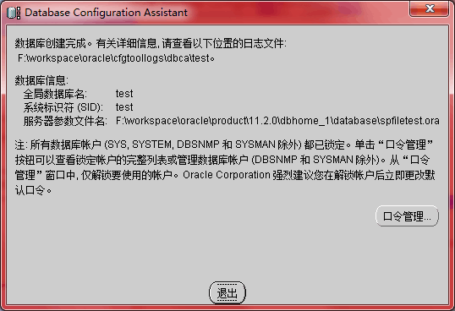

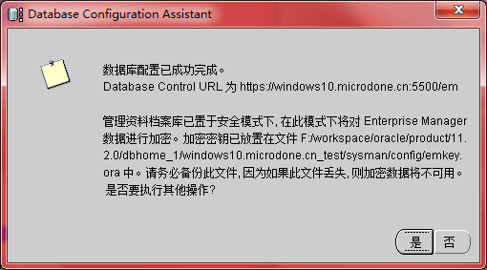

**Net manager 测试成功**

**服务名 test**

**Tcp/ip 本机ip (cmd-ifconfig-ipv4)**

**测试使用SYSMSN 1234**

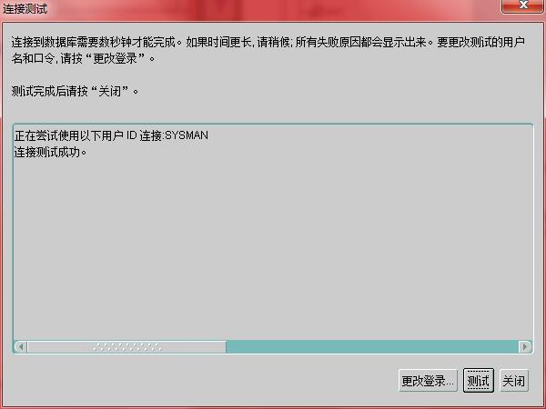

**登陆了test 使用SYSMAN 1234**

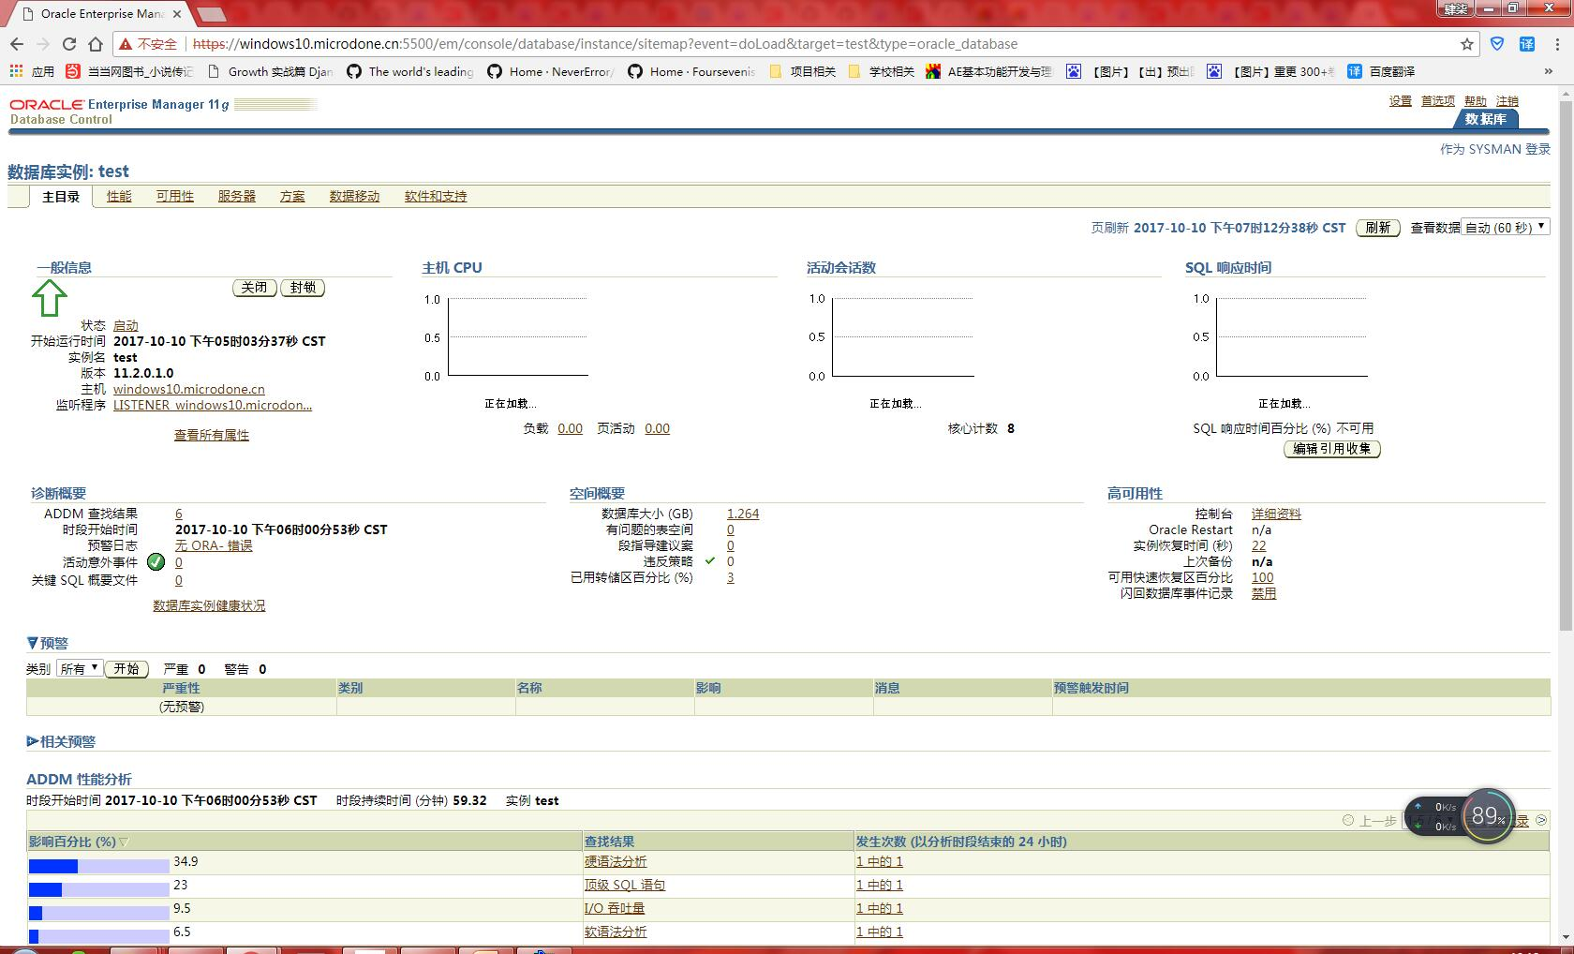

**创建新用户 LSQ**

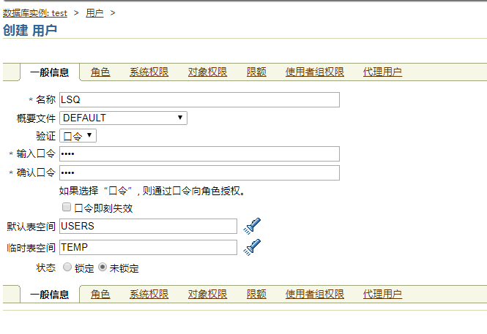

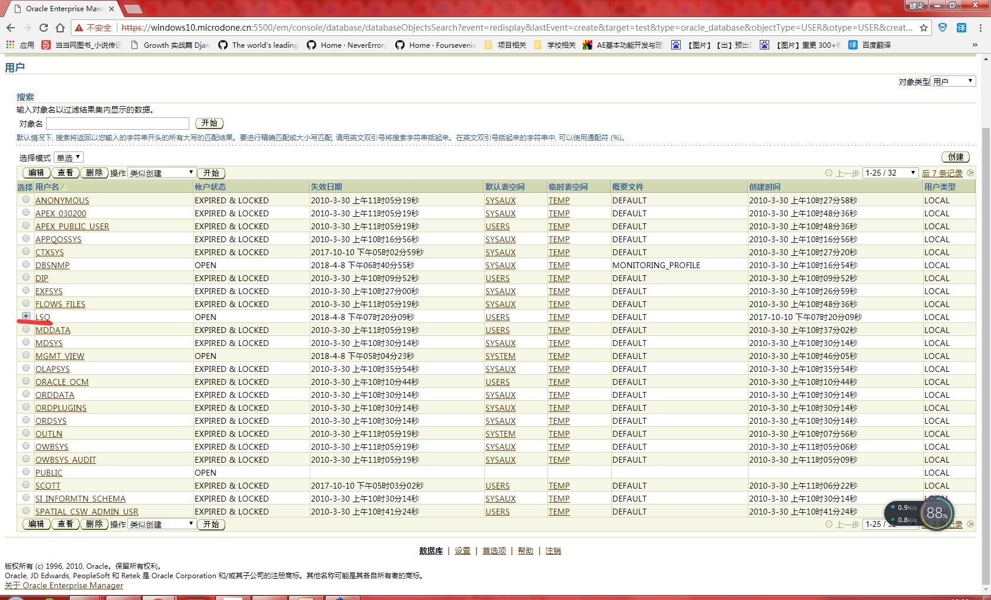

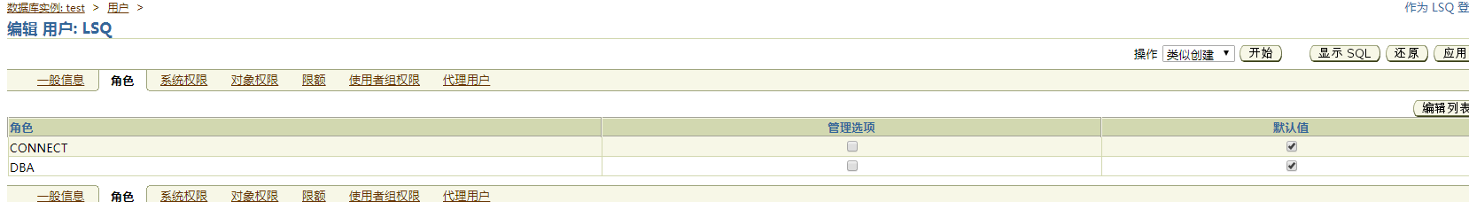

**11g版本没有isql*plus ,所以使用的是 ‘应用程序开发’-SQL PLUS**

**粘贴大法**

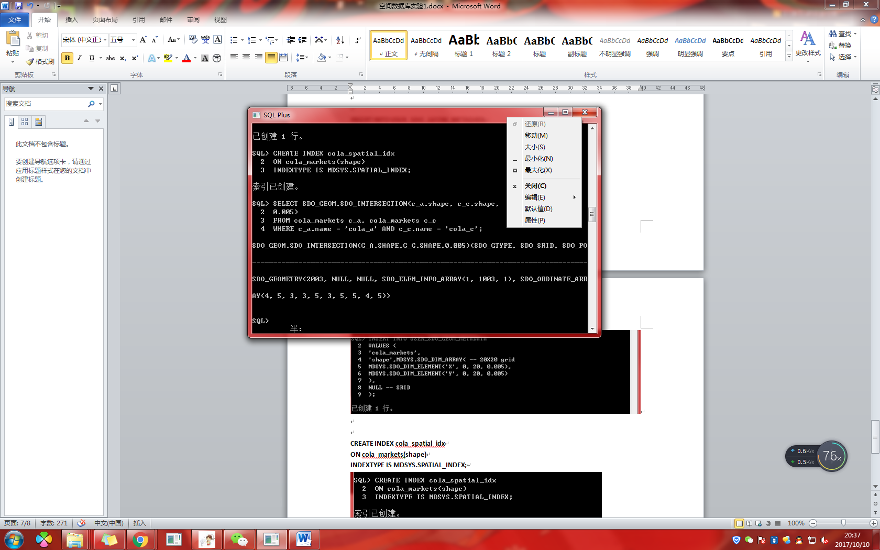

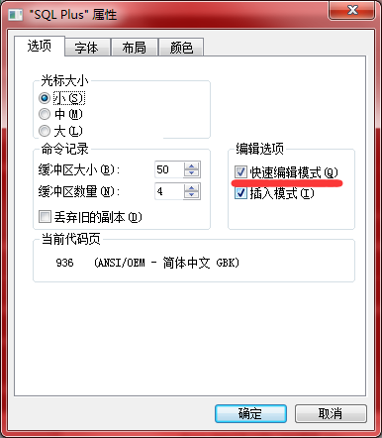

**drop INDEX cola_spatial_idx;**

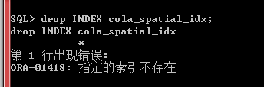

**drop TABLE cola_markets;**

**Delete from USER_SDO_GEOM_METADATA;**

**CREATE TABLE cola_markets (**

**mkt_id NUMBER PRIMARY KEY,**

**name VARCHAR2(32),**

**shape MDSYS.SDO_GEOMETRY);**

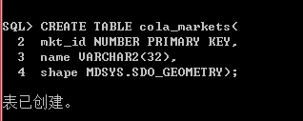

**INSERT INTO cola_markets VALUES(**

**1,**

**'cola_a',**

**MDSYS.SDO_GEOMETRY(**

**2003, -- 2-dimensional polygon**

**NULL,**

**NULL,**

**MDSYS.SDO_ELEM_INFO_ARRAY(1,1003,3), -- one rectangle (1003 = exterior)**

**MDSYS.SDO_ORDINATE_ARRAY(1,1, 5,7) -- only 2 points needed to**

**));**

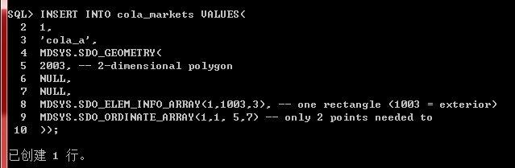

**INSERT INTO cola_markets VALUES(**

**2,**

**'cola_b',**

**MDSYS.SDO_GEOMETRY(**

**2003, -- 2-dimensional polygon**

**NULL,NULL,**

**MDSYS.SDO_ELEM_INFO_ARRAY(1,1003,1), -- one polygon (exterior polygon ring)**

**MDSYS.SDO_ORDINATE_ARRAY(5,1, 8,1, 8,6, 5,7, 5,1)**

**));**

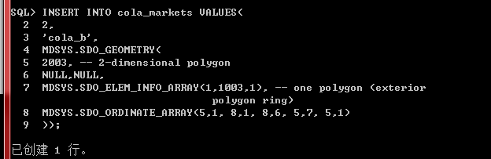

**INSERT INTO cola_markets VALUES(**

**3,**

**'cola_c',**

**MDSYS.SDO_GEOMETRY(**

**2003, -- 2-dimensional polygon**

**NULL,**

**NULL,**

**MDSYS.SDO_ELEM_INFO_ARRAY(1,1003,1), -- one polygon (exterior polygon ring)**

**MDSYS.SDO_ORDINATE_ARRAY(3,3, 6,3, 6,5, 4,5, 3,3)**

**));**

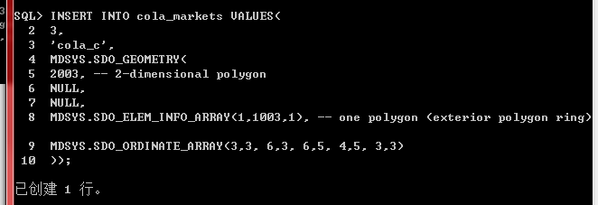

**INSERT INTO cola_markets VALUES(**

**4,**

**'cola_d',**

**MDSYS.SDO_GEOMETRY(**

**2003, -- 2-dimensional polygon**

**NULL,**

**NULL,**

**MDSYS.SDO_ELEM_INFO_ARRAY(1,1003,4), -- one circle**

**MDSYS.SDO_ORDINATE_ARRAY(8,7, 10,9, 8,11)**

**)**

**);**

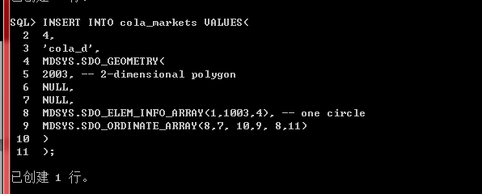

**INSERT INTO USER_SDO_GEOM_METADATA**

**VALUES (**

**'cola_markets',**

**'shape',MDSYS.SDO_DIM_ARRAY( -- 20X20 grid**

**MDSYS.SDO_DIM_ELEMENT('X', 0, 20, 0.005),**

**MDSYS.SDO_DIM_ELEMENT('Y', 0, 20, 0.005)**

**),**

**NULL -- SRID**

**);**

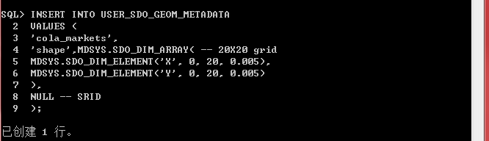

**CREATE INDEX cola_spatial_idx**

**ON cola_markets(shape)**

**INDEXTYPE IS MDSYS.SPATIAL_INDEX;**

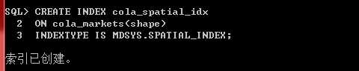

**SELECT SDO_GEOM.SDO_INTERSECTION(c_a.shape, c_c.shape, 0.005)**

**FROM cola_markets c_a, cola_markets c_c**

**WHERE c_a.name = 'cola_a' AND c_c.name = 'cola_c';**

